React
Exercise 1:
React App installation:
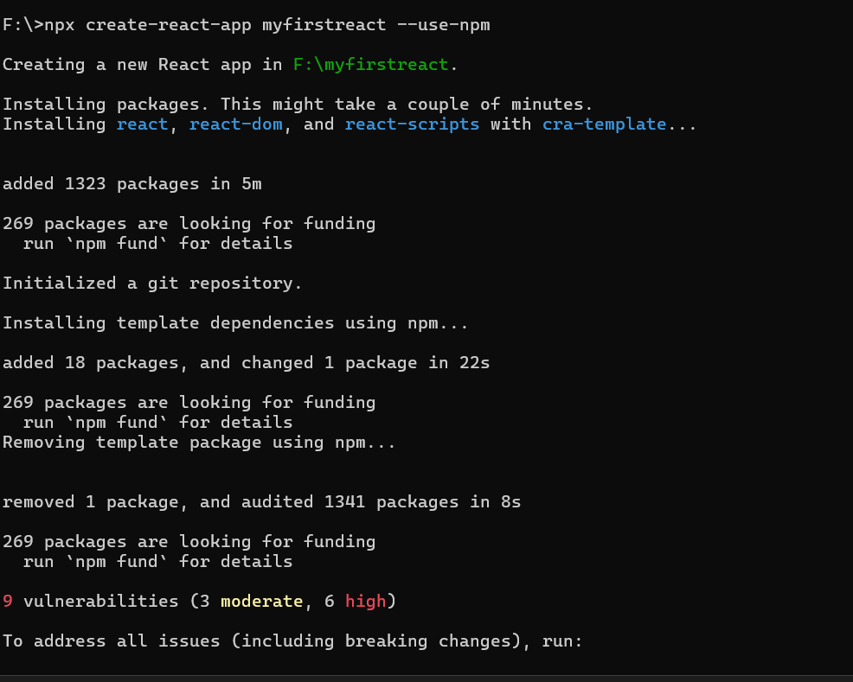
App.js:
import logo from './logo.svg';
import './App.css';

function App() {
return( <h1>Welcome the first session of React</h1>)
}
export default App;

Output:
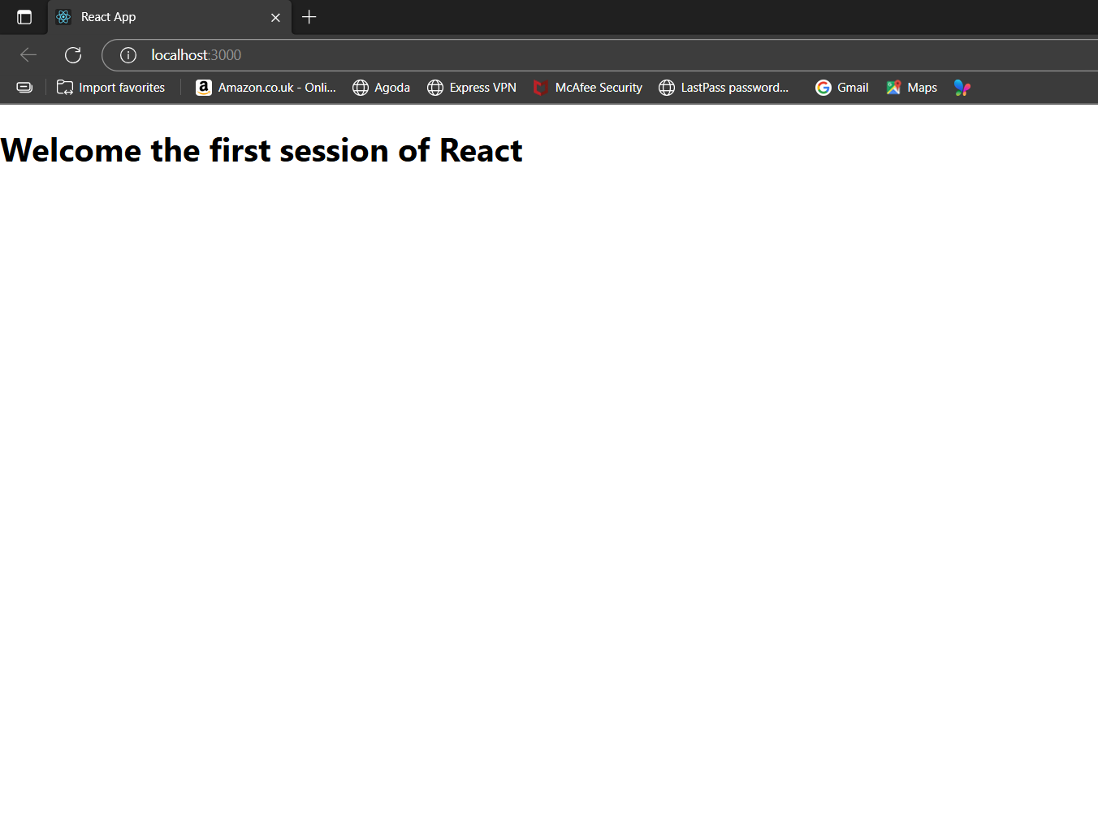

Exercise 2:
About.js:
import React, { Component } from 'react';
class About extends Component{
render(){
return( <div>
<h3>Welcome to the About Page of Student Management System</h3></div>
);
}
}
export default About;
Home.js:
import React, {Component} from 'react';
class Home extends Component{
render(){
return( <div>
<h3>Welcome to the Home Page of Student Management System</h3></div>
);
}
}
export default Home;
Contact.js:
import React, {Component} from 'react';
class Contact extends Component{
render(){
return(
<div>
<h3>Welcome to the Contact Page of Student Management System</h3></div>
);
}
}
export default Contact;

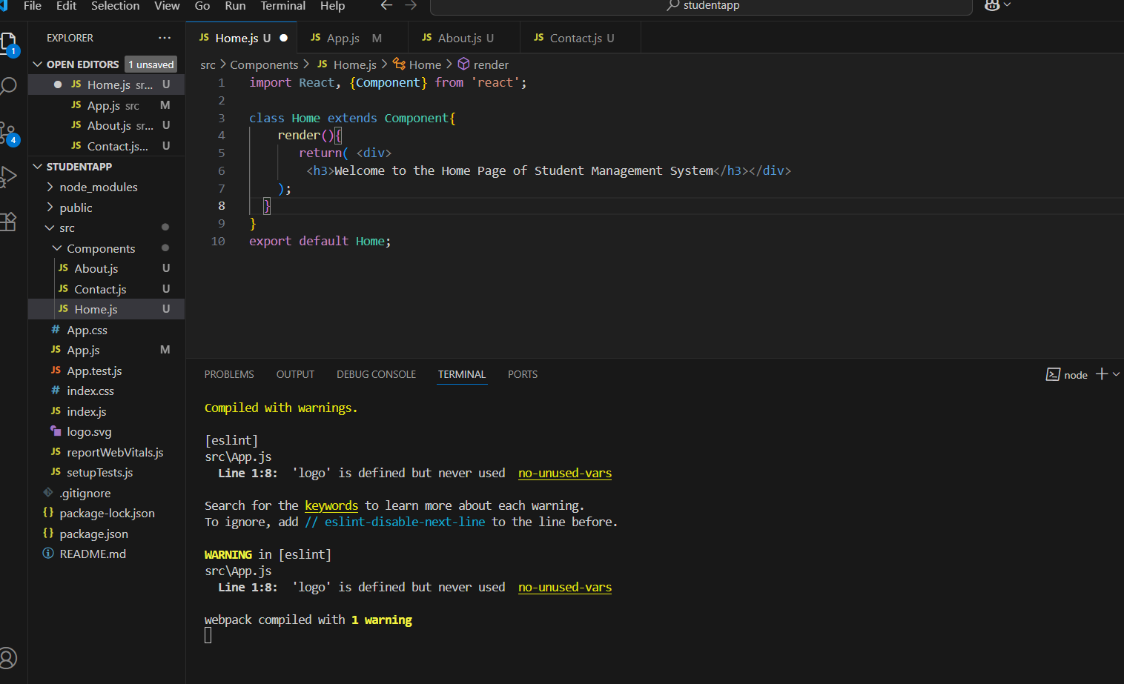

Output:
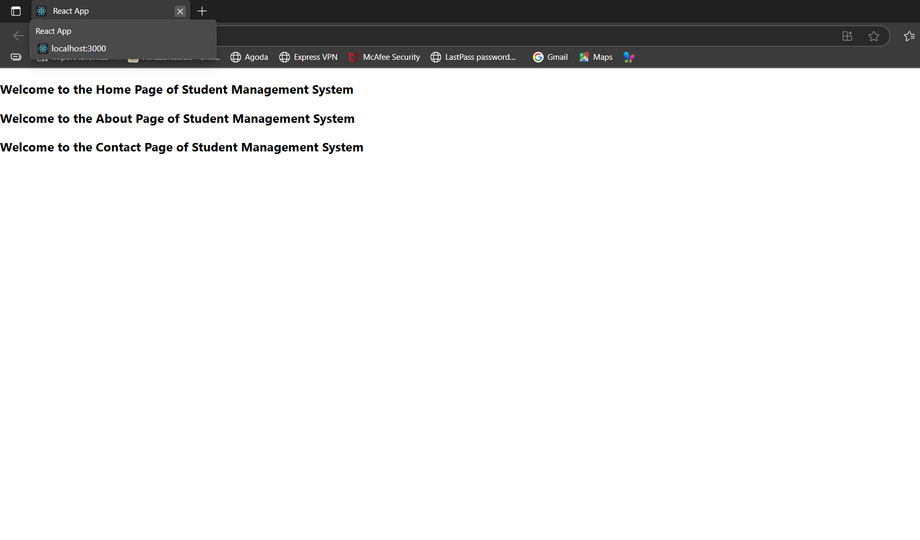
Exercise 3:
CalculatorScore.js
import '../Stylesheets/mystyle.css';
const percentToDecimal = (decimal) => {
return (decimal.toFixed(2) + '%');
};
const calculatePercentage = (total, goal) => {
return percentToDecimal(total / goal);
};
export const CalcScore = ({ Name, School, total, goal }) => {
return (
<div className="formatstyle">
<h1><font color="Brown">Student Details</font></h1>
<div className="Name">
<b><span>Name:</span></b>
<span>{Name}</span>
</div>
<div className="School">
<b><span>School:</span></b>
<span>{School}</span>
</div>
<div className="Total">
<b><span>Total:</span></b>
<span>{total}</span>
<span> Marks</span>
</div>
<div className="Score">
<b>Score:</b>
<span>{calculatePercentage(total, goal)}</span>
</div>
</div>
);
};
export default CalcScore;
App.js
import logo from './logo.svg';
import './App.css';
import {CalcScore} from '../src/Components/CalculateScore'
function App() {
return(
<div>
<CalcScore Name={"Steeve"}
School={"DNV Public School"}
total={284}
goal={3}
/>
</div>)
}
export default App;

mystyle.css:
.Name{
font-weight:300;
color:blue;
}
.School{
color:crimson;
}
.Total{
color:darkmagneta;
}
.formatstyle{
text-align:center;
font-size:large;
}
.Score{
color:forestgreen;
}
Output:
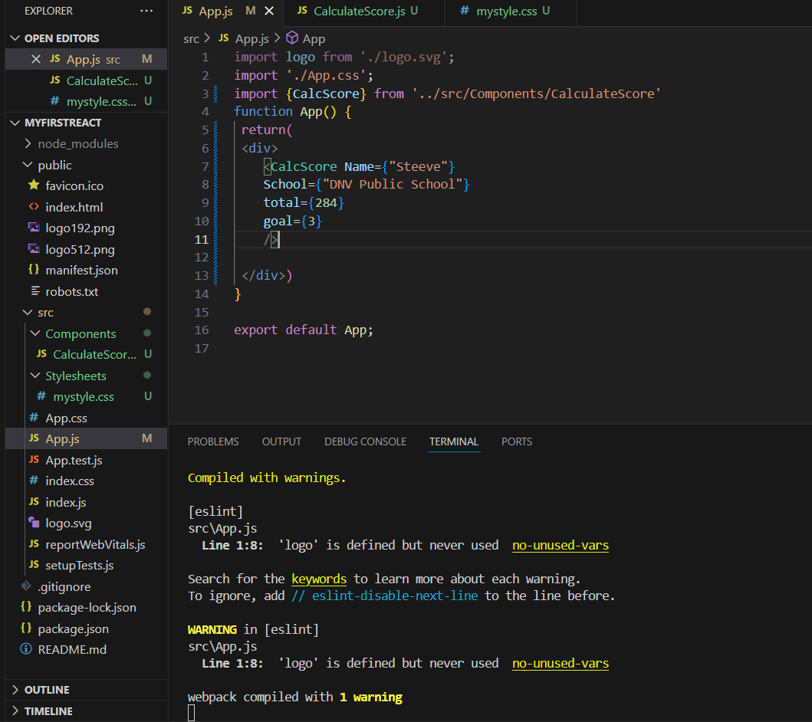

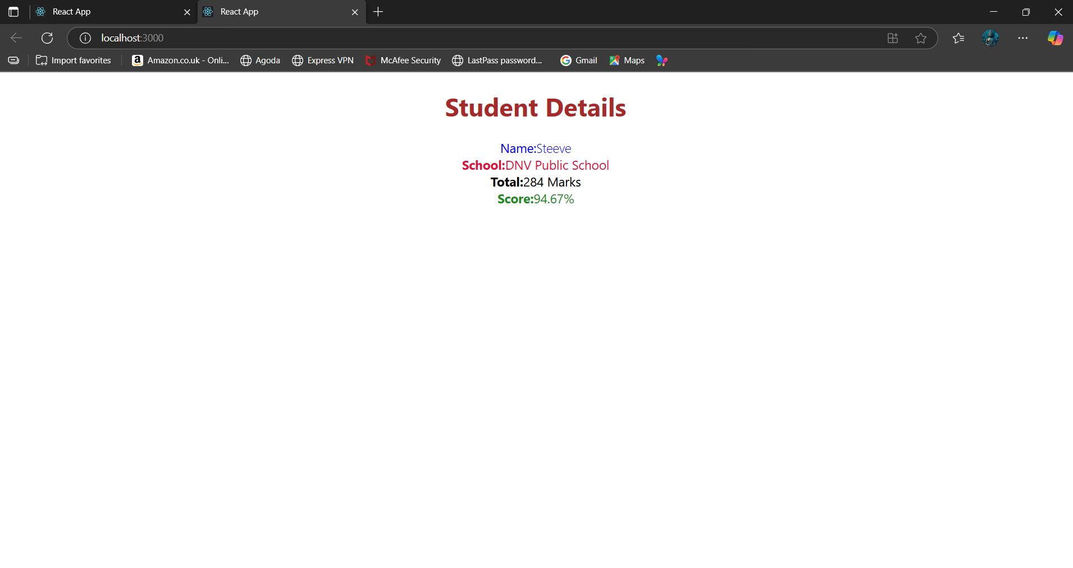
Exercise 4:
Post.js
import React, { Component } from 'react';
class Post extends Component {
render() {
const { title, body } = this.props;
return (
<div style={{ border: '1px solid #ccc', padding: '10px', marginBottom: '10px' }}>
<h3>{title}</h3>
<p>{body}</p>
</div>
);
}
}
export default Post;
Posts.js:
import React, { Component } from 'react';
import Post from './Post';
class Posts extends React.Component{
constructor(props){
super(props);
this.state = {
posts: []
};
}
loadPosts(){
fetch('https://jsonplaceholder.typicode.com/posts')
.then((response) => response.json())
.then((data) => {
this.setState({ posts: data });
})
.catch((error) => {
console.error('Error fetching posts:', error);
});
}
componentDidMount(){
this.loadPosts();
}
render(){
return (
<div>
<h1>Blog Posts</h1>
{this.state.posts.map((post) => (
<Post key={post.id} title={post.title} body={post.body} />
))}
</div>
);
}
componentDidCatch(error,info){
alert("An error occurred: " + error.message);
}
}
export default Posts;
App.js:
import logo from './logo.svg';
import './App.css';
import Posts from './Posts';
function App() {
return(
<div>
<div className="App">

<Posts/>
</div>
</div>)
}
export default App;
Output:
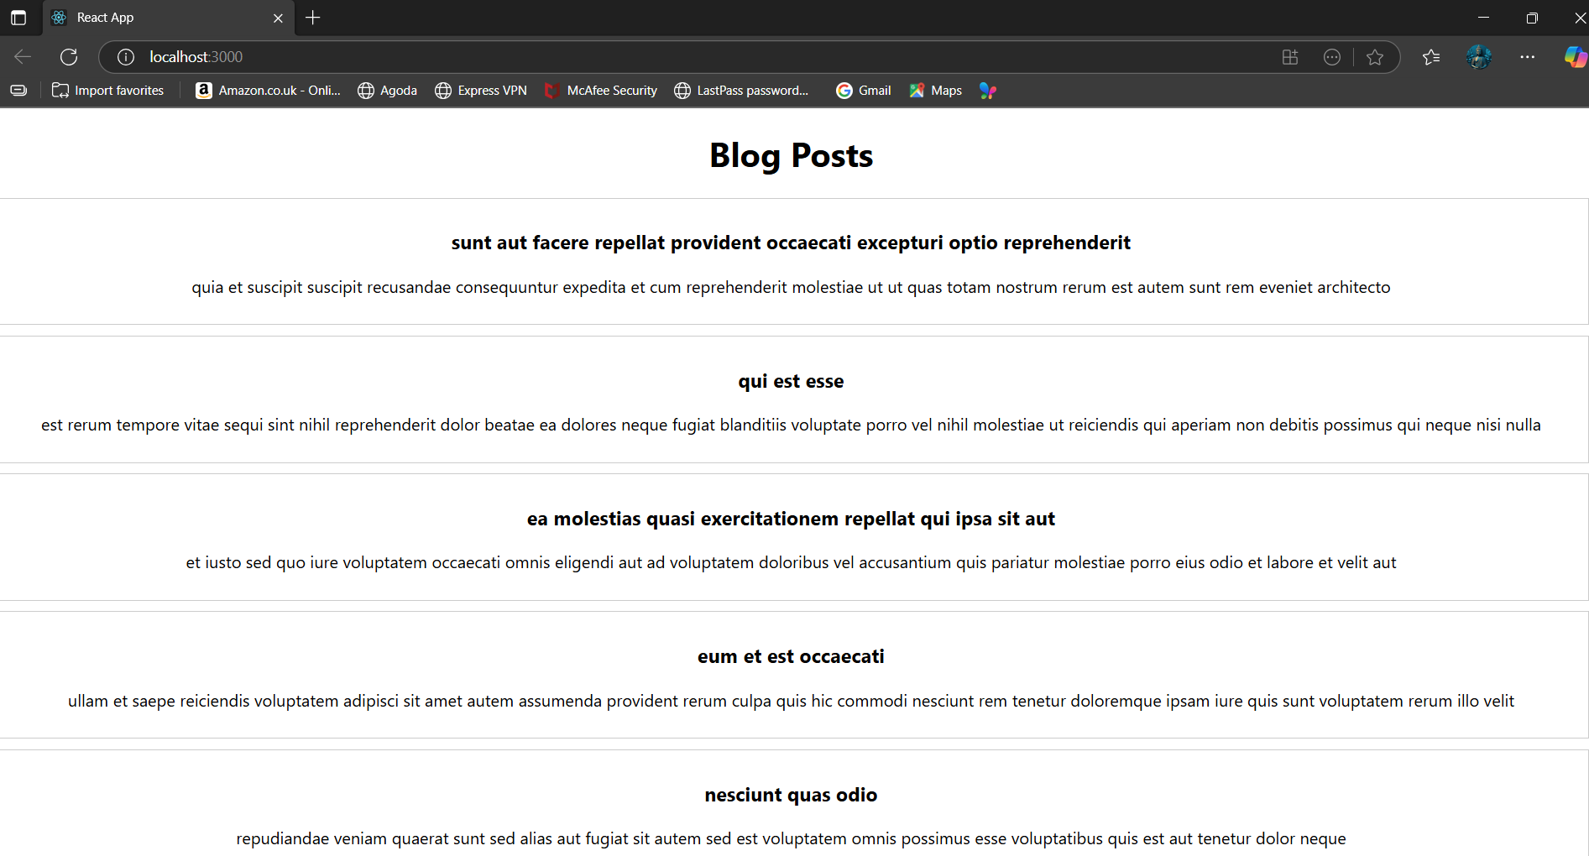
Exercise 5:
CohortDetails.js:
import styles from './CohortDetails.module.css';
function CohortDetails(props) {
const { cohort } = props;
const headingColor = cohort.currentStatus === 'Ongoing' ? 'green' : 'blue';

return (
<div className={styles.box}>
<h3 style={{ color: headingColor }}>
{cohort.cohortCode} - {cohort.technology}
</h3>
<dl>
<dt>Started On</dt>
<dd>{cohort.startDate}</dd>
<dt>Current Status</dt>
<dd>{cohort.currentStatus}</dd>
<dt>Coach</dt>
<dd>{cohort.coachName}</dd>
<dt>Trainer</dt>
<dd>{cohort.trainerName}</dd>
</dl>
</div>
);
}

export default CohortDetails;
CohortDetails.modules.css:
.box {
width: 300px;
display: inline-block;
margin: 10px;
padding: 10px 20px;
border: 1px solid black;
border-radius: 10px;
}

dt {
font-weight: 500;
}
Output:
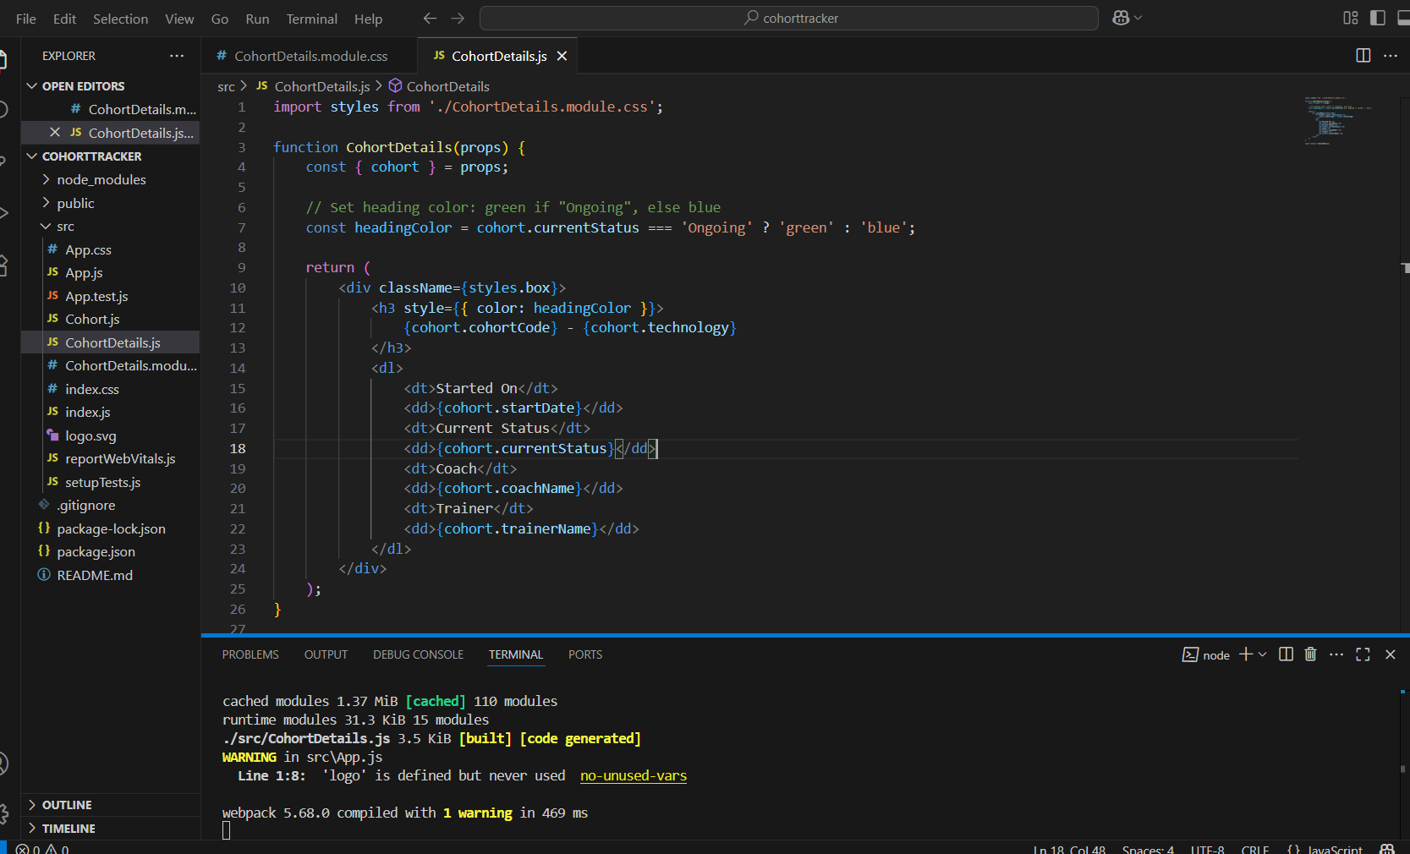

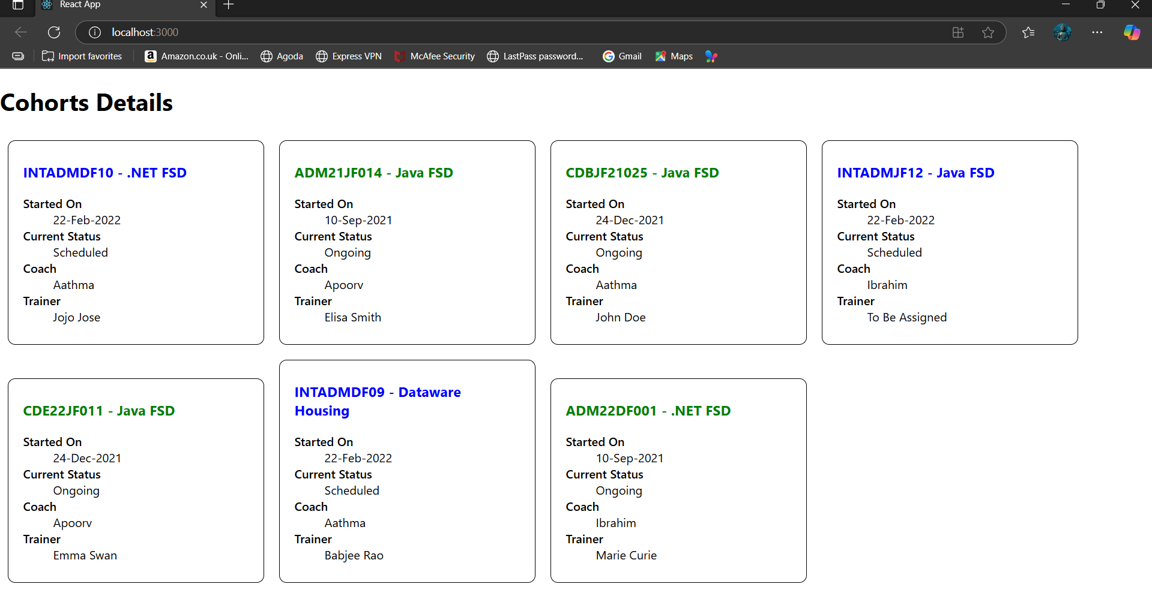

Exercise 6:
Header.js:
import React from 'react';
import { Link } from 'react-router-dom';
const Header = () => {
return (
<div>
<h1>My Academy Trainers App</h1>
</div>
);
};
export default Header;
Home.js:
import React from 'react';
const Home = () => {
return (
<div>
<h1>Welcome to Trainer Portal</h1>
</div>
);
};
export default Home;
trainer.js:
export class Trainer {
constructor(trainerId, name, email, phone, technology, skills) {
this.trainerId = trainerId;
this.name = name;
this.email = email;
this.phone = phone;
this.technology = technology;
this.skills = skills;
}
}
trainerdetails.js:
import React from 'react';
import { useParams } from 'react-router-dom';
import { trainers } from './trainermock';
const TrainerDetail = () => {
const { id } = useParams();
const trainer = trainers.find(t => t.trainerId === parseInt(id));
if (!trainer) return <p>Trainer not found!</p>;

return (
<div>
<h2>{trainer.name}</h2>
<p><strong>Email:</strong> {trainer.email}</p>
<p><strong>Phone:</strong> {trainer.phone}</p>
<p><strong>Technology:</strong> {trainer.technology}</p>
<p><strong>Skills:</strong> {trainer.skills.join(', ')}</p>
</div>
);
};
export default TrainerDetail;
trainerlist.js:
import React from 'react';
import { Link } from 'react-router-dom';
const TrainersList = ({ data }) => {
return (
<div>
<h2>Trainers List</h2>
<ul>
{data.map(trainer => (
<li key={trainer.trainerId}>
<Link to={`/trainer/${trainer.trainerId}`}>{trainer.name}</Link>
</li>
))}
</ul>
</div>
);
};
export default TrainersList;
trainermock.js:
export const trainers = [
{
trainerId: 1,
name: "John Doe",
email: "john@example.com",
phone: "1234567890",
technology: "React",
skills: ["JavaScript", "React", "Redux"]
},
{
trainerId: 2,
name: "Jane Smith",
email: "jane@example.com",
phone: "0987654321",
technology: "Node.js",
skills: ["JavaScript", "Node.js", "Express"]
},
{
trainerId: 3,
name: "Alice Johnson",
email: "alice@example.com",
phone: "1122334455",
technology: "Python",
skills: ["Python", "Flask", "Django"]
}
];
Output:
