React
Exercise 1:
Create a React Application named “cricketapp” with the following components
ListofPlayers.js:
import React from 'react';
const ListofPlayers = ({ players }) => {
return (
<ul>
{players.map((item, index) => (
<li key={index}>
Mr.{item.name} <span>{item.score}</span>
</li>
))}
</ul>
);
};
export default ListofPlayers;
IndianPlayers.js:
import React from 'react';
export function OddPlayers([first, , third, , fifth]) {
return (
<ul>
<li>First: {first}</li>
<li>Third: {third}</li>
<li>Fifth: {fifth}</li>
</ul>
);
}
export function EvenPlayers([, second, , fourth, , sixth]) {
return (
<ul>
<li>Second: {second}</li>
<li>Fourth: {fourth}</li>
<li>Sixth: {sixth}</li>
</ul>
);
}
ListofIndianPlayers.js:
import React from 'react';
const ListofIndianPlayers = ({ IndianPlayers }) => {
return (
<ul>
{IndianPlayers.map((player, index) => (
<li key={index}>{player}</li>
))}
</ul>
);
};
export default ListofIndianPlayers;
const T20Players = ['First Player', 'Second Player', 'Third Player'];
const RanjiTrophyPlayers = ['Fourth Player', 'Fifth Player', 'Sixth Player'];
export const IndianPlayers = [...T20Players, ...RanjiTrophyPlayers];
Scorebelow70.js:
import React from 'react';
const Scorebelow70 = ({ players }) => {
const players70 = players.filter((player) => player.score <= 70);
return (
<ul>
{players70.map((item, index) => (
<li key={index}>
Mr.{item.name} <span>{item.score}</span>
</li>
))}
</ul>
);
};
export default Scorebelow70;
App.js
import React from 'react';
import ListofPlayers from './ListofPlayers';
import Scorebelow70 from './Scorebelow70';
import { OddPlayers, EvenPlayers } from './IndianPlayers';
import ListofIndianPlayers, { IndianPlayers } from './ListofIndianPlayers';

function App() {
const flag = false;

const players = [
{ name: 'Rohit', score: 80 },
{ name: 'Virat', score: 65 },
{ name: 'Rahul', score: 90 },
{ name: 'Dhoni', score: 50 },
{ name: 'Hardik', score: 72 },
{ name: 'Jadeja', score: 67 },
{ name: 'Shami', score: 40 },
{ name: 'Bumrah', score: 88 },
{ name: 'Gill', score: 76 },
{ name: 'Pant', score: 58 },
{ name: 'Surya', score: 85 }
];

if (flag === true) {
return (
<div>
<h1>List of Players</h1>
<ListofPlayers players={players} />
<hr />
<h1>List of Players having Scores Less than 70</h1>
<Scorebelow70 players={players} />
</div>
);
} else {
return (
<div>
<div>
<h1>Indian Team</h1>
<h1>Odd Players</h1>
{OddPlayers(IndianPlayers)}
<hr />
<h1>Even Players</h1>
{EvenPlayers(IndianPlayers)}
</div>
<hr />
<div>
<h1>List of Indian Players Merged:</h1>
<ListofIndianPlayers IndianPlayers={IndianPlayers} />
</div>
</div>
);
}
}
export default App;

Output:
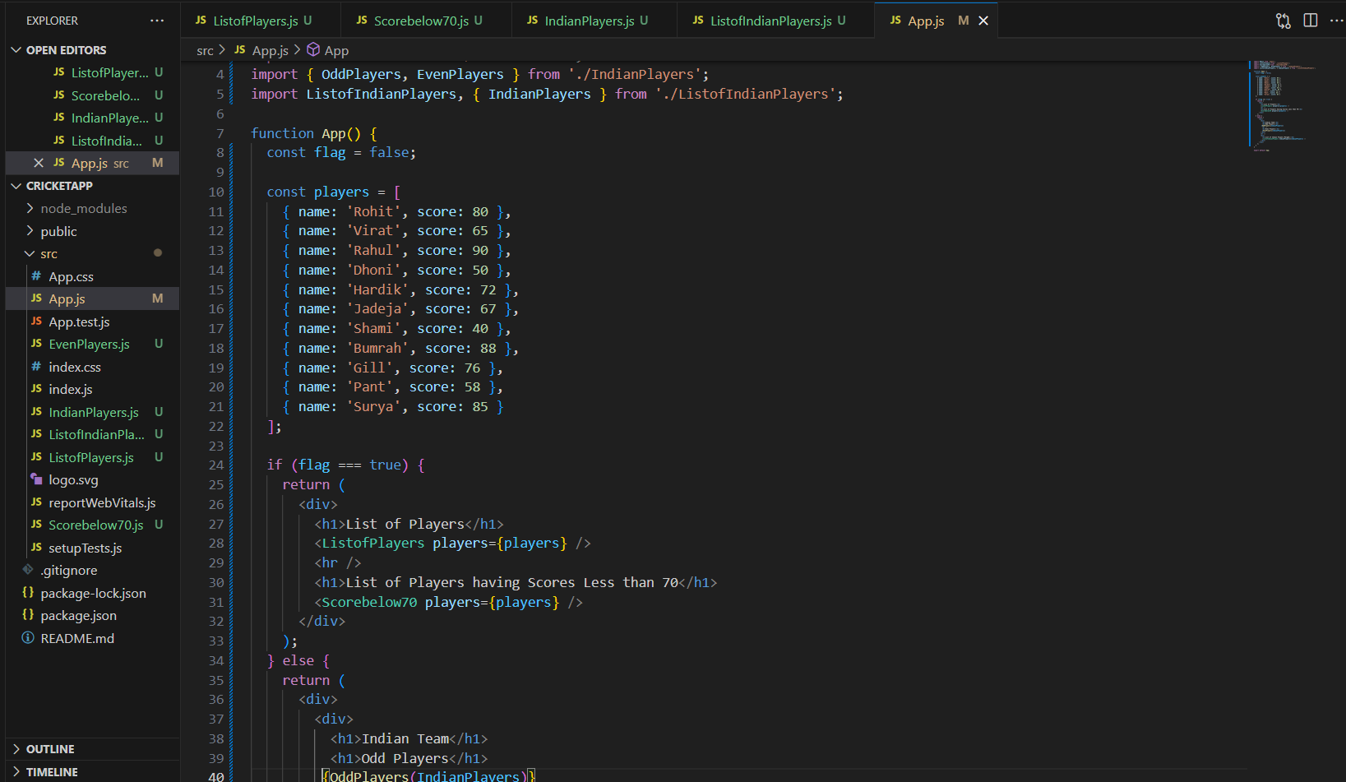
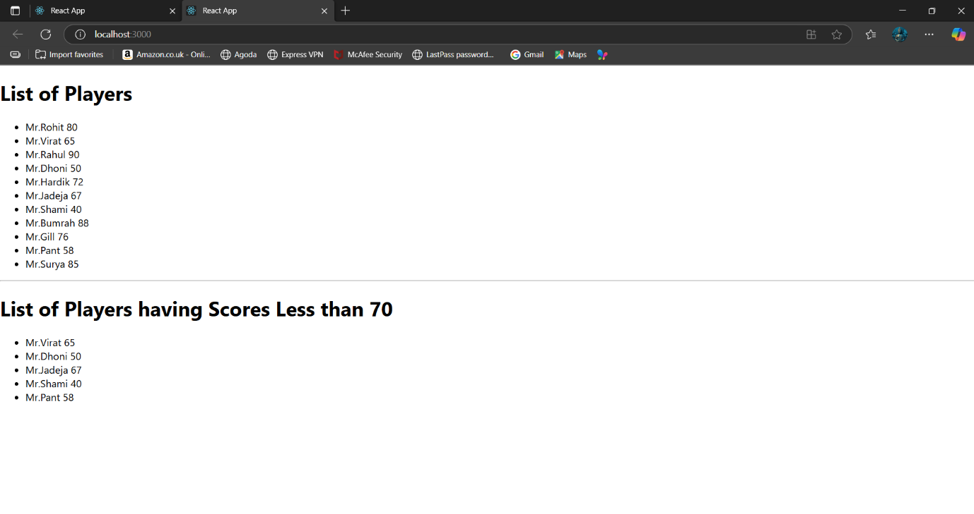
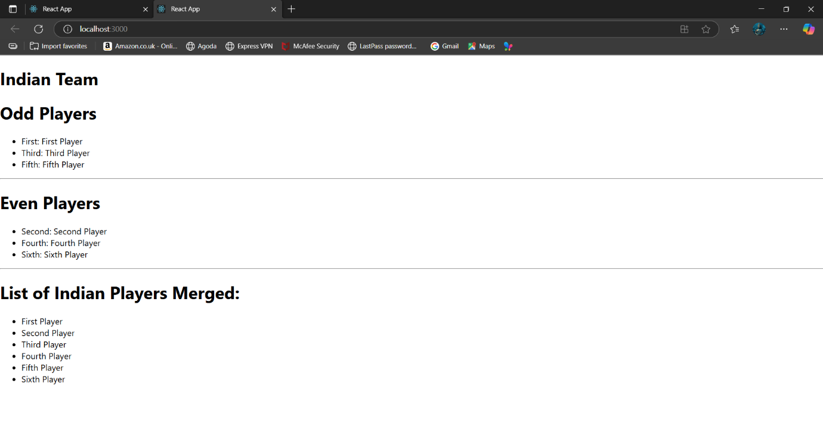
Exercise 2:
App.js
import React from 'react';
import './App.css';
function App() {
const headingElement = React.createElement("h1", null, "Office Space at Affordable Range");
const officeList = [
{
Name: "DBS",
Rent: 50000,
Address: "Chennai",
Image: process.env.PUBLIC_URL + "/office.jpg"
},
{
Name: "WeWork",
Rent: 75000,
Address: "Bangalore",
Image: process.env.PUBLIC_URL + "/office1.jpg"
},
{
Name: "Regus",
Rent: 45000,
Address: "Hyderabad",
Image: process.env.PUBLIC_URL + "/office3.jpg"
}
];

return (
<div style={{ textAlign: "center", fontFamily: "Arial" }}>
{headingElement}
{officeList.map((item, index) => {
const rentStyle = { color: item.Rent <= 60000 ? 'red' : 'green' };
return (
<div key={index} style={{ border: "1px solid gray", margin: "20px", padding: "20px" }}>
<h3>Name: {item.Name}</h3>
<h3 style={rentStyle}>Rent: ₹{item.Rent}</h3>
<h3>Address: {item.Address}</h3>
<img
src={item.Image}
alt={`${item.Name} Office`}
style={{ width: "300px", height: "150px", objectFit: "cover", borderRadius: "10px" }}
/>
</div>
);
})}
</div>
);
}
export default App;

Output:
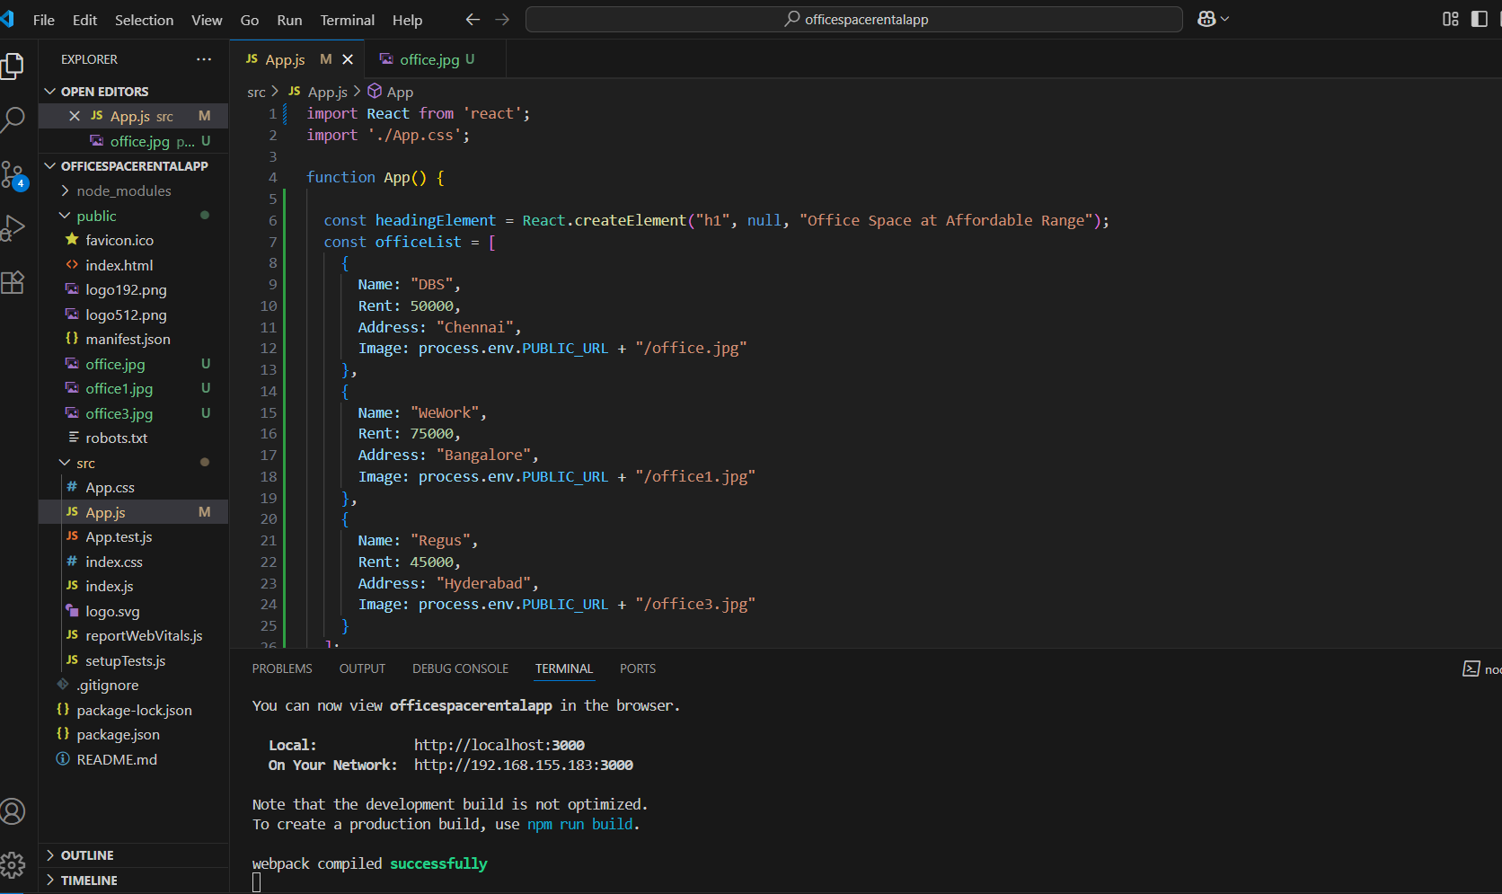

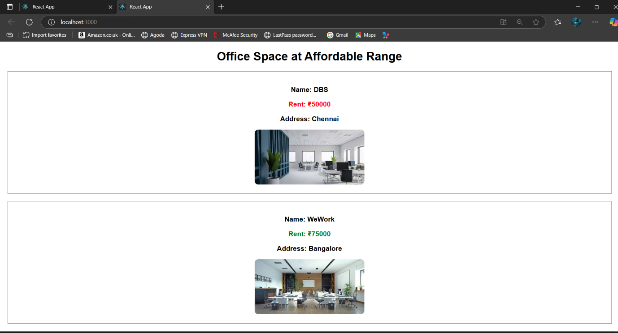

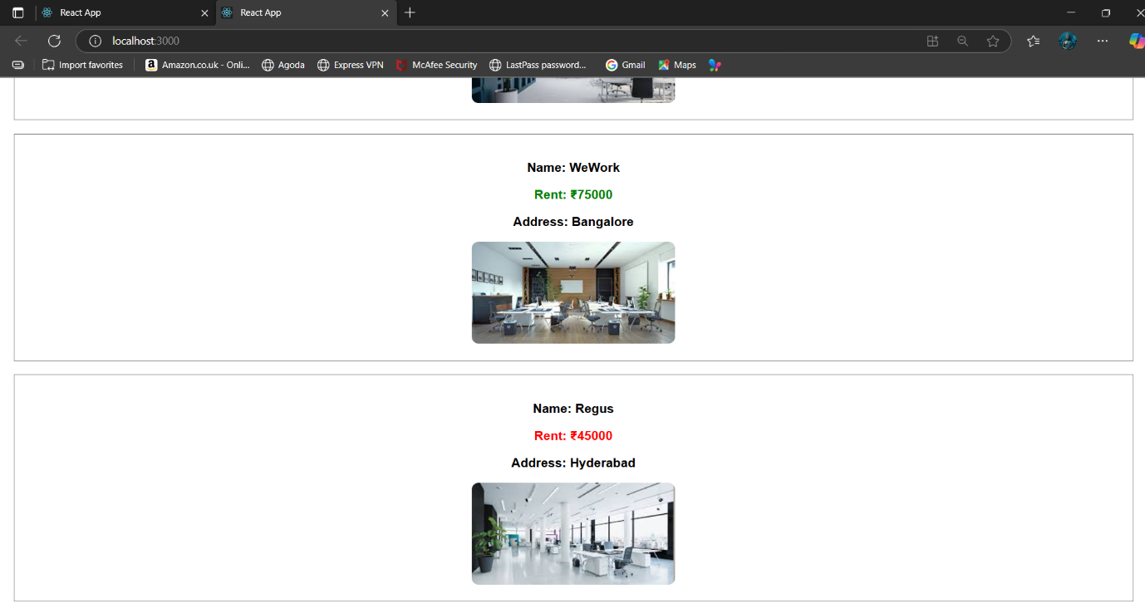
Exercise 3:
App.js:
import React, { Component } from 'react';
import CurrencyConverter from './CurrencyConverter';

class App extends Component {
constructor() {
super();
this.state = {
counter: 0,
};
}
increment = () => {
this.setState({ counter: this.state.counter + 1 });
this.sayHello();
};
decrement = () => {
this.setState({ counter: this.state.counter - 1 });
};
sayHello = () => {
alert("Hello! This is a static message.");
};
sayWelcome = (msg) => {
alert(msg);
};
handleClick = (event) => {
alert("I was clicked");
};

render() {
return (
<div style={{ textAlign: 'center', padding: '30px' }}>
<h1>Currency Converter</h1>
<h2>Counter: {this.state.counter}</h2>

<button onClick={this.increment}>Increment</button>{' '}
<button onClick={this.decrement}>Decrement</button>

<br /><br />
<button onClick={() => this.sayWelcome("Welcome")}>Say Welcome</button>

<br /><br />
<button onClick={this.handleClick}>Click on Me</button>

<br /><br />
<CurrencyConverter />
</div>
);
}
}
export default App;

CurrenyCoverter.js:
import React, { useState } from 'react';

function CurrencyConverter() {
const [amount, setAmount] = useState('');
const [description, setDescription] = useState('');

const handleSubmit = () => {
const inputAmount = parseFloat(amount);
const desc = description.trim().toLowerCase();

if (isNaN(inputAmount)) {
alert("Please enter a valid number");
return;
}

if (desc === "india") {
const euro = inputAmount * 0.011;
alert(`Converted Amount: € ${euro.toFixed(2)}`);
} else if (desc === "euro") {
// Euro to INR (1 EUR = 91 INR approx)
const inr = inputAmount * 91;
alert(`Converted Amount: ₹ ${inr.toFixed(2)}`);
} else {
alert("Please enter 'India' or 'Euro' in the description box");
}
};

return (
<div style={{ marginTop: '40px' }}>
<h2>Currency Converter</h2>

<input
type="text"
placeholder="Enter Description (India or Euro)"
value={description}
onChange={(e) => setDescription(e.target.value)}
style={{ marginBottom: '10px', width: '300px', padding: '8px' }}
/>
<br />
<input
type="number"
placeholder="Enter Amount"
value={amount}
onChange={(e) => setAmount(e.target.value)}
style={{ marginBottom: '10px', width: '300px', padding: '8px' }}
/>
<br />
<button onClick={handleSubmit}>Convert</button>
</div>
);
}
export default CurrencyConverter;

Output:
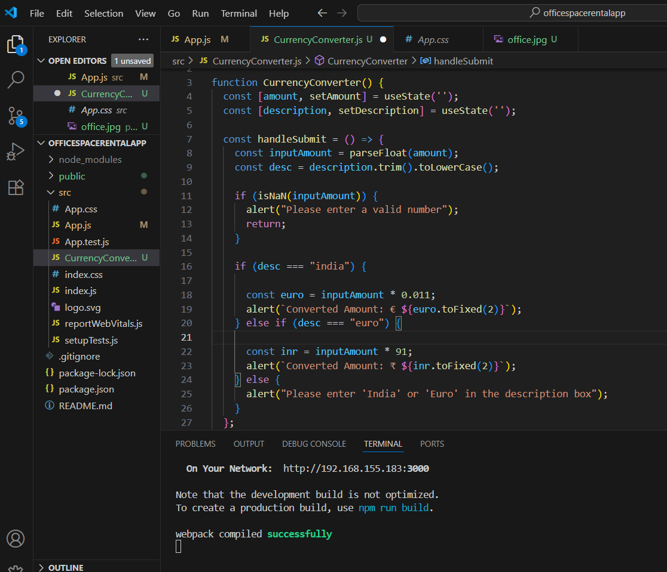
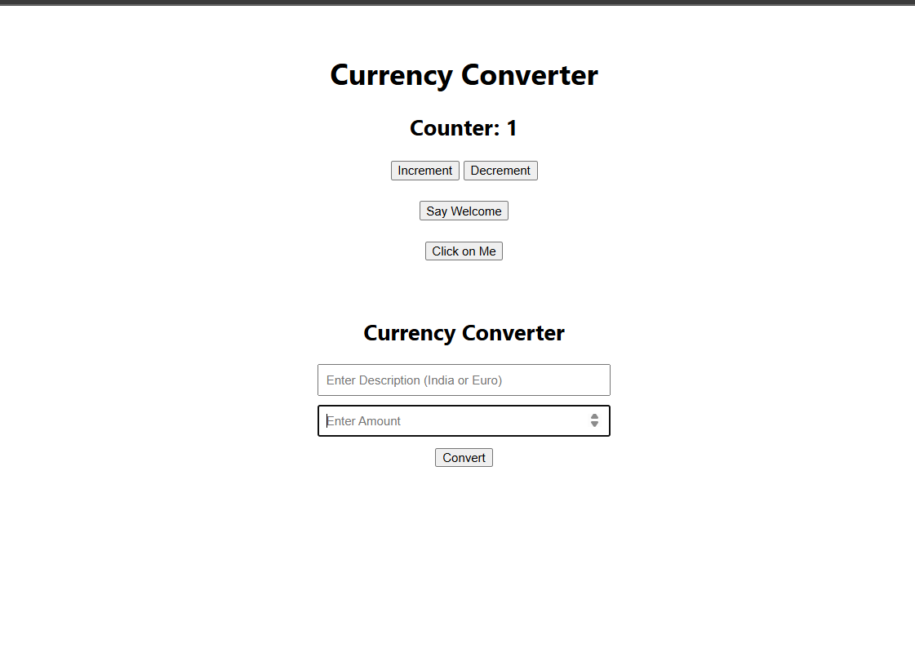
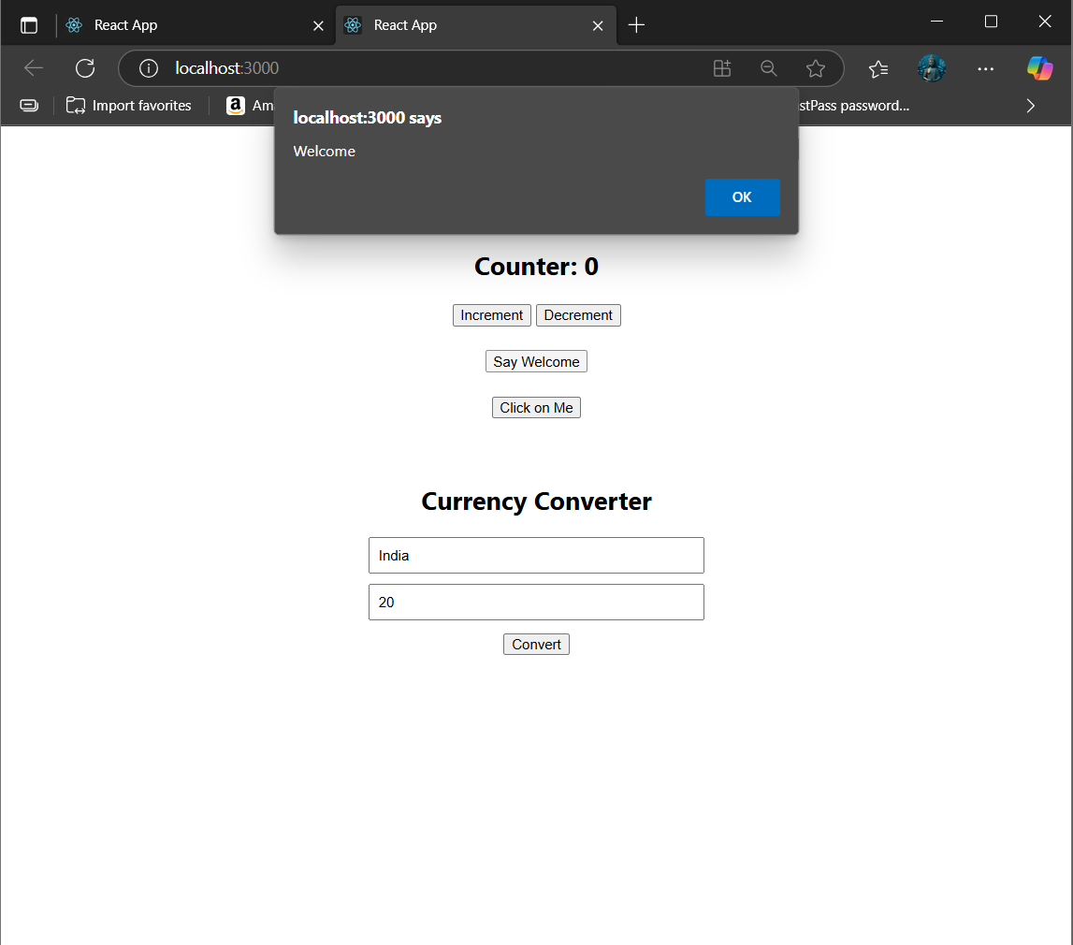
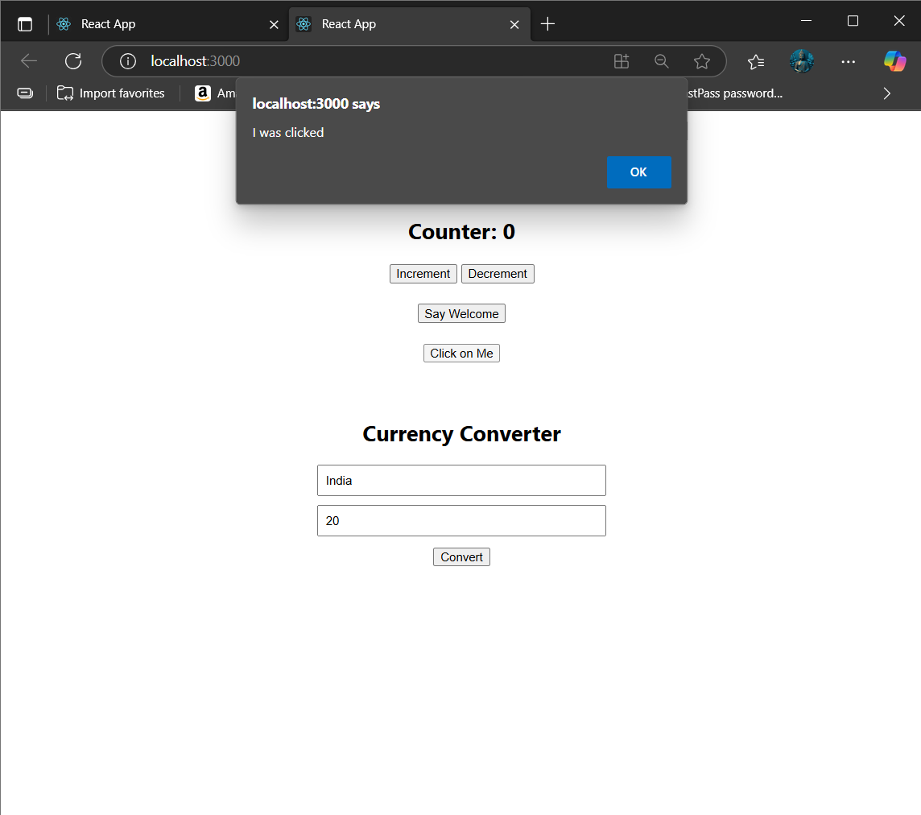
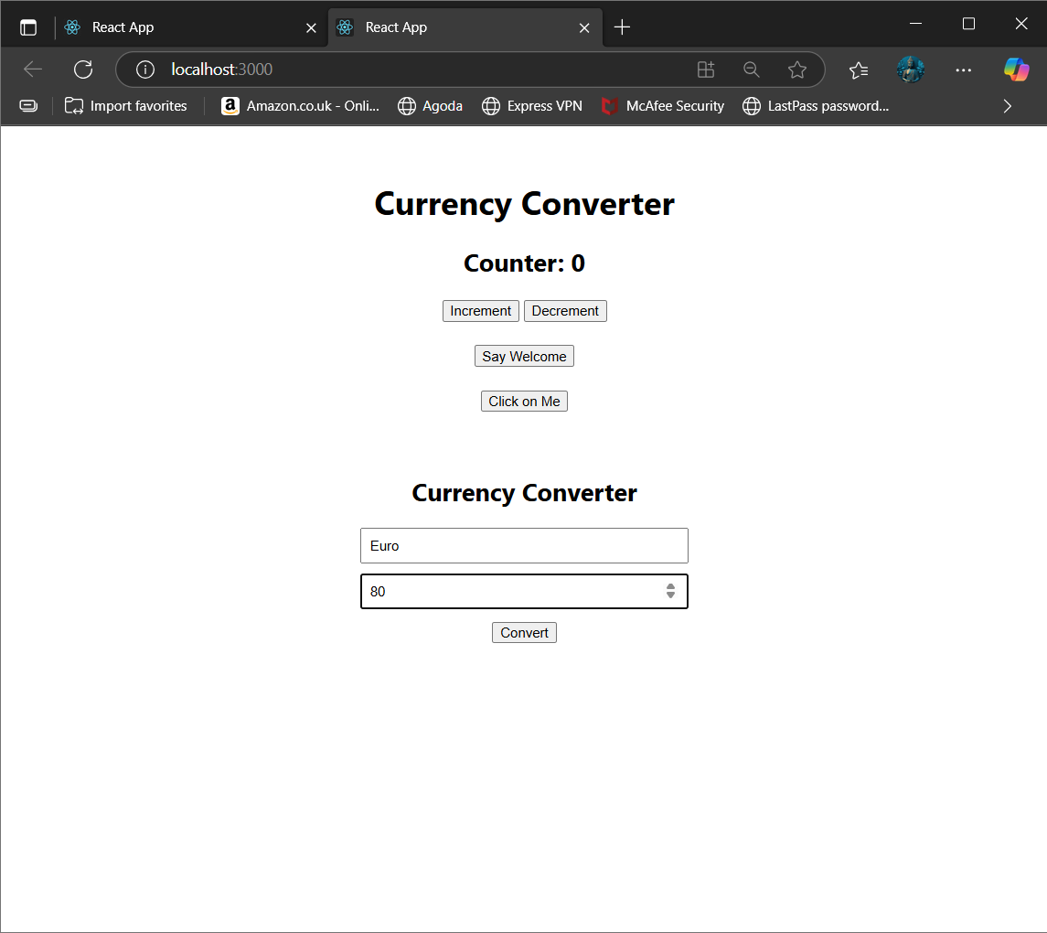
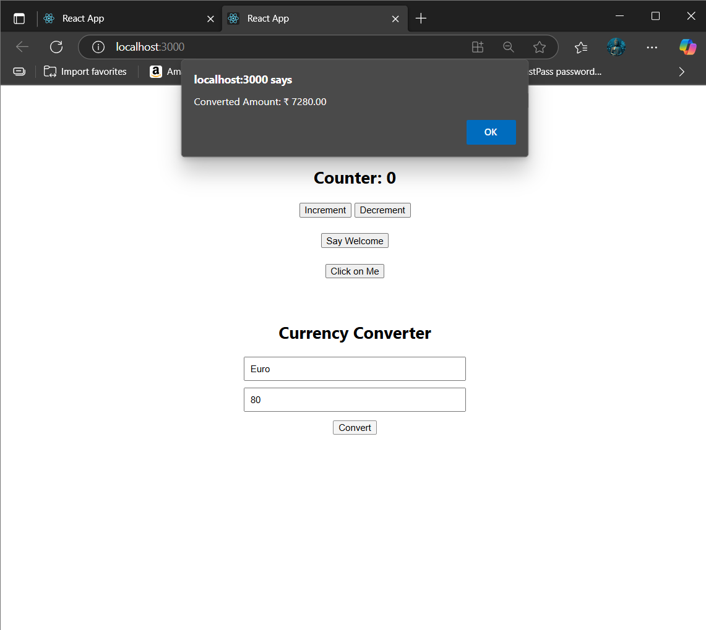
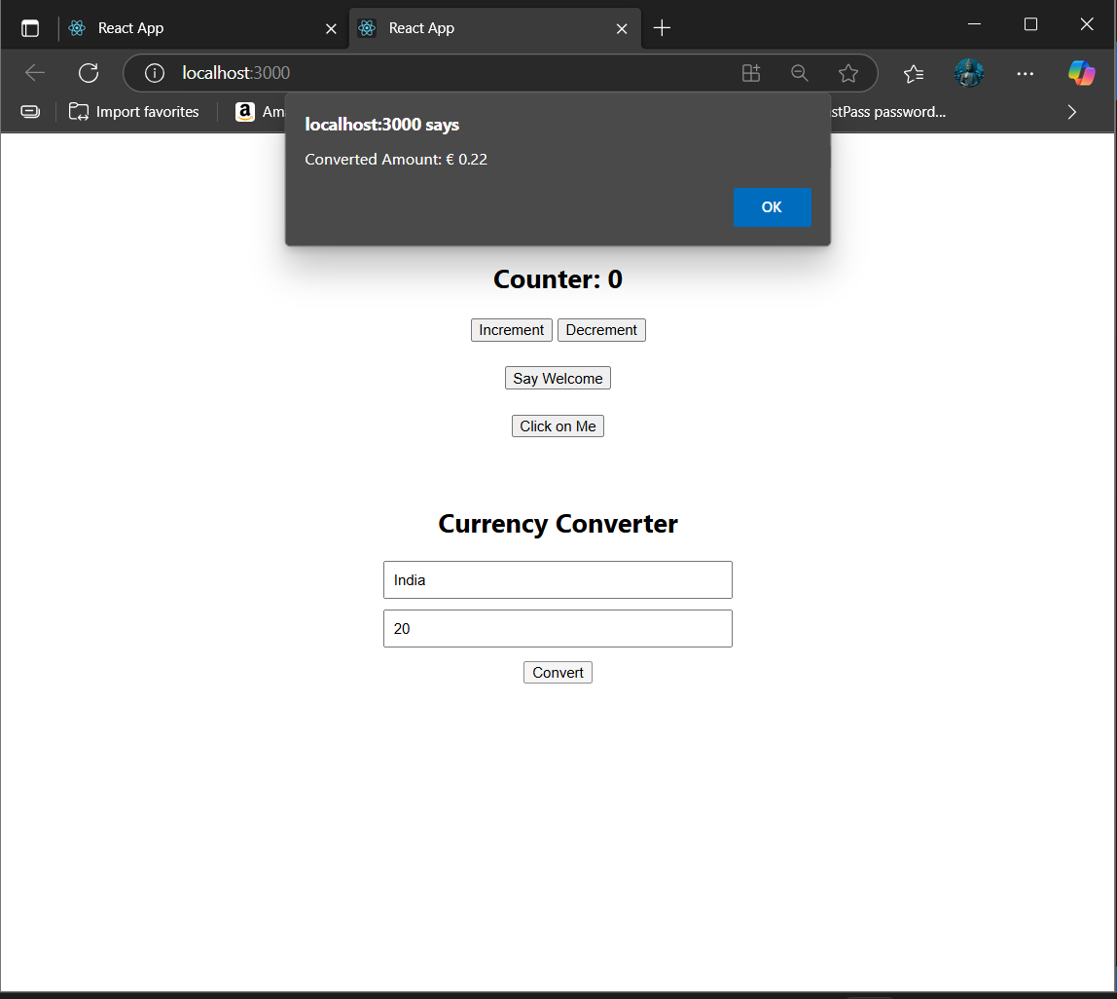
Exercise 4:
App.js:
import React, { useState } from 'react';
function LoginButton(props) {
return <button onClick={props.onClick}>Login</button>;
}
function LogoutButton(props) {
return <button onClick={props.onClick}>Logout</button>;
}
function GuestGreeting() {
return (
<div>
<h2>Welcome Guest!</h2>
<p>You can only view flight details.</p>
<ul>
<li>Flight A - 10:00 AM</li>
<li>Flight B - 01:00 PM</li>
<li>Flight C - 06:00 PM</li>
</ul>
</div>
);
}
function UserGreeting() {
return (
<div>
<h2>Welcome User!</h2>
<p>You can view and book tickets.</p>
<ul>
<li>Flight A - 10:00 AM <button>Book</button></li>
<li>Flight B - 01:00 PM <button>Book</button></li>
<li>Flight C - 06:00 PM <button>Book</button></li>
</ul>
</div>
);
}
function Greeting(props) {
const isLoggedIn = props.isLoggedIn;
if (isLoggedIn) {
return <UserGreeting />;
}
return <GuestGreeting />;
}
function App() {
const [isLoggedIn, setIsLoggedIn] = useState(false);

const handleLoginClick = () => {
setIsLoggedIn(true);
};

const handleLogoutClick = () => {
setIsLoggedIn(false);
};

let button;
if (isLoggedIn) {
button = <LogoutButton onClick={handleLogoutClick} />;
} else {
button = <LoginButton onClick={handleLoginClick} />;
}
return (
<div style={{ padding: "20px", fontFamily: "Arial" }}>
<h1>Flight Booking System</h1>
{button}
<Greeting isLoggedIn={isLoggedIn} />
</div>
);
}
export default App;

Output:
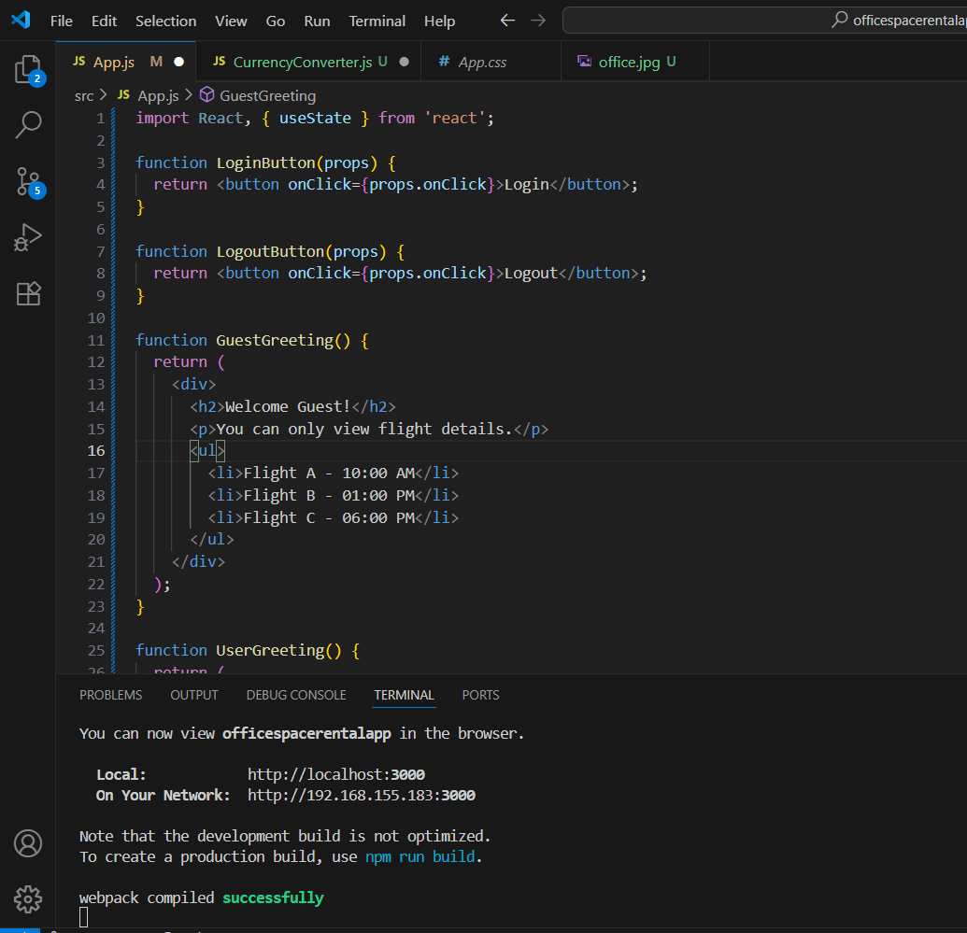
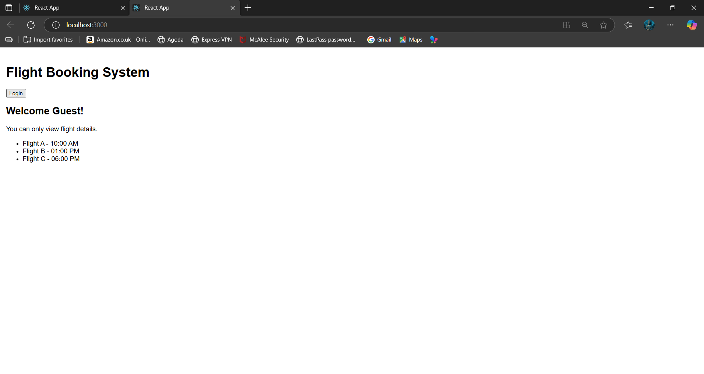

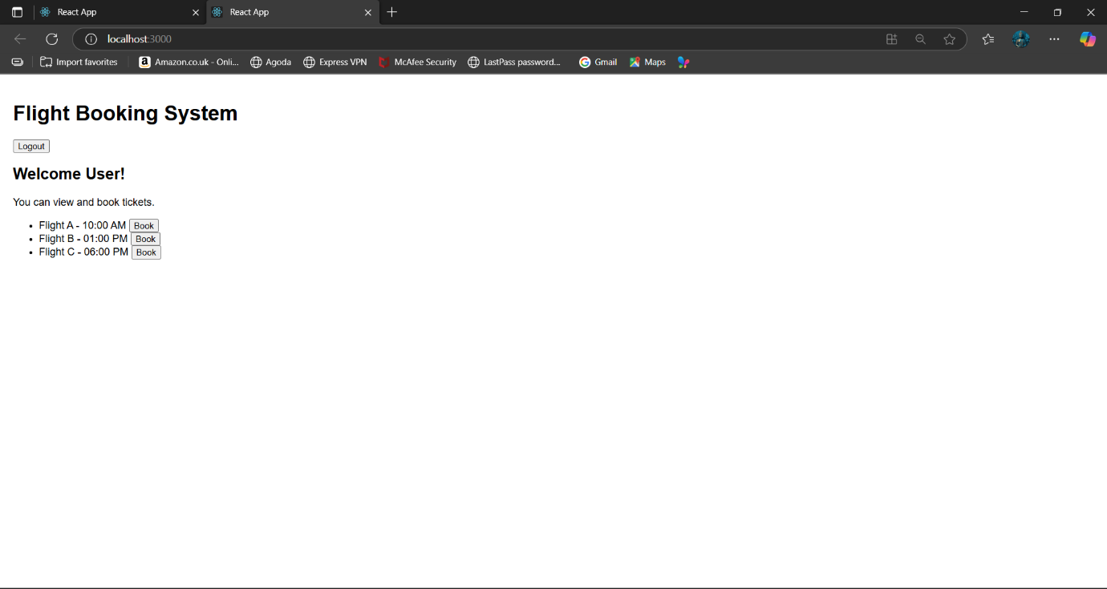
Exercise 5:
App.js:
import React from "react";
import BookDetails from "./components/BookDetails";
import BlogDetails from "./components/BlogDetails";
import CourseDetails from "./components/CourseDetails";

const App = () => {
return (
<div style={{ padding: "20px", fontFamily: "Arial" }}>
<h1>Blogger App</h1>
<hr />
<BookDetails />
<hr />
<BlogDetails />
<hr />
<CourseDetails />
</div>
);
};

export default App;
BookDetails.js
import React from "react";
const books = [
{ id: 101, bname: "Master React", price: 670 },
{ id: 102, bname: "Deep Dive into Angular 11", price: 6780 },
{ id: 103, bname: "Mongo Basics", price: 450 }
];
const BookDetails = () => {
return (
<div className="book-section">
<h2>📚 Book Details</h2>
<ul>
{books.map((book) => (
<li key={book.id}>
<strong>{book.bname}</strong> - ₹{book.price}
</li>
))}
</ul>
</div>
);
};
export default BookDetails;
BlogDetails.js:
import React from "react";
const blogs = [
{ id: 1, title: "React Basics", author: "John" },
{ id: 2, title: "Vue vs Angular", author: "Anna" },
{ id: 3, title: "State Management", author: "Dev" }
];
const BlogDetails = () => {
return (
<div className="blog-section">
<h2>📝 Blog Details</h2>
{blogs.length > 0 ? (
blogs.map((blog) => (
<div key={blog.id}>
<h4>{blog.title}</h4>
<p>Author: {blog.author}</p>
</div>
))
) : (
<p>No blogs to show.</p>
)}
</div>
);
};
export default BlogDetails;
CourseDetails.js:
import React from "react";
const courses = [
{ id: "C1", name: "React", duration: "2 months" },
{ id: "C2", name: "Angular", duration: "3 months" },
{ id: "C3", name: "Node.js", duration: "1.5 months" }
];
const CourseDetails = () => {
return (
<div className="course-section">
<h2>📘 Course Details</h2>
<table border="1" cellPadding="8">
<thead>
<tr>
<th>Course</th>
<th>Duration</th>
</tr>
</thead>
<tbody>
{courses.map((course) => (
<tr key={course.id}>
<td>{course.name}</td>
<td>{course.duration}</td>
</tr>
))}
</tbody>
</table>
</div>
);
};
export default CourseDetails;
Output:
