E-commerce Sales Data Cleaning
Service: Excel Data Cleaning & Quality Reporting
Tool: Microsoft Excel
Project type: Portfolio demonstration using sample data
Project overview
This project demonstrates how raw e-commerce sales data can be cleaned, standardized, and organized into a structured dataset suitable for business reporting.
Challenges identified
- Duplicate order record
- Missing quantity value
- Inconsistent text formatting
- Need for clear data-quality reporting
Work performed
- Identified and removed a duplicate record from the cleaned dataset.
- Standardized customer and region text values.
- Preserved missing values rather than guessing or fabricating data.
- Added data-quality status flags.
- Created a cleaning log documenting issues and actions.
- Built an automated summary of data-quality checks.
Figure 1. Cleaned dataset and data-quality summary
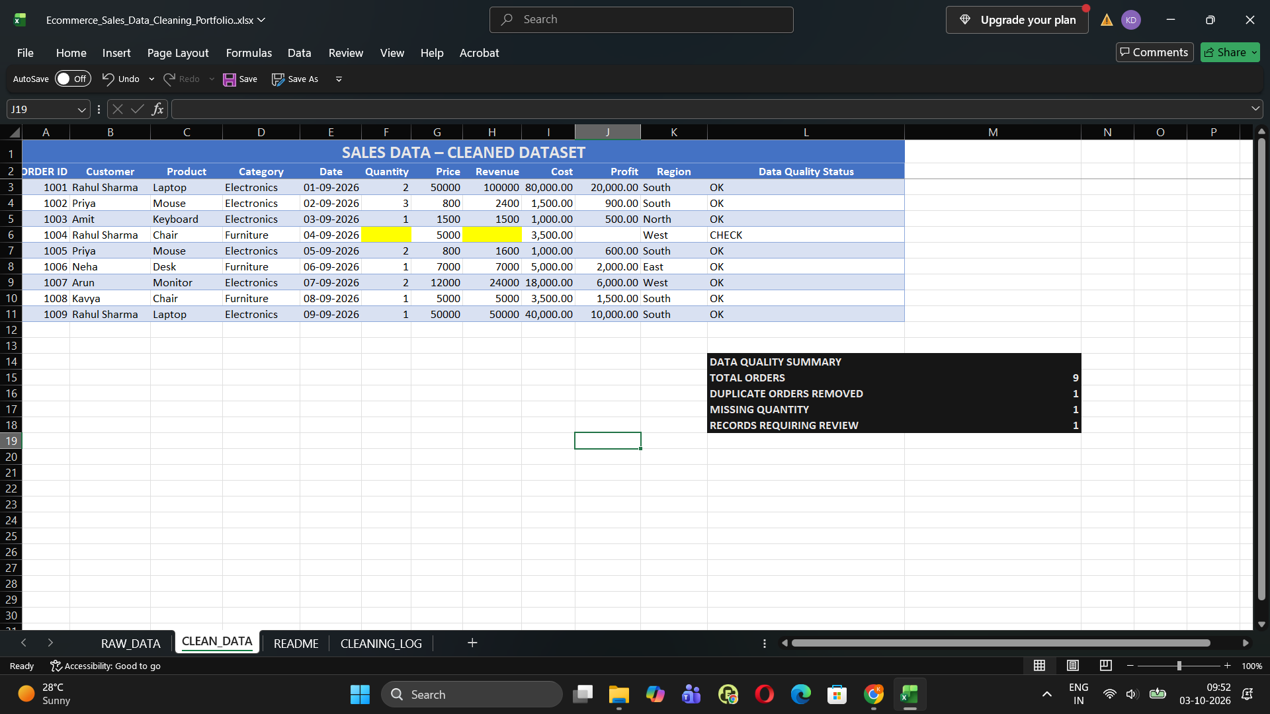

Deliverables
- Original raw dataset
- Cleaned dataset
- Cleaning log
- Data-quality summary
- README sheet
Figure 2. Documented data-cleaning log
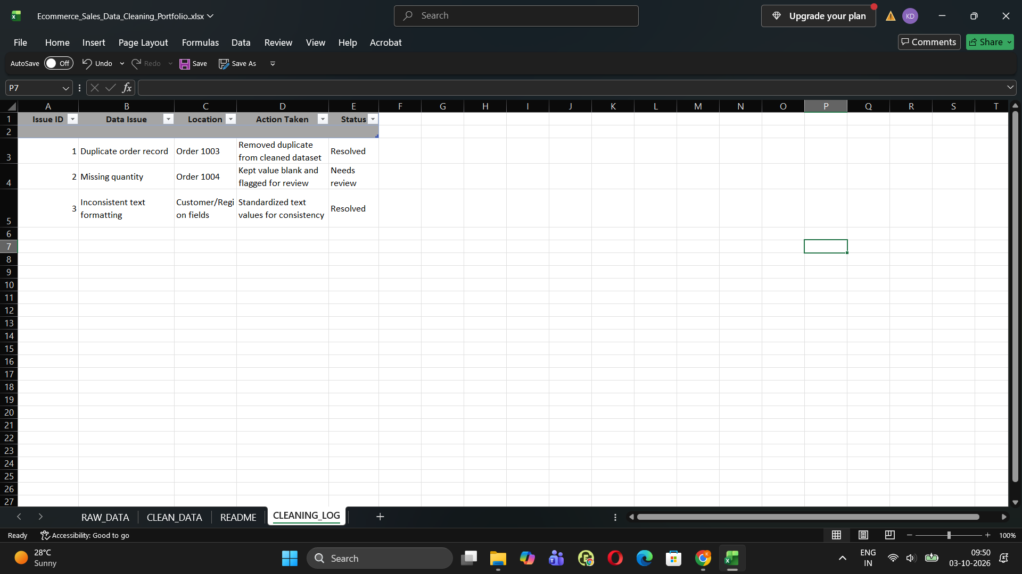
Outcome
The workbook contains 9 cleaned records, with 1 duplicate removed and 1 record flagged for review because its quantity is missing.
Note: This is a sample portfolio project, not work completed for an actual client. The dataset is used for demonstration purposes.

