FRIEND-RECOMMENDATION

SCHEME USING Ontology Representation

# 1. Introduction

An online social network (OSN) facilitates users to stay in touch with other users (such as distant family members or friends), easily share information, look for old acquaintances and establish friendship with new users based on shared interests. The wide availability of the Internet has resulted in the fast growth of OSNs, such as Google+, Facebook, MySpace, Twitter and LinkedIn, which resulted in a vast amount of social data containing personal and sensitive information about individual users.

Our project is a friend recommendation system which is an important aspect in the modern social network systems including Facebook, Twitter, Instagram and countless others. Using our mutual likes with other people the social network system adds people in our “suggested list” of friends. So our python project stores a dictionary that contains names of people along with the things they like. For implementation purposes we have created a Data Set of 50 different people. At runtime after we enter a desired name, our program calculates strength of “possible friendship” by taking in consideration of mutual likes with all other names in the dataset. This strength is between 0 and 1. After that, it displays all the suggested friends along with their corresponding strengths in the increasing order of the strengths.

Online social networks, such as Facebook and Google+, have been emerging as a new communication service for users to stay in touch and share information with family members and friends over the Internet. Since the users are generating huge amounts of data on social network sites, an interesting question is how to mine this enormous amount of data to retrieve useful information. Along this direction, social network analysis has emerged as an important tool for many business intelligence applications such as identifying potential customers and promoting items based on their interests. In particular, since users are often interested to make new friends, a friend recommendation application provides the medium for users to expand his/her social connections and share information of interest with more friends. Besides this, it also helps to enhance the development of the entire network structure.

Social network analysis involve mining the social data to understand user activities and to identify the relationships among various users. Especially, in applications such as business intelligence, social network analyses have boosted the research in developing various recommendation algorithms. For example, an algorithm may recommend a new application to a Facebook user based on either the applications he/she used in the past or the usage pattern of various applications used by his/her friends.

In general, a recommendation can be a friend, a product, an ad or even a content potentially relevant to the user. This work focuses on recommending new friends to a given user in an OSN.

OntologyRepresentations are ways of representing the relationships between various concepts. For example, "Cats are a type of mammal," or "An arm is a part of the body," or "If A is the father of B, then B is the son of A", or "Every animal has exactly one father, and the father of an animal is always himself an animal". Ontology representations can talk about types of concepts (i.e. cats, mammal) but they can also talk about properties (the "is father of" property, for example).

The line between "ontological" statements and simple logical "statements" (e.g. "John has exactly one car, and his car is a Buick") can be fuzzy. In short, ontological statements are kind of "meta". In more detail, ontological statements have to do with the properties of the vocabulary that we use to define things, rather than contingent properties of this particular world.

# 2. Literature Review Summary Table

*Autho Limitatio*

*Methodo ns/*

*rs Title Concept / logy Dataset Future*

*and (Study Theoretical used/ details/ Relevant Research/*

*Year ) model/ Impleme Analysis Finding Gaps*

*(Refer Framework ntation identified ence)*

Dr. This work This Since it is The Proposed

PRIV introduces a work hard to proposed protocols Wei ACY- set of consider control protocol in

Jiang, PRES privacy- s the parameters in computes Sections Advis ERVI preserving case of a real-world the 3 to 5 or Dr. NG friend outsourc dataset, this recommen assume Sanja FRIE recommend ed social work dation that either y ND ation networks simulated the scores of users’ Madri RECO protocols , where environment all users friend a Dr. MME based on users’ and computed within a lists, Bruce NDA different profile the radius of h social

M. TION existing data are computation from the tags, or

McMi S IN similarity encrypte costs. In all target user messages llin ONLI metrics in d and the A by using exchange Dr. NE the outsourc experiments, the d with

Dan SOCI literature. ed to the minimum similarity other

Lin AL Briefly, third- number of metric users of

Dr. NET depending party messages proposed an online

Akim WOR on the cloud exchanged as a social

Adek K underlying provider between any baseline. network pedjo (OSN) similarity s who two users U More (OSN) as u metric used, provide and V is specifically private

the social assumed to , the informati

|  |  |  |  |  |  |  |
| --- | --- | --- | --- | --- | --- | --- |
| **YEA R**2013 |  | proposed protocols guarantee the privacy | networki  ng  services to the | be uniformly distributed in [1, 1000].  Also, this | proposed protocol  generates the (scaled) | on. As a future work, it is also |
|  |  | of a user’s | users. | work assumes | recommen | desirable |
|  |  | personal | Under | that there is | dation | to |
|  |  | information | such an | no | scores | develop |
|  |  | such as | environ | communicati | along with | protocols |
|  |  | friend lists. | ment, | on delay | the | that can |
|  |  | These | this | between | correspond | recomme |
|  |  | protocols | work | participating | ing user | nd friends |
|  |  | are the first | proposes | users (which | IDs in such | based on |
|  |  | to make the | novel | further | a way that | other |
|  |  | friend | protocols | implies that | the relative | details |
|  |  | recommend | for the | users are | ordering | such as |
|  |  | ation | cloud to | online). In | among the | education |
|  |  | process | do friend | addition, the | users in the | and |
|  |  | possible in | recomme | number of | list of | employm |
|  |  | privacy- | ndations | child friends | recommen | ent in a |
|  |  | enhanced | in a | for each user | ded users is | privacy- |
|  |  | social | privacy | (including the | preserved. | preservin |
|  |  | networking | preservin | target user A) |  | g manner. |
|  |  | environmen | g | is varied from |  |  |
|  |  | ts | manner. | 50 to 250. |  |  |

# 3. Objective of the project

The objective of our project is to accurately recommend friends to a particular user in a dataset in python based on mutual likes of that user with all the other users in the dataset as well as to quantify the relationship of suggested friends with that particular user by assigning a relationship score which lies between 0 to 1 with 0 meaning no mutual likes and 1 meaning either the friend suggested is the same user or the friend suggested has exactly same likes as that person. We plan to achieve this system by using pre-defined library RECSYS in python. Currently we plan to take 50 plus users in our dataset with at least 10 likes of each users so that we can properly display functioning of our friend recommendation system as well as accurately show the relationship score of the recommended friends.

# 4. Innovation component in the project

Our project is innovative and it is different from the reference project used. Like all other recommended systems it displays recommended friends based on mutual likes using ontology . But the innovation component on which it differs from all other projects is that it accurately displays relationship score which all other projects fail to do. Thus it is very convenient in our system for a user to check and assess all the relationships and properly choose their friends circle.;

# 5. Work done and implementation

**a. Methodology adapted:**

In our case, we have utilized “svd” and “pyrecsys” for providing friend recommendations based on their likes. python-recsys supports two Recommender Algorithms: Singular Value Decomposition (SVD) and Neighborhood SVD. We have used Neighborhood SVD.

“pyrecsys” provides, out of the box, some basic algorithms based on matrix factorization.

python-recsys is a fast recommender engine for Python. It uses matrix factorization to provide recommendations and similiarities among items or users. The library is built on top of divisi2, which already implements SVD-like matrix factorization using numpy.

Under this library the main sub-tool we have utilized is “SVD”. pyrecsys makes use of SVD in order to decompose the input data (a matrix). Once the matrix is reduced into a lower dimensional space, pyrecsys can provide predictions, recommendations and similarity among the “elements”.

“from recsys.algorithm.factorize import SVD” : We have used this import statement to load dataset containing 50 different people along with the things they like.

“from recsys.datamodel.data import Data” : We have used this import statement in order to split the data into a lower dimensional space to be used by pyrecsys.

“svd.compute()” : is written to utilize classic Neigborhood SVD. Classic Neighbourhood algorithm uses the ratings of the similar users (or items) to predict the values of the input matrix.

We calculated svd for all the sub categories and then for the final representation we calculates an average of them which gave us a clear picture of the relationship

1. **Dataset used:**

The dataset of 50 + users that we created randomly for this project with at least 10 different “likes” of each user.

*Small example comic*

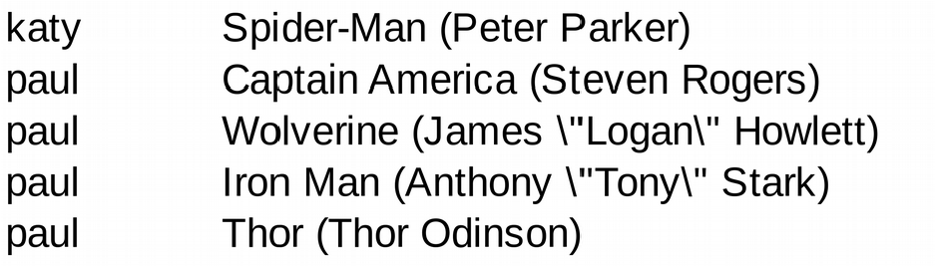

music



Movies

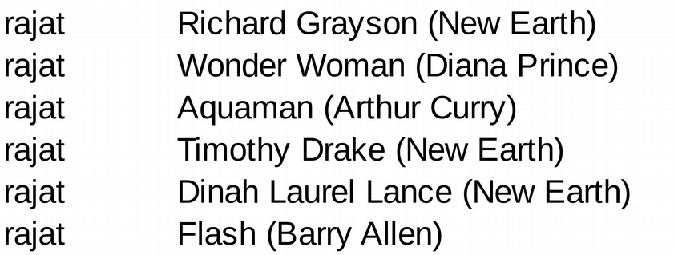

1. **Tools used:**

The main tool used in our python program is “python-recsys” also referred to as pyrecsys which is a Python Library for implementing a Recommender System.

python-recsys is a fast recommender engine for Python. It uses matrix factorization to provide recommendations and similiarities among items or users.

Under this library the main sub-tool we have utilized is “SVD”. pyrecsys makes use of SVD in order to decompose the input data (a matrix). Once the matrix is reduced into a lower dimensional space, pyrecsys can provide predictions, recommendations and similarity among the “elements”.

Python-recsys supports two Recommender Algorithms: Singular Value Decomposition (SVD) and Neighborhood SVD.

We have used Neighborhood SVD.

# d. Screenshot and Demo

The following two screen-shots include our python code utilizing pyrecsys and neighborhood SVD. Code-

from recsys.algorithm.factorize import SVD from recsys.datamodel.data import Data import csv import numpy as np import matplotlib.pyplot as plt print ("similarity in marvel comics") data_file=open('test1.csv','rU') reader=csv.DictReader(data_file) likes={} for row in reader: if row['username'] in likes: likes[row['username']].append(row['user_likes']) else:

likes[row['username']] = [row['user_likes']] data_file.close()

data = Data() VALUE = 1.0

for username in likes: for user_likes in likes[username]: data.add_tuple((VALUE, username, user_likes)) # Tuple format is: <value, row, column>

svd = SVD() svd.set_data(data) k = 5 # Usually, in a real dataset, you should set a higher number, e.g. 100 svd.compute(k=k, min_values=3, pre_normalize=None, mean_center=False, post_normalize=True)

l1=svd.similar('toby')

keylist3=sorted(l1,key=lambda x: x[0]) print(l1) labels, ys = zip(*keylist3) xs = np.arange(len(labels))

width = 1

plt.bar(xs, ys, width, align='center')

plt.xticks(xs, labels) #Replace default x-ticks with xs, then replace xs with labels plt.yticks(ys)

plt.savefig('netscore.png') plt.cla() # Clear axis plt.clf() # Clear figure

#close() print ("similarity in music") data_file=open('test2.csv','rU') reader=csv.DictReader(data_file) likes={} for row in reader: if row['username'] in likes: likes[row['username']].append(row['user_likes']) else:

likes[row['username']] = [row['user_likes']] data_file.close() data = Data() VALUE = 1.0

for username in likes:

for user_likes in likes[username]: data.add_tuple((VALUE, username, user_likes)) # Tuple format is: <value, row, column>

svd = SVD() svd.set_data(data) k = 5 # Usually, in a real dataset, you should set a higher number, e.g. 100 svd.compute(k=k, min_values=3, pre_normalize=None, mean_center=False, post_normalize=True) l2=svd.similar('toby')

keylist2=sorted(l2,key=lambda x: x[0]) print(l2)

labels, ys = zip(*keylist2)

xs = np.arange(len(labels)) width = 1 plt.bar(xs, ys, width, align='center')

plt.xticks(xs, labels) #Replace default x-ticks with xs, then replace xs with labels plt.yticks(ys) plt.savefig('netscore2.png') plt.cla() # Clear axis plt.clf() # Clear figure

#close() print ("similarity in Dc comics") data_file=open('test3.csv','rU') reader=csv.DictReader(data_file) likes={} for row in reader: if row['username'] in likes: likes[row['username']].append(row['user_likes']) else:

likes[row['username']] = [row['user_likes']] data_file.close() data = Data() VALUE = 1.0

for username in likes: for user_likes in likes[username]: data.add_tuple((VALUE, username, user_likes)) # Tuple format is: <value, row, column>

svd = SVD() svd.set_data(data) k = 5 # Usually, in a real dataset, you should set a higher number, e.g. 100 svd.compute(k=k, min_values=3, pre_normalize=None, mean_center=False, post_normalize=True) l3=svd.similar('toby')

keylist = sorted(l3,key=lambda x: x[0])

labels, ys = zip(*keylist) xs = np.arange(len(labels)) width = 1 plt.bar(xs, ys, width, align='center') plt.xticks(xs, labels) #Replace default x-ticks with xs, then replace xs with labels plt.yticks(ys) plt.savefig('netscore3.png') print(l3) plt.cla() # Clear axis plt.clf() # Clear figure #close()

#keylist = sorted(l3,key=lambda x: x[0])

#keylist2=sorted(l2,key=lambda x: x[0])

#keylist3=sorted(l1,key=lambda x: x[0]) #keylist = keylist+keylist2+keylist3 final=[] final2=[]

#for a,b,c in zip(keylist,keylist2,keylist3):

# fin.append(a[1]+b[1]+c[1])

#print (final) list(keylist) list(keylist2) list(keylist3)

#t = [[0 for x in range(len(keylist))] for y in range(len(keylist))]

final=[] for a in range(0,len(keylist)): temp=[]

temp.append(keylist[a][0])

temp.append(keylist[a][1]+keylist2[a][1]+keylist3[a][1]) final.append(temp)

labels, ys = zip(*final) xs = np.arange(len(labels)) width = 1 plt.bar(xs, ys, width, align='center')

plt.xticks(xs, labels) #Replace default x-ticks with xs, then replace xs with labels plt.yticks(ys)

plt.savefig('final.png') print(l3) plt.cla() # Clear axis plt.clf() # Clear figure print(final)

To show the implementation we have taken two inputs from the user. One input is given as the user “Toby’

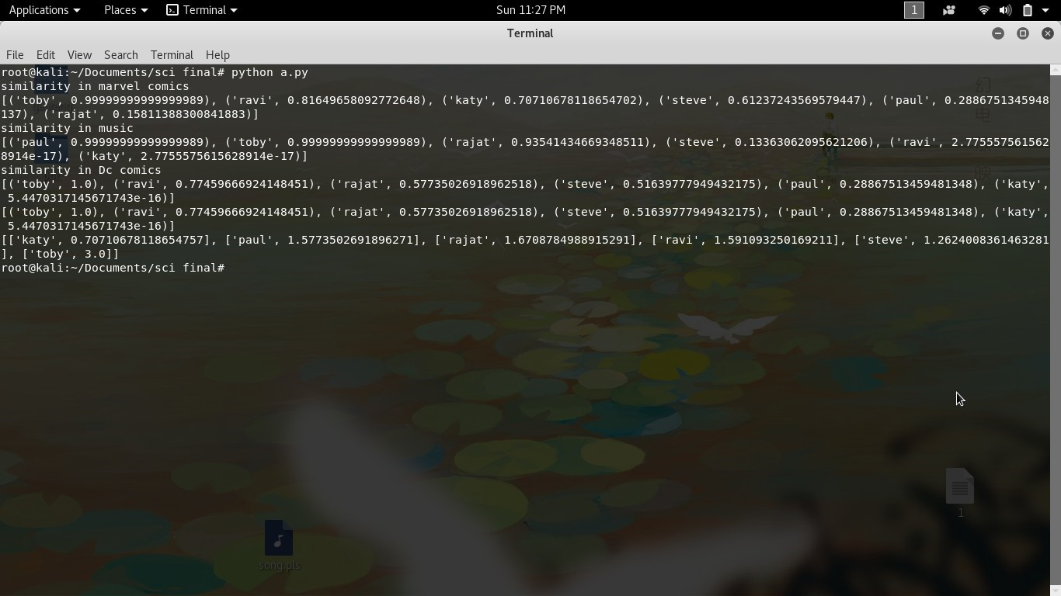

# 6. Results and discussion

The results obtained in our project are as we claimed in our objective.

We have successfully created a friend recommender system in python using predefined pyrecsys library. We included 50+ users in our dataset. Along with this we included at least 10 “likes” of each user for proper implementation of our system.

We are accurately able to suggest friends for any given user based on mutual likes that are searched from pool of different likes in our dataset.

Apart from this for proper assessing and creation of friend circle for any user the relationship with the suggested friends are quantified accurately by using a relationship score of each user with that particular user and displaying only those friends in the suggested friends list whose relationship score is greater than 0.

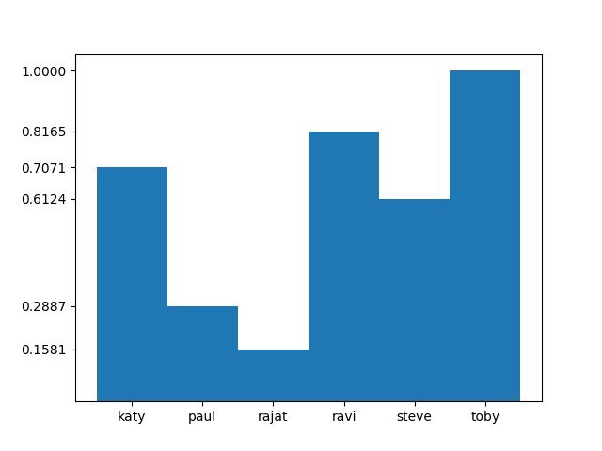

*Illustration 1: comic*

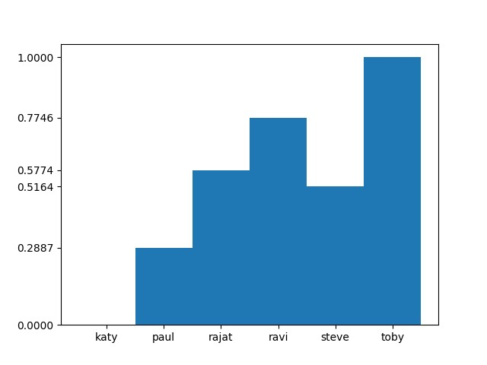

*Illustration 2: films*

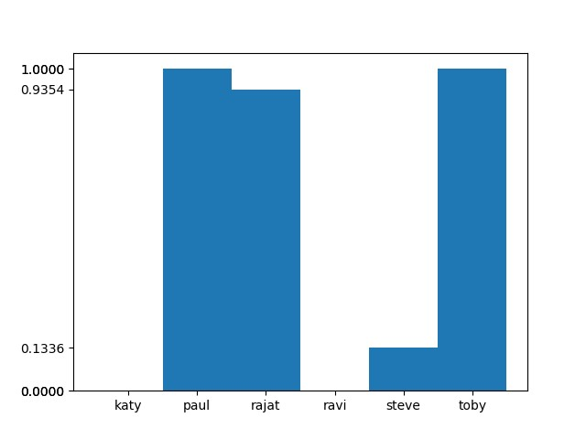

*Illustration 3: music*

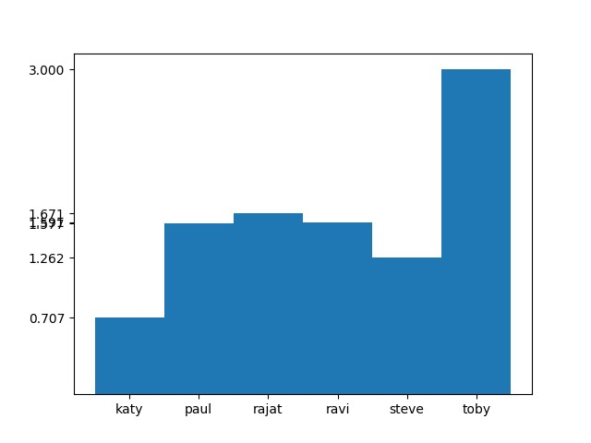

*Illustration 4: final*

Thus we were successfully able to create a friend recommender system just like a recommender system which is an essential part of large social networking sites including Facebook, Twitter, Instagram and many more which uses advanced and modified version of our system which is a very basic yet effective system on python.

We calculated svd for all the sub categories and then for the final representation we calculates an average of them which gave us a clear picture of the relationship

# 7. References

J. Chen, W. Geyer, C. Dugan, M. Muller, and I. Guy. Make new friends, but keep the old: recommending people on social networking sites. In Proceedings of the 27th international conference on Human factors in computing systems, pages 201– 210, 2009.

J. Naruchitparames, M. H. Giine, and S. J. Louis. Friend recommendations in social networks using genetic algorithms and network topology. In IEEE Congress on Evolutionary Computation (CEC), pages 2207 –2214, 2011.

X. Xie. Potential friend recommendation in online social network. In IEEE/ACM

Int’l Conference on Cyber, Physical and Social Computing and Int’l Conference on Green Computing and Communications, pages 831 –835, 2010.

S. Asur and B. A. Huberman. Predicting the future with social media. In Proceedings of IEEE/WIC/ACM International Conference on Web Intelligence and Intelligent Agent Technology, pages 492–499, 2010

W. Dong, V. Dave, L. Qiu, and Y. Zhang. Secure friend discovery in mobile social networks. In Proceedings IEEE INFOCOM, pages 1647 –1655, April 2011