# Employee Payroll management

# Backend role for Attendance Management

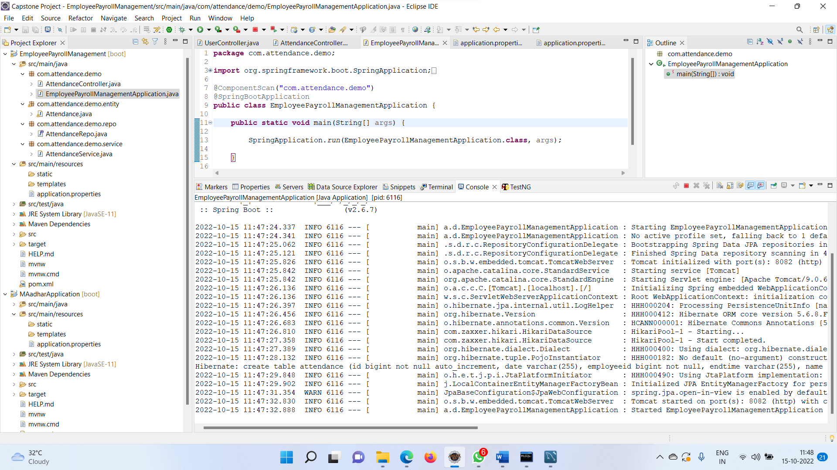

# Admin can put the attendance

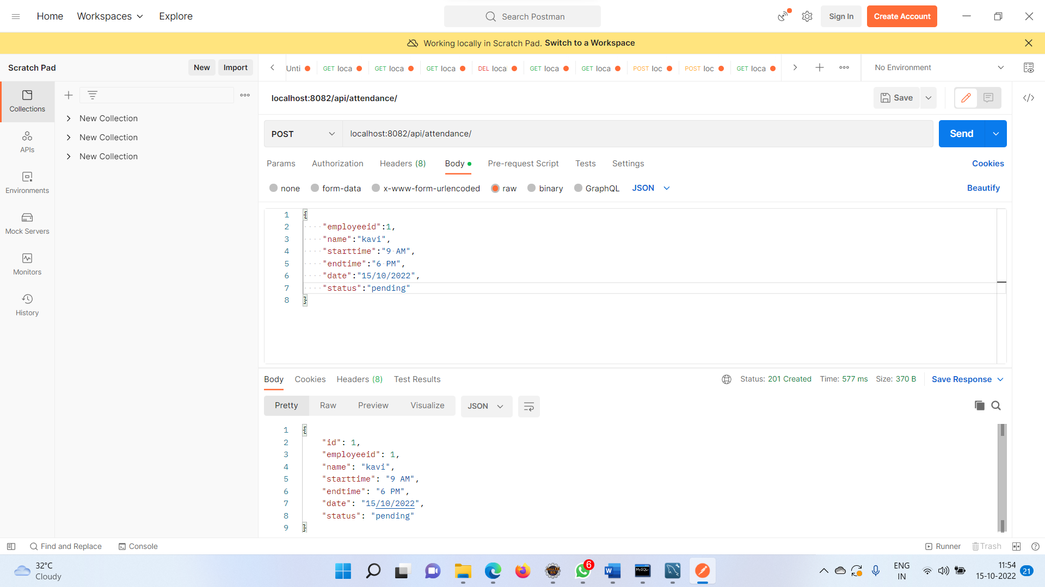

# Admin can view All this employee Attendance records

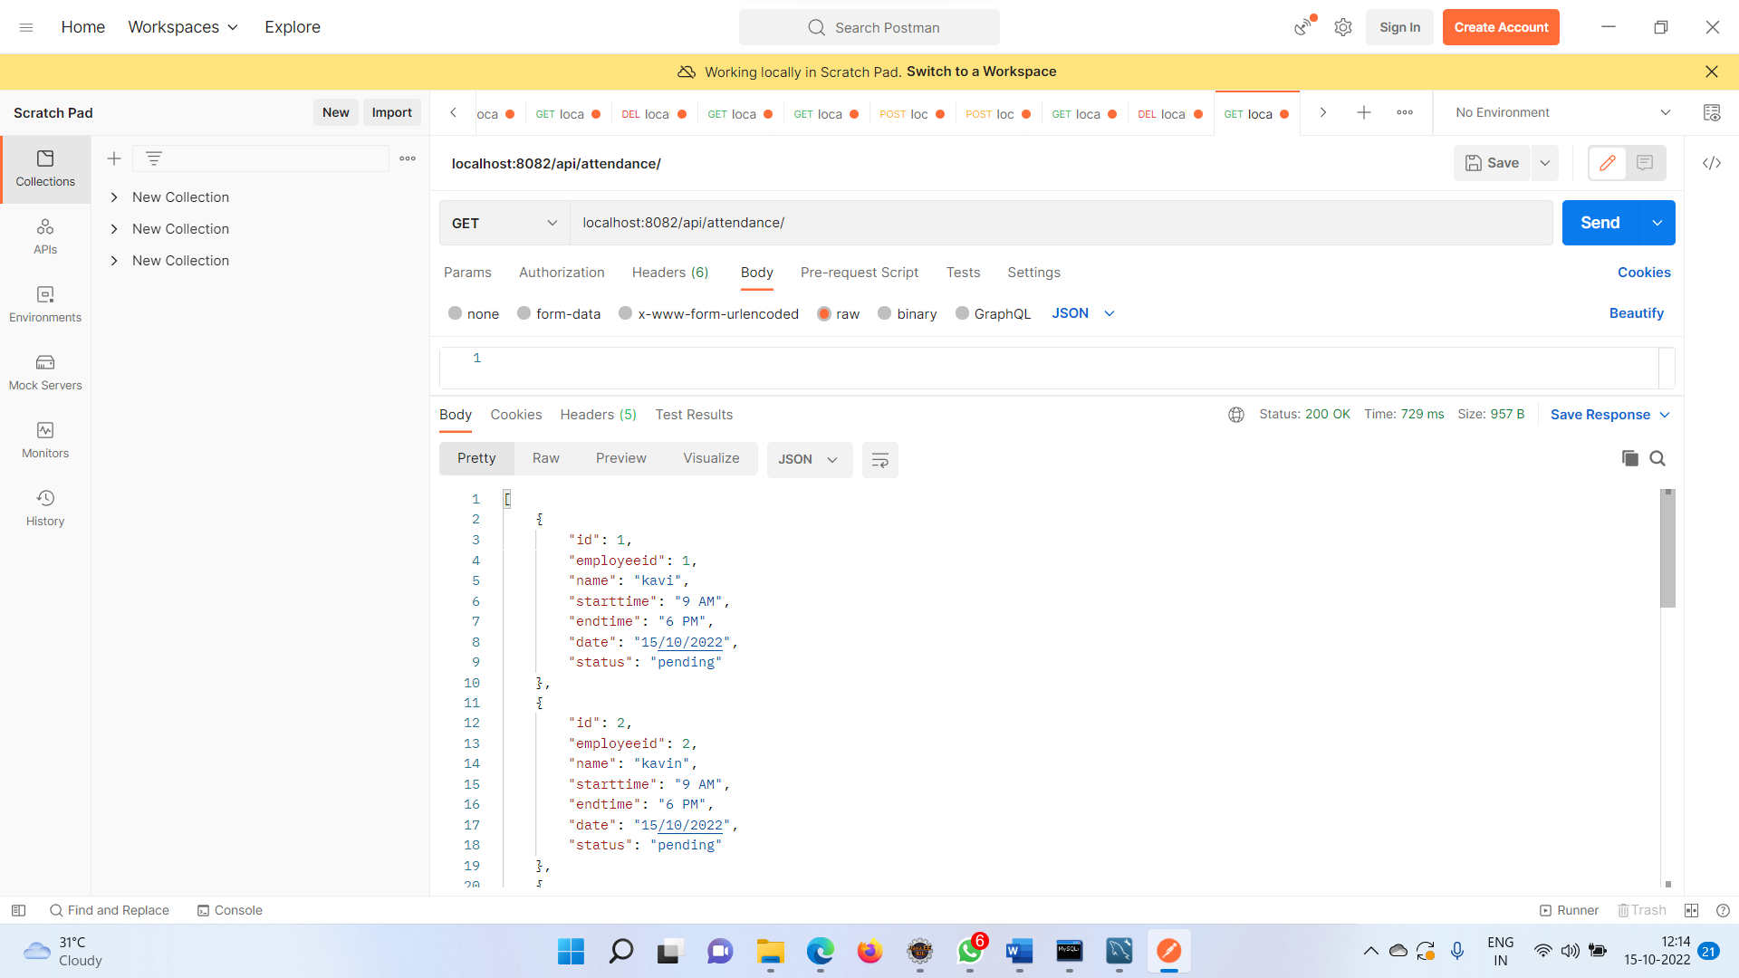

# Admin can Edit/Update the employee attendance

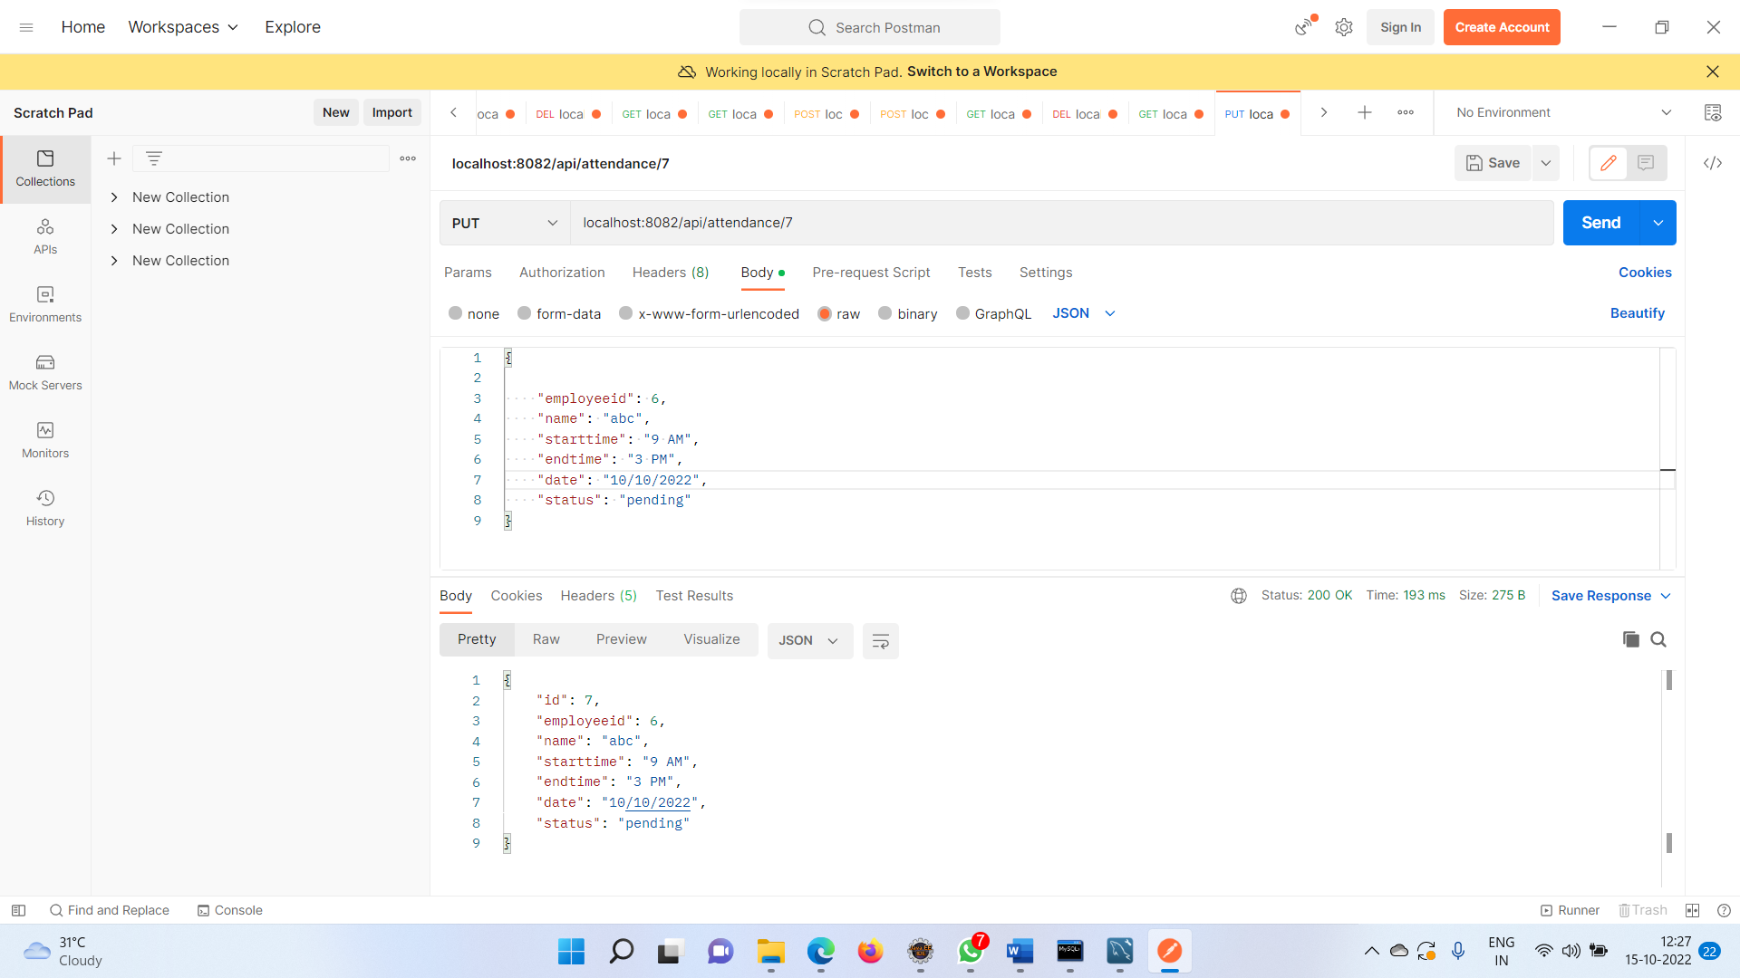

# Admin can Delete the Employee Attendance using Employee id

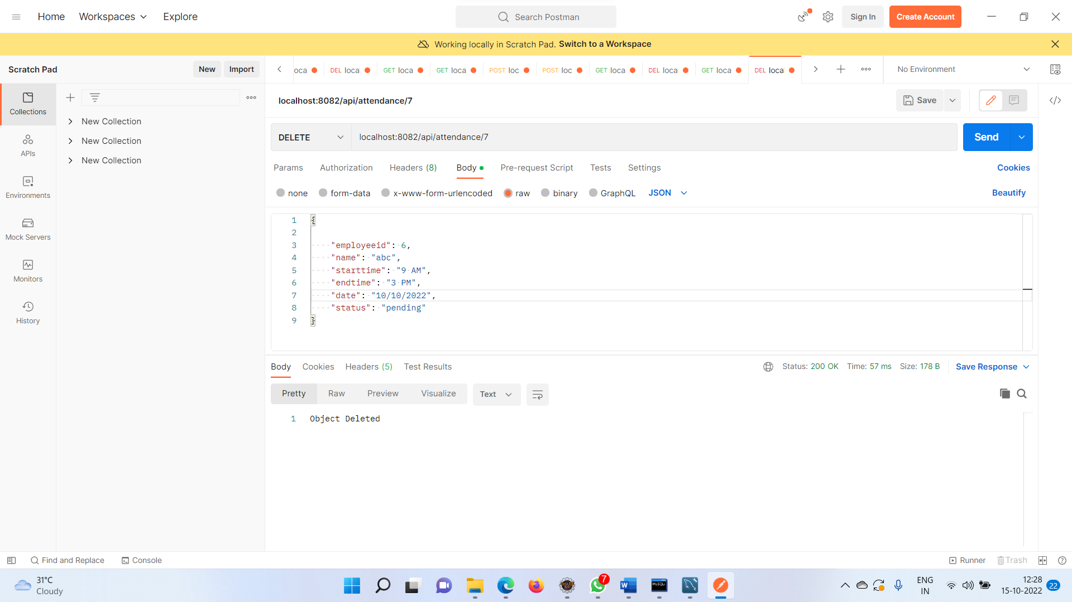

# Employee can View the attendance by Employee id

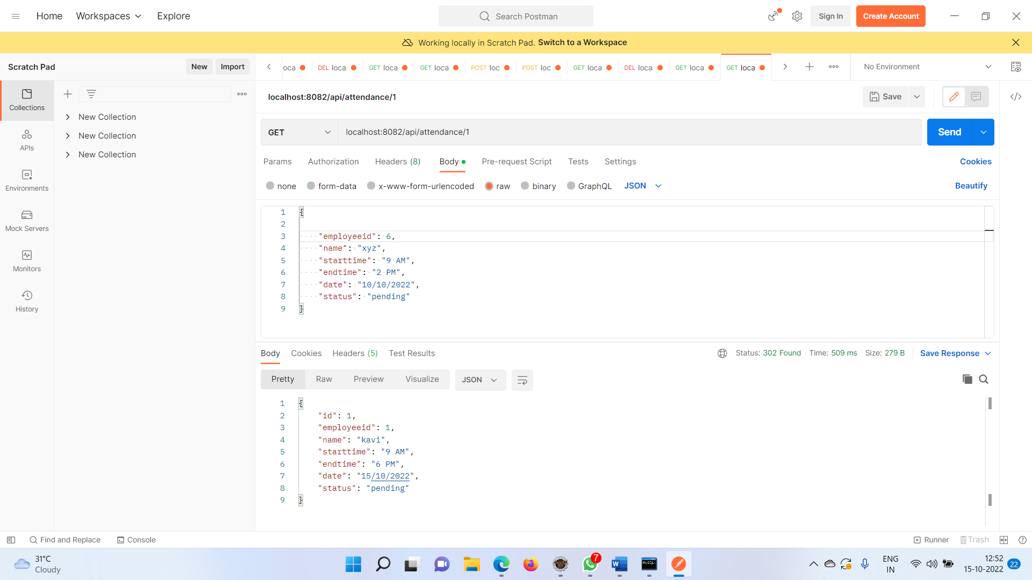

# Database Tables

