* **BandGap Reference Methodology**

**N>1**

**V**

**REF**

**V**

**PT**

**T**

**T**

X

**T**

**V**

**NT**

(a)

**Convex Waveform**

**T**

**L1**

**T**

**H1**

**V**

**REF**

**R**

**out**

**I**

**REF**

**I**

**PT**

**N>1**

**T**

**T**

**I**

**NT**

T

(b)

Fig. 1: (a) Ideal BGR characteristics, (b) Practical BGR characteristics.

* **Circuit Implementation of BGR**

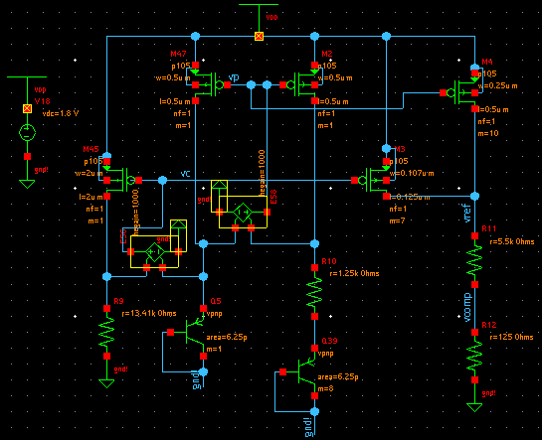

Fig. 2: Circuit implementation of BGR.

* **Curvature Compensation Technique**

**I**

**TC1**

**I**

**NTC1**

**I**

**PTC1**

**V**

**TC1**

**V**

**=**

**NTC1**

**V**

**+**

**PTC1**

**R**

**C**

**V**

**REF**

**T**

**L1**

**T**

**H1**

**T**

**T**

**T**

**L1**

**T**

**H1**

**V**

**REF_COMP**

Fig. 3: Curvature compensation method for BGR

* **Circuit Implementation of Curvature Compensation Technique**

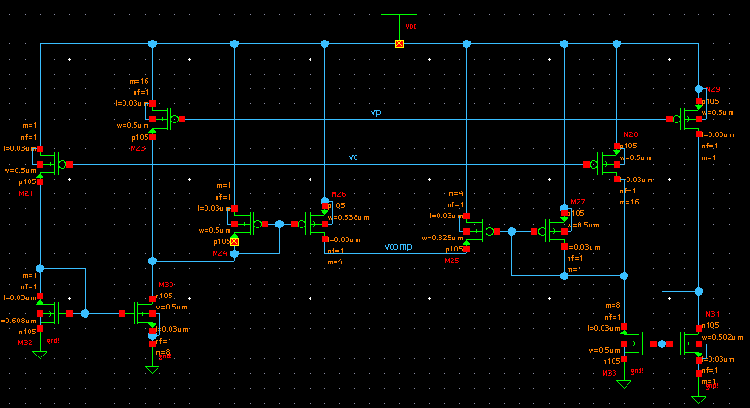

Fig. 4: Circuit implementation of curvature compensation technique

* **Simulation Results**

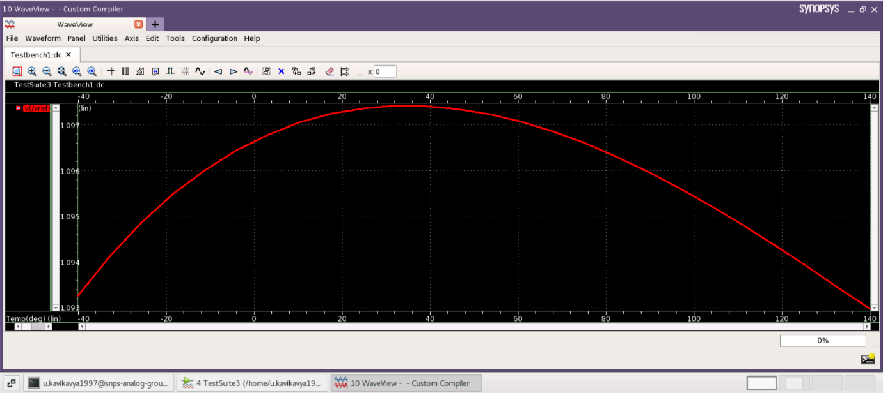

Fig. 5: Reference voltage variation with respect to temperature without curvature compensation.

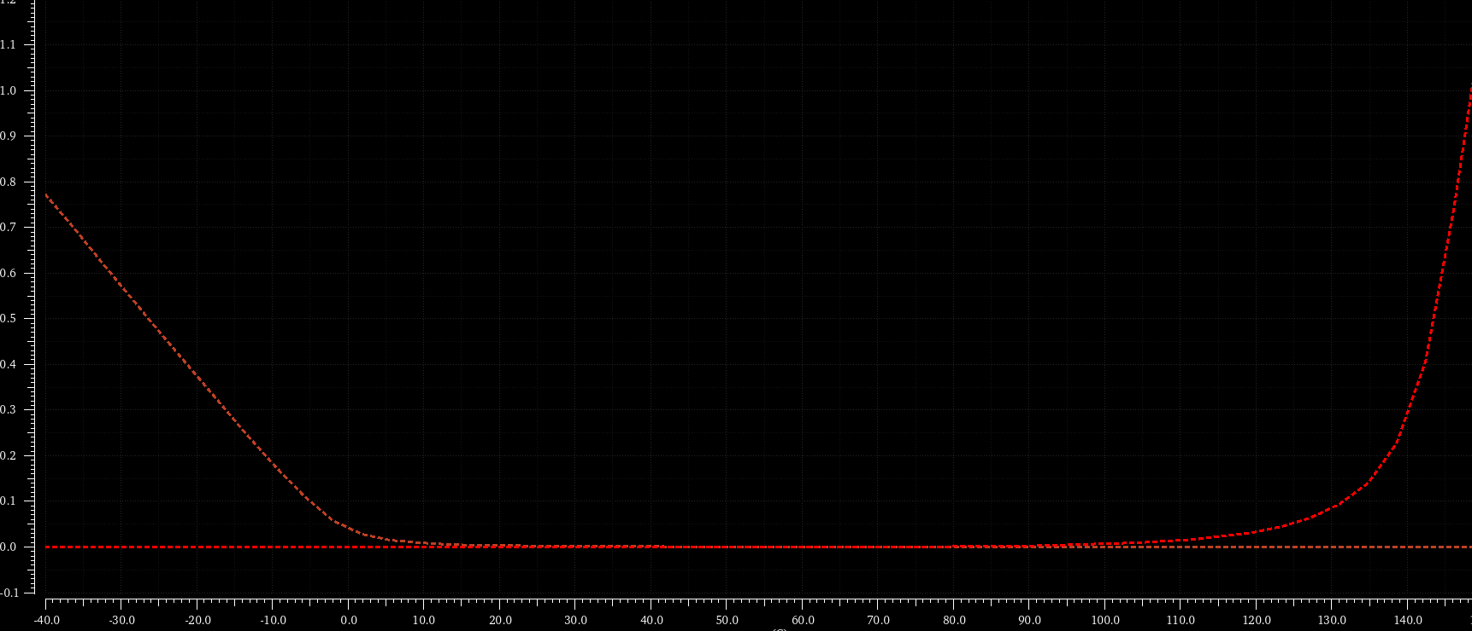

Fig. 6: Current variation with respect to temperature in BGR curvature compensation circuit.

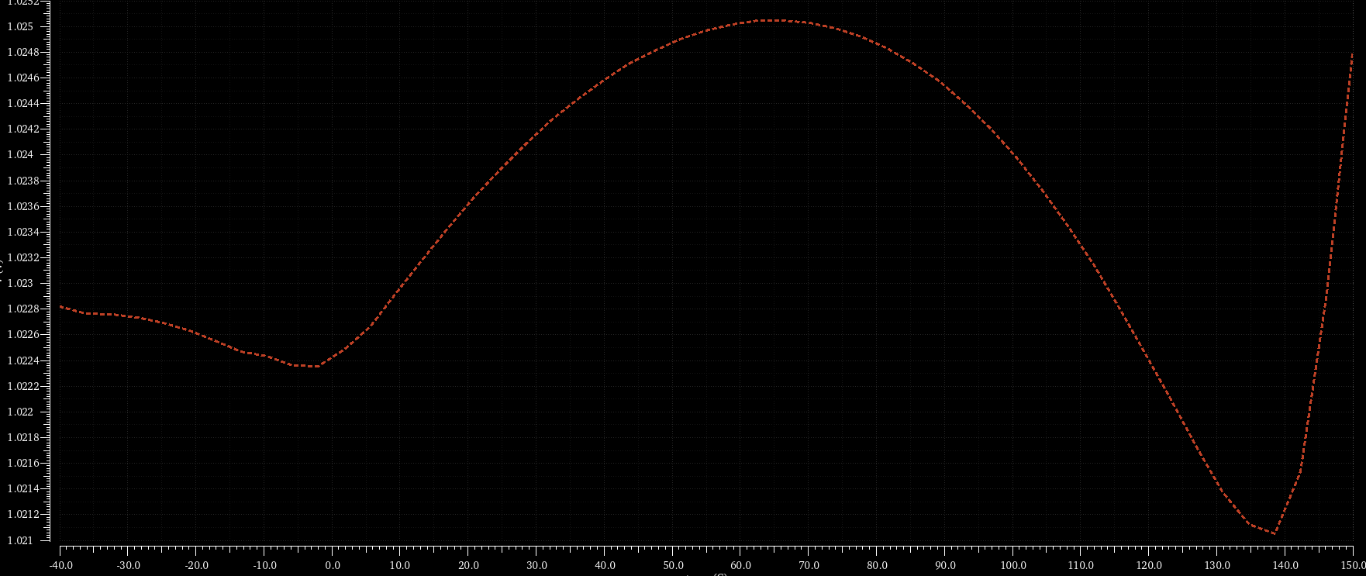

Fig. 7: Reference voltage variation with respect to temperature with curvature compensation.