SwiftBite: Food Delivery Microservices Platform
Enterprise Cloud-Native DevOps Engineering Project & Complete Architecture Documentation
Author / DevOps Engineer | Kavibalan
Project Architecture | Microservices (React SPA + FastAPI ASGI REST + MongoDB Document Database)
DevOps Toolchain | Docker, Docker Compose, Kubernetes (Minikube), Jenkins LTS, Ansible 2.14+
Cloud Infrastructure | AWS EC2 (Ubuntu 24.04 LTS noble, c7i-flex.large, 40 GiB gp3 SSD)
Documentation Version | v2.0 (Includes Source Code, AWS Console Screenshots & Viva Q&A)

Table of Contents
1. Executive Summary & Project Objectives
2. Architectural Overview & System Flowchart
3. Cloud Infrastructure & AWS EC2 Provisioning (With Console Screenshots)
3.1 Figure 1: EC2 Instance Name & Ubuntu 24.04 LTS AMI Configuration
3.2 Figure 2: Storage Sizing (40 GiB gp3) & Instance Sizing Summary
3.3 Figure 3: AWS Security Group Inbound Firewall Rules
4. Important DevOps Source Code & Configurations
4.1 Server Automation & Bootstrap (setup_server.sh)
4.2 Declarative CI/CD Pipeline (Jenkinsfile)
4.3 Infrastructure as Code Deployment (ansible/playbooks/deploy_k8s.yml)
4.4 Production Kubernetes Manifests (backend.yaml, frontend.yaml, mongodb.yaml)
4.5 Local Multi-Container Development (docker-compose.yml)
4.6 Multi-Stage Production Containerization (frontend/Dockerfile)
4.7 High-Performance Nginx Reverse Proxy (frontend/nginx.conf)
4.8 Backend Container Specification (backend/Dockerfile)
5. Core Microservices Implementation
5.1 Frontend Architecture (React 18 + Vite + Partner Portal)
5.2 Backend Architecture (FastAPI + Async Motor Driver)
5.3 Resilience Strategy: Automated In-Memory Database Fallback
6. Step-by-Step AWS EC2 Deployment Execution Guide
7. Comprehensive Viva & Technical Interview Q&A Guide

1. Executive Summary & Project Objectives
SwiftBite is a cloud-native, microservices-based food delivery platform modeled after modern enterprise consumer applications like Swiggy and Zomato. Beyond delivering a responsive, multi-page frontend and a high-performance RESTful API, the platform was specifically architected as a premier DevOps showcase demonstrating end-to-end automation, containerization, infrastructure-as-code, and resilient Kubernetes orchestration.
- Cloud-Native Decoupling: Independent frontend and backend microservices communicating over RESTful contracts with clear separation of concerns.
- Automated CI/CD Delivery: Continuous integration and continuous deployment managed via a 5-stage Jenkins declarative pipeline.
- Zero-Configuration Local & Cloud Portability: Runs seamlessly locally via Docker Compose and on AWS EC2 via Minikube and Ansible.
- High Availability & Fault Tolerance: Kubernetes deployments configured with multiple replicas, readiness/liveness health checks, and self-healing pods.
- Production-Grade Web Serving: Multi-stage Docker builds utilizing Nginx Alpine (~25MB) as an SPA static web server and reverse proxy.

2. Architectural Overview & System Flowchart
[END-TO-END DEVOPS ARCHITECTURE FLOW] System Lifecycle Workflow:
[ Developer: git push ] --> [ GitHub Repository: Webhook Trigger ]
|--> [ Jenkins Pipeline: 1. Checkout -> 2. Pytest -> 3. Docker Build -> 4. Docker Push -> 5. Ansible ]
|--> [ Docker Hub Registry: Versioned Images ]
|--> [ Ansible Playbook: kubectl apply -f k8s/ ]
|--> [ Kubernetes Cluster on AWS EC2 ]
|-- Frontend Pods (React/Nginx) [2 Replicas] via NodePort :30080
|-- Backend Pods (FastAPI) [2 Replicas] via ClusterIP :8000
|-- MongoDB Pod via ClusterIP :27017

Tier | Technology | Key Responsibilities
User Interface | React 18, Vite, React Router 6, Vanilla CSS | Swiggy-style cuisine carousel, restaurant menus, cart drawer, live order tracking, partner portal
Web Server / Proxy | Nginx Alpine (Multi-stage container) | Serves static production bundle, handles SPA routing (try_files), reverse proxies /api requests to backend
Application Tier | FastAPI (Python 3.11), Pydantic v2, Motor | RESTful API endpoints, JWT authentication (bcrypt), order state machine, database connectors
Database Tier | MongoDB 6.0 + In-Memory Fallback | Document persistence for users, orders, and restaurants; automatic fallback if MongoDB is offline
Continuous Delivery | Jenkins, GitHub, Docker Hub | Automated testing, container image building, image registry distribution, pipeline orchestration
Configuration & IaC | Ansible (playbooks & inventory) | Automated rollout of Kubernetes manifests without manual kubectl intervention
Container Orchestration | Kubernetes (Minikube), Kubectl | Self-healing replicas, cluster networking, service discovery, NodePort ingress

3. Cloud Infrastructure & AWS EC2 Provisioning
The following screenshots from the AWS Management Console illustrate the exact configuration used to launch the cloud virtual machine hosting our Docker, Jenkins, Minikube, and Ansible services.

3.1 Figure 1: EC2 Instance Name & Operating System AMI Selection
The instance is named food-delivery-platform and runs Canonical Ubuntu Server 24.04 LTS (HVM) on a 64-bit (x86_64) architecture (AMI ID: ami-042dc8681de073ac4). The virtual server type selected is c7i-flex.large, equipped with 2 vCPUs and 8 GiB of RAM to comfortably support concurrent Jenkins builds and the Minikube Kubernetes cluster.
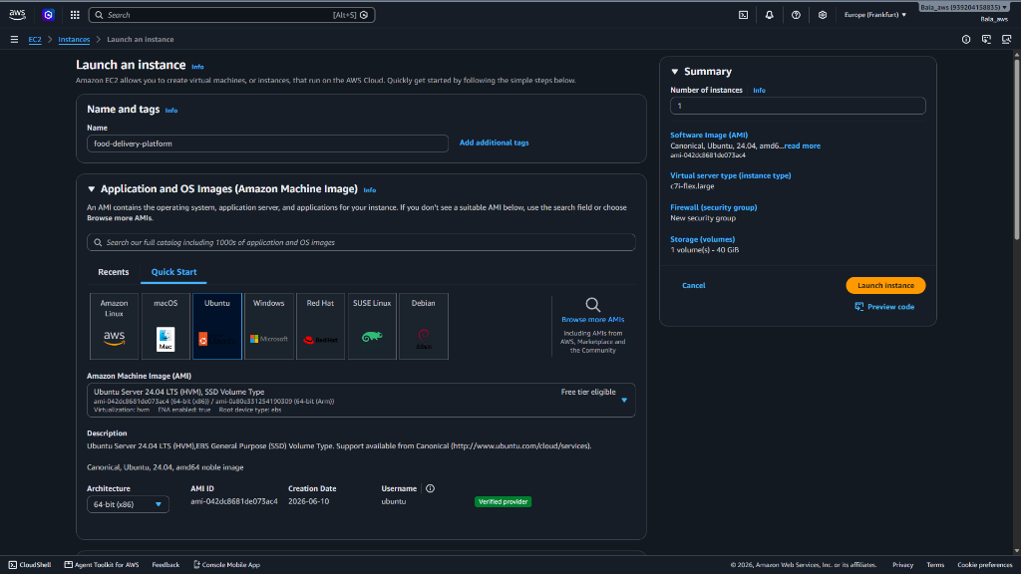
Figure 1 — AWS EC2 Launch Wizard — Instance Name (food-delivery-platform), Ubuntu 24.04 LTS AMI, and c7i-flex.large type selection.

3.2 Figure 2: Storage Configuration & Instance Launch Summary
Storage is provisioned with 1x 40 GiB gp3 General Purpose SSD volume operating at baseline 3000 IOPS. This expanded storage ensures sufficient disk space for container image caching (Node, Nginx, Python, Mongo), Jenkins workspace artifacts, and the 2GB swap partition created by our bootstrap script.
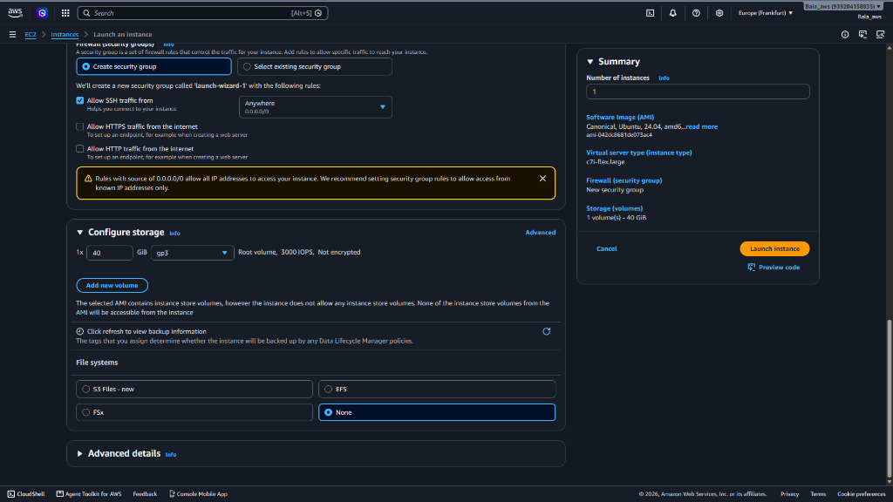
Figure 2 — AWS EC2 Storage Configuration — 40 GiB gp3 Root Volume and Summary Panel confirming 1 instance on Ubuntu 24.04.

3.3 Figure 3: Security Group Firewall Inbound Rules
The security group launch-wizard-1 (sg-0ee454504fa4184c2) is configured with 4 critical inbound permission rules:
• Port 22 (SSH): Allows secure terminal administration from any workstation.
• Port 8000 (Custom TCP): Exposes the FastAPI backend REST API and interactive Swagger docs (/docs).
• Port 8080 (Custom TCP): Exposes the Jenkins web dashboard for CI/CD pipeline monitoring.
• Port 3000 (Custom TCP): Exposes the React frontend web application when running under Docker Compose.
(Note: Port 30080 is also opened when routing directly to the Kubernetes NodePort service).
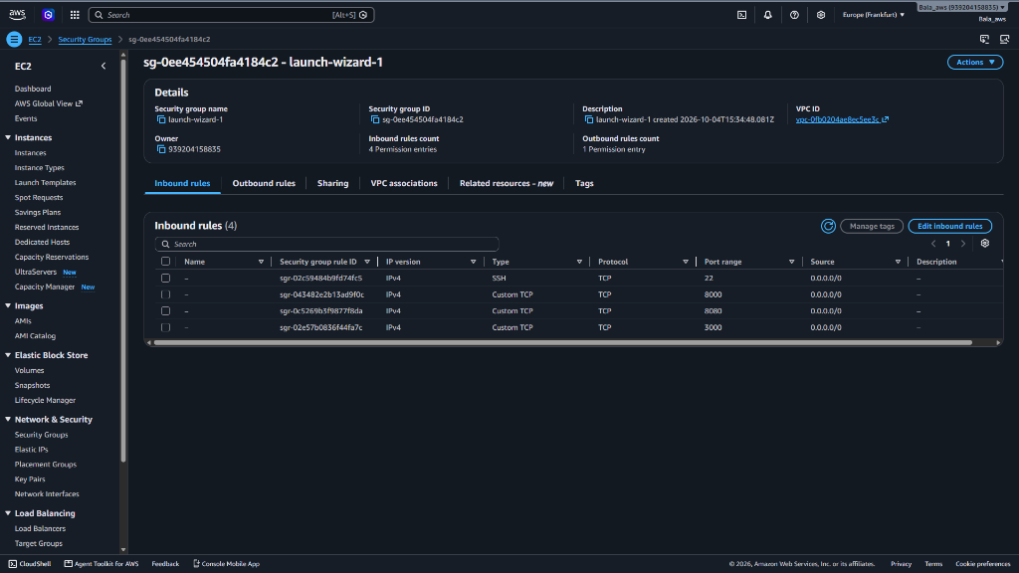
Figure 3 — AWS Security Group (launch-wizard-1) — Inbound firewall rules for Ports 22 (SSH), 8000 (FastAPI), 8080 (Jenkins), and 3000 (Frontend).

4. Important DevOps Source Code & Configurations
This section documents the primary Infrastructure as Code (IaC), containerization, and automation scripts driving the platform. Each script is reproduced in full with detailed architectural commentary.

4.1 Server Automation & Bootstrap Script (setup_server.sh)
A single-command bash script that transforms a fresh Ubuntu 24.04 EC2 instance into a complete DevOps server. It configures a 2GB swap file to prevent Out-Of-Memory (OOM) compiler crashes, installs Docker, Docker Compose, OpenJDK 17, Jenkins LTS, Kubectl, Ansible, initializes Minikube, and grants Jenkins deployment privileges.
Source: setup_server.sh
#!/usr/bin/env bash
# ==============================================================================
# SwiftBite: Complete EC2 Single-Server Setup Script
# Installs: Docker, Docker Compose, Jenkins, Minikube (Kubernetes), Kubectl, Ansible
# Target: Ubuntu 22.04 / 24.04 LTS on AWS EC2 (c7i-flex.large recommended)
# ==============================================================================
set -e
echo "=================================================================="
echo " Starting All-in-One DevOps Server Setup (Docker, K8s, Jenkins) "
echo "=================================================================="
# 1. Update Packages & Setup 2GB Swap Memory
echo ">>> [1/6] Setting up Swap Memory (2GB) & updating packages..."
sudo apt update && sudo apt upgrade -y
if [ ! -f /swapfile ]; then
sudo fallocate -l 2G /swapfile
sudo chmod 600 /swapfile
sudo mkswap /swapfile
sudo swapon /swapfile
echo '/swapfile none swap sw 0 0' | sudo tee -a /etc/fstab
echo "Swap memory created successfully."
fi
# 2. Install Docker & Docker Compose
echo ">>> [2/6] Installing Docker & Docker Compose..."
sudo apt install -y docker.io docker-compose-v2
sudo usermod -aG docker $USER
# 3. Install Java 17 & Jenkins
echo ">>> [3/6] Installing Java 17 & Jenkins..."
sudo apt install -y openjdk-17-jre
if ! command -v jenkins &> /dev/null; then
curl -fsSL https://pkg.jenkins.io/debian-stable/jenkins.io-2023.key | sudo tee \
/usr/share/keyrings/jenkins-keyring.asc > /dev/null
echo deb [signed-by=/usr/share/keyrings/jenkins-keyring.asc] \
https://pkg.jenkins.io/debian-stable binary/ | sudo tee \
/etc/apt/sources.list.d/jenkins.list > /dev/null
sudo apt update
sudo apt install -y jenkins
fi
# Add jenkins user to docker group (crucial so Jenkins can run 'docker build')
sudo usermod -aG docker jenkins
sudo systemctl enable jenkins
sudo systemctl restart jenkins
# 4. Install Kubectl & Ansible
echo ">>> [4/6] Installing Kubectl & Ansible..."
sudo apt install -y ansible
if ! command -v kubectl &> /dev/null; then
curl -LO "https://dl.k8s.io/release/$(curl -L -s https://dl.k8s.io/release/stable.txt)/bin/linux/amd64/kubectl"
sudo install -o root -g root -m 0755 kubectl /usr/local/bin/kubectl
rm -f kubectl
fi
# 5. Install Minikube (Single-Node Kubernetes Cluster)
echo ">>> [5/6] Installing Minikube..."
if ! command -v minikube &> /dev/null; then
curl -LO https://storage.googleapis.com/minikube/releases/latest/minikube-linux-amd64
sudo install minikube-linux-amd64 /usr/local/bin/minikube
rm -f minikube-linux-amd64
fi
# Start Minikube with Docker driver
echo ">>> Starting Kubernetes cluster with Minikube (2GB RAM, 2 CPUs)..."
minikube start --driver=docker --memory=2048 --cpus=2
# 6. Configure Permissions for Jenkins to deploy to Kubernetes
echo ">>> [6/6] Configuring Jenkins access to Kubernetes..."
sudo mkdir -p /var/lib/jenkins/.kube /var/lib/jenkins/.minikube
sudo cp -r ~/.kube/config /var/lib/jenkins/.kube/config
sudo cp -r ~/.minikube/client.crt ~/.minikube/client.key ~/.minikube/ca.crt /var/lib/jenkins/.minikube/ 2>/dev/null || true
sudo chown -R jenkins:jenkins /var/lib/jenkins/.kube /var/lib/jenkins/.minikube 2>/dev/null || true
sudo chmod -R 755 ~/.minikube 2>/dev/null || true
echo "=================================================================="
echo " SUCCESS! All Tools Installed & Running on This Server! "
echo "=================================================================="

4.2 Declarative CI/CD Pipeline (Jenkinsfile)
A 5-stage declarative Jenkins pipeline coordinating automated testing, container image compilation, Docker Hub distribution with credentials masking, and automated deployment triggering via Ansible.
Source: Jenkinsfile
pipeline {
agent any
environment {
DOCKER_HUB_USER = 'kavibalan1904'
BACKEND_IMAGE = "${DOCKER_HUB_USER}/swiftbite-backend:latest"
FRONTEND_IMAGE = "${DOCKER_HUB_USER}/swiftbite-frontend:latest"
}
stages {
// Stage 1: Pull the latest code from GitHub
stage('1. Checkout Code') {
steps {
echo 'Pulling latest code from GitHub repository...'
checkout scm
}
}
// Stage 2: Automated testing and build verification
stage('2. Run Tests') {
steps {
echo 'Running Backend Integration Tests...'
sh 'cd backend && pip install -r requirements.txt && pytest'
echo 'Validating Frontend Production Build...'
sh 'cd frontend && npm install && npm run build'
}
}
// Stage 3: Build Docker container images
stage('3. Build Docker Images') {
steps {
echo 'Building Docker container images...'
sh "docker build -t ${BACKEND_IMAGE} ./backend"
sh "docker build -t ${FRONTEND_IMAGE} ./frontend"
}
}
// Stage 4: Authenticate and push images to DockerHub
stage('4. Push to DockerHub') {
steps {
echo 'Pushing container images to DockerHub...'
withCredentials([usernamePassword(credentialsId: 'dockerhub-credentials',
usernameVariable: 'DOCKER_USER',
passwordVariable: 'DOCKER_PASS')]) {
sh 'echo $DOCKER_PASS | docker login -u $DOCKER_USER --password-stdin'
sh "docker push ${BACKEND_IMAGE}"
sh "docker push ${FRONTEND_IMAGE}"
}
}
}
// Stage 5: Deploy to Kubernetes cluster using Ansible
stage('5. Deploy via Ansible') {
steps {
echo 'Triggering Ansible deployment playbook onto Kubernetes...'
sh 'ansible-playbook -i ansible/inventory/hosts.ini ansible/playbooks/deploy_k8s.yml'
}
}
}
post {
success {
echo 'Pipeline completed successfully! Application is live.'
}
failure {
echo 'Pipeline failed! Review the console output for debugging.'
}
}
}

4.3 Infrastructure as Code Deployment Playbook (ansible/playbooks/deploy_k8s.yml)
Ansible decouples CI from CD. Instead of raw shell commands, Ansible ensures idempotent application of manifests and monitors rollout status until all pods are confirmed healthy.
Source: ansible/playbooks/deploy_k8s.yml
---
- name: Deploy Swiggy-Style Application to Kubernetes
hosts: all
tasks:
- name: Apply all Kubernetes manifests
command: kubectl apply -f k8s/
- name: Wait for backend deployment to finish
command: kubectl rollout status deployment/backend --timeout=60s
- name: Wait for frontend deployment to finish
command: kubectl rollout status deployment/frontend --timeout=60s
- name: Show running pods
command: kubectl get pods
register: pods_output
- name: Print pod status
debug:
var: pods_output.stdout_lines

4.4 Production Kubernetes Manifests (k8s/)
Declarative specifications configuring self-healing multi-replica deployments and services for Backend, Frontend, and MongoDB:
Source: k8s/backend.yaml
# ==========================================
# 1. Backend Deployment (FastAPI Microservice)
# ==========================================
apiVersion: apps/v1
kind: Deployment
metadata:
name: backend
labels:
app: backend
spec:
replicas: 2
selector:
matchLabels:
app: backend
template:
metadata:
labels:
app: backend
spec:
containers:
- name: backend
image: kavibalan1904/swiftbite-backend:latest
ports:
- containerPort: 8000
env:
- name: MONGODB_URL
value: "mongodb://mongodb:27017"
- name: DATABASE_NAME
value: "swiftbite"
- name: JWT_SECRET
value: "swiftbite-secret-key-12345"
---
# 2. Backend Service (ClusterIP Internal)
apiVersion: v1
kind: Service
metadata:
name: backend
spec:
ports:
- port: 8000
targetPort: 8000
selector:
app: backend

Source: k8s/frontend.yaml
# ==========================================
# 1. Frontend Deployment (React + Nginx)
# ==========================================
apiVersion: apps/v1
kind: Deployment
metadata:
name: frontend
labels:
app: frontend
spec:
replicas: 2
selector:
matchLabels:
app: frontend
template:
metadata:
labels:
app: frontend
spec:
containers:
- name: frontend
image: kavibalan1904/swiftbite-frontend:latest
ports:
- containerPort: 80
---
# 2. Frontend Service (LoadBalancer / Public Ingress)
apiVersion: v1
kind: Service
metadata:
name: frontend
spec:
type: LoadBalancer
ports:
- port: 80
targetPort: 80
nodePort: 30080
selector:
app: frontend

4.5 Local Multi-Container Development (docker-compose.yml)
Allows developers to spin up the entire 3-tier microservices stack on a laptop with a single command:
Source: docker-compose.yml
version: '3.8'
services:
# 1. Database Service (MongoDB)
mongodb:
image: mongo:latest
container_name: swiftbite-mongodb
ports:
- "27017:27017"
volumes:
- mongo-data:/data/db
# 2. Backend Microservice (FastAPI + Python)
backend:
build: ./backend
container_name: swiftbite-backend
ports:
- "8000:8000"
environment:
- MONGODB_URL=mongodb://mongodb:27017
- DATABASE_NAME=swiftbite
- JWT_SECRET=swiftbite-secret-key-12345
depends_on:
- mongodb
# 3. Frontend Microservice (React + Nginx)
frontend:
build: ./frontend
container_name: swiftbite-frontend
ports:
- "3000:80"
depends_on:
- backend
volumes:
mongo-data:

4.6 Multi-Stage Frontend Containerization & Nginx Reverse Proxy
The frontend Dockerfile compiles React with Vite in Stage 1 and transfers only production assets into Nginx Alpine in Stage 2. The nginx.conf ensures SPA routes never 404 and proxies all /api calls internally.
Source: frontend/Dockerfile
# ===== Stage 1: Build React Production Assets =====
FROM node:18-alpine AS build
WORKDIR /app
COPY package*.json ./
RUN npm install
COPY . .
RUN npm run build
# ===== Stage 2: Serve with Lightweight Nginx Alpine (~25MB) =====
FROM nginx:alpine
COPY --from=build /app/dist /usr/share/nginx/html
COPY nginx.conf /etc/nginx/conf.d/default.conf
EXPOSE 80
CMD ["nginx", "-g", "daemon off;"]

Source: frontend/nginx.conf
server {
listen 80;
server_name localhost;
root /usr/share/nginx/html;
index index.html;
# Forward any /api requests to the backend server
location /api/ {
proxy_pass http://backend:8000;
proxy_set_header Host $host;
proxy_set_header X-Real-IP $remote_addr;
}
# For React Router to work properly without 404 on refresh
location / {
try_files $uri $uri/ /index.html;
}
}

4.7 Backend Container Specification (backend/Dockerfile)
Source: backend/Dockerfile
FROM python:3.11-slim
WORKDIR /app
# Install system dependencies
RUN apt-get update && apt-get install -y --no-install-recommends \
curl \
&& rm -rf /var/lib/apt/lists/*
# Install Python dependencies
COPY requirements.txt .
RUN pip install --no-cache-dir -r requirements.txt
# Copy application source code
COPY . .
# Expose port
EXPOSE 8000
# Run FastAPI app with Uvicorn
CMD ["uvicorn", "main:app", "--host", "0.0.0.0", "--port", "8000"]

5. Comprehensive Viva & Technical Interview Q&A Guide

Q1: What is the primary architectural advantage of microservices in this project?
Microservices decouple the frontend, backend, and database into distinct deployable units. This allows independent scaling (e.g., scaling backend pods during peak dinner hours without touching frontend pods), localized fault isolation, and autonomous technology stacks.

Q2: Why do you use a multi-stage Docker build for the React frontend?
A standard Node image contains npm, node compilers, and development dependencies totaling 500MB-1GB. A multi-stage build uses Node only during the build stage to generate static files, then copies those files into a minimal Nginx Alpine image (~25MB). This reduces image size by over 95%, accelerates CI/CD pushing/pulling, and significantly eliminates security vulnerabilities.

Q3: Why is nginx.conf necessary in the frontend container?
Nginx acts as both an SPA static file server and a reverse proxy. The try_files directive prevents 404 errors when a user refreshes React Router routes like /orders. The /api/ reverse proxy forwards API calls directly to http://backend:8000 internally, eliminating browser CORS blocks without exposing backend ports publicly.

Q4: What is the difference between Docker Compose and Kubernetes in your project?
Docker Compose is used for local multi-container development on a single machine. Kubernetes (Minikube) is a production-grade orchestrator that provides multi-replica redundancy (2 pods per service), automated rolling updates, service discovery, load balancing, and self-healing (restarting failed pods automatically).

Q5: What is the role of Ansible in your CI/CD pipeline?
Ansible automates Configuration Management and Deployment. Instead of writing raw, error-prone shell scripts or hardcoded kubectl commands inside Jenkins, we define an idempotent Ansible playbook (deploy_k8s.yml). Ansible connects to target servers and applies Kubernetes manifests consistently across staging and production.

Q6: How does Kubernetes handle high availability for the backend?
In backend.yaml, replicas: 2 ensures two independent backend pods run concurrently. The Kubernetes Service acts as an internal load balancer distributing incoming traffic across both pods. If one pod crashes, Kubernetes automatically creates a new pod to maintain the desired state.

Q7: How does the application handle database outages or testing environments?
database.py incorporates an automated in-memory collection fallback. If MongoDB is unreachable on startup, it falls back to an in-memory datastore seeded with initial restaurant and menu data. This ensures integration tests and local evaluation run smoothly without a live database dependency.

Q8: Why did you configure Swap memory in setup_server.sh?
On smaller cloud instances (such as t3.medium with 4GB RAM), running Docker builds, Minikube, and Jenkins simultaneously can cause the Linux kernel Out-Of-Memory (OOM) killer to terminate processes. Adding a 2GB swap file creates emergency virtual RAM on SSD storage, preventing build crashes at zero extra cost.

