Sri Lanka Institute of Information Technology


B.Sc. (Hons) in Information Technology
Specializing in Cyber Security

IE2042- Database Management Systems for Security

Group Assignment

Health Clinic Management System

Group Number – 20
- IT23714120 - ATHAWUDA A.MM.G.K.P.
- IT23662032 - JAYAWEERA D. H. J. P. D. S
- IT23628472 - SENANAYAKE S.M.V.K.
- IT23627482 - GANGANATH A.N

Contents
Part 1 3
1. Assumptions 3
2. ERD and Logical Model 4
I. ERD 4
II. Logical model 4
3. Normalization 7
4. Implementation in SQL 7
I. Creating tables 8
II. Insert data 12
III. Triggers 14
IV. Views 16
V. Indexes 18
VI. Procedures 19
Part 2 21

Part 1

Assumptions

- User treated as a superclass entity, with Doctor, Nurse, Admin_Staff, and Patient treated as subclasses. (Inheritance)

- Each patient can have many visits (outpatient or inpatient).

- Inpatients are assigned to wards and beds during admission.

- Every visit is linked to a doctor and diagnosis.

- A patient may have multiple appointments.

- Appointments are scheduled by admin_staff and can involve a nurse and a doctor.

- Surgeries and diagnostic tests are part of the visit details.

- Billing is created for each service, and payments can be split into parts.

ERD and Logical Model

ERD

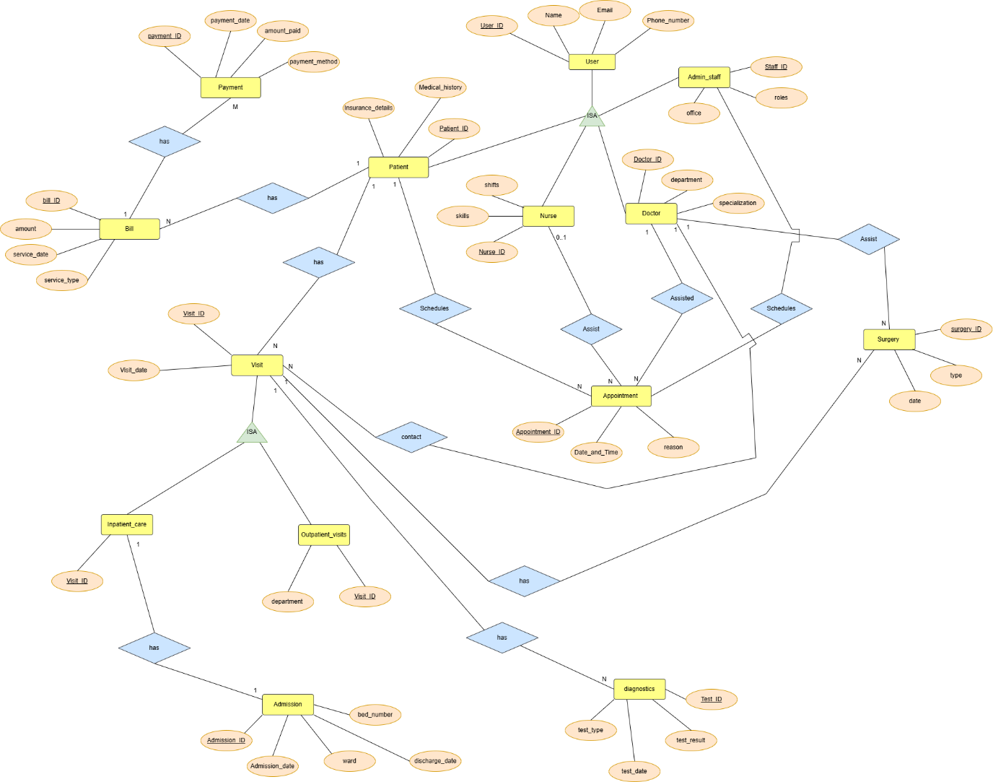

Logical model

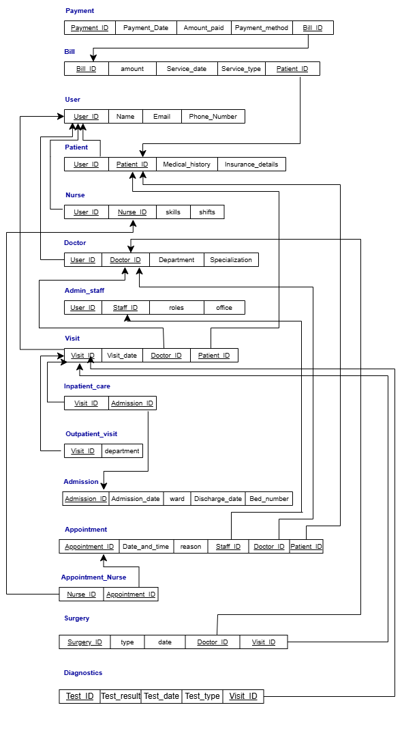

Normalization

The logical model created is already in 3NF (Third Normal Form).

- First Normal Form (1NF)

- All the attributes are atomic (simple and invisible).
- There are no repeated sets of data within the same table.
- Every table has a unique identifier.

- Second Normal Form (2NF)

- The logical model satisfies 1NF.
- Every nonprime attribute in model is not partially dependent on any key.

- Third Normal Form (3NF)

- The logical model satisfies 2NF.
- There are no transitive dependencies (no non-prime attribute is transitively dependent on any key)
- All attributes are directly dependent only on the primary key

So, the model satisfies 3NF.

Implementation in SQL

Creating tables

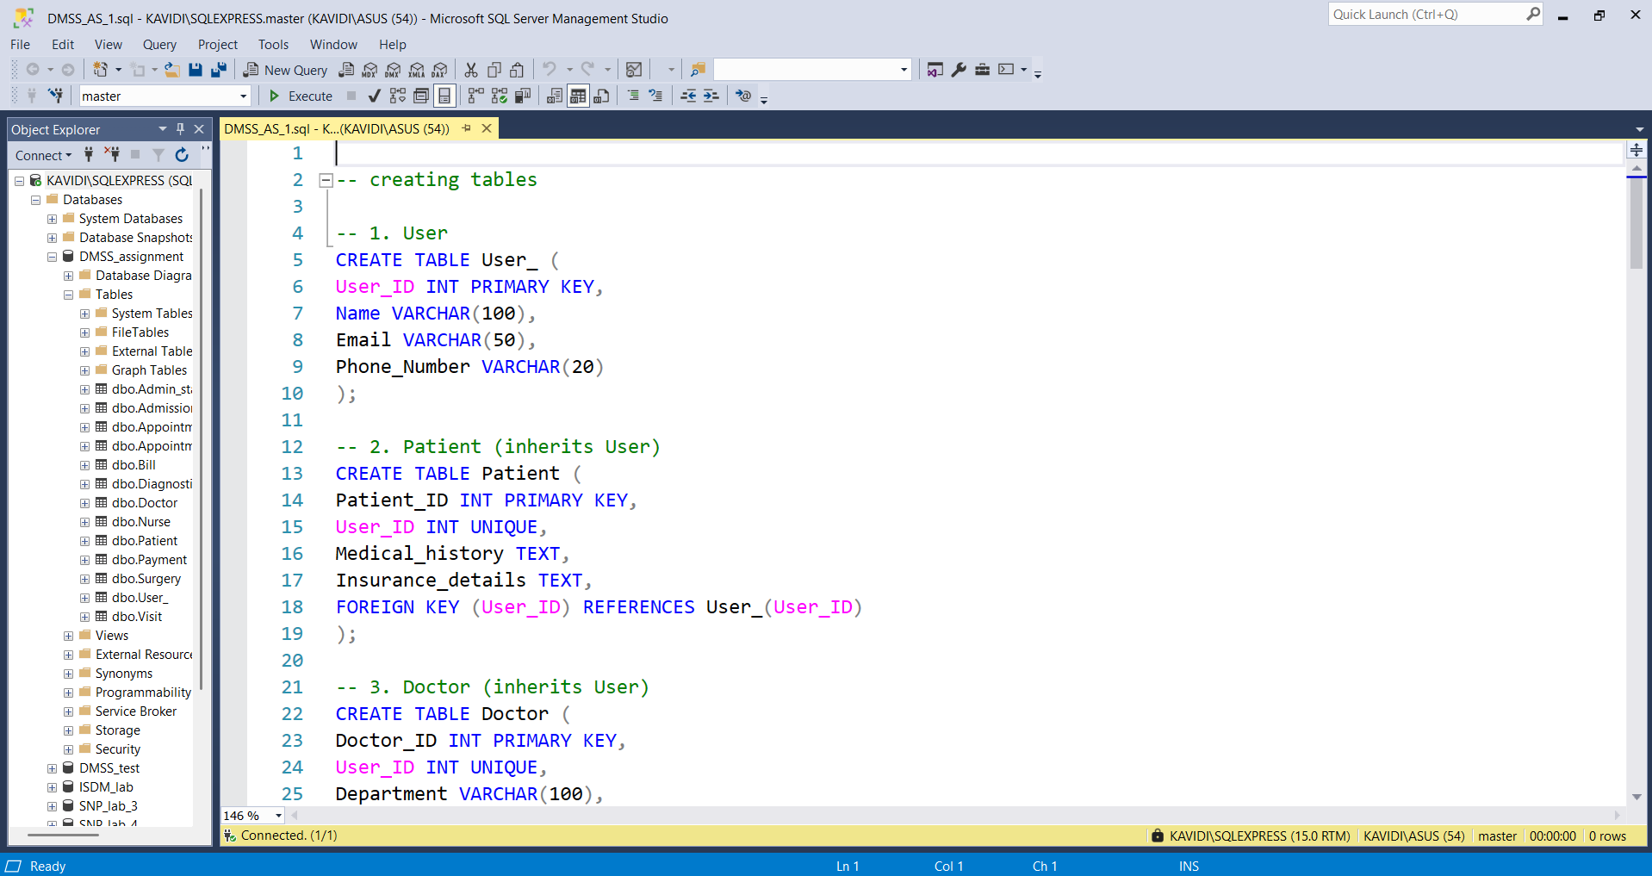
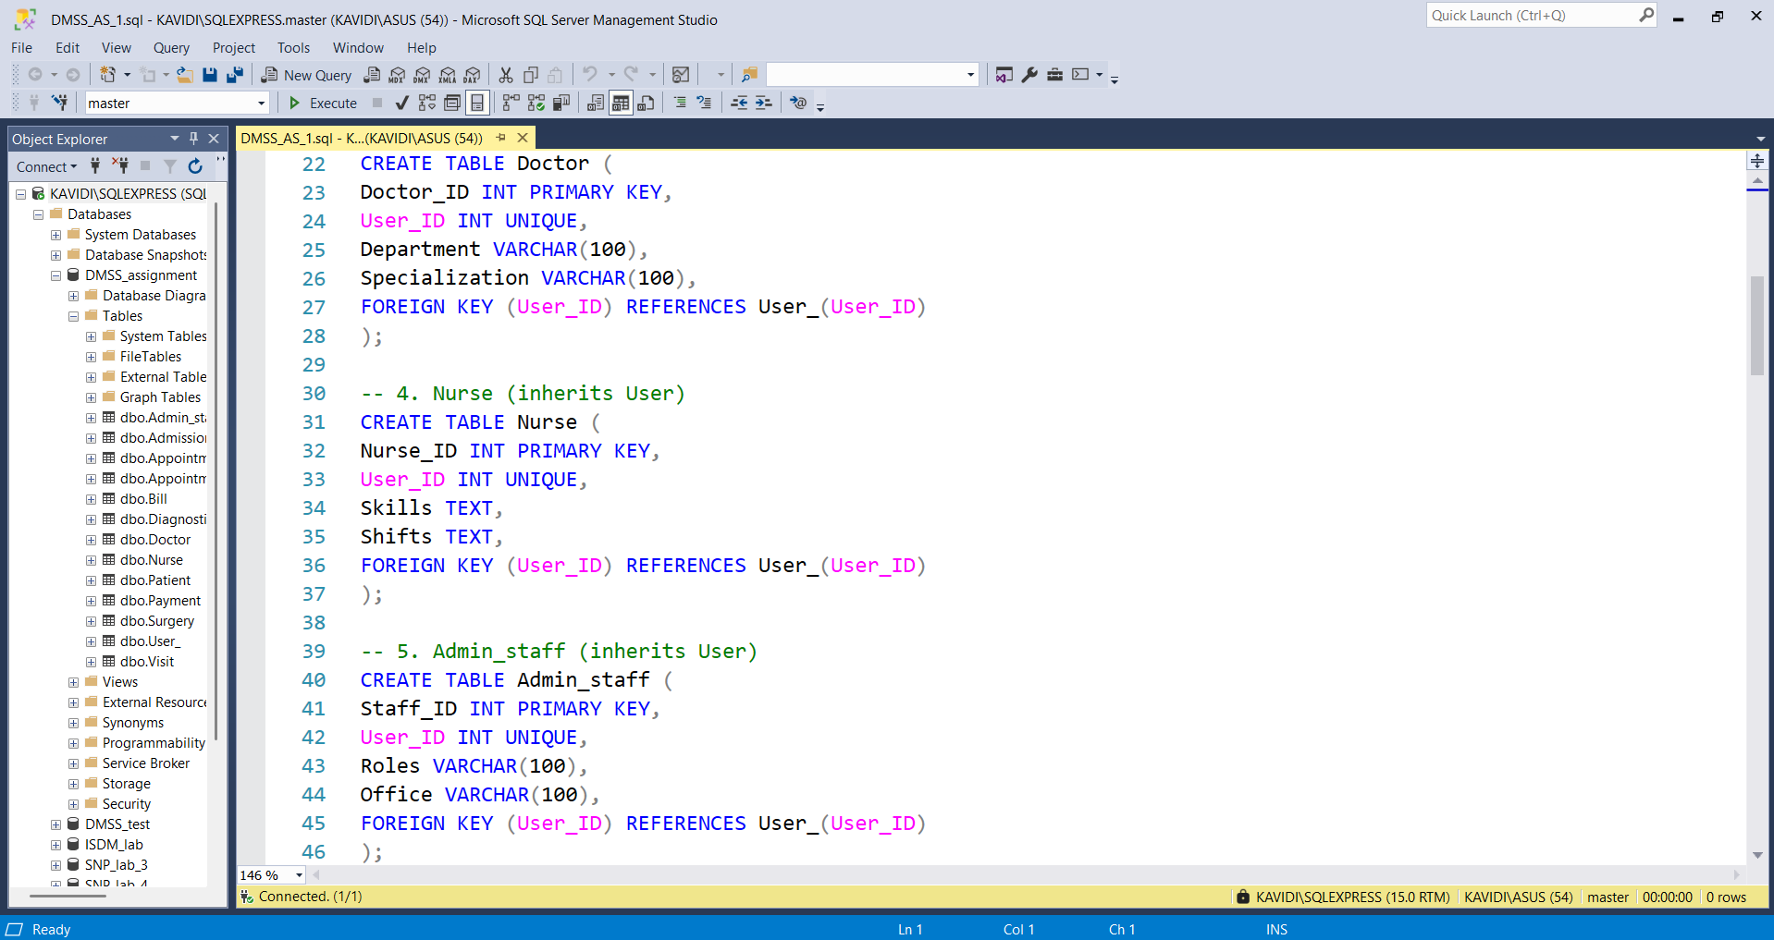
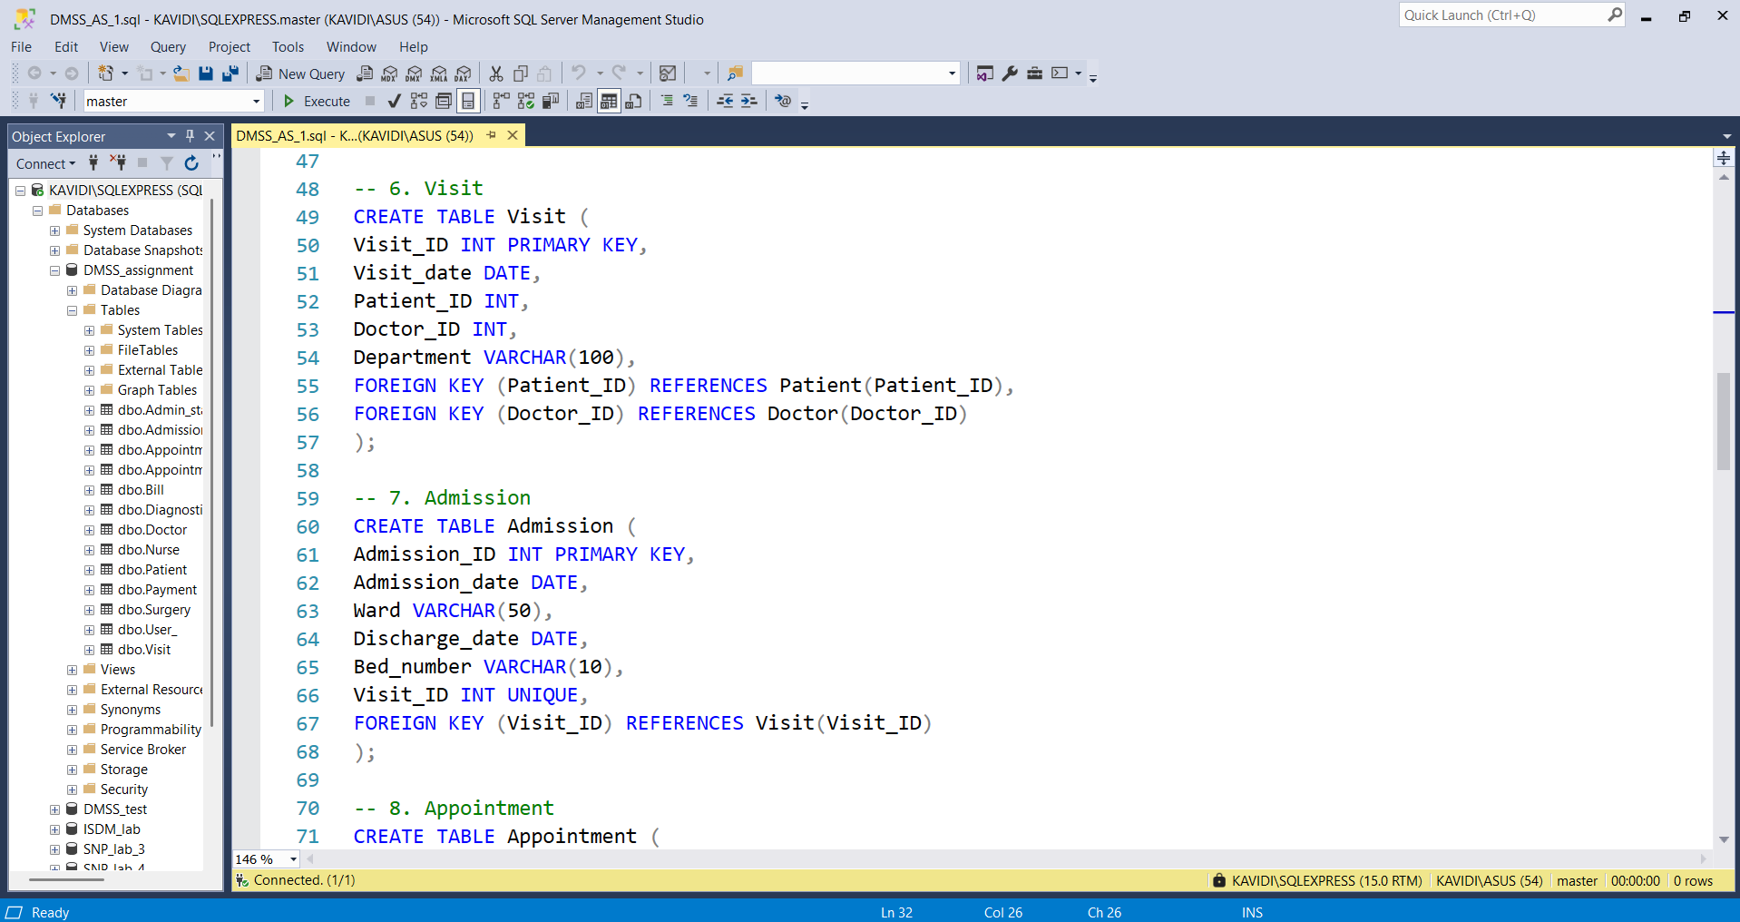

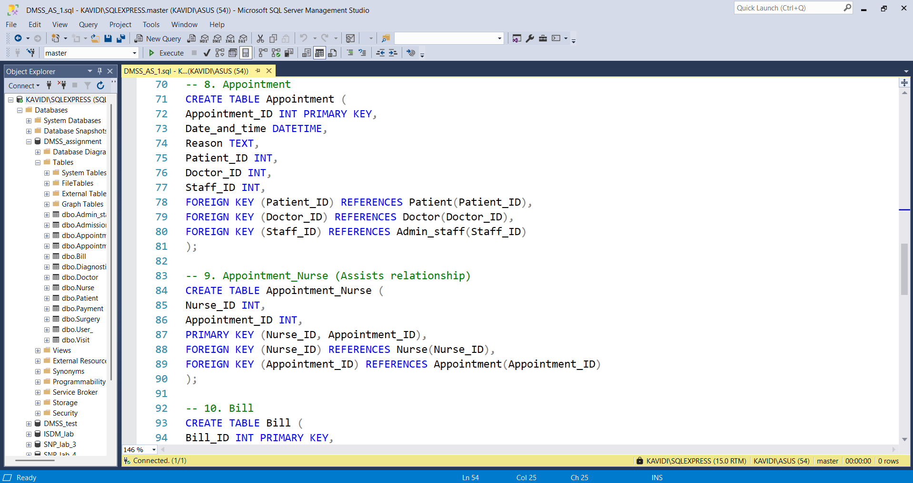
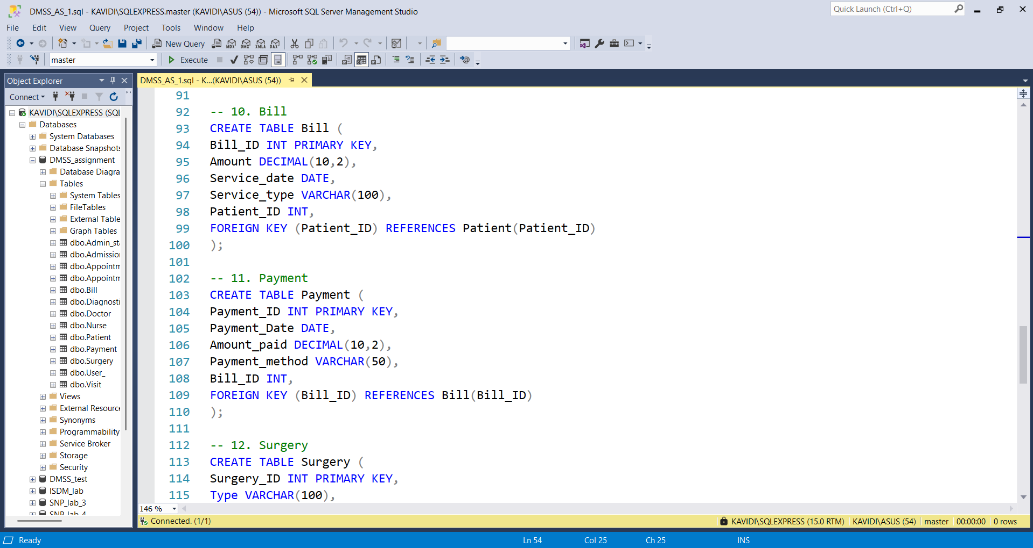
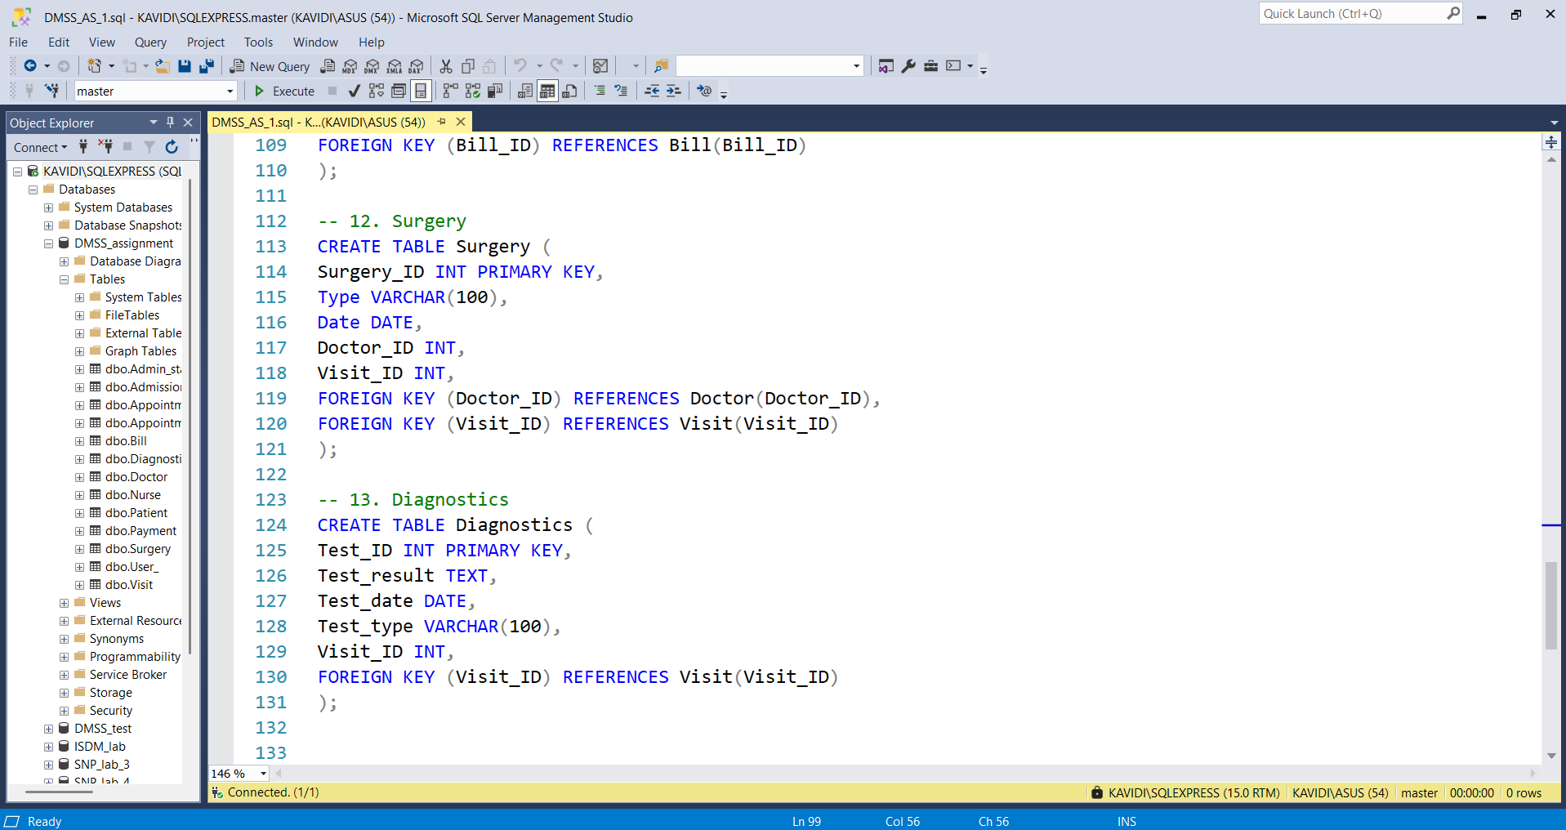

SQL code:

-- 1. User
CREATE TABLE User_ (
User_ID INT PRIMARY KEY,
Name VARCHAR(100),
Email VARCHAR(50),
Phone_Number VARCHAR(20)
);

-- 2. Patient (inherits User)
CREATE TABLE Patient (
Patient_ID INT PRIMARY KEY,
User_ID INT UNIQUE,
Medical_history TEXT,
Insurance_details TEXT,
FOREIGN KEY (User_ID) REFERENCES User_(User_ID)
);

-- 3. Doctor (inherits User)
CREATE TABLE Doctor (
Doctor_ID INT PRIMARY KEY,
User_ID INT UNIQUE,
Department VARCHAR(100),
Specialization VARCHAR(100),
FOREIGN KEY (User_ID) REFERENCES User_(User_ID)
);

-- 4. Nurse (inherits User)
CREATE TABLE Nurse (
Nurse_ID INT PRIMARY KEY,
User_ID INT UNIQUE,
Skills TEXT,
Shifts TEXT,
FOREIGN KEY (User_ID) REFERENCES User_(User_ID)
);

-- 5. Admin_staff (inherits User)
CREATE TABLE Admin_staff (
Staff_ID INT PRIMARY KEY,
User_ID INT UNIQUE,
Roles VARCHAR(100),
Office VARCHAR(100),
FOREIGN KEY (User_ID) REFERENCES User_(User_ID)
);

-- 6. Visit
CREATE TABLE Visit (
Visit_ID INT PRIMARY KEY,
Visit_date DATE,
Patient_ID INT,
Doctor_ID INT,
Department VARCHAR(100),
FOREIGN KEY (Patient_ID) REFERENCES Patient(Patient_ID),
FOREIGN KEY (Doctor_ID) REFERENCES Doctor(Doctor_ID)
);

-- 7. Admission
CREATE TABLE Admission (
Admission_ID INT PRIMARY KEY,
Admission_date DATE,
Ward VARCHAR(50),
Discharge_date DATE,
Bed_number VARCHAR(10),
Visit_ID INT UNIQUE,
FOREIGN KEY (Visit_ID) REFERENCES Visit(Visit_ID)
);

-- 8. Appointment
CREATE TABLE Appointment (
Appointment_ID INT PRIMARY KEY,
Date_and_time DATETIME,
Reason TEXT,
Patient_ID INT,
Doctor_ID INT,
Staff_ID INT,
FOREIGN KEY (Patient_ID) REFERENCES Patient(Patient_ID),
FOREIGN KEY (Doctor_ID) REFERENCES Doctor(Doctor_ID),
FOREIGN KEY (Staff_ID) REFERENCES Admin_staff(Staff_ID)
);

-- 9. Appointment_Nurse (Assists relationship)
CREATE TABLE Appointment_Nurse (
Nurse_ID INT,
Appointment_ID INT,
PRIMARY KEY (Nurse_ID, Appointment_ID),
FOREIGN KEY (Nurse_ID) REFERENCES Nurse(Nurse_ID),
FOREIGN KEY (Appointment_ID) REFERENCES Appointment(Appointment_ID)
);

-- 10. Bill
CREATE TABLE Bill (
Bill_ID INT PRIMARY KEY,
Amount DECIMAL(10,2),
Service_date DATE,
Service_type VARCHAR(100),
Patient_ID INT,
FOREIGN KEY (Patient_ID) REFERENCES Patient(Patient_ID)
);

-- 11. Payment
CREATE TABLE Payment (
Payment_ID INT PRIMARY KEY,
Payment_Date DATE,
Amount_paid DECIMAL(10,2),
Payment_method VARCHAR(50),
Bill_ID INT,
FOREIGN KEY (Bill_ID) REFERENCES Bill(Bill_ID)
);

-- 12. Surgery
CREATE TABLE Surgery (
Surgery_ID INT PRIMARY KEY,
Type VARCHAR(100),
Date DATE,
Doctor_ID INT,
Visit_ID INT,
FOREIGN KEY (Doctor_ID) REFERENCES Doctor(Doctor_ID),
FOREIGN KEY (Visit_ID) REFERENCES Visit(Visit_ID)
);

-- 13. Diagnostics
CREATE TABLE Diagnostics (
Test_ID INT PRIMARY KEY,
Test_result TEXT,
Test_date DATE,
Test_type VARCHAR(100),
Visit_ID INT,
FOREIGN KEY (Visit_ID) REFERENCES Visit(Visit_ID)
);

Insert data

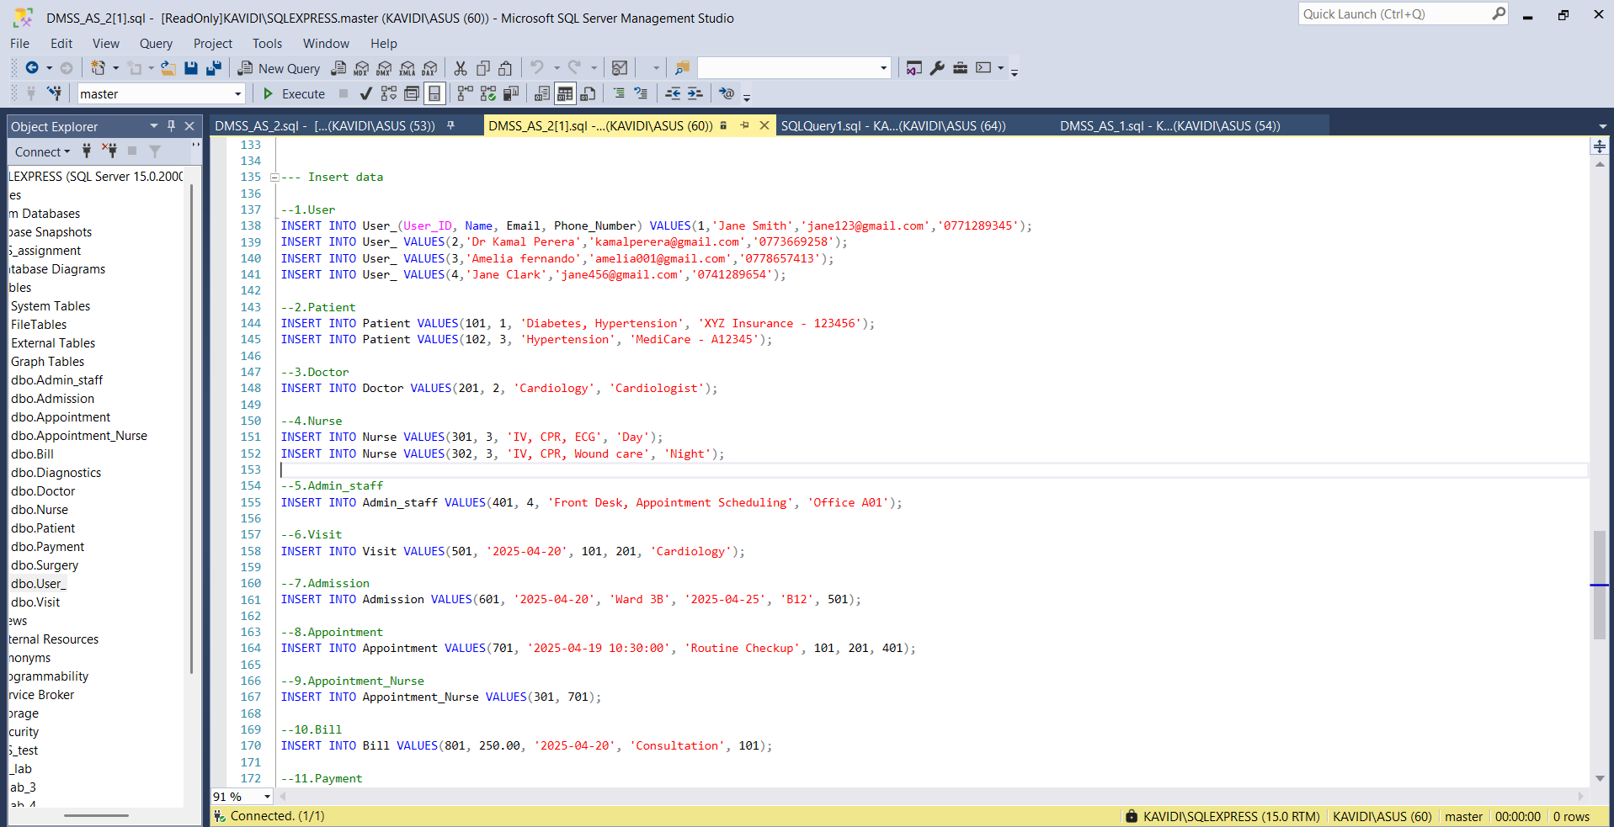
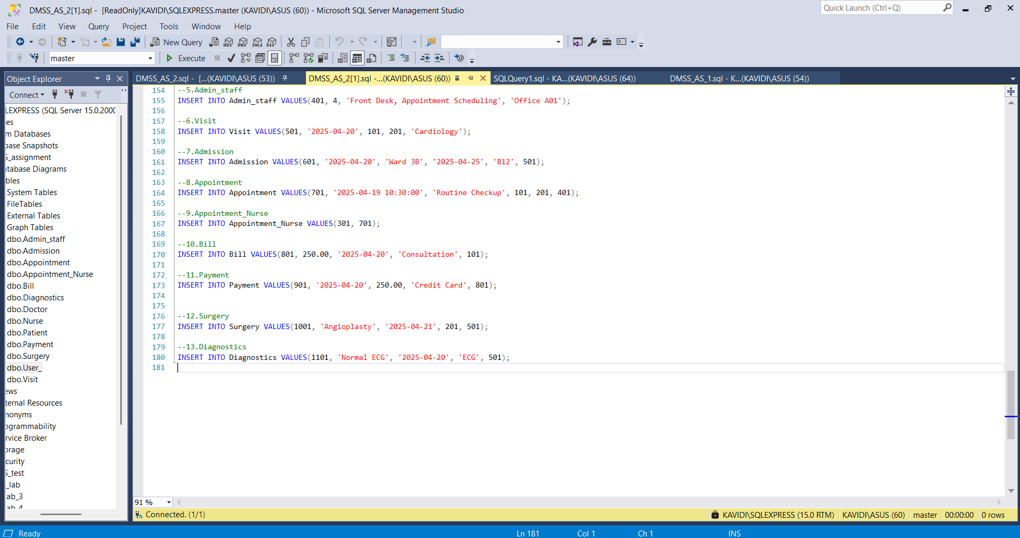
SQL code:

--1. User
INSERT INTO User_(User_ID, Name, Email, Phone_Number) VALUES(1,'Jane Smith’, ‘jane123@gmail.com','0771289345');
INSERT INTO User_ VALUES(2,'Dr Kamal Perera’, ‘kamalperera@gmail.com','0773669258');
INSERT INTO User_ VALUES(3,'Amelia fernando','amelia001@gmail.com','0778657413');
INSERT INTO User_ VALUES(4,'Jane Clark','jane456@gmail.com','0741289654');

--2.Patient
INSERT INTO Patient VALUES(101, 1, 'Diabetes, Hypertension', 'XYZ Insurance - 123456');
INSERT INTO Patient VALUES(102, 3, 'Hypertension', 'MediCare - A12345');

--3.Doctor
INSERT INTO Doctor VALUES(201, 2, 'Cardiology', 'Cardiologist');

--4.Nurse
INSERT INTO Nurse VALUES(301, 3, 'IV, CPR, ECG', 'Day');
INSERT INTO Nurse VALUES(302, 3, 'IV, CPR, Wound care', 'Night');

--5.Admin_staff
INSERT INTO Admin_staff VALUES(401, 4, 'Front Desk, Appointment Scheduling', 'Office A01');

--6.Visit
INSERT INTO Visit VALUES(501, '2025-04-20', 101, 201, 'Cardiology');

--7.Admission
INSERT INTO Admission VALUES(601, '2025-04-20', 'Ward 3B', '2025-04-25', 'B12', 501);

--8.Appointment
INSERT INTO Appointment VALUES(701, '2025-04-19 10:30:00', 'Routine Checkup', 101, 201, 401);

--9.Appointment_Nurse
INSERT INTO Appointment_Nurse VALUES(301, 701);

--10.Bill
INSERT INTO Bill VALUES(801, 250.00, '2025-04-20', 'Consultation', 101);

--11.Payment
INSERT INTO Payment VALUES(901, '2025-04-20', 250.00, 'Credit Card', 801);

--12.Surgery
INSERT INTO Surgery VALUES(1001, 'Angioplasty', '2025-04-21', 201, 501);

--13.Diagnostics
INSERT INTO Diagnostics VALUES(1101, 'Normal ECG', '2025-04-20', 'ECG', 501);

Triggers

Trigger Name: before_insert_appointment_check_doctor
Purpose:
This trigger prevents a doctor from being double-booked by blocking the insertion of a new appointment if the doctor already has an appointment at the same date and time.
How It Works (in SQL Server):
- INSTEAD OF INSERT: SQL Server doesn't support BEFORE INSERT, so we use INSTEAD OF INSERT.
- When a new appointment is inserted:
- The trigger checks the Appointment table to see if there’s already an appointment with the same Doctor_ID and Date_and_time.
- If a conflict exists, the trigger:
- Raises an error: 'Doctor is already booked at this time.'
- Rolls back the insertion.
- If there’s no conflict, the record is inserted as usual.

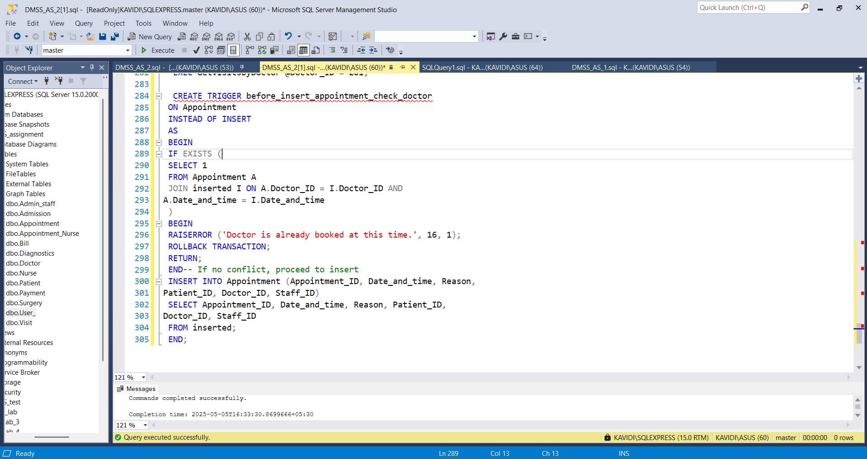

CREATE TRIGGER before_insert_appointment_check_doctor
ON Appointment
INSTEAD OF INSERT
AS
BEGIN
IF EXISTS (
SELECT 1
FROM Appointment A
JOIN inserted I ON A.Doctor_ID = I.Doctor_ID AND
A.Date_and_time = I.Date_and_time
)
BEGIN
RAISERROR ('Doctor is already booked at this time.', 16, 1);
ROLLBACK TRANSACTION;
RETURN;
END-- If no conflict, proceed to insert
INSERT INTO Appointment (Appointment_ID, Date_and_time, Reason,
Patient_ID, Doctor_ID, Staff_ID)
SELECT Appointment_ID, Date_and_time, Reason, Patient_ID,
Doctor_ID, Staff_ID
FROM inserted;
END;

AFTER DELETE Trigger
This trigger automatically cleans up related data (appointments and visits) after a patient is deleted, helping prevent orphan records and keeping your database consistent.
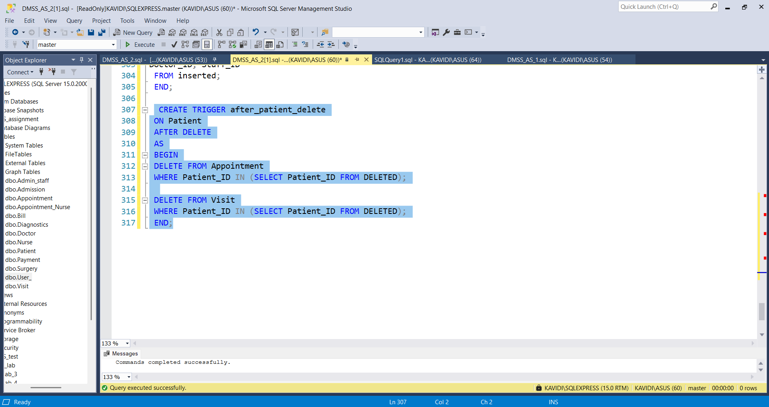

CREATE TRIGGER after_patient_delete
ON Patient
AFTER DELETE
AS
BEGIN
DELETE FROM Appointment
WHERE Patient_ID IN (SELECT Patient_ID FROM DELETED);

DELETE FROM Visit
WHERE Patient_ID IN (SELECT Patient_ID FROM DELETED);
END;

Views

View 1 – Doctors view
A doctor should be able to see:
- Their appointments with patients
- Visit details
- Any surgeries or diagnostic tests related to those visits
- Joins are used to combine doctor, appointment, and patient details.
- LEFT JOIN ensures that if there’s no surgery or diagnostic data, the appointment still shows.
- This view assumes that Visit, Surgery and Diagnostics are considered part of ‘treatment details’.
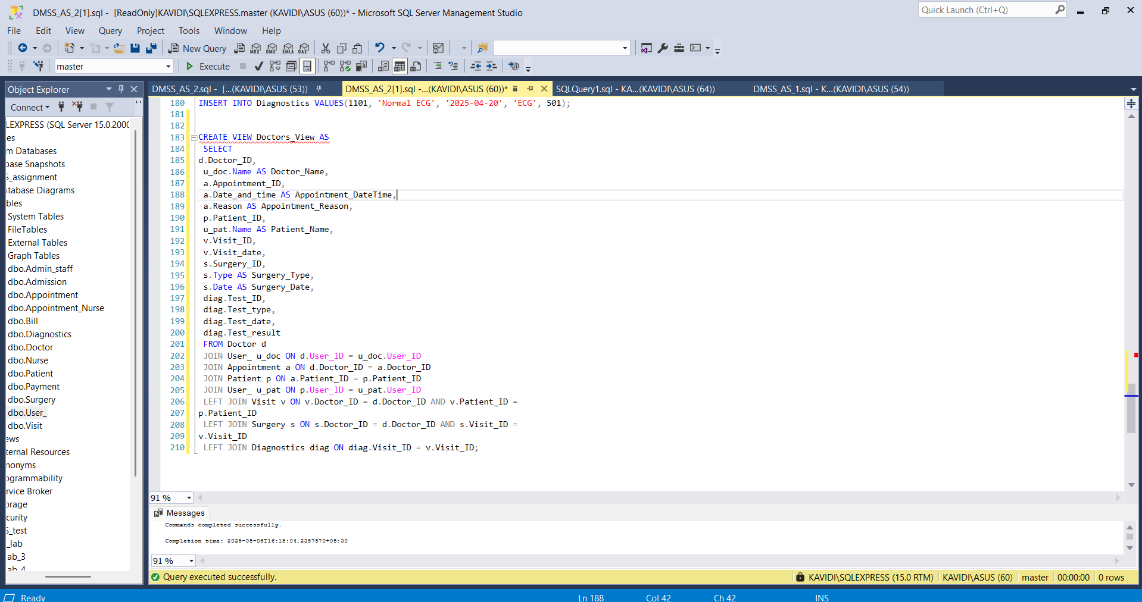
CREATE VIEW Doctors_View AS
SELECT
d.Doctor_ID,
u_doc.Name AS Doctor_Name,
a.Appointment_ID,
a.Date_and_time AS Appointment_DateTime,
a.Reason AS Appointment_Reason,
p.Patient_ID,
u_pat.Name AS Patient_Name,
v.Visit_ID,
v.Visit_date,
s.Surgery_ID,
s.Type AS Surgery_Type,
s.Date AS Surgery_Date,
diag.Test_ID,
diag.Test_type,
diag.Test_date,
diag.Test_result
FROM Doctor d
JOIN User_ u_doc ON d.User_ID = u_doc.User_ID
JOIN Appointment a ON d.Doctor_ID = a.Doctor_ID
JOIN Patient p ON a.Patient_ID = p.Patient_ID
JOIN User_ u_pat ON p.User_ID = u_pat.User_ID
LEFT JOIN Visit v ON v.Doctor_ID = d.Doctor_ID AND v.Patient_ID =
p.Patient_ID
LEFT JOIN Surgery s ON s.Doctor_ID = d.Doctor_ID AND s.Visit_ID =
v.Visit_ID
LEFT JOIN Diagnostics diag ON diag.Visit_ID = v.Visit_ID;

View 2 – Admin Staff View
Admin staff should see:
- Appointment schedules (with patient and doctor names)
- Admission details (with patient info)
- Appointment schedule includes date, reason, doctor, and patient names.
- Admission details (joined via Visit_ID) include ward, bed, and discharge info.
- LEFT JOIN is used for Admission to ensure all appointments are shown even if there's no admission.

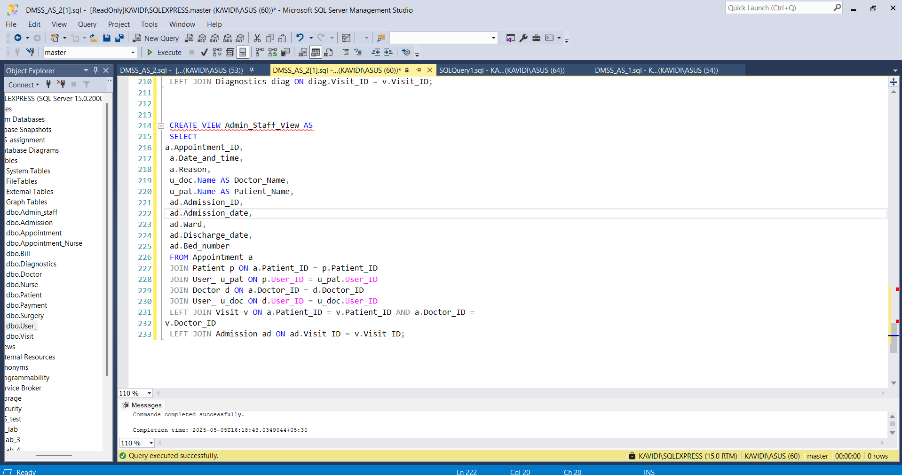

CREATE VIEW Admin_Staff_View AS
SELECT
a.Appointment_ID,
a.Date_and_time,
a.Reason,
u_doc.Name AS Doctor_Name,
u_pat.Name AS Patient_Name,
ad.Admission_ID,
ad.Admission_date,
ad.Ward,
ad.Discharge_date,
ad.Bed_number
FROM Appointment a
JOIN Patient p ON a.Patient_ID = p.Patient_ID
JOIN User_ u_pat ON p.User_ID = u_pat.User_ID
JOIN Doctor d ON a.Doctor_ID = d.Doctor_ID
JOIN User_ u_doc ON d.User_ID = u_doc.User_ID
LEFT JOIN Visit v ON a.Patient_ID = v.Patient_ID AND a.Doctor_ID =
v.Doctor_ID
LEFT JOIN Admission ad ON ad.Visit_ID = v.Visit_ID;

Indexes

Query 1: Appointments for a Given Patient in a Time Period

Why it’s needed:
- Doctors, nurses, or admin staff often need to check a patient’s recent visit history.
- Example: A doctor wants to review all past appointments from March to May for Patient 102.
- Useful for treatment planning, billing, or checkups
This means we need to filter by:
- Patient_ID
- Date_and_Time

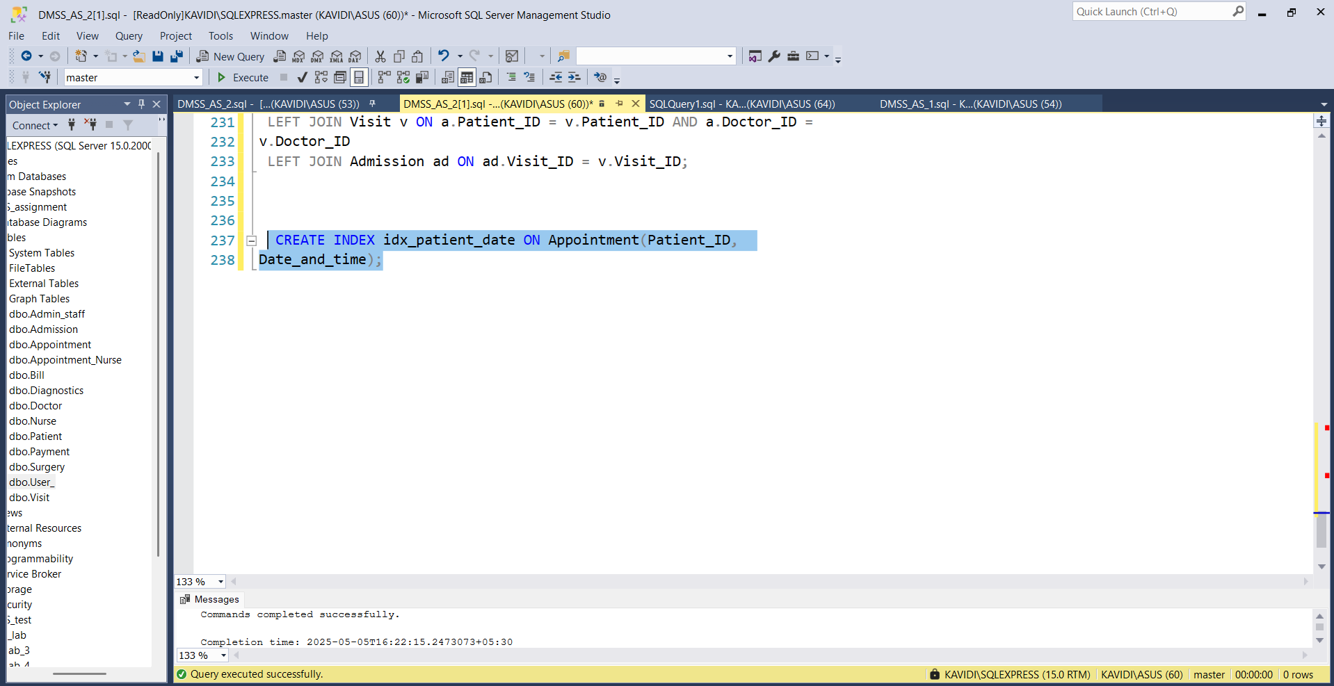
CREATE INDEX idx_patient_date ON Appointment(Patient_ID,
Date_and_time);

Query 2:
Why it’s needed:
- Patients or billing staff may want to see all the charges a patient has received.
- Example: A patient calls and asks: “Can I get a summary of all my bills?”
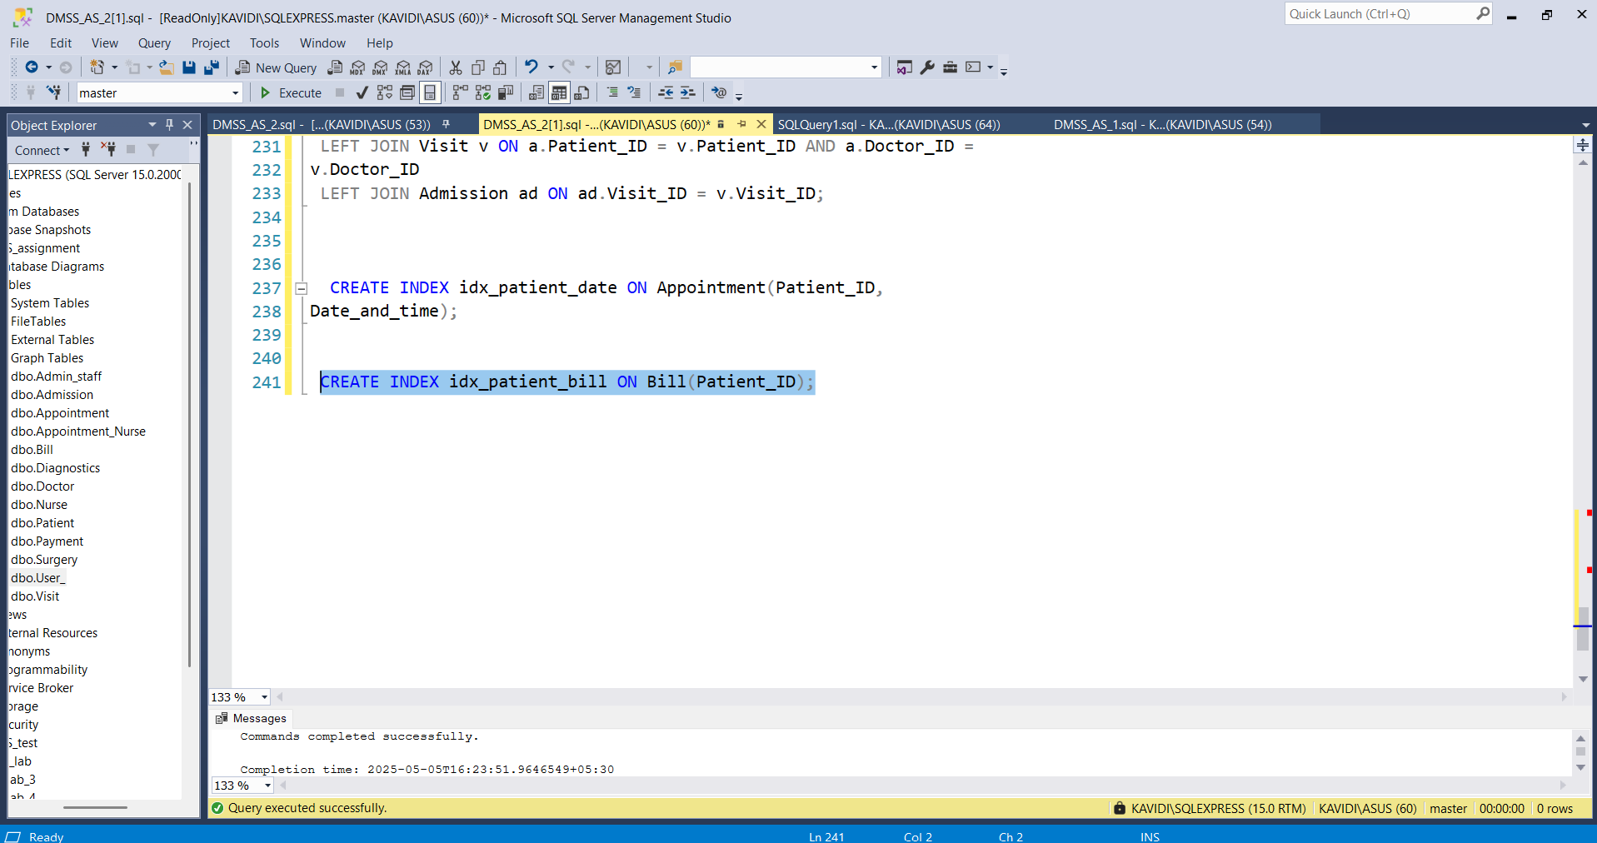

CREATE INDEX idx_patient_bill ON Bill(Patient_ID);

Procedures

Procedure 1: Appointments for a Given Patient in a Period

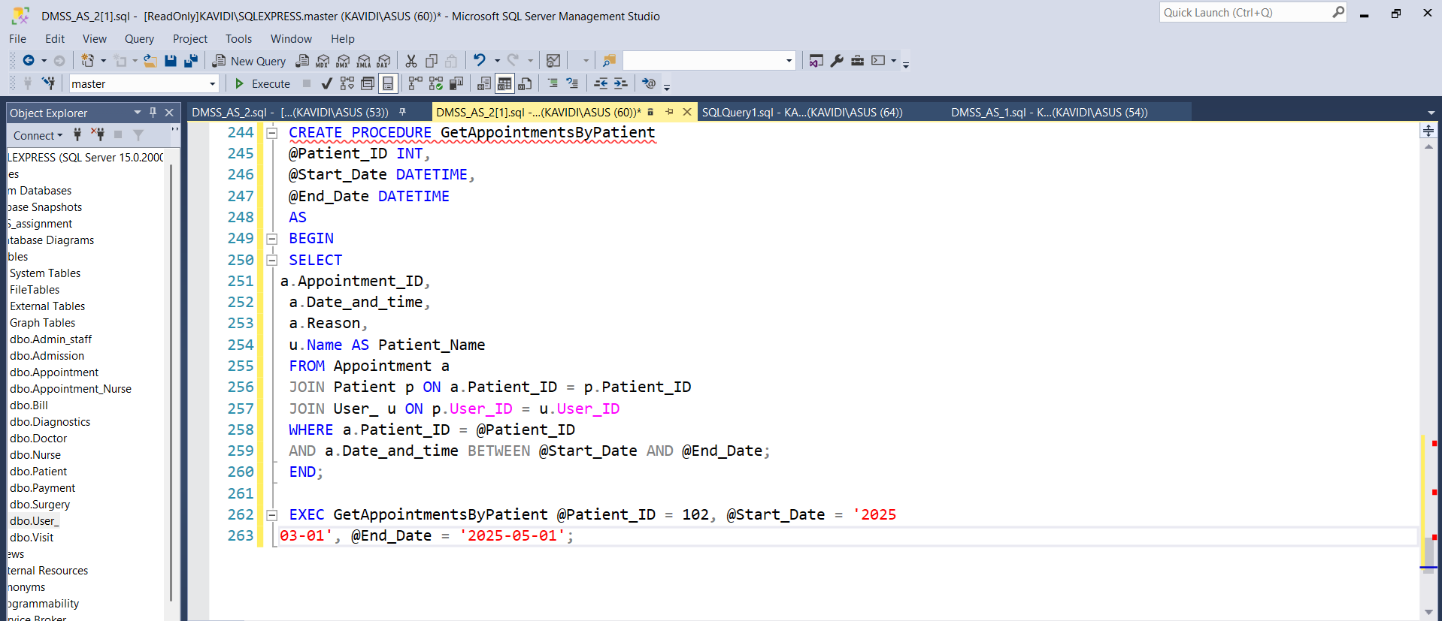

CREATE PROCEDURE GetAppointmentsByPatient
@Patient_ID INT,
@Start_Date DATETIME,
@End_Date DATETIME
AS
BEGIN
SELECT
a.Appointment_ID,
a.Date_and_time,
a.Reason,
u.Name AS Patient_Name
FROM Appointment a
JOIN Patient p ON a.Patient_ID = p.Patient_ID
JOIN User_ u ON p.User_ID = u.User_ID
WHERE a.Patient_ID = @Patient_ID
AND a.Date_and_time BETWEEN @Start_Date AND @End_Date;
END;

call it in SQL Server:

EXEC GetAppointmentsByPatient @Patient_ID = 102, @Start_Date = '2025
03-01', @End_Date = '2025-05-01';

Procedure 2: GetVisitsByDoctor

Purpose:
Show a list of all patient visits for a given doctor. This includes
- Visit ID
- Visit date
- Patient name
- Department
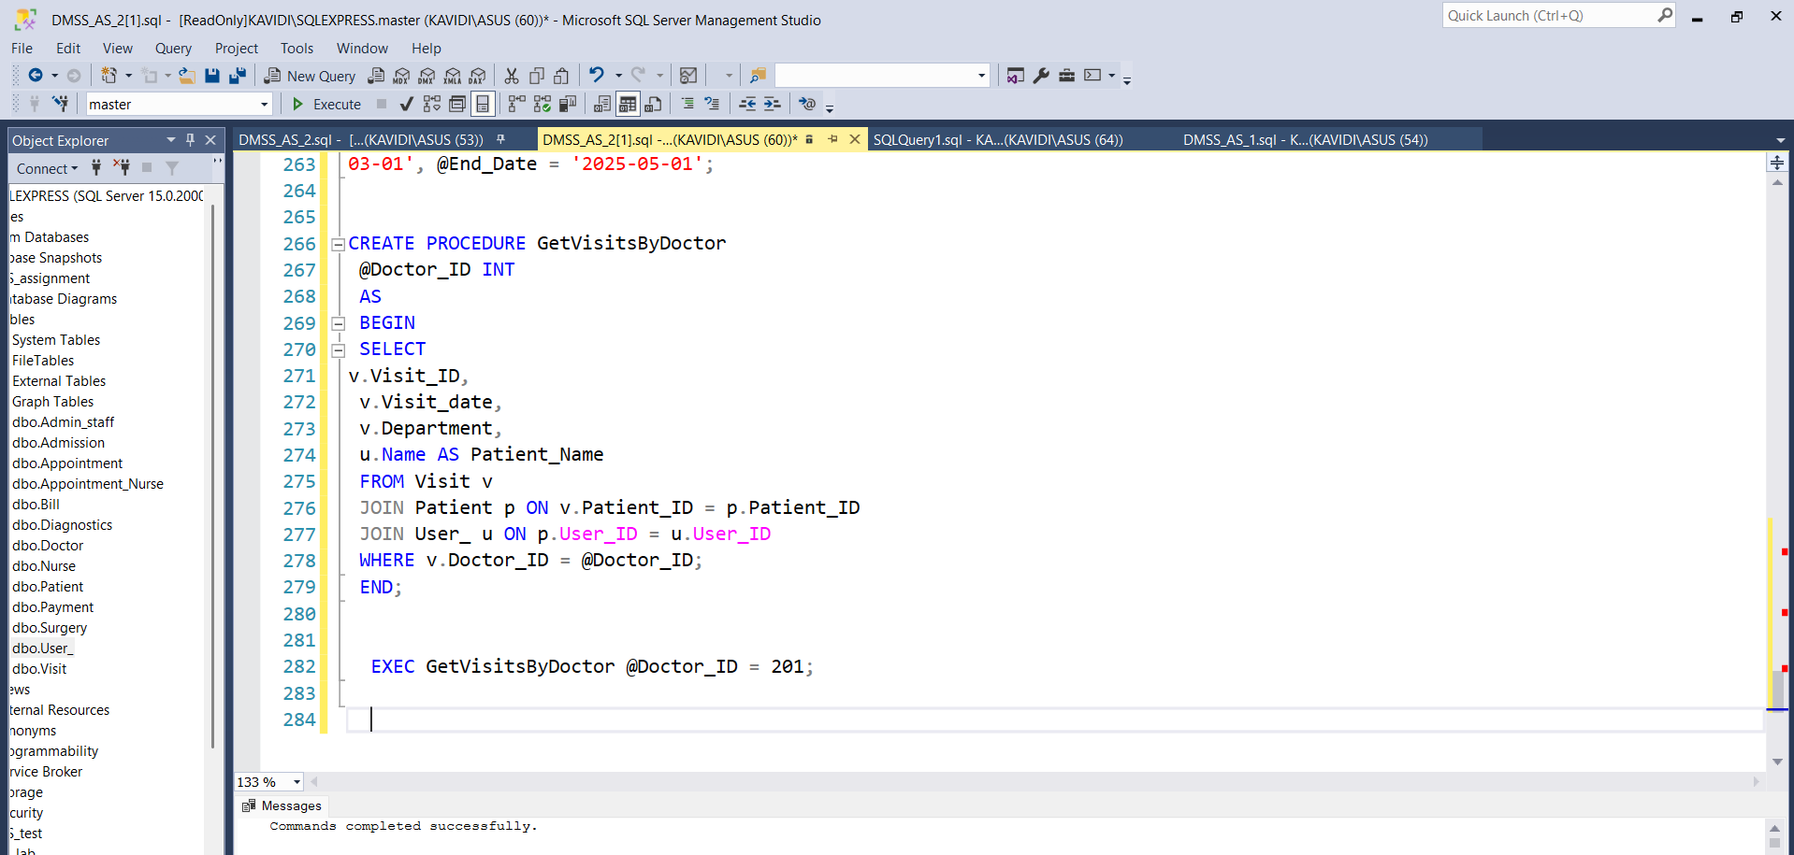
CREATE PROCEDURE GetVisitsByDoctor
@Doctor_ID INT
AS
BEGIN
SELECT
v.Visit_ID,
v.Visit_date,
v.Department,
u.Name AS Patient_Name
FROM Visit v
JOIN Patient p ON v.Patient_ID = p.Patient_ID
JOIN User_ u ON p.User_ID = u.User_ID
WHERE v.Doctor_ID = @Doctor_ID;
END;

EXEC GetVisitsByDoctor @Doctor_ID = 201;

Part 2

Database vulnerabilities:

Database Misconfiguration

Database misconfiguration is a severe danger that emerges because the database system is not properly or securely configured. Some of the most common misconfigurations include the use of default configurations, inadequate access control, unpatched software vulnerabilities, and running unnecessary services. Misconfigurations of this kind are often forgotten; however, they can lead to a situation where an attacker can break through the system and reach the network illegally without much difficulty.
How it works:
This vulnerability occurs mainly when the database is being installed or maintained. The reason is that the database is not updated, management interfaces are visible on the public network unintentionally, and administrators do not close the inactive ports and services. For example, when the default username "admin" and password "admin123" are set for the database, any attacker can log in without any requirement of complex hacking tools.
While talking about cloud computing, some of the most common misconfigurations are the exposure of database ports or the presence of storage buckets that are open to the public, which makes it available for unauthorized users to download and view sensitive data. Some other forms of misconfiguration lie in the realm of permission settings which are inadequate, such as providing users with more privileges than they need (e.g., offering read/write permissions when read-only privileges would have been enough).
Impacts on systems:
- Unauthorized Access: An assailant who is not identified or authenticated can log into the database.
- Data Exposure: There is a possibility that criminals can lay hands on personal information, the password, and the transaction records of the user which is confidential material.
- Operational Disruption: By modifying or deleting the data, hackers can cause downtime and the data to be corrupted.
- Legal Consequences: Should standards compliance such as GDPR or HIPAA be found wanting because of the user's data, the organization may face severe legal sanctions.
Strategies for mitigation:
- Modify Default Settings: Replace all the default access levels, usernames, and passwords immediately.
- Access Control: Allow users to have the least privileges through role-based access control RBAC.
- Network Controls: It is important that the database is not exposed to the general internet and a firewall, or a VPN protects the database.
- Security Enhancements: Regularly update the database software and the elements below by installing patches and updates.
- Configuration Audits: Running scans to identify and moderate insecure settings or policies done at regular intervals

Insecure Data Storage

Insecure data storage is one of the critical security issues that arise when personal data, e.g., passwords, credit card numbers, or the like, are stored in an inappropriate way. As a rule, it is plain text data, weak encryption that is Hashing), or not having access control in place as in the root causes. These vulnerabilities are what the hackers need and take advantage of to gain access to the information, modify them, or use them in malicious activities
How it works:
In situations where data is kept in un-hashed or unencrypted format, the users who have unauthorized access to the database can read it in its original format. For instance, if user passwords are kept in plain text rather than in encrypted format by using hashing algorithms such as bcrypt, a compromised database would end up leaking all user credentials instantly.
Another form of insecure storage is improper key management—where encryption keys are stored in the same location as the encrypted data. This defeats the purpose of encryption and gives attackers everything they need to decrypt sensitive data. Another indication of poor storage practices is the mismanagement of keys—marked by the storage of encryption keys within the same proximity as the associated encrypted data. This defeats the very purpose of encryption and provides adversaries with all necessary tools to decrypt sensitive data.)
Furthermore, the absence of strict permissions means that unauthorized users within the system can view and alter vital information, leading to internal data breaches or tampering.
Impact on systems:
- Data Breach: Hackers can steal private user information and use it for blackmailing or fraud.
- Identity theft occurs when exposed credentials and personal data facilitate impersonation, potentially resulting in significant financial detriment.
- Regulatory Non-Compliance: Not adequately protecting data can result in breaches of data protection legislation.
- Loss of User Trust: Users may lose faith in the system and move to competitors.
Strategies for mitigation:
- Data Encryption: Encrypt all sensitive data at rest using robust algorithms (e.g., AES256.
- Secure Password Storage: Store passwords of users with the help of hashing algorithms like bcrypt or Argon2.
- Access Restrictions: Implement fine-grained access control so that only legitimate users are granted access to sensitive fields.
- Key Management: Maintain secure and isolated key management systems for storing encryption keys.
- Security Testing: Perform regular security audits and reviews to verify the effectiveness of data protection controls

