ASSIGNMENT -1
1) Number Classification (if + function)
Write a shell script that uses a function to check whether a number is positive, negative, or zero using if.

echo -n "Enter a number: "
read number
if [ $number -gt 0 ]; then
echo "$number is Positive"
elif [ $number -lt 0 ]; then
echo "$number is Negative"
else
echo "$number is Zero"
fi
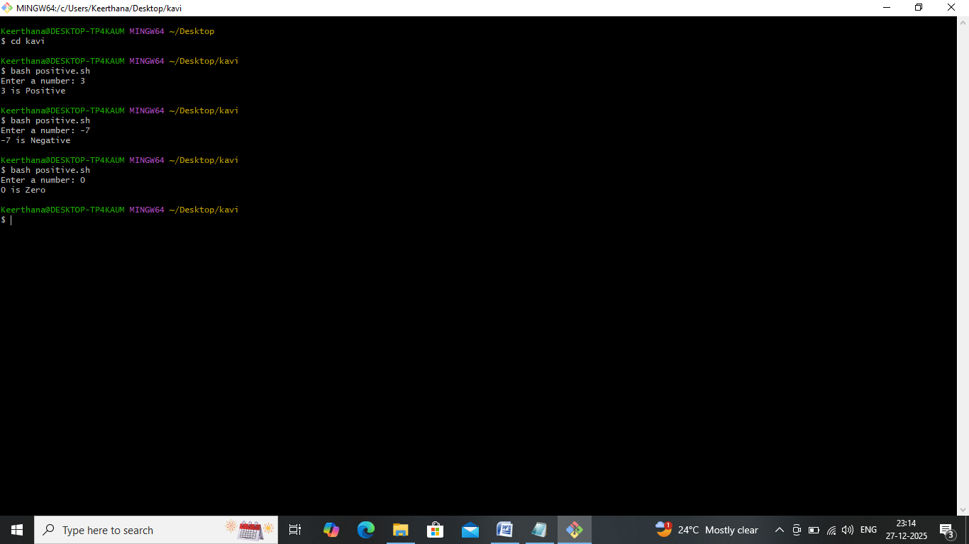
2)Factorial of a Number (while + function)
Write a shell script to calculate the factorial of a number using a while loop inside a function.

echo -n "Enter a number: "
read number
fact=1
i=$number
while [ $i -gt 1 ]
do
fact=$((fact * i))
i=$((i - 1))
done
echo "Factorial of $number is: $fact"
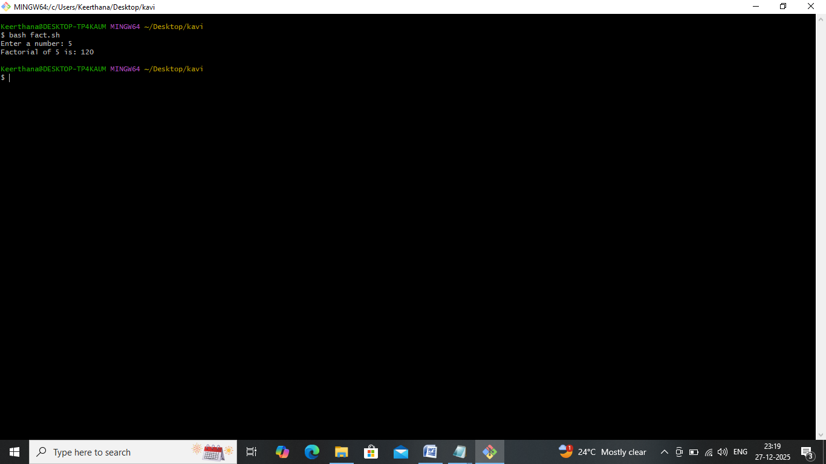

3)Sum of N Numbers (for + function)
Write a shell script to calculate the sum of numbers from 1 to N using a for loop inside a function.

echo -n "Enter the value of N: "
read n
sum=0
for (( i=1; i<=n; i++ ))
do
sum=$((sum + i))
done
echo "Sum of numbers from 1 to $n is: $sum"
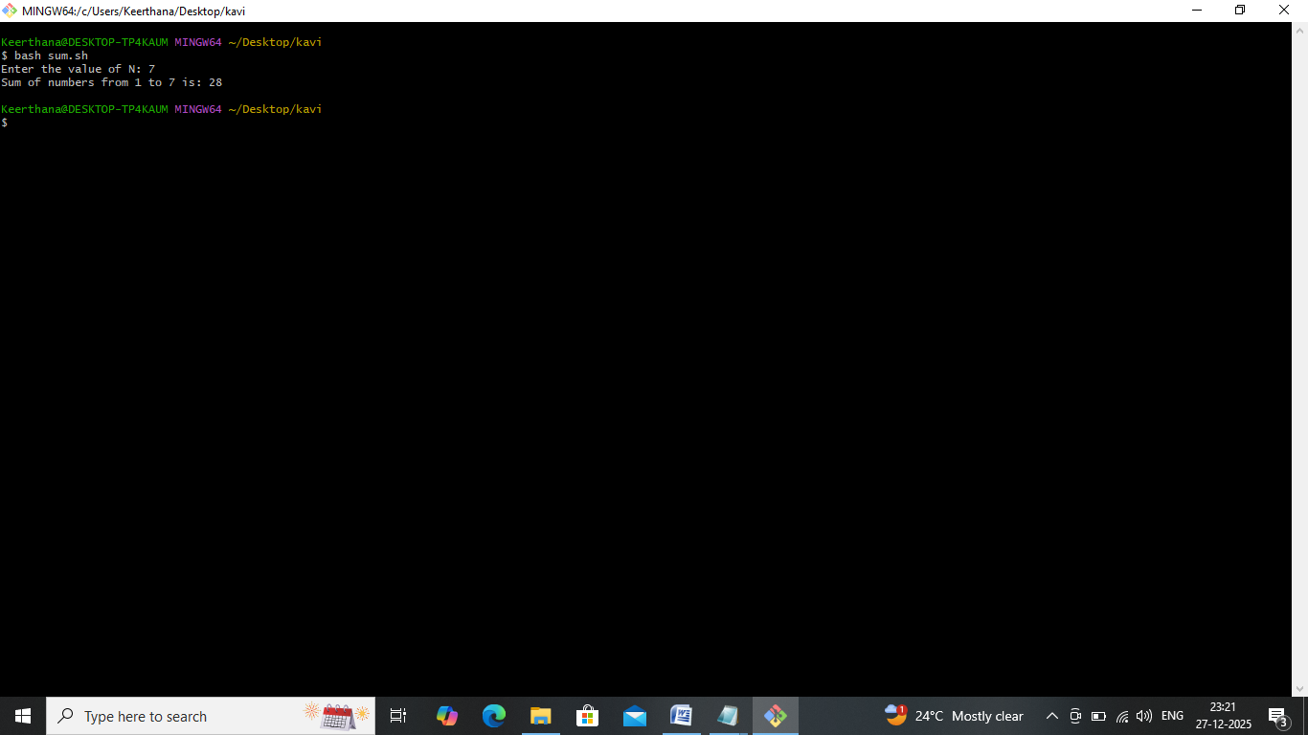

4)Prime Number Check (if + for + function)
Write a shell script that uses a function to check whether a given number is prime using if and for.

echo -n "Enter a number: "
read num
if [ $num -le 1 ]; then
echo "$num is not a prime number"
exit 0
fi
is_prime=1
for (( i=2; i<=num/2; i++ ))
do
if [ $((num % i)) -eq 0 ]; then
is_prime=0
break
fi
done
if [ $is_prime -eq 1 ]; then
echo "$num is a prime number"
else
echo "$num is not a prime number"
fi
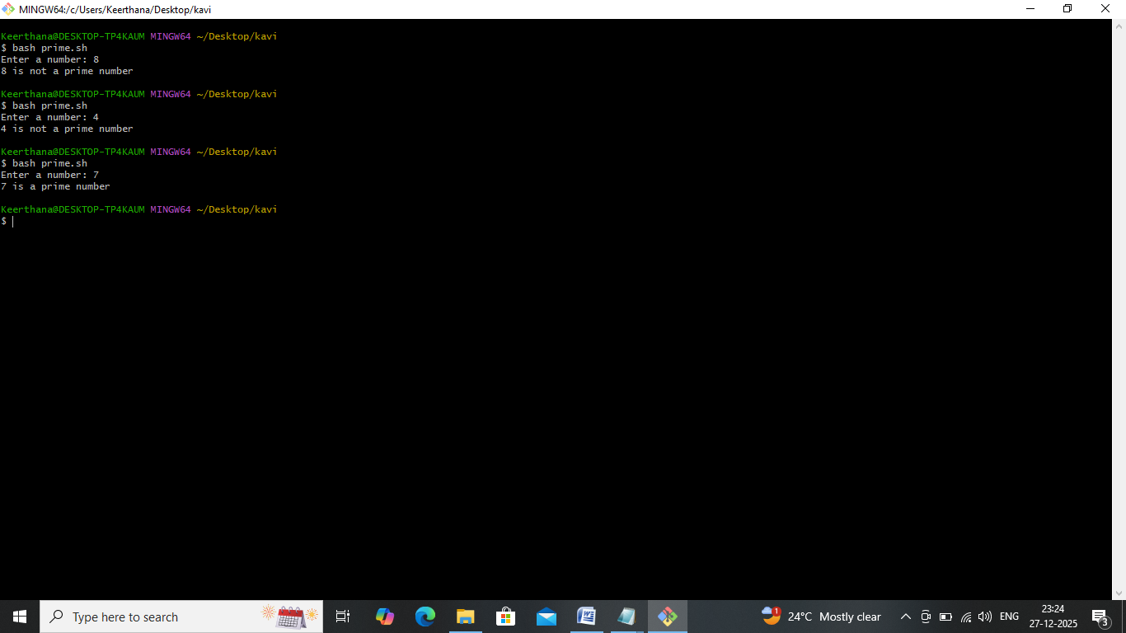

5)Reverse a Number (while + if)
Write a shell script to reverse a number using a while loop and if conditions where required.

echo -n "Enter a number: "
read num
rev=0
temp=$num
while [ $temp -ne 0 ]
do
digit=$((temp % 10))
rev=$((rev * 10 + digit))
temp=$((temp / 10))
done

if [ $num -lt 0 ]; then
# For negative numbers, make reversed also negative
rev=$((rev * -1))
fi
echo "Reverse of $num is: $rev"

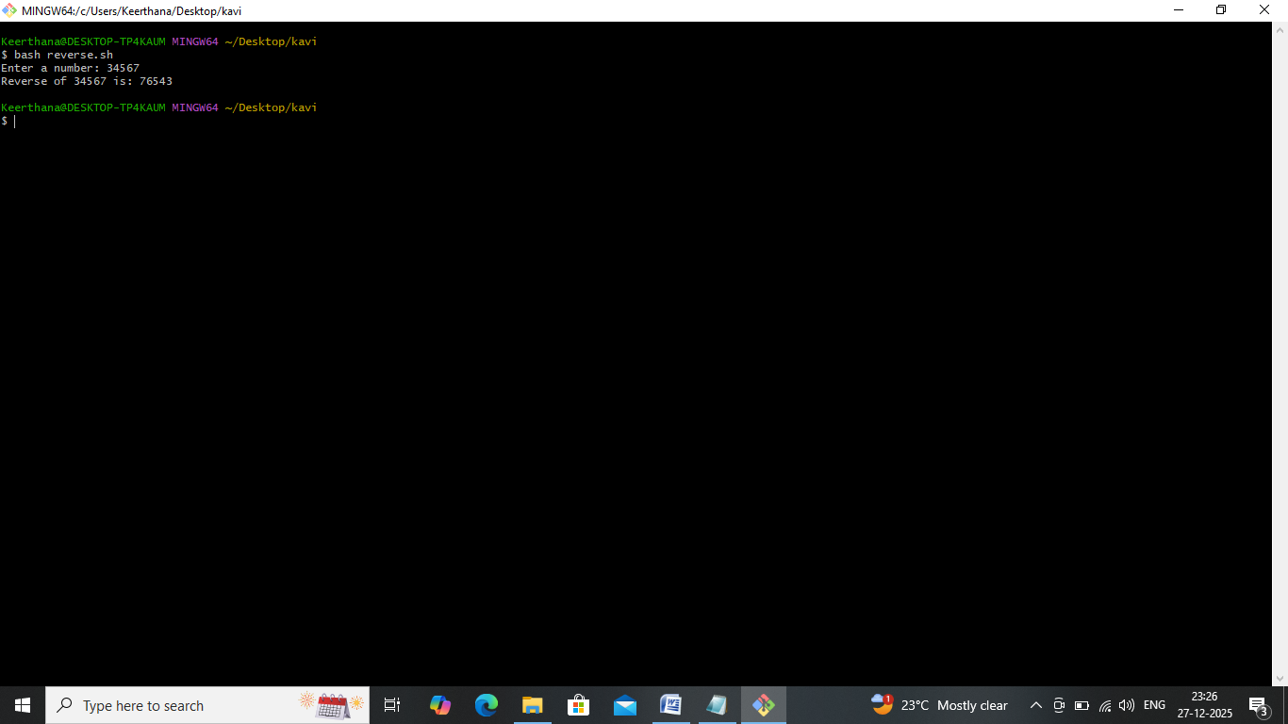

6) File Existence & Permission Check (if + function)
Write a shell script that uses a function to check if a file exists and whether it has read, write, and execute permissions.

check_file() {
file=$1

if [ -e "$file" ]; then
echo "File '$file' exists."
if [ -r "$file" ]; then
echo "File has read permission."
else
echo "❌ File does not have read permission."
fi
if [ -w "$file" ]; then
echo "File has write permission."
else
echo "File does not have write permission."
fi
if [ -x "$file" ]; then
echo "File has execute permission."
else
echo "File does not have execute permission."
fi
else
echo "File '$file' does not exist."
fi
}
echo -n "Enter the file name: "
read filename
check_file "$filename"
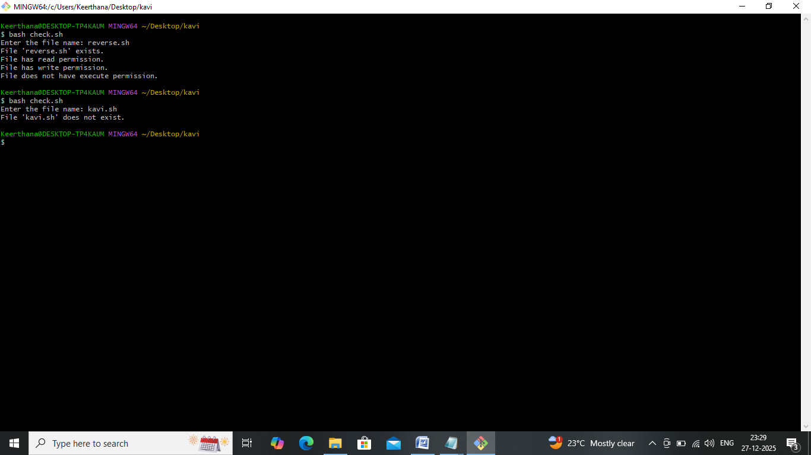

7)Menu-Driven Calculator (while + case + function)
Write a shell script that shows a menu in a while loop and performs add, subtract, multiply, divide using functions.

while true
do
echo "====== Menu Driven Calculator ======"
echo "1. Addition"
echo "2. Subtraction"
echo "3. Multiplication"
echo "4. Division"
echo "5. Exit"
echo -n "Enter your choice: "
read choice
case $choice in
1)
echo -n "Enter first number: "
read a
echo -n "Enter second number: "
read b
result=$((a + b))
echo "Result: $a + $b = $result"
;;
2)
echo -n "Enter first number: "
read a
echo -n "Enter second number: "
read b
result=$((a - b))
echo "Result: $a - $b = $result"
;;
3)
echo -n "Enter first number: "
read a
echo -n "Enter second number: "
read b
result=$((a * b))
echo "Result: $a * $b = $result"
;;
4)
echo -n "Enter first number: "
read a
echo -n "Enter second number: "
read b
if [ $b -ne 0 ]; then
result=$((a / b))
echo "Result: $a / $b = $result"
else
echo "Error: Division by zero is not allowed!"
fi
;;
5)
echo "Exiting Calculator. Goodbye!"
break
;;
*)
echo "Invalid choice. Please try again."
;;
esac
echo ""
done

