**Wearable activity device/Fitness band**

**Kavitha Ramakrishnan**

“We *shape our buildings:*

*Thereafter they shape us”*

Winston Churchill

I am choosing wearable activity tracker because personally I use this device since 2018 and I can connected to this technology and society with various kinds, I brought it for my fitness purposes, I thought it will increase my physical activity, and it does change on my physical activity and motivate to do more day by day even I thought it is more fancy and give me a luxuries look, and it track my footsteps, track my sleep like how much I sleep deep as well as normal sleep even my heart beat, it also sync those data to my mobile and show the details so that’s it. Apart from that I never thought about social connection and shaping technology and technology shape the users and all. But after this class I can explore more about why this device (Wearable activity tracker) looks like the way it is look. Even I thought what the things that make this technology more popular among people. Even I can assimilate the picture of this device.

I like to share about the history of Wearable activity tracker, in the year 1975 the first calculator-Watch called ‘Pulsar’ were invented [1] and this a baby for all we got right now

Figure 1 [1] (credits: History (twitter page)

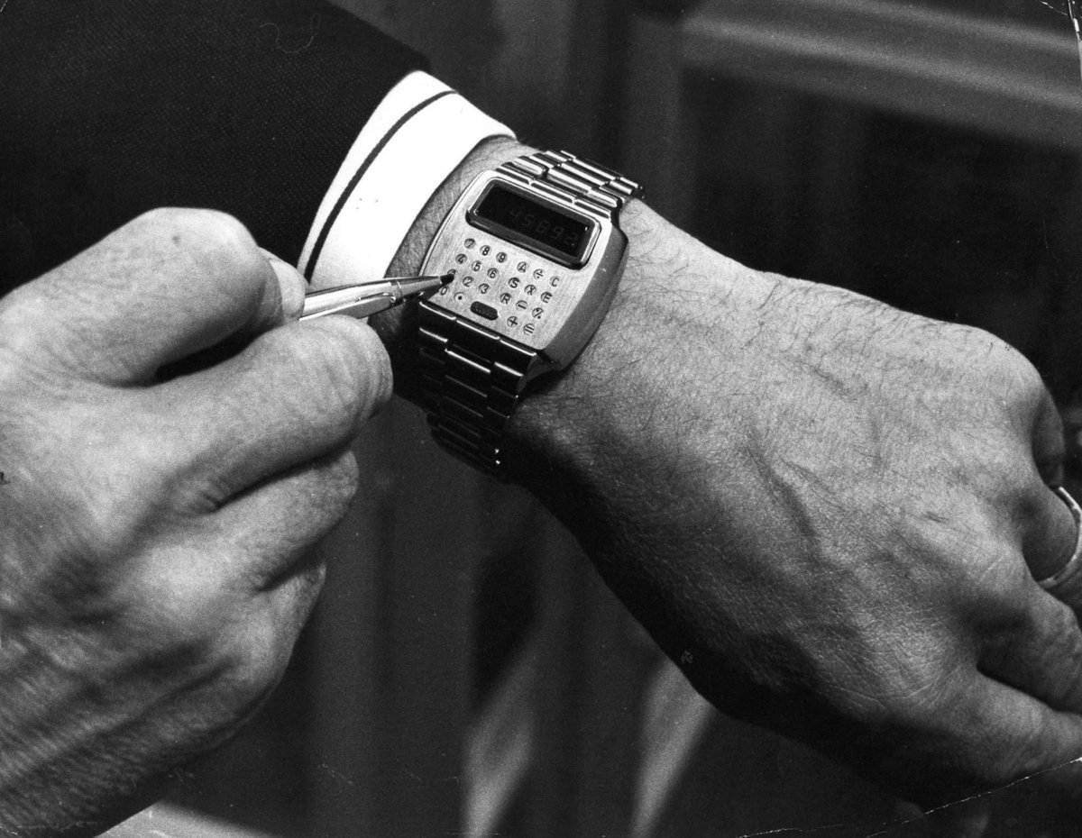

After that Sony Walkman arrived and then the first digital hearing aids were first released [2]. The Walkman was a portable cassette player with chunky buttons, headphones and a leather case [3].

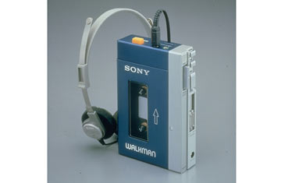

Figure 2. Sony Walkman [3]

Fitbit is a first product came to the market and still is on top of the list. Initially I thought about buying the device but I went with MI because of the cost. I have seen the Fitbit device change quite a bit over the years. Earlier the designs focused more on functionality. But now, I feel like the design decisions are based more on aesthetics than function. Color variants, strap designs and dials have taken place of accuracy of data, frequency of measurement and other such technical factors which used to be the major concern when WADs originally came into the market. Before this class, it might have been difficult to pin-point what brought about these changes in inputs to the WAD design. But now, I understand that these changes are motivated by several social factors. The social construction of technology theory provides a basis for me to be able to explain these social factors, at least partially. In a few stages, the WAD appears, gets accommodated with some design change, adopted and then completely accepted up to the point where the next technical change pushes the device back into this cycle. The relevant social groups effecting this change……….

But there is a limitations that I didn’t know that what are the limitations by the relevant social groups, from users that use the device and producers which are back bone of the value chain and raw material makers, those who made a raw material for the device and people who market the device. However, I can’t find who is pushing this technology more to shape. That is, I’m unsure of how much a relevant social group is able to refine a technology compared to other relevant social groups. This seems like a question scot is not fully able to answer.

Initially, I used to wear the MI device a lot and perform fitness activities, and it make more changes in my health behavior and it was keep motivate me to do more and more, I can say that this wearable activity device make me to do the proper way of exercising and make me more disciplined in every work I do after that.

Now days I drop the idea of use as a fitness band because of my academics but I can ensure to myself that if I can do the physical activity again with a same motivation that I have initially. So here I can connect the technology determinism theory to my usage of a WAD. I feel like this technology has changed my lifestyle in some form.

Looking at both the above aspects, I feel that the social factors influencing technology have not really worked in isolation. Technological determinism also play a role in evolution of the WAD design because they have used motivation techniques in their newer versions to encourage physical activity and even get motivated by looking at peers.

Reference:

1. First Calculator-watch “pulsar” (2018)

<https://twitter.com/history/status/979825867273752578>

1. Grace College, (2016) *“ Rapid Growth: The Past, Present and Future of Wearable Technology”*

<https://online.grace.edu/news/business/the-past-present-future-of-wearable-technology/>

1. Haire M (2009), *“A Brief History of the Walkman”* http://content.time.com/time/nation/article/0,8599,1907884,00.html