Customer Prioritization Scoring Framework

1. Business Objective
Design and develop a Data Science and Machine Learning–based customer prioritization framework to identify and rank customers with the highest potential for wallet expansion, retention, and margin improvement.

2. Data Understanding
The solution will leverage customer master data, historical sales performance, quotation patterns, payment behaviour, and service interactions to engineer relevant customer-level features, identify meaningful behavioural patterns, and develop data-driven customer segments and opportunity/risk scores.

2.1 Data Lineage
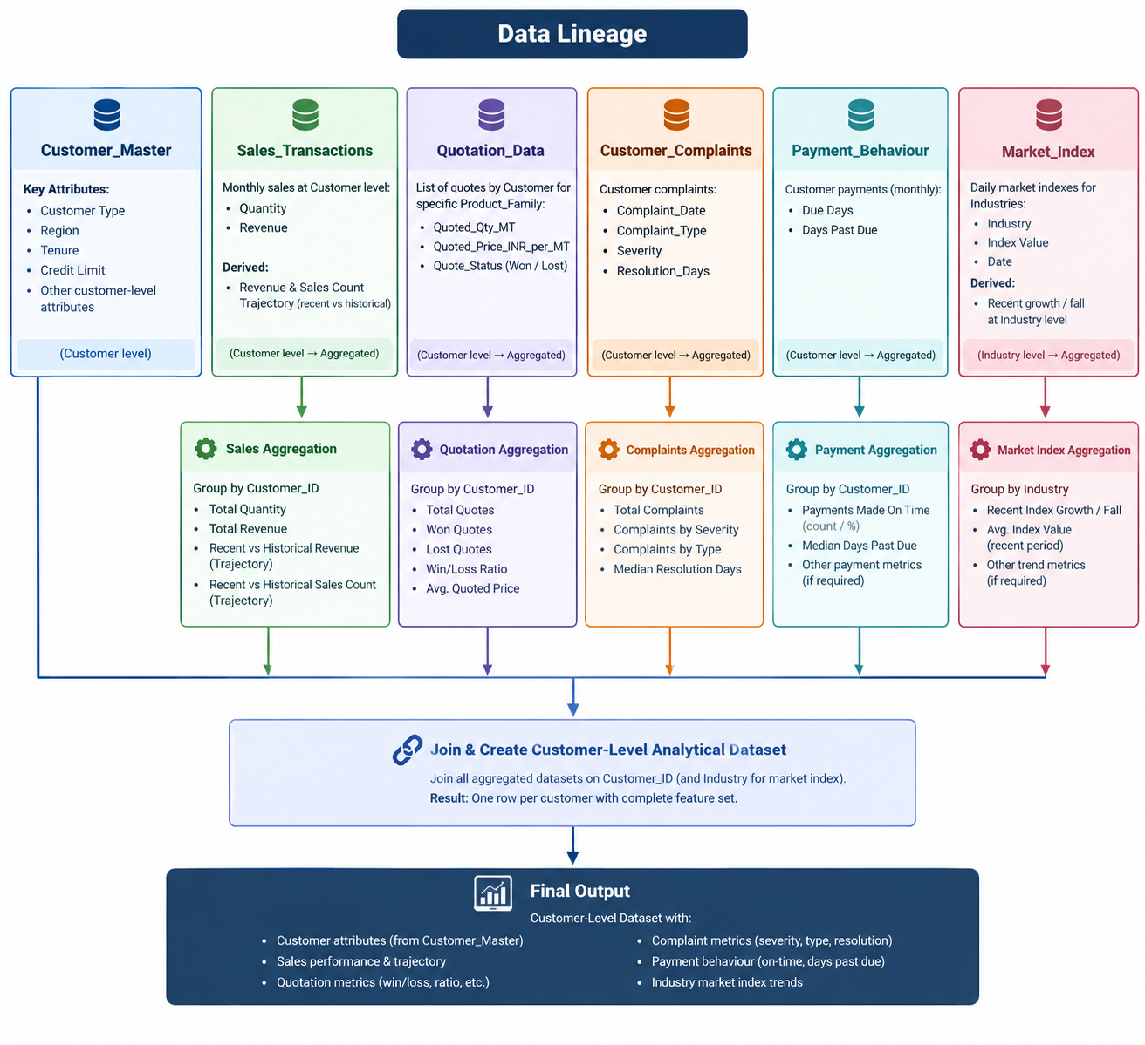

3. Exploratory Data Analysis
- Missing Data Summary – There are no missing values observed in all the datasets, including Quotations data where reason codes are available for all ‘Lost’ Quotations

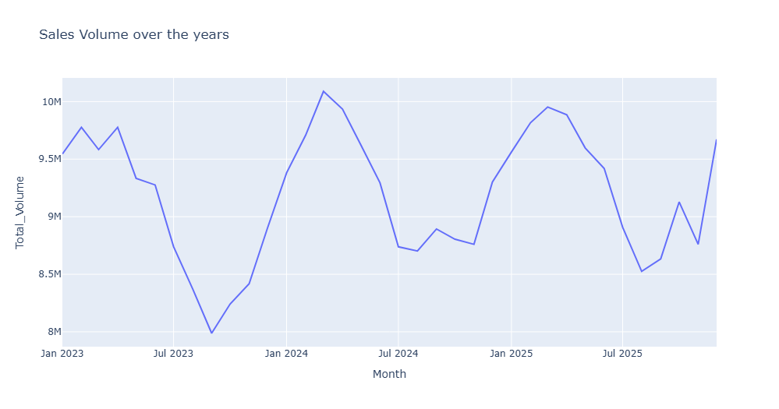
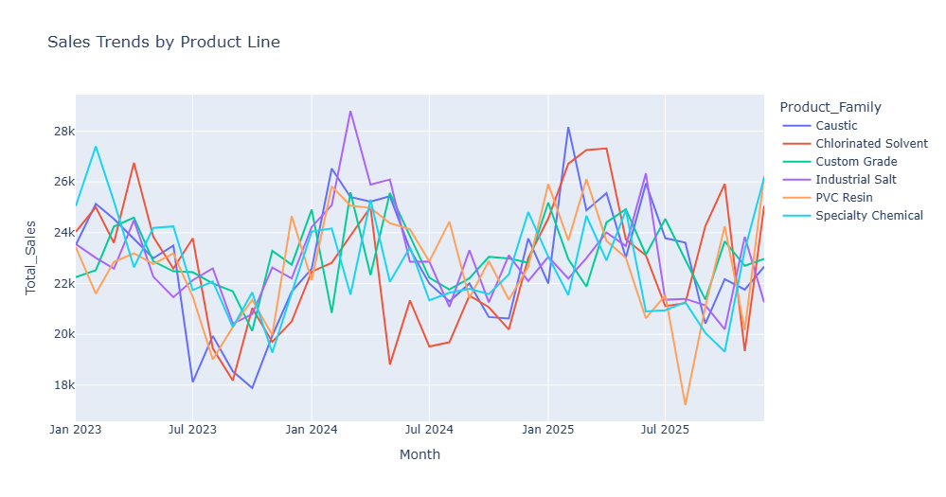
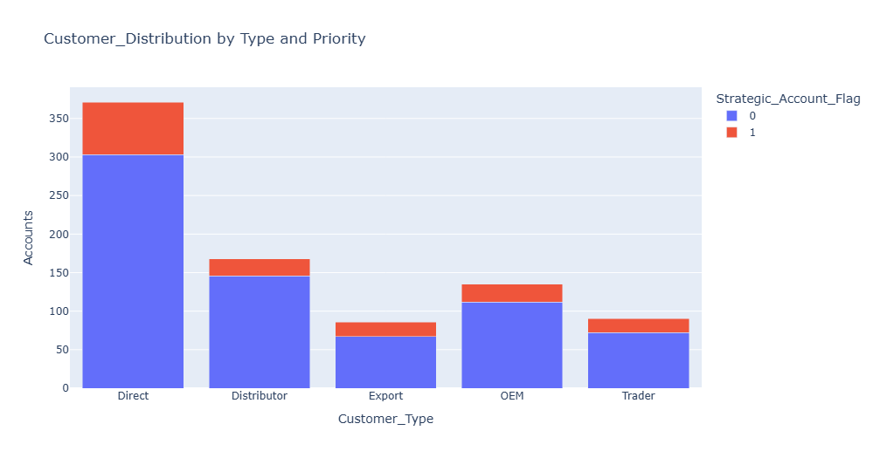

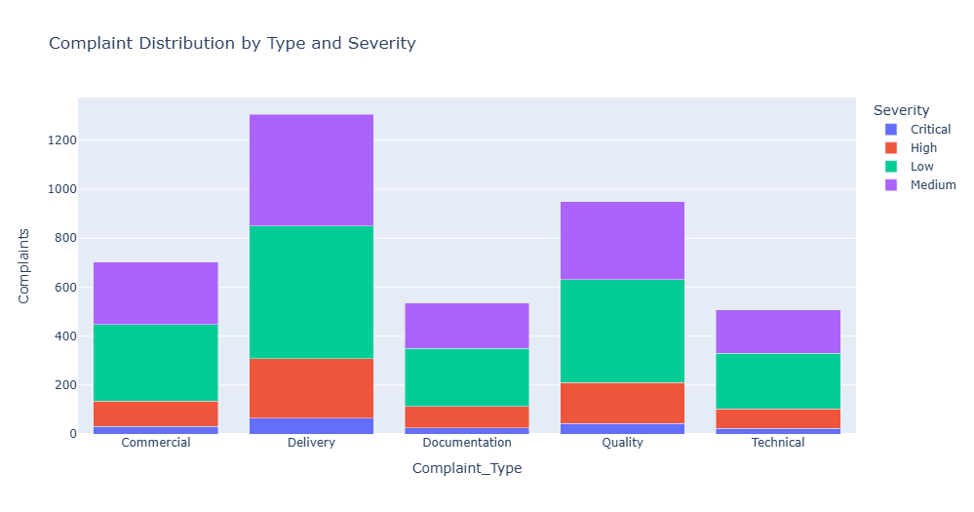
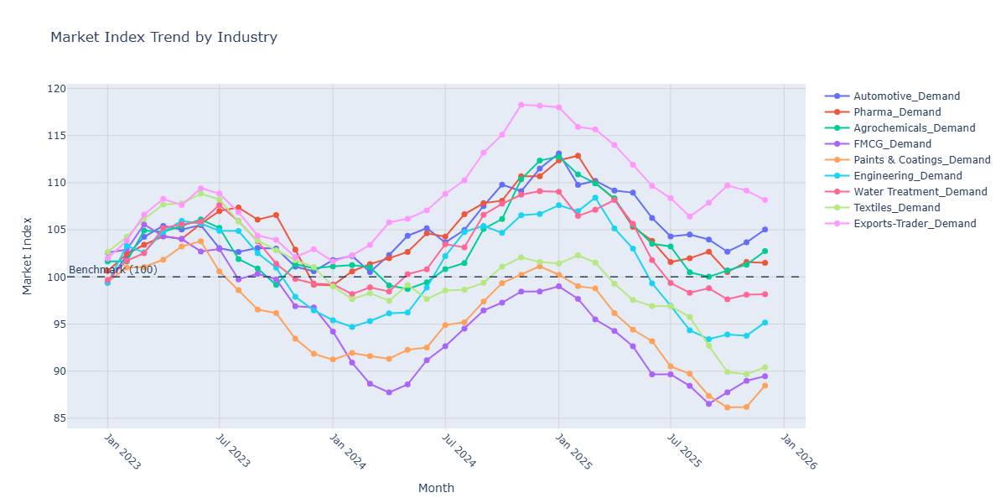

4. Scoring-based Prioritization Framework

1. Feature Engineering
The objective of feature engineering was to consolidate customer-level information from Sales, Quotations, Complaints, Payment Behaviour, and Market/Industry data into a single analytical dataset. The features were designed to capture customer value, growth momentum, sales potential, customer health, payment behaviour, and the external market environment.

Customer Master / Customer Profile
The Customer Master dataset was used as the foundation for customer-level attributes.
Derived or directly used features include:
- Customer_ID – Unique customer identifier used to combine information across datasets.
- Industry_Segment / Industry – Used to understand the customer's business segment and relate customer performance to the corresponding industry market trajectory.
- Customer_Type – Captures the nature/category of the customer relationship.
- Years_With_Company – Represents relationship tenure and provides context on the maturity of the customer relationship.
- Strategic_Account_Flag – Identifies strategically important customers and is used as an additional prioritisation consideration.
Thought process:
Customer profile variables provide the baseline context for interpreting customer performance. For example, declining revenue from a strategic account may require greater attention than a similar decline from a smaller, non-strategic account. However, tenure and strategic status should not by themselves determine opportunity; actual commercial behaviour remains more important.

Sales Transactions
The Sales Transactions dataset contains monthly customer-level sales information, primarily Quantity and Revenue.
The sales data was aggregated at customer level and used to derive:
- Recent 3M Net Sales Direction
- Overall Net Sales Direction
- Net Sales Trajectory
- Recent 3M Revenue Direction
- Overall Revenue Direction
- Revenue Trajectory
The underlying logic compares recent performance with historical performance to identify whether the customer's business is:
- Growing
- Stable
- Declining
- Recovering
- Deteriorating
The recent 3-month period was given greater importance because it represents the customer's current momentum, while the longer-term period provides context on the overall relationship.
Thought process:
A customer with strong historical revenue but recent deterioration should not be treated in the same way as a customer showing sustained growth. Therefore, both absolute customer value and the direction of change were considered.

Quotation Data
The Quotation dataset was used to understand the customer's current sales potential and historical conversion behaviour.
Derived features include:
- Total Quotes
- Win Ratio
- Recent 3M Quotes
- Recent 3M Win Ratio
- Loss-related indicators, including price-related losses where applicable.
The same metrics were calculated over both the overall available history and the recent 3-month period.
Thought process:
Revenue indicates realised business, whereas quotation behaviour provides an indicator of potential future business. A customer with a high number of recent quotations but a relatively low conversion rate may represent a sales opportunity where conversion can be improved.
The recent 3-month quotation metrics were particularly important because they capture current sales engagement rather than relying only on historical behaviour.

Complaint Data
The Complaint dataset was used to measure customer dissatisfaction and service-related risk.
- Derived features include:
- Total Complaints
- Recent 3M Complaints
- Median Resolution Days
- Most Frequent Complaint
- Complaint Category, combining complaint type and severity where appropriate.
Thought process:
Total complaints provide an indication of historical customer issues, while recent complaints indicate whether the customer's experience may be deteriorating. Median resolution days were included because a high number of complaints that are resolved quickly may represent a different level of risk compared with fewer complaints that remain unresolved for longer periods.

Payment Data
The Payment dataset was used to capture customer payment behaviour.
Derived features include:
- Total Instances
- Invoices Paid On or Before Due
- Invoices Paid After Due
- On-Time Payment Ratio
- Late Payment Ratio
- Median Days Past Due
Thought process:
Payment behaviour provides an important indicator of commercial and financial risk. Customers consistently paying on time generally present lower payment risk, whereas customers with frequent late payments or high days past due require greater caution.

Market / Industry Demand Data
The monthly industry demand indices were used to understand whether the external market surrounding each customer was growing or declining.
Derived features include:
- 12M Direction
- 3M Direction
- Overall Direction
- Market Trajectory
The market trajectory was derived by comparing recent and historical industry index movements.
A directional threshold of approximately ±3% was used:
- Greater than +3% → Growing
- Between -3% and +3% → Stable
- Less than -3% → Declining
Thought process:
Customer performance should be interpreted relative to the market in which the customer operates. For example, declining customer revenue in a rapidly growing industry may indicate a customer-specific problem, whereas declining revenue in a declining industry may be more attributable to external market conditions.

2. Opportunity Scoring
The Opportunity Score was designed to identify customers where additional sales attention could potentially generate incremental business.
The score was structured around four broad considerations:
- Customer Value and Growth
- Sales Opportunity
- Market Opportunity
- Strategic Importance
The objective was not simply to identify the largest customers, but to identify customers where there is a combination of commercial value, positive momentum, conversion potential, and favourable market conditions.

Columns Used for Opportunity Scoring
The following features were considered:
- Recent 3M Revenue / Net Sales
  - Represents current customer value.
  - Higher recent business indicates a larger immediate commercial base.
- Recent 3M Revenue Direction
  - Captures current momentum.
  - Growing customers receive a higher opportunity contribution than declining customers.
- Revenue Trajectory
  - Provides the longer-term context behind recent revenue movement.
  - Sustained growth is considered more attractive than temporary or isolated growth.
- Recent 3M Win Ratio
  - Measures the effectiveness of converting recent quotations into business.
  - A higher win ratio indicates stronger potential to convert active sales opportunities.
- Recent 3M Quotes
  - Represents the current level of sales engagement.
  - A customer with meaningful quotation activity provides a larger addressable opportunity than a customer with no recent quotations.
- Industry / Market Trajectory
  - Captures external demand conditions.
  - Customers operating in growing markets receive a positive opportunity contribution.
- Strategic Account Flag
  - Used as an additional prioritisation factor.
  - Strategic customers may warrant additional sales attention even when their purely quantitative opportunity score is similar to another customer.

Thresholds and Rationale

The scoring logic used directional thresholds rather than relying only on absolute values.
For growth-related measures, the same ±3% directional threshold was used as the market analysis:
Condition | Interpretation | Opportunity Contribution
Growth > +3% | Growing | Positive
-3% to +3% | Stable | Neutral / Moderate
Growth < -3% | Declining | Negative

For quotation conversion:
Win Ratio | Interpretation
Higher relative win ratio | Strong conversion potential
Mid-range win ratio | Moderate potential
Lower relative win ratio | Lower current conversion potential

For customer value and quotation volume, relative/percentile-based scoring was preferred over fixed absolute thresholds. This is because the appropriate revenue or quotation threshold depends heavily on the distribution of the company's customer base.
For example:
- Top customer revenue segment → higher opportunity points
- Middle customer revenue segment → moderate points
- Lower customer revenue segment → lower points
The same principle was applied to quotation activity.
Rationale:
Using percentiles makes the scoring adaptable to the actual customer population and avoids arbitrary thresholds such as "Revenue > X" that may become inappropriate when the customer base changes.
Interpretation
A high Opportunity Score represents customers where there is a combination of:
- Meaningful existing business
- Positive or improving revenue momentum
- Active quotation engagement
- Good quotation conversion potential
- Favourable industry conditions
- Strategic importance where applicable
The score should therefore be interpreted as a sales prioritisation indicator, rather than a prediction of guaranteed future revenue.

3. Risk Scoring
The Risk Score was designed independently from the Opportunity Score to identify customers where additional commercial attention may carry customer, financial, or relationship risk.
Keeping Opportunity and Risk separate is important because a customer can simultaneously have:
- High opportunity and high risk
- High opportunity and low risk
- Low opportunity and high risk
- Low opportunity and low risk
This provides a more useful business view than simply subtracting Risk Score from Opportunity Score.

Columns Used for Risk Scoring
The following features were considered:
- Recent 3M Complaints
  - Captures current customer dissatisfaction.
  - Recent complaints were given greater importance than historical complaints because they provide a stronger indication of current customer health.
- Total Complaints
  - Provides the longer-term history of customer issues.
  - Used as a supporting indicator rather than the sole measure of customer risk.
- Median Resolution Days
  - Indicates how quickly customer issues are typically resolved.
  - Longer resolution times indicate greater service-related risk.
- Recent 3M Complaint Share
  - Represents the proportion of historical complaints occurring recently.
  - A high recent share can indicate a deterioration in customer experience.
- Late Payment Ratio
  - Measures the frequency with which the customer pays after the agreed due date.
  - Higher late-payment behaviour increases financial risk.
- Median Days Past Due
  - Measures the typical severity of payment delays.
  - A customer that is frequently late by a few days presents a different risk profile from one with substantially longer payment delays.
- Revenue / Sales Direction
  - Deteriorating customer revenue can indicate relationship or commercial risk.
  - Recent decline was therefore considered as a supporting risk indicator.

Thresholds and Rationale
For payment behaviour, the following principle was used:
Payment Behaviour | Risk Interpretation
High On-Time Payment Ratio | Low Risk
Moderate On-Time Payment Ratio | Medium Risk
High Late Payment Ratio | High Risk
Higher Median Days Past Due | Increasing Risk
For customer complaints:
Complaint Behaviour | Risk Interpretation
Low / Stable Complaints | Lower Risk
Moderate Complaint Activity | Medium Risk
High Recent Complaint Activity | Higher Risk
Increasing Complaint Frequency | Higher Risk
Longer Resolution Time | Higher Risk
For revenue direction:
Revenue Direction | Risk Interpretation
Growing | Lower Risk contribution
Stable | Neutral
Declining | Higher Risk contribution

As with Opportunity Scoring, relative/percentile-based thresholds were preferred for variables such as complaint counts, resolution days, late-payment ratios, and days past due wherever the underlying distributions were highly variable.
Rationale:
A fixed threshold may not be meaningful across different customer populations. For example, 10 complaints may be extremely high for one customer segment but relatively normal for another. Relative scoring allows the risk framework to reflect the actual behaviour of the company's customer base.
Important Considerations
- Complaint counts should ideally be normalised where customer size varies significantly. For example, complaints per unit of revenue or complaints per quotation can provide a more meaningful comparison than raw complaint counts alone.
- Win Ratio should be interpreted together with quotation volume. A customer with one quotation and one win has a 100% win ratio, but this does not provide the same level of evidence as a customer with 20 quotations and a 70% win ratio.
- Payment risk should distinguish unpaid invoices from genuinely on-time payments. Missing payment information should not automatically be treated as an on-time payment.
- Strategic Account Flag should not automatically reduce risk. A strategic customer can still have significant complaint, payment, or revenue deterioration risk.
- Opportunity and Risk should remain separate so that Sales can distinguish between "high-value but needs attention" and "high-value and healthy growth" customers.
The resulting framework therefore provides two complementary perspectives:
- Opportunity Score → Where should Sales focus for potential growth?
- Risk Score → Which customers require caution or intervention?

5. Next Steps on the Roadmap
The current Opportunity and Risk Scoring framework provides a strong initial basis for customer prioritisation. The following areas can be explored further to improve the depth and commercial applicability of the framework:

Leverage Additional Customer and Commercial Attributes

- Several potentially valuable attributes are yet to be fully explored and incorporated into the scoring framework.
- Customer Region can help identify geographical patterns and regional opportunities or risks.
- Credit Limit can provide an indication of the customer's financial capacity and potential headroom for additional business.
- Contribution Margin can help distinguish high-revenue customers from customers that are also commercially attractive from a profitability perspective.
- Quotation Loss Reasons can provide deeper insight into why opportunities are being lost and help identify actionable areas such as pricing, competition, product fit, or service-related issues.
- Payment Invoice Amounts in addition to payment timeliness, can help quantify the financial exposure associated with delayed payments and provide a more complete view of payment risk.

Further Experimentation with Product Recommendations

- An initial Product Recommendation framework was tested using Sales data to identify potential cross-sell and upsell opportunities.
- However, the analysis indicates that many customers already purchase a broad range of products, with several customers purchasing most or nearly all products in the portfolio.
- This limits the effectiveness of a simple product affinity/recommendation approach.
- Further experimentation is therefore recommended using additional dimensions such as purchase frequency, purchase recency, product penetration, product combinations, customer segment, industry, order quantities, and similar-customer behaviour.
- The objective should be to move beyond generic product recommendations and identify specific whitespace opportunities, such as products commonly purchased by similar customers but not yet purchased by the target customer, as well as potential upsell opportunities based on product mix, quantity, or customer purchasing trajectory.

