Multi-Node Bluetooth Low Energy (BLE) Based Classroom Attendance System Using Cooperative RSSI Verification with ESP32
Kavin, Lohith Krishnan
Department of Computer Science and Engineering
Amrita Vishwa Vidyapeetham, Chennai, India

Abstract— Reliable classroom attendance tracking remains a persistent challenge in academic institutions. Manual roll-call is time-consuming and interruptive, RFID and biometric methods require dedicated hardware and raise privacy or cost concerns, and single-receiver Bluetooth Low Energy (BLE) attendance systems suffer from Received Signal Strength Indicator (RSSI) instability caused by obstacles, device orientation, and multipath interference, leading to false absences or false presences. This paper proposes a Multi-Node BLE Attendance System that deploys two independent ESP32 microcontrollers as spatially distributed BLE scanning nodes within a classroom. Each node independently measures the RSSI of nearby student smartphones, and a cooperative verification stage fuses the two readings using a dual-threshold, time-windowed decision rule before attendance is logged. By requiring corroboration from more than one vantage point, the proposed design reduces the single point-of-failure inherent to one-node BLE systems while remaining hardware-light, low-cost, and free of camera-based or biometric identity capture. The system is designed and prototyped using commodity ESP32 development boards, and this paper details the architecture, cooperative decision logic, hardware bill of materials, and the evaluation methodology used to validate detection reliability against a single-node baseline.
Keywords— Bluetooth Low Energy, Multi-Node Sensing, RSSI, Classroom Attendance, ESP32, Cooperative Verification, Embedded Systems, Proximity Detection
I. INTRODUCTION
Attendance recording is a routine but essential activity in higher education, and the method used to capture it directly affects instructional time, data integrity, and administrative overhead. Manual roll-call remains widespread despite being slow, error-prone, and vulnerable to proxy responses given verbally on behalf of an absent student.
Automated alternatives have been explored extensively. Radio Frequency Identification (RFID) systems replace the verbal roll-call with tag-based scanning but require dedicated readers and issued cards that can be lost, forgotten, or shared between students, which reintroduces the proxy-attendance problem the system was meant to solve. Biometric methods such as fingerprint or facial recognition improve identity assurance but introduce privacy concerns, sensitivity to environmental conditions such as lighting, and a recurring hardware or computational cost. Quick Response (QR) code scanning is inexpensive to deploy but is easily circumvented by sharing a screenshot of the code among students.
Bluetooth Low Energy (BLE) has emerged as an attractive middle ground because nearly every student already carries a BLE-capable smartphone, removing the need to issue additional hardware to end users. Existing BLE attendance implementations, however, typically rely on a single broadcasting or scanning node and a fixed RSSI threshold to infer proximity. Because RSSI is highly sensitive to obstruction, multipath reflection, and the orientation of the transmitting device relative to the receiver, a single vantage point frequently cannot distinguish a student seated inside the classroom from one standing just outside the doorway, producing both false positives and false negatives.
This paper addresses that specific weakness by distributing the sensing task across two independently placed ESP32 nodes rather than a single receiver. Each node scans for nearby BLE advertisements and records an RSSI value; a cooperative verification stage combines both readings before a presence decision is made. The objective is not to replace BLE as the sensing modality but to make BLE-based proximity inference more robust using redundancy at the physical layer, while keeping the implementation realistic for a low-cost embedded systems project — specifically avoiding dependencies such as camera-based identity verification, cloud infrastructure, or machine-learning models that add cost and complexity disproportionate to the scope of a classroom-scale deployment.
II. LITERATURE REVIEW
A substantial body of work has examined automated attendance tracking through different sensing modalities. Ishaq and Bibi review RFID-based attendance systems and note their continued dependence on dedicated readers and tag distribution as a practical deployment barrier [7]. Mahesh et al. combine face recognition with RFID to strengthen identity assurance, illustrating the broader trend of layering verification methods to reduce impersonation, at the cost of additional hardware and computation [8]. Complementary approaches include privacy-preserving, zero-effort tracking that avoids requiring an explicit action from the user [3], and BLE indoor-positioning frameworks that combine coarse location estimation with classroom-level presence logging [4].
Within BLE-specific research, Radwan et al. present a BLE-based attendance marking system and evaluate its practicality for classroom-scale deployment [5]. Jain proposes a teacher-broadcast architecture in which a single instructor device advertises a session-specific identifier while student devices scan and self-report proximity to a backend server; this design minimizes BLE channel congestion by keeping the number of broadcasters low, but places the entire proximity decision on a single vantage point [2]. The reference architecture this project was benchmarked against — a smartphone-broadcast, single ESP32-class receiver system layered with session-ID matching and face verification — follows a similar single-node philosophy while adding a camera-based identity layer to reduce proxy attendance [10].
Several studies have specifically examined the reliability of RSSI as a distance proxy. Al-Maktary et al. empirically evaluate RSSI-based distance estimation using ESP32 BLE modules under line-of-sight, wall-obstruction, and mobile-tracking conditions, and report that estimation error grows substantially once a wall or other obstruction lies between transmitter and receiver [14]. This finding motivates the use of more than one receiver: an obstruction that weakens the signal at one node is unlikely to equally affect a second node placed at a different location and orientation within the same room.
Multi-anchor and multi-node BLE architectures have been explored primarily for indoor positioning rather than attendance. Onggo et al. describe a wireless classroom attendance system that distributes ESP32 master and slave units around a room and applies RSSI-based restrictions to prevent cross-room attendance leakage, demonstrating that distributing sensing hardware spatially improves boundary discrimination compared to a single receiver [1]. Multi-anchor BLE localization work similarly distributes several fixed receivers through a space and fuses their independent readings into a single position or presence estimate, rather than relying on any one receiver's view of the device [12]. These works motivate the present system's core design choice, while this paper narrows the scope specifically to a two-node cooperative presence-verification problem rather than full positional localization, which is unnecessary for a binary in-classroom/not-in-classroom decision and keeps the hardware and computational footprint appropriate for a low-cost embedded systems capstone.
Across this literature, three gaps recur: (i) single-receiver BLE systems remain vulnerable to RSSI fluctuation from obstruction and orientation; (ii) higher-assurance systems close that gap by adding a camera or biometric identity layer rather than strengthening the proximity-sensing layer itself; and (iii) multi-node BLE work that does exist is oriented toward fine-grained indoor localization rather than a lightweight, cooperative presence check suited to a single classroom. The system proposed in this paper is positioned to close the third gap directly.
III. PROPOSED SYSTEM
The proposed system uses two ESP32 development boards, denoted Node 1 and Node 2, placed at different fixed locations within the classroom — for example, opposite corners or the front and back of the room. Each node continuously performs a passive BLE scan and records the RSSI of any nearby smartphone advertisement it detects, without requiring the student to install a dedicated application in the minimum viable configuration, since standard BLE advertising packets (or a lightweight companion broadcast, where finer control over the advertised identifier is required) are sufficient for presence sensing.
The central design decision distinguishing this system from single-node BLE attendance approaches is the cooperative verification stage. Rather than accepting or rejecting presence based on one RSSI reading against one fixed threshold, the system requires corroborating evidence from both nodes within a shared time window before attendance is confirmed. This cooperative check is intended to reduce two classes of error common to single-node systems: false negatives, where a legitimate in-classroom student is missed because the single receiver's line of sight happens to be obstructed at that moment, and false positives, where a device just outside the room is picked up because it happens to be within range and orientation of the one receiver present.
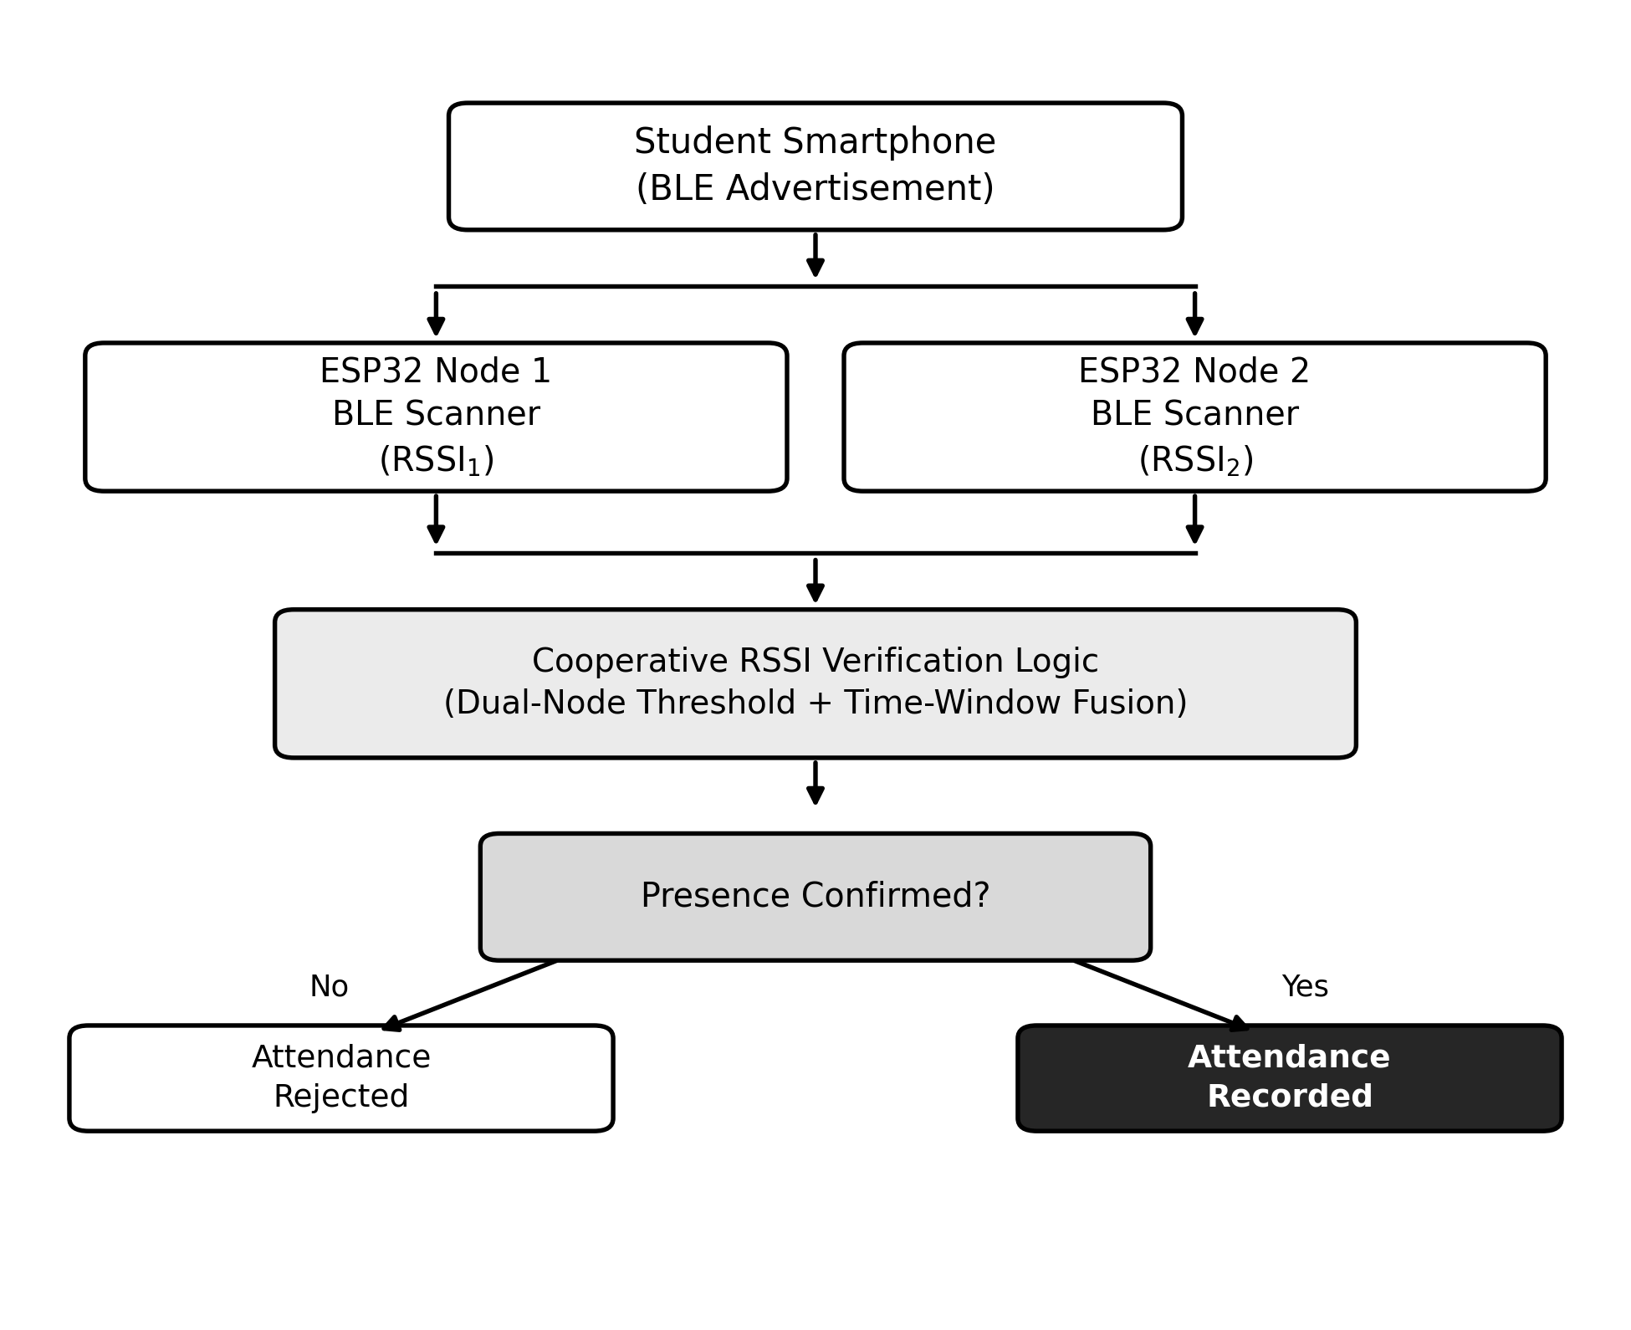
Fig. 1. System architecture and cooperative RSSI verification flow.
As shown in Fig. 1, a student's smartphone advertises a BLE signal that is independently observed by both ESP32 nodes. Each node reports its measured RSSI (RSSI₁ and RSSI₂) to the verification logic, which is implemented as a lightweight decision rule executed on an aggregating host during the prototype stage. The verification logic evaluates whether the device satisfies the cooperative presence condition described in Section IV before attendance is recorded; if the condition is not met, no attendance entry is created and the system continues scanning.
The system deliberately excludes camera-based face verification, cloud inference, and machine-learning components. This is a scope decision rather than an oversight: the objective of this work is to demonstrate that meaningful reliability gains over a single-node BLE baseline are achievable purely through spatial redundancy at the sensing layer, using hardware that remains inexpensive and easy to reproduce in a standard classroom.
IV. METHODOLOGY AND COOPERATIVE VERIFICATION LOGIC
A. System Working Flow
1. Student enters the classroom carrying a BLE-capable smartphone.
2. The smartphone advertises a BLE signal, either as a standard advertisement or a lightweight session-tagged broadcast.
3. ESP32 Node 1 and Node 2 independently scan for nearby BLE devices and record RSSI values with timestamps.
4. Both nodes report their RSSI readings for matching device identifiers to the verification logic.
5. The verification logic applies the cooperative decision rule described below.
6. If the presence condition is satisfied, attendance is recorded; otherwise the reading is discarded and scanning continues.
B. Cooperative Decision Rule
Let RSSI₁ and RSSI₂ denote the readings obtained by Node 1 and Node 2 respectively for a given device within a shared observation window T, and let θ denote an empirically calibrated proximity threshold for the room. Presence is confirmed only when both of the following conditions hold within the window T:
RSSI₁ ≥ θ₁ AND RSSI₂ ≥ θ₂
where θ₁ and θ₂ are calibrated independently for each node to account for differences in mounting position, antenna orientation, and local obstruction patterns. Requiring agreement from both nodes rather than either node alone reduces the chance that a single transient fluctuation — such as a person briefly walking between a student and one node — causes an incorrect decision, since the second node's independent line of sight is unlikely to be obstructed in the same instant. Where a single momentary dropout at one node is a concern, the rule can be relaxed to a rolling-majority form over the observation window (for example, presence confirmed if the dual-threshold condition holds for a majority of samples within T) rather than requiring instantaneous agreement on every sample, improving tolerance to brief occlusion without abandoning the cooperative principle.
Threshold calibration follows the log-distance path loss relationship commonly used for BLE proximity estimation, in which RSSI is expected to decrease approximately logarithmically with distance in line-of-sight conditions, with additional attenuation introduced by walls, furniture, and body shadowing [14]. θ₁ and θ₂ are set empirically for the deployment room by recording RSSI at the classroom boundary from each node's position and selecting a threshold that separates in-room readings from just-outside-room readings with a safety margin, rather than assuming a single fixed value transfers correctly across nodes or rooms.
V. HARDWARE IMPLEMENTATION
The prototype is built entirely from low-cost, readily available components, keeping the total bill of materials modest and reproducible for other institutions. Table I summarizes the hardware used.
Component | Qty. | Purpose
ESP32 Dev. Board | 2 | BLE scanning nodes
Breadboard | 2 | Prototype circuit setup
Jumper Wires | 1 set | Node interconnects
USB Cable | 2 | Programming / power
Laptop | 1 | Programming and data logging
TABLE I. HARDWARE BILL OF MATERIALS
Each ESP32 node runs firmware that performs continuous or periodic BLE scanning, extracts the RSSI and address of detected advertisements, and streams timestamped readings to the aggregation point over USB serial in the prototype configuration. Using two independent, identically programmed nodes keeps the firmware simple and avoids introducing wireless inter-node coordination as an additional point of failure during the current phase of the project.
VI. EVALUATION METHODOLOGY
As this system is at the design and prototyping stage, this section describes the evaluation methodology that will be used to validate the cooperative approach against a single-node baseline, rather than reporting final field results. The evaluation is structured to isolate the specific claim made in Section III — that cooperative dual-node verification reduces detection error relative to a single receiver — under conditions representative of normal classroom use.
A. Planned Test Conditions
- Distance variation across the typical BLE range used indoors (approx. 5–15 m), sampled at fixed intervals from each node's position.
- Line-of-sight versus obstructed conditions, including desks, seated students, and partition walls between a device and one node.
- Boundary discrimination: devices held just inside versus just outside the classroom doorway, to test whether the dual-threshold rule reduces cross-boundary false positives compared to a single node.
- Multiple concurrent devices scanning simultaneously, to observe whether cooperative verification introduces latency as class size increases.
B. Comparison with Existing Approaches
Table II summarizes the expected qualitative differences between a conventional single-node BLE attendance system and the proposed multi-node cooperative design, based on the mechanisms described in Sections III and IV rather than on a fielded deployment.
Parameter | Single-Node (Existing) | Multi-Node (Proposed)
BLE Nodes | Single ESP32 | Two ESP32 Nodes
Signal Basis | Single RSSI reading | Dual, corroborated RSSI
Boundary Discrimination | Limited | Improved
Resilience to Occlusion | Low | Higher (redundant path)
Identity Verification | None / external app | None (scope excluded)
Implementation Cost | Low | Low
TABLE II. EXISTING VS. PROPOSED APPROACH
VII. LIMITATIONS
- RSSI variability: even with two nodes, RSSI remains an indirect and noisy proxy for distance, and extreme or simultaneous obstruction at both nodes could still degrade accuracy.
- Device heterogeneity: differences in Bluetooth chipset and antenna design across smartphone models can shift baseline RSSI, requiring threshold calibration to be conservative rather than device-specific.
- Fixed node placement: the calibrated thresholds are specific to the physical layout of the deployment room and would need recalibration if node positions change.
- Prototype-stage aggregation: the current implementation aggregates readings over a wired serial connection to a host machine, which is suitable for demonstration but would need to be replaced with a wireless or networked aggregation path for an unattended, permanent installation.
VIII. FUTURE SCOPE
- Extending the cooperative logic to three or more nodes for larger or irregularly shaped classrooms.
- Replacing the wired aggregation link with an ESP-NOW or Wi-Fi based inter-node communication path for standalone operation.
- Automated, on-site threshold recalibration to reduce manual tuning when nodes are repositioned.
- Integration with existing learning management or attendance record systems via a simple API.
IX. CONCLUSION
This paper presented a Multi-Node BLE Attendance System that addresses the core reliability weakness of single-receiver BLE attendance methods — RSSI instability caused by obstruction and device orientation — by distributing sensing across two independently placed ESP32 nodes and requiring cooperative, corroborated verification before attendance is recorded. Unlike systems that respond to reliability concerns by adding a camera-based or biometric identity layer, the proposed approach strengthens the underlying proximity-sensing layer itself, keeping the implementation low-cost, hardware-light, and reproducible. The architecture, cooperative decision rule, and an evaluation methodology for validating the approach against a single-node baseline have been described; empirical validation against these planned test conditions is the immediate next step for this project.
REFERENCES
[1] Onggo et al., “Revolutionizing Classroom Attendance: A Wireless Smart System Using ESP-NOW Protocol,” Jurnal Infotel, vol. 16, no. 4, pp. 695–712, Nov. 2024.
[2] A. Jain, “A BLE-Based Smart Attendance System for Scalable and Contactless Classroom Automation,” IJERT, Jul. 2025.
[3] A. Shene, J. Aldridge, and H. Alamleh, “Privacy-Preserving Zero-effort Class Attendance Tracking,” ResearchGate, Apr. 2021.
[4] A. Puckdeevongs, N. K. Tripathi, A. Witayangkurn, and P. Saengudomlert, “Classroom Attendance Systems Based on Bluetooth Low Energy,” Information (MDPI), Jun. 2020.
[5] Y. Radwan et al., “Smart Attendance Marking System Based on BLE,” in Proc. 2023 Int. Conf. Innovation and Intelligence for Informatics, Computing, and Technologies (3ICT), IEEE, 2023.
[6] Y. Alfiyya et al., “Attendance Detection System using Bluetooth Low Energy Based on ESP32 with Realtime Monitoring Through Website,” in Proc. IEEE Conf., Dec. 2024.
[7] K. Ishaq and S. Bibi, “IoT based smart attendance system using RFID: A systematic literature review,” arXiv:2308.02591, 2023.
[8] B. L. Mahesh, R. Rashmi Adyapady, and U. G. Nithin Kurup, “Seamless Attendance Monitoring with Face Recognition and RFID Technology,” in Proc. 2024 IEEE Int. Conf. Distributed Computing, VLSI, Electrical Circuits and Robotics (DISCOVER), IEEE, 2024.
[9] D. Hercog, T. Lerher, M. Truntič, and O. Težak, “Design and implementation of ESP32-based IoT devices,” Sensors, vol. 23, no. 15, p. 6739, 2023.
[10] S. Shaikh, S. Gupta, S. Pal, and A. Singh, “Bluetooth-Based Smart Attendance System using BLE and Mobile Devices,” IJERT, vol. 15, no. 4, Apr. 2026.
[11] US Patent US20170201858A1, “Dynamic User-Defined Check-in Points.”
[12] B. Morawska, P. Lipiński, K. Lichy, and M. T. Leplawy, “Probabilistic Grid System for Indoor Mobile Localization Using Multi-Power Bluetooth Beacon Emulator,” Sensors, vol. 25, no. 18, p. 5635, Sep. 2025.
[13] S. Tippannavar, Y. S. D., and E. A. Madappa, “Two Factor Authentication using RFID and Biometric Sensor,” Jun. 2022.
[14] O. Al-Maktary et al., “Evaluation of RSSI-Based Distance Estimation with ESP32 BLE Modules for Indoor Asset Tracking,” Jurnal Teknik Elektro, vol. 17, no. 2, pp. 172–179, Oct. 2025.

