QUANTUM COMPUTING · COURSE PROJECT REPORT
Quantum Search Lab (GrovX)
An Application-Driven Implementation and Evaluation of Grover’s Search Algorithm
Live website: https://Kavin-JS.github.io/GrovX/
Source code: https://github.com/Kavin-JS/GrovX
Name
Register number
Department
Institution
Submitted on

Abstract
Searching an unsorted collection for one marked item has no structure to exploit: a classical program must inspect, on average, half of the N items. Grover’s algorithm solves the same problem with about (π/4)√N queries to an oracle, a quadratic reduction. This project implements Grover’s algorithm as an explicit quantum circuit (Hadamard, Pauli-X and multi-controlled-Z gates) on a state-vector simulator written in JavaScript, applies it to recovering a secret n-bit code from a yes/no check, and evaluates it against classical linear search.
The circuit is verified against the closed-form success probability sin²((2k+1)θ) for every iteration count tested. For N = 4 to 16,384, the algorithm succeeds with at least 94.5% probability (at least 99.5% for n ≥ 5) using 1 to 100 oracle queries, where linear search needs 2.5 to 8,199 on average. A resource model shows that a 14-qubit run needs 26 logical qubits and about 30,000 two-qubit gates, and that a gate error rate of 10⁻³ leaves essentially no chance of success without error correction. The results confirm a real but quadratic advantage that is limited today by circuit depth and noise. The work is delivered as an interactive website.
Keywords: Grover’s algorithm, amplitude amplification, unstructured search, quantum simulation, query complexity, resource estimation
Contents
1. Introduction 3
2. Problem Statement and Objectives 4
3. Background 5
4. Application and System Design 7
5. Implementation 8
6. Experimental Setup 10
7. Results 11
8. Classical versus Quantum Comparison 15
9. Resource Requirements 16
10. Practical Advantages 19
11. Limitations 19
12. Conclusion 20
13. Future Scope 20
References 21
Appendix A. Running the Project 21
Appendix B. Code Excerpts 22

1. Introduction
Search is one of the most basic tasks in computing. Whenever the only way to recognise the answer is to test candidates one at a time, whether the candidates are records in an unsorted table, passwords, or keys of a cipher, the best classical strategy is to test them until one succeeds. With N candidates that takes N tests in the worst case and (N+1)/2 on average.
Quantum computers change the cost model. A register of n qubits can hold a superposition of all N = 2^{n} candidates, and a single application of the test to that register evaluates it on every candidate at once. The difficulty is that a measurement returns only one candidate, chosen at random. Grover’s algorithm (1996) shows how to use interference to steer the amplitudes so that the marked candidate is the likely measurement outcome after only about (π/4)√N applications of the test. The speed-up is quadratic rather than exponential, and it is known to be the best possible for unstructured search.
This project builds a working, inspectable implementation of Grover’s algorithm and asks how much of the theoretical advantage survives when resources are counted honestly. The implementation is a gate-level simulation, the evaluation compares it with a classical baseline on queries, time, qubits, gates and noise tolerance, and everything is delivered as an interactive website so that each result can be reproduced by running it.

2. Problem Statement and Objectives

2.1 Problem statement
Develop an application-driven implementation of a foundational quantum algorithm and evaluate its performance, resource requirements, and practical advantages compared to a classical solution. This project chooses Grover’s search algorithm and the application of finding one secret item (an n-bit unlock code, or one record in an unsorted table) when the only available operation is a yes/no check.

2.2 Objectives
- Implement Grover’s algorithm as an explicit quantum circuit and run it on a quantum circuit simulator.
- Build an interactive web application that demonstrates classical and quantum search side by side.
- Compare Grover’s algorithm with classical linear search on query complexity, success probability and run time.
- Estimate the resources a real machine would need: qubits, gate counts, circuit fidelity under noise, and run time.
- Identify where a practical advantage exists and where it is lost.

2.3 Scope
The quantum part runs on a classical simulator; no quantum hardware is used. The simulator is exact for the gates involved (Section 5.1), so the measured probabilities are those an ideal machine would produce. Noise is treated analytically through a resource model rather than injected into the simulation. The oracle is assumed to be given; how a real lock or database would be turned into a reversible circuit is discussed as a limitation (Section 11) but not implemented.

3. Background

3.1 Qubits, superposition and measurement
A register of n qubits is described by 2^{n} complex amplitudes a_{x}, one for each bit string x. The register is measured with probability |a_{x}|² of returning x, and the squares of the amplitudes always sum to 1. Gates are unitary transformations of the amplitude vector. Quantum algorithms work by arranging for the amplitudes of wrong answers to cancel and those of right answers to add up (interference).

3.2 Gates used in this project
Table 1. Quantum gates used by Grover’s circuit.
Gate | Action | Role in the algorithm
Hadamard (H) | |0⟩ → (|0⟩ + |1⟩)/√2, |1⟩ → (|0⟩ − |1⟩)/√2 | Creates the uniform superposition; used in the diffusion step
Pauli-X | swaps |0⟩ and |1⟩ (a NOT gate) | Selects which bit pattern the oracle marks; used in the diffusion step
Multi-controlled Z | flips the sign of the state |11…1⟩ only | The only non-trivial two-or-more-qubit gate; marks a state by a sign flip

3.3 The oracle model
The search problem is given by a function f(x) that equals 1 for the secret item w and 0 otherwise. The algorithm may not look inside f; it can only evaluate it. The quantum version is a phase oracle U_{f} that flips the sign of the marked state:
U_f |x⟩ = (−1)^f(x) |x⟩
Each application of U_{f} is one query. Comparing algorithms by the number of queries is standard, because it does not depend on the machine and it isolates the part of the problem that cannot be avoided. Classically, finding a single marked item needs N queries in the worst case and (N+1)/2 on average.

3.4 Grover’s algorithm
- Apply H to all n qubits, giving every state the amplitude 1/√N. Call this state |s⟩.
- Apply the oracle U_{f}. The marked state’s amplitude changes sign; no probability changes yet.
- Apply the diffusion operator 2|s⟩⟨s| − I, which reflects every amplitude about the mean: a → 2·mean − a. Because the marked amplitude is now below the mean, it ends up well above it, and all other amplitudes shrink slightly.
- Repeat steps 2 and 3 about (π/4)√N times, then measure all qubits.
The diffusion operator is built from H and X gates around a multi-controlled Z: H^{⊗n} X^{⊗n} (MCZ) X^{⊗n} H^{⊗n} equals −(2|s⟩⟨s| − I), which differs from the ideal operator only by a global phase of −1 that cannot be observed.

3.5 Geometric picture and number of iterations
Throughout the algorithm the state stays in a two-dimensional plane spanned by the marked state |w⟩ and the uniform superposition of all other states. The oracle reflects the state about the non-marked axis, and the diffusion reflects it about |s⟩; two reflections compose into a rotation by 2θ, where sin θ = √(M/N) for M marked items (Figure 1). After k iterations the state is at angle (2k+1)θ, so
P(k) = sin²((2k+1)θ), k_opt ≈ π/(4θ) − ½ ≈ (π/4)√(N/M)
The probability peaks near k_{opt} and then falls: too many iterations rotate the state past the marked axis. The algorithm therefore needs to know M (or an estimate of it) to stop at the right time.
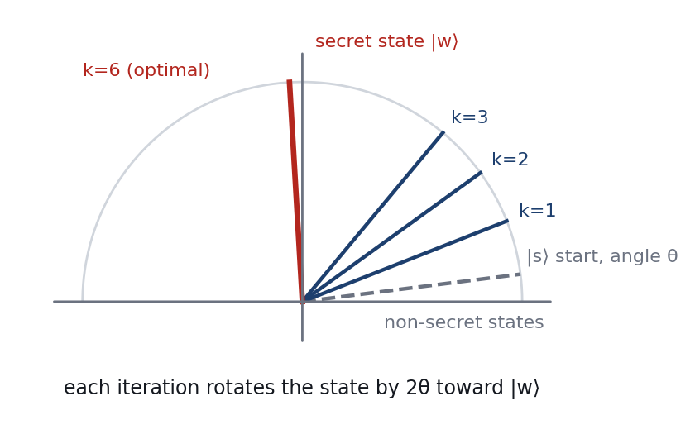
Figure 1. Grover’s iterations as rotations in the plane of the marked state and the non-marked states (N = 64, one marked item).

3.6 Complexity and optimality
Grover’s algorithm uses O(√N) queries against Θ(N) classically. Bennett, Bernstein, Brassard and Vazirani (1997) proved that any quantum algorithm for unstructured search needs Ω(√N) queries, and Zalka (1999) showed that Grover’s constant is optimal. The advantage is therefore quadratic, not exponential, and cannot be improved by a cleverer algorithm.

4. Application and System Design

4.1 The application
The application is recovering one secret item from a yes/no check. Two concrete forms are implemented in the Lab page of the website:
- Secret unlock code. A lock accepts an n-bit code and only reports whether a submitted code opens it. The search space is all 2^{n} codes and the oracle is the lock check.
- Unsorted database record. A table holds N records in no particular order and the only operation is "does record x match the query?".
Both are the same abstract problem: a search index x in {0, …, N−1} and an oracle f(x). The same structure appears in brute-force key search for symmetric ciphers, which is why Grover’s algorithm features in discussions of post-quantum security (Section 10).

4.2 Architecture
The system is a single-page website with no server. A controller in the browser runs the classical search and Grover’s circuit for the parameters chosen by the user, times them, samples measurements, and passes the results to charts and tables. A separate resource model estimates what a real machine would need (Figure 2).
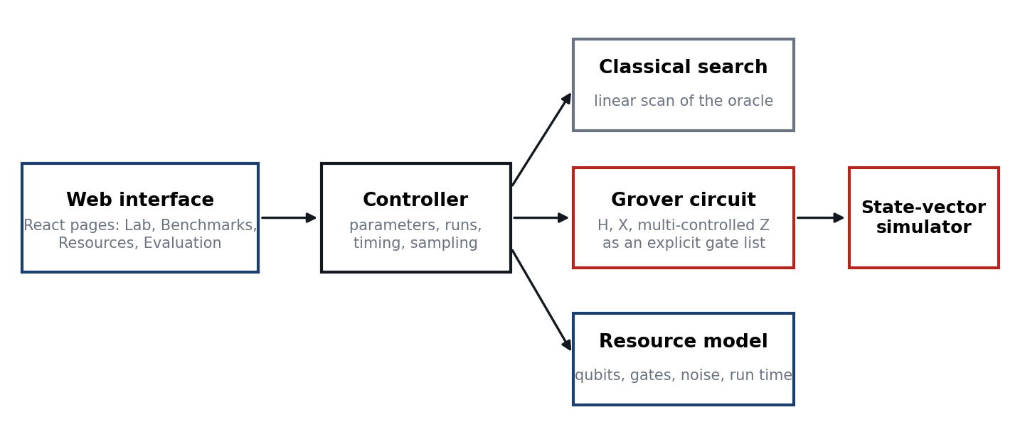
Figure 2. System architecture. All components run in the browser.

4.3 Modules
Table 2. Source modules and their responsibilities.
Module | Responsibility
quantum/simulator.js | State-vector simulator: H, X, multi-controlled Z, sampling
quantum/grover.js | Builds the oracle, diffusion and iteration as gate lists; runs them; theory formulas
quantum/resources.js | Qubit, gate, fidelity and run-time model; crossover scan
classical/linearSearch.js | Classical baseline with query counting and timing
experiments/benchmark.js | Sweep over N = 2^{n}, statistics, CSV export
pages/ | Home, Algorithm, Lab, Benchmarks, Resources, Evaluation
tests/grover.test.js | Automated verification of the simulator and the algorithm

5. Implementation

5.1 State-vector simulator
The simulator stores the 2^{n} amplitudes in a Float64Array. Grover’s circuit uses only H, X and multi-controlled Z, and all three have real matrix entries, so a real-valued vector represents the state exactly with no approximation. Qubit q corresponds to bit q of the array index. A Hadamard on qubit q combines each pair of entries that differ only in bit q; X swaps them; a multi-controlled Z negates every entry whose index has all the control bits set. Each gate costs O(2^{n}) operations, and a Grover iteration uses O(n) gates, so a run of k ≈ (π/4)·2^{n/2} iterations costs about n·2^{3n/2} operations. This is why the simulator, unlike the algorithm it imitates, becomes slow quickly and the website limits interactive runs to n ≤ 12 (benchmarks to n ≤ 14).

5.2 Building the circuit
The circuit is constructed as an explicit list of gate operations rather than computed by a formula. The oracle for a secret x applies X to every qubit where the bit of x is 0, then a multi-controlled Z on all n qubits, then the same X gates again; the net effect is to negate the amplitude of |x⟩ only. The diffusion operator is H, X, multi-controlled Z, X, H on all qubits. A short global-phase correction (a sign change of the whole vector) is applied after each diffusion so that plotted amplitudes read as 2·mean − a; it is not counted as a gate. Figures 3 and 4 show the structure, and Appendix B lists the code.
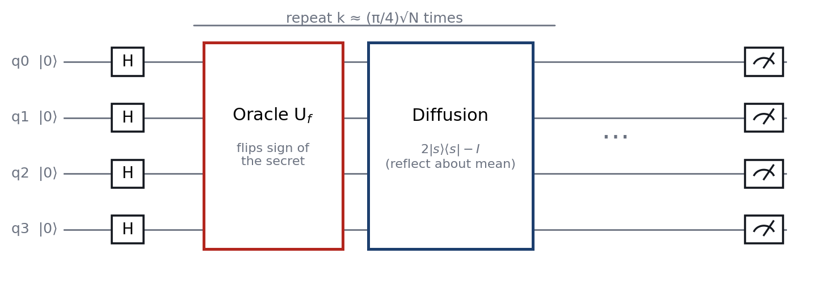
Figure 3. Block structure of Grover’s circuit for n = 4.
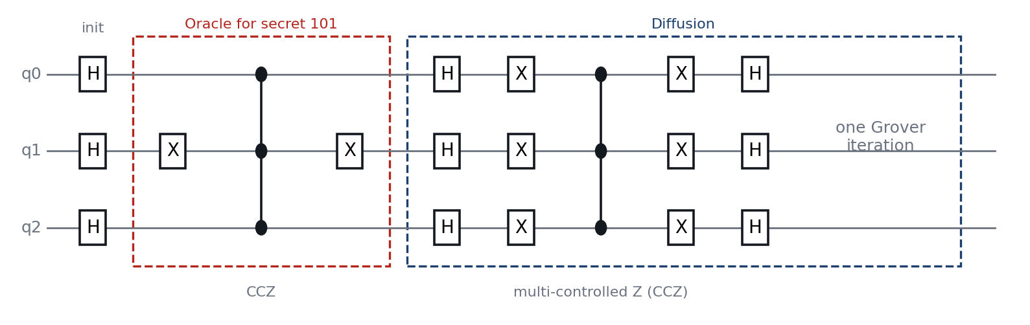
Figure 4. Gate-level circuit for n = 3 with secret 101: one Grover iteration (oracle followed by diffusion), as executed by the simulator.

5.3 Measurement
A measurement is simulated by sampling from the probability distribution |a_{x}|². The simulator builds the cumulative distribution once and draws each shot with a binary search, so hundreds or thousands of shots are cheap. The Lab page reports the most frequent outcome and the fraction of shots that hit a marked item.

5.4 Classical baseline
The classical solution scans the indices in order, calls the oracle for each, and stops at the first match. Every call is counted as one query. The run time is measured with the browser’s high-resolution timer, repeating the search many times and averaging to overcome timer resolution.

5.5 Resource and noise model
The resource model estimates what an ideal gate-based machine would need to run the same circuit. Its assumptions are stated on the Resources page and repeated here:
- A multi-controlled Z on n qubits is built from 2n−3 Toffoli gates using n−2 ancilla qubits (a compute ladder, one central gate, and an uncompute ladder). For n = 2 it is a single controlled-Z.
- A Toffoli gate is 6 CNOT gates plus 9 single-qubit gates.
- The error rate of single-qubit gates is one tenth of the two-qubit error rate.
- A two-qubit gate takes 200 ns and a single-qubit gate 20 ns; gates execute one after another.
- Circuit fidelity is the product of gate fidelities. If the circuit fails, the output is assumed to be uniformly random, so the noisy success probability is P·F + (1−F)/N.
- Error correction is not modelled; a rough overhead of 1,000 physical qubits per logical qubit is quoted for orientation only.

5.6 Verification
Twelve automated tests (Vitest) check the implementation. They confirm that H on all qubits gives a uniform state, that H is its own inverse, that X and the multi-controlled Z act as specified, that sampling follows the distribution, that the state stays normalised, and that the optimal iteration counts follow (π/4)√N. The central test runs the full circuit for n = 2, 3, 4, 5, 6, 8 and 10 with one and two marked items and compares the success probability after every iteration k from 0 to 2k_{opt}+2 with sin²((2k+1)θ); all agree to nine decimal places. Further tests cover the classical search, monotonic growth of the resource model, and the crossover scan.

5.7 Web application and deployment
The website is written in React 18 with Vite and the Recharts library. It uses hash-based routing so that it can be hosted as static files on GitHub Pages, and it contains no backend, database, API keys or environment variables. A GitHub Actions workflow builds the project and publishes it on every push.

6. Experimental Setup

6.1 Design of the experiments
Table 3. Experimental parameters.
Parameter | Value
Search space size | N = 2^{n} for n = 2, 3, …, 14 (N = 4 to 16,384)
Marked items | M = 1 for the main sweep; M = 1, 2, 4 for the multi-item study (n = 6, 8, 10)
Grover iterations | k = round(π/(4θ) − ½), the optimal count, unless stated
Classical queries | Mean over 2,000 random secrets per size (linear scan in index order)
Classical time | Mean of 20 timed runs, each averaged over many repeated searches
Grover simulation time | Median of 3 runs, full gate-level circuit
Metrics | Queries, success probability, run time, gate counts, qubits, fidelity

6.2 Environment
The measurements were produced by running the website’s own modules under Node.js 22 (V8 engine) on a single core of a cloud virtual machine. Query counts and probabilities do not depend on the machine. Timings do: the browser numbers shown on the website will differ, so timings should be read for their trends (how they scale with n) and not for their absolute values.

6.3 Query counting
Queries are counted the same way for both algorithms: one query per evaluation of the oracle. Grover’s algorithm needs one further classical check to confirm the measured answer; that constant is ignored, as is standard.

7. Results

7.1 Amplitude amplification
Figure 5 shows the amplitudes of all 32 states for n = 5 with secret item 19. Initially every amplitude is 1/√32. After each iteration the secret’s amplitude grows while the others shrink, and the probability of measuring the secret goes 3.1% → 25.8% → 60.2% → 89.7% → 99.9% over iterations 0 to 4. Four iterations are enough, against 16.5 classical queries on average.
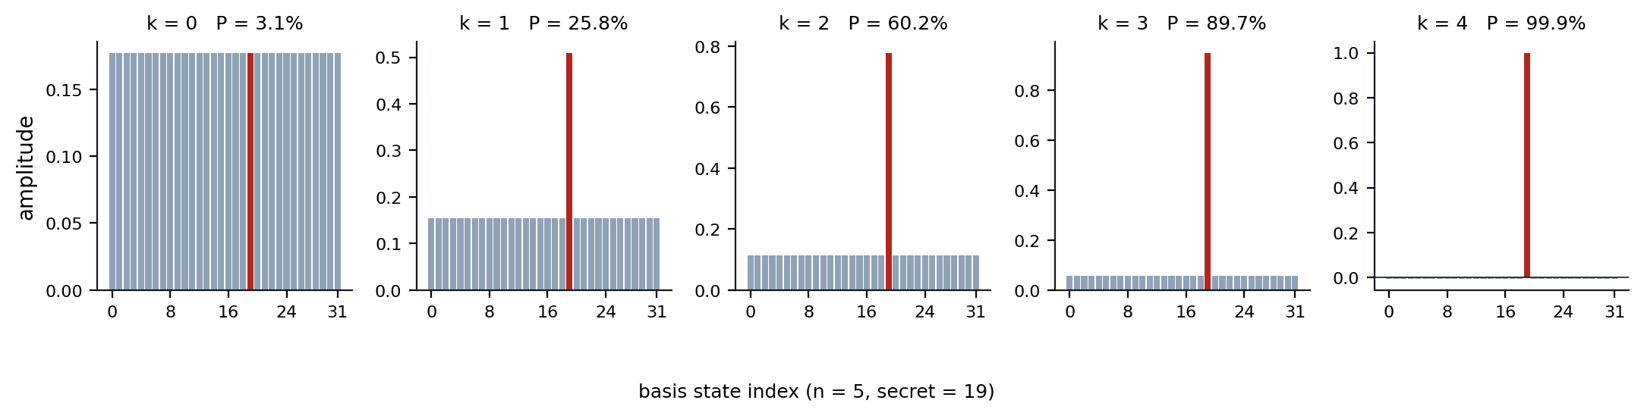
Figure 5. Amplitudes of the 32 basis states after k = 0 to 4 Grover iterations (n = 5, secret item 19 in red).

7.2 Success probability against the number of iterations
Figure 6 plots the success probability for n = 6 (N = 64) as the number of iterations grows. The simulated points lie exactly on the theoretical curve sin²((2k+1)θ). The probability reaches 99.66% at k = 6, the predicted optimum, then decreases, reaches nearly zero near k = 12, and rises again. Stopping at the right iteration matters.
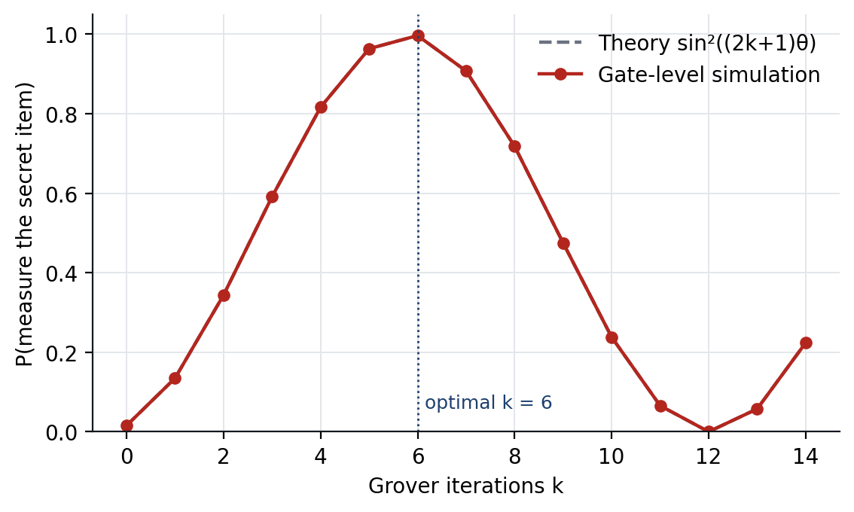
Figure 6. Success probability against iterations for n = 6; simulation (red) and theory (grey dashed).

7.3 Query complexity
Table 4 and Figure 7 compare the number of queries. Grover’s iteration count follows (π/4)√N and the classical average follows (N+1)/2, so the reduction factor grows with N: 20.4× at n = 10 and 82.0× at n = 14. Extrapolating the formulas, the reduction is about 650× at n = 20 (524,288 against 804) and about 670,000× at n = 40.
Table 4. Queries and success probability for one marked item (classical values are means over 2,000 random secrets).
n | N | Classical (avg) | Grover k | Reduction | P(success)
2 | 4 | 2.5 | 1 | 2.5× | 100.00%
3 | 8 | 4.4 | 2 | 2.2× | 94.53%
4 | 16 | 8.4 | 3 | 2.8× | 96.13%
5 | 32 | 16.5 | 4 | 4.1× | 99.92%
6 | 64 | 32.8 | 6 | 5.5× | 99.66%
7 | 128 | 65.2 | 8 | 8.1× | 99.56%
8 | 256 | 129.8 | 12 | 10.8× | 99.99%
9 | 512 | 256.1 | 17 | 15.1× | 99.94%
10 | 1,024 | 510.1 | 25 | 20.4× | 99.95%
11 | 2,048 | 1,040.6 | 35 | 29.7× | 100.00%
12 | 4,096 | 2,031.5 | 50 | 40.6× | 99.99%
13 | 8,192 | 4,063.3 | 71 | 57.2× | 99.99%
14 | 16,384 | 8,198.5 | 100 | 82.0× | 100.00%

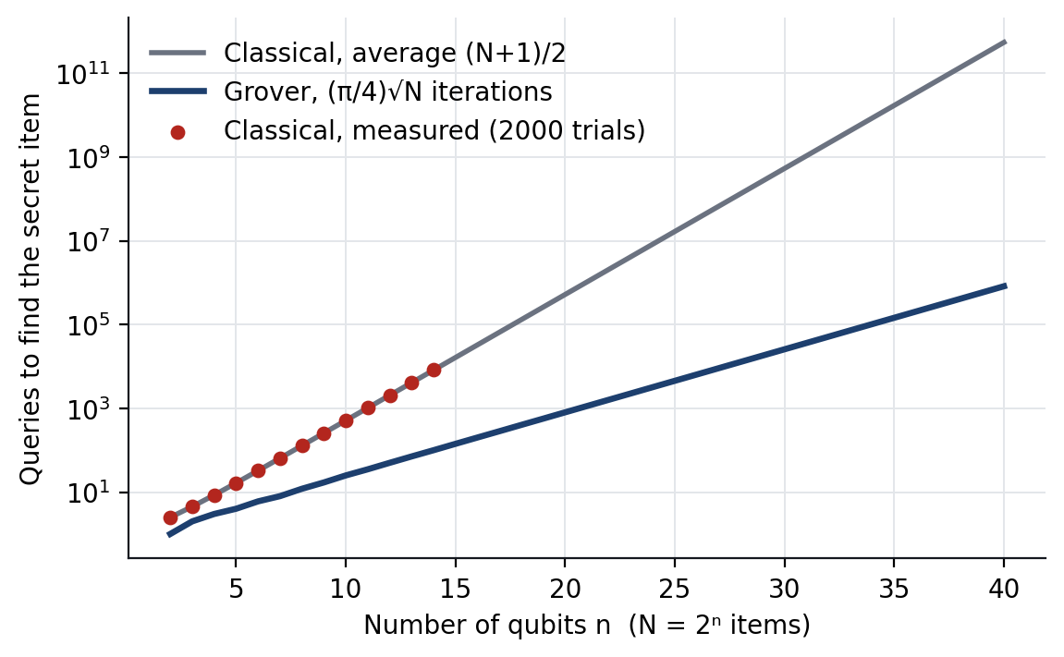
Figure 7. Queries against qubit count (log scale). Lines extend the formulas to n = 40; red dots are measured classical averages.

7.4 Success probability across sizes
Grover’s algorithm is probabilistic. At the optimal iteration count the success probability is at least 99.5% for every n ≥ 5 (Figure 8). It is lower for very small N because the iteration count must be a whole number while the rotation per iteration, 2θ, is coarse: at n = 3 the best integer choice (k = 2) leaves a success probability of 94.5%.
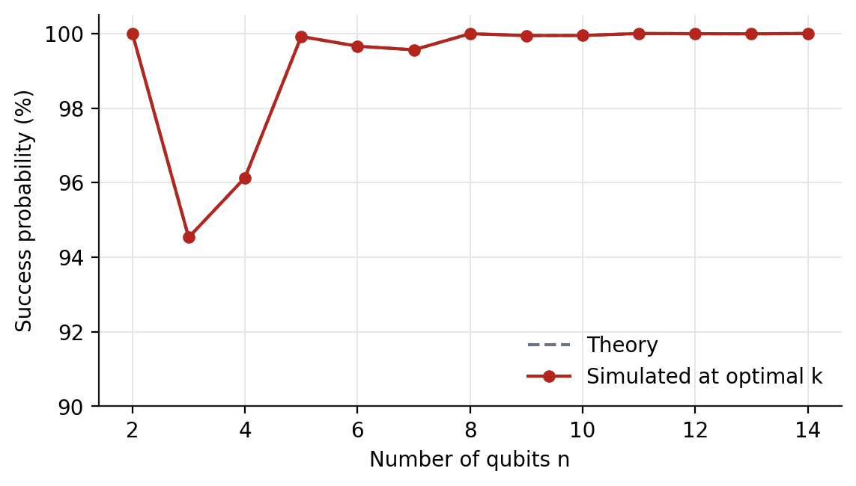
Figure 8. Success probability at the optimal iteration count against n.

7.5 More than one secret item
With M marked items the rotation per iteration is larger and fewer iterations are needed: k_{opt} ≈ (π/4)√(N/M) (Table 5). The classical average also improves, to (N+1)/(M+1), so the quadratic relationship is unchanged.
Table 5. Effect of the number of marked items M.
n | N | M | Classical (avg) | Grover k | P(success)
6 | 64 | 1 | 32.5 | 6 | 99.66%
6 | 64 | 2 | 21.7 | 4 | 99.92%
6 | 64 | 4 | 13.0 | 3 | 96.13%
8 | 256 | 1 | 128.5 | 12 | 99.99%
8 | 256 | 2 | 85.7 | 8 | 99.56%
8 | 256 | 4 | 51.4 | 6 | 99.66%
10 | 1,024 | 1 | 512.5 | 25 | 99.95%
10 | 1,024 | 2 | 341.7 | 17 | 99.94%
10 | 1,024 | 4 | 205.0 | 12 | 99.99%

7.6 Simulation time against classical time
Table 6 and Figure 9 give wall-clock times. On the same processor, simulating Grover’s circuit is far slower than the classical search, by a factor of about 3,297 at n = 14 (138.6 ms against 0.042 ms). This is expected: the simulator pays 2^{n} operations for every gate, so its run time grows roughly as 2^{3n/2} while the classical search grows as 2^{n}. The result is not evidence against Grover’s algorithm. It shows that a simulator cannot demonstrate the speed-up, and that the advantage can only be realised on quantum hardware, where the 2^{n} amplitudes are held physically by n qubits.
Table 6. Measured times and the logical gate counts of the executed circuit.
n | Classical time (µs) | Simulation time (ms) | H gates | X gates | MCZ gates
2 | 0.02 | 0.17 | 6 | 4 | 2
3 | 0.04 | 0.15 | 15 | 20 | 4
4 | 0.05 | 0.24 | 28 | 36 | 6
5 | 0.09 | 0.24 | 45 | 64 | 8
6 | 0.24 | 0.07 | 78 | 120 | 12
7 | 0.45 | 0.19 | 119 | 192 | 16
8 | 0.91 | 0.47 | 200 | 264 | 24
9 | 1.56 | 0.53 | 315 | 476 | 34
10 | 3.41 | 1.80 | 510 | 650 | 50
11 | 4.37 | 5.37 | 781 | 1,190 | 70
12 | 9.72 | 14.82 | 1,212 | 1,700 | 100
13 | 23.63 | 43.45 | 1,859 | 2,698 | 142
14 | 42.03 | 138.57 | 2,814 | 4,200 | 200

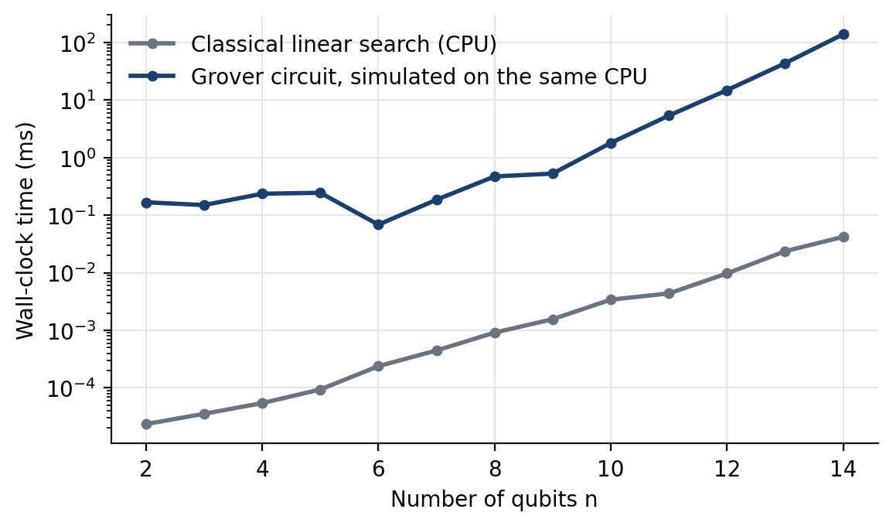
Figure 9. Wall-clock time: classical search against simulation of the Grover circuit on the same CPU (log scale). The small dip near n = 6 is JIT warm-up noise.

7.7 Validation summary
Over the whole benchmark the largest difference between the simulated success probability and the closed-form value is 3.9e-13, which is floating-point rounding. Together with the unit tests of Section 5.6, this shows that the circuit implemented is Grover’s algorithm and that the simulator is faithful.

8. Classical versus Quantum Comparison
Table 7 summarises the comparison. The quantum column describes an ideal fault-tolerant machine; the measured results for this project are in Section 7.
Table 7. Classical linear search compared with Grover’s algorithm.
Factor | Classical linear search | Grover’s algorithm
Query complexity | O(N); (N+1)/2 on average | O(√N); about 0.785·√N
Queries at n = 14 | 8,199 (average) | 100
Result | Deterministic, exact | Probabilistic; ≥ 99.5% at n ≥ 5 here
Extra knowledge | None | Number of marked items M, to choose k
Memory | O(1) beyond the data | n qubits, plus about n−2 ancillas
Oracle | Any function call | Must be a reversible quantum circuit
Parallelism | p machines give a factor p | p machines give only a factor √p
Sensitivity to errors | Negligible | Very high; circuit depth grows as n√N
Hardware | Any CPU | Fault-tolerant quantum computer for large N
Measured time here | 0.042 ms at n = 14 | 139 ms (simulation)

9. Resource Requirements

9.1 Qubits and gates
The register needs n = log₂N qubits. Implementing the multi-controlled Z gates with Toffoli gates adds n−2 ancilla qubits, for 2n−2 logical qubits in total (26 at n = 14, 58 at n = 30). Qubit requirements therefore grow only linearly with n.
Circuit length is the real cost. Each iteration contains two multi-controlled Z gates, each about 2n−3 Toffolis, so the total number of two-qubit gates is about k·2(2n−3)·6, which grows as n·√N (Table 8, Figure 10). At n = 14 the circuit has about 30,000 two-qubit gates; at n = 30 about 1.8 × 10⁷.
Table 8. Estimated resources for Grover’s algorithm with one marked item and a simple comparison oracle.
n | N | Iterations | Logical qubits | Toffoli | Two-qubit gates | Single-qubit gates
8 | 256 | 12 | 14 | 3.12 × 10² | 1.87 × 10³ | 3.38 × 10³
10 | 1,024 | 25 | 18 | 8.50 × 10² | 5.10 × 10³ | 9.15 × 10³
14 | 16,384 | 100 | 26 | 5.00 × 10³ | 3.00 × 10⁴ | 5.34 × 10⁴
20 | 1,048,576 | 804 | 38 | 5.95 × 10⁴ | 3.57 × 10⁵ | 6.32 × 10⁵
30 | 1.07 × 10⁹ | 25,735 | 58 | 2.93 × 10⁶ | 1.76 × 10⁷ | 3.10 × 10⁷
40 | 1.10 × 10¹² | 823,549 | 78 | 1.27 × 10⁸ | 7.61 × 10⁸ | 1.34 × 10⁹

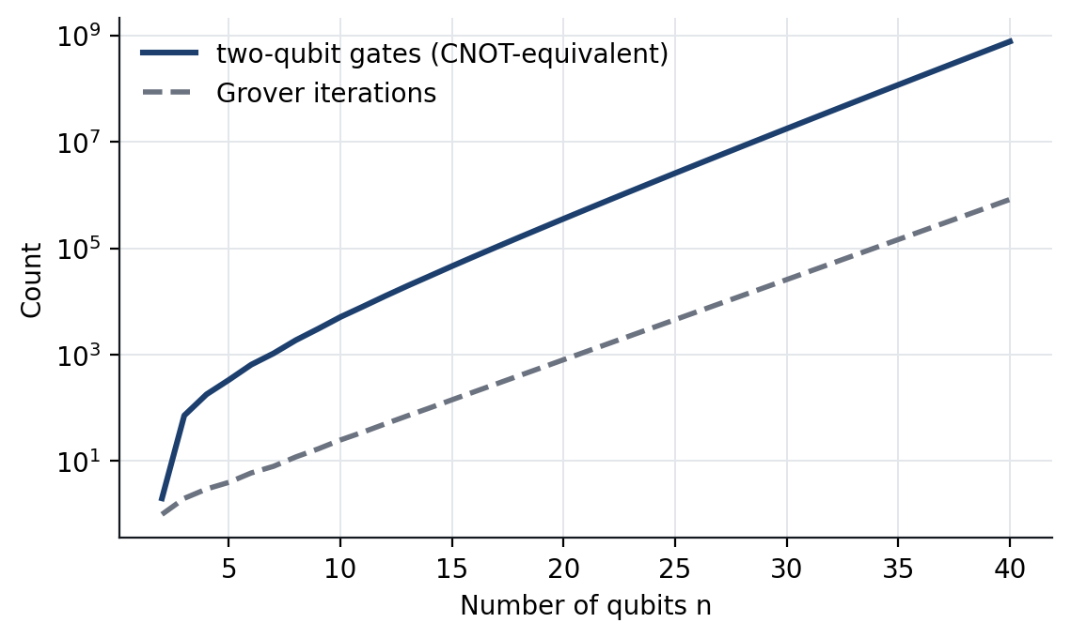
Figure 10. Two-qubit gate count and Grover iterations against n (log scale).

9.2 Effect of noise
Every gate has a small chance of error, and a circuit of thousands of gates multiplies those chances. If each two-qubit gate fails with probability p, the whole circuit succeeds with fidelity of about (1−p)^{number of gates}. Table 9 and Figure 11 show what this does at n = 14, where the circuit has about 30,000 two-qubit gates: at an error rate of 10⁻³, roughly the best available today, the fidelity is 4.4 × 10⁻¹⁶ and the run essentially always fails; only at 10⁻⁶ does it succeed (96.5%). Larger circuits are more fragile: going from n = 10 to n = 20 multiplies the two-qubit gate count by about 70, so the error rate must fall by about the same factor to keep the same success probability.
Table 9. Fidelity and success probability at n = 14 (100 iterations).
Two-qubit error rate | Circuit fidelity | Success probability
1 × 10⁻² | 7.1 × 10⁻¹⁵⁵ | 0.006%
1 × 10⁻³ | 4.4 × 10⁻¹⁶ | 0.006%
1 × 10⁻⁴ | 2.9 × 10⁻² | 2.9%
1 × 10⁻⁶ | 9.7 × 10⁻¹ | 96.5%

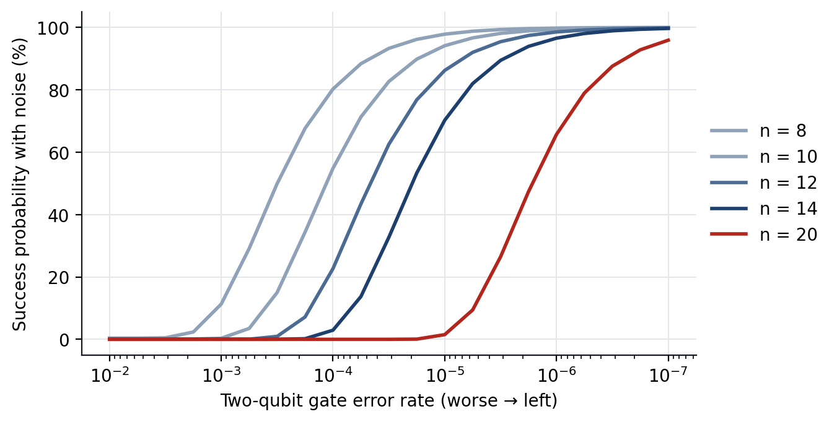
Figure 11. Success probability of Grover’s algorithm under the noise model, for several n.

9.3 Where could the quantum run be faster?
Comparing the ideal quantum run time with a classical core that checks a guess in 1 µs (Figure 12), the quantum circuit stays ahead from n = 14 upward when the oracle is the simple n-bit comparison. That comparison counts only gate time. Once noise is included, the picture narrows: at an error rate of 10⁻⁶ there is a window of about n = 14 to 21 where the circuit is both faster and correct at least half the time (at n = 20 the model gives 84.0 ms against 524.3 ms classically, with fidelity 66%); at n = 30 the fidelity is 1.0 × 10⁻⁹ and the run is useless. At error rates of 10⁻³ or 10⁻⁴ there is no usable window at all.
A realistic oracle changes the balance further. If checking a guess costs the quantum machine 5,000 Toffoli gates (a modest hash-style circuit), the sustained crossover moves from n = 14 to n = 27, and none of the error rates tested (10⁻² to 10⁻⁶) gives a usable window, because each iteration is so much longer.
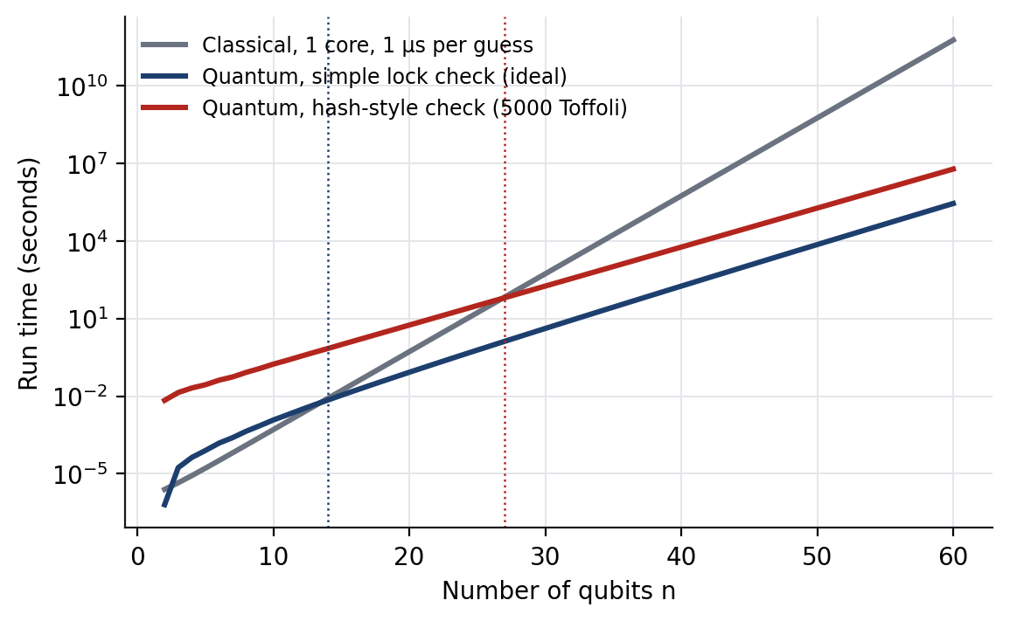
Figure 12. Ideal run time: one classical core against the quantum circuit for a simple oracle and for a 5,000-Toffoli oracle. Dotted lines mark the sustained crossover.

9.4 Error correction
The results above are why practical Grover search is expected to need fault-tolerant machines. A rough figure of 1,000 physical qubits per logical qubit gives about 26,000 physical qubits for n = 14 and 58,000 for n = 30, before the extra cost of implementing non-Clifford gates such as Toffoli fault-tolerantly. Such machines are far beyond the devices available today.

10. Practical Advantages
- A proven query reduction. The quadratic reduction in oracle queries holds for any unstructured search problem, and it is optimal.
- Modest qubit count. Only log₂N data qubits are needed, plus about n−2 ancillas, so the register is small even for enormous search spaces.
- No special structure needed. The algorithm requires only the ability to build the oracle; the problem need not be sorted, indexed or otherwise organised.
- A reusable building block. Amplitude amplification, the core idea, is used inside other algorithms, including quantum counting, minimum finding and speed-ups of backtracking search.
- Relevance to security. Brute-force search for a k-bit symmetric key needs about 2^{k−1} guesses classically and about 0.785·2^{k/2} Grover iterations, which effectively halves the key length; for k = 128 the iteration count is about 2^{63.7}. This is why doubling symmetric key sizes is the usual recommendation for long-term security. In practice each iteration also requires a full reversible cipher circuit, so real attacks cost much more than the iteration count suggests.

11. Limitations
- Oracle cost. Real checks such as a hash or a cipher become large reversible circuits. Section 9.3 shows that a 5,000-Toffoli oracle removes any usable advantage in the model.
- Database lookup. Loading N classical records into a quantum memory costs at least N operations, which erases the advantage; Grover’s algorithm helps only when the oracle can compute membership directly.
- Noise and depth. The circuit length grows as n√N, and without error correction the fidelity collapses (Section 9.2).
- Only quadratic. Constant factors and slower quantum gate times can offset a quadratic gain, as the crossover analysis shows.
- Poor parallelism. Grover iterations are sequential. Splitting the search across p classical machines divides the work by p, but p quantum machines reduce the time only by √p.
- Iteration count. The algorithm needs M, or an estimate of it, and overshooting reduces the success probability (Figure 6).
- Limits of this study. The simulation is exact but ideal; noise is modelled analytically and not injected into the circuit, and the resource figures are back-of-envelope estimates for comparing trends. Timings depend on the machine.

12. Conclusion
This project implemented Grover’s search algorithm as an explicit gate-level circuit, verified it against theory, and evaluated it against classical linear search. Five findings stand out.
- The implementation is correct. The simulated success probability matches sin²((2k+1)θ) to within rounding for every iteration count and size tested.
- The query advantage is real and quadratic. For N = 16,384 Grover needs 100 queries against 8,199 on average, a 82× reduction, and the gap widens as √N.
- Success is probabilistic but high. At least 99.5% for n ≥ 5, provided the iteration count is chosen correctly.
- A simulator cannot show the speed-up. Simulation time grows much faster than classical search; only quantum hardware can realise the query advantage.
- Noise and oracle cost limit practical advantage. Qubit needs are modest, but circuit length makes noisy hardware fail, and a realistic oracle shifts the crossover far out.
In short, Grover’s algorithm reduces oracle-query complexity from O(N) to O(√N), at the cost of quantum hardware, probabilistic measurement and deep circuits. On today’s noisy machines it is not a practical win. Its value is as a foundation: an optimal method that becomes relevant with error-corrected quantum computers, and a reason to lengthen symmetric keys now.

13. Future Scope
- Run the same circuit on a cloud quantum device or with a noisy simulator, and measure how the success probability actually falls.
- Inject noise into the simulation (depolarising errors per gate) instead of using the analytical model.
- Implement a real reversible oracle, such as a small hash or a SAT formula, to measure the true cost of the oracle.
- Add quantum counting to estimate M, and fixed-point amplitude amplification to avoid overshooting.
- Export the circuit as OpenQASM and run it in Qiskit for cross-checking.

References
- L. K. Grover, "A fast quantum mechanical algorithm for database search," in Proc. 28th Annual ACM Symposium on Theory of Computing (STOC), 1996, pp. 212–219.
- C. H. Bennett, E. Bernstein, G. Brassard and U. Vazirani, "Strengths and weaknesses of quantum computing," SIAM Journal on Computing, vol. 26, no. 5, pp. 1510–1523, 1997.
- M. Boyer, G. Brassard, P. Høyer and A. Tapp, "Tight bounds on quantum searching," Fortschritte der Physik, vol. 46, pp. 493–505, 1998.
- C. Zalka, "Grover’s quantum searching algorithm is optimal," Physical Review A, vol. 60, pp. 2746–2751, 1999.
- G. Brassard, P. Høyer, M. Mosca and A. Tapp, "Quantum amplitude amplification and estimation," in Quantum Computation and Information, AMS Contemporary Mathematics, vol. 305, 2002.
- M. A. Nielsen and I. L. Chuang, Quantum Computation and Quantum Information, Cambridge University Press, 2010 (Chapter 6: Quantum search algorithms).

Appendix A. Running the Project
Requirements: Node.js 18 or newer. From the repository root (https://github.com/Kavin-JS/GrovX):
npm install
npm run dev # opens http://localhost:5173/GrovX/
npm test # 12 unit tests
npm run build # production build in dist/
npm run build:docs # production build in docs/ for GitHub Pages

The deployed website is at https://Kavin-JS.github.io/GrovX/. The pages are Home, Algorithm, Lab, Benchmarks, Resources and Evaluation. The Lab page runs both searches for a chosen n, secret and number of secrets; the Benchmarks page reruns the sweep of Section 7 in the browser and exports the data as CSV.

Appendix B. Code Excerpts
The core of the implementation is short. The oracle, diffusion and iteration are built as gate lists (src/quantum/grover.js):
const range = (n) => Array.from({ length: n }, (_, i) => i);

export function oracleOps(n, target) {
const flips = range(n).filter((q) => !((target >> q) & 1))
.map((q) => ({ g: 'X', q }));
return [...flips, { g: 'MCZ', qs: range(n) }, ...flips];
}

export function diffusionOps(n) {
const qs = range(n);
return [
...qs.map((q) => ({ g: 'H', q })), ...qs.map((q) => ({ g: 'X', q })),
{ g: 'MCZ', qs },
...qs.map((q) => ({ g: 'X', q })), ...qs.map((q) => ({ g: 'H', q })),
{ g: 'GP' }, // cancel the global -1
];
}

The multi-controlled Z gate in the simulator visits only the amplitudes whose index has all control bits set (src/quantum/simulator.js):
mcz(qubits) {
let mask = 0;
for (const q of qubits) mask |= 1 << q;
const { a, N } = this;
for (let i = mask; i < N; i = (i + 1) | mask) a[i] = -a[i];
}

The optimal iteration count and the success probability are the two closed-form results used to check the circuit:
const theta = (N, M = 1) => Math.asin(Math.sqrt(M / N));
const optimalIterations = (N, M = 1) =>
Math.max(0, Math.round(Math.PI / (4 * theta(N, M)) - 0.5));
const theoreticalProbability = (N, M, k) =>
Math.pow(Math.sin((2 * k + 1) * theta(N, M)), 2);

