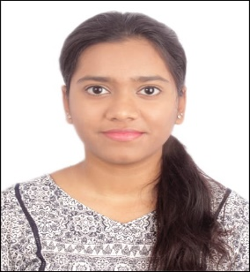
R I D A I S M A I L Mobile: +91-7259652904
Email: irida4104@gmail.com
LinkedIn: https://www.linkedin.com/in/rida-ismail4/
P R O F I L E S U M M A R YBCA student with hands-on experience in SQL, Python, and Excel. Skilled in data analysis, visualization, and reporting through internships and projects. Detail-oriented and motivated to apply analytical and problem-solving skills to contribute as an Analyst Trainee at Cognizant.
S K I L L S
- Technical Proficiency: Microsoft Excel, MySQL, Python, C++, HTML, CSS, JavaScript, PowerPoint, and Word.
- Data and Analysis Tools: Jupyter Notebook, RStudio, Tableau (in progress)
- Core Competencies: Data Cleaning & Transformation, Analytical Thinking, Requirement Analysis, Problem-Solving, Visualization, Team Collaboration, Proactive Learning
E D U C A T I O N
- Bachelors of Computer Applications (BCA) 2023 - 2026
Pursuing 3rd year at Mount Carmel Autonomous College, Bangalore, Karnataka
- Completed PUC with Distinction from M.E.S Indian School – Doha, Qatar 2021 - 2022
- Achieved Distinction in schooling at Sri Chaitanya Techno School, Bangalore 2020
W O R K E X P E R I E N C EGaoTek Inc May – June 2025
Web Developer Intern
- Created, uploaded and managed industry pages on the WordPress website.
- Implemented front-end features using HTML, CSS, and JavaScript based on UI/UX requirements.
Unified Mentor July - August 2025
Data Analyst Intern
- Analyzed content performance trends to identify areas of improvement and implemented data-driven updates.
- Used Excel/other tools to track metrics, generate simple reports, and support decision-making.
P R O J E C T S / C E R T I F I C A T I O N
- Analyzed E-commerce Furniture Sales data in Python and Excel to find top products and seasonal trends.
- Examined Electric Vehicle Adoption Trends in India using Python and Tableau to identify growth patterns.
- Currently pursuing Tableau BI (Beginner to Advanced) certification from SmartInternz – In Progress.
- Developed a responsive School Website using HTML & CSS with dedicated sections for all levels.

