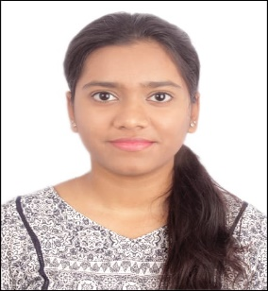
R I D A I S M A I L Mobile: +91-7259652904
Email: irida4104@gmail.com
LinkedIn: https://www.linkedin.com/in/rida-ismail4/
P R O F I L E S U M M A R YBCA student with strong foundations in Python, SQL, and Excel. Hands-on experience in data cleaning, transformation, and visualization through projects and internships. Skilled in building dashboards and generating insights, with exposure to ETL workflows and BI tools. Curious learner, motivated to grow at the intersection of data analysis, engineering, and business intelligence.
S K I L L S
- Technical Proficiency: Python (Pandas, NumPy), SQL, Excel, Tableau, Power BI, Jupyter Notebook
- Data Skills: Data Cleaning, Transformation, Visualization, Dashboards, Basic ETL concepts
- Other Tools: C++, HTML, CSS, JavaScript, RStudio, WordPress
- Core Competencies: Analytical Thinking, Problem-Solving, Team Collaboration, Fast Learner
E D U C A T I O N
- Bachelors of Computer Applications (BCA) 2023 - 2026
Pursuing 3rd year at Mount Carmel Autonomous College, Bangalore, Karnataka
- Completed PUC with Distinction from M.E.S Indian School – Doha, Qatar 2021 - 2022
- Achieved Distinction in schooling at Sri Chaitanya Techno School, Bangalore 2020
W O R K E X P E R I E N C EGaoTek Inc May – June 2025
Web Developer Intern
- Created, uploaded and managed industry pages on the WordPress website.
- Implemented front-end features using HTML, CSS, and JavaScript based on UI/UX requirements.
Unified Mentor July - August 2025
Data Analyst Intern
- Analyzed content performance trends to identify areas of improvement and implemented data-driven updates.
- Used Excel/other tools to track metrics, generate simple reports, and support decision-making.
P R O J E C T S / C E R T I F I C A T I O N
- Analyzed E-commerce Furniture Sales data in Python and Excel to find top products and seasonal trends.
- Examined Electric Vehicle Adoption Trends in India using Python and Tableau to identify growth patterns.
- Currently pursuing Tableau BI (Beginner to Advanced) certification from SmartInternz – In Progress.
- Developed a responsive School Website using HTML & CSS with dedicated sections for all levels.

