ABOUT US AND CONTACT

CODE:

<!DOCTYPE html>

<html lang="en">

<head>

    <meta charset="UTF-8">

    <meta name="viewport" content="width=device-width, initial-scale=1.0">

    <title>About Us - Flavour fusion</title>

</head>

<body style="background-color: rgb(255, 218, 185);">

    <table style="width: 100%; border-collapse: collapse;">

        <tr>

            <td></td> <!-- Left margin -->

            <td style="text-align: center; padding: 20px; background-color: rgb(255, 218, 185)">

                <h1>Flavour fusion</h1>

                <p><b>Delicious Moments, Memorable Experiences</b></p>

            </td>

            <td></td> <!-- Right margin -->

        </tr>

        <tr>

            <td></td>

            <td style="text-align: center;">

                <img src="c:\Users\Kavin parithi\Pictures\front end.jpg" alt="Restaurant Image" style="max-width: 100%; height: auto; border-radius: 4px; width: 25%;">

            </td>

            <td></td>

        </tr>

        <tr>

            <td></td>

            <td style="text-align: left; padding: 20px;">

                <h2>About Us</h2>

                <img src = "c:\Users\Kavin parithi\Pictures\restaurant.jpg" width="700" height="440" alt="scissors" title="not recommended" style="float: left; margin-right: 40px; margin-bottom: 20px;">

                <font face = "Helvetica" size:16px >

                <p>The journey of Flavour Fusion is a tale woven with passion, diversity, and a shared dream among its founders Kavin, Manish, Durga, and Karan. What began as individual culinary pursuits eventually converged into a collective vision, giving birth to a restaurant that celebrates the richness of global flavors</p>

                <p><b>Inception</b> The story begins with Kavin's vision to create a dining establishment that transcends traditional boundaries. His passion for diverse cuisines and innovative culinary concepts ignited the spark that would later become Flavour Fusion. The idea took shape as he shared his dream with Manish, a skilled chef with a worldly palate and a knack for crafting exceptional dishes.</p>

                <p><b>Culinary Collaboration:</b> With Kavin's vision and Manish's culinary expertise, the duo laid the foundation for Flavour Fusion. As the menu began to take form, Durga joined the team, bringing her warmth and hospitality. Together, they envisioned a space where patrons could experience a melting pot of flavors, reflecting the rich tapestry of global cuisine.</p>

                <p><b>The Heart of Hospitality:</b> Durga's touch transformed Flavour Fusion into more than just a restaurant—it became a home away from home. Her dedication to creating an inviting atmosphere ensured that every guest felt a sense of belonging, making the dining experience at Flavour Fusion truly exceptional.</p>

                <p><b>Strategic Growth:</b> As the restaurant gained momentum, Karan joined the team, injecting his business acumen into the mix. His strategic approach ensured the seamless operation and growth of Flavour Fusion, allowing the restaurant to not only survive but thrive in a competitive culinary landscape.</p>

                <p><b>Culmination of Dreams:</b> Today, Flavour Fusion stands as a testament to the collective dreams and efforts of Kavin, Manish, Durga, and Karan. The restaurant is a haven for food enthusiasts seeking an immersive culinary experience that goes beyond borders. Each dish is a result of their shared dedication to excellence, cultural diversity, and the joy of creating memorable dining moments.</p>

                <p>The first branch of Flavour fusion,  opened its doors to customers in 1968. This was at a time when the city’s restaurant industry was dominated by two giants —Kenneis Bhavan and Ideal Coffee house. The two groups enjoyed a reputation as the food factories of Chennai because of the massive volumes of food they would produce. Though these two giants were located close by, we did not aim at competing with them We only wanted to satisfy the hunger of those who came in search of us.</p>

                </font>

                <img src = "c:\Users\Kavin parithi\Pictures\food2.jpeg" width="500" height="300" alt="scissors" title="not recommended" style="float: right; margin-right: 40px; margin-bottom: 20px;" />

                <b>Vision</b><br>

                     <p align = "left">Be constantly changing & evolving to remain the most preferred choice of food lovers</p><br>

                <b>Mission</b><br>

                    <p align = "left"> Our mission is to provide quality services that exceed customer expectations</p><br>

                    <b>Values</b><br>

                    • Excellent Hospitality Service<br>

                    • Passion to delight Foodies<br>

                    • Caring for people Health<br>

                    • Contribute to Environmental Safety

                    <h3 align = "center">Our Clients</h3>

                    <img src = "c:\Users\Kavin parithi\Pictures\clients.png" width="1500" height="300" alt="scissors" title="not recommended" style="float: center; margin-right: 40px; margin-bottom: 20px;" />

            <b>Contact Us</b><br>

                     Corporate Office<br>

                     418, Ashok nagar, Chennai – 641043.<br>

                     +91 422 4522444 , +91 422 2437722<br>

                     office@flavourfusion.com<br>

            <h4>Contact form</h4>

            <form action="#" method="post">

                <table>

                    <tr>

                        <td><label for="firstName">First Name:</label></td>

                        <td><input type="text" id="firstName" name="firstName" required></td>

                    </tr>

                    <tr>

                        <td><label for="email">Email ID:</label></td>

                        <td><input type="email" id="email" name="email" required></td>

                    </tr>

                    <tr>

                        <td><label for="phoneNumber">Phone Number:</label></td>

                        <td>

                            <input type="tel" id="phoneNumber" name="phoneNumber" pattern="[0-9]{10}" required>

                            <small>Enter a 10-digit phone number without spaces or dashes</small>

                        </td>

                    </tr>

                    <tr>

                        <td><label for="comments">Comments:</label></td>

                        <td><textarea id="comments" name="comments" rows="4" required></textarea></td>

                    </tr>

                    <tr>

                        <td colspan="2"><input type="submit" value="Submit"></td>

                    </tr>

                </table>

            </form>

            </td>

            <td></td>

        </tr>

    </table>

</body>

</html>

IMAGES



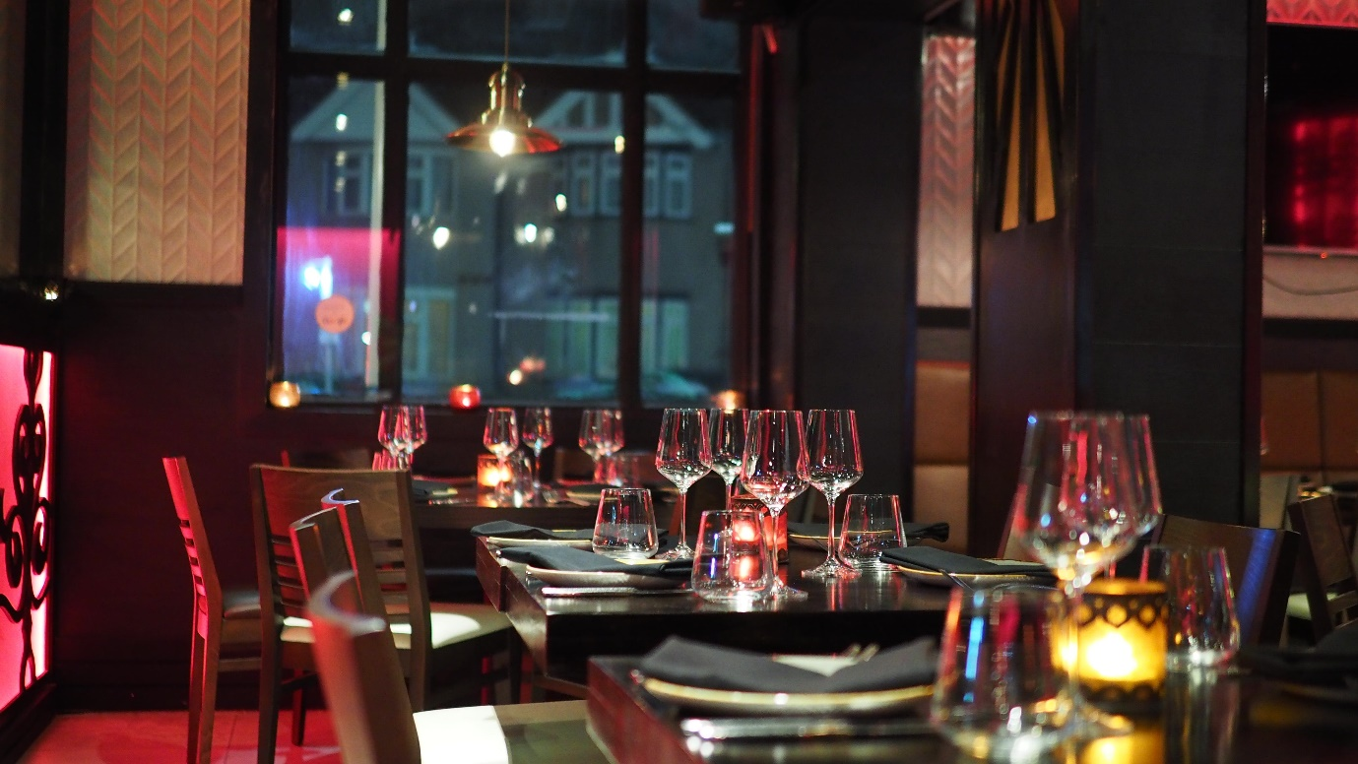

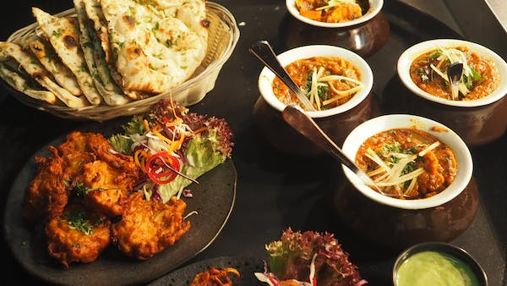



BLOG

CODE:

<!DOCTYPE html>

<html lang="en">

<head>

    <meta charset="UTF-8">

    <meta name="viewport" content="width=device-width, initial-scale=1.0">

    <title>Flavour Fusion Restaurant Blog</title>

</head>

<body style="background-color: rgb(255, 218, 185);">

    <header>

        <center>

            <h1><font size = "10">Flavour Fusion</font></h1>

            <p>The finest quality of restaurant</p>

        </center>

        <p style="float: right">Need help? Call us:3456789012/8721307645<br>

        Email enquiry:flavourfusion5@gmail.com</p>

        <div>

            <label for="stateSearch">Select a State:</label>

            <select id="stateSearch">

                <option value="Andhra Pradesh">Andhra Pradesh</option>

                <option value="Arunachal Pradesh">Arunachal Pradesh</option>

                <option value="Assam">Assam</option>

                <option value="Bihar">Bihar</option>

                <option value="Chhattisgarh">Chhattisgarh</option>

                <option value="Goa">Goa</option>

            </select>

        </div>

        <img src = "c:\Users\Kavin parithi\Pictures\front end.jpg" width="1500" height="440" alt="scissors" title="not recommended">

        <h2 align="center">Our menu</h2>

        <img src = "c:\Users\Kavin parithi\Pictures\Menu.png" width="1500" height="360" alt="scissors" title="not recommended">

        <h3 align="center"><font size="5">Our services</font></h3>

        <table cellspacing="20" align="center">

            <tr>

                <td>

                    <img src="c:\Users\Kavin parithi\Pictures\IM1.png" width="300" height="340" alt="scissors" title="not recommended">

                </td>

                <td>

                    <img src="c:\Users\Kavin parithi\Pictures\IM2.png" width="300" height="340" alt="scissors" title="not recommended">

                </td>

                <td>

                    <img src="c:\Users\Kavin parithi\Pictures\IM3.png" width="300" height="340" alt="scissors" title="not recommended">

                </td>

            </tr>

            <tr>

                <td>

                    <img src="c:\Users\Kavin parithi\Pictures\IM4.png" width="300" height="340" alt="scissors" title="not recommended">

                </td>

                <td>

                    <img src="c:\Users\Kavin parithi\Pictures\IM5.png" width="300" height="340" alt="scissors" title="not recommended">

                </td>

                <td>

                    <img src="c:\Users\Kavin parithi\Pictures\IM6.png" width="300" height="340" alt="scissors" title="not recommended">

                </td>

            </tr>

        </table>

        <h4 align="center"><font size="5">Enquire now</font></h4>

        <table cellspacing="80">

            <tr>

                <td>

        <font size = "4">

        <p><b>Career</b><br>

            WE REQUIRE FULL TIME / PART TIME - For our Indian vegetarian restaurants in different<br>

            locations<br>

        </p>

        </font>

                </td>

            <td>

                    <font size = "4">

                    <p><b>Franchise</b><br>

                        This form will help you present your<br>

                        personal and business information<br>

                        essential for considering your application.<br>

                        Please complete it thoroughly and note<br>

                        that completing this application form<br>

                        places no continuing obligation on you<br>

                         and or Saravana Bhavan.

                    </p>

                    </font>

                </td>

                <td>

                    <font size = "4">

                    <p><b>Feedback</b><br>

                        Your response matters the most to us<br>

                    </p>

                    </font>

                </td>

            </tr>

        </table>

    <h5 align ="center"><font size="5">Chef's recommendations</font></h5>

    <table cellspacing="10" align="center">

        <tr>

            <td>

                <img src="c:\Users\Kavin parithi\Pictures\DM1.png" width="300" height="340" alt="scissors" title="not recommended">

            </td>

            <td>

                <img src="c:\Users\Kavin parithi\Pictures\DM2.png" width="300" height="340" alt="scissors" title="not recommended">

            </td>

            <td>

                <img src="c:\Users\Kavin parithi\Pictures\DM3.png" width="300" height="340" alt="scissors" title="not recommended">

            </td>

            <td>

                <img src="c:\Users\Kavin parithi\Pictures\DM4.png" width="300" height="340" alt="scissors" title="not recommended">

            </td>

        </tr>

<table cellspacing="0" cellpadding="0" border="0" width="100%">

    <tr>

        <td bgcolor="green" height="4"></td>

    </tr>

    <table cellspacing="10" cellpadding="5" border="0" width="100%">

        <tr>

            <td>

                <table cellspacing="10" bgcolor="lightpink" width="100%">

                    <tr>

                        <td>

                            <font size="3">

                                <p>

                                    <b>OTHER SERVICES</b><br>

                                    Outdoor catering<br>

                                    Sweets and Savouries<br>

                                    Fresh Bakes<br>

                                    Dairy Products<br>

                                </p>

                            </font>

                        </td>

                        <td>

                            <font size="3">

                                <p>

                                    <b>CONTACTS</b><br>

                                    7708967755 / 7401005577<br>

                                    feedback@flavourfusion.com<br>

                                    flavourfusion.co.in<br>

                                </p>

                            </font>

                        </td>

                        <td>

                            <font size="3">

                                <p>

                                    <b>QUICK LINKS</b><br>

                                    About us<br>

                                    Our Menu <br>

                                    Contact Us<br>

                                </p>

                            </font>

                        </td>

                        <td>

                            <font size="3">

                                <p>

                                    <b>Follow us</b><br>

                                    Facebook<br>

                                    Twitter<br>

                                    Instagram<br>

                                    Youtube<br>

                                </p>

                            </font>

                        </td>

                    </tr>

                </table>

            </td>

        </tr>

        <tr>

            <td bgcolor="green" height="4"></td>

        </tr>

    </table>

    <details>

        <summary>Welcome to Flavour Fusion! Connect to chat</summary>

    </details>

</body>

</html>

PICTURES

