Supply Chain Analysis
Diagnostic & Comparative Report
Project Code: CDACL-003
Data source: Live MySQL database (project_supply_chain_data)
Kavin V
ID: PTID-CDA-SEP-26-11151

Table of Contents
1. Executive Summary 3
2. Methodology 3
3. Data Profiling & Quality Assessment 4
4. Diagnostic Findings 4
5. Product Type Comparison Report 6
6. Interactive Dashboard 7
7. Recommendations 9
8. Conclusion 9

1. Executive Summary
This report presents a diagnostic and comparative analysis of the supply chain dataset for CDACL-003, covering 100 SKUs across three product categories — cosmetics, haircare, and skincare — sourced live from the project's MySQL database.
Skincare generates the highest total revenue and unit volume, but cosmetics is the only product category where average price covers average manufacturing and shipping cost, and it also leads on defect rate and lead time. Logistics analysis identifies Route B as a cost inefficiency, and location analysis flags Delhi as an underperforming market despite a comparable SKU count to other cities.
Key numbers at a glance:
- Total revenue across all products: INR 5,77,604.82
- 100 SKUs, 0 data quality issues (no nulls, duplicates, negatives, or outliers)
- Best-performing supplier: Supplier 1 (lowest defect rate, fastest lead time)
- Cost inefficiency identified: Route B (~20% costlier than Route A/C with no speed advantage)

2. Methodology
Data was accessed directly from the project's live MySQL database rather than a static export, ensuring the analysis reflects the current state of the dataset at time of reporting.

2.1 Data Source
- Database: project_supply_chain_data (MySQL, live connection)
- Tables used: supply_chain_data (100 rows × 24 columns), Supplier_Performance (3 rows, reference only)

2.2 Process
- Connect: established a live connection to the database
- Profile: reviewed shape, data types, and unique categorical values
- Clean: checked for nulls, duplicates, negative values, and statistical outliers
- Analyze: ran diagnostics across revenue, stock, lead time, cost, quality, carriers, suppliers, and location
- Visualize: built a 3-page interactive Power BI dashboard connected live to the database

3. Data Profiling & Quality Assessment
The main dataset required no cleaning — it was submission-ready as pulled from the database. Two structural observations were noted and preserved rather than treated as errors:
Check | Result
Missing values | None
Duplicate rows | None
Duplicate SKUs | None (100 of 100 unique)
Negative values | None across any numeric column
Outliers (IQR method) | None on Price, Revenue, Shipping/Manufacturing costs, Defect rates
'Lead times' vs 'Lead time' | Confirmed distinct metrics (correlation ≈ 0)
Revenue vs Price × Units sold | Revenue generated is an independent field, not derived from Price × Units

Note on the reference table: Supplier_Performance uses supplier names “Supplier A/B/C”, while the main dataset uses “Supplier 1–5”. These do not match in either naming convention or count, so the two tables were kept independent throughout this analysis rather than joined.

4. Diagnostic Findings

4.1 Revenue & Volume
Skincare leads on both total revenue (INR 2,41,628.16) and unit volume, driven by scale rather than price — its average price (47.26) is close to haircare's (46.01). Cosmetics carries the highest average price (57.36) but the lowest sales volume of the three categories.

4.2 Stock vs. Demand
Skincare carries the tightest stock-to-sold ratio (0.08) of the three product types, meaning it is sold closest to the edge of available stock — a stockout risk worth monitoring. Cosmetics carries the largest buffer (0.13).

4.3 Lead Time
Cosmetics has the shortest manufacturing lead time (13.31 days); haircare runs longest (17.06 days). Shipping times are more evenly matched across categories (5.3–6.6 days).

4.4 Quality & Inspection
Items marked “Fail” on inspection show a higher average defect rate (2.57%) than those marked “Pass” (2.04%) — an internally consistent result that supports the reliability of the inspection data.

4.5 Supplier Performance
Supplier 1 is the strongest performer, combining the lowest defect rate with a competitive lead time. Supplier 5 has the highest defect rate; Supplier 4 has the highest average cost without a corresponding quality advantage.
Supplier | Avg Defect Rate (%) | Avg Total Cost | Avg Mfg Lead Time (days)
Supplier 1 | 1.80 | 574.85 | 12.59
Supplier 2 | 2.36 | 515.03 | 15.59
Supplier 3 | 2.47 | 468.80 | 14.93
Supplier 4 | 2.34 | 521.81 | 15.33
Supplier 5 | 2.67 | 536.02 | 16.33
Table 1: Supplier performance summary (from supply_chain_data)

4.6 Carrier Performance
Carrier B is both the fastest and least expensive of the three carriers; Carriers A and C are closely matched.
Carrier | Avg Shipping Time (days) | Avg Shipping Cost
Carrier A | 6.14 | 5.55
Carrier B | 5.30 | 5.51
Carrier C | 6.03 | 5.60
Table 2: Shipping carrier performance

4.7 Route Performance
Route B costs noticeably more than Routes A and C without a corresponding improvement in shipping time — a clear cost-efficiency gap.
Route | Avg Cost | Avg Shipping Time (days)
Route A | 485.48 | 6.02
Route B | 595.66 | 5.70
Route C | 500.47 | 5.25
Table 3: Route performance

4.8 Location Performance
Mumbai and Kolkata lead on total revenue. Delhi produces the lowest revenue of the five cities despite having a mid-sized SKU count (15), comparable to Bangalore (18) — this is flagged for further investigation rather than fully explained by the current dataset.
Location | Total Revenue (INR) | Avg Defect Rate (%) | SKU Count
Bangalore | 1,02,601.72 | 2.09 | 18
Chennai | 1,19,142.82 | 2.64 | 20
Delhi | 81,027.70 | 2.23 | 15
Kolkata | 1,37,077.55 | 2.29 | 25
Mumbai | 1,37,755.03 | 2.12 | 22
Table 4: Revenue and quality by location

5. Product Type Comparison Report
This section directly compares the three product categories on margin, cost, quality, and fulfillment speed.
Metric | Cosmetics | Haircare | Skincare
Total Revenue (INR) | 1,61,521.27 | 1,74,455.39 | 2,41,628.16
Avg. Price | 57.36 | 46.01 | 47.26
Approx. Margin / Unit | +8.25 | -8.35 | -6.64
Avg. Defect Rate (%) | 1.92 | 2.48 | 2.33
Avg. Manufacturing Lead Time (days) | 13.31 | 17.06 | 13.78
Stock-to-Sold Ratio | 0.13 | 0.12 | 0.08
Table 5: Product type comparison scorecard
Note on margin: “Approx. Margin / Unit” is a directional proxy (average price minus average manufacturing and shipping cost for that category), not a precise per-SKU calculation, since these are column-level averages rather than paired per-row values.

5.1 Scorecard Summary
- Revenue: Skincare leads
- Margin per unit: Cosmetics leads (only category with a positive margin)
- Total cost: Haircare leads (lowest average total cost)
- Lead time: Cosmetics leads (shortest manufacturing lead time)
- Defect rate: Cosmetics leads (lowest average defect rate)
Cosmetics ranks first on three of five dimensions despite generating the least total revenue of the three categories — it is the efficiency and quality leader, while skincare is the volume leader.

6. Interactive Dashboard
A 3-page Power BI dashboard was built with a live connection to the project database, so all visuals stay current with the underlying data. Screenshots of each page are included below.

6.1 Page 1 — Executive Overview
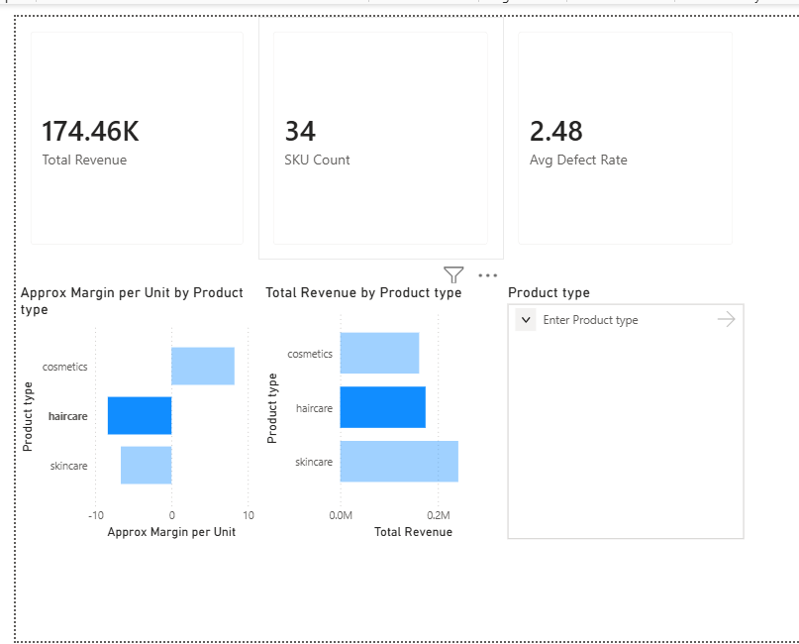
Figure 1: Executive overview page, filtered to Haircare via the Product type slicer

6.2 Page 2 — Product Comparison
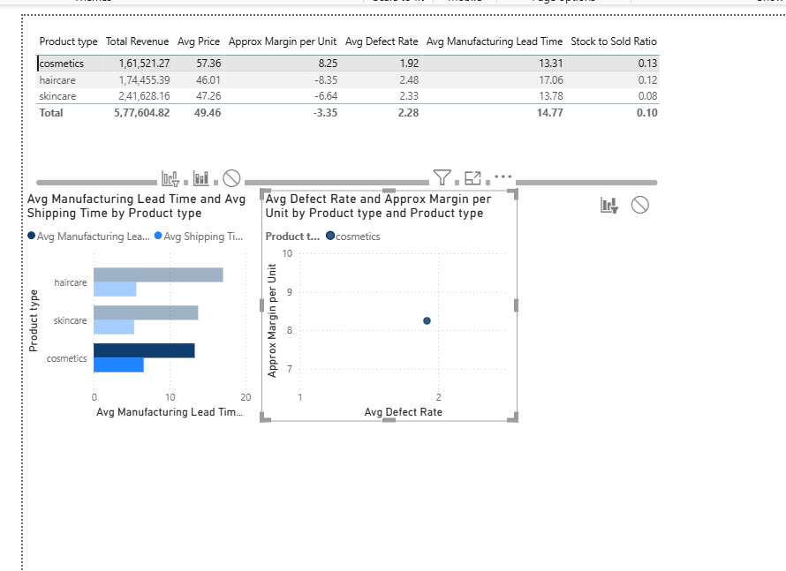
Figure 2: Product comparison table, lead time chart, and defect-rate/margin scatter plot

6.3 Page 3 — Logistics & Suppliers
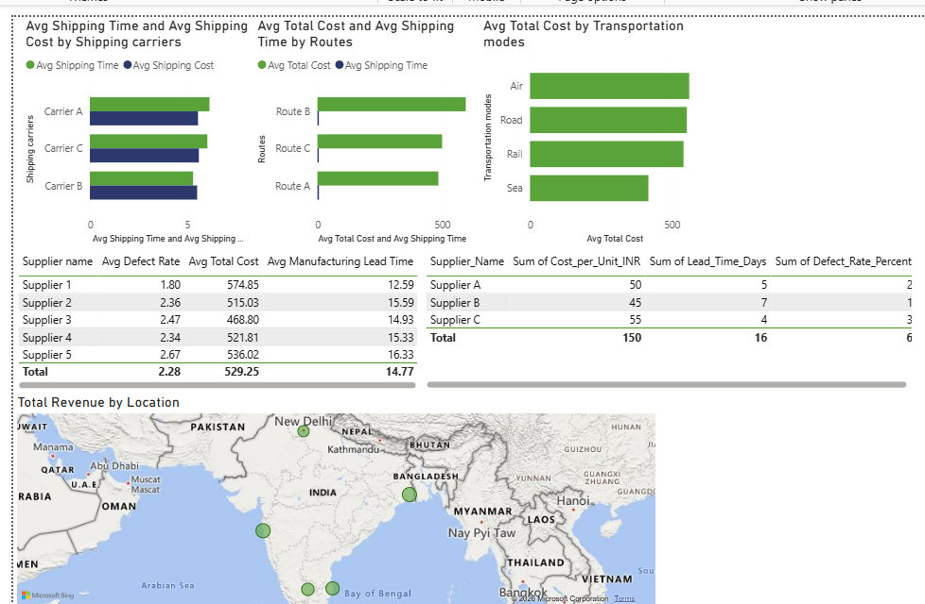

Figure 3: Carrier, route, transportation mode, supplier, and location performance

7. Recommendations
- Review haircare and skincare pricing — both run negative approximate margins against average manufacturing and shipping cost, unlike cosmetics.
- Increase skincare safety stock — it carries the lowest stock-to-sold ratio (0.08) of the three categories, indicating the highest stockout risk.
- Audit Supplier 5 and Supplier 4 — highest defect rate and highest manufacturing cost respectively, without an offsetting quality or speed benefit.
- Re-evaluate Route B — costs roughly 20% more than Routes A and C with no material speed advantage.
- Investigate Delhi's underperformance — lowest total revenue despite a mid-sized SKU count relative to other cities.

8. Conclusion
The supply chain dataset was clean and required no corrective action, allowing the analysis to focus entirely on interpretation. The findings point to a consistent story: cosmetics is the quality and margin leader on a smaller base, skincare drives volume but runs thinner margins and tighter stock buffers, and haircare is the least differentiated of the three categories. Logistics analysis surfaces two concrete inefficiencies — Route B's cost premium and Delhi's revenue gap — that merit follow-up outside the scope of this dataset.

