Read file

Input

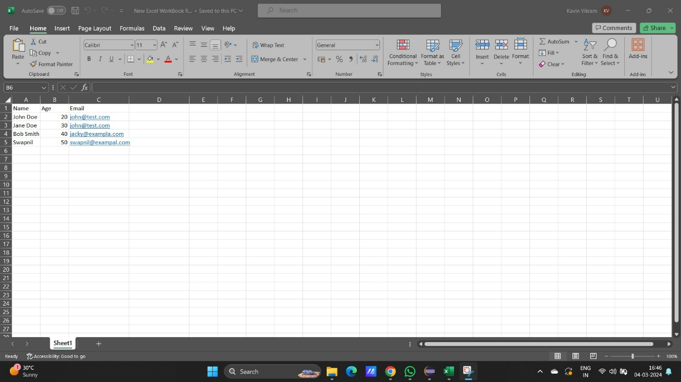

Code

package javaTask13Answers;

import java.io.FileInputStream;

import java.io.IOException;

import org.apache.poi.xssf.usermodel.*;

public class ReadExcelData {

public static void main(String[] args) throws IOException {

// **TODO** Auto-generated method stub

String excelFilePath = "D:\\guvi classs\\Class Task answers\\Task13\\New Excel WorkBook Read.xlsx";

FileInputStream inputstream = new FileInputStream(excelFilePath);

XSSFWorkbook workbook = new XSSFWorkbook(inputstream);

XSSFSheet sheet = workbook.getSheetAt(0);

// using For loop

int rows = sheet.getLastRowNum();

int column = sheet.getRow(1).getLastCellNum();

for (int r = 0; r <= rows; r++) // represent row

{

XSSFRow row = sheet.getRow(r);

for (int c = 0; c < column; c++) {

XSSFCell cell = row.getCell(c);

switch (cell.getCellType()) {

case ***STRING***:

System.***out***.print(cell.getStringCellValue());

break;

case ***NUMERIC***:

System.***out***.print(cell.getNumericCellValue());

break;

}

System.***out***.print(" | ");

}

System.***out***.println();

}

}

}

Outtput

Name | Age | Email |

John Doe | 20.0 | john@test.com |

Jane Doe | 30.0 | john@test.com |

Bob Smith | 40.0 | jacky@exampla.com |

Swapnil | 50.0 | swapnil@exampal.com |

Write files

package javaTask13Answers;

import java.io.FileOutputStream;

import java.io.IOException;

import org.apache.poi.xssf.usermodel.XSSFCell;

import org.apache.poi.xssf.usermodel.XSSFRow;

import org.apache.poi.xssf.usermodel.XSSFSheet;

import org.apache.poi.xssf.usermodel.XSSFWorkbook;

public class WriteData {

public static void main(String[] args) throws IOException {

XSSFWorkbook workbook =new XSSFWorkbook();

XSSFSheet sheet =workbook.createSheet("Emp info");

Object Empdta[][]= { {"EmpID","Name","Email"},

{"123","Ram","ram@123"},

{"124","Som","som@123"},

{"125","Jam","jam@123"} };

//using for loop

int rows=Empdta.length;

int cols=Empdta[0].length;

System.***out***.println(rows);

System.***out***.println(cols);

for(int r=0;r<rows;r++) {

XSSFRow row =sheet.createRow(r);

for(int c=0;c<cols;c++){

XSSFCell cell=row.createCell(c);

Object value =Empdta[r][c];

if(value instanceof String)

cell.setCellValue((String)value);

if(value instanceof Integer)

cell.setCellValue((Integer)value);

}

}

String filepath ="D:\\guvi classs\\Class Task answers\\Task13\\WriteData.xlsx";

FileOutputStream os=new FileOutputStream(filepath);

workbook.write(os);

os.close();

System.***out***.println("Employee.xlsx file written succefully...");

}

}

Output

4

3

Employee.xlsx file written succefully...

