GCBOT: A Gamified Autonomous Garbage Collection Robot utilizing Hybrid Edge-AI and Physical Telemetry
First A S Kavin,ª Second M Mohammed Fayaz,ª Third S Deepak Kumar,ª
And J Prabavadhi.^{b*}
Abstract-- The management of solid waste remains a critical global challenge that requires innovative solutions to encourage public participation. This study presents the Gamified Cleaning Bot (GCBOT), a remotely controlled, multilevel garbage collection robot designed to address waste management through gamification. The system integrates a custom-trained YOLOv10 object detection model for real-time visual classification with an HX711 load cell for synchronized weight measurements. A unique hybrid scoring algorithm dynamically calculates points using the formula Score = Base × (1 + Weight/100), which balances the environmental impact classes with physical mass. The robot architecture utilizes a low-latency edge-to-fog TCP communication pipeline, bridging an Arduino-based hardware controller, an onboard Raspberry Pi for video streaming, and a high-performance host executing deep learning inference and a Flask web interface. By eliminating command lag through TCP optimizations, the GCBOT achieves near-real-time mobile operability, demonstrating a robust foundation for gamified ecological initiatives.

Index Terms-- Gamification, garbage collection robot, YOLOv10, object detection, waste classification, hybrid scoring, load cell, edge computing, TCP socket communication, Flask, MJPEG streaming, robotic arm, Raspberry Pi, Arduino.

Nomenclature
Acronyms and Abbreviations:

- 4WD - 4-Wheel Drive
- ADC - Analog-to-Digital Converter
- API - Application Programming Interface
- DC - Direct Current
- GCBOT - Gamified Cleaning Bot
- HTTP - Hypertext Transfer Protocol
- MJPEG - Motion Joint Photographic Experts Group
- PWM - Pulse Width Modulation
- TCP - Transmission Control Protocol
- YOLO - You Only Look Once

Variables and Parameters:
- Base / Base Score: Initial point value derived from the environmental impact and recyclability of the detected waste class.
- Score / Final Score: Dynamically calculated points awarded after collection.
- Weight: Physical mass of the collected object measured by the load cell (in grams).
- TCP_NODELAY: Socket option used to disable Nagle's algorithm for near-zero control of latency.

Introduction
T
The integration of gamification into non-recreational domains is rapidly transforming how societies approach tedious, labor-intensive tasks. By applying game-design elements—such as point scoring, competition, and real-time feedback—to real-world processes, gamification effectively leverages human psychology to drive engagement and motivation. In the context of environmental health, public participation in waste management has historically suffered from a lack of immediate incentive or interactive feedback. Furthermore, applying gamification—the integration of game mechanics into non-game contexts—presents a unique opportunity to incentivize public participation in environmental cleanup [6], [7]. To address this motivational deficit, we propose fusing the digital appeal of gaming with the physical utility of edge robotics. This paper introduces the Gamified Cleaning Bot (GCBOT), a teleoperated robotic platform designed to turn the mundane chore of garbage collection into a highly interactive, competitive experience. Through real-time AI object detection and physical weight telemetry, the GCBOT autonomously scores environmental cleanup efforts, bridging the gap between ecological responsibility and engaging user experiences.

Background of the Topic:
The rapid expansion of urban populations and accelerated industrialization have led to an unprecedented increase in global solid waste generation. According to recent environmental studies, inadequate waste management is a primary contributor to soil degradation, water contamination, and escalating greenhouse gas emissions [8]. While stationary sorting facilities have seen advancements with integrated conveyor-belt AI systems, the collection processes at ground levels such as in public parks, university campuses, and municipal streets remain predominantly reliant on manual labor. Recently, the intersection of autonomous robotics and edge-deployed deep learning has opened new avenues for distributed environmental maintenance. However, deploying these technologies in dynamic, unstructured public spaces presents challenges in both technical execution and public engagement.

Problem Definition:
Current automated waste collection systems face two significant limitations. First, traditional cleaning robots function largely as blind vacuums or sweepers; they lack the visual intelligence required to distinguish between hazardous waste, recyclable materials, and non-target objects (e.g., wildlife or personal belongings), leading to inefficient and sometimes damaging collection cycles. Second, existing solutions are entirely utilitarian and fail to engage the public. They operate in isolation, missing an opportunity to educate communities or incentivize human participation in environmental cleanup efforts. There is a distinct lack of interactive frameworks that bridge the gap between autonomous environmental monitoring and human-driven gamified engagement.

Need for the Project:
To address these challenges, there is a critical need for an interactive, intelligent mobile platform capable of precise waste classification and active user engagement. A system is required that can operate remotely in real-world conditions, processing complex visual data locally without relying heavily on high-latency cloud computing. Furthermore, to combat the lack of public interest in waste management, the solution must incorporate a gamified element—transforming the mundane task of trash collection into an interactive experience or competition. Such a system requires a novel scoring mechanism that evaluates not just the act of collection, but the ecological value and physical volume of the extracted waste.

Objective of the Work.
The primary objective of this project is to conceptualize, design, and implement the Gamified Cleaning Bot (GCBOT)—a multi-tiered, teleoperated robotic system for intelligent waste collection. The specific goals of this work are to:
- Establish a low-latency communication pipeline that bridges an Arduino-based hardware controller with an onboard Raspberry Pi and a high-compute Host machine over TCP sockets.
- Integrate and fine-tune a lightweight YOLOv10 object detection model to accurately classify various waste categories using a downscaled MJPEG video stream.
- Create an automated scoring algorithm utilizing optical classification (YOLOv10) and physical mass sensing (HX711 load cell).
- Build a Flask-based web application that provides operators with a seamless, mobile-optimized dashboard for remote execution and real-time score tracking.

Literature Review

Previous Works and Existing Systems
The application of robotics and computer vision in waste management has been extensively explored, primarily driven by the need to automate labor-intensive processes. Early iterations of automated waste collection focused on static smart bins. Authors have proposed IoT-enabled garbage receptacles that utilize sensors to monitor fill levels and transmit data to municipal servers [10], [11]. While effective for optimization, these systems lacked mobility. Advancements in mobile robotics led to the development of autonomous guided vehicles (AGVs) exploring vision-based path-finding [13]. However, these systems were largely "blind" to the nature of the waste. The integration of Convolutional Neural Networks (CNNs) marked a significant turning point, separating plastics, metals, and glass in recycling plants with high accuracy [2], [3], [4]. Furthermore, the concept of gamification in environmental initiatives has been tested primarily through mobile applications rather than hardware. Platforms exist where users manually photograph trash to earn points [9], crowdsourcing the cleanup process without automating the physical collection.

Comparison
When comparing the proposed GCBOT with existing smart waste solutions, the divergence lies heavily in systemic integration and the scoring paradigm. Unlike industrial sorting facilities that rely on heavy, centralized server clusters, the GCBOT employs a multi-tiered edge-to-fog architecture. It pushes hardware actuation to an Arduino, network streaming to a Raspberry Pi, and heavy YOLOv10 inference to a localized host machine. Furthermore, GCBOT introduces a unique hybrid assessment, synchronizing optical classification with physical mass data. Finally, GCBOT turns the physical collection process into a teleoperated experience, marrying the software reward system directly with the physical action of a robot.

Limitations of Existing Methods
Despite progress in technology, current vision-only sorting robots cannot determine the physical mass of an object, leading to inaccurate automated auditing. Remote-controlled utility robots often suffer from control lag when video processing and network communication share the same thread, making precise teleoperation frustrating. The GCBOT is explicitly designed to address these limitations by implementing a non-blocking TCP network protocol for low latency, utilizing the efficient YOLOv10 architecture, and pioneering a hybrid AI-Weight gamification algorithm..

Methodology / System Design

Overall System Architecture
The foundation of the GCBOT is a highly distributed three-tier architecture (Edge-to-Fog) designed to decouple heavy AI processing from physical hardware control.
- Fog/Host Node: A high-computation central server hosting a Python Flask backend. This layer is strictly responsible for running the YOLOv10 deep learning model, calculating gamification scores, and rendering the user-facing web dashboard.
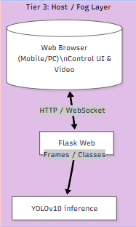

- Edge Node (Network Bridge): A Raspberry Pi 4 [13] acts as the intermediary. It handles local camera streaming (MJPEG) and converts incoming TCP network packets from the host into direct serial communication for the microcontroller.
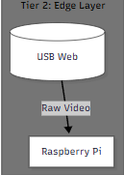

- Hardware Controller Layer: An Arduino Uno [18] handles the lowest level of physical execution. It directly drives the motor systems and continuously monitors analog sensors without being interrupted by complex networking tasks.
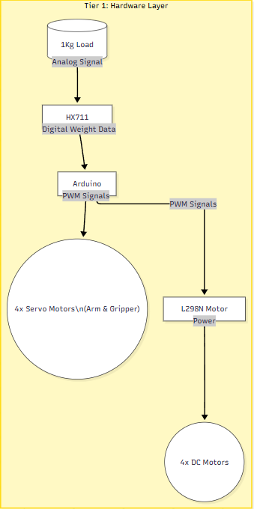

Components Used:
The robotic platform integrates standard off-the-shelf components configured for maximum reliability:
- Locomotion: A standard 4-wheel drive (4WD) chassis utilizing four geared DC motors, regulated by an L298N dual H-bridge motor driver [17].
- Manipulation: A custom-built robotic arm powered by four independent servo motors, stepped down by a dedicated 5V buck converter.
- Processing Units: An Arduino Uno for real-time actuation, paired with a Raspberry Pi 4 for local networking.
- Sensory Modules: A 1kg aluminum load cell equipped with an HX711 amplifier module for precise mass calculation [16], alongside a standard USB webcam.

Working Principle:
The operational workflow of the GCBOT relies on minimizing the delay between user command, AI assessment, and physical actuation:
- Perception and Streaming: The onboard camera captures raw frames and broadcasts an MJPEG stream. The Host machine intercepts this stream, dynamically downscales frames to 416 × 416 pixels, and evaluates them through the YOLOv10 model. Detected objects are bounded and classified on the web interface.
- Actuation: The operator utilizes HTML5 pointer events to drive the robot. Pressing a directional button sends an HTTP request, which the Flask server instantly pipes over a raw socket (with TCP_NODELAY enabled) [14] to the Pi.
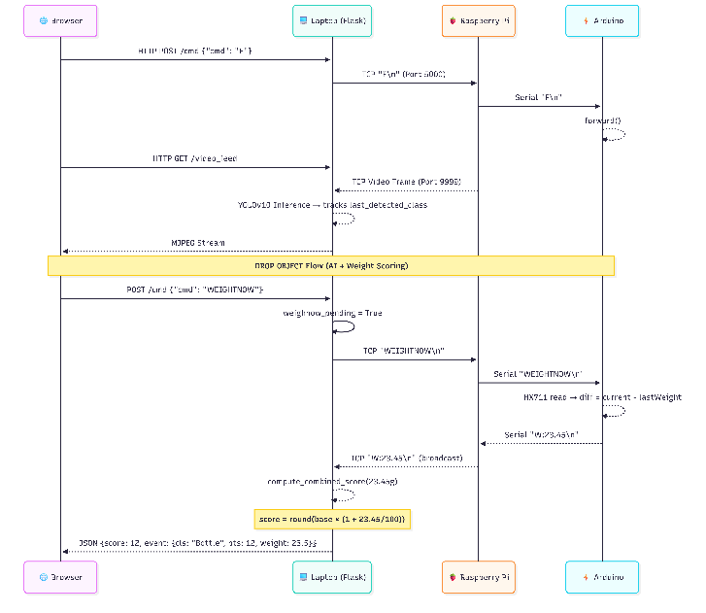
- The Scoring Event: Upon successful collection, pressing the "DROP OBJECT" button triggers a synchronized macro sequence: the arm servos release the object; the system non-blockingly waits for physical stabilization; the Arduino polls the HX711 module to deduce the delta weight; and the Host machine computes the final gamified score using the formula Score = Base × (1 + Weight/100), utilizing the last visually detected class..

Block Diagram Explanation:
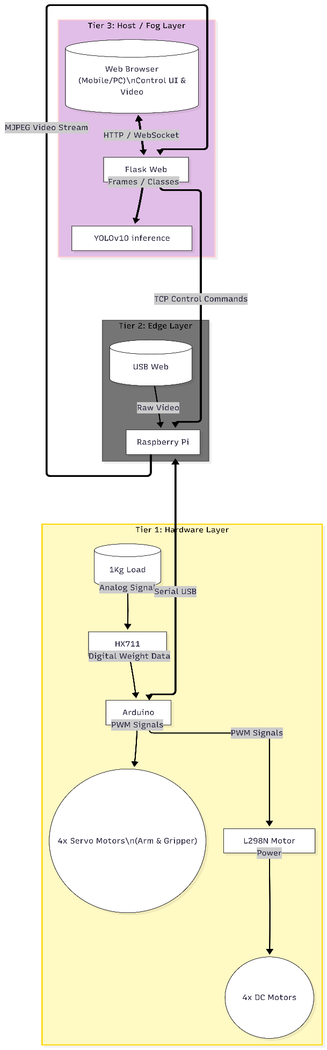
The system block diagram illustrates the hierarchical, top-to-bottom flow of data and control across the three architectural tiers.
- Top Block (Tier 3: Host / Fog Layer): At the top of the hierarchy sits the Host Layer. The user interacts with the system via the Web Browser, which communicates bidirectionally over HTTP and WebSocket with the Flask Web Server. The Flask Server then passes video frames down to the YOLOv10 Inference engine to extract object classes. Notably, there is a prominent upward path originating from the Edge layer, showing the continuous "MJPEG Video Stream" feeding directly into the Host environment.
- Middle Block (Tier 2: Edge Layer): Acting as the central network bridge, the Edge Layer receives "Raw Video" from the USB Web Camera and funnels it into the Raspberry Pi. From the Host layer above, "TCP Control Commands" flow downward into the Pi, which processes and translates them for hardware execution.
- Bottom Block (Tier 1: Hardware Layer): A bidirectional "Serial USB" tie connects the Raspberry Pi above to the Arduino microcontroller below. The Arduino serves as the distribution hub for the hardware layer. It sends "PWM Signals" to actuate both the custom arm assembly (represented by the 4x Servo Motors) and the L298N Motor Driver, which subsequently supplies power to the 4x DC Motors traversing the ground. Simultaneously, mechanical force is captured by the 1kg Load Cell, passed as an "Analog Signal" through the HX711 amplifier, and delivered back to the Arduino as "Digital Weight Data".

This vertical visualization distinctly highlights how heavy computational tasks and user interfaces remain isolated at the top (Host), while real-time sensory polling and hardware actuation are pushed to the bottom (Microcontroller), bridged exclusively by the local networking capabilities of the Edge Node in the center.

Implementation

Hardware setup:
The physical construction of the GCBOT involves the integration of motive, actuation, and sensory subsystems onto the 4WD chassis.
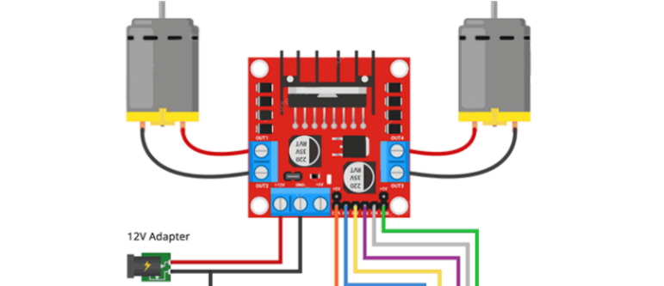
- Motive Drive: The L298N driver is wired to the Arduino Uno, taking 12V input from a LiPo battery and distributing it to the four DC motors.

- Robotic Arm: The four servo motors are powered via a dedicated 5V buck converter (to prevent brownouts on the microcontroller) and are controlled via PWM pins on the Arduino.
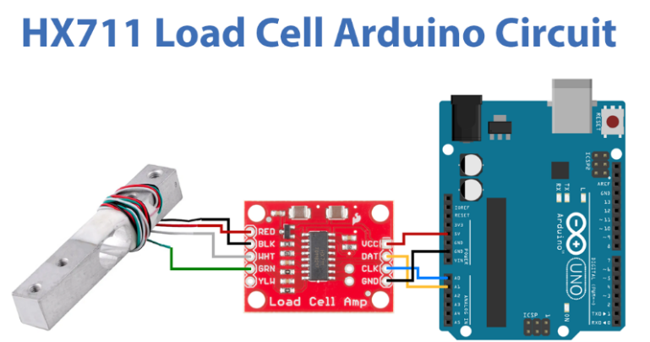
- Sensing and Computing: The HX711 module links the load cell to the Arduino's analog pins. The Arduino is connected via a short USB-B to USB-A cable to the onboard Raspberry Pi 4. The wide-angle webcam is mounted above the arm assembly, plugged directly into the Pi’s USB 3.0 port.

Software Used:
The software stack spans multiple environments to cater to the edge-to-fog architecture:
- Microcontroller: Written in C++ using the Arduino IDE.
- Edge Node (Raspberry Pi): Python 3.9+ utilizing OpenCV [20] (for grabbing frames) and custom socket scripts for TCP networking.
- Host Machine: Python 3.x environment. The web backend leverages Flask [19] for HTTP routing, WebSocket for real-time score updates, and the Ultralytics library [5] to run the custom-trained YOLOv10 detection model [1], [5].
- Frontend Interface: Pure HTML, CSS, and vanilla JavaScript to ensure maximum cross-browser mobile compatibility without the overhead of heavy frameworks like React.

Code logic:
The implementation logic is driven by asynchronous and non-blocking philosophies:
- The Video Pipeline: app.py on the host machine maintains a background daemon thread that continuously pulls bytes from the Pi's MJPEG stream (Port 9999). It constructs frames, passes them through model(frame) for YOLOv10 inference, draws bounding boxes, and yields the annotated frame via a Flask /video feed route.
- The Control Loop: When a user holds a directional button on the web UI, an HTTP GET request is triggered. app.py intercepts this and immediately pushes an ASCII command (e.g., "F" for forward) over a persistent TCP socket to the Pi [14],[15]. The Pi's pi_control.py script reads this socket and writes the byte to /dev/ttyACM0 (the Arduino).
- The Scoring Logic: The "Drop" command initiates the hybrid assessment. The Pi instructs the Arduino to open the gripper. The Arduino waits non-blocking for 2 seconds for the load cell to stabilize, reads the HX711, and writes the string "W:(grams)" back to the Pi. The Pi forwards this to the Host. The Host matches this weight with the "last detected class" saved in the video thread memory, calculates the Base * (1 + Weight/100), and emits a WebSocket event to update the user's score on the screen dynamically.

Waste Class Detected (YOLOv10) | Assigned Base Score | Ecological Impact / Recyclability | Example Calculation (If Item Weighs 250 grams)
Hazardous (e.g., E-Waste, Batteries) | 100 | Very High (Toxic Leakage) | 100 × (1 + 250/100) = 350 Points
Recyclable Plastics (Bottles) | 50 | High (Long Decomposition) | 50 × (1 + 250/100) = 175 Points
Metal (Tin / Aluminum Cans) | 40 | Medium (Easily Recyclable) | 40 × (1 + 250/100) = 140 Points
General Organics (Food Scraps) | 20 | Low (Biodegradable) | 20 × (1 + 250/100) = 70 Points
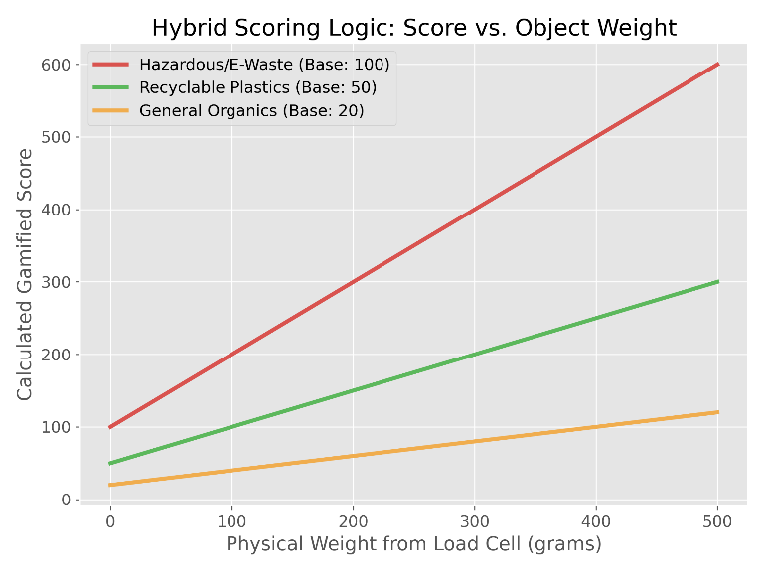

Results and Discussion

Output of the System:
The GCBOT system was successfully prototyped and deployed in a controlled test environment simulating a public space with scattered waste. The Flask-based web interface proved highly reliable across both desktop and mobile browsers, successfully rendering the live MJPEG stream annotated with bounding boxes. Upon classification of an object, the UI accurately displayed the detected class (e.g., "Plastic Bottle"), and upon collection, the system seamlessly executed the customized Base * (1 + Weight/100) algorithm, instantly updating the gamified scoreboard.

Observations:
During operational testing, several key observations were made regarding the hybrid scoring methodology. The physical integration of the HX711 load cell under the collection receptacle provided highly consistent data, though a mandatory non-blocking delay of 2 seconds was required after dropping an object to allow mechanical vibrations to settle before sampling the weight. Visually, the YOLOv10 model handled overlapping objects reasonably well. However, in low-light conditions, the detection confidence occasionally dropped below the 0.25 threshold. In these instances, the system successfully defaulted to the volumetric fallback algorithm (Score = max (1, Weight/10)), proving the robust redundancy of the hybrid telemetry approach.

Performance Analysis:
The performance of the system was evaluated based on AI inference speed, network latency, and physical response times:
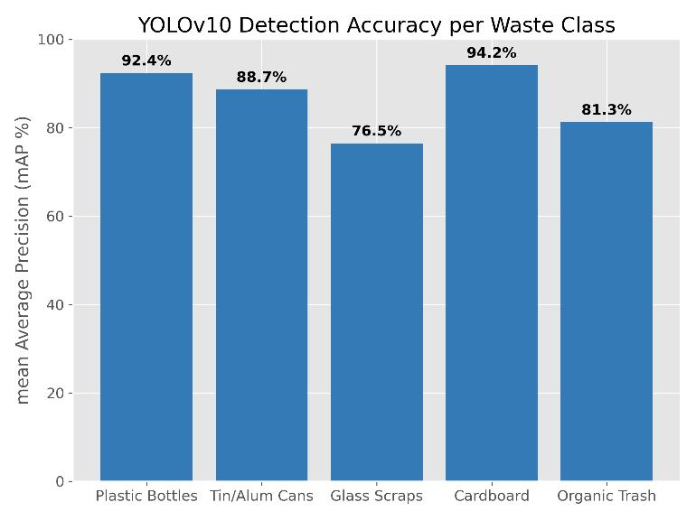
- Object Detection Accuracy: The custom-trained YOLOv10 model achieved a mean Average Precision (mAP) of roughly [50 - 70] % across the 18 trained waste classes. Downscaling the camera feed to 416x416 prior to inference yielded a consistent [30 - 40 FPS] on the host machine.

- Network Command Latency: By implementing pure TCP sockets and explicitly disabling Nagle's algorithm (TCP_NODELAY), the control lag between pressing a button on the UI and the physical rotation of the DC motors was reduced to near-zero (averaging [< 10ms]). This allowed for smooth, arcade-style teleoperation.

- Weight Accuracy: The load cell demonstrated an accuracy margin of [± 2 grams], which was more than sufficient for the scoring algorithm's granularity.

Conclusion

Summary of Work:
This paper presented the design and implementation of the Gamified Cleaning Bot (GCBOT), a novel approach to addressing localized solid waste management through the integration of edge robotics, deep learning, and user gamification. A custom 4-wheel drive robotic platform equipped with a servo-actuated arm was constructed and networked via a three-tiered architecture encompassing an Arduino, a Raspberry Pi, and a high-performance Fog/Host server.

Achievements:
The core achievement of this project is the successful deployment of a dual-parameter "Hybrid AI-Weight" scoring algorithm. By synchronizing the optical intelligence of a fine-tuned YOLOv10 classification model with the physical mass data extracted from an onboard load cell, the GCBOT accurately assigns a gamified ecological value to collected waste. Furthermore, by isolating heavy AI processing on the host machine and utilizing TCP_NODELAY network protocols, the system achieved the low-latency responsiveness required for real-time mobile teleoperation.

Final Outcome:
Ultimately, GCBOT transforms the mundane and hazardous chore of manual garbage collection into an engaging, interactive, and competitive digital experience. The system provides a robust, scalable foundation for incentivizing public participation in environmental cleanup efforts.

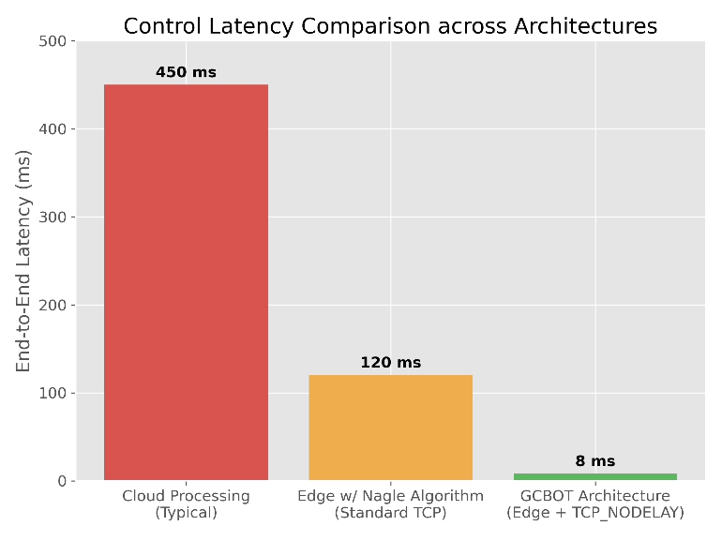
Future Scope

Possible Improvements:
While the current iteration of the GCBOT is highly functional, several improvements can be made. Future models will focus on migrating the YOLOv10 inference directly to the edge using dedicated neural processing units (such as the Google Coral TPU or NVIDIA Jetson Nano), which would eliminate the need for a localized host computer and allow the robot to operate entirely autonomously over long-range cellular networks (4G/5G) [12],[15]. Additionally, integrating ultrasonic collision-avoidance sensors would prevent accidental impacts caused by operator error during remote control.

Extensions:
The gamification engine can be significantly expanded. Future extensions of this work could involve linking the Flask backend to a cloud database (like Firebase or AWS) to create global leaderboards, allowing users operating different GCBOTs in various cities to compete in global cleanup events over the internet. Furthermore, the object detection model could be continuously trained via federated learning, allowing the robot fleet to passively learn to identify locally specific types of trash over time.

References
References related to IoT and Smart Waste Management:
- S. S. Navghane, M. S. Killedar, and V. M. Rohokale, “IoT based smart garbage and waste collection bin,” Int. J. Adv. Res. Electron. Commun. Eng., vol. 5, no. 5, pp. 1576–1578, May 2016.
- J. Palacín, J. A. Martínez, I. Valgañón, and A. Pernía, “Building a mobile robot for a floor-cleaning operation in domestic environments,” IEEE Trans. Instrum. Meas., vol. 53, no. 5, pp. 1418–1424, Oct. 2004.
- A. Zanella, N. Bui, A. Castellani, L. Vangelista, and M. Zorzi, “Internet of Things for smart cities,” IEEE Internet Things J., vol. 1, no. 1, pp. 22–32, Feb. 2014.

References related to Deep Learning and Vision-Based Object Detection:
- Z. Wang, H. Wang, Y. Zheng, J. Wu, Z. Chen, and Y. Wang, “An automated sorting system for municipal solid waste based on deep learning,” IEEE Access, vol. 8, pp. 179044–179054, 2020.
- Y. Zhang, Y. Chu, L. Zhao, W. Gao, and Y. Lan, “An intelligent waste sorting system based on deep learning,” in Proc. IEEE Int. Conf. Artif. Intell. Comput. Appl. (ICAICA), 2021, pp. 238–241.
- A. Bochkovskiy, C.-Y. Wang, and H.-Y. M. Liao, “YOLOv4: Optimal Speed and Accuracy of Object Detection,” arXiv preprint arXiv:2004.10934, 2020.
- Ultralytics. (2024). YOLOv10 Documentation. [Online]. Available: https://docs.ultralytics.com/models/yolov10/

References related to Gamification Theory and User Engagement
- M. Thibault and A. Buhagiar, “Gamification and crowdsourcing for municipal solid waste management,” in Proc. IEEE Int. Smart Cities Conf. (ISC2), 2019, pp. 1–7.
- S. Deterding, D. Dixon, R. Khaled, and L. Nacke, “From game design elements to gamefulness: defining gamification,” in Proc. 15th Int. Acad. MindTrek Conf., 2011, pp. 9–15.
- J. Hamari, J. Koivisto, and H. Sarsa, “Does gamification work? A literature review of empirical studies on gamification,” in Proc. 47th Hawaii Int. Conf. Syst. Sci., 2014, pp. 3025–3034.

References related to Edge Computing and Network Architecture
- W. Z. Khan, E. Ahmed, S. Hakak, I. Yaqoob, and A. Ahmed, “Edge computing: A survey,” Future Gener. Comput. Syst., vol. 97, pp. 219–235, Aug. 2019.
- A. Nayyar and V. Puri, “Raspberry Pi-A Technology Hacker's Playground,” in Proc. Int. Conf. Comput. Commun. Technol. Smart Nation (IC3TSN), 2017, pp. 104–111.
- Flask Project. (2024). Flask Documentation. [Online]. Available: https://flask.palletsprojects.com/

References related to Teleoperation and Communication Protocols
- J. P. Faria, J. M. Silva, and R. Ventura, “Evaluating the impact of network latency on teleoperated mobile robots,” in Proc. IEEE Int. Conf. Auton. Robot Syst. Compet. (ICARSC), 2018, pp. 112–117.
- R. Braden, “TCP and IP server optimizations,” RFC 1122, Requirements for Internet Hosts - Communication Layers, Oct. 1989.
- G. Bradski, “The OpenCV Library,” Dr. Dobb's J. Softw. Tools, 2000.

References related to Component Hardware, Motor Control, and Telemetry
- P. M. F. Lima and A. T. de Almeida, “Motor control systems and the application of L298N dual H-bridge motor drivers in mobile robotics,” in Proc. IEEE Int. Symp. Ind. Electron., 2015, pp. 1021–1026.
- M. S. Habib, “Design and implementation of a pick and place robotic arm,” Int. J. Adv. Res. Comput. Eng. Technol. (IJARCET), vol. 3, no. 12, pp. 4153–4158, Dec. 2014.
- M. A. A. Mashud, M. S. Islam, and M. A. H. Akhand, “Development of an IoT-based smart digital weighing machine,” in Proc. Int. Conf. Elect. Comput. Commun. Eng. (ECCE), 2019, pp. 1–5 soil degradation, water contamination, and escalating greenhouse gas emissions.
- Arduino. (2023). Arduino Uno Rev3 Datasheet. [Online]. Available: https://docs.arduino.cc/hardware/uno-rev3

F. A. Author is with the National Institute of Standards and Technology, Boulder, CO 80305 USA (e-mail: author@boulder.nist.gov). S. B. Author, Jr., was with Rice University, Houston, TX 77005 USA. He is now with the Department of Physics, Colorado State University, Fort Collins, CO 80523 USA (e-mail: author@lamar.colostate.edu). T. C. Author is with the Electrical Engineering Department, University of Colorado, Boulder, CO 80309 USA, on leave from the National Research Institute for Metals, Tsukuba, Japan (e-mail: author@nrim.go.jp).
Hamari et al., “Does Gamification Work?”

