**INDEX**

|  |  |  |
| --- | --- | --- |
| **S.NO** | **CONTENT** | **PAGE NO.** |
| **1** | **ABSTRACT** | **6** |
| **2** | **INTRODUCTION** | **7** |
| **3** | **OBJECTIVES** | **8** |
| **4** | **DATASET** | **9** |
| **5** | **TESTBED** | **10** |
| **6** | **LITERATURE SURVEY** | **10** |
| **7** | **METHODOLOGY USED** | **12** |
| **8** | **ARCHITECTURE (PROPOSED MODEL)** | **15** |
| **9** | **RESULTS** | **15** |
| **10** | **CONCLUSION & FUTURE WORKS** | **18** |
| **11** | **REFERENCES** | **19** |

**ABSTRACT**

Brain tumor is one of the leading cases of cancer-related death. Pin-point classification is really important when dealing with one of the delicate parts of the body [Brain]. With accurate detection of this tumor, doctors can then proceed with what can be done to minimize or cure it. An accurate detection also requires lots of training and this is where large datasets come into the picture. Another issue is in regards to the large dataset, as labeling each image is time consuming and will be complex.

# 

# **INTRODUCTION**

Brain tumor is one among the foremost rigorous diseases in life science. An efficient and efficient analysis is usually a key concern for the radiologist within the premature phase of tumor growth. Histological grading, supported by a stereotactic biopsy test, is the gold standard and also the convention for detecting the grade of a tumor. The biopsy procedure requires the neurosurgeon to drill a tiny low hole into the skull from which the tissue is collected. Many risk factors must be taken into consideration during a biopsy test, this including bleeding of the brain tumor which may cause infection, seizures, stroke, coma and even death. But the most concern with the stereotactic biopsy is that it's not 100% accurate which can lead to a significant diagnostic error followed by a wrong clinical management of the disease. Application within the detection of tumor in resonance Imaging(MRI) is an incredibly important thing which provides information about abnormal tissues which is critical for planning treatment. Recent studies indicate that automatic computerized detection of tumors is the best alternative as it saves precious time and at the same time provides a good accuracy. Also, If the computerized approach is made robust when detecting tumors in the brain, it will be of great help to many doctors as it frees them from manually detecting tumors as the human error should also be taken into account when done manually.

**OBJECTIVES**

Early detection of the tumor in the brain before it aggravates using the detection model plays a crucial role in improvising the treatment of the tumor which helps in improving the health condition of the patients. This type of model is necessary in hospitals due to a fewer number of skilled doctors who can attend to this issue. Medical imaging helps the model in training as a visual representation is given to the model in order to understand what the image is about. One of the most efficient methods towards an image is segmentation. Precise segmentation of the tissues will help in the diagnosis of the tumor within the brain and this will help the doctors in planning the treatment.

**Dataset:**

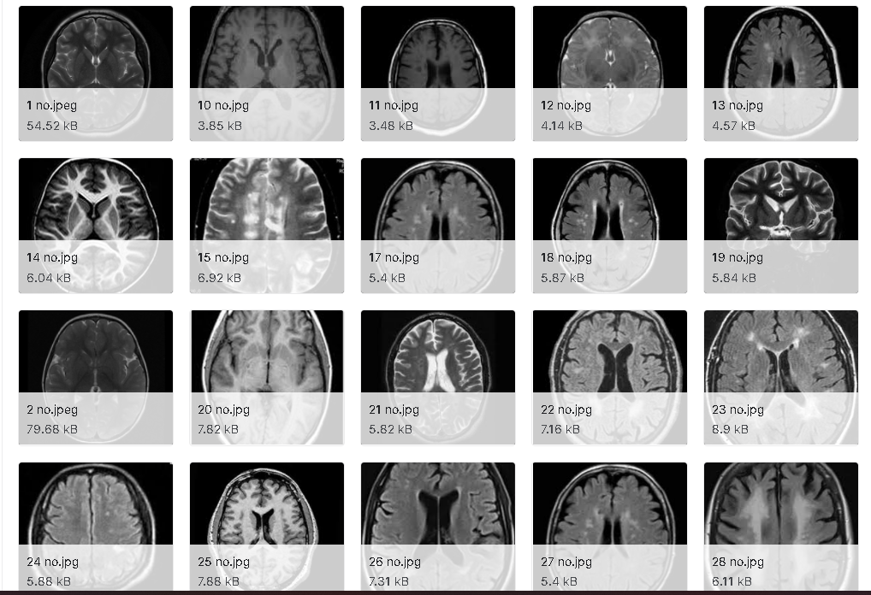

This is the “Brain MRI Images for Brain Tumor Detection Dataset”. It contains 98 MRI images of the brain which is used in training our model. We can multiply the dataset by using data augmentation which redirects the position of the brain in the MRI image. This helps the model to train better and detect the tumor when the image is placed in a slanting position.

## 

## **Testbed:**

**RAM requirements:** 8GB

**Hard disk requirements:** 40GB

**Tools:** Google Colab, Google Drive

**LITERATURE SURVEY**

Pratibha Sharma, SangamChoudhary [1] in their paper proposed the usage of Brain Tumor Detection Technology with the help of Edge Detection. The given images are first converted to its gray scale counterpart. The gray scale images are then taken as the inputs and the noise in each image needs to be removed with filters. Then the Image is enhanced to perform the edge detection at its maximum capability. The image is then turned into binary and finally the edge detection is performed.

P GokilaBrindha, M Kavinraj [2] in their paper proposed various Deep Learning Techniques for the process of Brain Tumor Detection. They took the two most common and very important models: ANN and CNN. Both the models are trained with the same dataset and the accuracies are displayed. The ANN model provides a 80.77% accuracy to the testing data whereas the CNN model provides a 89% accuracy to the testing data making it more reliable than the ANN model.

Ginni Gary, Ritu Gary [3] in their paper proposed the hybrid ensemblement of different Machine Learning Algorithms. The Hybrid model is selected from the list of Machine Learning algorithms like Random Forest, K-Nearest Neighbor and Decision tree based on the Majority Voting Method. Segmentation of the images is done with the help of the Otsu’s Thresholding method and Feature extraction is also done for the image classification process. This method was trained with 2556 MRI Brain tumor images which was split in 85:15 for training and testing and providing an accuracy of 97.305%.

VarunRana, Sanjay Singh [4] in their paper proposed the comparison of standard CNN, Depthwise Separable CNN, Support Vector Machine (SVM) and Adaboost. Both the models are trained with the same dataset with 80% used for training and 20% used for testing. Amongst the 4 models, Depthwise Separable CNN provides the best accuracy with 92%, simple CNN provides 87%, SVM provides 83.33% and Adaboost provides 89.9%.

VipinY.Borole, Sunil S.Nimbhore [5] in their paper proposed the usage of Image Processing techniques to Detect Brain tumors. They have taken the Brain Tumor dataset which is full of MRI scanned images. The preprocessing process is done to clean all the images from the Noise. Image processing techniques are used like Feature Extraction, Image Enhancement, Edge Detection and finally Segmentation is done to all the MRI images.

Ana Mustaqeem, Ali Javed [6] in their paper proposed the model of Watershed and Thresholding Based Segmentation for the Brain Tumor Detection. All the image processings towards the images are performed. Thresholding segmentation is performed to convert the gray scale images into binary images depending on the common threshold value. Watershed Segmentation is one of the best used methods for group pixels of the image based on the intensity of the image. It separates the high intensity pixels from the low intensity images.

K. Sudharani, Dr.T.C.Sarma [7] in their paper proposed an advanced morphological technique for automated brain tumor detection. They first modified the image for the model to train better. Histogram techniques are used and thresholds are applied to enhance the tumor parts present on the MRI images. With the Advanced Morphology technique, they were able to extract the main parts that are the tumor parts present in the MRI scanned images. This helps in extracting the information present in a single image which is described by the region's shape.

**METHODOLOGIES USED**

The brain tumor dataset is divided into two categories “Yes” and “No”. The “Yes” folder contains images which are non-tumor and the “No” folder consists of images which are tumor. Then this dataset is divided into training and testing in the ratio 80:20. The features of the images are extracted after image segmentation is done. The features which are extracted were used for training the model for Brain tumor detection.

**Models used:**

VGG 16:

VGG16 is a convolution neural network (CNN) architecture. Most unique thing about this is the fact that instead of utilizing a large number of hyper-parameters they mainly focus on having convolution layers which have a 3x3 filter with a stride 1 and always use the same padding and maxpool layer of the 2x2 filter of stride 2. It utilizes this arrangement of convolution and max pool layers throughout the entire architecture. In the end, it consists of 2 FC’s(fully connected layers) followed by a softmax layer as the output. The 16 in VGG16 stands for the 16 layers present in the model which are considered as the weights of the model.

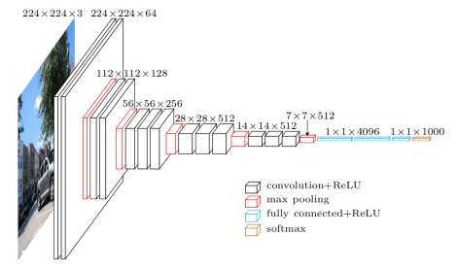

**Resnet50:**

ResNet50 is a variant of the ResNet model which has a total of 48 Convolution layers along with a single MaxPool and as well as a single Average Pool Layer. There are a total of 3.8 x 10^9 Floating points operations in the ResNet50 model. The ResNet50 model is a widely used ResNet model and we have explored and understood the ResNet50 architecture in depth. ResNet is a powerful model which is of importance when it comes to computer vision tasks and images. ResNet utilizes a function called the skip connection so as to add the output from the earlier/previous layer to the future/later layer. This in turn helps in removing the gradient problem in the model.

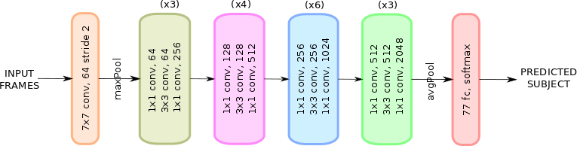

**InceptionV3**

The Inception V3 may be a deep learning model supported by Convolutional Neural Networks, which is employed for image classification. When multiple deep layers of convolutions were employed in a model it resulted within the overfitting of the info. To avoid this from happening the inception V1 model uses the thought of using multiple filters of various sizes on the identical level. Thus within the inception models rather than having deep layers, we've parallel layers thus making our model wider instead of making it deeper. The inception V3 is simply the advanced and optimized version of the inception V1 model. The Inception V3 model utilizes a variety of techniques to optimize the network to achieve a better model adaptation.

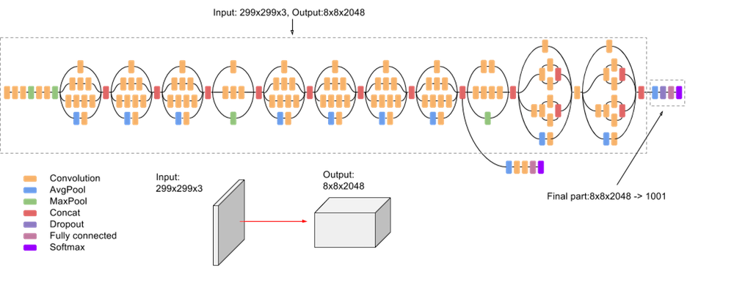

**Architecture (Proposed Model)**

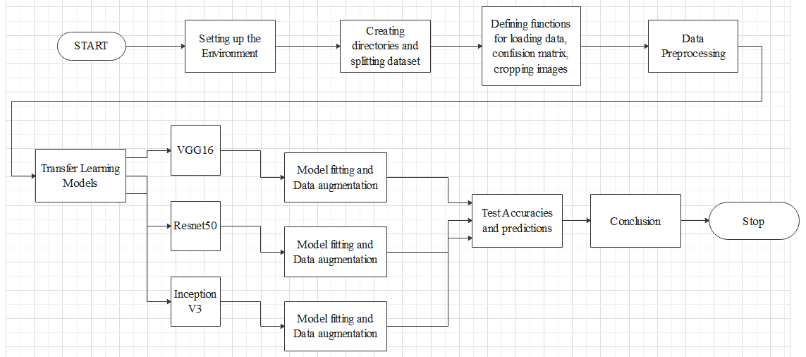

**Results**

After model fitting the Accuracy score is better than other models for RESNET50 because, ResNet improves the efficiency of deep neural networks with more neural layers while minimizing the percentage of errors. In other words, the skip connections which are added to the outputs from the previous layers towards the outputs of stacked layers, making it possible and easier to train much deeper and powerful networks than previously possible.

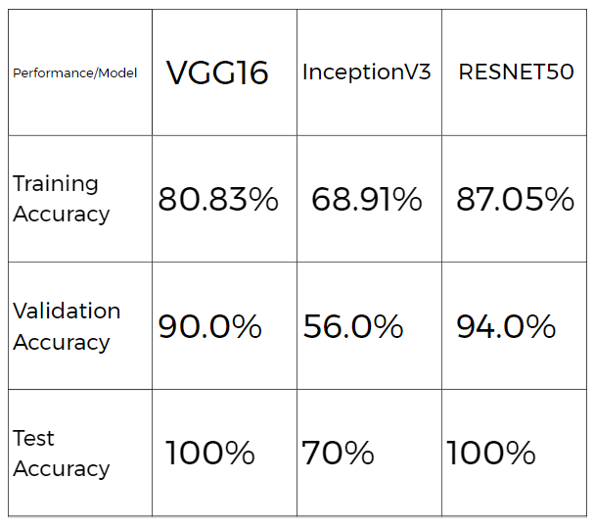

**Graphs:**

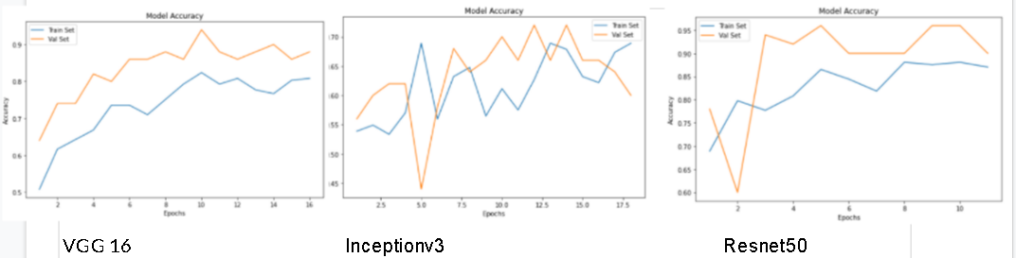

**VGG 16 Confusion Matrix**

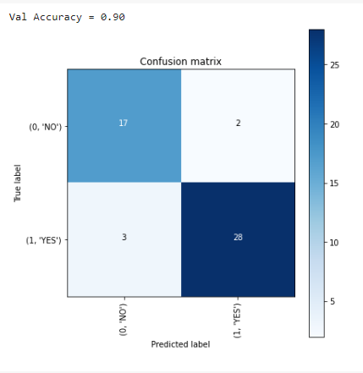

**ResNet 50 Confusion Matrix**

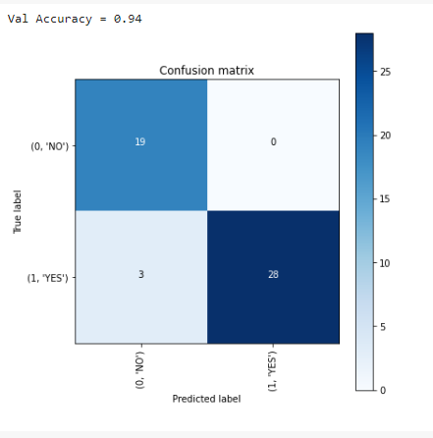

**Inception V3 Confusion Matrix**

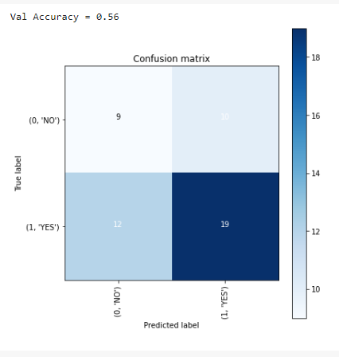

**Conclusion and future works:**

Most of the Brain tumors were detected in a very malignant stage which can be very difficult or uphill to treat the disease. Detecting tumors using the model with machine learning algorithms will help us to predict tumors in an early stage and helps to cure the tumors easily. Faster the detection of the tumor, the easier and safer it is to cure the patient. By using this brain tumor model we are able to get a decent accuracy compared to manual checking. Different models provide different accuracies depending on the training as well as the dataset given to the model. The higher the accuracy, the better the model and also better the detection process.

In the future we will try to increase the performance of the model and increase the accuracy by training with different types of brain tumor images. With new models being discovered year after year, much better models can be formed and this can help increase the accuracy of detection. An increase in the number of data’s present in the dataset is also another factor in improving the detection of the brain tumor. The dataset can also be categorized into benign and malignant types and this will help the doctors to proceed accordingly.

**References:**

1. <https://iopscience.iop.org/article/10.1088/1757-899X/1055/1/012115>
2. <https://www.hindawi.com/journals/jhe/2022/2693621/>
3. <https://arxiv.org/abs/2101.00216>
4. <https://papers.ssrn.com/sol3/papers.cfm?abstract_id=3867216>
5. <https://www.sciencedirect.com/science/article/pii/S1877050920306542>
6. <https://www.frontiersin.org/articles/10.3389/fncom.2019.00083/full>
7. <https://d1wqtxts1xzle7.cloudfront.net/40014067/IJETTCS-2015-10-01-7-with-cover-page-v2.pdf?Expires=1651122789&Signature=dIUa7S5Ah11RA~hO0suxtPR~Zu6NJL6m50QV8pBnejYjctdxSQmcl5lUr5bPpuaGZFePQz0i31KO5jI5z5VCGKdpEV2lJKFtVviU7a7rLjHh0XrYIvlMb411uRKNgDUKeCQfq9qvZ-5ScMgV1ax6h7gBZ1wXqjziqv3HdQQl47Jn3PwektlSPLU1kT6rnbyixwcr0-IP3Q5BBKvgy5wQlQzxQAKzv0HSzr6CFdrYnvd6fzyKlIHyWU1U8zBg~bNACvqLtrOaE3dWUZPguR4WeJEIgw5Yjklaz9lHxYj4NP0tS-AO-3tsbjNIpsbuCgCrOba3Cx2ki5DTR1kQFzwRww__&Key-Pair-Id=APKAJLOHF5GGSLRBV4ZA>
8. <https://www.researchgate.net/profile/Ali-Javed/publication/274709993_An_Efficient_Segmentation_based_Algorithm_for_Brain_Tumour_Detection/links/559ee29708ae97223ddc567d/An-Efficient-Segmentation-based-Algorithm-for-Brain-Tumour-Detection.pdf>
9. <https://www.mygreatlearning.com/blog/introduction-to-vgg16/>
10. <https://medium.com/@nutanbhogendrasharma/image-classification-with-resnet50-model-12f4c79c216b>
11. <https://iq.opengenus.org/inception-v3-model-architecture/>
12. <https://blog.paperspace.com/popular-deep-learning-architectures-resnet-inceptionv3-squeezenet/>
13. <https://www.researchgate.net/profile/Arjun-Nichal/publication/317547838_A_Review_Paper_on_Brain_Tumor_Segmentation_and_Detection/links/5965f589a6fdcc85dd3b9b93/A-Review-Paper-on-Brain-Tumor-Segmentation-and-Detection.pdf>
14. <https://www.sciencedirect.com/science/article/pii/S2212017316302420>
15. <https://link.springer.com/chapter/10.1007/978-981-13-2414-7_12>
16. <https://www.mecs-press.net/ijmecs/ijmecs-v5-n2/IJMECS-V5-N2-8.pdf>
17. <https://www.academia.edu/download/37989317/j9.pdf>