System Architecture
IT4010 Research Project – Explainable AI-Driven IDS and SOC Automation for Industrial IoT Security
How the four student components connect within the Energy Plant IIoT environment

1. Purpose
This document explains how the four student components of the project connect into a single end-to-end pipeline. The environment referred to throughout is the general Energy Plant IIoT environment (covering the Nuclear, Electric, Solar, and Wind power sub-domains), not any single sub-domain in isolation.

2. Architecture Diagram
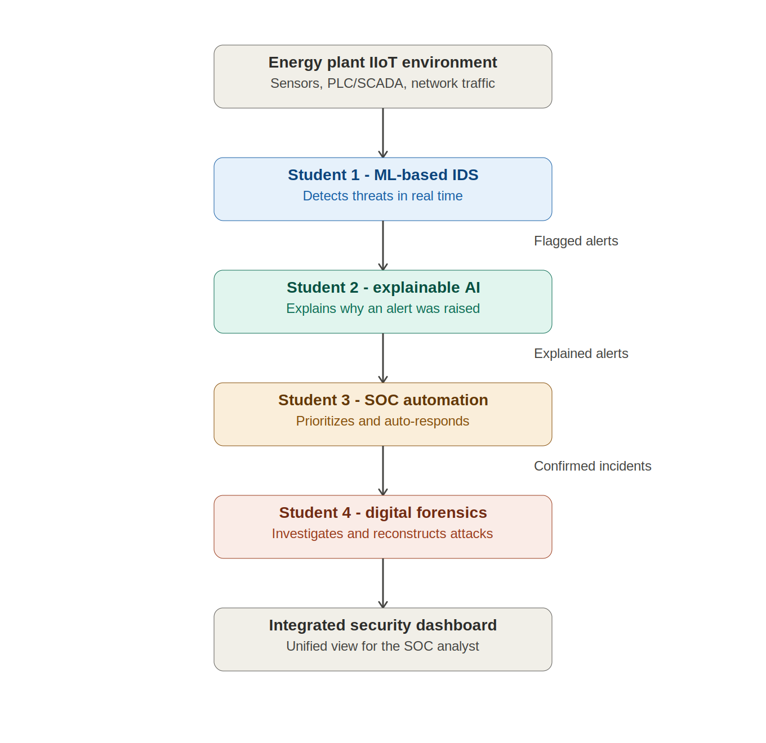

3. How It Works
The four components form a straight, sequential pipeline. Each student's output becomes the next student's input:
- Energy plant IIoT environment: sensors, PLCs/SCADA controllers, and network traffic generate the raw data the whole system depends on.
- Student 1 (ML-based IDS): ingests the raw traffic and sensor data, and uses Random Forest, XGBoost, and Isolation Forest models to detect malicious activity in real time. Output: a flagged alert containing the predicted label, a confidence score, a timestamp, and the underlying feature values.
- Student 2 (Explainable AI): takes each flagged alert and applies SHAP and LIME to generate a human-readable explanation of why the model raised it, including feature importance. Output: an explained alert.
- Student 3 (SOC automation): takes explained alerts, scores and prioritizes them by risk, and triggers automated response recommendations. Output: a confirmed, prioritized incident.
- Student 4 (Digital forensics): takes confirmed incidents and performs evidence correlation, attack timeline reconstruction, and post-incident investigation. Output: a forensic investigation report.
- Integrated security dashboard: combines detection, explanation, prioritization, and forensic output from all four components into a single unified view for the SOC analyst.

4. Data Handoff Between Stages
Stage | Component | Data handed to the next stage
0 | Energy plant IIoT environment  (sensors, PLC/SCADA, network traffic) | Raw network traffic and sensor/telemetry data
1 | Student 1 – ML-based Intrusion Detection System | Flagged alerts: predicted label, confidence score, timestamp, source features
2 | Student 2 – Explainable AI (SHAP/LIME) | Explained alerts: original alert plus human-readable explanation and feature importance
3 | Student 3 – SOC alert prioritization and automation | Confirmed/prioritized incidents with risk score and recommended response
4 | Student 4 – Digital forensics and incident investigation | Forensic report: evidence correlation, attack timeline, root-cause analysis
5 | Integrated security dashboard | Unified view combining detection, explanation, response, and investigation for the SOC analyst

5. Key Coordination Point
Since every downstream component depends on Student 1's output, the exact structure of the alert object (fields, data types, and value ranges for the predicted label, confidence score, timestamp, and feature set) should be agreed upon early between all four students. This ensures Student 2's explanations, Student 3's prioritization logic, and Student 4's forensic timelines can all be built against a stable, shared data format.

