Entities Relation Extraction using LinearSVM

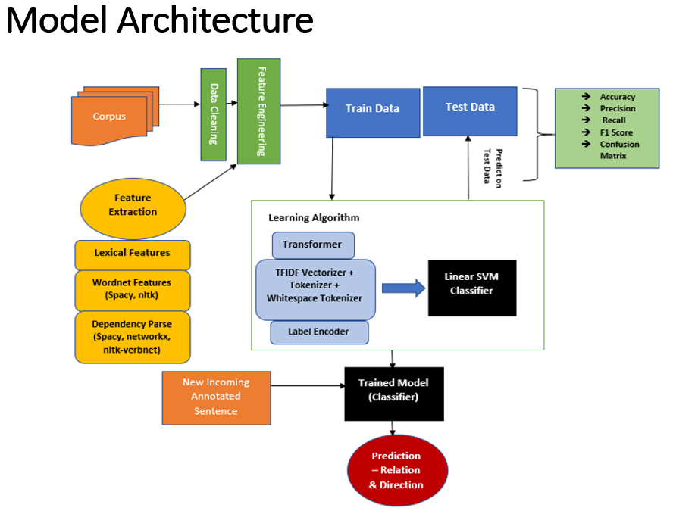

Features:

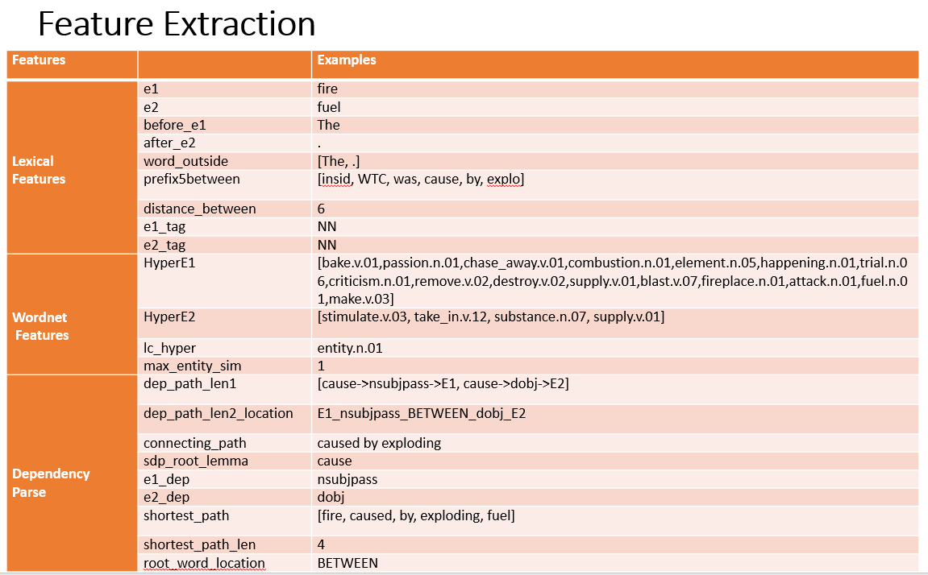

Python Packages used:

---------------------

NLTK

Spacy

networkx

sklearn

matplotlib

Dataset - RelationExtraction/dataset/

Report - RelationExtraction/Report

How to run the model

--------------------

1) First run Model.py under RelationExtraction Folder - This will create train_df.csv and test_df.csv under RelationExtraction which will have all the features extracted from train and test data respectively.

2) Run model_run.ipynb to train the model and test on new input sentence

-> For new input sentence, update the entity anotated sentence in RelationExtraction/dataset/predict_input.txt file.

-> After you train the model using model_run.ipynb, run the last cells after "####Run below for predict new input sentenc ###", to predict on new sentence using trained classifier.