CS 6375

ASSIGNMENT #2: Neural Network

Names of students: Kavin Kuppusamy (KXK190026)

Prachi Vats (PXV180021)

Number of free late days used: __________0__________   
Note: You are allowed a **total** of 4 free late days for the **entire semester**. You can use at most 2 for each assignment. After that, there will be a penalty of 10% for each late day.

Please list clearly all the sources/references that you have used in this assignment.

**Project Report**

**Title:**

Implementation of Neural Network.

**Assumptions Considered:**

User will supply the accurate dataset paths for Training, Validation and Testing process.

**Accomplishments:**

* Given the dataset, the pre-processing of dataset was performed with help of sckitlearn packages. Some of the pre-processing steps are
  + Converting Non-numerical values to numerical values
  + If there is a missing value, replace it with the mean of the column.
  + Feature scaling the data using MinMax normalization method to scale the data values in range (0,1).
* Along with the Input layer and output layer, created the Neural network with 2 hidden layers
* Further with the Sigmoid activation, we implement the other two activation function namely ReLu and Tanh.
* After trained the network with the training set, we calculate the accuracy with the test error for the test dataset.
* Corrected the weights while propagating through the layers.

**Datasets Used:**

Iris Dataset

<https://archive.ics.uci.edu/ml/machine-learning-databases/iris/iris.data>

Hepatitis Dataset:

<https://archive.ics.uci.edu/ml/machine-learning-databases/hepatitis/hepatitis.data>

**Result Analogy:**

|  |  |  |  |
| --- | --- | --- | --- |
| **Dataset** | **Activation Function** | **Training Error** | **Test Error** |
| **Iris** | Sigmoid | 0.829 | 0.150 |
| Tanh | 27.575 | 3.346 |
| ReLu | 30.75 | 5.125 |
| **Hepatitis** | Sigmoid | 10.681 | 1.720 |
| Tanh | 41.914 | 26.413 |
| ReLu | 35.0 | 8.0 |

**Output Results:**

**Iris Dataset**

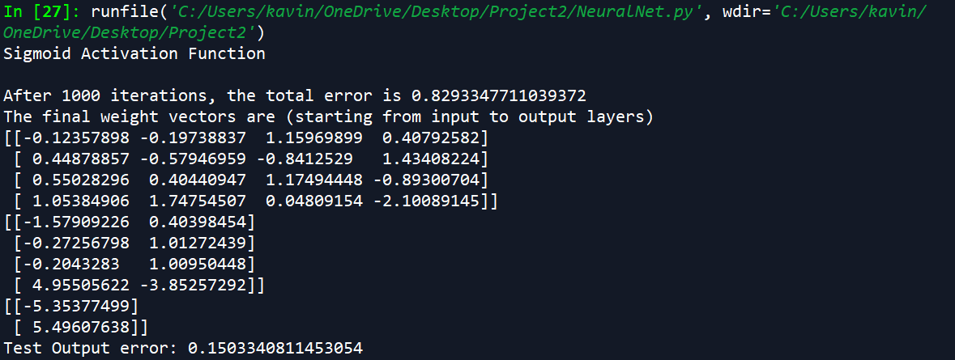

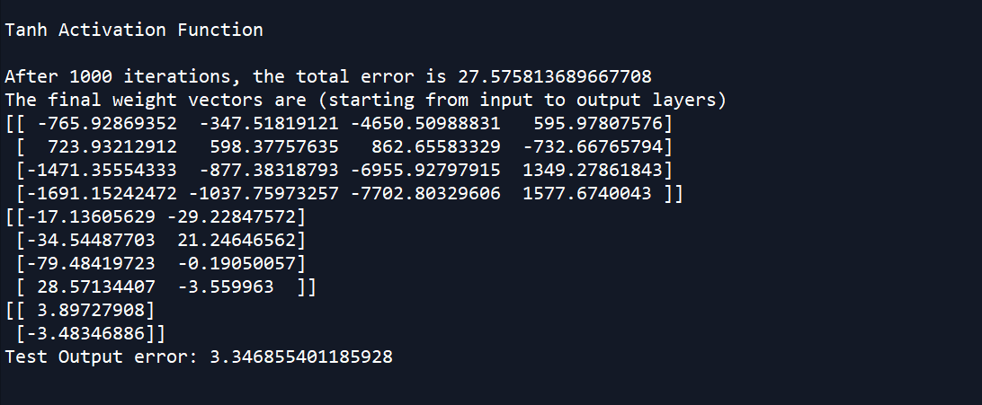

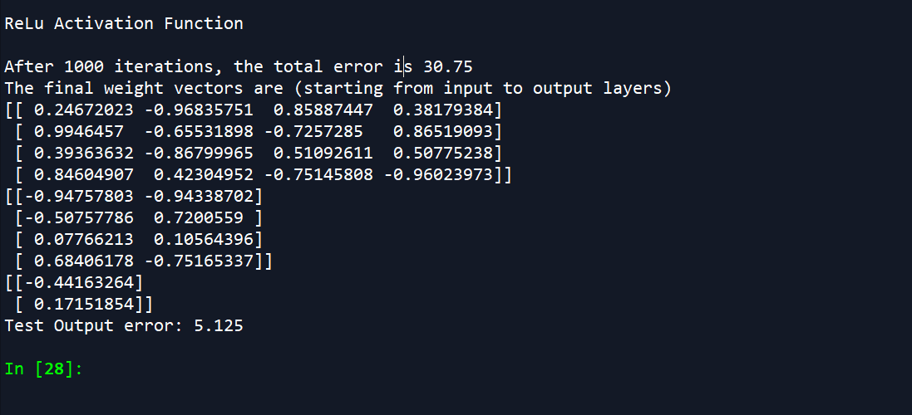

Hepatitis Dataset:

