Retail Reward Application:

apiUrl: http://localhost:8080/api/v1/rewards/customers

Positive Flow:
Case 1:
Request : customerId
Response : Customer reward points for 3 months
Result : Success
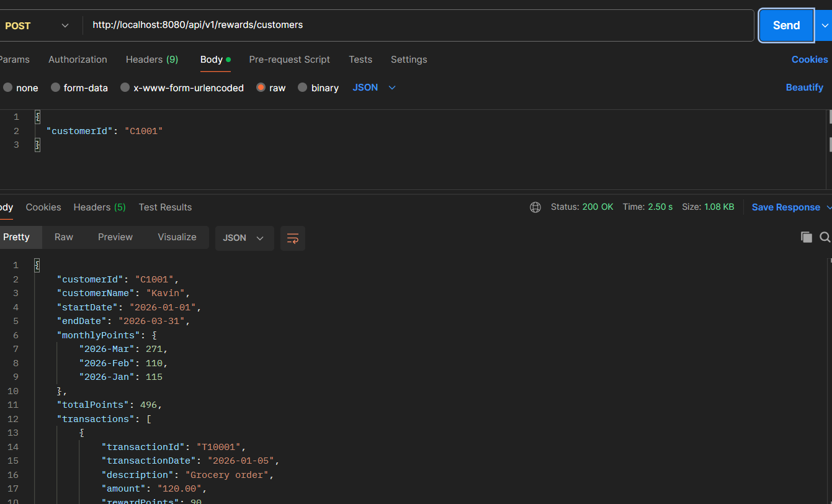

Case 2:
Request : customerId and months
Response : Customer reward points for given months
Result : Success
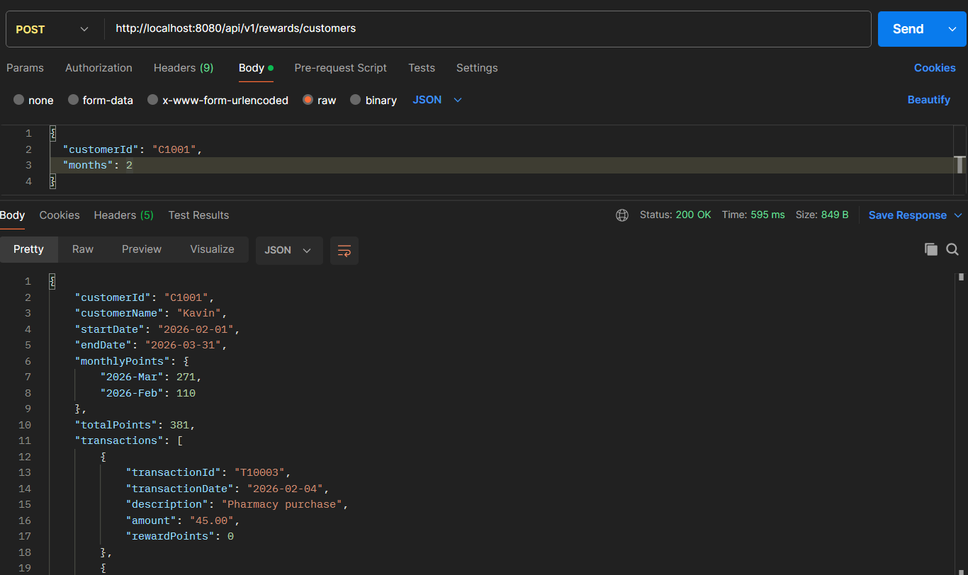Case 3:
Request : customerId and date range
Response : Customer reward points for given date range
Result : Success
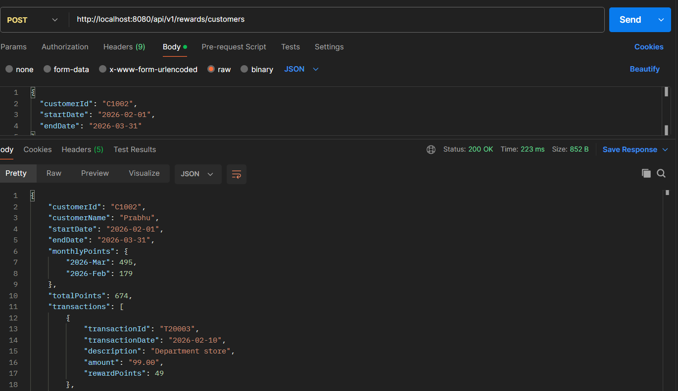

Case 4:
Request : customerId and date range (no transaction)
Response : Customer reward points for given date range
Result : Success
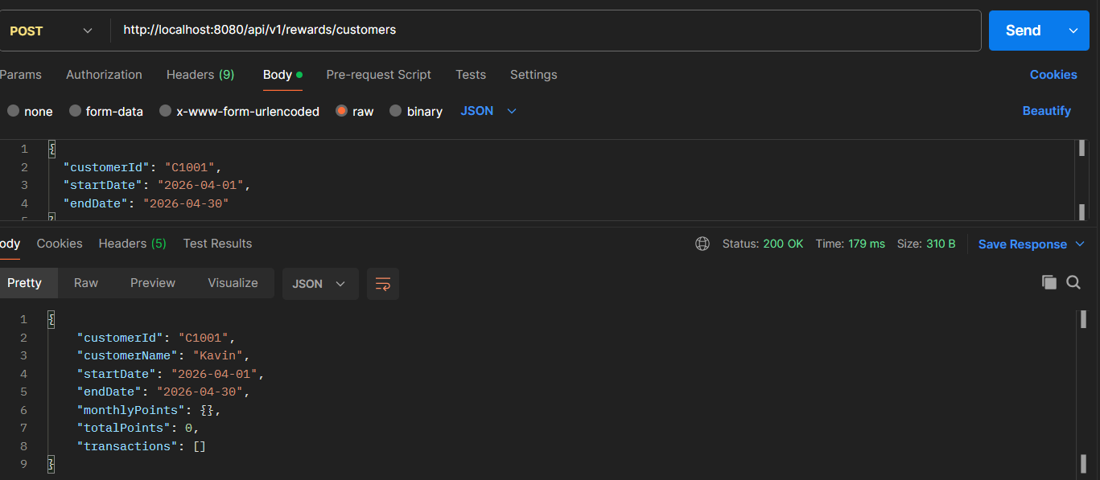
Case 5:
Request : customerId, months and date range
Response : customer data for given months
Result : Success

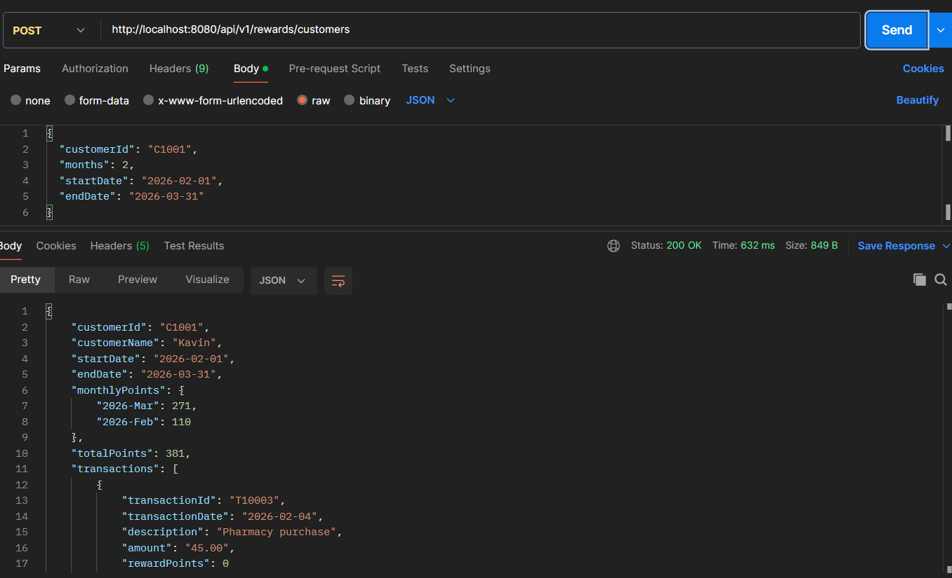

Negative Flow:

Case 1:
Request : empty request body
Response : Error response
Result : Success
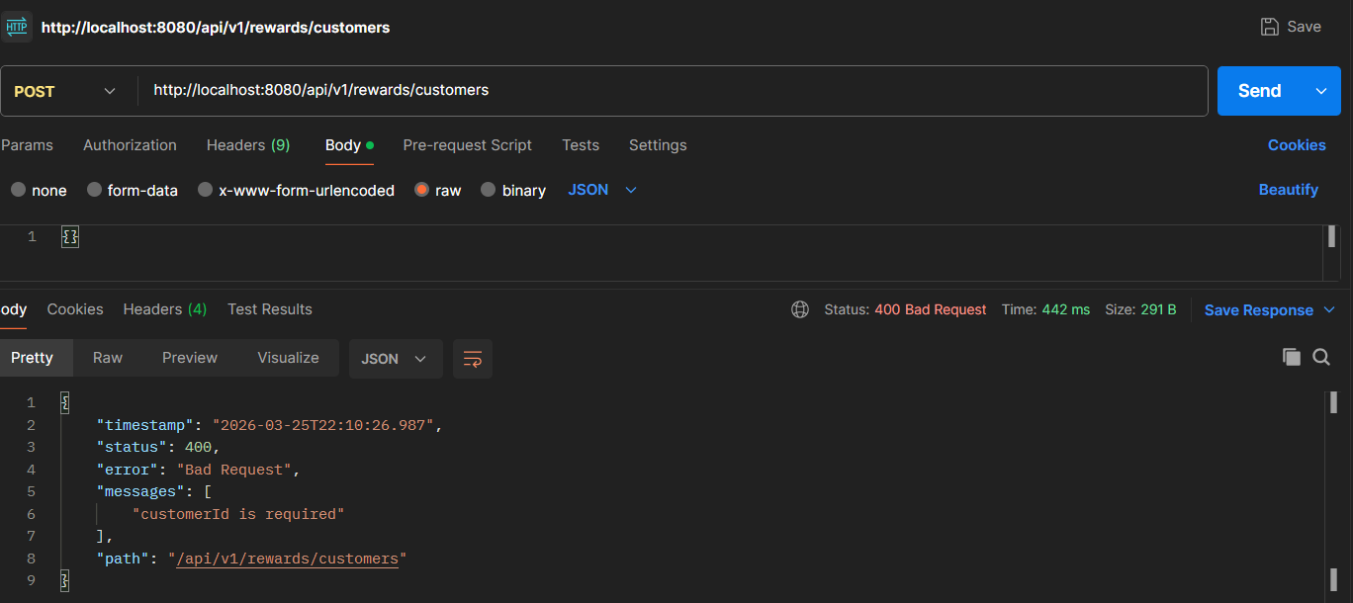

Case 2:
Request : empty customerId
Response : Error response
Result : Success
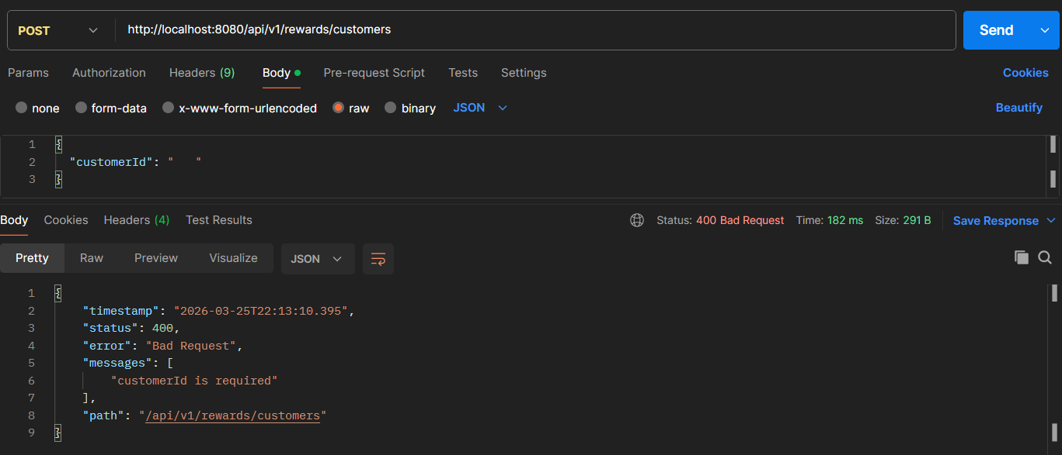

Case 3:
Request : invalid customerId
Response : Error response
Result : Success

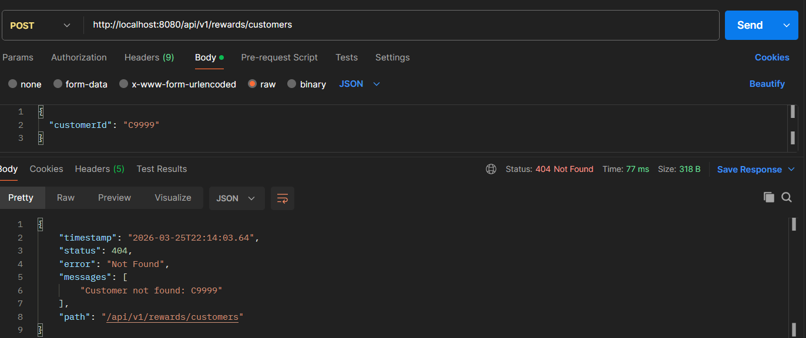

Case 4:
Request : invalid month
Response : Error response
Result : Success
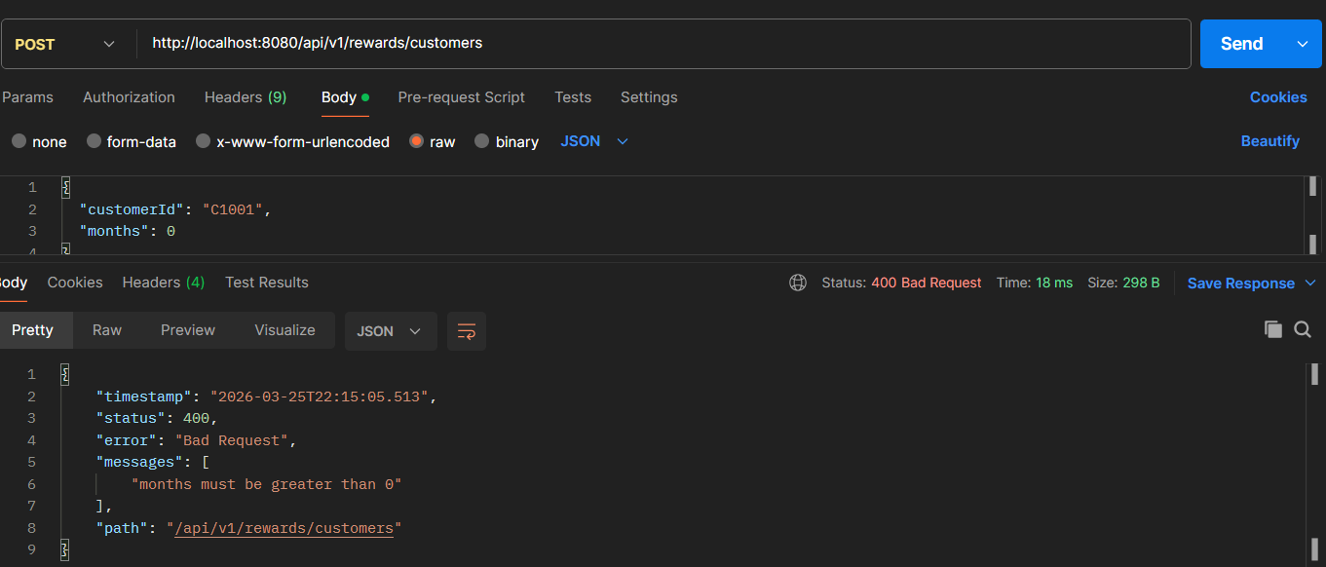
Case 5:
Request : invalid date range
Response : Error response
Result : Success
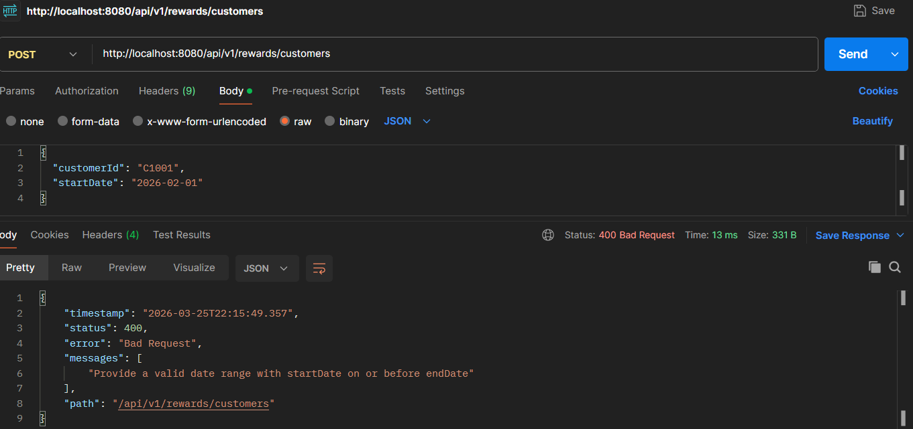

Case 6:
Request : invalid date range
Response : Error response
Result : Success
