Retail Reward Application:

apiUrl: http://localhost:8080/api/v1/rewards/customers

Positive Flow:

Case 1:
Input : empty request
Output : all customer reward points for 3 months
Expected Output : Success
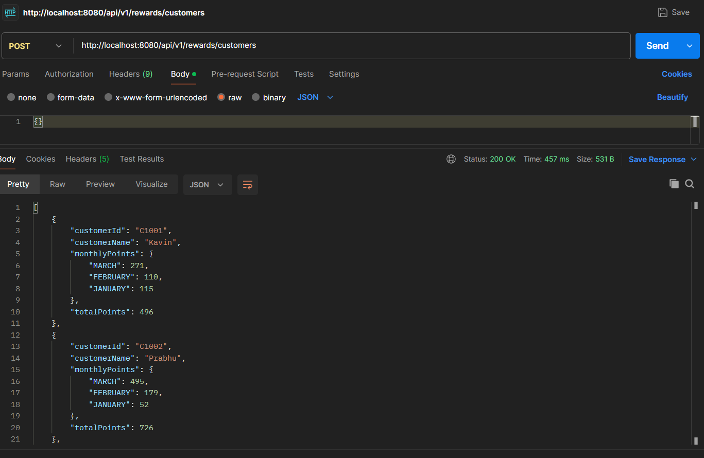

Case 2:
Input : request with month
Output : all customer reward points for given months
Expected Output : Success

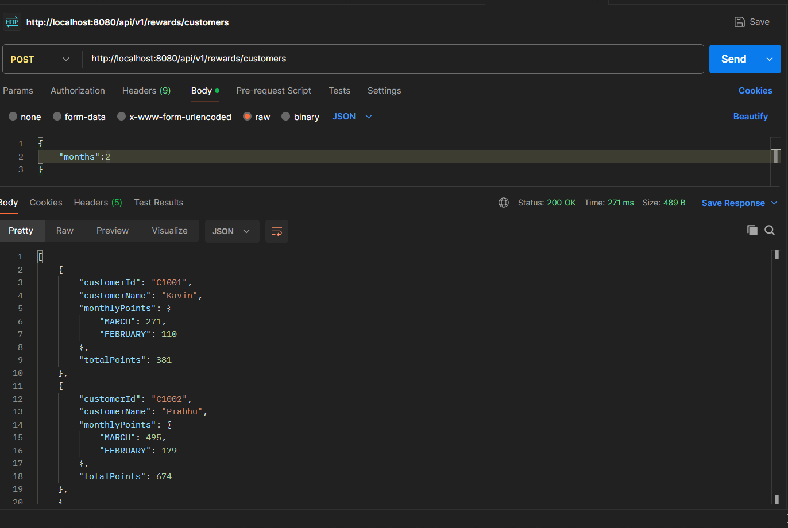

Case 3:
Input : request with date range
Output : all customer reward points for given date range
Expected Output : Success

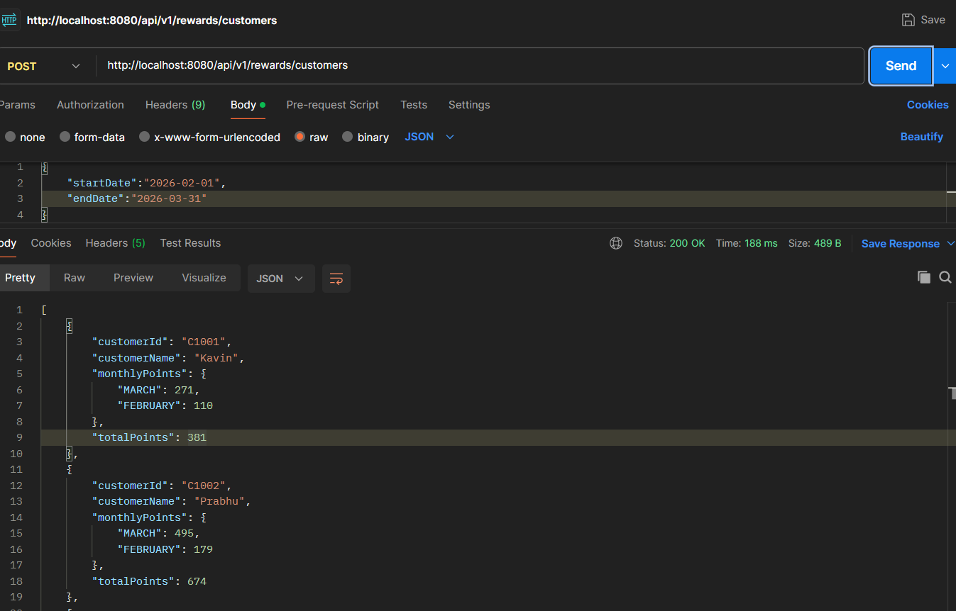

Case 4:
Input : request with date range and customerId
Output : reward points for given date range for given customer
Expected Output : Success

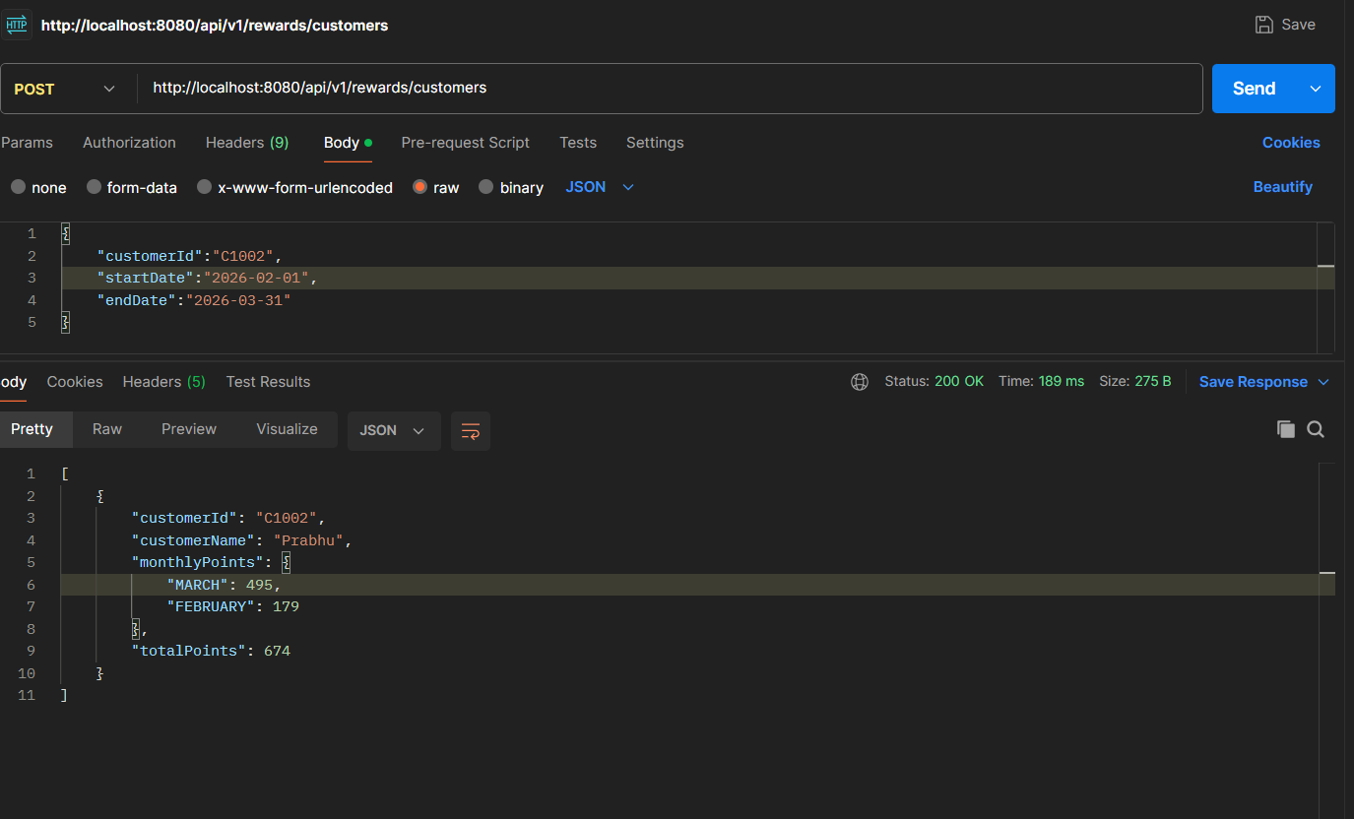

Case 5:
Input : request with month and customerId
Output : reward points for given month for given customer
Expected Output : Success

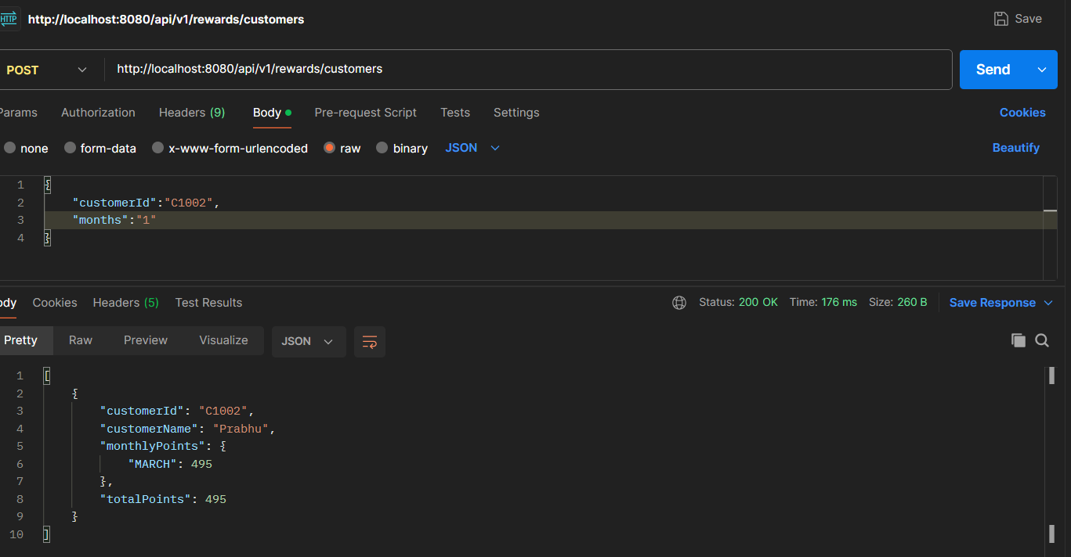

Case 6:
Input : request with customerId
Output : 3 months reward points for given customer
Expected Output : Success

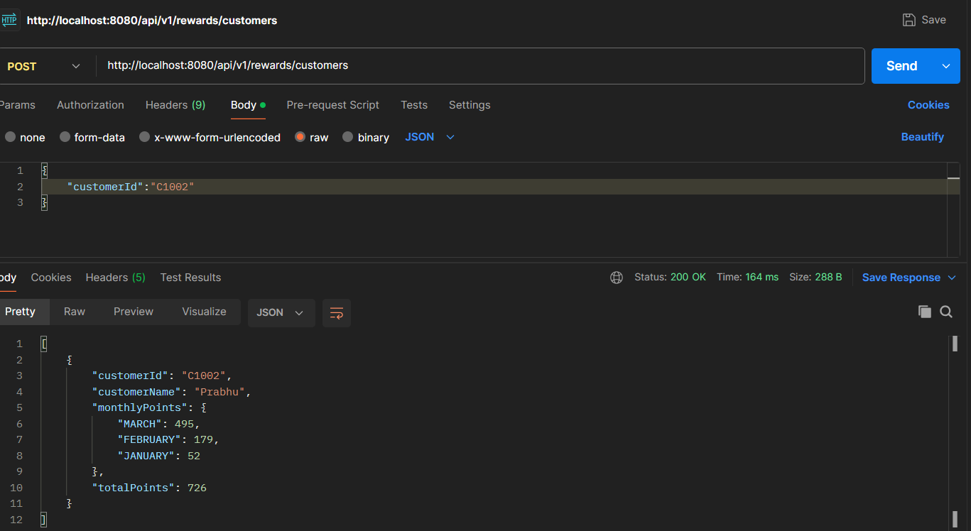

Case 7:
Input : request with customerId , month and date range
Output : reward points for given months for given customer
Expected Output : Success

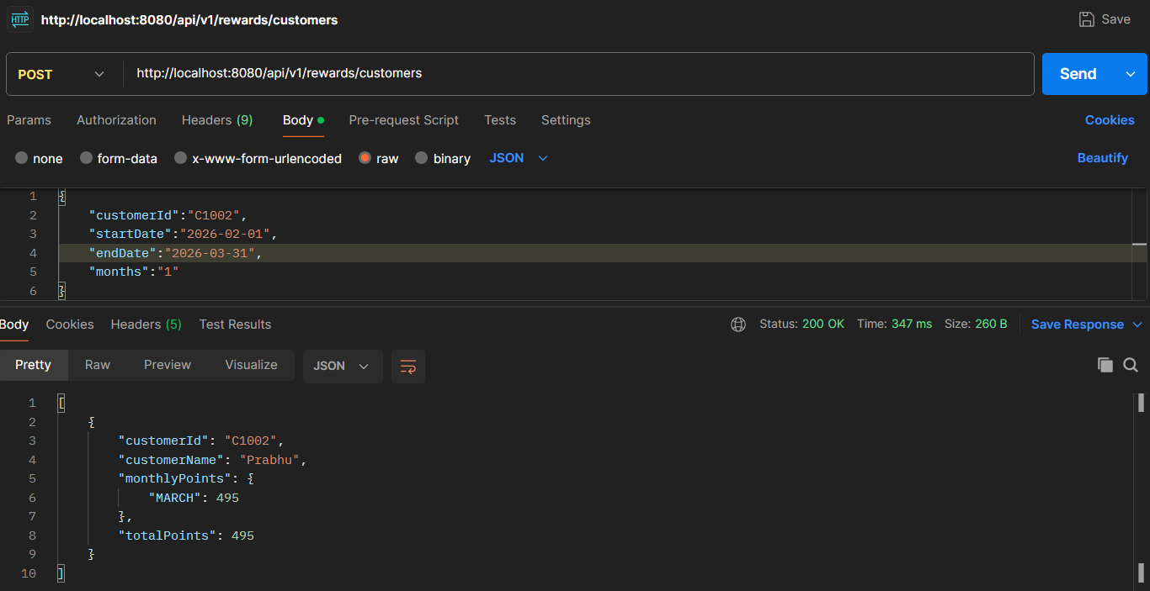

Case 8:
Input : request with multiple customerIds , month and date range
Output : reward points for given months for given customers
Expected Output : Success

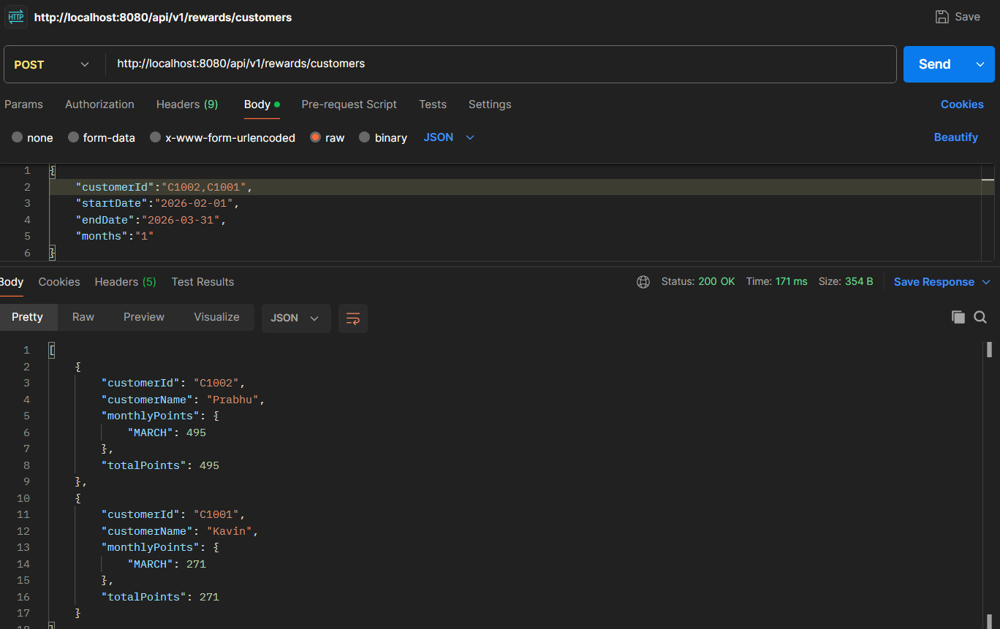

Case 9:
Input : request with multiple customerIds and date range
Output : reward points for given date range for given customers
Expected Output : Success

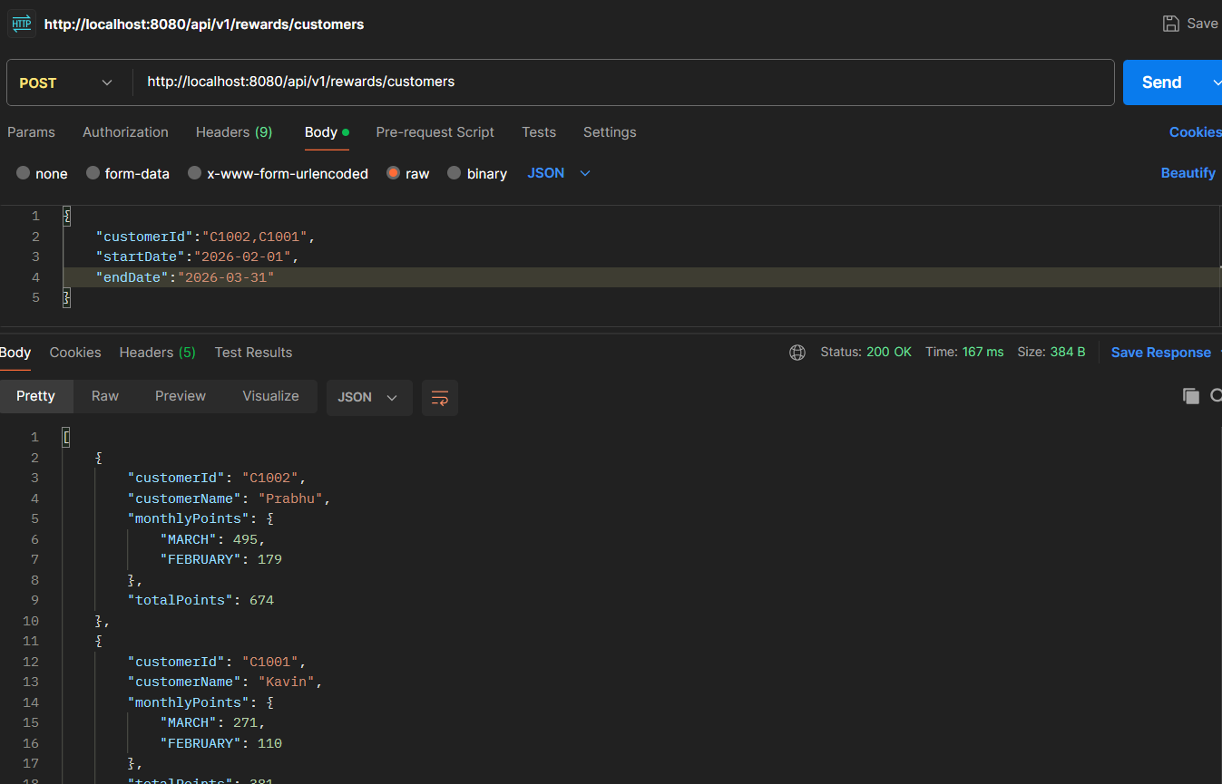
Case 10:
Input : request with multiple customerIds
Output : 3 months reward points for given customers
Expected Output : Success

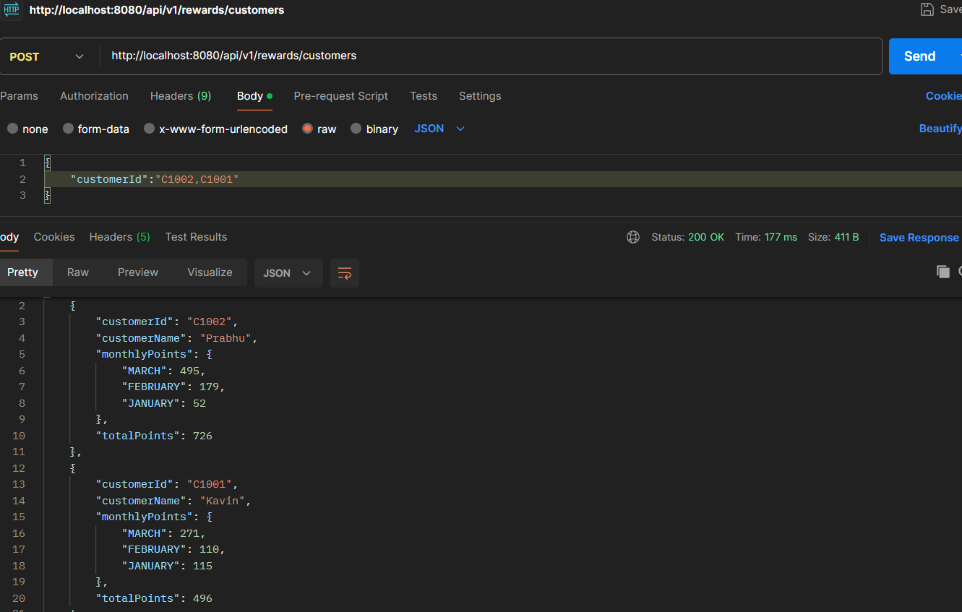

Negative Flow:

Case 11:
Input : request with multiple customerId and anyone date range is null or empty
Output : Error Response
Expected Output : Success

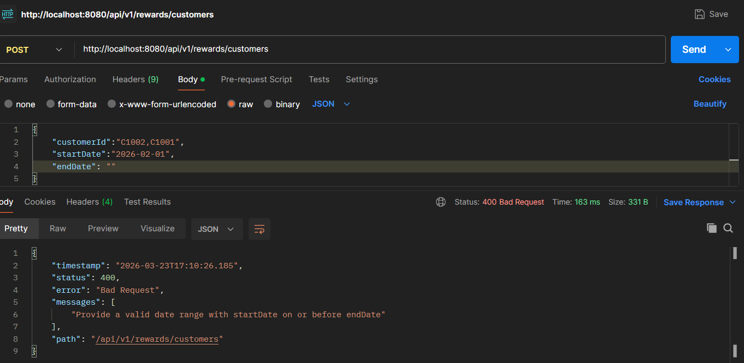
Case 12:
Input : request customerId and month is 0
Output : Error Response
Expected Output : Success

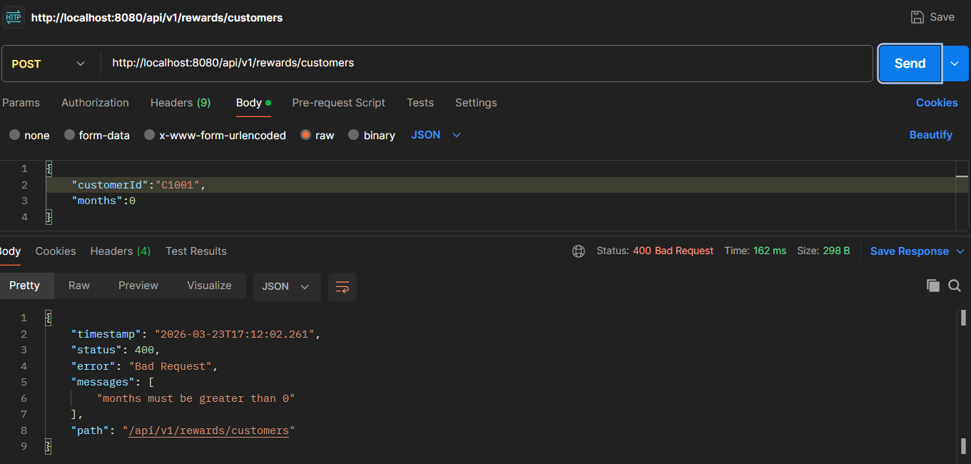

Case 13:
Input : customerId no in the dataset
Output : Error Response
Expected Output : Success

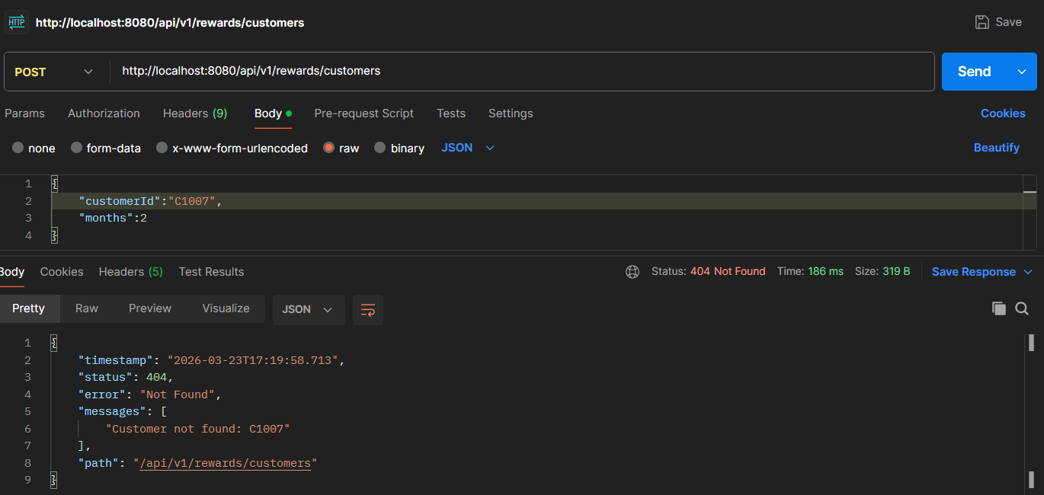

apiUrl: http://localhost:8080/api/v1/rewards/customers/transactions

Positive Flow:

Case 1:
Input : empty request
Output : all customers 3 months transactions
Expected Output : Success

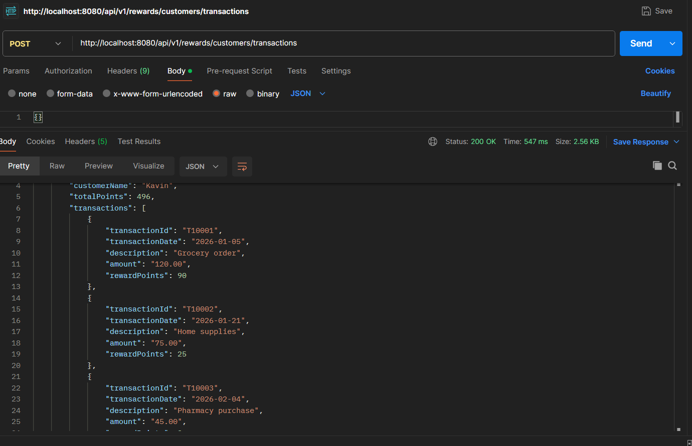

Case 2:
Input : request with months
Output : all customers all transactions for the given month
Expected Output : Success

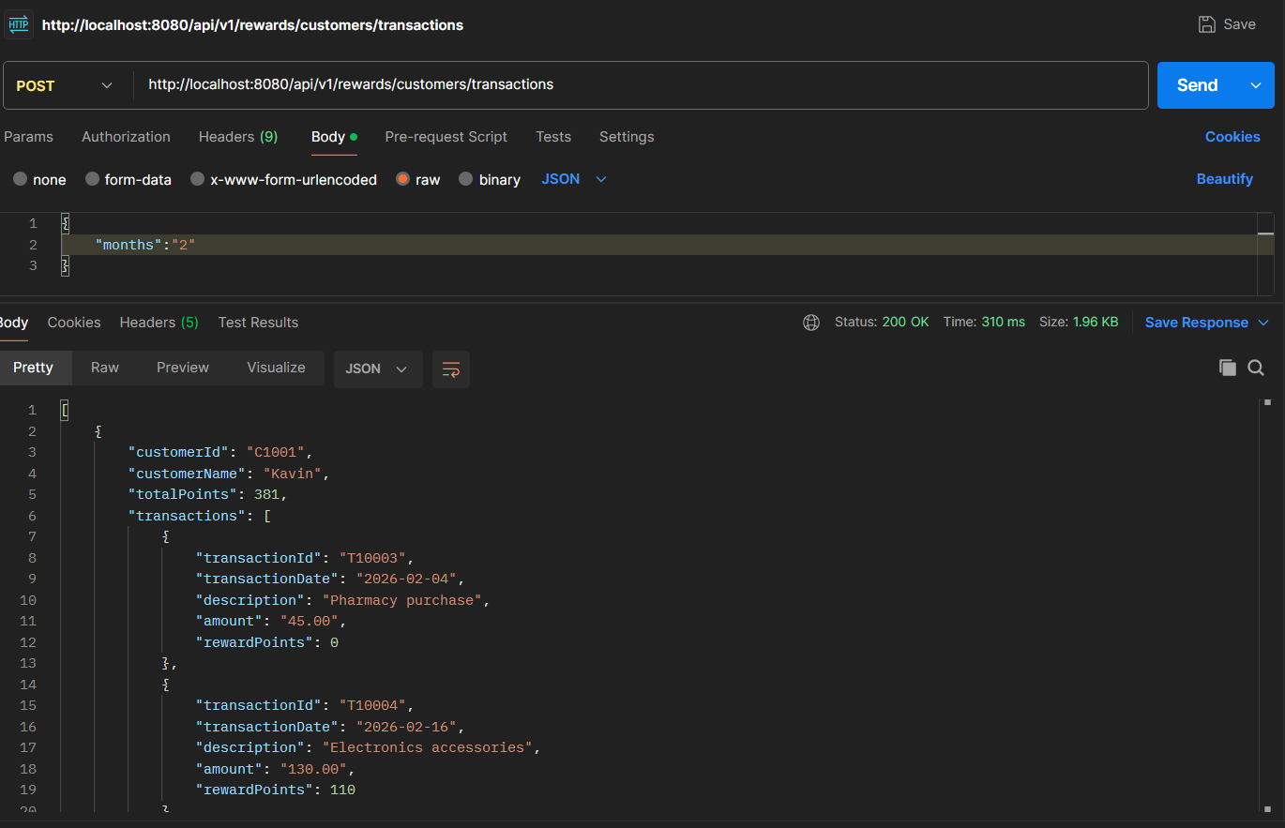

Case 3:
Input : request with date range
Output : all customers all transactions for the given date range
Expected Output : Success

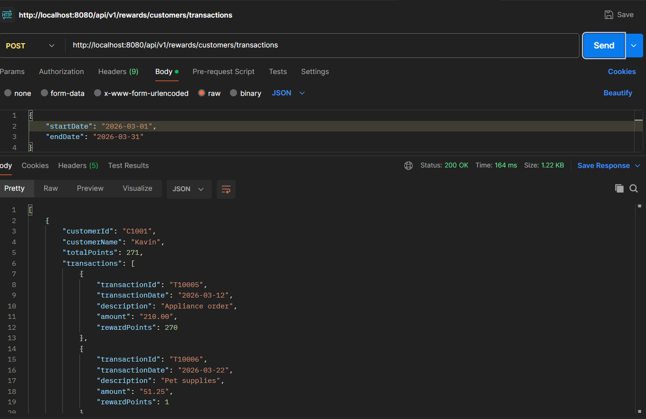

Case 4:
Input : request with customerId
Output : all customers all transactions for the given date range
Expected Output : Success
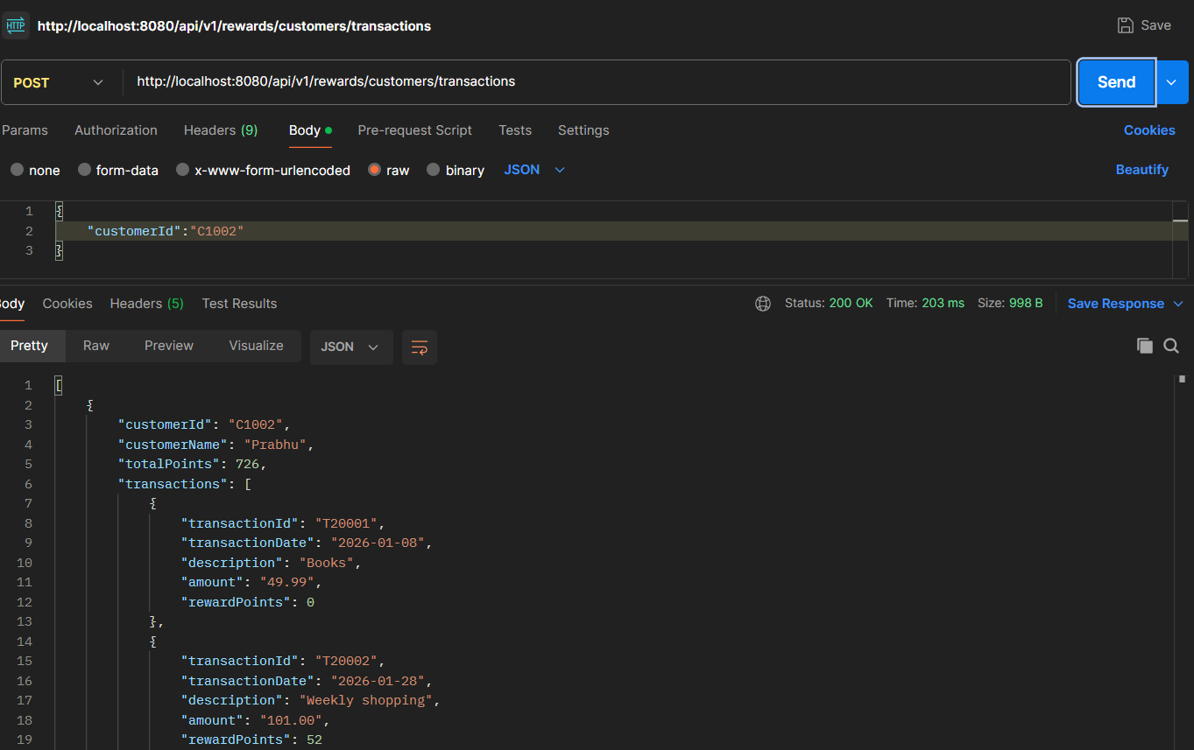

Case 5:
Input : request with customerId and date range
Output : all customers all transactions for the given date range
Expected Output : Success
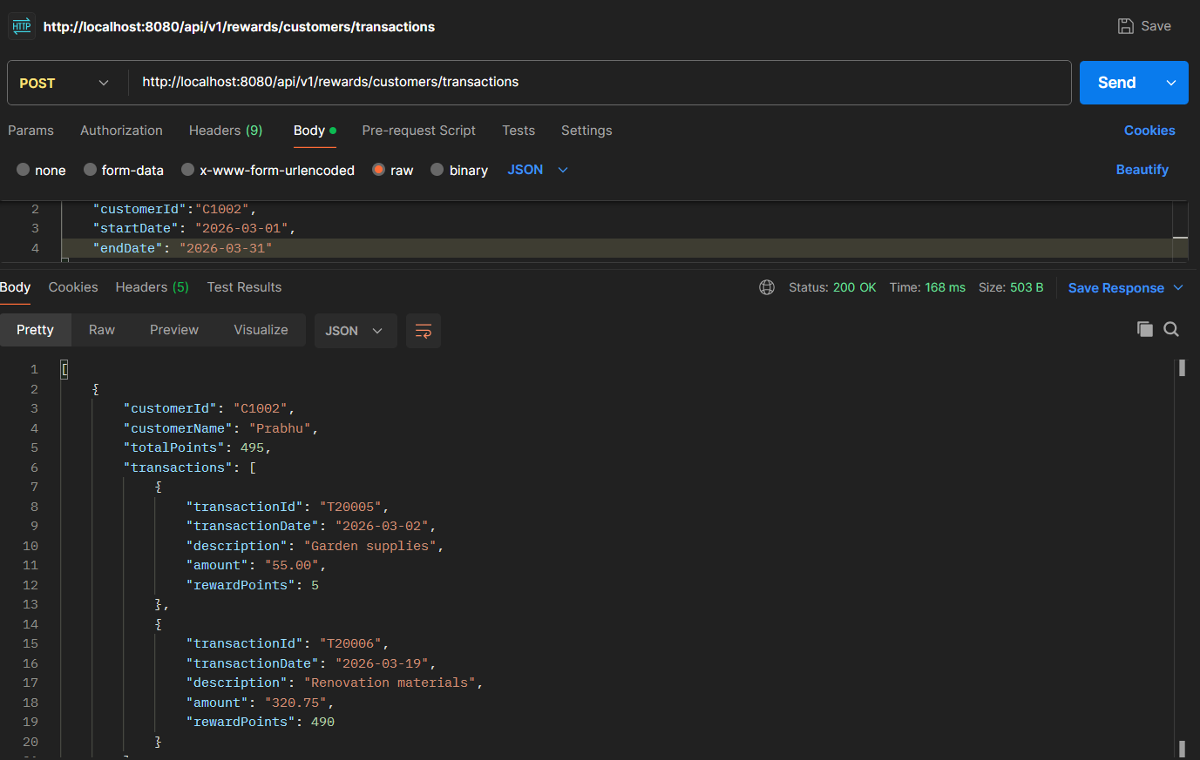
Case 6:
Input : request with customerId and date range (startdate > endDate)
Output : Error response
Expected Output : Success
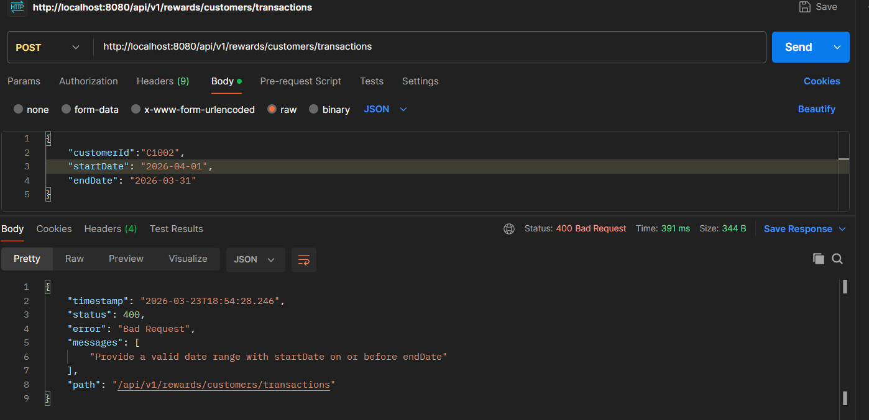

Case 7:
Input : request with invalid customerId
Output : Error response
Expected Output : Success
