# **Meeting Minutes / Engineering Document Submission Guidelines.**

Subha Annamalai

Robo-Phantoms

Team # 23954

October 10, 2023

**Meeting Minutes / Engineering Document Submission Guidelines.**

Hi Team, Documenting is an important step for the success of our team. So, I kindly request you to all submit the documents on time.

**Soft Due Date**

Soft Due Date is the **recommended** due date. So, it will help us stay on track as a team. It will also give me some time to give you feedback, and make necessary changes. Finishing the documents by this date will help our team be more successful, and will keep the team up to date with actual building process. So, **AIM** for completing and uploading the document by this date.

**Figure 1**

*Your reward for completing the assignment on time awaits!*



**Hard Due Date**

Hard Due Date is the **absolute** due date. If you do not submit by this day, our documentation work is going to pile up. It will not only make us derail from our goal, and we will also have to work hard later. So**, Do Not** miss the date.

**Figure 2**

*Lost in the Pile? Don't let your papers pile on you.*

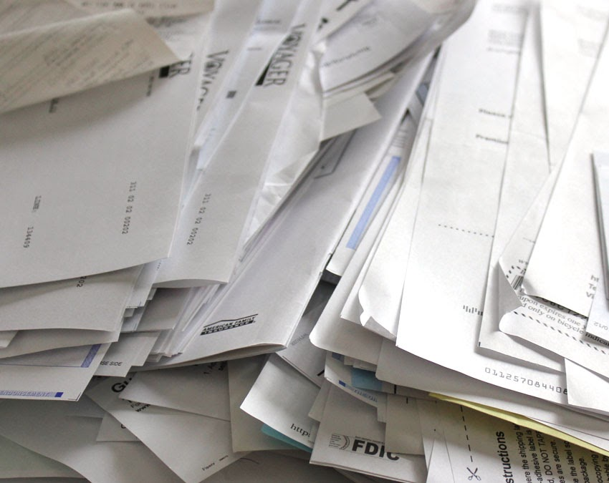

[This Photo](https://365projects.blogspot.com/2013/02/taming-paper-clutter.html) by Unknown Author is licensed under [CC BY-NC](https://creativecommons.org/licenses/by-nc/3.0/)

Imagine where you all want to be?

Please read the below guidelines carefully.

**Meeting Minutes Submission Guidelines**

**Soft Due Date**

Our meetings are scheduled for every Saturday and Sunday. Meeting Notes must be submitted by that **Tuesday.** For Example, if the meeting was on October 7 or October 8, then the soft due date is on Tuesday, October 10, 2023 by 7:00 PM.

**Hard Due Date**

Our meetings are scheduled for every Saturday and Sunday. Meeting Notes must be submitted by that **Thursday**. For Example, if the meeting was on October 7 or October 8, then the soft due date is on Thursday, October 12,2023 by 7:00 PM. This will allow us to be complete our work before next meeting.

**Submission Format**

***File Format***

Please submit your document in .docx format. Use the template in <https://github.com/srinathmadasu76/FTC_2023/tree/main/Documentation/Meeting%20Minutes>

***File Naming***

Name your file in YYYY-MM-DD format. For Example 2023-10-08.

***Submission Method***

Submit your file by creating feature branch in GitHub. Place it in the Documentation/MeetingMinutes directory in that branch, and create pull request. Follow the procedure in <https://github.com/srinathmadasu76/FTC_2023/blob/main/Documentation/Procedures/GitHub%20Procedure.pdf> document.

**Engineering Notebook Submission Guidelines**

**Soft Due Date**

Our meetings are scheduled for every Saturday and Sunday. Meeting Notes must be submitted by following **Tuesday**. (The week after completing the presentation). For example, if the presentation was on October 7,2023 or October 8,2023, then the soft due date is on Tuesday, October 10, 2023 by 7:00 PM.

**Hard Due Date**

Our meetings are scheduled for every Saturday and Sunday. Meeting Notes must be submitted by following **Thursday**. (The week after completing the presentation). For example, if the presentation was on October 7,2023 or October 8,2023, then the soft due date is on Thursday, October 12, 2023 by 7:00 PM.

**Submission Format**

***File Format***

Please submit your document in .docx format. Use the following document <https://github.com/srinathmadasu76/FTC_2023/blob/main/Documentation/Procedures/student-paper-setup-guide.pdf> as guideline for formatting. In our documents, we will be using **Font: Book Antiqua, Font Size for the Title: 14, Text Font Size: 12, Line spacing: 1.5.**

The below document can be used as a reference for the general structure of the document. This will provide a guidance on which phase of Engineering Design Process we are currently on, and follow the guidelines on documentation procedures.

<https://github.com/srinathmadasu76/FTC_2023/blob/main/Documentation/Notebooks/Engg%20Portfolio/Engg%20Portfolio%20Template.docx>

***File Naming***

Name your file in Your First Name_Title format.

Example: Subha_EnggNotebook_Template.

***Submission Method***

Submit your file by creating feature branch in GitHub. Place it in the Documentation/Engg Notebook directory in that branch, and create pull request. Follow the procedure in <https://github.com/srinathmadasu76/FTC_2023/blob/main/Documentation/Procedures/GitHub%20Procedure.pdf> document.

! If you have any questions, reach out to anyone in the team. Do not wait until last minute to ask for help.