UCS2612 Machine Learning Laboratory A5: K Nearest Neighbour Algorithm

Name : Kavin Siva S

Roll No : **3122 21 5001 306**

**----------------------------------------------------------------------------------------------**

Develop a python program to predict the Online Shoppers Purchasing Intention using K- Nearest Neighbour algorithm. Visualize the features from the dataset and interpret the results obtained by the model using Matplotlib library.

**Code and Output:**

import pandas as pd shopping_online=pd.read_csv('/home/mllab2/Desktop/onlineShop/online

_shoppers_intention.csv')pip install pandas shopping_online.info()

shopping_online.isnull().sum() from sklearn import preprocessing

# Loop over each column in the DataFrame where dtype is 'object'for col in shopping_online.select_dtypes(include=['object','bool']).columns:

# Print the column name and the unique values print(f"{col}: {shopping_online[col].unique()}")

# Loop over each column in the DataFrame where dtype is 'object'for col in shopping_online.select_dtypes(include=['object','bool']).columns:

# Handle missing values (replace with a default value or drop rows) shopping_online[col].fillna('unknown', inplace=True)

# Convert all values to strings

shopping_online[col] = shopping_online[col].astype(str)

# Initialize a LabelEncoder object label_encoder = preprocessing.LabelEncoder()

# Fit the encoder to the unique values in the column

label_encoder.fit(shopping_online[col].unique())

# Transform the column using the encoder

shopping_online[col] = label_encoder.transform(shopping_online[col])

# Print the column name and the unique encoded valuesprint(f"{col}:

{shopping_online[col].unique()}") pip install scikit-learn

import matplotlib.pyplot as plt import seaborn as sns

correlation_matrix = shopping_online.corr()

plt.figure(figsize=(12, 10))

sns.heatmap(correlation_matrix, annot=True, cmap='coolwarm', fmt='.2f', linewidths=.5)

plt.title('Correlation Heatmap') plt.show()

pip install matplotlib pip install seaborn

from sklearn import metrics

from sklearn.neighbors import KNeighborsClassifier

from sklearn.model_selection import train_test_split, StratifiedKFold, cross_val_score, cross_validate, GridSearchCV

from sklearn.metrics import accuracy_score, precision_score, recall_score, f1_score, classification_report, confusion_matrix,roc_auc_score, make_scorer

x_o=shopping_online.drop('Revenue',axis=1) y_o=shopping_online['Revenue']

from sklearn.model_selection import train_test_split x_train_o,x_test_o,y_train_o,y_test_o=train_test_split(x_o,y_o,test_size

=0.2,random_state=42,stratify=y_o)

from sklearn.neighbors import KNeighborsClassifier from sklearn.metrics import accuracy_score

# Initialize the KNN classifier

knn_classifier = KNeighborsClassifier(n_neighbors=5) # You can adjustthe number of neighbors

# Train the model knn_classifier.fit(x_train_o, y_train_o)

# Predict on the test set

y_pred_o = knn_classifier.predict(x_test_o)

# Evaluate the model

accuracy = accuracy_score(y_test_o, y_pred_o) print("Accuracy:", accuracy)

import numpy as np class KNNClassifier:

def init (self, k=5):self.k =

k

def fit(self, X, y): self.X_train = X self.y_train = y

def predict(self, X):

y_pred = [self._predict(x) for x in X] return np.array(y_pred)

def _predict(self, x):

distances = [np.linalg.norm(x - x_train) for x_train in self.X_train]k_indices = np.argsort(distances)[:self.k]

k_nearest_labels = [self.y_train[i] for i in k_indices]most_common = max(set(k_nearest_labels),

key=k_nearest_labels.count) return most_common

# Example usage:

# Instantiate the classifier knn_classifier = KNNClassifier(k=5)

# Train the classifier knn_classifier.fit(x_train_o.values, y_train_o.values)

# Predict on the test set

y_pred_o = knn_classifier.predict(x_test_o.values)

# Evaluate the model

accuracy = np.mean(y_pred_o == y_test_o.values) print("Accuracy:", accuracy)

# Example usage:

# Instantiate the classifier knn_classifier = KNNClassifier(k=3)

# Train the classifier knn_classifier.fit(x_train_o.values, y_train_o.values)

# Predict on the test set

y_pred_o = knn_classifier.predict(x_test_o.values)

# Evaluate the model

accuracy = np.mean(y_pred_o == y_test_o.values) print("Accuracy:", accuracy)

import numpy as np class KNNClassifier:

def init (self, k=5, epochs=1):self.k = k self.epochs = epochs

def fit(self, X, y): self.X_train = X self.y_train = y

def predict(self, X):

y_pred = [self._predict(x) for x in X] return np.array(y_pred)

def _predict(self, x):

distances = [np.linalg.norm(x - x_train) for x_train in self.X_train]k_indices = np.argsort(distances)[:self.k]

k_nearest_labels = [self.y_train[i] for i in k_indices]most_common = max(set(k_nearest_labels),

key=k_nearest_labels.count) return most_common

# Iterate through epochs for _ in range(self.epochs):

for x, y in zip(X, y): self._update_weights(x, y)

# Example usage:

# Instantiate the classifier

knn_classifier = KNNClassifier(k=5, epochs=3) # Set number of epochs to3

# Train the classifier knn_classifier.fit(x_train_o.values, y_train_o.values)

# Predict on the test set

y_pred_o = knn_classifier.predict(x_test_o.values)

# Evaluate the model

accuracy = np.mean(y_pred_o == y_test_o.values) print("Accuracy:", accuracy)

import numpy as np

import matplotlib.pyplot as plt

from sklearn.metrics import pairwise_distances

class KNNClassifier:

def init (self, k=5, distance='euclidean'):self.k = k self.distance = distance

def fit(self, X, y): self.X_train = X self.y_train = y

def predict(self, X):

distances = pairwise_distances(X, self.X_train, metric=self.distance)y_pred

= [self._predict(dist) for dist in distances] return np.array(y_pred)

def _predict(self, distances):

k_indices = np.argsort(distances)[:self.k] k_nearest_labels

= [self.y_train[i] for i in k_indices]most_common = max(set(k_nearest_labels),

key=k_nearest_labels.count)

return most_common

# Function to evaluate accuracy for a given k and distance metric

def evaluate_knn(k, distance_metrics, x_train, y_train, x_test, y_test):accuracies

= []

for distance_metric in distance_metrics:

knn_classifier = KNNClassifier(k=k, distance=distance_metric) knn_classifier.fit(x_train, y_train)

y_pred = knn_classifier.predict(x_test) accuracy = np.mean(y_pred == y_test) accuracies.append(accuracy)

return accuracies

# Define the value of k and distance metricsk = 20 distance_metrics = ['euclidean', 'manhattan', 'minkowski']

# Evaluate accuracy for the specified k value and distance metricsaccuracies = evaluate_knn(k, distance_metrics, x_train_o.values, y_train_o.values, x_test_o.values, y_test_o.values)

print(accuracies)#

Plot results plt.figure(figsize=(10, 6))

plt.bar(distance_metrics, accuracies)

plt.title(f'Accuracy for k={k} and Different Distance Metrics')plt.xlabel('Distance Metric')

plt.ylabel('Accuracy')

plt.ylim(0, 1) # Set y-axis limits between 0 and 1 plt.grid(axis='y')

plt.show()

import numpy as np

import matplotlib.pyplot as plt

from sklearn.metrics import roc_curve, auc

class KNNClassifier:

def init (self, k=5, distance='euclidean'):self.k = k self.distance = distance

def fit(self, X, y): self.X_train = X self.y_train = y

def predict_proba(self, X):

distances = pairwise_distances(X, self.X_train, metric=self.distance)y_probs

= []

for dist in distances:

k_indices = np.argsort(dist)[:self.k] k_nearest_labels = [self.y_train[i] for i in k_indices]

class_probs = [k_nearest_labels.count(c) / self.k for c in np.unique(self.y_train)]

y_probs.append(class_probs) return np.array(y_probs)

# Function to plot ROC curve

def plot_roc_curve(y_true, y_prob, title): fpr, tpr, _ = roc_curve(y_true, y_prob) roc_auc

= auc(fpr, tpr)

plt.plot(fpr, tpr, lw=2, label='ROC curve (area = %0.2f)' % roc_auc)

# Function to plot ROC curves for training and testing data on the samegraph def plot_roc_curves(classifier, x_train, y_train, x_test, y_test, title):

classifier.fit(x_train, y_train)

y_train_prob = classifier.predict_proba(x_train)[:, 1] y_test_prob = classifier.predict_proba(x_test)[:, 1]

plt.figure(figsize=(8, 6))

plot_roc_curve(y_train, y_train_prob, f'Training {title} ROC Curve') plot_roc_curve(y_test, y_test_prob, f'Testing {title} ROC Curve')

plt.plot([0, 1], [0, 1], color='navy', lw=2, linestyle='--')

plt.xlim([0.0, 1.0])

plt.ylim([0.0, 1.05]) plt.xlabel('False Positive Rate') plt.ylabel('True Positive Rate') plt.title('ROC Curves') plt.legend(loc="lower right") plt.show()

# Instantiate KNN classifier

knn_classifier = KNNClassifier(k=20, distance='euclidean')

# Plot both ROC curves

plot_roc_curves(knn_classifier, x_train_o.values, y_train_o.values,x_test_o.values, y_test_o.values, 'KNN Classifier')

import numpy as np

import matplotlib.pyplot as plt

from sklearn.metrics import roc_curve, auc, pairwise_distances

class KNNClassifier:

def init (self, k=5, distance='euclidean'):self.k = k self.distance = distance

def fit(self, X, y): self.X_train = X self.y_train = y

def predict_proba(self, X):

distances = pairwise_distances(X, self.X_train, metric=self.distance)y_probs

= []

for dist in distances:

k_indices = np.argsort(dist)[:self.k] k_nearest_labels = [self.y_train[i] for i in k_indices]

class_probs = [k_nearest_labels.count(c) / self.k for c in np.unique(self.y_train)]

y_probs.append(class_probs) return np.array(y_probs)

# Function to plot ROC curve

def plot_roc_curve(y_true, y_prob, title): fpr, tpr, _ = roc_curve(y_true, y_prob) roc_auc

= auc(fpr, tpr)

plt.plot(fpr, tpr, lw=2, label=f'{title} (area = %0.2f)' % roc_auc)

# Function to plot ROC curves for training and testing data on the samegraph def plot_roc_curves(x_train, y_train, x_test, y_test, k=20):

distance_metrics = ['euclidean', 'manhattan', 'minkowski'] plt.figure(figsize=(8, 6))

for distance_metric in distance_metrics:

knn_classifier = KNNClassifier(k=k, distance=distance_metric) knn_classifier.fit(x_train, y_train)

y_train_prob = knn_classifier.predict_proba(x_train)[:, 1]y_test_prob

= knn_classifier.predict_proba(x_test)[:, 1]

plot_roc_curve(y_train, y_train_prob, f'Training

{distance_metric.upper()}')

plot_roc_curve(y_test, y_test_prob, f'Testing

{distance_metric.upper()}')

plt.plot([0, 1], [0, 1], color='navy', lw=2, linestyle='--')

plt.xlim([0.0, 1.0])

plt.ylim([0.0, 1.05]) plt.xlabel('False Positive Rate') plt.ylabel('True Positive Rate')

plt.title('ROC Curves for Different Distance Metrics') plt.legend(loc="lower right")

plt.show()

# Plot ROC curves for all distance metrics plot_roc_curves(x_train_o.values, y_train_o.values, x_test_o.values,y_test_o.values)

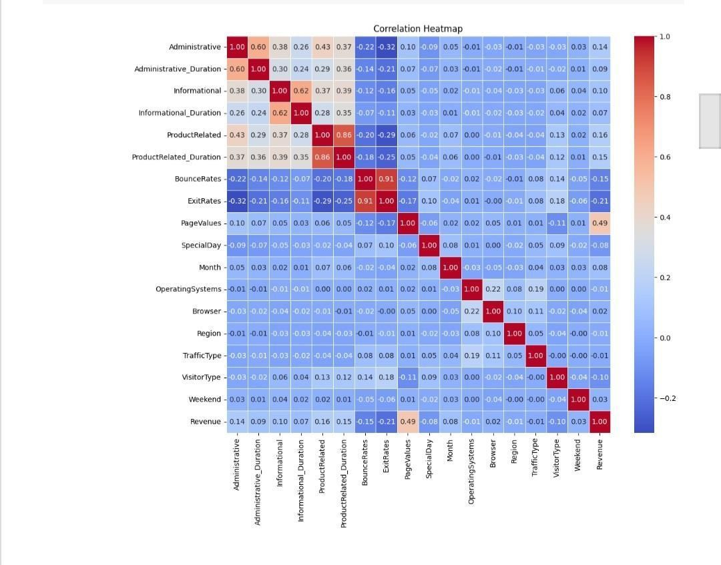

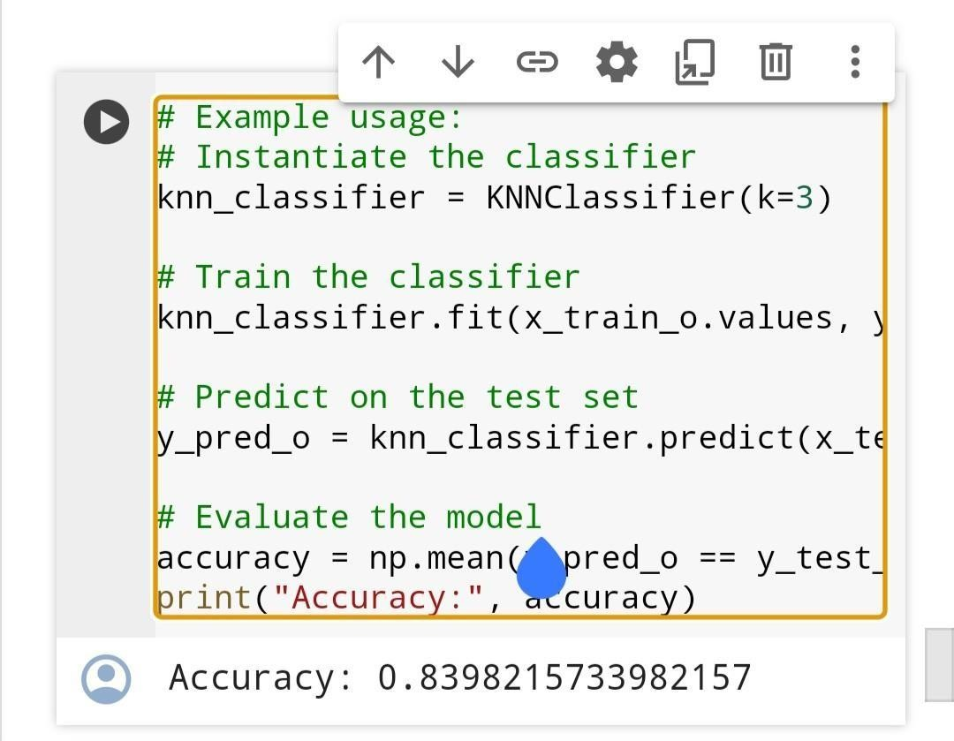

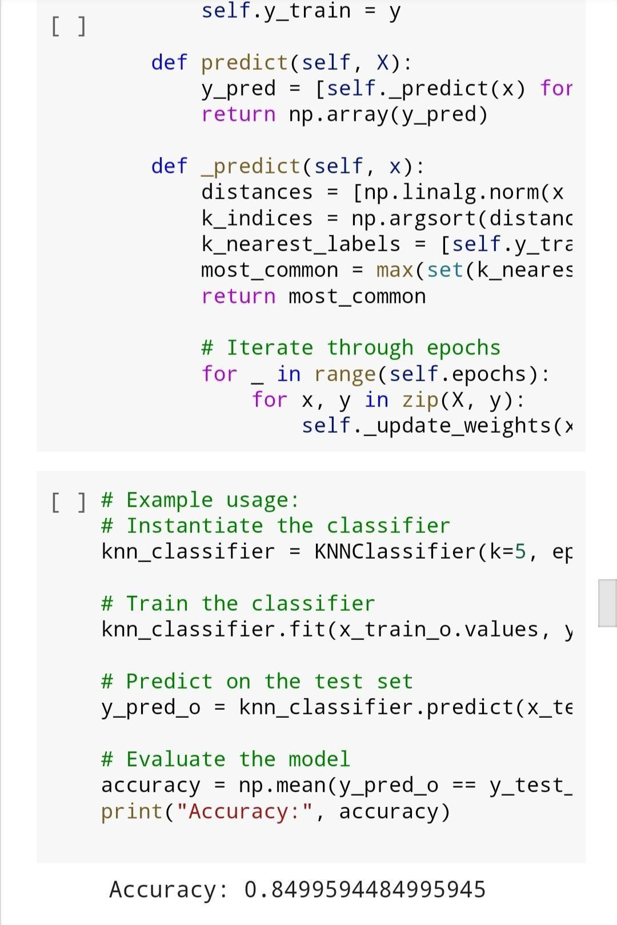

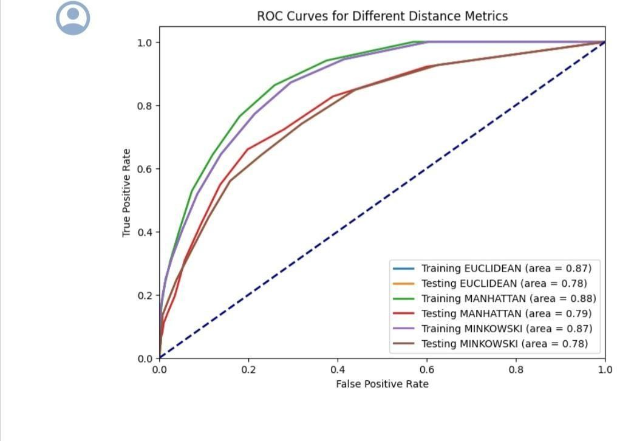

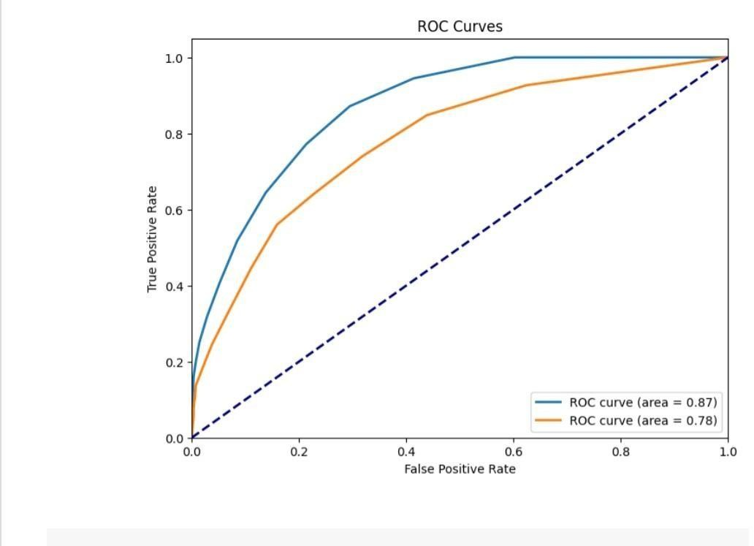

**Learning Outcome:-**

* Better Understanding about the K Nearest Neighbours
* The K Nearest Neighbors was performed using built in functions.
* The model worked well for k value of 5
* From the above results I conclude **that K Nearest Neighbors (KNN) Workswell for the dataset**