**TASK 1:**

**1:**

**Task 1: Write a simple script that displays “Hello, World!” on the web page using an alert box.**

<!DOCTYPE html>

<html lang="en">

<head>

    <meta charset="UTF-8">

    <meta name="viewport" content="width=device-width, initial-scale=1.0">

    <title>Task1</title>

</head>

<body>

    <script>

        alert("Hello World");

    </script>

</body>

</html>

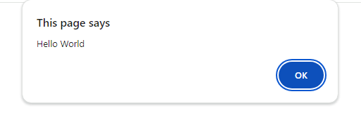

**Task 2: Experiment with different data types in JavaScript (e.g., string, number, boolean) by declaring and logging them in the console.**

<!DOCTYPE html>

<html lang="en">

<head>

    <meta charset="UTF-8">

    <meta name="viewport" content="width=device-width, initial-scale=1.0">

    <title>Task1</title>

</head>

<body>

    <script>

        var name="Kavina S";

        var rollno="L224";

        var age=19;

        var eligible=Boolean(age>=18);

        console.log(name);

        console.log(rollno);

        console.log(age);

        console.log(eligible);

    </script>

</body>

</html>

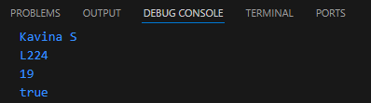

**Task 3: Use the console to perform basic math operations like addition, subtraction, multiplication, and division.**

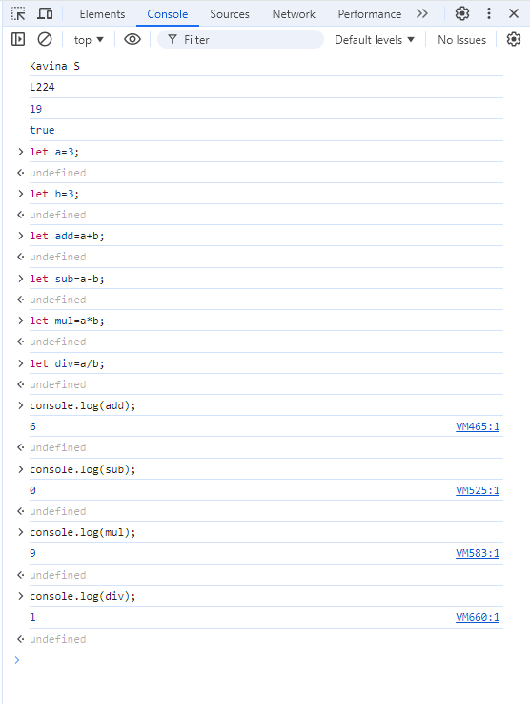

**Task 4: Declare two strings and concatenate them using the + operator.**

<!DOCTYPE html>

<html lang="en">

<head>

    <meta charset="UTF-8">

    <meta name="viewport" content="width=device-width, initial-scale=1.0">

    <title>Task1</title>

</head>

<body>

    <script>

        var str1="Hello";

        var str2="World";

        document.write(str1+"<br>");

        document.write(str2+"<br>");

        document.write("Concatinated String:"+str1+str2);

    </script>

</body>

</html>

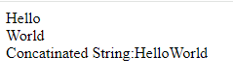

**Task 5: Use the typeof operator to check the data type of various variables.**

<!DOCTYPE html>

<html lang="en">

<head>

    <meta charset="UTF-8">

    <meta name="viewport" content="width=device-width, initial-scale=1.0">

    <title>Task1</title>

</head>

<body>

    <script>

        var name="Kavina";

        var age=19;

        var eligible=Boolean(age>=18);

        var st1={

            name:"Kavina",

            age:19

        }

        document.write(typeof name+"<br>");

        document.write(typeof(age)+"<br>");

        document.write(typeof eligible+"<br>");

        document.write(typeof st1+"<br>");

    </script>

</body>

</html>

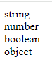

**2:**

**Task 6: Write a multi-line JavaScript comment and a single-line comment. Explain the difference.**

<!DOCTYPE html>

<html lang="en">

<head>

    <meta charset="UTF-8">

    <meta name="viewport" content="width=device-width, initial-scale=1.0">

    <title>Task1</title>

</head>

<body>

    <script>

        //var str1="Hello";

        var str2="World";

        /*document.write(str1+"<br>");

        document.write(str2+"<br>");

        document.write("Concatinated String:"+str1+str2);*/

    </script>

</body>

</html>

**Task 7: Create a script with both semicolon-separated and not separated lines. Note any differences in behavior.**

<!DOCTYPE html>

<html lang="en">

<head>

    <meta charset="UTF-8">

    <meta name="viewport" content="width=device-width, initial-scale=1.0">

    <title>Task1</title>

</head>

<body>

    <script>

        var age=30;

        if(age>=18){

            document.write("Eligible to vote"+"<br>");

        }

        else; //does not checks the condition

        {

            document.write("Not Eligible to vote");

        }

    </script>

</body>

</html>



**Task 8: Use proper indentation to format a nested loop.**

<!DOCTYPE html>

<html lang="en">

<head>

    <meta charset="UTF-8">

    <meta name="viewport" content="width=device-width, initial-scale=1.0">

    <title>Task1</title>

</head>

<body>

    <script>

        for(var a=0;a<5;a++){

            for(var b=0;b<=a;b++){

                document.write("@");

        }

        document.write("<br>");

        }

    </script>

</body>

</html>

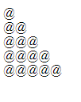

**Task 9: Declare multiple variables in a single line.**

<!DOCTYPE html>

<html lang="en">

<head>

    <meta charset="UTF-8">

    <meta name="viewport" content="width=device-width, initial-scale=1.0">

    <title>Task1</title>

</head>

<body>

    <script>

        var name="Kavina",age=19,rollno;

        rollno="l224";

        document.write(name+"<br>"+age+"<br>"+rollno);

    </script>

</body>

</html>

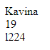

**Task 10: Place a script tag at the top and bottom of an HTML document. Note any differences in behavior.**

<!DOCTYPE html>

<html lang="en">

<head>

    <meta charset="UTF-8">

    <meta name="viewport" content="width=device-width, initial-scale=1.0">

    <title>Task1</title>

    <script>

        var name="Kavina",age=19;

        document.write(name+"<br>"+age+"<br>");

    </script>

</head>

<body>

    <script>

        var name="Kavina",age=19;

        document.write(name+"<br>"+age+"<br>");

    </script>

</body>

</html>



**TASK 2:**

**1:**

**Task 11: Write a script without using “use strict” and try to assign a value to an undeclared variable. Note the result.**

<!DOCTYPE html>

<html lang="en">

<head>

    <meta charset="UTF-8">

    <meta name="viewport" content="width=device-width, initial-scale=1.0">

    <title>Task2</title>

</head>

<body>

    <script>

        var a,b;

        a=10;

        c=19;

        document.write(a+"<br>"+c+"<br>"+b);

    </script>

</body>

</html>

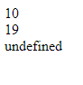

**Task 12: Enable “use strict” mode and repeat the above action, noting the difference.**

<!DOCTYPE html>

<html lang="en">

<head>

    <meta charset="UTF-8">

    <meta name="viewport" content="width=device-width, initial-scale=1.0">

    <title>Task2</title>

</head>

<body>

    <script>

        "use strict"

        var a,b;

        a=10;

        c=19;

        document.write(a+"<br>"+c+"<br>"+b);

    </script>

</body>

</html>

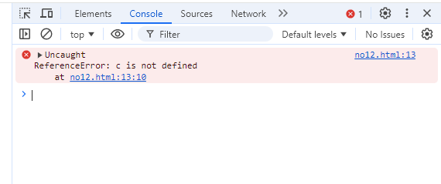

**Task 13: In “use strict” mode, try to delete a variable, function, or function parameter.**

<!DOCTYPE html>

<html lang="en">

<head>

    <meta charset="UTF-8">

    <meta name="viewport" content="width=device-width, initial-scale=1.0">

    <title>Task2</title>

</head>

<body>

    <script>

        "use strict"

        var a,b;

        a=10;

         var s1={

            name:"Kavina",

            rollno:"L224",

            Dept:"EC",

            Age:19

         }

         document.write(`a: ${a} <br> b: ${b} <br> name: ${s1.name} <br> dept: ${s1.Dept} <br>`);

         delete s1.name;

        document.write(`a: ${a} <br> b: ${b} <br> name: ${s1.name} <br> dept: ${s1.Dept}`);

    </script>

</body>

</html>

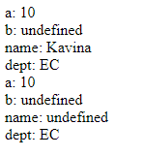

**Task 14: Assign a value to an undeclared variable without “use strict” and then with “use strict”.**

<!DOCTYPE html>

<html lang="en">

<head>

    <meta charset="UTF-8">

    <meta name="viewport" content="width=device-width, initial-scale=1.0">

    <title>Task2</title>

</head>

<body>

    <script>

        var a=10;

        b=20;

        document.write(`a: ${a} <br> b: ${b}`);

    </script>

</body>

</html>



<!DOCTYPE html>

<html lang="en">

<head>

    <meta charset="UTF-8">

    <meta name="viewport" content="width=device-width, initial-scale=1.0">

    <title>Task2</title>

</head>

<body>

    <script>

        "use strict"

        var a=10;

        b=20;

        document.write(`a: ${a} <br> b: ${b}`);

    </script>

</body>

</html>

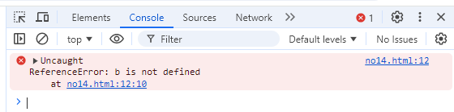

**Task 15: Declare a variable with a reserved keyword in “use strict” mode.**

<!DOCTYPE html>

<html lang="en">

<head>

    <meta charset="UTF-8">

    <meta name="viewport" content="width=device-width, initial-scale=1.0">

    <title>Task2</title>

</head>

<body>

    <script>

        "use strict"

        const a=10;

        document.write(`a= ${a}`);

    </script>

</body>

</html>



**2:**

**Task 16: Declare variables using let, const, and var. Discuss when each should be used.**

<!DOCTYPE html>

<html lang="en">

<head>

    <meta charset="UTF-8">

    <meta name="viewport" content="width=device-width, initial-scale=1.0">

    <title>Task2</title>

</head>

<body>

    <script>

        let a=20;

         a=56;//let variable can be reassigned but can't redeclared

        var b=78;

        var b=334;//var variable can be redeclared and reassigned

        const c=49;//const variable can't be redeclared and reassigned

        document.write(`a: ${a} b: ${b} c: ${c}`);

    </script>

</body>

</html>



**Task 17: Attempt to reassign a const variable and observe the result.**

<!DOCTYPE html>

<html lang="en">

<head>

    <meta charset="UTF-8">

    <meta name="viewport" content="width=device-width, initial-scale=1.0">

    <title>Task2</title>

</head>

<body>

    <script>

        const id=224;

        id=200;

        document.write(`id=${id}`);

    </script>

</body>

</html>

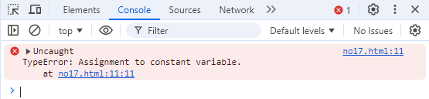

**Task 18: Declare a variable without initializing it and print its value.**

<!DOCTYPE html>

<html lang="en">

<head>

    <meta charset="UTF-8">

    <meta name="viewport" content="width=device-width, initial-scale=1.0">

    <title>Task2</title>

</head>

<body>

    <script>

        var a;

        document.write(`a=${a}`);

    </script>

</body>

</html>



**Task 19: Assign a number, string, and boolean value to a variable and print its type using typeof.**

<!DOCTYPE html>

<html lang="en">

<head>

    <meta charset="UTF-8">

    <meta name="viewport" content="width=device-width, initial-scale=1.0">

    <title>Task2</title>

</head>

<body>

    <script>

        var name="Kavina";

        var id=224;

        var eligible=Boolean(id==224);

        document.write(`${typeof name} <br> ${typeof id} <br> ${typeof eligible}`);

    </script>

</body>

</html>



**Task 20: Rename a variable and observe the outcome.**

<!DOCTYPE html>

<html lang="en">

<head>

    <meta charset="UTF-8">

    <meta name="viewport" content="width=device-width, initial-scale=1.0">

    <title>Task2</title>

</head>

<body>

    <script>

        var name="Kavina";

        name2=name;

        document.write(name2);

    </script>

</body>

</html>



**TASK 3:**

**1:**

**Task 21: Create variables of different data types (e.g., string, number, boolean, null, undefined, object).**

<!DOCTYPE html>

<html lang="en">

<head>

    <meta charset="UTF-8">

    <meta name="viewport" content="width=device-width, initial-scale=1.0">

    <title>Task3</title>

</head>

<body>

    <script>

        let name="Kavina";

        let age=19;

        let rollno="l224";

        let a,b=null;

        let iscorrectrollno=Boolean(rollno=="l224");

        var s1={

            name:"Kavina",

            Rollno:"L224",

            Age:19,

            Dept:"ECE"

        }

        document.write(`name=${name} <br> age=${age} <br> a=${a} <br> b=${b} <br> name in s1=${s1.name} <br> Rollno in s1=${s1.Rollno} <br> Age in s1=${s1.Age}`);

    </script>

</body>

</html>

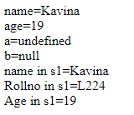

**Task 22: Use the typeof operator to determine the type of various variables.**

<!DOCTYPE html>

<html lang="en">

<head>

    <meta charset="UTF-8">

    <meta name="viewport" content="width=device-width, initial-scale=1.0">

    <title>Task3</title>

</head>

<body>

    <script>

        let name="Kavina";

        let age=19;

        let rollno="l224";

        let a,b=null;

        let iscorrectrollno=Boolean(rollno=="l224");

        var s1={

            name:"Kavina",

            Rollno:"L224",

            Age:19,

            Dept:"ECE"

        }

        document.write(`name=${typeof name} <br> age=${typeof age} <br> a=${typeof a} <br> b=${typeof b} <br> s1=${typeof s1}`);

        </script>

    </body>

    </html>

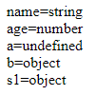

**Task 23: Declare a symbol and print its type.**

<!DOCTYPE html>

<html lang="en">

<head>

    <meta charset="UTF-8">

    <meta name="viewport" content="width=device-width, initial-scale=1.0">

    <title>Task3</title>

</head>

<body>

    <script>

        let sy=Symbol("#");

        console.log(`Type of Symbol: ${typeof(sy)}`);

    </script>

</body>

</html>



**Task 24: Assign the value null to a variable and check its type using typeof.**

<!DOCTYPE html>

<html lang="en">

<head>

    <meta charset="UTF-8">

    <meta name="viewport" content="width=device-width, initial-scale=1.0">

    <title>Task3</title>

</head>

<body>

    <script>

        let name=null;

        console.log(typeof(name));

    </script>

</body>

</html>



**Task 25: Differentiate between declaring a variable using var and let in terms of scope.**

<!DOCTYPE html>

<html lang="en">

<head>

    <meta charset="UTF-8">

    <meta name="viewport" content="width=device-width, initial-scale=1.0">

    <title>Task3</title>

</head>

<body>

    <script>

        var name="Kavina";//function scope

        let Roll_no="L224";//window scope

        document.write(`Name:${name} <br> Roll no:${Roll_no}`);

    </script>

</body>

</html>

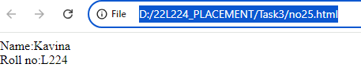

**TASK 3.2:**

**Task 26: Convert a string to a number using both implicit and explicit conversion.**

<!DOCTYPE html>

<html lang="en">

<head>

    <meta charset="UTF-8">

    <meta name="viewport" content="width=device-width, initial-scale=1.0">

    <title>TASK 3.2</title>

</head>

<body>

    <script>

        //var str="9a.99"; n_str = NaN nn_str = NaN

        var str = "99.99";

        document.write(`str=${str}<br> type=${typeof str} <br>`);

        var n_str=Number(str);

        document.write(`n_str= ${n_str} type= ${typeof n_str} <br>`);

        var nn_str=Math.ceil(str);

        document.write(`nn_str= ${nn_str} type= ${typeof nn_str} <br>`);

        console.log(str);

    </script>

</body>

</html>

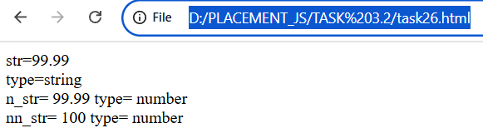

**Task 27: Convert a boolean to a string and vice versa.**

<!DOCTYPE html>

<html lang="en">

<head>

    <meta charset="UTF-8">

    <meta name="viewport" content="width=device-width, initial-scale=1.0">

    <title>TASK 3.2</title>

</head>

<body>

    <script>

        var eligible=true;

        var str=String(eligible);

        document.write(`eligible=${typeof eligible} str=${typeof str} `);

        var str_bool=Boolean(str);

        document.write(`str_bool=${typeof str_bool}`);

    </script>

</body>

</html>

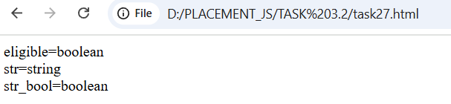

**Task 28: Practice basic arithmetic operators (+, -, *, /, %).**

**<head>**<!DOCTYPE html>

<html lang="en">

<head>

    <meta charset="UTF-8">

    <meta name="viewport" content="width=device-width, initial-scale=1.0">

    <title>Task3.2</title>

</head>

<body>

    <script>

        var num1=Number(prompt("Enter num1:",0));

        var num2=Number(prompt("Enter num2:",0));

        document.write(`Add=${num1+num2}<br>sub=${num1-num2}<br>mul=${num1*num2}<br>div=${num1/num2}`);

    </script>

</body>

</html>

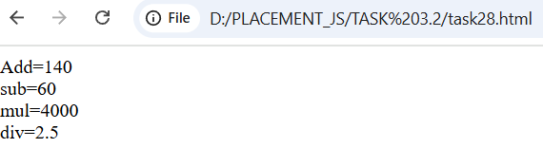

**Task 29: Use the ++ and -- operators on a numeric variable.**

<!DOCTYPE html>

<html lang="en">

<head>

    <meta charset="UTF-8">

    <meta name="viewport" content="width=device-width, initial-scale=1.0">

    <title>Task3.2</title>

</head>

<body>

    <script>

        var a=10;

        document.write(`a=${a}<br>++a:${++a} <br>--a:${--a}<br>a++:${a++}<br>a--:${a--}<Br>a=${a}`);

    </script>

</body>

</html>

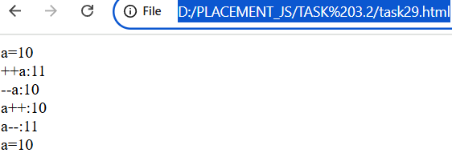

**Task 30: Explore the precedence of operators by combining multiple operators in a single expression.**

<!DOCTYPE html>

<html lang="en">

<head>

    <meta charset="UTF-8">

    <meta name="viewport" content="width=device-width, initial-scale=1.0">

    <title>Task3.2</title>

</head>

<body>

    <script>

        let a=10,b=20,c=30;

        let exp=a+b*c/a-b;

        document.write(`ans for expression a+b*c/a-b=${exp}`);

    </script>

</body>

</html>

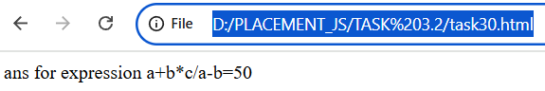

**TASK 4:**

**Task 31: Compare two numbers using relational operators (>, =, <=).**

<!DOCTYPE html>

<html lang="en">

<head>

    <meta charset="UTF-8">

    <meta name="viewport" content="width=device-width, initial-scale=1.0">

    <title>Task4</title>

</head>

<body>

    <script>

        var num1=Number(prompt("Enter num1:",0));

        var num2=Number(prompt("Enter num2:",0));

        document.write(typeof num1+"<br>");

        if(num1>num2){

            document.write("Num1 is Greater than num2");

        }

        else if(num1<num2){

            document.write("Num1 is Lesser than num2");

        }

        else{

            document.write("Num1 and num2 are equal");

        }

    </script>

</body>

</html>

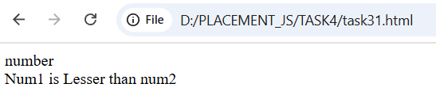

**Task 32: Use equality () and strict equality (=) operators to compare different data types and note the differences.**

<!DOCTYPE html>

<html lang="en">

<head>

    <meta charset="UTF-8">

    <meta name="viewport" content="width=device-width, initial-scale=1.0">

    <title>Task4</title>

</head>

<body>

    <script>

        var num1=10;

        var num2="10";

        document.write(`num1=${num1} type=${typeof(num1)}<br>`);

        document.write(`num2=${num2} type=${typeof(num2)}<br>`);

        if(num1==num2){

            document.write("num1 and num2 are equal in equality operator <br>");

        }

        else{

            document.write("num1 and num2 are not equal in equality operator <br>");

        }

        if(num1===num2){

            document.write("num1 and num2 are equal in strict equality operator <br>");

        }

        else{

            document.write("num1 and num2 are not equal in strict equality operator <br>");

        }

    </script>

</body>

</html>

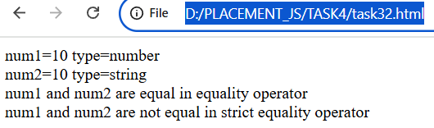

**Task 33: Compare two strings lexicographically.**

<!DOCTYPE html>

<html lang="en">

<head>

    <meta charset="UTF-8">

    <meta name="viewport" content="width=device-width, initial-scale=1.0">

    <title>Task33</title>

</head>

<body>

    <script>

        let name1 = "Kavina";

        let name2 = "Kaviya";

        if(name1 == name2){

            document.write(`name1 = ${name1} and name2 = ${name2} are equal <br>`);

        }

        else if(name1 > name2){

            document.write(`name1 = ${name1} greater than name2 = ${name2} <br>`);

        }

        else if(name1 < name2){

            document.write(`name1 ${name1} lesser than name2 ${name2} <br>`);

        }

        else{

            document.write(`name1 = ${name1} and name2 = ${name2} are not equal <br>`);

        }

    </script>

</body>

</html>

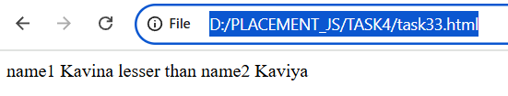

**Task 34: Use the inequality (!=) and strict inequality (!==) operators to compare values.**

<!DOCTYPE html>

<html lang="en">

<head>

    <meta charset="UTF-8">

    <meta name="viewport" content="width=device-width, initial-scale=1.0">

    <title>Task4</title>

</head>

<body>

    <script>

        var num1=10;

        var num2="20";

        document.write(`num1=${num1} //${typeof(num1)}<br>`);

        document.write(`num2=${num2} //${typeof(num2)}<br>`);

        if(num1!=num2){

            document.write("num1 and num2 are not equal in inequality operator <br>");

        }

        else{

            document.write("num1 and num2 are equal in inequality operator <br>");

        }

        if(num1!==num2)

        {

            document.write("num1 and num2 are not equal in strict inequality operator <br>");

        }

        else{

            document.write("num1 and num2 are equal in strict inequality operator <br>");

        }

    </script>

</body>

</html>

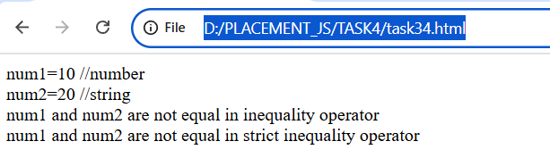

**Task 35: Compare null and undefined using both == and ===.**

<!DOCTYPE html>

<html lang="en">

<head>

    <meta charset="UTF-8">

    <meta name="viewport" content="width=device-width, initial-scale=1.0">

    <title>Task4</title>

</head>

<body>

    <script>

        let name=null,dept;

        document.write(`name=${name} //${typeof name} <br> dept=${dept} //${typeof dept}<br>`);

        if(name==dept){

            document.write("name and dept are Equal in equallity operator.<br>");

        }

        else{

            document.write("name and dept are  not Equal in equallity operator.<br>");

        }

        if(name===dept)

        {

            document.write("name and dept are Equal in Strict equallity operator.<br>");

        }

        else{

            document.write("name and dept are  not Equal in Strict equallity operator.<br>");

        }

    </script>

</body>

</html>

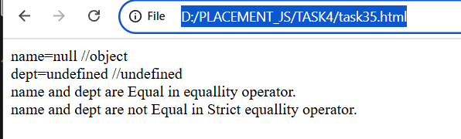

**TASK 4.2:**

**Task 36: Write an if statement that checks if a number is even or odd.**

<!DOCTYPE html>

<html lang="en">

<head>

    <meta charset="UTF-8">

    <meta name="viewport" content="width=device-width, initial-scale=1.0">

    <title>Task4.2</title>

</head>

<body>

    <script>

        num1=24;

        document.write("The given number=",num1,"<br>");

        if(num1%2==0){

            document.write("The given number is even");

        }

        else{

            document.write("The given number is odd");

        }

    </script>

</body>

</html>

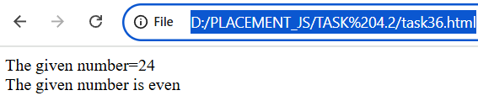

**Task 37: Use nested if statements to classify a number as negative, positive, or zero.**

<!DOCTYPE html>

<html lang="en">

<head>

    <meta charset="UTF-8">

    <meta name="viewport" content="width=device-width, initial-scale=1.0">

    <title>Task4.2</title>

</head>

<body>

    <script>

        var num1=-90;

        document.write("The given number=",num1,"<br>");

        if(num1){

            if(num1>0){

                document.write("The given number is positive <br>");

            }

            if(num1==0){

                document.write("The given number is zero <br>");

            }

            if(num1<0)

            {

                document.write("The given number is negative <br>");

            }

        }

    </script>

</body>

</html>

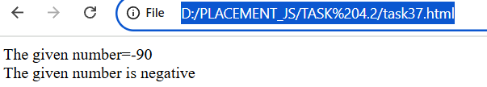

**Task 38: Use the conditional (ternary) operator ‘?’ to rewrite a simple if…else statement.**

<!DOCTYPE html>

<html lang="en">

<head>

    <meta charset="UTF-8">

    <meta name="viewport" content="width=device-width, initial-scale=1.0">

    <title>Task4.2</title>

</head>

<body>

    <script>

        var num1=999945789;

        document.write("The given number=",num1,"<br>");

        var res=(num1%2==0)?"Even":"Odd";

        document.write("The given number is ",res);

    </script>

</body>

</html>

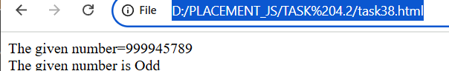

**Task 39: Check the validity of a variable using the ? operator.**

<!DOCTYPE html>

<html lang="en">

<head>

    <meta charset="UTF-8">

    <meta name="viewport" content="width=device-width, initial-scale=1.0">

    <title>Task4.2</title>

</head>

<body>

    <script>

        var num1;

        var isvalid=num1??"Default value";//checks the variable is null or undefined//if defined then the value will be returned

        document.write(isvalid);

    </script>

</body>

</html>

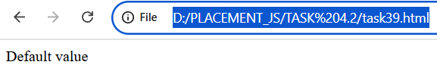

**Task 40: Use the conditional operator to assign a value to a variable based on a condition.**

<!DOCTYPE html>

<html lang="en">

<head>

    <meta charset="UTF-8">

    <meta name="viewport" content="width=device-width, initial-scale=1.0">

    <title>Task4.2</title>

</head>

<body>

    <script>

        var name="Kavina";

        var dept=(name=="Kavina")?"ECE":null;

        document.write(`Dept : ${dept}`);

    </script>

</body>

</html>

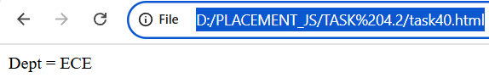

**TASK 5:**

**Task 41: Evaluate various combinations of logical operators (&&, ||, !).**

<!DOCTYPE html>

<html lang="en">

<head>

    <meta charset="UTF-8">

    <meta name="viewport" content="width=device-width, initial-scale=1.0">

    <title>Task5</title>

</head>

<body>

    <script>

        let s1={

            name:"Kavina",

            r_no:"L224",

            //age:19,

            Dept:"ECE"

        }

        if(s1.r_no=="L224" && s1.name=="Kavina"){

            document.write("She is a student of KCE<br>");

        }

        if(s1.age>=18 || s1.Dept=="ECE"){

            document.write("She is eligible to vote for KCE<br>");

        }

        if(!s1.age){

            document.write("She is not eligible to vote for KCE");

        }

    </script>

</body>

</html>

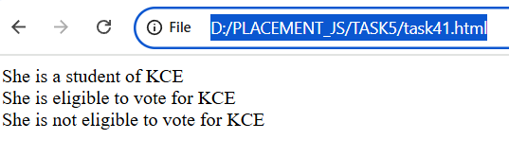

**Task 42: Use logical operators to write a condition that checks if a number is in a given range.**

<!DOCTYPE html>

<html lang="en">

<head>

    <meta charset="UTF-8">

    <meta name="viewport" content="width=device-width, initial-scale=1.0">

    <title>Task5</title>

</head>

<body>

    <script>

        var num1=5678;

        if(num1>=0 && num1<=6000){

            document.write("The number is in the given range");

        }

        else{

            document.write("The number is not in the given range");

        }

    </script>

</body>

</html>

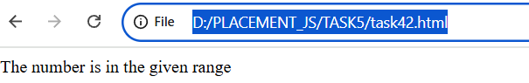

**Task 43: Use the NOT (!) operator to invert a boolean value.**

<!DOCTYPE html>

<html lang="en">

<head>

    <meta charset="UTF-8">

    <meta name="viewport" content="width=device-width, initial-scale=1.0">

    <title>Task5</title>

</head>

<body>

    <script>

        let isvalid=!true;

        document.write(isvalid);

    </script>

</body>

</html>

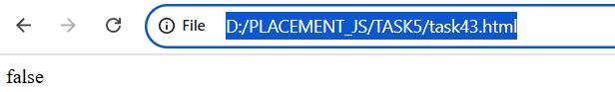

**Task 44: Evaluate the short-circuiting nature of logical operators.**

<!DOCTYPE html>

<html lang="en">

<head>

    <meta charset="UTF-8">

    <meta name="viewport" content="width=device-width, initial-scale=1.0">

    <title>Task5</title>

</head>

<body>

    <script>

        var num1=10;

        var num2=20;

        if(num1==10 || num2==20){

            document.write("OR:<br>If any one of the operand is true,the result is true for OR operator.It checks until the operand is true.");

        }

        if(num1==10 && num2==20){

            document.write("<br>AND:<br>If both the operands are true,the result is true for AND operator.It checks till the last operand is true.");

        }

    </script>

</body>

</html>

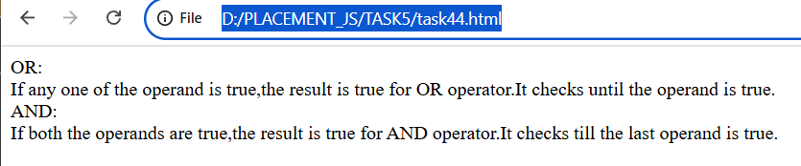

**Task 45: Compare two non-boolean values using logical operators and observe the result.**

<!DOCTYPE html>

<html lang="en">

<head>

    <meta charset="UTF-8">

    <meta name="viewport" content="width=device-width, initial-scale=1.0">

    <title>Task5</title>

</head>

<body>

    <script>

        var a="Kavina";

        var b='Kavina';

        if(a=="Kavina" && b=="Kavina"){

            document.write("True");

        }

        else{

            document.write("False");

        }

    </script>

</body>

</html>

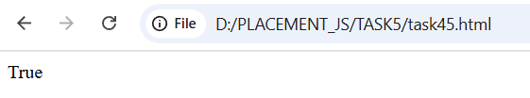

**TASK 5.2:**

**Task 46: Write a function that takes two numbers as arguments and returns their sum.**

<!DOCTYPE html>

<html lang="en">

<head>

    <meta charset="UTF-8">

    <meta name="viewport" content="width=device-width, initial-scale=1.0">

    <title>Task5.2</title>

</head>

<body>

    <script>

        let num1=27;

        let num2=24;

        let res=sum(num1,num2);

        function sum(x,y){

            return x+y;

        }

        document.write(`Sum of ${num1} and ${num2} is ${res}`);

    </script>

</body>

</html>

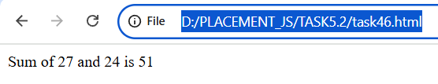

**Task 47: Create a function that calculates the area of a rectangle.**

<!DOCTYPE html>

<html lang="en">

<head>

    <meta charset="UTF-8">

    <meta name="viewport" content="width=device-width, initial-scale=1.0">

    <title>Task5.2</title>

</head>

<body>

    <script>

        let length=5.5,breadth=10;

        let area=rect_area(length,breadth);

        function rect_area(l,b){

            return l*b;

        }

        document.write(`Area of a Reactangle of length ${length} and breadth ${breadth} is ${area}`);

    </script>

</body>

</html>

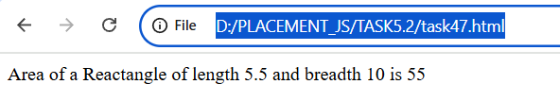

**Task 48: Declare a function without parameters and call it.**

<!DOCTYPE html>

<html lang="en">

<head>

    <meta charset="UTF-8">

    <meta name="viewport" content="width=device-width, initial-scale=1.0">

    <title>Task5.2</title>

</head>

<body>

    <script>

        let res=display();

        function display(){

            document.write("Hey there,It's me Kavina from Department of Electronics and Communication Engineering <br>Great to see you all<br>");

            return "Hey there,It's me Kavina from Department of Electronics and Communication Engineering <br>Great to see you all";

        }

        document.write(res);

    </script>

</body>

</html>

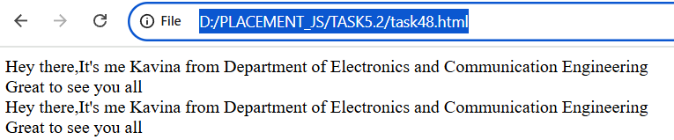

**Task 49: Write a function that returns nothing and observe the default return value.**

<!DOCTYPE html>

<html lang="en">

<head>

    <meta charset="UTF-8">

    <meta name="viewport" content="width=device-width, initial-scale=1.0">

    <title>Task5.2</title>

</head>

<body>

    <script>

        var res=display();

        function display(){

            return ;

        }

document.write(display());

        document.write(res);

    </script>

</body>

</html>

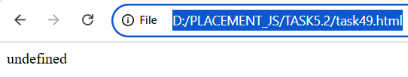

**Task 50: Declare a function with default parameters and call it with different arguments.**

<!DOCTYPE html>

<html lang="en">

<head>

    <meta charset="UTF-8">

    <meta name="viewport" content="width=device-width, initial-scale=1.0">

    <title>Task5.2</title>

</head>

<body>

    <script>

        var name="Kavina",Dept="ECE",age=19;

        display(name,Dept,age);

        function display(n,d,a){

            document.write(`Name is ${n} <br>Department is ${d} <br>Age is ${a}`);

        }

    </script>

</body>

</html>

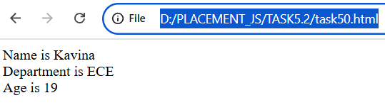

**TASK 5.3:**

**Task 51: Declare a simple arrow function named greet that takes one parameter name and returns the string “Hello, name!”. Test your function with various names.**

<!DOCTYPE html>

<html lang="en">

<head>

    <meta charset="UTF-8">

    <meta name="viewport" content="width=device-width, initial-scale=1.0">

    <title>Task5.3</title>

</head>

<body>

    <script>

        let name=prompt("Ente your name:","kavi");

        let res=(name)=>{document.write("Hello ",name,"!")};

        res(name);

    </script>

</body>

</html>

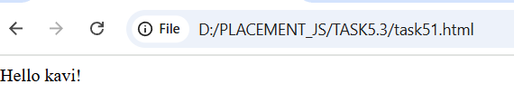

**Task 52: Write an arrow function named add that takes two parameters and returns their sum. Validate your function with several pairs of numbers.**

<!DOCTYPE html>

<html lang="en">

<head>

    <meta charset="UTF-8">

    <meta name="viewport" content="width=device-width, initial-scale=1.0">

    <title>Task5.3</title>

</head>

<body>

    <script>

        let num1=Number(prompt("Enter number 1:",0));

        let num2=Number(prompt("Enter number 2:",0));

        let add=(a,b)=>{return a+b};

        let res=add(num1,num2);

        document.write(`Sum of ${num1} and ${num2} is ${res}`);

    </script>

</body>

</html>

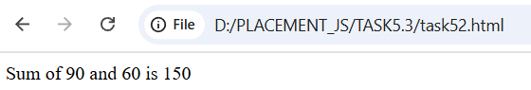

**Task 53: Declare an arrow function named isEven that checks if a number is even. If the number is even, it should return true; otherwise, false. Remember that if the arrow function body has a single statement, you can omit the curly braces.**

<!DOCTYPE html>

<html lang="en">

<head>

    <meta charset="UTF-8">

    <meta name="viewport" content="width=device-width, initial-scale=1.0">

    <title>Task5.3</title>

</head>

<body>

    <script>

        let num=prompt("Enter a number:",0);

        let isEven=(a)=>(a%2==0)?true:false;

        document.write(isEven(num));

    </script>

</body>

</html>

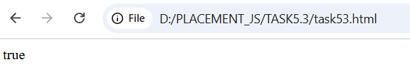

**Task 54: Implement an arrow function named maxValue that takes two numbers as parameters and returns the larger number. Here, you'll need to use curly braces for the function body and the return statement.**

<!DOCTYPE html>

<html lang="en">

<head>

    <meta charset="UTF-8">

    <meta name="viewport" content="width=device-width, initial-scale=1.0">

    <title>Task5.3</title>

</head>

<body>

    <script>

        let num1=prompt("Enter a number1:",0);

        let num2=prompt("Enter a number1:",0);

        document.write(`Number 1:${num1} <br>Number 2:${num2}<br>`);

        let maxValue = (num1,num2) => {

            if(num1 > num2) return num1;

            else return num2;

        }

        document.write(maxValue(num1,num2));

    </script>

</body>

</html>

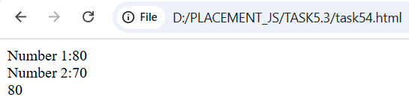

**Task 55: Examine the behavior of the this keyword inside an arrow function vs a traditional function. Create an object named myObject with a property value set to 10 and two methods: multiplyTraditional using a traditional function and multiplyArrow using an arrow function. Both methods should attempt to multiply the value property by a number passed as a parameter. Check the value of this inside both methods.**

<!DOCTYPE html>

<html lang="en">

<head>

    <meta charset="UTF-8">

    <meta name="viewport" content="width=device-width, initial-scale=1.0">

    <title>Task5.3</title>

</head>

<body>

    <script>

        let mul = {

            value : 10,

            multiplyTraditional(num){

                return this.value*num;

            },

            multiplyArrow : (num) => this.value*num

        }

        let num = Number(prompt("Enter the number : ",0));

        document.write(mul.multiplyTraditional(num)+"<br>");

        document.write(mul.multiplyArrow(num));

    </script>

</body>

</html>

