**REACT BASICS:**

**1.HOW TO WRITE YOUR FIRST REACT COMPONENT**

**TASKS:**

**1. Create a simple functional component named Greeting that returns “Hello, World!” within a**

**tag.**

//App.js

import './App.css';

import {Greeting} from './Task1.js'

function App() {

  return (

    <Greeting />

  );

}

export default App;

//Task1.js

export function Greeting(){

    return (<h1>Hello World!</h1>);

}



**2. Modify the Greeting component to display “Hello, React!”.**

//Task2.js

import { useState } from "react";

export function Greeting(){

    //declaration static variable

    const [sen,setSen] = useState("Hello World!");

    function modify(){

        setSen("Hello,React!");

    }

    return (<>

    <button onClick = {modify}>click</button>

    <h1>{sen}</h1>

    </>);

}

//App.js

import './App.css';

import {Greeting} from './Task2.js';

function App() {

  return (

     <Greeting />

  );

}

export default App;

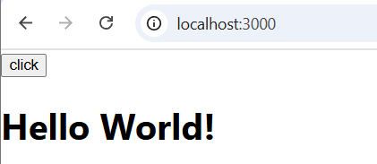

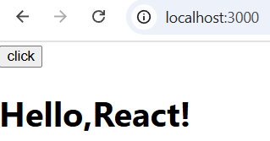

**3. Create a Gallery functional component to display an image.**

//Task3.js

import source from "./pexels-anjana-c-169994-674010.jpg";

export function Gallery(){

    return (<img src = {source} alt="Peacock feature" width = {250} height = {250} />);

}

//App.js

import './App.css';

import { Gallery } from './Task3.js';

function App() {

  return(<Gallery />);

}

export default App;

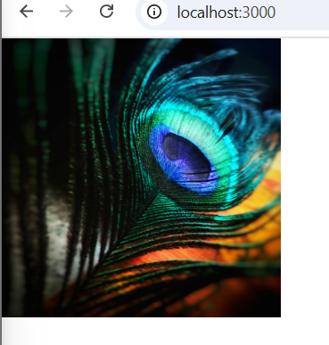

**4. Add Greeting to the Gallery component and display the image and greeting.**

//Task4.js

import source from './pexels-anjana-c-169994-674010.jpg';

export function Gallery_Greeting(){

    return (<>

    <img src = {source} alt="Peacock feature" width = {250} height = {250} />

    <h1>Welcome to react!</h1>

    </>);

}

//App.js

import './App.css';

import { Gallery_Greeting } from './Task4';

function App() {

  //Task4

  return(<Gallery_Greeting />);

}

export default App;

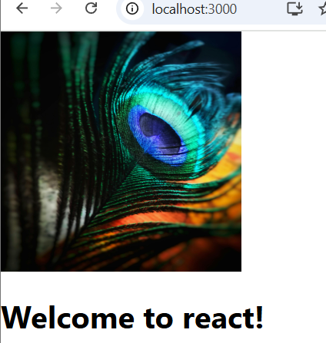

**5. Write a component called Profile which displays a hardcoded user’s name and age.**

//Task5.js

export function Profile(){

    let name = "Kavina";

    let age = 19;

    return (<p>Name : {name} <br /> Age : {age}</p>);

}

//App.js

import './App.css';

import {Profile} from './Task5.js';

function App() {

  //Task5

  return(<Profile />);

}

export default App;

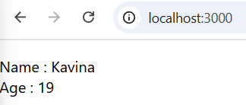

**2. WHEN AND HOW TO CREATE MULTI-COMPONENT FILES**

**TASKS:**

**1. Create a file named UserComponents.js and inside it, define two components: UserName and UserAge that display hardcoded names and ages respectively.**

//UserComponents.js

export function UserName(){

    let name = "Kavina";

    return (<p>Name : {name} </p>);

}

export function UserAge(){

    let age = 19;

    return (<p>Age : {age} </p>);

}

//App.js

import './App.css';

import { UserName,UserAge } from './Task6';

function App() {

  //Task6

  return(<>

  <UserName />

  <UserAge />

  </>)

}

export default App;

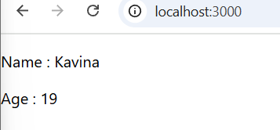

**2. Export both UserName and UserAge from UserComponents.js.**

//UserComponents.js

export function UserName(){

    let name = "Kavina";

    return (<p>Name : {name} </p>);

}

export function UserAge(){

    let age = 19;

    return (<p>Age : {age} </p>);

}

//App.js

import './App.css';

import { UserName,UserAge } from './UserComponents.js';

function App() {

  //Task6

  return(<>

  <UserName />

  <UserAge />

  </>);

}

export default App;

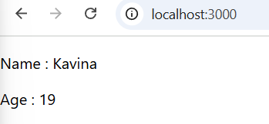

**3. In a separate file, import and use both UserName and UserAge components using named imports.**

//UserComponents.js

export function UserName(){

    let name = "Kavina";

    return (<p>Name : {name} </p>);

}

export function UserAge(){

    let age = 19;

    return (<p>Age : {age} </p>);

}

//App.js

import './App.css';

//import {Greeting} from './Task1.js';

//import {Greeting} from './Task2.js'

//import { Gallery } from './Task3.js';

// import { Gallery_Greeting } from './Task4';

// import {Profile} from './Task5.js';

//import {UserName,UserAge} from './Task6';

import { UserName,UserAge } from './UserComponents.js';

function App() {

  //Task6,Task7,Task8

  return(<>

  <UserName />

  <UserAge />

  </>);

}

export default App;



**4. Convert UserAge into a default export and modify the importing file to accommodate the change.**

//Task9.js

export function UserName(){

    let name = " Kavina";

    return (<p>Name : {name}</p>);

}

export default function UserAge(){

    let age = 19;

    return (<p>Age : {age}</p>);

}

//App.js

import './App.css';

import UserAge,{UserName} from "./Task9.js";

// import {Image} from "./image.js";

function App() {

    //Task9

  return(

    <>

    <UserName />

    <UserAge />

    </>

  )

  }

export default App;

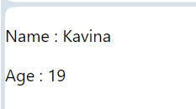

**5. Split UserName and UserAge into separate files and adjust your imports.**

//Task10(i).js

export function UserName(){

    let name = "Kavina";

    return(<p>Name : {name}</p>);

}

//Task10(ii).js

export function UserAge(){

    let age = 19;

    return (<p>Age : {age}</p>);

}

//App.js

import './App.css';

import { UserName } from './Task101.js';

import { UserAge } from './Task102.js';

function App() {

  //Task10

  return (<>

  <UserName />

  <UserAge />

  </>

  );

}

export default App;



**3. HOW TO ADD MARKUP TO JAVASCRIPT WITH JSX:**

**TASKS:**

**1. Create a component that displays an unordered list (<ul>**

**) of 3 favorite fruits.**

//Task11.js

export function Fruits(){

    return (<ul>

        <li>Apple</li>

        <li>Banana</li>

        <li>Strawberry</li>

    </ul>);

}

//App.js

import './App.css';

import { Fruits } from './Task11';

function App() {

  //Task11

  return (<>

  <p>Unordered List:</p>

  <Fruits />

  </>);

}

export default App;

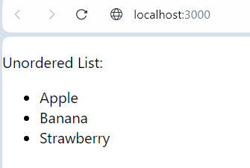

**2. Update the above component to display a picture (<img>) of each fruit next to its name. (Use hardcoded image URLs for now.)**

//Task12

import s1 from "./Apple.jpg";

import s2 from "./Banana.jpg";

import s3 from "./Strawberry.jpg";

export function FruitsImage(){

    let w = 25 ;

    let h = 25 ;

    return (<ul>

        <li>Apple<img src = {s1} alt="Apple" width='25' height='25'/></li>

        <li>Banana<img src = {s2} alt="Banana" width={w} height={h}/></li>

        <li>Strawberry<img src = {s3} alt="Strawberry" width={w} height={h}/></li>

    </ul>);

}

//App.js

import './App.css';

import { FruitsImage } from './Task12.js';

function App() {

  //Task12

  return(

    <FruitsImage />

  );

}

export default App;

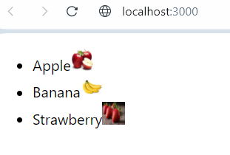

**3. Create a component WebsiteLink that displays a hardcoded URL in an anchor (<a>) tag.**

//Task13

export function WebsiteLink(){

    let url = "https://www.w3schools.com/";

    return (<a href={url}>{url}</a>);

}

//App.js

import './App.css';

import { WebsiteLink } from './Task13.js';

function App() {

  //Task13

  return(

    <WebsiteLink />

  );

}

export default App;

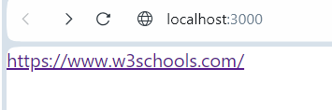

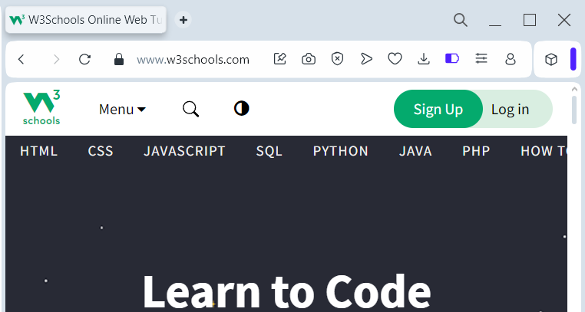

**4. Make a JSX component that mimics a simple blog post with a title, content, and author. (All hardcoded.)**

//Task14.js

import source from "./book.jpg";

export function Blog(){

    return(

        <>

        <p><b>TITLE : </b>The Magic of Reading Books</p>

        <p><b>AUTHOR : </b>Kavina</p>

        <b>CONTENT : </b>

        <p>In a world full of screens and notifications, picking up a book can feel like a breath of fresh air. Reading not only takes you on incredible journeys through stories and ideas but also strengthens your mind and broadens your perspective.</p>

            <img src={source} alt="book"/>

<p>Books are gateways to different worlds, allowing you to explore new cultures, expand your knowledge, or simply escape for a while. They improve focus, creativity, and even empathy by helping you see life from different viewpoints.Whether it's fiction, non-fiction, or poetry, there's always something for everyone. So, next time you’re looking for a moment of calm or inspiration, try reaching for a book. You might just find magic within its pages.</p>

        </>

    )

}

//App.js

import './App.css';

import {Blog} from './Task14.js';

function App() {

    //Task14

  return(<Blog />);

export default App;

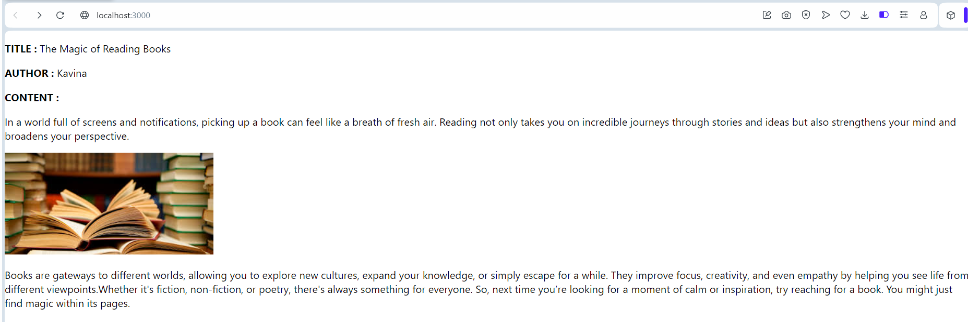

**5. Design a Footer component with hardcoded copyright information using JSX.**

//Task15

export function Footer(){

    return(<p>Copyright &copy; 2025 : Developed by KAVINA</p>)

}

//App.js

import './App.css';

import { Footer } from './Task15.js';

function App() {

  //Task15

  return (<Footer />);

}

export default App;

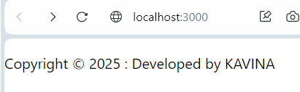

**4. JAVASCRIPT IN JSX WITH CURLY BRACES**

**TASKS:**

**1. Display today’s date in a component using the JavaScript Date object.**

//task16

import React from "react";

export function TodayDate(){

    let date = new Date();

    return(<>

    <p>Today's Date : {date.toISOString()}</p>

    <p>Today's Date : {date.toDateString()}</p>

    <p>Today's Date : {date.toTimeString()}</p>

    <p>Today's Date : {date.getFullYear()}</p>

    <p>Today's Date : {date.getHours()}</p>

    <p>Today's Date : {date.getDate()}</p>

    <p>Today's Date : {date.getDay()}</p>

    </>

    );

}

//App.js

import './App.css';

import { TodayDate } from './Task16';

function App() {

  //Task16

  return (<TodayDate />);

}

export default App;

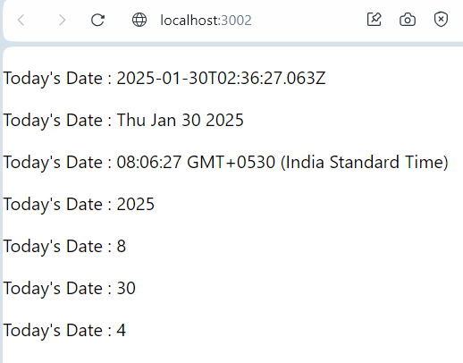

**2. Create a component that displays a random quote from a hardcoded list of quotes.**

//Task17

import { useState } from "react";

export function Quotes(){

    let q =[

        "The only way to do great work is to love what you do.",

        "Success is not final, failure is not fatal: it is the courage to continue that counts.",

        "Do what you can, with what you have, where you are.",

        "The best way to predict the future is to create it.",

        "Opportunities don't happen. You create them."

    ];

    const [quote,setQuote] = useState(q[0]);

    function change(){

        setQuote(q[Math.floor(Math.random()*q.length)]);

    }

    return (<>

    <h4>Quote : </h4>

    <p>{quote}</p>

    <button onClick={change}>click</button>

    </>);

}

//App.js

import './App.css';

import { Quotes } from './Task17';

function App() {

  //Task17

  return(<Quotes />);

}

export default App;

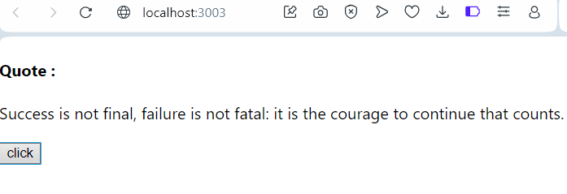

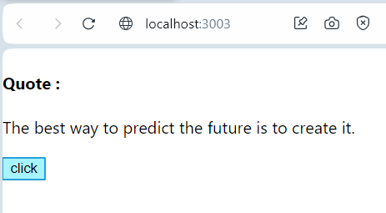

**3. Write a component called MathResult that displays the result of a simple arithmetic operation (e.g., addition) of two hardcoded numbers.**

//Task18

import React from "react";

export function MathResult(props){

    let a = 10;

    let b = 5;

    return (<>

    <p> Sum : {Number(props.a)+Number(props.b)}</p>

    <p>Sum : {a+b} </p>

    </>

    );

}

//App.js

import './App.css';

import { MathResult } from './Task18';

function App() {

  //Task18

  return(<MathResult a="5" b="60"/>);

  //return(<MathResult />);

}

export default App;

