**RELEASES MODULE**

**COHORT: INTQEA21QE035**

**TEAM D**

|  |  |
| --- | --- |
| 906699 | Koushalya B |
| 906785 | Kavina K |
| 906766 | Deeparasi M |
| 906841 | Mukesh L |
| 906820 | Raksha PK |

**INTRDOUCTION:**

The Releases module is on the mainspring webpage.  This module enables us to submit the Releases for the project

**FRAMEWORKS, TOOLS & JARS USED:**

* Java (Version 1.8)
* Selenium-Java (Version 3.141.59)
* TestNG (Version 7.3.0)
* Cucumber-Java (Version 1.2.5)
* Cucumber-Jvm-deps (Version 1.0.5)
* Cucumber-testng (Version 1.2.5)
* Cucumber-junit (Version 1.2.5)
* Cucumber-core (Version 1.2.5)
* Apache poi (Version 4.1.2)
* Apache poi ooxml (Version 4.1.2)
* Commons-io (Version 2.6.0)
* Page Object Model
* Maven

**URL USED:** [**https://pratesting.cognizant.com**](https://pratesting.cognizant.com)

**STEPS TO EXECUTE RELEASES MODULE:**

1. **Open the Browser.**
2. **Open the URL.**
3. **URL asks for cognizant login.**

**4.Enter valid mail id and click next**

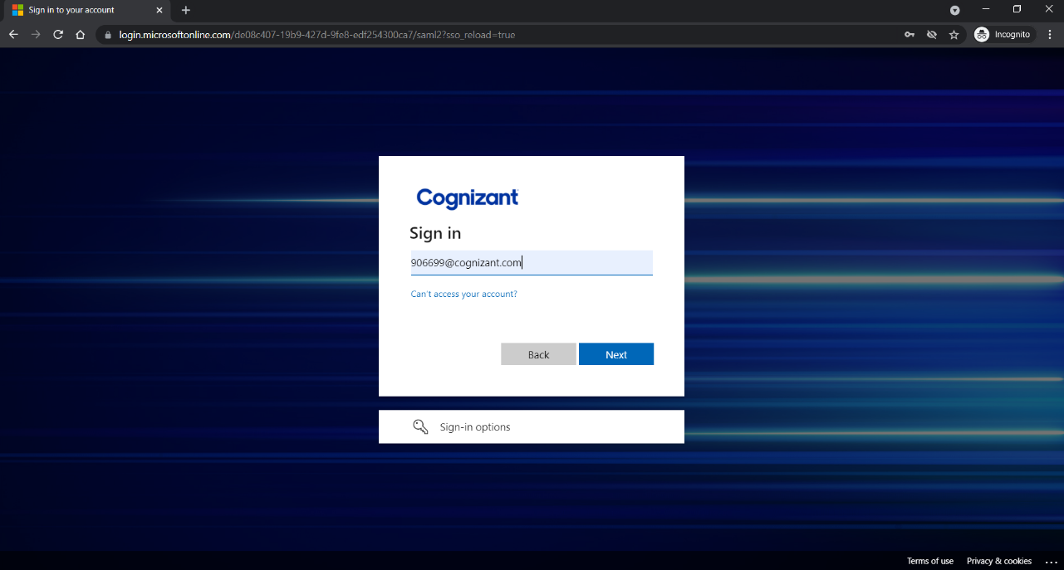

**5.Enter the Password and press sign in**

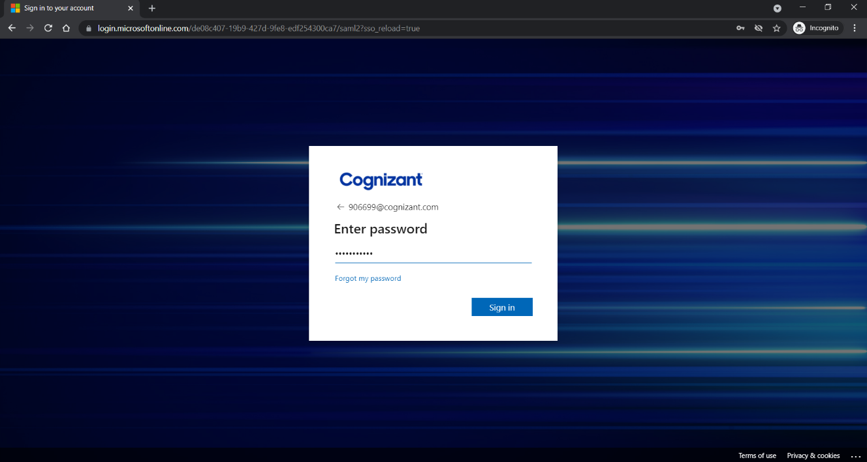

**6. Enter the code and press verify**

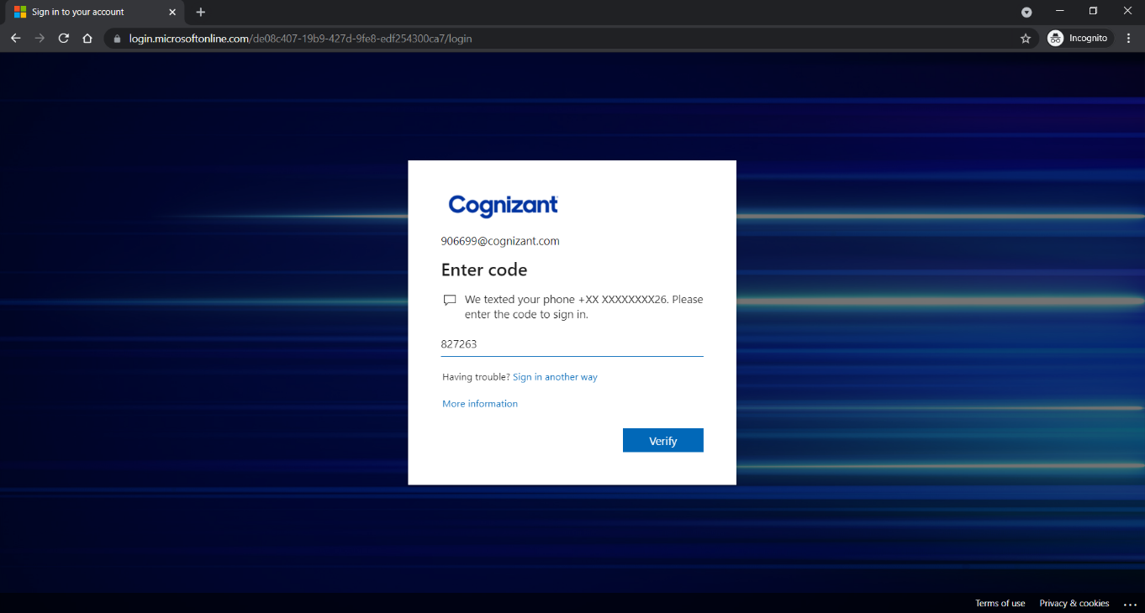

**7. Click Yes to stay signed in**

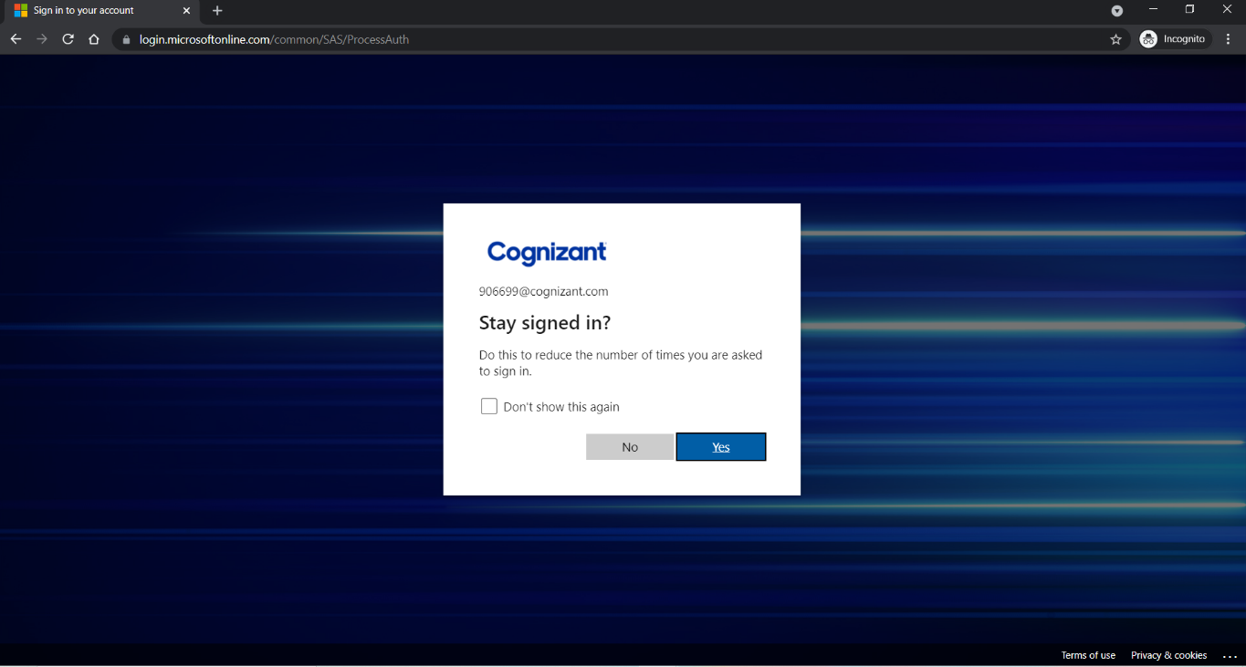

**8. Pratesting webpage opens**

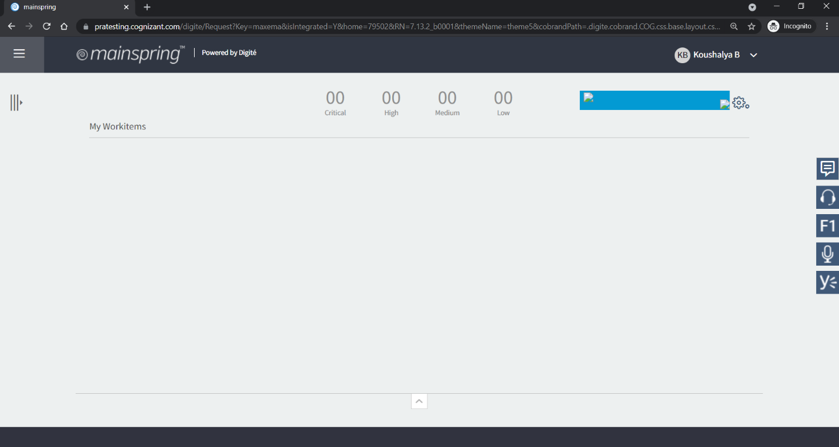

**9. Mouse hover to Menu**

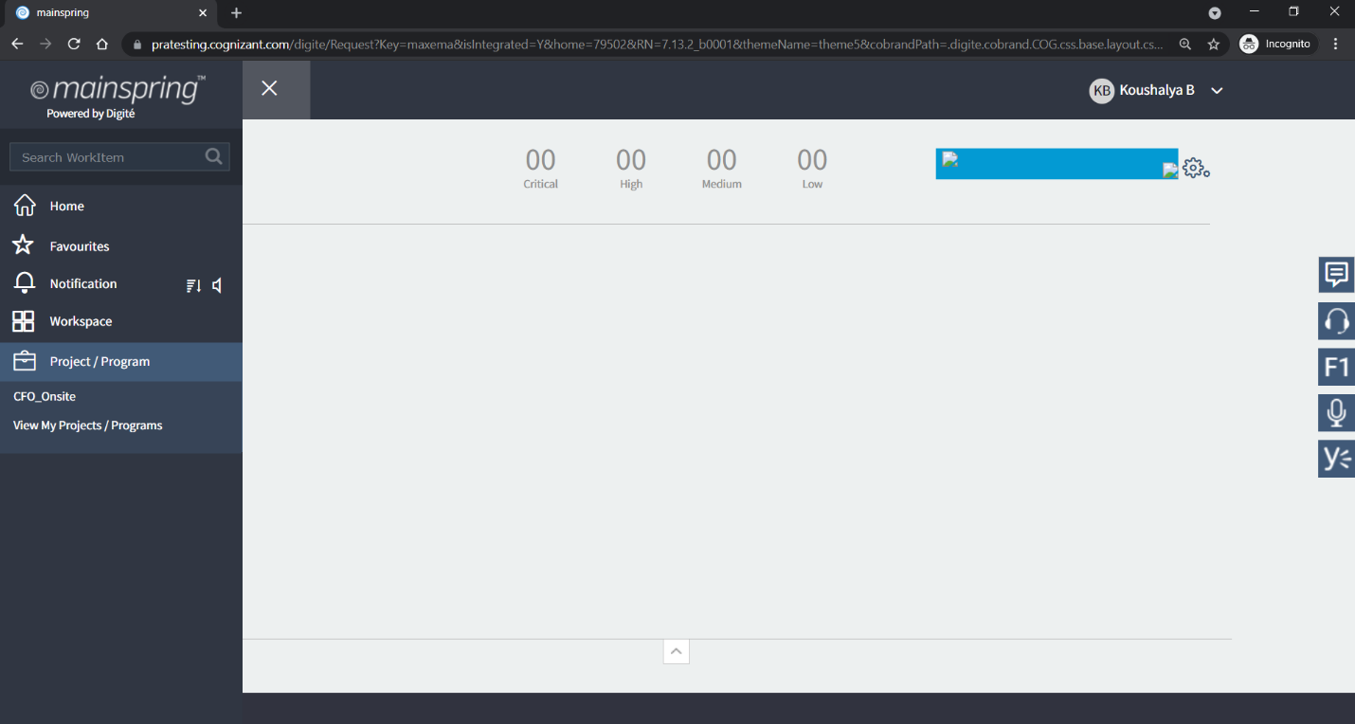

**10. Click on CFO_Onsite**

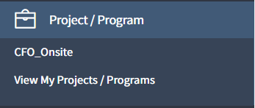

**11. Page navigates to Project Details page**

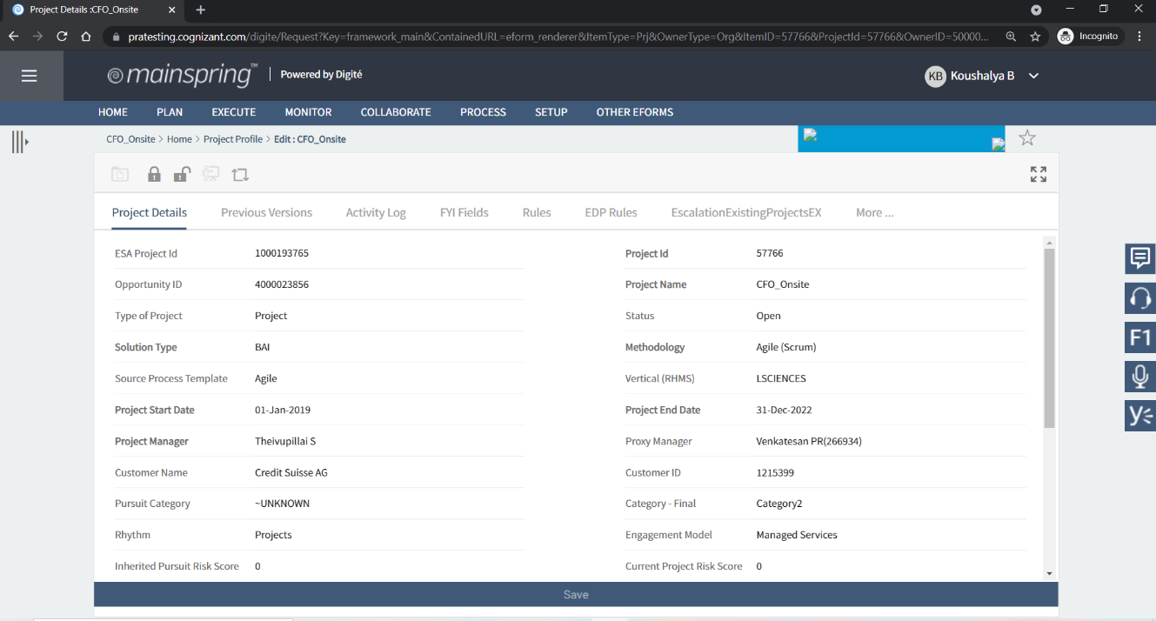

**12. Mouse hover to Plans**

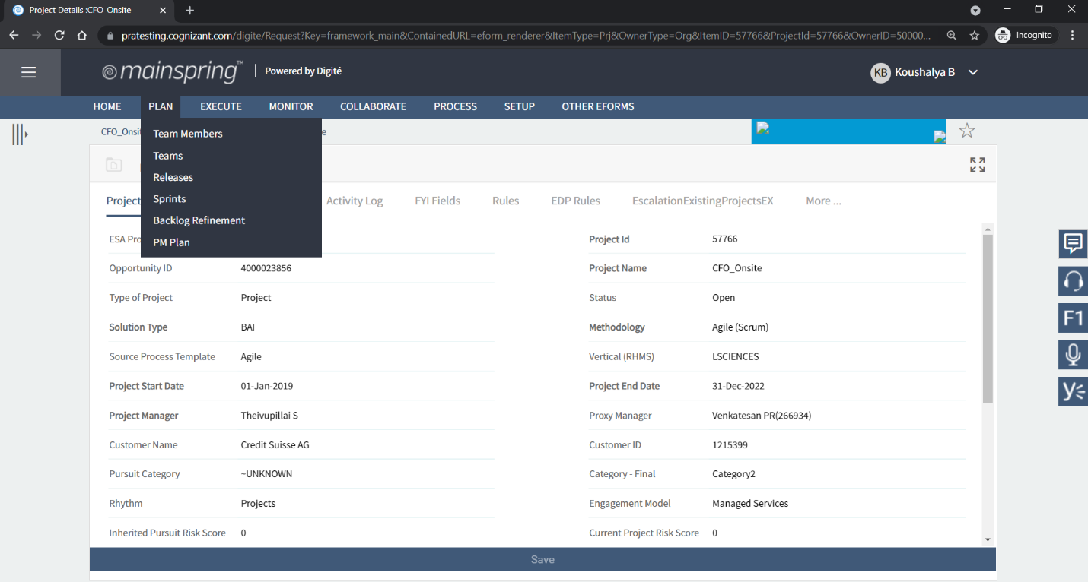

**13. Navigates to Releases page**

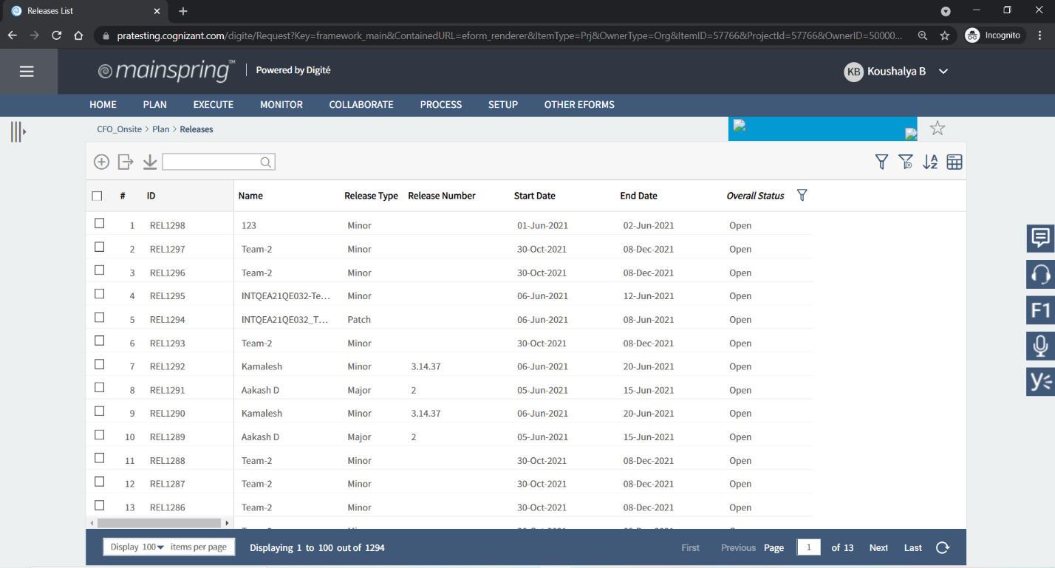

**14.Click on add button(+) and enter the details:**

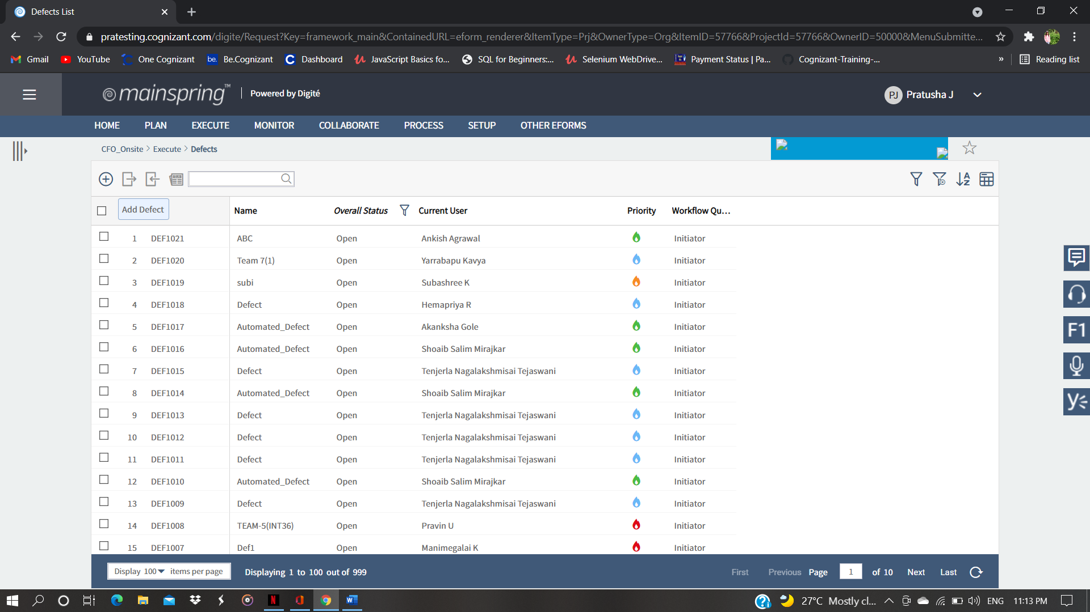

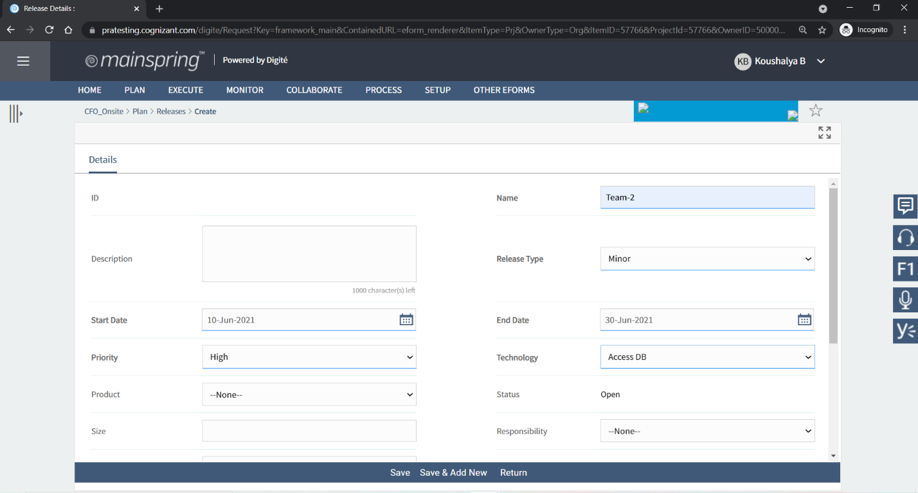

**15.Click Save Button**

