LernPath+

# Project ID: R24-112

# Project Proposal Report

K.A.K.N. Jayasinghe

# BSc Special (Hons) - Information Technology (Specialization in Information Technology)

Department of Information Technology Sri Lanka Institute of Information Technology

Sri Lanka

February 2024

LeanPath+

# Project ID: R24-112

Project Proposal Report

K.A.K.N. Jayasinghe

IT21032806

# Supervisor: Ms. Sanjeevi Chandrasiri

BSc Special (Hons) - Information Technology (Specialization in Information Technology)

Department of Information Technology Sri Lanka Institute of Information Technology

Sri Lanka February 2024

## DECLARATION OF THE CANDIDATE AND SUPERVISOR

We declare that this is our own work, and this project proposal does not incorporate without acknowledgement any material previously submitted for a Degree or Diploma in any other University or institute of higher learning and to the best of our knowledge and belief it does not contain any material previously published or written by another person except where the acknowledgement is made in the text.

|  |  |  |
| --- | --- | --- |
| Name | Student ID | Signature |
| K.A.K.N.Jayasinghe | IT21032806 |  |

The above candidates are carrying out research for the undergraduate dissertation under my supervision.

 29/02/2024

|  |  |
| --- | --- |
| ……………………………… | ……………………………… |
| Ms. Sanjeevi Channdrasiri | Date |

## ABSTRACT

The need for tailored learning experiences has grown in importance in the field of online education. This study investigates how adaptive machine learning approaches might be incorporated into e-learning platforms to improve user efficacy and engagement. Conventional systems frequently have trouble meeting the needs of a wide range of users, which lowers engagement and produces less than ideal learning results. The study offers a comprehensive architecture that includes powerful engagement metrics with a user feedback loop, a dynamic learning pathway generator, an adaptive recommendation engine, and an advanced content tagging algorithm. The framework attempts to transform online learning by utilizing insights from machine learning, educational technology, and user-centered design concepts. From a methodological standpoint, the study analyzes and tags learning resources according to content using machine learning classifiers and natural language processing approaches. The platform gives insights into user engagement and pleasure, dynamically develops individualized learning routes, and suggests adapted material through iterative trial and improvement. Thorough study of algorithmic performance, user input, and learning objectives are all part of testing and assessment. The findings show notable gains in user happiness, retention of knowledge, and engagement. Recommendations for further enhancing and applying the framework in other educational contexts are provided in the research's conclusion. The ultimate objective is to create a vibrant and welcoming learning environment that encourages inquiry, promotes development, and helps students move toward significant learning goals. The goal of the project is to enable learners to manage their educational journeys confidently and enthusiastically by redefining the boundaries of online education. This will open the door for individualized, accessible, and transformative learning experiences.

# Table of Contents

DECLARATION OF THE CANDIDATE AND SUPERVISOR 3

ABSTRACT 4

1. INTRODUCTION 7
   1. Entertainment based platforms 7
   2. Social Media Networks and Platforms 8
   3. Hotel industry. 10
   4. Background survey 12
   5. Literature Survey 12
   6. Research Gap 20
   7. Research problem 22
2. OBJECTIVES 24
   1. Main Objectives 24
   2. Specific Objectives 24
3. METHODOLOGY 26
   1. requirement gathering and feasibility studying 29
   2. Analyzing 33
      1. Functional Requirements 33
      2. Non-Functional requirements 33
      3. User requirements 34
      4. System requirements 34
   3. Design 35
   4. Implementation 37
   5. Software Testing 39
   6. Maintenance 40

4. COMMERCIALIZATION 41

1. DESCRIPTION OF PERSONAL AND FACILITIES 42
2. BUDGET AND BUDGET JUSTIFICATION 43
3. REFERENCE LIST 44
4. APPENDICES 45

## LIST OF FIGURES

Figure 1 : Social media users over time 8

Figure 2 : Popular social media networks 9

Figure 3 : Age groups of the users 12

Figure 4 : User Gender 13

Figure 5 : User Type 14

Figure 6 : Usage of social media platforms to get notified about an event 14

Figure 7 : Likeliness to attend to an online hosted event. 15

Figure 8 : Use of the application 16

Figure 9 : What are your preferred event types 17

Figure 10 : Expectations from community 18

Figure 11 : Agile model 29

Figure 12 : Requirements in a social media platform 29

Figure 13 : Survey participants' ratings on each social media platform requirement 30

Figure 14 : High level system architecture diagram for proposed component 35

Figure 15 : High level system architecture diagram for the whole system 36

Figure 16 : Gantt chart 40

Figure 17 : WBC 45

## List of tables

Table 1 : Proposed system compared to existing systems 22

Table 2 : Description of personal and facilities 43

Table 3 : Budget and budget justification 43

## LIST OF ABBREVIATIONS

GUI Graphical User Interface

API Application Programming Interface

USA United States of America

USD United States Dollars

IT Information Technology

WBC Work Breakdown Chart

# INTRODUCTION

The goal of creating individualized learning experiences is crucial in the rapidly growing field of online education. Current e-learning systems frequently struggle to meet the various needs and preferences of individual users, which lowers engagement and decreases retention of the material. To transform the tailored e-learning user experience, our research integrates adaptive machine learning techniques to tackle these difficulties. The goal of the project is to enable students to navigate their educational journeys successfully and enthusiastically by utilizing powerful engagement statistics, a dynamic learning pathway generator, an adaptive recommendation engine, and a sophisticated content tagging system. This research aims to reshape the online learning environment by combining machine learning, educational technology, and user-centric design principles. This will enable a dynamic and inclusive learning environment that stimulates curiosity, promotes development, and produces significant learning outcomes.

### Static Content Delivery

Static material libraries and pre-established learning routes are the mainstays of traditional e-learning systems. Users are given pre-designed modules and courses, frequently with little room for them to explore interests outside of the pre-established curriculum [1]. The inability of learners to interact with resources that closely match their unique interests, learning preferences, and career objectives is a result of this static approach to content distribution.

### Limited Personalization

Traditional e-learning platforms frequently have little to no personalization. Regardless of their unique learning preferences, styles, and skill levels, students enjoy a consistent learning experience [2]. Users could feel disengaged from the learning process as a result, which would lower their motivation and produce worse learning results. The efficacy and applicability of e-learning platforms in meeting the varied needs of contemporary learners are compromised by the absence of tailored learning experiences.

### Rudimentary Recommendation Systems

Although some platforms have recommendation systems, these are frequently simple and undeveloped. The majority of recommendations are based on straightforward algorithms, including content-based or collaborative filtering, which could not fully represent users' complex preferences and learning styles [3]. This could lead to an overload of repetitive or unnecessary content for users, which would be detrimental to their overall learning experience and lower their level of engagement.

### Lack of Adaptability

The inability of current e-learning systems to modify learning paths and material delivery in real-time in response to user interactions and feedback indicates their lack of flexibility. Over time, users may become less engaged and motivated because of difficulties navigating through large material libraries [4]. Lack of adaptive learning mechanisms makes it difficult for users to move through the learning process smoothly, which impedes the acquisition and retention of knowledge.   
  
The proposed research, on the other hand, seeks to remedy these deficiencies by putting forth a fresh framework for customized e-learning. The framework aims to transform the online learning experience by incorporating adaptive machine learning techniques and offering users personalized recommendations, adaptable learning pathways, and instantaneous feedback systems.

This research emphasizes the critical need for innovation in the sector by providing a comparative analysis of the shortcomings present in traditional e-learning systems. The suggested framework aims to close the gap between static, one-size-fits-all techniques and the dynamic, individualized learning experiences that modern learners need by utilizing insights from machine learning, educational technology, and user experience design.   
  
We explore the methodology, implementation, testing, and assessment of the suggested framework in the sections that follow, emphasizing its potential to expand the parameters of online learning and promote a vibrant, diverse learning environment.

# Background survey

# Literature Survey

From the crude computer-based training (CBT) systems of the 1960s to the complex digital learning environments of today, the evolution of e-learning has been a dynamic journey spanning several decades [1][2]. Technological, pedagogical, and instructional design advances have propelled this growth and given rise to a variety of e-learning platforms and approaches. Traditional e-learning systems continue to confront obstacles that limit their ability to effectively cater to the varied needs and preferences of learners, even with the notable advancements in the sector [3][4].

Static content distribution mechanisms, which offer learners pre-defined courses and modules that might not accommodate their unique learning preferences and styles, are a common feature of traditional e-learning systems [5]. This one-size-fits-all strategy hinders students' capacity to interact with the content in an efficient manner and could eventually lead to disinterest and decreased motivation. Furthermore, conventional e-learning platforms sometimes lack strong personalization tools, making it difficult to modify the learning process to fit the particular requirements and traits of each learner [6].

Moreover, a lot of conventional e-learning platforms have very basic recommendation systems that rely on oversimplified algorithms that might not adequately represent learners' preferences and learning patterns [7]. Consequently, learners can be exposed to repetitive or unnecessary content, which would negatively impact their entire learning experience. Furthermore, conventional e-learning platforms are not flexible enough to modify learning paths and content delivery in real-time in response to user interactions and feedback [8]. This lack of flexibility may impede students' development and restrict their capacity to successfully meet their learning goals.

The literature addresses these issues by highlighting a number of recent developments in e-learning that show promise for improving the educational process [9][10]. Personalized learning paths, data-driven analytics, immersive learning experiences, and adaptive learning technologies are a few of them. With research showing that personalization, in particular, can improve student engagement, motivation, and information retention, it has become a prominent theme in the conversation around e-learning today [11].

Even so, there is still a sizable vacuum in the literature when it comes to thorough, user-centered strategies for customized e-learning [12]. By integrating adaptive machine learning approaches to improve user engagement, efficacy, and pleasure in e-learning environments, this research seeks to close this gap [13][14]. The suggested framework aims to transform the online learning experience by utilizing insights from machine learning, educational technology, and user experience design. It does this by offering learners personalized recommendations, flexible routes, and instantaneous feedback systems.

# Research Gap

Thanks to developments in both pedagogy and technology, e-learning has made significant strides. Nevertheless, despite this ever-changing landscape, there is still a substantial vacuum in the literature about the creation of really user-centric methods for tailored e-learning. Even though they are easily accessible and convenient, traditional e-learning systems frequently lack the flexibility needed to meet the various needs and preferences of different learners [1][2].

The low degree of customization available on traditional e-learning platforms is one of the main issues. Static material libraries and general learning routes are frequently offered to learners, and it's possible that these don't closely match their own learning preferences, interests, and skill levels [3]. The success of the educational attempt may be eventually impacted by learners' decreased motivation and engagement as a result of this lack of tailored experiences [4].

Furthermore, current e-learning platform recommendation systems are typically crude, depending on oversimplified algorithms that might not precisely reflect the subtleties of learners' tastes and actions [5]. As a result, students could be overloaded with redundant or irrelevant information, which could cause cognitive overload and cause them to lose interest in what they are studying [6]. Furthermore, learners are unable to adjust and advance at their own pace in traditional e-learning systems due to the static structure of learning pathways and content delivery [7].

To improve user happiness and engagement in e-learning environments, these deficiencies must be addressed with creative frameworks that incorporate adaptive machine learning approaches [8][9]. Such frameworks seek to transform the online learning experience by utilizing insights from machine learning, educational technology, and user experience design. They do this by offering learners individualized recommendations, adaptive pathways, and real-time feedback mechanisms that are catered to their particular needs and preferences [10].

Table 1 : Proposed system compared to existing systems

# Research problem

The constraints of traditional e-learning systems give rise to a key research topic that is addressed by the Dynamic Learning Pathway Generator. Conventional learning environments frequently offer rigid, preset learning paths that don't take into account the different requirements, interests, and skill levels of individual students. These systems don't take into account how dynamic learning is, and they can't modify their paths in reaction to feedback and real-time user interactions. As a result, students could struggle to stay interested and attain the best possible knowledge acquisition and retention.

The need for a solution that provides adaptive and individualized learning pathways catered to each user's distinct traits is at the core of this research challenge. Current e-learning platforms usually provide general approaches that ignore the nuances of each learner's unique experience. Lack of customized learning paths prevents students from interacting with the material to the fullest extent, which lowers motivation and produces less than ideal learning results. Thus, creating a Dynamic Learning Pathway Generator that can dynamically modify learning sequences according to user preferences, learning styles, and performance metrics is the research challenge.

The design and integration of user-centric features present a challenge that goes beyond the technical requirements of implementation. To guarantee the effectiveness of the created routes, a thorough comprehension of user behavior, cognitive processes, and instructional objectives is required. The research topic also includes the requirement to strike a balance between coherence and adaptation such that the dynamically generated paths preserve logical progression and coherence while meeting the demands of different learners.

# OBJECTIVES

### Main Objectives

The primary objectives of the component are to enhance users' social connections by categorizing them based on shared interests, suggesting posts according to community interests, filtering posts by verified users, and ultimately rendering the system more enticing to users.

Additionally, the component aims to render unfamiliar surroundings more familiar to users while maintaining their psychological well-being.

### Specific Objectives

1. Implementing a mobile application as an entertainment platform.

The proposed solution involves the design and implementation of a mobile application dedicated to providing an entertainment platform with a specific section for user communities. This application should include features such as a profile feature, content catalog feature, similarity calculation feature, hybrid filtering feature, and social features to achieve the intended goal.

1. Building a model for recommending most suitable event using an algorithm.

The objective is to develop a model that recommends the most suitable events to users based on their preferences, such as timeliness, cost, and social relevance. By analyzing user behavior data, we can identify user preferences and map them to available event lists to present users with a concise list of events that best match their needs.

1. Building a model for recommending most suitable community for a user by using an algorithm.

The proposed model involves building an algorithm that recommends the most suitable community for a user based on their preferences. After analyzing user behavior, users will be grouped into main categories to assign them to relevant communities, helping them to become familiar with unfamiliar surroundings. With the help of this algorithm, users will receive personalized notifications, suggestions, and a personalized feed.

1. Identify what user preferences are.

The goal is to identify user preferences by analyzing their behavior. This includes parameters such as geographical locations, hotels, events, and other users with whom they would like to interact more. The algorithm will process the data gathered by tracking user activity within the application to develop a deeper understanding of the user.

1. Retrieving user location data using google API

The location data of users will be tracked with their explicit permission to gain insights into the places and events that they are most likely to visit, as well as to identify other users who share similar interests in the same geographical area. This data can be accessed via Google Maps API endpoints.

1. Building a model for notifying businesses about the important information such as trends and predictions by using an algorithm.

Through the use of an algorithm, business users will have access to critical business information, such as current trends, competition status, business forecasts, and recommended actions to maximize business performance. Additionally, a monthly dashboard report will be provided to users, offering further insights into the market through advanced analysis.

# METHODOLOGY

Night-Out is an event management application with 4 components,

* 1. User behavior analyzation system.
  2. Community based recommendation system.
  3. Socializing process and reviews system.
  4. Profit maximization system.

In this proposal, we specially focus on the Community based recommendation component. The main objective of this component is to enhance users' social connections by categorizing them based on shared interests, suggesting posts according to community interests, filtering posts by verified users, and ultimately rendering the system more enticing to users. Additionally, the component aims to render unfamiliar surroundings more familiar to users while maintaining their psychological well-being.

To achieve this we develop four modules within the component;

* + 1. Content catalog: This module is responsible for storing the content that will be used for recommendation generation. The process involves the following steps:
       - The module identifies which data is essential to make recommendations.
       - The system fetches the dataset.
       - The dataset is saved in a traceable form to ensure its integrity and accessibility.
       - The best matches are sorted out to be used for the current recommendation.
       - The results are returned to the recommendation generation module.
    2. Similarity calculations: Responsible for calculating the similarity between users based on their preferred content. The process involves the following steps:
       - User inputs are collected to determine their preferences.
       - The system retrieves the available item list.
       - A comparison is made between the user inputs and the item list to identify commonalities.
       - The similarity between user preferences and the content list is calculated.
       - The results are saved to prioritize items based on user preferences.
    3. Review system: Enables users to react, interact, and provide feedback through the system. The system works through the following steps:
       - A post feature is implemented to allow users to share their opinions and experiences.
       - Image upload support is added to posts, enabling users to add relevant visuals to their posts.
       - Posts can be edited or deleted to ensure that the information presented is accurate and up-to-date.
       - User posts are visible in user profiles and to all users, allowing for increased visibility and interaction.
       - A reply feature is implemented for posts, enabling users to engage in discussion and exchange feedback.
    4. Recommendation generation: This operates based on the modules and content-based filtering as mentioned earlier. The process involves the following steps:
       - Pre-processed data is collected from the above-mentioned modules.
       - Content-based filtering is implemented to analyze the data.
       - The data set is filtered based on the results obtained from content-based filtering.
       - Similarity conditions are checked to ensure that the recommendations are relevant to the user.
       - Recommendations are generated and presented to the users.

To complete the project, we want to apply the agile development methodology. This strategy places a strong emphasis on adaptability, teamwork, and quick iteration. It is based on the Agile Manifesto, which identifies four values: valuing people over processes and technologies, valuing working software over thorough documentation, valuing customer collaboration over contract negotiations, and valuing adapting to change over sticking to a schedule.

Agile methodologies are distinguished by brief development cycles, known as sprints, when cross-functional teams collaborate to create usable software or products. To make sure that the product satisfies their needs and that modifications can be made rapidly in response to input, the teams work closely with the customer or end-user. Continuous improvement is another key component of the agile process, which includes regular reviews and retrospectives to find areas for improvement. The seven phases of agile model;

1. Planning: This phase involves identifying the scope of the project, defining the project goals, and creating a roadmap or backlog of tasks that need to be completed.
2. Analysis: In this phase, the team conducts a detailed analysis of the project requirements, user needs, and potential risks.
3. Design: Based on the analysis, the team designs the software or product, identifying features, functionalities, and user interfaces.
4. Implementation: This is the phase where the actual development work takes place. The team works on coding, testing, and integration of different modules.
5. Testing: The team performs a variety of tests throughout this phase, including user acceptability testing, integration testing, and unit testing, to make sure the software or product satisfies the necessary quality standards.
6. Deployment: To make sure the software or product satisfies the necessary quality standards, the team does numerous sorts of testing throughout this phase, including unit testing, integration testing, and user acceptability testing.
7. Monitoring: The final phase involves monitoring the software or product in production to identify and fix any issues, and continuously improve the product.

Figure 11 : Agile model

### requirement gathering and feasibility studying

We gathered the requirements at two levels

* + 1. Primary data gathering
    2. Secondary data gathering

In primary data gathering, we mainly focused on user requirements. We are planning conducted a background survey through google forms to identify user requirements and the questions we are hoping to ask are mentioned bellow.

Figure 12 : Requirements in a social media platform

In addition to the questionnaire,

* we acquired data from event planners and consultants and gathered requirements.
* Contacted with an IT consultant and gathered information.

In secondary data gathering,

* We studied existing systems
* We studied from various online resources such as online tutorials and web articles.
* We also gathered information from books and articles.

After performing requirement gathering, we performed a feasibility study,

* + - 1. Technical Feasibility

To successfully complete the research, all the team members should have the technical knowledge to proceed with the project. We made sure that we can acquire the required knowledge in order to complete the project addition to we already acquired knowledge.

* + - 1. Economic Feasibility

Financial resources are very important when we conduct the project. We made sure we have enough funds in order to complete project without having to stop half the way. We also made sure to plan handling unforeseen financial needs in the future.

* + - 1. Legal Feasibility

Not meeting legal feasibility is when a project runs afoul of legal restrictions such as zoning rules, data privacy laws, or social media laws. We made sure there are no conflicts with laws in our proposed system.

* + - 1. Operational Feasibility

This involves to what extent the project can be completed to meet the needs of the company. We had a discussion with Underground Music Coven members and made sure we are feasible in operational feasibility.

* + - 1. Scheduling Feasibility

Scheduling Feasibility means if a project can be completed and delivered in defined time. In our case, it is 1 year. We made sure the project is deliverable in the defined time period.

Process of gathering secondary data for our research.

We undertook various activities. These included studying existing systems, referring to online resources such as tutorials and articles, as well as gathering information from books and articles. After completing the requirement gathering phase, we conducted a feasibility study to determine the viability of our proposed project. The feasibility study encompassed several key areas;

* + - * 1. Starting with technical feasibility: We ensured that all team members possessed the necessary technical expertise to successfully complete the project, and also took steps to acquire additional knowledge as required.
        2. Next, we assessed economic feasibility: recognizing the critical role of financial resources in the success of the project. We confirmed that we had sufficient funds to complete the project and also developed contingency plans to manage any unforeseen financial challenges.
        3. In addition, we addressed legal feasibility: ensuring that our proposed system did not run afoul of any relevant laws or regulations, such as those pertaining to data privacy or social media.
        4. We also considered operational feasibility: which refers to the ability of the project to meet the needs of the company. We are planning to work closely with the businesses such as hotels in order to acquire more information regarding this area.
        5. Finally, we evaluated scheduling feasibility: which relates to the project's ability to be completed and delivered within the defined time frame. Given that our project timeline was set at one year, we ensured that our proposed project could be delivered within this timeframe.

### Analyzing

By analyzing the gathered data, we categorized collected requirements as follows

* + 1. Functional Requirements
       - Based on similar interests, the system should be able to analyze user behavior data and classify people into pertinent categories.
       - The system should have a feed section that suggests posts based on community interests.
       - Users should be able to interact with the posts by commenting.
       - The system should filter posts by verified users and prevent disliked posts and posts similar to those from appearing in the community feed.
       - The system should be able to gather data through mobile data such as search history and app usage, and web analytic tools such as Google analytics.
    2. Non-Functional requirements
       - The system should be able to handle large amounts of data and provide fast and reliable responses to user requests.
       - The system should ensure that user data is kept secure and only accessible by authorized personnel.
       - The system should be able to scale up or down based on changing user demands and data volumes.
       - The system should be easy to use and navigate for users of all technical levels.
       - There should be little downtime for maintenance or updates, and the system should always be dependable.
    3. User requirements

1. The system should be user-friendly and easy to navigate, with clear instructions and guidance provided to the user.
2. The system should allow users to create profiles with basic personal information such as name, age, and location.
3. The system should enable users to connect with other users who share similar interests or are located in the same vicinity.
4. The system should provide users with relevant and timely recommendations for events, activities, and other content based on their interests and location.
5. The system should allow users to interact with posts by commenting, liking, or sharing, and also enable them to report inappropriate or offensive content.
   * 1. System requirements

Software requirements

* + - * Operating System: Windows
      * Web browser: Google Chrome
      * Database management system: MySQL
      * Programming languages: Python, JavaScript, and PHP
      * Frameworks: React, Django, and Node.js
      * Development environments: PyCharm, PhpStorm, NumPy, pandas
      * Version control system: Git
      * Application programmable interfaces: google maps

Hardware Requirements

* + - * Processor: Intel Core i5 or similar AMD series CPU
      * Memory (RAM): 8 GB
      * Storage: 256 GB Solid State Drive (SSD)
      * Display: 15-inch 1080p HD
      * Graphics card: NVIDIA GeForce GTX 1650 or equivalent
      * Internet connectivity: Wi-Fi 5 or Ethernet connection

### Design

To proceed with the design phase, we have developed a system architecture diagram to consolidate all necessary components. The design phase will commence by wireframing each interface of the web application using Figma software. Upon completion of the wireframes, usability tests will be conducted using Hi-fidelity prototypes, with a focus on identifying and resolving issues from the user's perspective. This process will be efficient and effective, as it will save time and effort in advance of the implementation phase by reducing the risk of failing user acceptance testing. Subsequently, we will design the system's structure, starting with attribute identification and database design, before moving on to designing the hardware and software solutions.

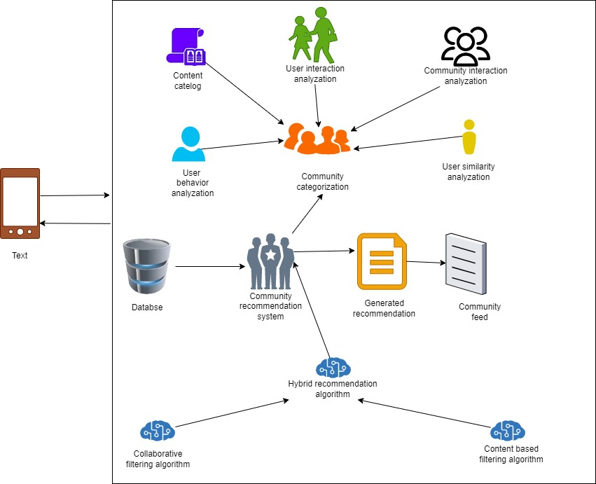

Phone

Figure 14 : High level system architecture diagram for proposed component

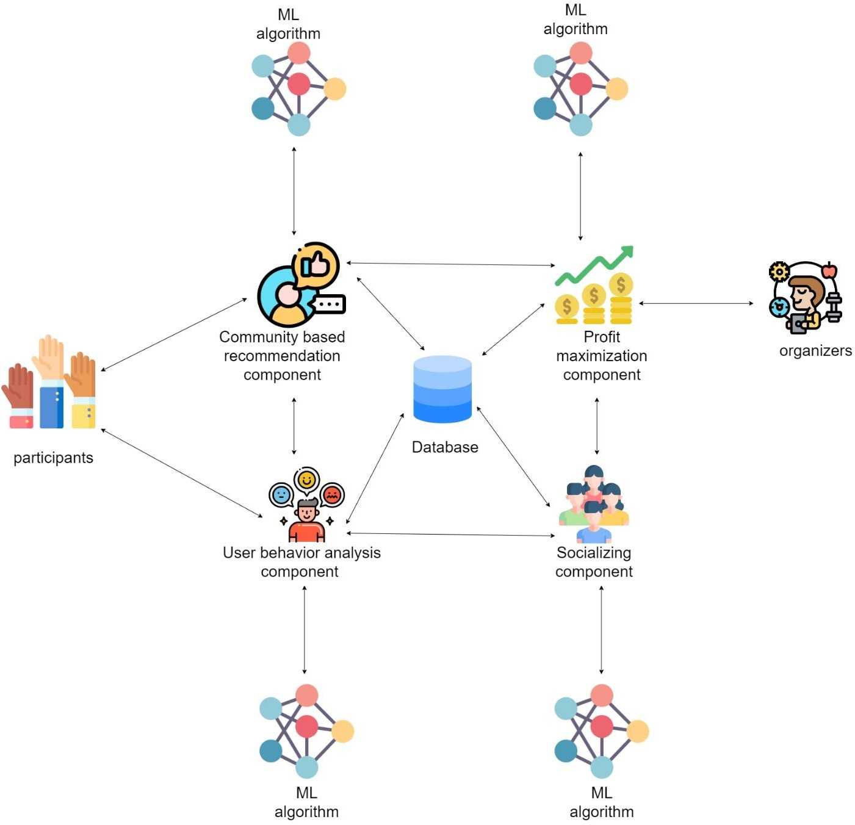

Figure 15 : High level system architecture diagram for the whole system

### Implementation

### Software Testing

### Maintenance

The process of software development does not terminate at the completion of testing. Upon completion of development and launch, the software must be continuously maintained. The software should be updated to address security vulnerabilities, performance issues, bugs, and accuracy concerns to ensure that it operates at its optimal level.

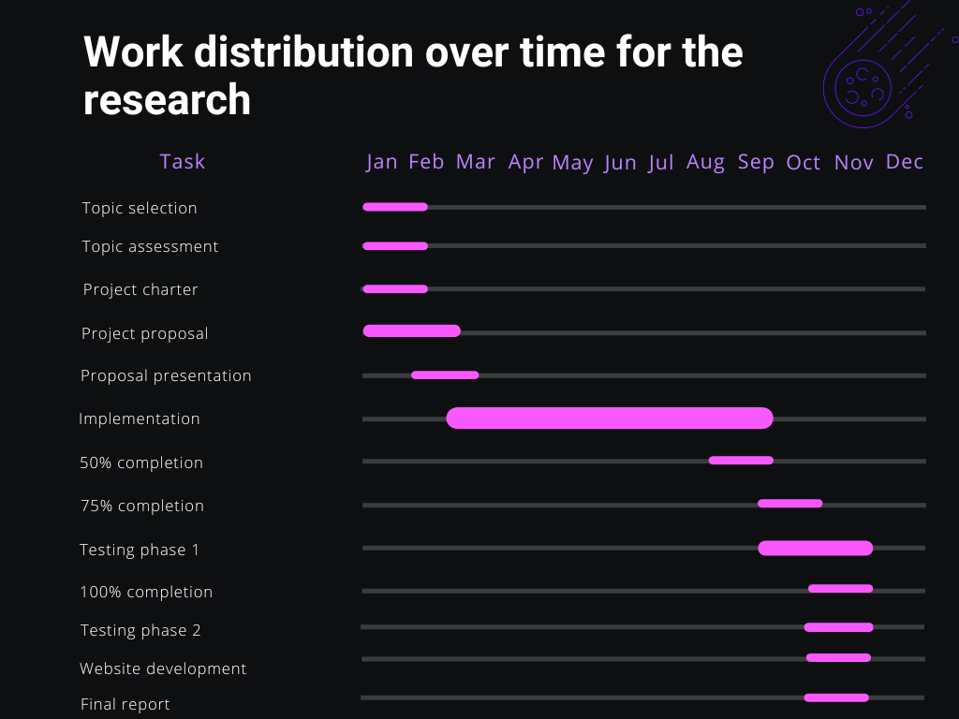

Figure 16 : Gantt chart

# COMMERCIALIZATION

# DESCRIPTION OF PERSONAL AND FACILITIES

|  |  |  |
| --- | --- | --- |
| Member | Component | Task |
| ayasinghe K.A.K.N | **Dynamic Learning Pathway Generator:** This component assembles a dynamic learning pathway for each user by sequencing recommended content. It ensures a varied mix of formats and difficulty levels, promoting a well-rounded learning experience. | 1. Algorithm Development: Task: Develop algorithms for creating adaptive learning paths. Details: Design algorithms that take into account content tags, user preferences, and learning goals to dynamically generate personalized learning paths. Ensure flexibility in the algorithm to cater to diverse user profiles.  2. Content Tag Integration:  Task: Integrate content tags into the algorithm. Details: Ensure that the algorithm considers content tags associated with each learning resource. Content tags can include topics, skills, formats, and other relevant metadata that contribute to the diversity of the learning pathway.  3. User Preference Incorporation: Task: Incorporate user preferences into the learning path algorithm. Details: Integrate the user profile, including learning preferences identified in the user profiling component, to tailor the learning path according to the individual's preferred content formats, difficulty levels, and styles.  4. Learning Goal Alignment: Task: Align learning paths with user-defined learning goals. Details: If users have explicitly defined learning goals, ensure that the algorithm aligns the recommended learning path  with these goals. This customization enhances the relevance of the learning experience.  5. Dynamic Pathway Adjustment: Task: Implement mechanisms for dynamic pathway adjustment. Details: Develop a system that continually monitors user performance and interactions with the learning path. Adjust the pathway dynamically based on user progress, achievements, and feedback to ensure ongoing relevance and effectiveness.  6. Regular Pathway Updates: Task: Establish a process for regular pathway updates. Details: Plan and implement regular updates to the learning pathways. This may involve introducing new content, removing outdated material, and adjusting the sequence of recommended resources based on evolving educational needs.  7. User Progress Visibility: |

|  |  |  |
| --- | --- | --- |
|  |  | Task: Provide visibility to users on their progress within the learning pathway. Details: Implement a user interface feature that allows users to track their current progress, achievements, and upcoming milestones within the learning pathway. This fosters transparency and motivation.  8. Gamification Integration: Task: Optionally, integrate gamification elements. Details: Consider adding gamification elements such as badges, points, or levels to enhance user engagement. Gamification can provide additional incentives for users to progress through the learning pathway.  9. Privacy and Ethical Considerations: Task: Incorporate privacy controls and ethical considerations. Details: Implement measures to protect user privacy in the learning pathway generation process. Ensure compliance with data protection regulations and communicate transparently about data usage. |

Table 2 : Description about personal and facilities

# BUDGET AND JUSTIFICATION

|  |  |
| --- | --- |
| Resource | Price (LKR) |
| Electricity | 5000 |
| Stationary | 2000 |
| Internet | 6000 |
| Server / domain | 9000 |
| Total | 22000 |

Table 3 : Budget and budget justification

# REFERENCE LIST

1. “Online Entertainment Platforms”: [https://theenterpriseworld.com/facts-about-online-](https://theenterpriseworld.com/facts-about-online-entertainment-platforms/) [entertainment-platforms/](https://theenterpriseworld.com/facts-about-online-entertainment-platforms/). 2020
2. “The rise of social media,” in *Sport, Racism and social media*, Routledge, 2017, pp 13-24.
3. “Most popular social networks worldwide”: [https://www.statista.com/statistics/272014/global-social-networks-ranked-by-number-of-](https://www.statista.com/statistics/272014/global-social-networks-ranked-by-number-of-users/) [users/](https://www.statista.com/statistics/272014/global-social-networks-ranked-by-number-of-users/). [Accessed: 21-Jan-2023].
4. Traci Ruether , “History of Streaming Media”: [https://www.wowza.com/blog/history-of-](https://www.wowza.com/blog/history-of-streaming-media) [streaming-media](https://www.wowza.com/blog/history-of-streaming-media) . 21-Feb-2023.
5. [Merriam-Webster](https://www.merriam-webster.com/dictionary/social%20media), “The Evolution of Social Media”,

<https://online.maryville.edu/blog/evolution-social-media/>, 2021.

1. “The 7 different types of social media”, [https://biteable.com/blog/the-7-different-types-of-](https://biteable.com/blog/the-7-different-types-of-social-media/) [social-media/](https://biteable.com/blog/the-7-different-types-of-social-media/), biteable, 21-Mar-2018.
2. Anubha Jain, “Event Management in Hotel Industry”, [https://qloapps.com/event-](https://qloapps.com/event-management-in-hotel-industry/) [management-in-hotel-industry/](https://qloapps.com/event-management-in-hotel-industry/), 23-Sep-2022.
3. Hannah Tow, “108 Shocking Event Industry Statistics You Need to Know”,

<https://www.g2.com/articles/event-industry-statistics#planning>, 12- July -2019.

1. Alexander Felfernig, Michael Jeran, Gerald Ninaus, Florian Reinfrank & Stefan Reiterer, “Toward the Next Generation of Recommender Systems: Applications and Research Challenges”, Multimedia Services in Intelligent Environments pp 81–98, <https://link.springer.com/chapter/10.1007/978-3-319-00372-6_5>, [First Online: 01-Jan-2013].
2. Kifayat Ullah Khan a, Batjargal Dolgorsuren a, Tu Nguyen Anh a, Waqas Nawaz a b, Young-Koo Lee a, “Faster compression methods for a weighted graph using locality sensitive hashing”, Information Sciences [pp 237-253], [https://www.sciencedirect.com/science/article/abs/pii/S0020025516316085?via%3Dihub,](https://www.sciencedirect.com/science/article/abs/pii/S0020025516316085?via%3Dihub) dec-2017.

[11 U. Yeliz Eseryel, “Decision-making Processes in Community-based Free/Libre Open Source Software-development Teams with Internal Governance”, [https://www.researchgate.net/publication/340722857_Decision-](https://www.researchgate.net/publication/340722857_Decision-making_Processes_in_Community-based_FreeLibre_Open_Source_Software-development_Teams_with_Internal_Governance_An_Extension_to_Decision-making_Theory) [making_Processes_in_Community-based_FreeLibre_Open_Source_Software-](https://www.researchgate.net/publication/340722857_Decision-making_Processes_in_Community-based_FreeLibre_Open_Source_Software-development_Teams_with_Internal_Governance_An_Extension_to_Decision-making_Theory) [development_Teams_with_Internal_Governance_An_Extension_to_Decision-](https://www.researchgate.net/publication/340722857_Decision-making_Processes_in_Community-based_FreeLibre_Open_Source_Software-development_Teams_with_Internal_Governance_An_Extension_to_Decision-making_Theory) [making_Theory](https://www.researchgate.net/publication/340722857_Decision-making_Processes_in_Community-based_FreeLibre_Open_Source_Software-development_Teams_with_Internal_Governance_An_Extension_to_Decision-making_Theory) , Communications of the Association for Information Systems [DOI:10.17705/1CAIS.04620], Jan-2020

1. “Cold start (recommender systems)” , [https://en.wikipedia.org/wiki/Cold_start_(recommender_systems)#:~:text=The%20cold%20s](https://en.wikipedia.org/wiki/Cold_start_(recommender_systems)#%3A~%3Atext%3DThe%20cold%20start%20problem%20may%2Clearnt%20from%20their%20respective%20users) [tart%20problem%20may,learnt%20from%20their%20respective%20users](https://en.wikipedia.org/wiki/Cold_start_(recommender_systems)#%3A~%3Atext%3DThe%20cold%20start%20problem%20may%2Clearnt%20from%20their%20respective%20users)., 2018.
2. Nitin Mishra, Saumya Chaturvedi, Aanchal Vij, Sunita Tripathi, “Research Problems in Recommender systems”, [https://iopscience.iop.org/article/10.1088/1742-](https://iopscience.iop.org/article/10.1088/1742-6596/1717/1/012002/pdf) [6596/1717/1/012002/pdf](https://iopscience.iop.org/article/10.1088/1742-6596/1717/1/012002/pdf), Journal of Physics: Conference Series, [doi:10.1088/1742- 6596/1717/012002], 2021.
3. Satya Keerthi Gorripati, Valli Kumari Vatsavayi, “A Community Based Content Recommender Systems”. [https://www.ripublication.com/ijaer17/ijaerv12n22_165.pdf,](https://www.ripublication.com/ijaer17/ijaerv12n22_165.pdf) International Journal of Applied Engineering Research [ISSN 0973-4562 Volume 12, Number 22], [pp. 12989-12996], 2017.

# APPENDICES

Appendix: Work breakdown chart

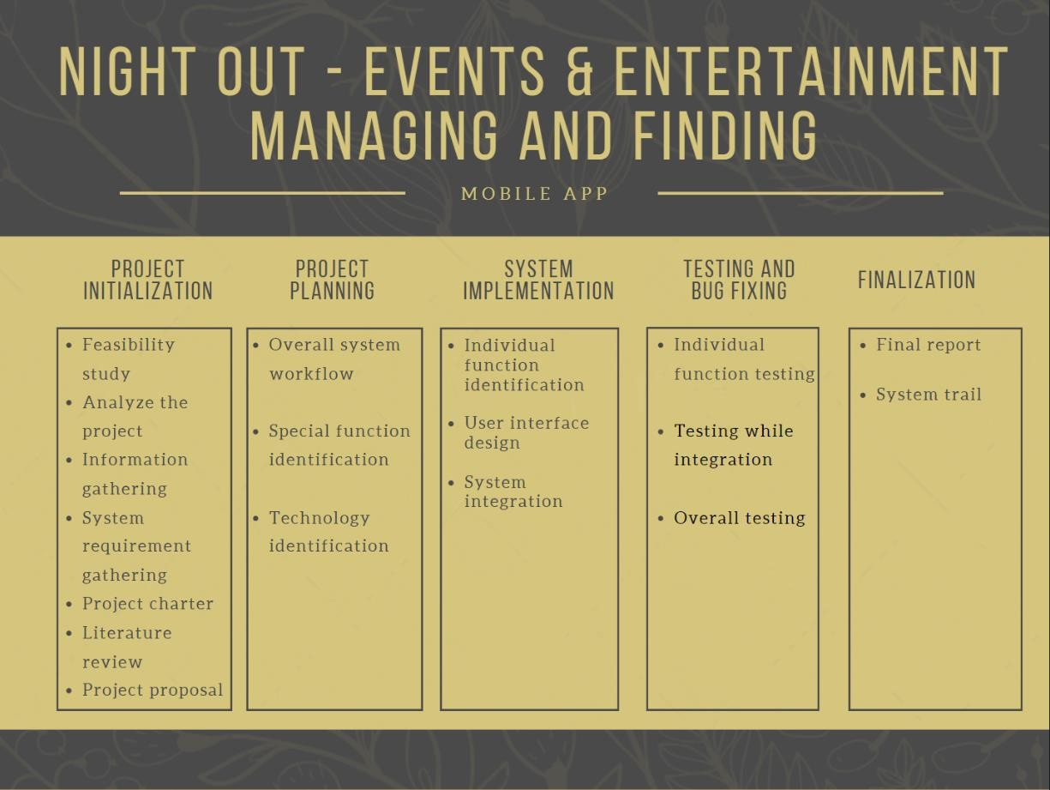

Figure 17 : WBC