Q1

**CODE:**

package Q1;  
  
public class square_root {  
 public static void main(String[] args) {  
  
 double A=2.0;  
 double B=3.0;  
 double C=4.0;  
 double X=5.0;  
 double Y=6.0;  
 double r=7.0;  
  
 //a. The square root of B*B + 4AC  
 double square_rt = Math.*sqrt*(B * B + 4 * A * C);  
 System.*out*.println("a.The square root of B² + 4AC: " + square_rt);  
  
 // b. The square root of X + 4Y*Y*Y  
 double squart = Math.*sqrt*(X + 4 * Math.*pow*(Y, 3));  
 System.*out*.println("b.The square root of X + 4Y³: " + squart);  
  
 // c. The cube root of the product of X and Y  
 double cube_root = Math.*pow*(X * Y, 1.0/3.0);  
 System.*out*.println("c.The cube root of the product of X and Y: " + cube_root);  
  
 // d. The area of a circle  
 double area = Math.*PI* * r * r;  
 System.*out*.println("d.The area of the circle is: " + area);  
  
  
  
  
  
  
 }  
}

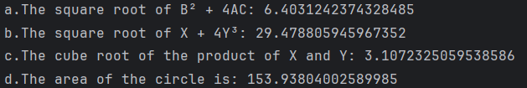

Q2

**CODE:**

package Q2;  
import java.util.*;  
  
public class Converter {  
  
 public static void main(String[] args) {  
  
 Scanner scanner = new Scanner(System.*in*);  
 System.*out*.println("Enter centimeter value:-");  
 double centimeter = scanner.nextDouble();  
  
 double CmtoInch = 2.54;  
 double Inchtofoot = 12;  
  
 double Cminch = centimeter/CmtoInch;  
 double InchFoot = Cminch/Inchtofoot;  
  
 System.*out*.println(centimeter + "to inch is : " + Cminch + " and To Foot is : " + InchFoot );  
 }  
}

Q3

**CODE:**

package Q3;  
  
import java.util.*;  
  
public class Temperture {  
 public static void main(String[] args) {  
  
 Scanner scanner= new Scanner(System.*in*);  
 System.*out*.println("Enter Temperature in degrees celsius:-");  
 double celsius=scanner.nextDouble();  
  
 double Fahrenheit=(1.8*celsius)+32;  
  
 System.*out*.println(celsius +"to Farenheit is:- " + Fahrenheit);  
 }  
}

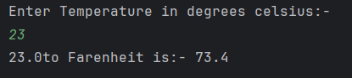

**Q4**

**CODE:**

package Q4;  
  
import java.util.*;  
  
public class Calories {  
 public static void main(String[] args) {  
  
 Scanner scanner=new Scanner(System.*in*);  
 System.*out*.println("Enter Your Body Weight:-");  
 double bodyweight=scanner.nextDouble();  
  
 double calories=bodyweight*19;  
  
 System.*out*.println("A Person needs "+calories +" Calories for his "+ bodyweight +" KG Body weight");  
 }  
}

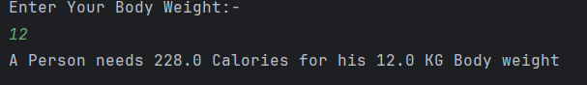

Q5

**CODE:**

package Q5;  
  
import java.util.*;  
  
public class Temparture {  
 public static void main(String[] args) {  
  
 Scanner scanner= new Scanner(System.*in*);  
 System.*out*.println("Enter Temperature in degrees Fahrenheit:-");  
 double Fahrenheit=scanner.nextDouble();  
  
 double celsius=((double) 5 /9)*(Fahrenheit-32);  
  
 System.*out*.println(Fahrenheit +"to Celsius is:- " + celsius);  
 }  
}

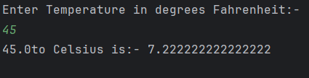

Q6

**CODE:**

package Q6;  
import java.util.*;  
import java.time.Year;  
  
public class year {  
  
 public static void main(String[] args) {  
 Scanner scanner=new Scanner(System.*in*);  
 System.*out*.println("Enter a year:- ");  
 int Byear=scanner.nextInt();  
  
 int currentyear=Year.*now*().getValue();  
  
 System.*out*.println("You were Born in " + Byear + " and will be "+ (currentyear-Byear) + " This year");  
 }  
}

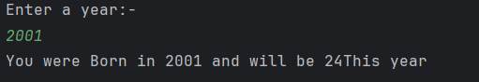

**Q7**

**CODE:**

package Q7;  
  
import java.util.*;  
  
public class BMI {  
 public static void main(String[] args) {  
 Scanner scanner=new Scanner(System.*in*);  
 System.*out*.println("Enter your weight:- ");  
 int w= scanner.nextInt();  
 System.*out*.println("Enter your height:- ");  
 int h= scanner.nextInt();  
  
 double formula=(double) h/100.0;  
 double BMI=(double) w / (formula*formula);  
  
 System.*out*.println("Your BMI IS "+ BMI);  
  
 }  
}

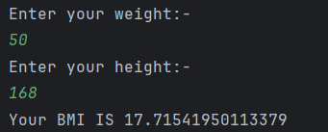

**Q8**

**CODE:**

package Q8;  
import java.util.*;  
  
public class Volume {  
 public static void main(String[] args) {  
  
 Scanner scanner = new Scanner(System.*in*);  
 System.*out*.print("Enter the radius of the sphere: ");  
 double radius = scanner.nextDouble();  
  
 final double PI=3.14;  
  
 double volume=(4.0/3.0)* (PI *(radius*radius*radius));  
  
 System.*out*.println("The Volume is " + volume);  
 }  
}



**Q9**

**CODE:**

package Q9;  
import java.util.*;  
  
public class Money {  
 public static void main(String[] args) {  
  
 Scanner scanner = new Scanner(System.*in*);  
  
 System.*out*.println("ENTER dollars:-");  
 double P=scanner.nextDouble();  
  
 System.*out*.println("ENTER Years:-");  
 double N=scanner.nextDouble();  
  
 System.*out*.println("ENTER Percentage:-");  
 double R=scanner.nextDouble();  
  
 double Investment = P*Math.*pow*((1+(R/100)),N);  
  
 System.*out*.println(" Money earned after N years :- " + Investment);  
 }  
}

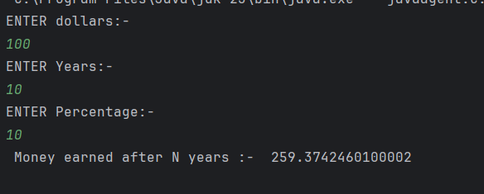

**Q10**

**CODE:**

package Q10;  
  
import java.util.*;  
  
public class Loan_Calculator {  
 public static void main(String[] args) {  
  
 int monthsinyear=12;  
  
 Scanner scanner = new Scanner(System.*in*);  
  
 System.*out*.println("Loan amount:-");  
 double loan_amount=scanner.nextDouble();  
  
 System.*out*.println("annual interest rate:-");  
 double annual_interest_rate=scanner.nextDouble();  
  
 System.*out*.println("loan period:-");  
 double loan_period=scanner.nextDouble();  
  
 double monthlyinterestrate=annual_interest_rate/100.0/monthsinyear;  
 double numberofpayments=loan_period*monthsinyear;  
 double monthlypayment=(loan_amount*monthlyinterestrate)/(1-Math.*pow*(1/(1+monthlyinterestrate),numberofpayments));  
 double totalpayment=monthlypayment*numberofpayments;  
  
 System.*out*.println("Monthly interest rate is :- " + monthlyinterestrate +"%");  
 System.*out*.println("Number of payments is :- " + numberofpayments );  
 System.*out*.println("Monthly Payment is :- " + monthlypayment +" rupees");  
 System.*out*.println("Total payment is :- " + totalpayment +" rupees");  
  
  
  
 }  
}

