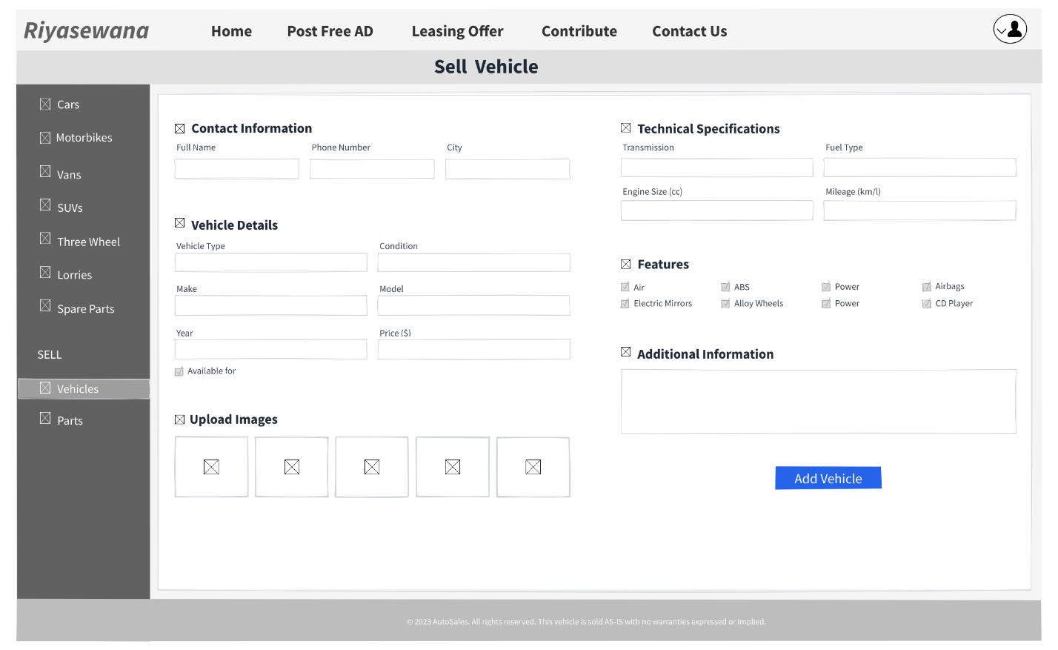
Vision 01 - Sell Vehicle P age
Vision 02 - Sell Vehicle Page
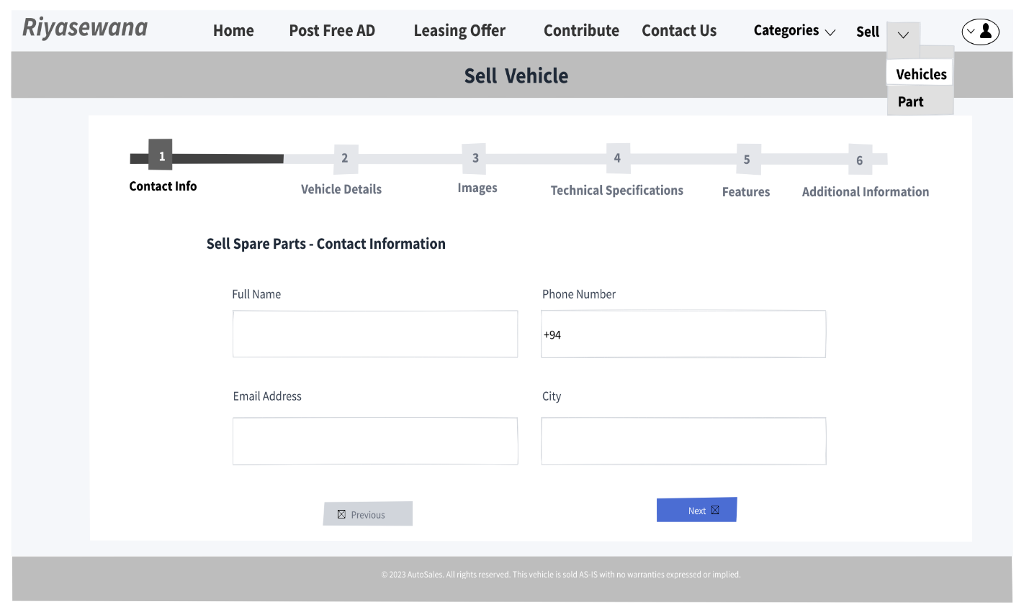
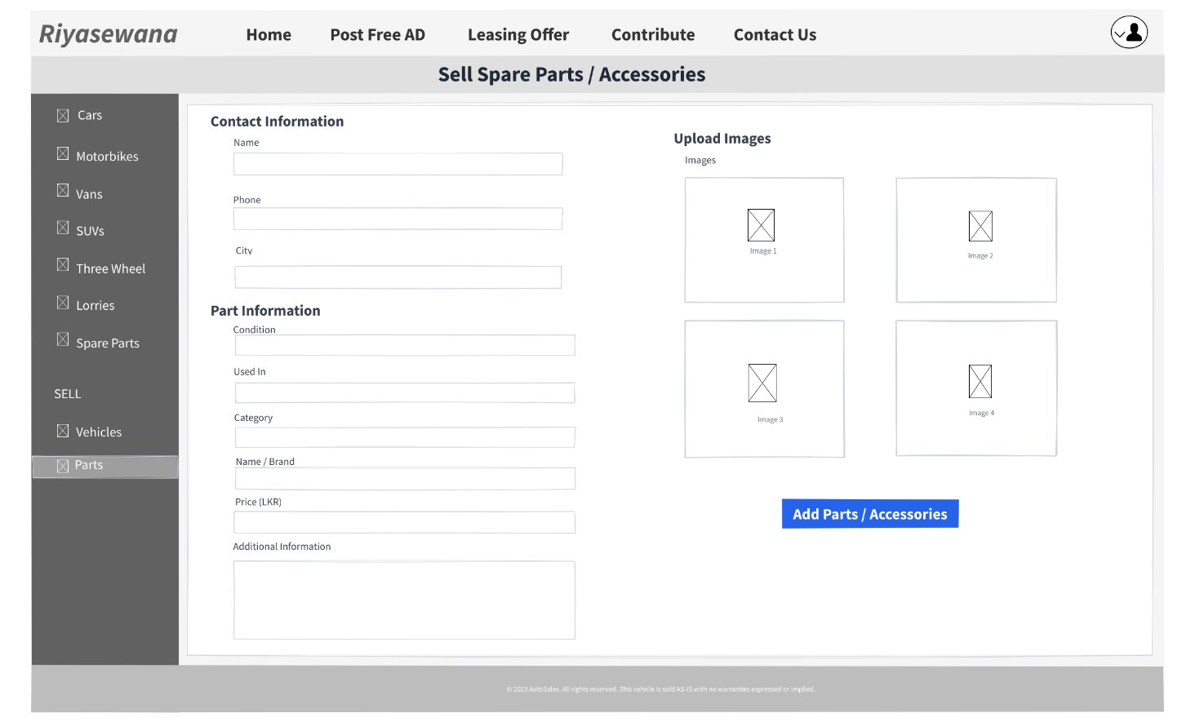
Vision 01 - Sell Part Page
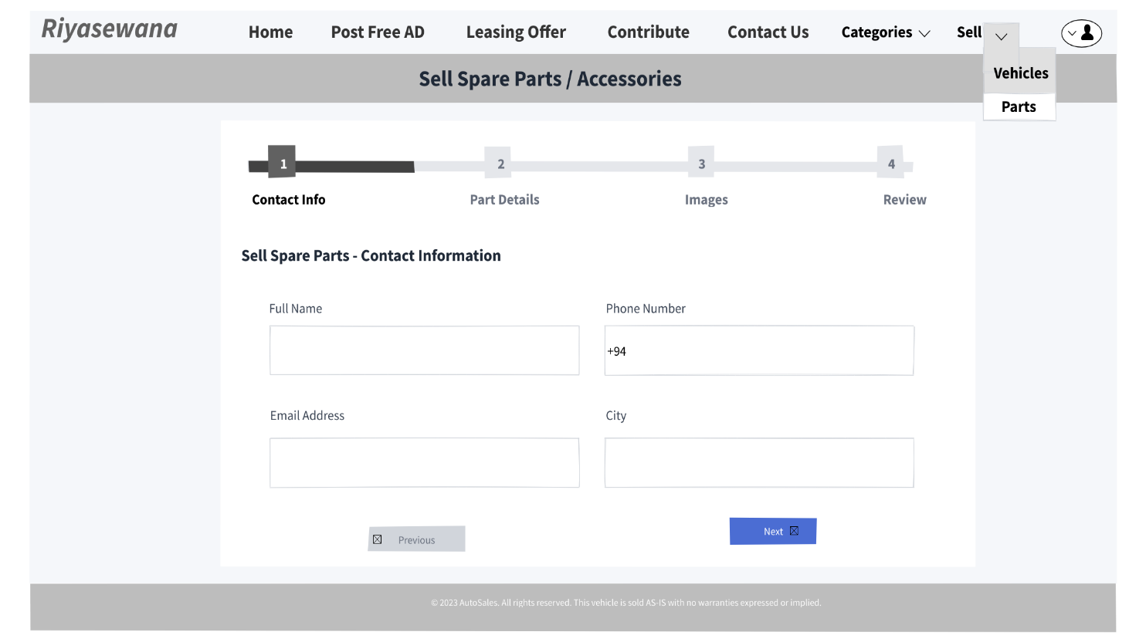
Vision 02 - Sell Part Page
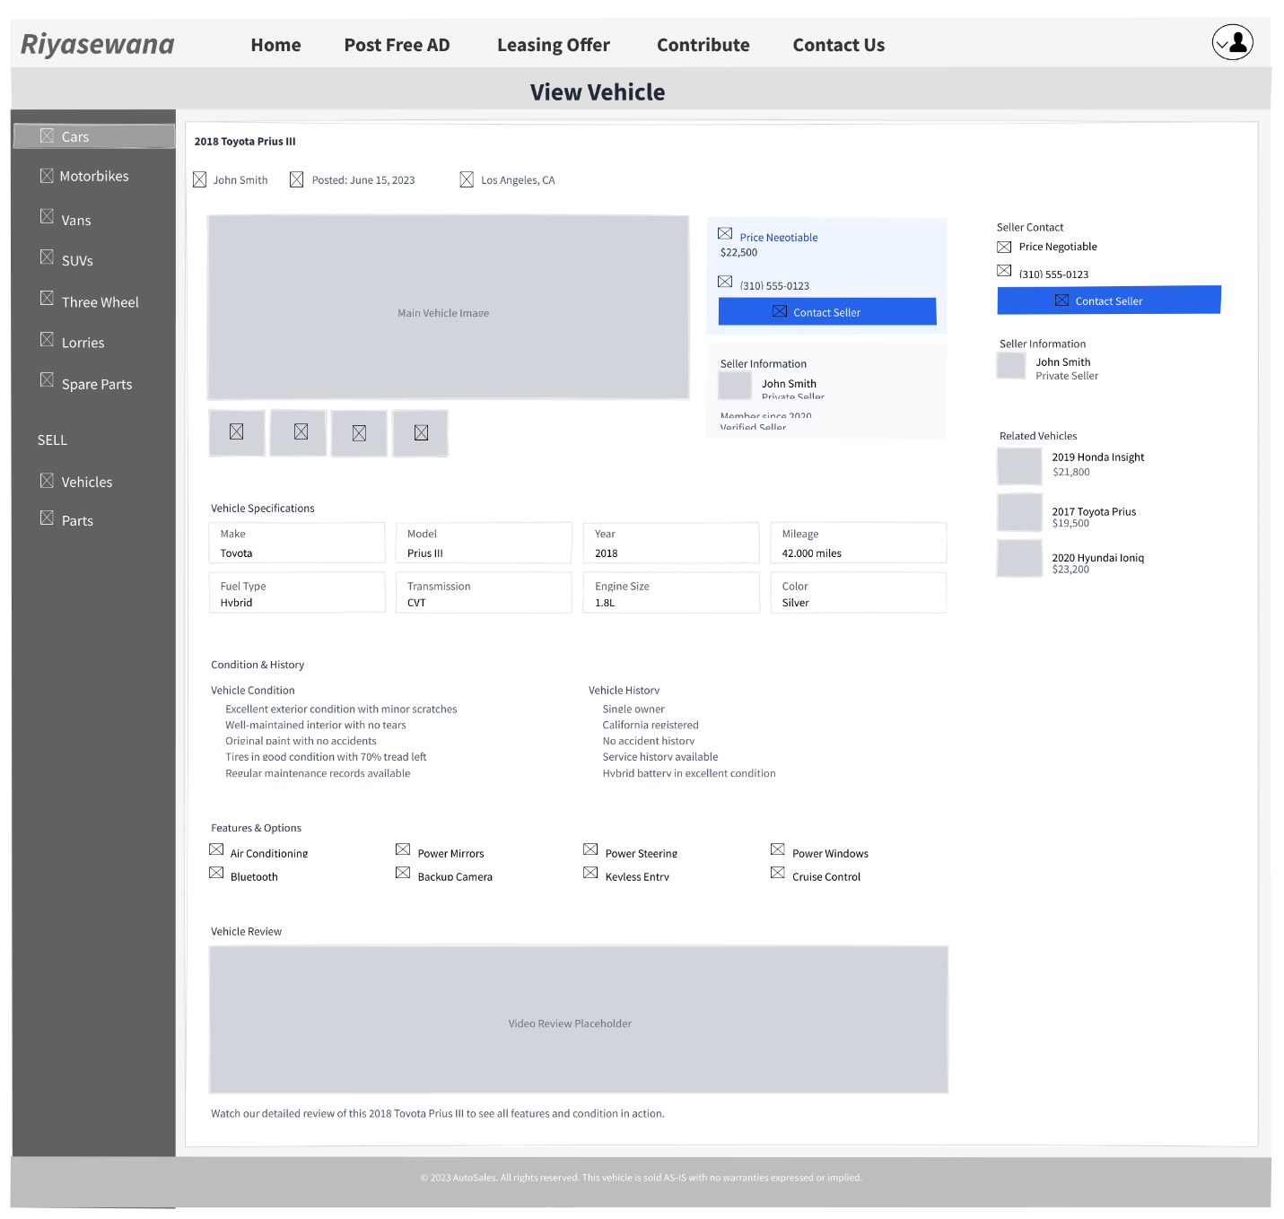
Vision 01 - View Vehicle Page

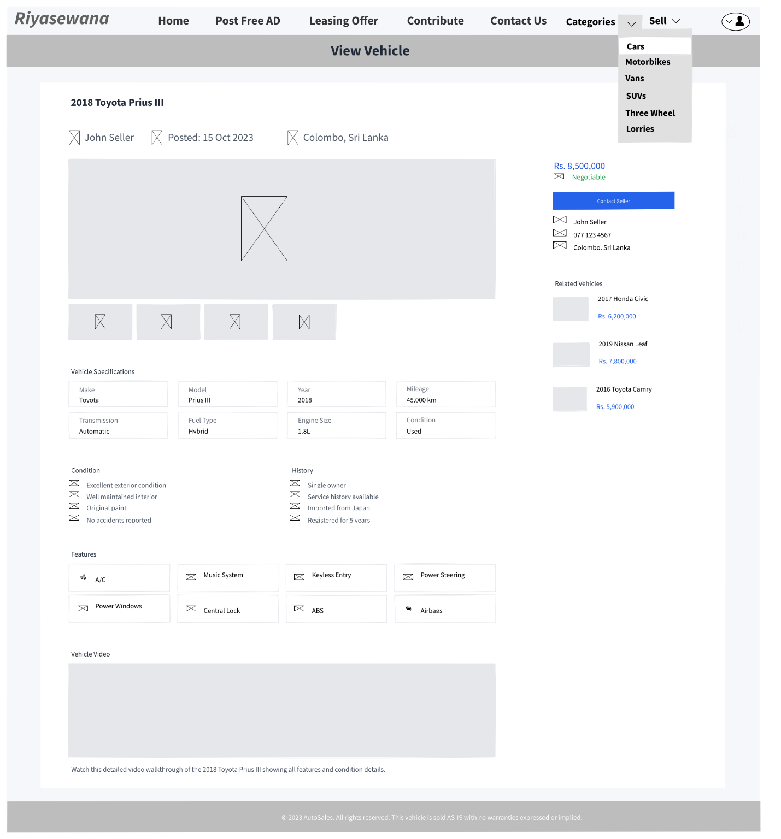
Vision 02 - View Vehicle Page

Interface Name | Justification of the variant 1 | Justification of the variant 2 | How the best design was selected
Sell Vehicle page | This variant uses a single-page layout that displays all form fields at once. This allows the user to see the entire scope of information required without any navigation, which can be efficient for users familiar with the process.  Pros  Provides a complete overview of all required information on a single screen.  Cons  The long, dense form can be overwhelming and intimidating, leading to higher abandonment rates.  Lacks guidance and progress indication, which can confuse new users. | This variant uses a multi-step form wizard. It breaks the complex task of listing a vehicle into smaller, manageable chunks (Contact Info, Vehicle Details, etc.), reducing cognitive load and making the process feel less daunting.  Pros  Dramatically reduces cognitive load and perceived effort for the user.  Includes a clear progress tracker (e.g., Steps 1-6) to motivate users.  Cons  Requires more clicks to navigate between steps.  Users cannot easily see all required information at a single glance. | Selected variant – Variant 2 Variant 2 is selected as the best design. The step-by-step approach is a modern UX standard that significantly improves user experience by guiding the user, providing clear progress indicators, and reducing the likelihood of form abandonment. It is less intimidating and more user-friendly than the dense, single-page form in Variant 1.
Sell Part page | This design uses a condensed, single-page form. It relies on checkboxes for category selection and presents all fields for part information and contact details in one view, assuming the user can efficiently process everything simultaneously.  Props  Very compact; all actions are contained on one page.  Cons  The checkbox-based category selection is less intuitive than a dropdown or a dedicated field.  The form layout is cluttered and lacks visual hierarchy, making it difficult to scan. | This variant applies the same successful multi-step principle from the Sell Vehicle V2 design to the parts listing process. It separates the task into clear stages (Contact Info, Part Details, Images, Review), creating a structured and guided user journey.  Props  Offers a clean, guided, and less cluttered experience.  Maintains consistency with the improved Sell Vehicle workflow.  Cons  Follows the same minor trade-off as the vehicle form: it requires navigation between steps. | Selected variant – Variant 2 Variant 2 is selected as the best design. Consistency with the Sell Vehicle flow creates a cohesive platform experience. The multi-step form is inherently superior for usability, making the task of listing a part feel simple and straightforward, even for users who are not tech-savvy. The checkbox interface in V1 is less intuitive.
View Vehicle page | This variant uses a multi-column layout that presents a large amount of information simultaneously. It emphasizes technical specifications and detailed condition history, catering to a user who wants to deeply analyze the vehicle's details without any navigation.  Props  Provides an immense amount of detail all in one place for thorough reviewers.  Cons  The layout is very busy and cluttered, making it difficult to find specific information quickly.  Poor visual hierarchy; critical elements like the price and contact button are not prominently featured. | This variant uses a more modern, single-column layout that prioritizes the most important information (price, seller contact, key specs) at the top. It uses visual hierarchy, whitespace, and sections to improve scannability and includes valuable features like "Related Vehicles."  Props  Excellent scannability; users can find key information (price, contact) in seconds.  Clean, modern design with better use of whitespace and typography.  The "Related Vehicles" section is a crucial feature for engagement and sales.  Cons  Does not display quite as much text-heavy information "above the fold" as V1. | Selected variant – Variant 2 Variant 2 is selected as the best design. It demonstrates a much stronger understanding of visual hierarchy, information architecture, and user goals. The layout is less cluttered, easier to read, and strategically organized to guide the user from critical buying decisions (price, contact) to supporting details. The addition of "Related Vehicles" is a key feature that V1 lacks.

