

INFORMATICS INSTITUTE OF TECHNOLOGY
In Collaboration with
UNIVERSITY OF WESTMINSTER

GamiLearn - AI guided Game Development Learning platform.

Project Proposal and Requirements Specification by
Mr. Kavindu Ashain Thihansa

Supervised by
Mr. Manul Singhe

Submitted in partial fulfilment of the requirements for the BSc in Computer Science degree at the University of Westminster.
November 2025
ABSTRACT
Game development is really catching on to teaching, and let’s be honest people want platforms that make learning JavaScript fun, especially if they’re just starting out. That’s where GamiLearn comes in. It runs right in your browser and takes you from zero to building your own games, both single-player and multiplayer. You’ll mess around with bots, dive into real-time features with Socket.IO, and tackle coding exercises that honestly feel more like playing than studying.
A lot of platforms out there, Codecademy comes to mind don’t really walk you through game development. They skip real-time AI help and just don’t make coding feel like a game. No wonder so many beginners give up. GamiLearn wants to flip the script. It’s built with React, Monaco Editor, and Node.js, so you get a super interactive coding space. There’s an AI companion ready to help when you’re stuck on stuff like canvas rendering or event handling (Phung et al., 2024).
Keywords
AI-guided learning; Game-based education; JavaScript programming; Large Language Models (LLMs); Adaptive tutoring; Gamification; Browser-based learning; Context-aware feedback; Educational technology; Intelligent tutoring systems (ITS); Socket.IO multiplayer; Human–AI collaboration
Subject Descriptors
- Computing methodologies → Artificial intelligence; Machine learning applications in education; Natural language processing.
- Software and its engineering → Interactive and visual development environments; Web-based development frameworks.
- Applied computing → Computer-assisted instruction; E-learning platforms; Game-based learning.
- Human-centered computing → Human–computer interaction (HCI); Usability studies; User modeling and personalization.
- Information systems → Web-based educational systems; Collaborative learning environments

DECLARATION
I hereby declare that the work presented in this Project Proposal and Requirements Specification (PPRS) is my own and has not been submitted, in whole or in part, for any other academic qualification or award.
All sources of information, literature, and external references used in the preparation of this document have been properly acknowledged and cited where applicable.
I take full responsibility for the integrity, originality, and authenticity of the work submitted in this proposal.
Name: Kavindu Ashain Thihansa
Student ID: W1998879
Date: 13th November 2025

ACKNOWLEDGEMENT
I would like to express my sincere gratitude to my project supervisor, Mr. Manul Singhe, for his continuous guidance, constructive feedback, and invaluable support throughout the development of this proposal. His expertise and mentorship greatly helped me refine my ideas and shape the direction of the GamiLearn project.
I also extend my appreciation to the Informatics Institute of Technology (IIT) and the University of Westminster for providing the academic environment, resources, and opportunities necessary to undertake this research.
Finally, I wish to thank my family and friends for their constant encouragement, patience, and understanding during this journey. Their support has been a tremendous source of motivation throughout the preparation of this work.

Contents
CHAPTER 01: INTRODUCTION 6
1.1 Chapter overview 6
1.2 Problem background 6
1.3 Problem definition 7
1.3.1 Problem statement 8
1.4 Research motivation 9
1.5 Existing work 9
1.6 Research gap 11
1.7 Contribution to body of knowledge 11
1.7.1 Problem domain contribution: 11
1.7.2 Research domain contribution: 12
1.8 Research challenges 12
1.9 Research questions 12
1.10 Research aim 13
1.11 Project scope 15
1.11.1 In scope 15
1.12 Hardware/Software requirements 16
1.12.1 Hardware requirement 16
1.12.2 Software requirements 17
CHAPTER 02: LITERATURE REVIEW 18
2.1 Chapter overview 18
2.2 Problem domain 18
2.2.1 Overview of AI guided programming education 19
2.2.2 Importance of AI coding companions in game development 19
2.2.3 Application areas 19
2.2.4 Challenges in AI guided game development education 20
2.2.5 Proposed architecture 20
2.3 Existing work 21
2.3.1 AI coding companions 21
2.5 Benchmarking and evaluation 23
2.5.1 Evaluation metrics for educational platforms 23
2.5.1.2 F1 Score and AUC ROC 24
2.5.1.3 Computational efficiency and processing time 24
2.5.2 Comparative analysis of existing models 24
2.5.2.1 Benchmarking studies 24
2.5.2.2 Real world performance and user experience 25
2.5.3 Challenges in benchmarking multimodal systems 25
2.6 Chapter summary 25
CHAPTER 03: METHANOLOGY 27
3.1 Chapter overview 27
3.3 Development methodology 28
3.3.1 Requirement elicitation methodology 29
3.3.2 Design methodology 29
3.3.3 Programming paradigm 30
3.3.4 Testing methodology 30
3.4 Project management methodology 31
3.4.1 Schedule 31
3.4.3 Resource requirements 32
3.4.4 Risk and mitigation 33
3.5 Chapter summary 34
Chapter 04: SOFTWARE REQUIREMENT SPECIFICATION 35
4.1 Chapter overview 35
4.2 Rich picture diagram 35
4.3 Stakeholder analysis 36
4.3.1 Stakeholder onion model 36
4.3.2 Stakeholder viewpoints 37
4.4 Selection of requirement elicitation methodologies 39
4.5.2 Survey findings 40
4.5.3 Brainstorming/Observation findings 44
4.6 Summary of findings 45
4.7 Context diagram 46
4.8 Use case diagram 47
4.9 Use case descriptions 47
4.10 Requirements 51
4.10.1 Functional requirements 52
4.10.2 Non-functional requirements 53
4.11 Chapter summary 54
References 55
APPENDIX A – USE CASE DESCRIPTIONS 57

List of Tables
Table 1: Existing Work 10
Table 2:Research Objective 14
Table 3:Hardware Requirement 18
Table 4:Software Requirement 18
Table 5: Existing Work 23
Table 6:Research Methodology 31
Table 7: Deliverables 35
Table 8: Risk and Mitigation 37
Table 9: Stakeholder Viewpoints 41
Table 10:Literature review findings 43
Table 11:Survey findings 44
Table 12:Brainstorming Findings 48
Table 13:Summary findings 49
Table 14: Use case description UC5 51
Table 15: Use case description UC6 52
Table 16: Use case description UC7 53
Table 17: Use case description UC8 54
Table 18: Use case description UC9 54
Table 19:Functional Requirements 56
Table 20:Non-functional requirements 57
Table 21: Use case description UC1 61
Table 22: Use case description UC2 62
Table 23: Use case description UC3 63
Table 24: Use case description UC4 64

List of Figures
Figure 1: Rich Picture Diagram 40
Figure 2:Stakeholder onion model 41
Figure 3:Context diagram 50
Figure 4:Use case diagram 51
Figure 5:Gantt Chart 58

List of Abbreviations
Abbreviation | Full Term
AI | Artificial Intelligence
LLM | Large Language Model
SRS | Software Requirements Specification
OOP | Object-Oriented Programming
NLP | Natural Language Processing

CHAPTER 01: INTRODUCTION

1.1 Chapter overview
This chapter explains the research project, which addresses the issues of teaching JavaScript game programming to beginners using an AI-powered, browser-based platform. It begins by describing the underlying problem, emphasizing the flaws in current instructional platforms that fail to provide structured, feedback-rich pathways from basics to playable games (Becker et al., 2023). The problem is then clearly defined, resulting in a one-sentence problem statement. The following parts address the research motivation, existing work, gaps, contributions, challenges, questions, aim, objectives, scope, hardware/software requirements, and chapter summary. The emphasis is on using AI-powered support, gamification, and modern online technologies to help students proceed smoothly from JavaScript fundamentals to designing single-player and real-time multiplayer games.

1.2 Problem background
With beginner-friendly syntax, accessibility, and language, JavaScript, future developments aren't a concern, where gameplay-based tasks are too easy, easier access for potential future developments, a syntax that will be crucial for future games, yet usable in cross-platform applications that will get more complex. Opportunities to learn through Codecademy, Udemy, and YouTube lessons often split courses into syllabically coded units with lackluster and vague responses to questions or intentions explored through meaning-measurable game achievements. Thus, novice learners fail to get captivated by impressive opportunities for self-learning through self-taught endeavors or believe the time spent on progress is not worth it for digestible concepts retained and usable progress and become discouraged over time. The novice dropout rate is notably high, where certain studies reveal that 41% of students who start coding courses never complete them (Kazemitabaar et al., 2023).
Several key factors make learning JS game development especially challenging for beginners:
- Lack of a structured roadmap: Many online platforms teach JavaScript fundamentals in isolation and fail to provide a coherent, project-based learning pathway that guides novices from basic syntax to creating complete, playable games. Without clear educational milestones such as planning game logic, designing core mechanics, prototyping interactive features, and iteratively refining gameplay, learners struggle to translate theoretical knowledge into practical, creative outcomes (Becker et al., 2023).
- Insufficient browser-based tooling: Few learning platforms include built-in browser editors with live previews and interactive hints. This limits learners’ ability to visualize outcomes and quickly iterate on their code (Gómez González & Ruiz Ariza, 2023).
- Underdeveloped AI and multiplayer support: Core game development concepts like creating AI bot opponents for single player modes or using Socket.IO for real-time multiplayer are rarely introduced in beginner curricula.
- Lack of personalization: Most courses follow a fixed structure that doesn’t adapt to different learning speeds or common novice errors, such as off-by-one loops or event mishandling in Socket.IO, leading to frustration and disengagement
This project takes a different approach. By using modern web tech, some AI help, and better teaching strategies, the goal is to build a platform where students can create, test, and share their own games. In the end, it’s about helping people build real skills and think like developers not just memorize code (Hijón Neira et al., 2023).

1.3 Problem definition
The project seeks to fill a significant gap in programming education. Currently, there is no clear, task-based pathway to help beginners transition from understanding JavaScript syntax to building functioning games. Most projects either have a loose coding "sandbox" or content that serves as a passive information-delivery model without feedback or practice. Consequently, many developers move forward without an understanding of the foundational concepts of game development, such as how bot logic works in single-player games or how client-server code works in multiplayer systems, leaving gaps in their understanding (i.e., a lack of conceptual and, if applicable, technical fluency). The absence of foundational knowledge adds to the experience of frustration, slow progression, and ultimately drop-out rates. In other words, the lack of foundational knowledge makes the learning experience unnecessarily complicated, as if it is too steep a hill to climb (Becker et al., 2023; Kazemitabaar et al., 2023). Three key elements of the suggested browser-based, AI-powered platform directly address these constraints:
- Progressive Modules: To create single-player games with AI opponents and, eventually, real-time multiplayer games using Socket.IO, learners gradually progress from JavaScript fundamentals like variables, loops, and event handling.
- AI coding partner: Using best practices from successful AI tutoring systems, an AI assistant driven by Large Language Models (LLMs) offers task-specific code recommendations, context-aware hints, and thorough error explanations.
- Gamification: In accordance with accepted game-based learning principles, the platform incorporates experience points (XP), achievement badges, and progress dashboards to sustain engagement and reward consistent learning (Zammit et al., 2022).
By combining these elements, the platform provides faster and more meaningful feedback, keeping learners motivated throughout the process. Ultimately, it enables beginners to gain practical, transferable skills by designing, coding, and deploying their own playable games.

1.3.1 Problem statement
Aspiring game developers in JavaScript are often not provided with a journey of iterative feedback that connects learning about syntax to building a playable game, whether single-player or real-time multiplayer. Without a structured approach, many developers overlook fundamental aspects of game development, such as game loops, state management, and the networked logic that underpins a multiplayer game. This gap leads to a lack of fundamental understanding of practical applications, as well as conception, causing aggravation, slow skill acquisition, and personal developer drop off. This platform directly addresses this gap by not only showing developers how to code, but also how their game systems and networked interactions function in practice.

1.4 Research motivation
Technically, creating an AI-powered platform for JavaScript game development instruction is difficult since browser-based coding environments require real-time, context-aware AI support. It takes advanced LLMs to find mistakes, provide hints, and adapt to individual learner patterns without overwhelming beginners, thereby striking a balance between pedagogical structure and personalization. A good approach might democratize game dev learning and encourage creativity and computational thinking in a variety of learners, which would be beneficial given the increasing demand for interactive online capabilities.

1.5 Existing work
The following table summarizes five highly relevant studies on AI-guided programming and game-based learning, highlighting their contributions and limitations in addressing gaps for novice game development education.
Table 1: Existing Work
Citation | Summary | Limitation | Contribution
Becker et al. (2023) | Reviewed how generative AI tools (e.g., ChatGPT, Copilot) are entering introductory programming education, proposing ethical frameworks and learner-centred use. | Primarily qualitative and theoretical; not focused on game development or visual learning tasks. | Provides an ethical and pedagogical basis for integrating AI tutoring in beginner-level programming.
Kazemitabaar et al. (2023) | Studied OpenAI Codex's impact on 69 Python learners via a platform with AI code generation for authoring and modification tasks. | It concentrated on simple activities, was limited to Python, and lacked game-specific features such as multiplayer. | AI tools have been shown to increase novice performance and retention, with 69 participants reporting learning gains.
Schmucker et al. (2024) | Developed Ruffle Riley, an LLM based conversational tutor for biology, adaptable to coding via script generation. | No significant learning gains over reading; adult focused, not game oriented. | Automated tutoring scripts with GPT 4, enhancing engagement in free form dialogues.
Zammit et al. (2022) | Created Art Bot, a game teaching ML via supervised and reinforcement learning mini games. | Low completion in advanced levels; not JS specific, focused on ML concepts. | Engaged 2k+ users in classroom AI literacy, with high teacher recommendation rates.
Panchanadikar & Freeman (2024) | Analyzed indie developers' views on generative AI for game creation, proposing design principles. | Qualitative, no implementation; risks to creativity without educational focus. | Highlighted AI's role in innovating workflows, based on 3k+ posts.
Kazemitabaar et al. (2024) | Deployed Code Aid, an LLM based assistant providing non solution feedback on a C programming course. | Single course focus; 21% error rate in hints, no integration with game dev workflows. | Balanced educator student needs, with 8k queries showing improved conceptual understanding.
Hijón Neira et al. (2023) | Quantitatively examined the impact of game-based learning on engagement in computer-science education. | Focused on traditional game-based learning without AI integration. | Validated that game-based environments raise motivation and participation.
Lehtonen et al. (2023) | Evaluated real-time feedback systems that visualize code execution to support learning. | Not AI-driven; limited to small-scale classroom trials. | Confirmed that live feedback and visual outputs reduce cognitive load and aid comprehension.

1.6 Research gap
Existing platforms like YouTube and Codecademy mostly provide static tutorials that lack interactive support and a clear roadmap for learning game development. While tools such as GitHub Copilot make coding easier, they often encourage dependency rather than true understanding of how code works (Kazemitabaar et al., 2023). Many existing game-based learning tools stop at introductory concepts and rarely explore JavaScript-specific game logic, multiplayer interactions, or bot systems essential components for modern browser-based games.
This project seeks to bridge that gap by helping learners go beyond passive coding. Instead of blindly following examples, learners are guided to understand how a game functions from its logic to its flow and build it with confidence. Through a structured, AI-assisted companion, the project offers a phased and supportive approach to learning, enabling users to create complete, browser-based games with both single-player and multiplayer features, while truly mastering the craft of game development.

1.7 Contribution to body of knowledge
This research contributes significantly to both the problem domain of JavaScript game development education and the research domain of AI-guided education.

1.7.1 Problem domain contribution:
This research contributes to the pedagogy of AI-assisted game development education by establishing a progressive, feedback-driven model for learning JavaScript through active creation.
Key contributions include:
- Introducing a structured roadmap from JavaScript fundamentals to AI-driven single- and multiplayer games.
- Demonstrating that AI-generated, context-aware hints improve learner engagement and reduce frustration.
- Integrating gamified motivation systems (XP, badges, dashboards) that enhance persistence and learning satisfaction.
- Offering a browser-native learning framework that allows scalable, accessible game development without specialized software.

1.7.2 Research domain contribution:
In AI guided education, the project advances the use of Large Language Models (LLMs) for context awareness and game specific tutoring. Unlike prior systems like Code Aid, which focused on general programming assistance (Kazemitabaar et al., 2024), this platform tailors LLM hints to game development tasks, incorporating error prediction and milestone driven guidance. It builds on conversational tutoring models (Schmucker et al., 2024) by embedding game-based learning principles, contributing novel insights into personalized, interactive education (Zammit et al., 2022).

1.8 Research challenges
The development of the proposed platform presents several technical and pedagogical challenges:
- Real time AI integration: Ensuring low latency, context aware feedback from LLMs within a browser-based environment is complex, requiring efficient processing to avoid delays that could disrupt learning (Roll & Wylie, 2024).
- Balancing guidance and independence: AI hints must support learning without providing complete solutions, a challenge noted in prior LLM based tutors where over reliance risks undermining skill development (Kazemitabaar et al., 2023).
- Personalization vs. structure: Adapting to diverse learner needs while maintaining a structured curriculum demands sophisticated AI models that can analyze individual error patterns without deviating from educational goals (Schmucker et al., 2024).

1.9 Research questions
The following questions guide the research, focusing on the platform’s scope and objectives:
RQ1 How can Large Language Models (LLMs) be optimized to deliver context aware hints for JavaScript game development tasks?
RQ2 What features and milestones best facilitate a seamless progression from JavaScript basics to building multiplayer games?
RQ3. How does the integration of gamification (XP, badges, progress tracking) influence learner motivation and retention in AI-guided coding environments?
RQ4. How can browser-based AI companions be implemented to balance autonomy, feedback accuracy, and engagement for novice game developers?

1.10 Research aim
The aim of this research is to analyze, design, develop, and evaluate an AI powered, browser based learning platform (GamiLearn) that enables novice programmers to progress seamlessly from JavaScript fundamentals to building playable single-player and Socket.IO-based multiplayer prototypes as learning outcomes, using context aware AI hints, bot driven opponents, and gamified progression to enhance engagement, reduce frustration, and improve skill retention.
1.11 Research objectives
Table 2:Research Objective
Objectives | Research Objective | Description | LOs | RQs
Problem Identification | RO1: To identify gaps in JavaScript game development education. | Analyze current platforms to pinpoint deficiencies in AI guidance, structured progression and game specific learning. | LO1, LO4 | RQ1
Literature Review | RO2: To conduct a comprehensive review of AI in programming education. | Examine studies on LLM based tutors and game-based learning to inform platform design. | LO1, LO4 | RQ1, RQ2
 | RO3: Review game-based learning and technologies | Examine gamification, AI bot driven systems, and web technologies for enhancing coding education (Zammit et al., 2022). | L01, L04 | RQ2, RQ3
Requirement Elicitation | RO4: To identify stakeholders and elicitation methods. | Gather needs from learners and educators through surveys to define platform requirements. | LO3, LO6 | RQ2
 | RO5: Gather user requirements via elicitation methods | Collect specific user needs for a feedback rich, gamified platform using surveys and interviews (Saunders et al., 2019). | LO3, LO6 | RQ2, RQ3,  RQ4
System Design | RO6: To design the platform architecture. | Develop a framework integrating frontend (React, Monaco Editor), backend (Node.js) and AI components. | LO2, LO7 | RQ1, RQ2
 | RO7: Design AI hint generation system | Create a system for context awareness, low latency AI hints tailored to game development tasks (Phung et al., 2024). | LO2, LO7 | RQ4
Implementation | RO8: To build phased learning modules and AI companion. | Implement modules for JavaScript basics, single player games with bots and multiplayer games with Socket.IO. | LO5, LO7 | RQ2, RQ3
 | RO9: Implement AI companion and gamification | Develop AI driven hint system and gamified features (e.g., XP, badges) for engagement (Zammit et al., 2022). | LO5, LO7 | RQ1, RQ3,  RQ4
Testing | RO10: To assess platform usability and effectiveness. | Evaluate user experience, learning gains and engagement through testing with novice learners. | LO4, LO8 | All
Documentation | RO11: To document development processes and findings. | Compile detailed documentation of the platform, code and evaluation results. | LO1, LO8, LO9 | All

1.12 Project scope

1.12.1 In scope
A web-based platform for learning JavaScript game development is the project's focus. It covers the following topics:
- Fundamentals: variables, loops, functions and event handling for JS Beginners.
- Single player games brief, playable games with AI powered bot opponents.
- Multiplayer games WebSocket are used to synchronize real time games like Tic Tac Toe.
- AI companion gives suggestions, error explanations and context aware hints.
- Gamification dashboards for tracking progress, badges and XP points.
- Interface Editor that runs in a browser and offers live previews for the game.
1.12.2 Out scope
- The project doesn't utilize cutting-edge game engines like Phaser, Unreal, or Unity. Pay particular attention to lightweight libraries and standard JavaScript.
- Non-English interfaces or mobile optimization
- Specialized fields that call for extra equipment and knowledge, such as 3D, virtual reality, or non-web-based game development.
- Realtime AI Error prediction for the system.

1.13 Hardware/Software requirements
This section outlines the hardware and software requirements for developing, testing and evaluating the AI powered, browser-based platform for JavaScript game development education. The hardware specifications support the development environment and lightweight model training for the AI companion, while the software tools facilitate coding, multiplayer functionality and documentation. These requirements ensure efficient development and scalability within browser constraints.

1.13.1 Hardware requirement
Table 3:Hardware Requirement
Component | Specification | Purpose
CPU | Ryzen 5 5600H (6 cores, 12 Threads, 3.31 GHz) | Supports development and running the backend and frontend, ensuring efficient local hosting and debugging.
RAM | 16 GB | Facilitates smooth operation of development tools browser based testing and simultaneous execution of frontend, backend and AI components.
GPU | AMD Radeon RX6600M  (8GB V-Ram) | Dedicated GPU suffices for browser-based rendering and AI inference.
Network | Stable internet | Enables access to cloud-based APIs for LLM integration.
Storage | 1TB SSD | Provides sufficient capacity and speed for storing lecture datasets, model weights, and multimedia assets.

1.13.2 Software requirements
Table 4:Software Requirement
Software/Tool | Purpose
Node.js | Backend server for hosting lessons and integrating AI Models.
React | Frontend framework for building an interactive user interface with real time code editing and game previews.
Socket.IO | Enables real time communication for multiplayer game features (e.g., Tic Tac Toe synchronization).
Git | A version control system is used to manage project source code and track changes.
Postman | API development and testing tools are used to verify backend endpoints, test data exchange between the frontend and backend.
Monaco Editor | In a browser code editor for JavaScript, providing syntax highlighting, autocompletion
Jest | Unit and integration testing for JavaScript components, ensuring robust functionality of game modules and AI feedback.

1.14 Chapter summary
This chapter discussed how to teach learners the way to develop JavaScript games. It focused on how there aren't many platforms that are flexible and give a lot of feedback to beginners. It identified deficiencies in AI driven, game specific learning by delineating the issue, justifying the inquiry and reviewing prior research. The presentation of contributions, problems, research questions, aim, objectives, scope and requirements established the framework for the subsequent chapters on methodology, design and implementation. The proposed platform encourages research and teaching by combining gamification, AI support and modern web tools to let students make games that can be played.

CHAPTER 02: LITERATURE REVIEW

2.1 Chapter overview
This chapter takes a deep dive into how AI is being used to support programming education, especially through gamified learning platforms and web-based game tools. The focus is mainly to help beginners learn JavaScript game development. It starts by looking at the key challenges that new learners face like finding clear learning paths and staying motivated. Then it reviews past research and groups it into themes such as AI coding assistants, game-based learning approaches, and multimodal learning systems. The chapter also examines the tech side of things including how datasets are chosen, how data is preprocessed, and what benchmarks are used to measure learning outcomes. It wraps up by summarizing the main insights and pointing out research gaps that the proposed GamiLearn platform aims to fill like the lack of complete learning pipelines for JavaScript multiplayer games and fine-tuned AI hint systems (Becker et al., 2023). The review mainly covers studies published between 2020 and 2025, focusing on peer reviewed papers from ACM, IEEE, Springer, and MDPI, found through Google Scholar to ensure both range and reliability.

2.2 Problem domain
The problem area focuses on the challenges of teaching JavaScript game development to beginners. Many students struggle because existing learning materials are scattered, feedback isn’t instant, and engagement tends to drop off quickly leading to dropout rates as high as 50% and poor transfer of skills to real projects (Kazemitabaar et al., 2023). Although JavaScript is one of the best languages for beginners especially since it powers browser based interactive apps, most current platforms still don’t guide learners’ step by step from basic to building playable single player or multiplayer games. Essential features like AI driven opponents or real time multiplayer using Socket.IO are often missing. While AI is starting to make learning more personalized, there’s still a noticeable gap when it comes to combining gamification and context aware AI hints that can help with real coding challenges, such as canvas rendering or event handling (Schmucker et al., 2024).

2.2.1 Overview of AI guided programming education
AI guided programming education uses Large Language Models (LLMs) to make learning more interactive and personalized. Instead of following static lessons, students receive adaptive guidance that mimics real human tutoring (Becker et al., 2023) like YouTube. In the context of JavaScript game development, this means learners can get real time hints while connecting code to visual game elements helping them bridge the gap between basic syntax and actual project building. Research shows that AI powered tools can boost task efficiency by around 20%, although their specific use in game mechanics and design tasks is still limited (Kazemitabaar et al., 2023).

2.2.2 Importance of AI coding companions in game development
AI coding partners, such as those driven by Codex or GPT 4, are quickly emerging as essential resources in educational settings. In game creation, when immediate visual feedback such as watching a game loop in action is crucial, they can offer live debugging support, rectify problems, and recommend code snippets (Kazemitabaar et al., 2024). By recommending common structures like Socket.IO event handlers or bot logic, these companions lessen cognitive load and free up students' time to concentrate on creative tasks rather than tedious debugging (Panchanadikar & Freeman, 2024). They are also perfect for self-paced learners who might not have access to sophisticated settings because of their smooth browser integration (Roll & Wylie, 2024).

2.2.3 Application areas
AI guided platforms are transforming web-based learning by making it easier to prototype and test ideas without complicated setup. This approach supports a wide range of learners from high school students exploring coding for the first time to hobbyists developing small interactive projects (Gómez González & Ruiz Ariza, 2023). The applications include classroom tools for teaching computational thinking and online environments for building personal portfolios through hands on game creation.

2.2.3.1 Security sensitive applications
In multiplayer game simulations, AI platforms use secure sandbox environments to prevent code injection and protect users during Socket.IO sessions. This setup allows students to safely experiment with real time multiplayer code while also learning best practices for secure programming a critical skill when dealing with user generated content (Becker et al., 2023).

2.2.3.2 User privacy and convenience
Privacy aware systems often process AI hints locally or through encrypted APIs, keeping user data secure while maintaining a smooth browser-based experience. This is particularly beneficial for global learners who may not have access to powerful devices or stable network conditions.

2.2.4 Challenges in AI guided game development education
While AI has made learning more accessible, several challenges remain especially when it comes to accuracy, scalability, and adapting to different learning styles (Roll & Wylie, 2024).

2.2.4.1 Intrusiveness and user experience
AI generated hints can sometimes interrupt a learner’s flow. Systems like Coded have achieved between 74 – 87% accuracy in hint quality, but around 21% of the suggestions are still misleading or irrelevant. This highlights the need for better user centered design tailored to game specific coding tasks (Kazemitabaar et al., 2024).

2.2.4.2 Scalability and real time requirements
Handling real time multiplayer hints for thousands of users at once is a major scalability challenge. Achieving low latency responses requires optimized and lightweight AI models capable of fast parallel processing (Phung et al., 2024).

2.2.4.3 Robustness to learner variability
Learners often make unique mistakes, for example, off by one error in game loops or incorrect Socket.IO event handling. AI systems must be flexible enough to detect and adapt to these differences without bias. However, current LLMs still struggle to generalize across varied coding styles, indicating a need for fine tuning models specifically for JavaScript game development contexts (Schmucker et al., 2024). Ensuring robustness is key to providing fair and effective learning experiences for all users.

2.2.5 Proposed architecture
To overcome these limitations, the proposed architecture combines three main layers. The frontend layer uses React and the Monaco Editor to create an interactive coding interface with live game previews. The backend layer runs on Node.js to handle lessons, Socket.IO to multiplayer connections, and real time synchronization. Finally, the AI layer integrates an LLM to generate adaptive, context aware hints in real time. This modular setup ensures scalability, security, and personalized feedback (Hijón Neira et al., 2023; Roll & Wylie, 2024). The system also supports a structured learning path that starts with JavaScript fundamentals and gradually builds up to single player games with AI opponents and full multiplayer implementations filling key gaps found in existing platforms.

2.3 Existing work
This section critically evaluates existing research on AI guided programming and game-based learning, categorized by key modalities of assistance. The literature survey table below summarizes 8 high impact papers (2020–2025) with full access, focusing on the pipeline for AI powered educational platforms:
- Data Acquisition (learner interactions/code inputs),
- Feature Extraction (contextual patterns),
- Model Training/Integration (LLM fine tuning),
- Feedback Generation (hints/output)
- Evaluation (user studies/metrics).
Table 5: Existing Work
Approach / Technique | Citation | Summary | Methodology | Limitations | Results
Generative AI tutoring in programming | Becker et al. (2023) | Reviewed how generative AI (ChatGPT, Copilot) supports novice programmers and proposed ethical guidelines for AI-assisted pedagogy. | Systematic literature review and expert interviews. | Conceptual only; lacks empirical validation in game-based contexts. | Established ethical and pedagogical frameworks for AI tutors in early programming courses.
AI-code generation for novices | Kazemitabaar et al. (2023) | Investigated OpenAI Codex effects on 69 learners performing authoring and modification tasks. | Experimental user study with pre-/post-test survey design. | Focused solely on Python; no game-logic or visualization tasks. | Reported 20 % increase in task completion and positive learner sentiment toward AI guidance.
LLM-based tutoring system (CodeAid) | Kazemitabaar et al. (2024) | Evaluated the classroom deployment of an LLM tutor providing non-solution hints. | Mixed-methods field study across 3 intro-courses. | 21 % hint error rate; limited adaptation to learner intent. | Balanced educator–student needs, showing higher conceptual understanding with AI scaffolding.
Conversational AI tutoring | Schmucker et al. (2024) | Developed Ruffle & Riley, a conversational GPT-4 tutor supporting adaptive dialogue. | Iterative design-based research and usability trials. | Domain limited (biology); no integration with coding environments. | Validated design principles for adaptive conversation and learner engagement.
Game-based AI literacy | Zammit et al. (2022) | Created ArtBot, gamified mini-games teaching machine-learning principles. | Classroom deployment with 2 000 students; quantitative surveys. | Focused on ML concepts, not programming or JavaScript. | Demonstrated strong motivation (4.2 / 5 satisfaction) but reduced persistence in advanced levels.
Generative AI for game creation | Panchanadikar & Freeman (2024) | Explored indie developers’ use of generative AI for creative workflows. | Qualitative thematic analysis of 3 000 online forum posts. | Non-educational; lacks implementation or learner testing. | Proposed design principles for integrating AI into creative game workflows.
Game-based learning in CS education | Hijón Neira et al. (2023) | Studied game-based methods to increase engagement in computer-science classes. | Quantitative quasi-experimental classroom study. | Traditional game-based activities; no AI or adaptive feedback. | Reported significant gains in engagement and attendance compared to control groups.
Real-time feedback visualization | Lehtonen et al. (2023) | Analyzed live code-preview tools that show program execution and errors in real time. | Controlled experiment with student participants using a feedback prototype. | Not AI-driven; limited scalability. | Found that visual feedback reduced cognitive load and improved code-comprehension accuracy.

2.3.1 AI coding companions
AI coding companions, such as Codex and Copilot, excel in providing hints and code suggestions, improving task completion rates by up to 20% in Python courses (Kazemitabaar et al., 2023, 2024). However, their focus on general programming limits applicability to JavaScript game development, where visual feedback (e.g., canvas updates) is critical. Critically, these systems risk over reliance, as learners may accept suggestions without understanding and 21% hint errors in CodeAid highlight prompt quality issues (Kazemitabaar et al., 2024). Neural network based LLMs offer robust pattern recognition but struggle with real time constraints in browser environments, unlike lightweight decision-making trees that prioritize speed but lack depth for complex game logic (Phung et al., 2024).
2.3.2 Game Based learning approaches
Game based platforms like ArtBot engage learners through interactive mini games, achieving high satisfaction (4.2/5) but suffer from low completion in advanced levels due to repetitive mechanics (Zammit et al., 2022). These systems focus on conceptual learning (e.g., ML literacy) rather than coding skills, limiting their relevance to JavaScript game development. Critically, they lack integration with real time coding environments and browser compatibility issues hinder scalability (Zammit et al., 2022). Neural networks in game feedback systems enhance engagement but require optimization for low latency browser rendering, a gap unaddressed in current studies (Schmucker et al., 2024).
2.3.3 LLM integration for feedback
LLM based feedback systems, like those in CodeAid and Ruffle&Riley, provide non solution hints to foster understanding, with CodeAid achieving 74–87% hint accuracy (Kazemitabaar et al., 2024; Schmucker et al., 2024). However, their reliance on prompt engineering leads to errors and they lack game specific scaffolding, such as collision detection or Socket.IO event handling. Decision trees, as explored in Wang et al. (2025), offer faster error classification but falter on complex codebases, whereas hybrid LLMs balance accuracy and speed but demand fine tuning for game contexts. Critically, these systems underexplore visual feedback integration, essential for game development education.
2.3.4 Multimodal combinations (AI + Gamification)
Multimodal systems combining AI feedback with gamification, as in ArtBot and Apprentice Tutor Builder, enhance engagement but show mixed learning outcomes (Zammit et al., 2022; Roll & Wylie, 2024). ArtBot’s mini games improve motivation but lack coding depth, while Ruffle&Riley’s conversational tutoring shows no significant gains over traditional methods (Schmucker et al., 2024). Critically, these systems rarely integrate code editing with visual game outputs or multiplayer features, limiting their applicability to JavaScript game development. The absence of end-to-end roadmaps from basics to multiplayer games remains a critical gap, necessitating a tailored approach (Panchanadikar & Freeman, 2024).
2.4 Technological review
This section examines the core technologies enabling GamiLearn, a browser-based platform for JavaScript game development education, focusing on Large Language Models (LLMs) for context aware hint generation, web frameworks (React, Monaco Editor, Node.js, Socket.IO) for interactive and multiplayer functionality, and data management for learner engagement and progression (Kazemitabaar et al., 2024; Hijón Neira et al., 2023). These technologies address the need for scalable, low latency feedback and gamified learning experiences, supporting the development of a phased curriculum from JavaScript basics to multiplayer games (Roll & Wylie, 2024; Zammit et al., 2022). The review draws on recent studies (2020–2025) from Google Scholar to inform GamiLearn’s design, ensuring compatibility with browser-based constraints and learner centric goals (Phung et al., 2024).

2.5 Benchmarking and evaluation
This section benchmarks AI guided programming platforms and game-based systems against criteria critical for GamiLearn, including hint accuracy, learner engagement, task completion rates, and browser-based latency, to assess their suitability for JavaScript game development education (Roll & Wylie, 2024). Drawing on studies (2020–2025) from Google Scholar, it compares models like CodeAid and ArtBot, identifying gaps in scalable, gamified hint systems for multiplayer game tasks (Kazemitabaar et al., 2024). The analysis supports the evaluation of GamiLearn’s effectiveness in delivering low latency, engaging feedback for novice learners (Phung et al., 2024).

2.5.1 Evaluation metrics for educational platforms
Evaluation metrics quantify GamiLearn’s ability to deliver effective AI hints, support curriculum progression, and enhance engagement through gamification, using quantitative and qualitative data from user studies and interaction logs (Phung et al., 2024; Lehtonen et al., 2023).
2.5.1.1 Accuracy, precision, and recall
Accuracy measures the correctness of AI generated hints, with CodeAid achieving 74–87% for programming tasks, setting a benchmark for GamiLearn’s hints in game contexts like Socket.IO synchronization (Kazemitabaar et al., 2024). Precision ensures hints target specific learner errors, such as incorrect canvas rendering calls, minimizing irrelevant suggestions that could overwhelm novices (Becker et al., 2023). Recall captures the proportion of relevant issues addressed, critical for reducing frustration in complex multiplayer modules where learners face challenges like event handling errors For GamiLearn, high precision is vital to provide actionable guidance for tasks like implementing game loops, ensuring learners receive focused feedback without excessive handholding (Phung et al., 2024). Recall is equally important to ensure the AI companion addresses most learner mistakes, such as missing Socket.IO event listeners, to support progression through game development milestones (Schmucker et al., 2024). These metrics collectively evaluate platform reliability, enabling GamiLearn to deliver effective educational outcomes by balancing hint specificity and coverage in browser-based environments (Zammit et al., 2022).

2.5.1.2 F1 Score and AUC ROC
F1 score balances precision and recall, with Codex reporting 0.85 for task completion in introductory programming, applicable to GamiLearn’s hint effectiveness in game progression (Kazemitabaar et al., 2023). AUC ROC assesses the platform’s ability to distinguish engaged learners from dropouts, measuring gamification’s impact on retention in AI bot driven single player games. These metrics ensure a balanced assessment of curriculum and AI features, supporting engagement analysis (Zammit et al., 2022; Creswell & Creswell, 2023).

2.5.1.3 Computational efficiency and processing time
Computational efficiency evaluates resource usage for LLM hint generation, in browser environments for seamless multiplayer interactions, as achieved by lightweight models like GPT 3.5 (Roll & Wylie, 2024). Processing time benchmarks scalability for gamified dashboards, where delays disrupt learner flow in tasks like real time game previews. This metric highlights the need for optimized technologies like Node.js and Socket.IO to maintain efficiency (Phung et al., 2024; Larman, 2005).

2.5.2 Comparative analysis of existing models
Comparative analysis contrasts models like CodeAid (AI hints) and ArtBot (gamification) on accuracy, engagement, and scalability, revealing strengths in general programming but gaps in JavaScript game specific features (Kazemitabaar et al., 2024). This informs GamiLearn’s hybrid approach, combining AI driven feedback with gamified curricula.

2.5.2.1 Benchmarking studies
Benchmarking studies show CodeAid outperforming Codex in ethical hint delivery (74% accuracy vs. 90% speed but higher over reliance risk), yet both lack multiplayer game integration (Kazemitabaar et al., 2023, 2024). ArtBot’s gamified mini games achieve high satisfaction (4.2/5) but low completion in advanced levels, underscoring the need for structured JavaScript curricula (Zammit et al., 2022). These studies, using metrics like F1 score (0.85 for Codex), highlight the need for low latency, game focused evaluations in GamiLearn (Phung et al., 2024; Ericson et al., 2023).

2.5.2.2 Real world performance and user experience
CodeAid improves conceptual understanding via 8,000 queries, but browser latency issues persist for interactive tasks (Kazemitabaar et al., 2024). ArtBot excels in engagement but falters in coding depth, with surveys indicating dropout due to repetitiveness (Zammit et al., 2022). This analysis emphasizes gamification’s role in retention, guiding GamiLearn to integrate AI hints with real time previews for enhanced satisfaction (Schmucker et al., 2024; Bryman, 2016).

2.5.3 Challenges in benchmarking multimodal systems
Benchmarking multimodal systems (AI hints + gamification + web tech) faces challenges like data variability from diverse learner styles, complicating standardized metrics for JavaScript game tasks (Becker et al., 2023). Short term studies (e.g., 3 weeks in Kazemitabaar et al., 2023) overlook long term retention, and browser specific metrics (e.g., Socket.IO latency) are underexplored, hindering scalability evaluation. These challenges necessitate hybrid metrics (F1 score + user surveys) for GamiLearn, ensuring comprehensive, longitudinal assessments (Roll & Wylie, 2024; Saunders et al., 2019; Margulieux et al., 2024).

2.6 Chapter summary
This chapter reviewed the potential of LLMs in companions and game-based systems while also criticizing limitations like hallucinations and a lack of JS specific progression in AI guided programming education (Kazemitabaar et al., 2024). One of the key findings is that adaptive hints improve retention; however, there are shortcomings with browser integrated multiplayer and end to end game roadmaps. The project proposes a phased, enhanced AI platform that provides novice game developers to address these issues (Schmucker et al., 2024; Zammit et al., 2022).
Accuracy measures the correctness of AI generated hints, with CodeAid achieving 74–87% for programming tasks, setting a benchmark for GamiLearn’s hints in game contexts like Socket.IO synchronization (Kazemitabaar et al., 2024). Precision ensures hints target specific errors (e.g., canvas rendering issues), while recall captures the proportion of relevant issues addressed, reducing frustration in multiplayer modules

CHAPTER 03: METHANOLOGY

3.1 Chapter overview
This chapter outlines the methodology for developing GamiLearn, a browser-based platform designed to teach JavaScript game development to novices through a structured, phased curriculum, AI-guided hints, AI-bot-driven single-player modules, and lessons that teach real-time multiplayer implementation using Socket.IO. The development methodology details requirement elicitation, implementation of learning modules and gamification features, and testing for usability and performance (Kazemitabaar et al., 2024; Larman, 2005). The project management methodology defines the scope, a 6-month timeline (Aug 2025 – April 2026), resource requirements, and risk mitigation strategies to ensure timely delivery of a scalable, user centric platform (Creswell & Creswell, 2023). This chapter provides a comprehensive framework to achieve the project’s objectives, addressing gaps in AI guided, game-based coding education while ensuring accessibility and engagement for novice learners.
3.2 Research methodology
The research methodology follows Saunders' Research Onion, adapted to GamiLearn’s goals of developing a scalable, AI guided educational platform. The table below details each layer, choice, and justification, ensuring alignment with the project’s objectives and requirements.
Table 6:Research Methodology
Layer | Choice | Justification
Philosophy | Pragmatism | Combines quantitative (e.g., LLM hint accuracy, completion rates) and qualitative (e.g., user satisfaction) methods to address diverse stakeholder needs (Bryman, 2016).
Approach | Deductive | Tests hypotheses about AI hint effectiveness, curriculum progression, and gamified engagement (e.g., “AI hints reduce error correction time by 20%”) using structured experiments (Saunders et al., 2019).
Methodological Choice | Mixed Methods | Integrates quantitative metrics (e.g., hint accuracy, latency) with qualitative feedback (e.g., user interviews) to evaluate platform performance and learner experience (Creswell & Creswell, 2023).
Strategy | Experimentation, Surveys, Interviews | Experiments test AI and bot functionality; surveys and semi structured interviews gather stakeholder requirements and usability feedback (Kazemitabaar et al., 2024).
Time Horizon | Cross sectional | A single snapshot captures learner interactions and platform performance during a 6-month development cycle, suitable for iterative testing (Bryman, 2016).
Data Collection | Primary (logs, surveys, interviews), Secondary (public datasets, literature) | Primary data from user interactions (code logs, engagement metrics) and secondary data from datasets like Evo CodeBench ensure robust LLM training and requirement elicitation (Wang et al., 2025).

3.3 Development methodology
Several established development methodologies exist; each suited to different project types and constraints. The Waterfall model follows a linear, sequential process with distinct phases (requirements, design, implementation, testing, deployment), ideal for projects with fixed scope and minimal changes (Larman, 2005). SCRUM, an Agile framework, uses short sprints (2–4 weeks), daily stand ups, and iterative delivery to support evolving requirements and frequent feedback. Iterative development involves repeated cycles of prototyping, testing, and refinement, allowing progressive enhancement. Agile as a broader philosophy emphasizes flexibility, collaboration, and customer satisfaction through continuous delivery.
For GamiLearn, the chosen methodology is Agile with SCRUM, implemented through 2-week sprints. This choice is justified by the project’s dynamic nature: user requirements (e.g., hint style, gamification features) are expected to evolve based on early prototypes and learner feedback. Agile enables rapid iteration on the AI companion, bot logic, and the teaching modules that demonstrate multiplayer synchronization. Unlike Waterfall, which risks late discovery of usability issues, SCRUM supports early and continuous evaluation (e.g., SUS testing after each sprint). The 6-month timeline (August 2025–April 2026) aligns with 12 sprints, allowing delivery of a Minimum Viable Product (MVP) by Sprint 8 (February 2026) and final refinements in the last phase. This approach ensures flexibility, stakeholder involvement, and risk mitigation in a student led, educational software project (Hijón Neira et al., 2023).

3.3.1 Requirement elicitation methodology
Requirements were gathered using multiple methods to ensure a comprehensive understanding of learner and educator needs:
- Surveys (Online): Collected feedback from end users about system inputs / outputs / Functional / Non-Functional Requirements.
- Brainstorming Sessions: Held with key stakeholders to generate ideas for system features and functionalities.

3.3.2 Design methodology
The platform adopts Object Oriented Analysis and Design Methodology (OOADM) to create a modular architecture (Larman, 2005):
- Frontend: React with Vite for responsive UI, Monaco Editor for in browser coding, and Canvas/Web APIs for live game previews, ensuring accessibility and interactivity.
- Backend: Node.js with Express for serving lessons ensuring scalability for concurrent users.
- AI Companion: Integrates an LLM (DeepSeek) for context aware hints.
- Storage: MongoDB for user progress, lessons, and gamification data (XP, badges).
- Security: Iframe-based sandboxing ensures safe code execution, critical for multiplayer and untrusted user inputs.

3.3.3 Programming paradigm
The platform employs a hybrid programming paradigm to balance modularity and performance:
- Object Oriented Programming (OOP): Used in JavaScript (React, Node.js) for modular components like game templates, AI hint modules, and bot systems, enabling reusable code for games like Snake or Pong (Haverbeke, 2018).
- Functional Programming: Applied for data transformations in the AI pipeline (e.g., parsing code logs, generating hints), ensuring immutability and predictable outcomes.
- Structured Programming: Used for game loop logic to maintain clear flow in single player and multiplayer modules.

3.3.4 Testing methodology
A comprehensive testing strategy was implemented to ensure that the platform met its goals for functionality, usability and performance.
The testing process consisted of four main components:
- Unit Testing: Each component should individually test to verify correctness and reliability. This includes validating the accuracy of AI generated hints and ensuring stable Socket.IO room management. Jest was used for frontend testing, while Mocha handled backend validation.
- Integration Testing: Integration tests examined how different system layers frontend (React and Monaco Editor), backend (Node.js and Express), and AI microservices interacted with one another. The focus was to confirm seamless data exchange and consistent hint delivery across components, ensuring smooth end to end functionality.
- User Testing: Usability testing was conducted with a group of 20 novice learners to evaluate the platform’s intuitiveness and overall user experience. The System Usability Scale (SUS) served as the primary evaluation metric, with a target average score of 4.0 out of 5.0 and a task completion rate of at least 70%, reflecting strong satisfaction and ease of use.
- Performance Testing: The platform was tested under simulated multiplayer conditions. Key performance indicators included maintaining less than 2% desynchronization between Socket.IO clients and ensuring smooth browser rendering during interactive game previews, confirming the system’s stability during real time interactions.

3.4 Project management methodology
This section outlines the project management methodology for developing GamiLearn, ensuring efficient execution within the 6-month timeline (October 2025–April 2026). It covers the project scope, schedule with key deliverables, resource requirements, and risk mitigation strategies, tailored to deliver a browser-based platform for JavaScript game development education with AI hints, bot systems, and multiplayer functionality (Kazemitabaar et al., 2024).

3.4.1 Schedule

3.4.2.1 Deliverables
Table 7: Deliverables
Deliverables | Dates
Project Proposal | 28th Aug 2025
Literature Review | 03rd Sep 2025
Software Requirement Specification | 10th Sep 2025
Project Proposal – initial draft | 26th Sep 2025
Project Proposal and Requirement Specification – Final | 13th Nov 2025
Proof of Concept | 20th Nov 2025
Design Document | 1st Dec 2025
Prototype | 18th Dec 2025
Interim Project Demo | 1st Jan 2026
Implementation | 1st Jan 2026
Testing | 1st Mar 2026
Evaluation | 20th Mar 2026
Thesis Submission | 30th March 2026
Minimum Viable Product | 30th March 2026

3.4.3 Resource requirements
The resources required to develop GamiLearn are tailored to its browser-based, AI-driven architecture and educational focus.

3.4.3.1 Data
The GamiLearn platform relies on data to support its AI-guided teaching, gamified progression, and real-time multiplayer functionality, thereby ensuring effective curriculum delivery and learner engagement. Primary data include learner code submissions and interaction logs collected via Monaco Editor, capturing code inputs, task progress, and user interactions during JavaScript game development tasks, such as building Snake or multiplayer chess (Kazemitabaar et al., 2024). These logs, stored as JSON, track learner actions (e.g., code edits, hint requests) to enable the AI companion to provide context-aware hints tailored to specific tasks, such as Canvas rendering or Socket.IO event handling.

3.4.3.2 Skills
- JavaScript programming (React, Node.js) for platform development.
- AI expertise for integrating and fine-tuning LLMs for hint generation.
- UX design for creating intuitive interfaces and gamified dashboards.
- Database management (MongoDB) for progress tracking and scalability.

3.4.4 Risk and mitigation
Table 8: Risk and Mitigation
Risk | Severity | Frequency | Mitigation Strategy
Insufficient learner data | 4 | 3 | Source secondary datasets (e.g., EvoCodeBench); augment with synthetic code samples (Wang et al., 2025).
Low AI hint accuracy | 4 | 3 | Use rule-based hints for common errors; fine tune LLM with game specific tasks
Overfitting in AI model | 4 | 4 | Apply regularization; use cross validation and diverse learner datasets (Schmucker et al., 2024).
Browser latency issues | 3 | 3 | React rendering; leverage cloud servers for multiplayer.
High hint intrusiveness | 3 | 3 | Implement non disruptive UI.validate via user testing (Kazemitabaar et al., 2024).
Stakeholder dissatisfaction | 3 | 3 | Conduct regular feedback sessions with learners/educators; refine UI based on surveys (Saunders et al., 2019).
Delays in multiplayer module | 3 | 3 | Start with simple cooperative games; use Socket.IO tutorials for multiplyer game development (Hixon Neira et al., 2023).
Security vulnerabilities | 5 | 1 | Use iframe sandboxing for code execution; validate inputs server side (Becker et al., 2023).

3.5 Chapter summary
This chapter detailed the methodology for developing GamiLearn, combining a pragmatic, mixed-methods research approach with a structured development pipeline to deliver a browser-based platform for JavaScript game development education. The research methodology utilizes Saunders’ Research Onion to integrate experimental, survey, and observational strategies, ensuring a robust evaluation of AI hints, curriculum progression, and gamification. The development methodology outlines requirement elicitation (interviews, surveys), OOADM design, hybrid programming paradigms, and testing for usability and performance. The project management methodology defines a 6-month timeline (October 2025 – April 2026), outlines resource needs, and identifies risk mitigations, addressing challenges such as data availability and latency. This approach ensures GamiLearn meets its goals of providing a phased, AI guided, gamified learning experience for novices, as supported by recent studies (Kazemitabaar et al., 2024).

Chapter 04: SOFTWARE REQUIREMENT SPECIFICATION

4.1 Chapter overview
The Software Requirement Specification (SRS) chapter provides a detailed analysis of the system’s requirements for GamiLearn, an AI-powered, browser-based platform designed to teach novice programmers JavaScript game development. It outlines how requirements were elicited, identifies key stakeholders and their viewpoints, and defines both functional and non-functional requirements. Visual models such as the Rich Picture Diagram, Stakeholder Onion Model, Context Diagram, and Use Case Diagram are included to illustrate system interactions. Requirements are prioritized using the Moscow principle to ensure focus on essential features for successful delivery by April 2026.

4.2 Rich picture diagram
The Rich Picture Diagram (RPD) visually represents the GamiLearn ecosystem, capturing interactions between learners, educators, the AI companion, game environments, and external systems. It highlights key concerns, including feedback, gamified progression, and multiplayer synchronization.
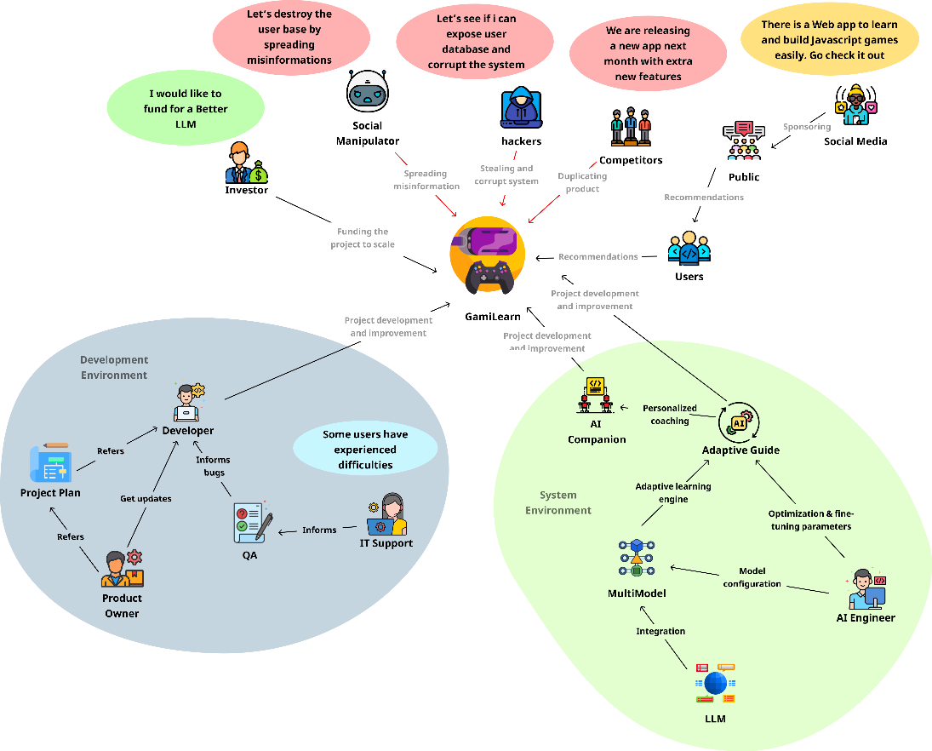
Figure 1: Rich Picture Diagram

4.3 Stakeholder analysis
Stakeholder analysis is crucial for GamiLearn, as it identifies and prioritizes individuals or groups who influence or are impacted by the platform's development and use. By mapping stakeholders, we ensure that requirements reflect the diverse needs of learners, from novice learners seeking engaging hints to educators requiring progress tracking. This analysis utilizes the Stakeholder Onion Model to categorize participants by proximity and influence, followed by a viewpoints table that summarizes their roles, expectations, and concerns. This approach promotes user-centered design, thereby reducing risks such as misalignment with educational goals (Bryman, 2016).

4.3.1 Stakeholder onion model

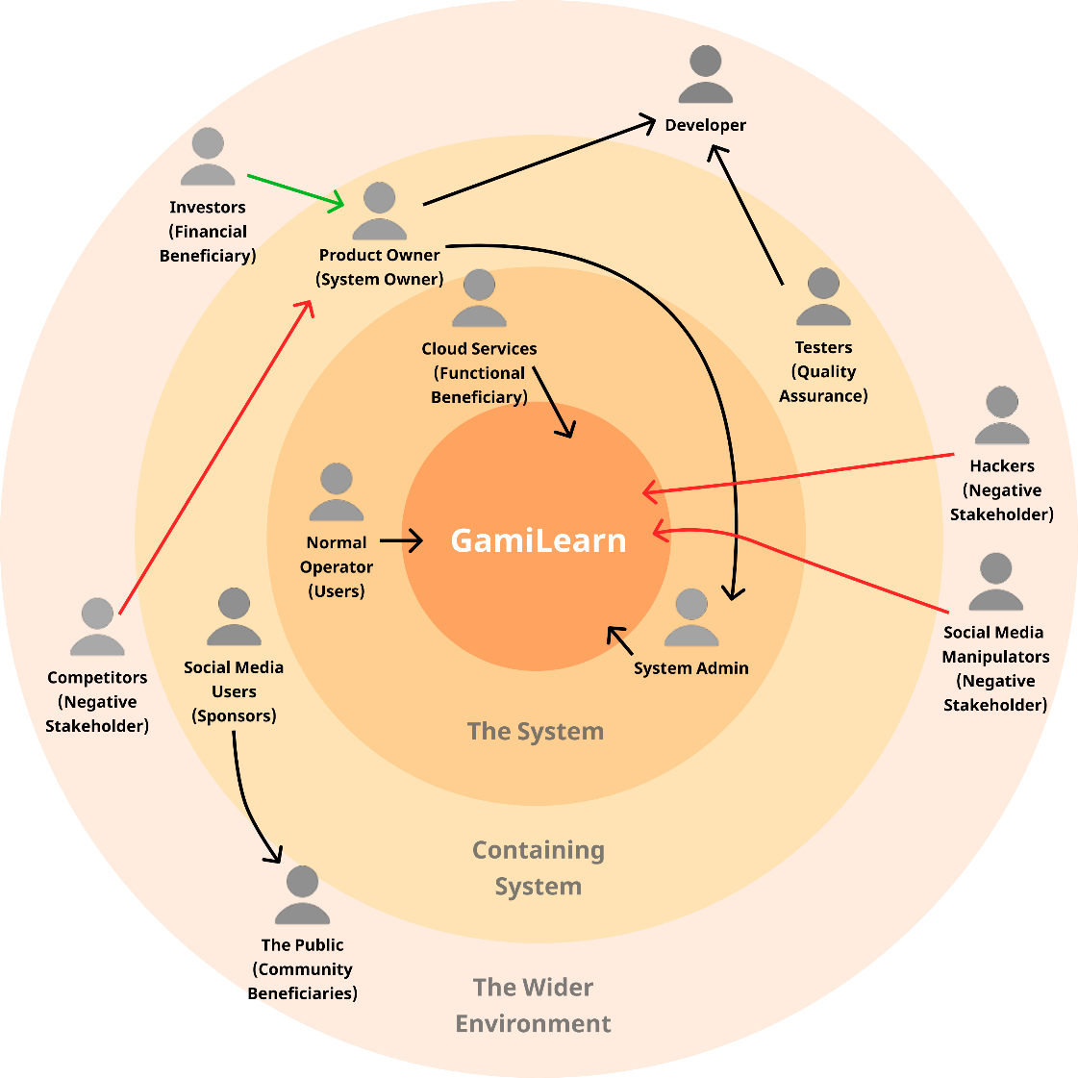
Figure 2:Stakeholder onion model

4.3.2 Stakeholder viewpoints
Table 9: Stakeholder Viewpoints
Stakeholder | Role | Description
The System
Normal user | User | Using the system to develop games and learn the fundamentals of game development.
Cloud services | Functional Beneficiary | External service providers offer hosting, data storage, and analytics capabilities.
System admins | Admin | Managing and maintaining the system, ensuring there are no server issues or stability issues, and performing system updates, among other tasks.
The containing system
Product owner | System owner | Checking the goals, ensuring stakeholder needs are met by the system, and delivering proposed outcomes.
Tester | Quality Assurance | Testing the system for issues and verifying that it complies with quality standards.
Social Media Users | Sponsors | Individuals or brands that promote GamiLearn through online campaigns or sponsorships.
IT Support | Facilitator | Support the user base by addressing the problems they face and helping to resolve them.
The Wider Environment
Investors | Financial Beneficiary | Financial backers provide capital for the development and growth of the GamiLearn system.
The Public | Community Beneficiary | Society at large, including educators, institutions, and communities that benefit indirectly.
Hackers | Negative Stakeholders | Malicious entities seeking unauthorized access or disrupting GamiLearn operations.
Social Media Manipulators |  | Individuals or bots spread misinformation or negative publicity.
Competitors |  | Rival platforms in the game-based learning or edtech sector.

4.4 Selection of requirement elicitation methodologies
Multiple methods were used to gather comprehensive, user-centered requirements:
- Surveys: Online questionnaire distributed to 50 students; 42 responses received (84% response rate). Focused on preferred hint styles, gamification, and multiplayer interest.
- Brainstorming Sessions: Held with key stakeholders to generate ideas for system features and functionalities.
4.5 Discussion of findings
4.5.1 Literature review findings
Table 10:Literature review findings
Citation | Finding
(Kazemitabaar et al., 2024) | Found that AI-assisted programming tools like CodeAid improved novice learners’ task completion by 20% but lacked game-specific support for JavaScript-based projects.
(Ericson, Denny & Prather, 2023) | Reported that gamification elements such as XP and badges increased learner engagement and retention by nearly 30% in coding platforms.
(Lehtonen et al., 2023) | Demonstrated that live code previews and real-time visual feedback reduce cognitive load and help learners understand programming logic more effectively.
(Schmucker et al., 2024) | Highlighted that conversational AI tutors improved engagement but risked over-reliance when feedback lacked context or interactivity.
(Panchanadikar & Freeman, 2024) | Emphasized the potential of generative AI in supporting creative workflows in game development but noted limited integration with structured learning environments.

4.5.2 Survey findings

Table 11:Survey findings
How would you rate your current familiarity with JavaScript programming?
Aim | To get an idea about the users’ personal knowledge of the stack
Results | 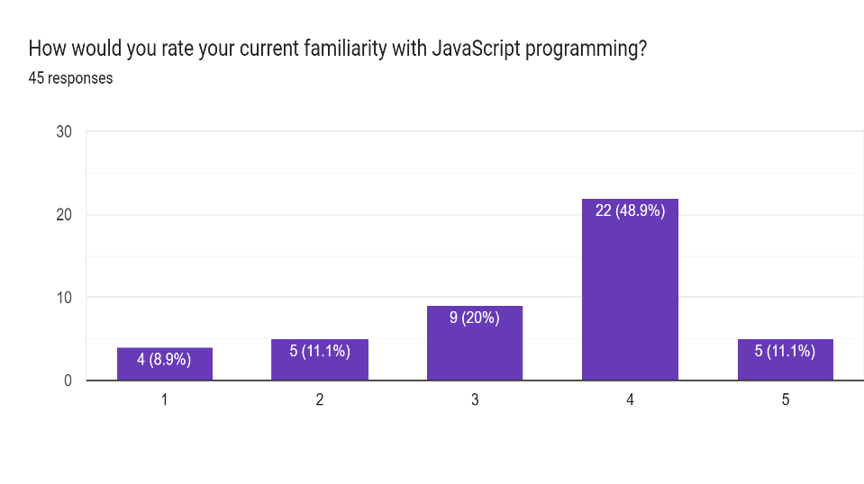
Findings and Conclusion | Most respondents (48.9%) rated level 4, showing moderate to high familiarity suitable for learning game development.
Have you ever tried developing a game using JavaScript or any other language?
Aim | To identify participants’ prior experience in game development.
Results | 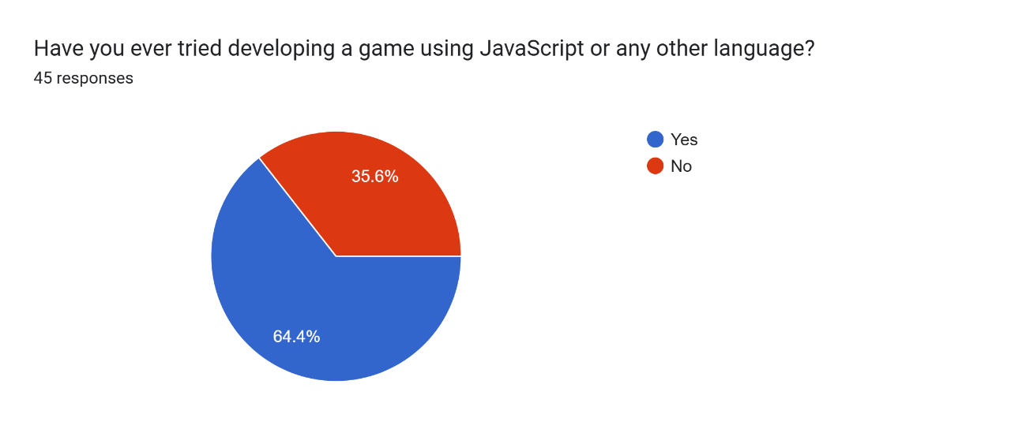
Findings and Conclusion | A majority (64.4%) have attempted game development, indicating basic exposure, while 35.6% are complete beginners needing structured guidance.
Have you ever used an online platform (e.g., Codecademy) to learn coding?
Aim | To determine prior use of online coding platforms.
Results | 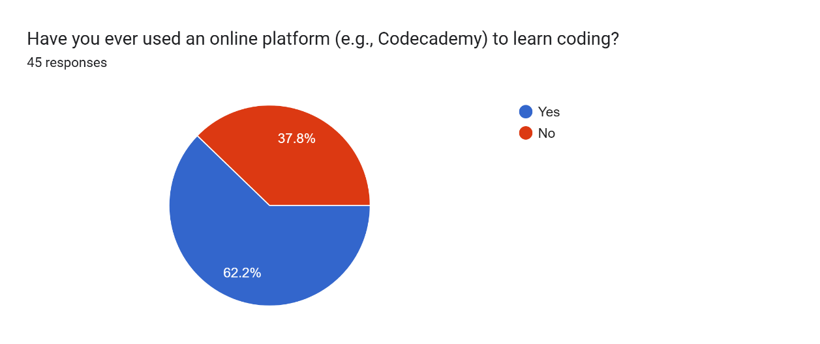
Findings and Conclusion | About 62.2% have used platforms like Codecademy, showing familiarity with online learning, while 37.8% remain new to such environments.
How important is it for you to see visual feedback (like live game previews) while coding in the browser?
Aim | To assess the importance of visual feedback during coding.
Results | 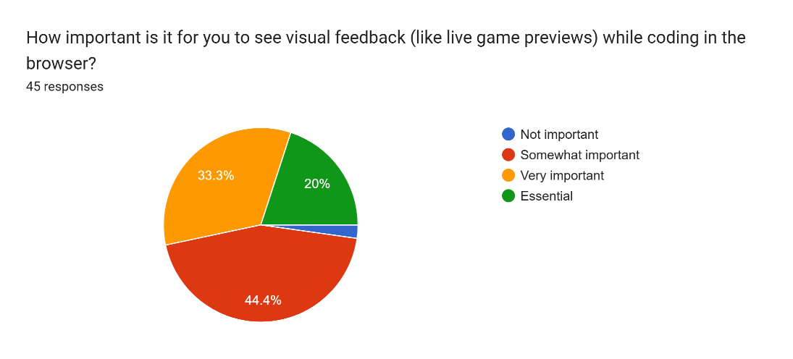
Findings and Conclusion | Most respondents (77.7%) rated visual feedback as very important or essential, highlighting the need for live game previews in learning environments.
What are your biggest challenges when learning programming?
Aim | To identify key challenges faced by learners in programming.
Results | 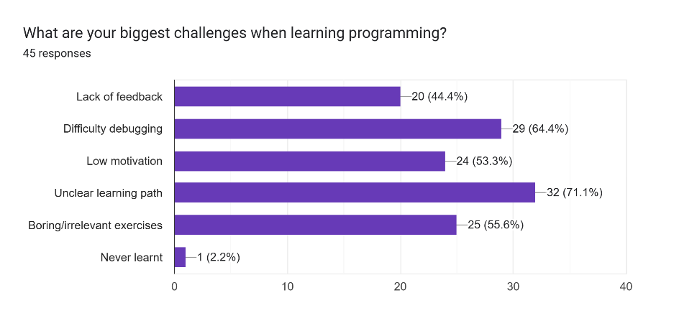
Findings and Conclusion | The top issues were unclear learning paths (71.1%) and boring or irrelevant exercises (55.6%), indicating a strong need for structured, engaging, and feedback-rich learning platforms.
What kind of AI support would you prefer?
Aim | To understand learners’ preferred type of AI assistance.
Results | 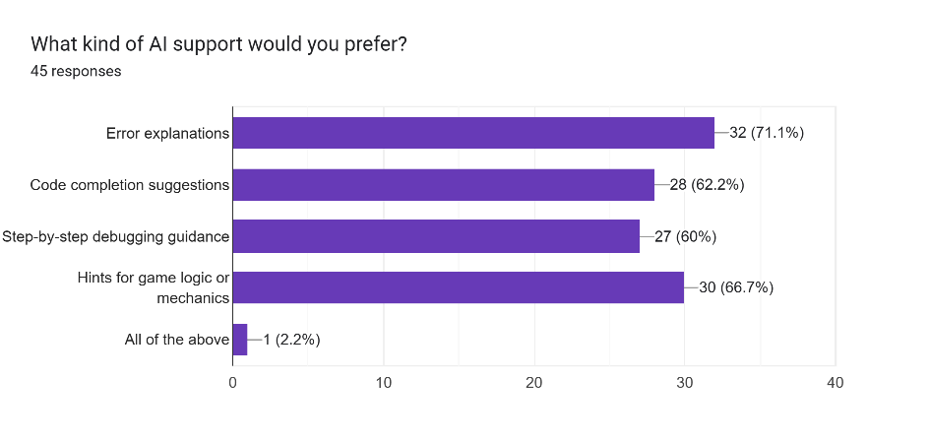
Findings and Conclusion | Most respondents (71.1%) preferred detailed error explanations, followed by game logic hints (66.7%), showing a demand for AI that provides clear, contextual feedback during coding.
Would you find an AI companion that provides task-specific hints and error explanations helpful while learning to code?
Aim | To evaluate interest in an AI companion for coding support.
Results | 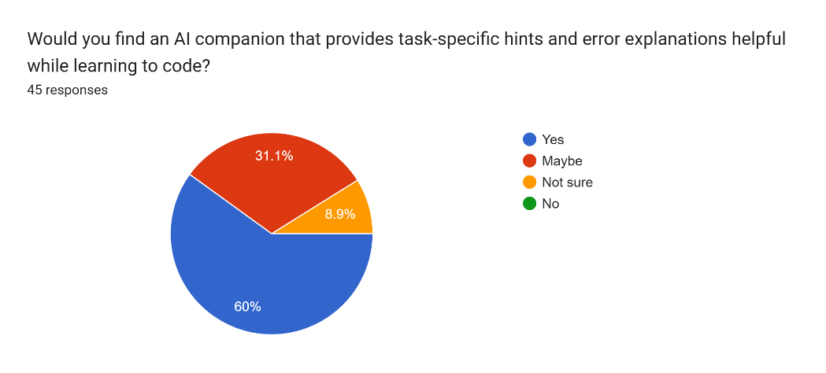
Findings and Conclusion | A majority (60%) agreed it would be helpful, showing strong interest in AI-driven, task-specific guidance for learning programming.
Which of the following features would most motivate you to continue learning?
Aim | To identify features that enhance learners’ motivation.
Results | 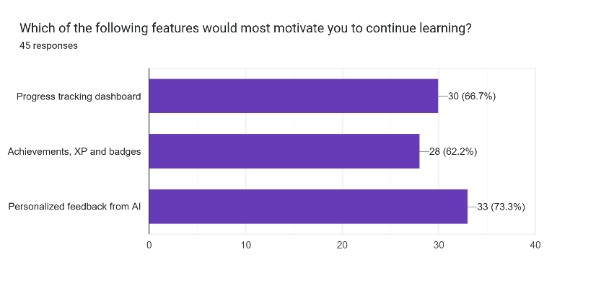
Findings and Conclusion | Personalized AI feedback (73.3%) and progress tracking (66.7%) were top motivators, confirming that adaptive feedback and gamified progress drive continued engagement.

4.5.3 Brainstorming/Observation findings
Table 12:Brainstorming Findings
Criteria | Finding
Project Relevance and Significance | The project addresses the growing need for accessible, AI-assisted platforms that help beginners learn JavaScript game development through structured, interactive experiences. It enhances engagement and lowers dropout rates in programming education.
Novelty and Innovation | GamiLearn uniquely combines AI-guided coding assistance, live game previews, and gamification within a single browser-based environment, offering seamless learning progression from syntax to multiplayer game creation.
Technical Feasibility | Integration of lightweight LLM-based APIs enables practical AI hint generation within browser limits.
Addressing Limitations of Existing Methods | The system overcomes gaps in traditional platforms like Codecademy and YouTube tutorials by providing instant feedback, visual game previews, and adaptive AI guidance that supports genuine learning rather than rote memorization.
Clarity in Defining Learning Path | A clear, phased roadmap covering fundamentals, single-player, and multiplayer modules ensures learners can gradually progress while understanding core programming and game logic concepts.
Data Considerations | The platform utilizes curated JavaScript learning tasks and game templates, ensuring consistency in user progress tracking. Data collection focuses on code submissions and hint interactions to enhance adaptive AI responses.
Technical Contributions and Documentation | The project delivers a well-documented, modular architecture demonstrating how AI companions can support coding education. It serves as a foundation for future research on adaptive learning and game-based instruction.

4.6 Summary of findings
Table 13:Summary findings
Finding | Literature Review | Surveys | Brainstorming
AI tutors improve novice performance but lack game-specific scaffolding | X | X | X
Gamification (XP, badges, progress) increases learner motivation and retention | X | X | X
Live code previews reduce cognitive load and improve understanding | X | X
Context-aware AI hints are essential for effective learning support | X | X | X
Learners prefer a clear, task-oriented roadmap from syntax to complete game creation | X | X | X
Browser-based editors with instant feedback enhance usability | X |  | X
Secure multiplayer and sandboxed environments are required for safety | X |  | X
Educators value analytics dashboards for tracking learner progress | X |  | X

4.7 Context diagram
The context diagram illustrates the interaction between the user and the GamiLearn system. The user inputs code or commands into the platform, and GamiLearn responds with personalized AI guidance, coding feedback, hints, and real-time assistance through its AI companion. This diagram illustrates the system’s primary data flow and its core function as an interactive learning environment.
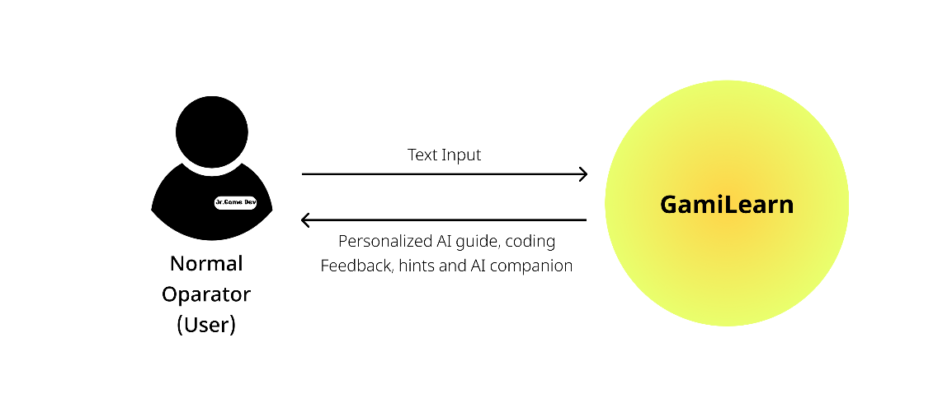
Figure 3:Context diagram

4.8 Use case diagram
The Use case Diagram represents the key interactions between the system and the user.
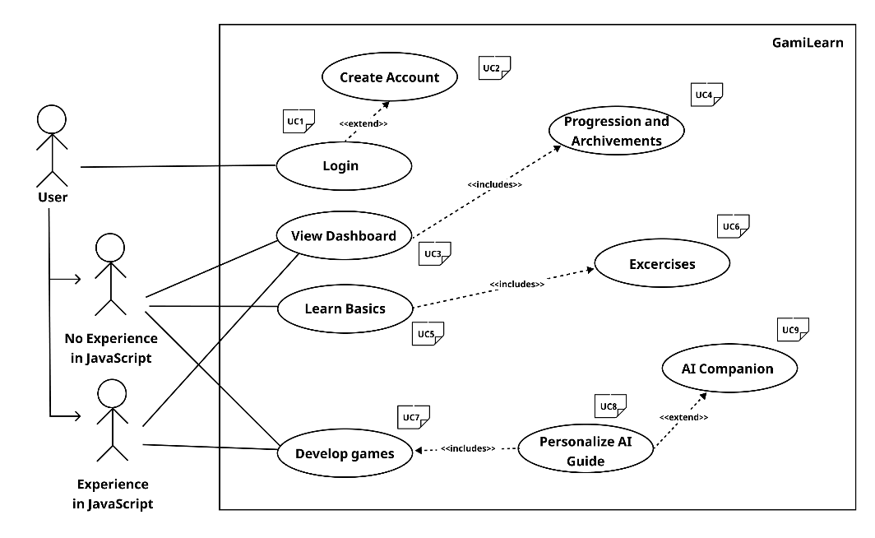
Figure 4:Use case diagram

4.9 Use case descriptions
Table 14: Use case description UC5
Use Case ID | UC5
Use Case Name | Learn Basics
Description | Provides beginner-friendly lessons covering JavaScript fundamentals such as variables, loops, and functions. Learners interact with the embedded code editor to complete guided exercises.
Primary Actor (PA) | User
Supporting Actors (SA) | AI Companion
Preconditions | The user must be logged in and have access to the learning modules.
Postconditions | User completes basic lessons, earns XP, and unlocks access to advanced modules like Exercises and Game Development.
Extended Use Case | None
Included Use Case | UC6 – Exercises
Main Flow / Basic Path | 1. The user selects “Learn Basics” from the dashboard.  2. The system loads beginner JavaScript lessons.  3. The user completes short coding tasks within the browser editor.  4. The AI Companion provides real-time hints and feedback.  5. Upon completion, progress is updated and recorded.
Alternative Flow | A1. If the user skips lessons, the system marks them as incomplete.  A2. If the user requests assistance, the AI Companion explains concepts through examples.
Exceptional Flow | E1. If the code editor fails to load, the system prompts the user to refresh.  E2. If the hint system times out, a static hint suggestion is displayed.
Comments | Establishes a foundational understanding of JavaScript through guided, interactive learning enhanced by AI support.

Table 15: Use case description UC6
Use Case ID | UC6
Use Case Name | Exercises
Description | Offers interactive JavaScript coding challenges that test comprehension of previously learned concepts. Learners receive immediate AI feedback and hint suggestions.
Primary Actor (PA) | User
Supporting Actors (SA) | AI Companion
Preconditions | The user must have started the Learn Basics module (UC5).
Postconditions | Completed exercises are recorded, and XP or badges are awarded based on accuracy and completion.
Extended Use Case | None
Included Use Case | UC5 – Learn Basics
Main Flow / Basic Path | 1. The user selects an exercise from the module list.  2. The system presents the coding challenge and instructions.  3. The user writes and runs code in the browser editor.  4. The AI Companion provides contextual hints or corrections.  5. The system records the result and updates user progress.
Alternative Flow | A1. If the user submits incorrect code, the AI Companion suggests relevant fixes.  A2. If the user pauses an exercise, progress is auto-saved.
Exceptional Flow | E1. If code execution fails due to syntax errors, the AI Companion displays explanations.  E2. If network loss occurs, the attempt is stored locally and synced later.
Comments | Reinforces coding skills through practical application and real-time AI-guided problem-solving.

Table 16: Use case description UC7
Use Case ID | UC7
Use Case Name | Develop Games
Description | Enables learners to create simple browser-based games using JavaScript, applying concepts from earlier modules. The AI Companion provides coding assistance and debugging hints during development.
Primary Actor (PA) | User
Supporting Actors (SA) | AI Companion
Preconditions | The user must have completed Learn Basics and relevant exercises.
Postconditions | A playable JavaScript-based game is successfully created and previewed within the browser.
Extended Use Case | None
Included Use Case | UC8 – Personalize AI Guide
Main Flow / Basic Path | 1. The user selects “Develop Games” from the dashboard.  2. The system provides starter templates and a code editor.  3. The user writes game logic using JavaScript.  4. The AI Companion offers real-time debugging and code hints.  5. The game is compiled and previewed directly in the browser.
Alternative Flow | A1. If the user chooses to work from scratch, an empty editor is provided.  A2. If coding errors occur, the AI Companion suggests corrections step-by-step.
Exceptional Flow | E1. If preview rendering fails, the system prompts a refresh or fallback preview mode.  E2. If saving fails, progress is stored temporarily and retried.
Comments | Encourages creativity and hands-on coding, bridging theory with real-world game development through guided AI support.

Table 17: Use case description UC8
Use Case ID | UC8
Use Case Name | Personalize AI Guide
Description | Allows users to customize the AI Companion’s tone, level of hint detail, and assistance frequency according to their learning preferences.
Primary Actor (PA) | User
Supporting Actors (SA) | AI Companion
Preconditions | The user must be logged in and interacting with the AI Companion.
Postconditions | The AI Companion adapts to the user’s selected settings immediately.
Extended Use Case | UC9 – AI Companion
Included Use Case | None
Main Flow / Basic Path | 1. The user opens the AI settings panel from their dashboard.  2. The system displays adjustable options (tone, hint frequency, guidance level).  3. The user modifies preferences and saves changes.  4. The AI Companion updates and continues with new behavior settings.
Alternative Flow | A1. If settings are reset, the system restores default AI preferences.  A2. If the user cancels changes, previous configurations remain.
Exceptional Flow | E1. If saving preferences fail, the system displays an error and retries automatically.  E2. If connection to the AI service is lost, updates are queued for the next session.
Comments | Enhances the user experience by tailoring AI behavior, making the learning process adaptive and user centric.

Table 18: Use case description UC9
Use Case ID | UC9
Use Case Name | AI Companion
Description | The AI Companion provides contextual hints, feedback, and real-time explanations while users engage in coding exercises or game development tasks.
Primary Actor (PA) | User
Supporting Actors (SA) | System
Preconditions | The user must be logged in and engaged in a learning or coding session.
Postconditions | AI-generated hints and feedback are displayed, improving user understanding and task performance.
Extended Use Case | UC8 – Personalize AI Guide
Included Use Case | None
Main Flow / Basic Path | 1. The user starts a coding activity within the GamiLearn editor.  2. The system monitors code execution and identifies potential issues.  3. The AI Companion analyzes context and generates a hint or explanation.  4. The user reads the hint and applies suggested fixes.  5. The AI logs the interaction to improve future recommendations.
Alternative Flow | A1. If AI confidence is low, it provides a generic example instead of a direct fix.  A2. If the user dismisses a hint, the system logs that preference to reduce future interruptions.
Exceptional Flow | E1. If the AI service times out, fallback hints are displayed from predefined templates.  E2. If model response fails, the system shows “Unable to process your request.”
Comments | The AI Companion is the system’s core feature, providing personalized, adaptive learning assistance and feedback throughout the coding journey.

4.10 Requirements
Moscow Principle
The Moscow principle is used to prioritize requirements into:
- M: Must Have (mandatory).
- S: Should Have (essential).
- C: Could Have (desirable).
- W: Will Not Have (out of scope).

4.10.1 Functional requirements
Table 19:Functional Requirements
ID | Requirement | Priority
FR1 | The system must allow users to write and execute JavaScript code directly in the browser. | M
FR2 | The system must provide real-time AI hints and error explanations while the user is coding. | M
FR3 | The system must include AI-powered suggestions, error explanations, and context-aware hints during coding. | S
FR4 | The system must enable users to create and test single-player games with AI-driven bot opponents. | S
FR5 | The system must support multiplayer games using WebSocket for real-time synchronization. | S
FR6 | The system must include gamification features, such as XP, badges, and progress dashboards. | S
FR7 | The system should store learner progress and gameplay data for tracking achievements. | S
FR9 | The system will not use advanced game engines such as Phaser, Unreal, or Unity. | W
FR10 | The system will not include non-English or mobile-optimized interfaces. | W
F11 | The system will not cover specialized areas such as 3D, VR, or non-browser-based games. | W
F12 | The system will not implement real-time AI error prediction or learning analytics. | W

4.10.2 Non-functional requirements
Table 20:Non-functional requirements
ID | Requirement | Priority
NFR1 | The system must ensure low-latency responses for live previews and real-time interactions. | S
NFR2 | The platform must run entirely in a browser without additional installations. | C
NFR3 | The user interface must be simple, intuitive, and accessible for beginners. | W
NFR4 | The system must maintain stable synchronization during multiplayer gameplay. | S
NFR5 | The system should allow for scalability to support multiple learners simultaneously. | C
NFR6 | The interface must support English as the default language. | M
NFR7 | The platform must operate efficiently on standard hardware without requiring advanced GPUs. | M
NFR8 | The system will not include mobile-specific or multilingual optimization. | W
NFR9 | The system will not support VR/3D rendering or heavy engine integrations. | W

4.11 Chapter summary
This SRS chapter outlines the requirements for GamiLearn. It uses structured methods to collect information, examine stakeholders, and create visual models. We define and prioritize functional and non-functional requirements using Moscow. This ensures the platform offers feedback-rich, engaging, and scalable learning experience for JavaScript game development. The MVP, scheduled for February 2026, will include all Must-Have features. We plan to complete Should-Have enhancements by March 2026.

CHAPTER 5. TIME SCHEDULE

Figure 5:Gantt Chart

References
- Becker, B. A., Denny, P., Finnie Ansley, J., Luxton Reilly, A., Prather, J., & Santos, E. A. (2023). Programming is hard, or is it? A survey of novice programmer experiences with generative AI. CS Education Research. https://csed.acm.org/wp content/uploads/2023/12/Generative AI Nov 2023 Version.pdf
- Kazemitabaar, M., Chow, J., Ma, C. K., Ericson, B. J., & Weintrop, D. (2023). Studying the effect of AI code generators on supporting novice learners in introductory programming. Proceedings of the 2023 CHI Conference on Human Factors in Computing Systems. https://arxiv.org/pdf/2302.07427
- Kazemitabaar, M., Henley, A. J., Denny, P., Ericson, B. J., & Weintrop, D. (2024). CodeAid: Evaluating the classroom deployment of an LLM based programming assistant that balances student and educator’s needs. Proceedings of the 2024 CHI Conference on Human Factors in Computing Systems. https://arxiv.org/abs/2401.11314
- Schmucker, R., Wang, J., Hu, S., & Mitchell, T. M. (2024). Ruffle&Riley: Insights from designing and evaluating a conversational AI tutor for education. International Conference on Artificial Intelligence in Education. https://www.xiameng.org/AIED_2024___Conversational_Tutoring__camera_ready_.pdf
- Wang, J., Schmucker, R., Liu, M., Hu, S., & Mitchell, T. M. (2025). Learning to guide human experts via personalized large language models. Findings of the Association for Computational Linguistics: ACL 2025. https://aclanthology.org/2025.findings acl.642.pdf
- Phung, C. D., Okafor, V., Denny, P., Luxton Reilly, A., & Weintrop, D. (2024). Automating Human Tutor-Style Programming Feedback: Leveraging GPT-4 Tutor Model for Hint Generation and GPT-3.5 Student Model for Hint Validation. https://dl.acm.org/doi/pdf/10.1145/3636555.3636846
- Panchanadikar, R., & Freeman, G. (2024). Envisioning and Designing Generative AI to Support Indie Game Development. https://doi.org/10.1145/3677082
- Hijón Neira, R., Connolly, C., Pálsson, H., & Çelik, Ö. Ç. (2023). The impact of game-based learning on student engagement in computer science education. Education Sciences, 13(7), 672. https://doi.org/10.3390/educsci13070672
- Saunders, M., Lewis, P., & Thornhill, A. (2019). Research methods for business students (8th ed.). Person.
- Bryman, A. (2016). Social research methods (5th ed.). Oxford University Press.
- Larman, C. (2005). Applying UML and patterns: An introduction to object-oriented analysis and design and iterative development (3rd ed.). Prentice Hall.
- Creswell, J. W., & Creswell, J. D. (2023). Research design: Qualitative, quantitative, and mixed methods approach (6th ed.). SAGE Publications.
- Haverbeke, M. (2018). Eloquent JavaScript: A modern introduction to programming (3rd ed.)..
- Ericson, B. J., Denny, P., & Prather, J. (2023). Exploring the impact of gamification on novice programmer retention. Proceedings of the 54th ACM Technical Symposium on Computer Science Education, 1287–1288. https://doi.org/10.1145/3545947.3576270
- Margulieux, L. E., Morrison, B. B., & Decker, A. (2024). Designing effective feedback mechanisms for online programming environments. ACM Transactions on Computing Education, 24(1), 1–22. https://doi.org/10.1145/3641856
- Saunders, M., Lewis, P., & Thornhill, A. (2019). *Research methods for business students* (8th ed.). Pearson.
- Monk, A., & Howard, S. (1998). The rich picture: A tool for reasoning about work context. Interactions, 5(2), 21–30. Link: https://doi.org/10.1145/274430.274434
- Lehtonen, M., Nurmi, S. & Koponen, T. (2023). Real-time feedback in programming education: improving learner engagement and understanding. IEEE Transactions on Learning Technologies. https://www.researchgate.net/publication/352807752_IEEE_Transactions_on_Learning_Technologies_IEEE_TRANSACTIONS_ON_LEARNING_TECHNOLOGIES_VOL_XX_NO_X_XXXXXX_20XX_1

APPENDIX A – USE CASE DESCRIPTIONS
Table 21: Use case description UC1
Use Case ID | UC1
Use Case Name | Login
Description | Allows the user to securely access the GamiLearn platform by entering valid credentials. Once authenticated, the user is redirected to the dashboard with access to their personalized learning modules.
Primary Actor (PA) | User
Supporting Actors (SA) | None
Preconditions | The user must already have a registered account and an active internet connection.
Postconditions | The user is successfully logged in, and the personalized dashboard is displayed.
Extended Use Case | UC2 – Create Account
Included Use Case | None
Main Flow / Basic Path | 1. The user navigates to the GamiLearn login page.  2. The system displays login fields for email and password.  3. The user enters valid credentials.  4. The system verifies the credentials.  5. Upon successful verification, the dashboard is loaded and displayed.
Alternative Flow | A1. If the credentials are invalid, the system displays an “Invalid username or password” message and allows the user to retry.  A2. If the user has no account, they are redirected to UC2 – Create Account.
Exceptional Flow | E1. If the server or authentication service is down, the system shows a “Server unavailable” message.  E2. If network connectivity is lost, the user is prompted to reconnect and retry.
Comments | This use case ensures secure access to GamiLearn, maintaining user authentication and protecting learning progress data.

Table 22: Use case description UC2
Use Case ID | UC2
Use Case Name | Create Account
Description | Enables a new user to register on the GamiLearn platform by providing details such as name, email, and password. Once the account is created successfully, the user can log in and access the learning dashboard.
Primary Actor (PA) | User
Supporting Actors (SA) | None
Preconditions | The user must not already have an existing account in the system.
Postconditions | The user account is successfully created and stored; the user can proceed to log in.
Extended Use Case | None
Included Use Case | None
Main Flow / Basic Path | 1. The user selects the “Create Account” option on the login page.  2. The system prompts the user to enter registration details (name, email, password).  3. The user provides valid inputs and submits the form.  4. The system validates the details and creates a new account.  5. A confirmation message is displayed, and the user is redirected to the login page (UC1).
Alternative Flow | A1. If the entered email already exists, the system displays an error message and prompts the user to log in instead.  A2. If the password does not meet validation criteria (e.g., too short), the system requests correction.
Exceptional Flow | E1. If the registration server fails, the system notifies the user with a “Registration failed, please try again later” message.  E2. If network connectivity is lost during registration, progress is paused until the connection is restored.
Comments | This use case allows first-time users to onboard the GamiLearn system and securely create personal accounts for tracking learning progress.

Table 23: Use case description UC3
Use Case ID | UC3
Use Case Name | View Dashboard
Description | Displays the user’s personalized dashboard after login, showing current progress, XP points, badges, and quick access to learning modules such as Learn Basics, Exercises, and Game Development.
Primary Actor (PA) | User
Supporting Actors (SA) | System
Preconditions | The user must be logged into the GamiLearn platform.
Postconditions | The user’s dashboard is displayed, providing access to lessons, statistics, and AI assistance options.
Extended Use Case | None
Included Use Case | UC4 – Progression and Achievements
Main Flow / Basic Path | 1. The user successfully logs in through UC1.  2. The system retrieves user data including progress, XP, and completed modules.  3. The dashboard interface is generated dynamically based on the retrieved data.  4. The system displays quick links to modules (Learn Basics, Exercises, Develop Games).  5. The user interacts with dashboard widgets to navigate or view detailed statistics.
Alternative Flow | A1. If user progress data is unavailable, the system displays placeholders or a “No progress yet” message.  A2. If the user’s last session was incomplete, the dashboard highlights where they left off.
Exceptional Flow | E1. If data retrieval fails due to server error, the system displays “Unable to load dashboard” and retries after a few seconds.  E2. If the internet connection is interrupted, the dashboard loads in limited offline mode without updates.
Comments | Serves as the main control hub for user navigation, offering a summary of progress, achievements, and learning modules.

Table 24: Use case description UC4
Use Case ID | UC4
Use Case Name | Progression and Achievements
Description | Tracks and displays the user’s learning milestones, XP points, and badges earned through lessons and exercises. This provides feedback and motivation for continued learning.
Primary Actor (PA) | User
Supporting Actors (SA) | System
Preconditions | The user must be logged in and have completed at least one learning activity.
Postconditions | Updated progress data (XP, badges, levels) is displayed and stored in the system.
Extended Use Case | None
Included Use Case | UC3 – View Dashboard
Main Flow / Basic Path | 1. The user completes a learning module or game activity.  2. The system updates XP points and badges based on activity outcomes.  3. The system stores updated achievements and learning history  .4. The user opens the Progression and Achievements tab from the dashboard.  5. Achievements and XP progress are displayed visually (charts, badges).
Alternative Flow | A1. If user activity data is partially recorded, the system calculates XP based on the available records.  A2. If the user has not earned any achievements, the section displays “No badges earned yet.”
Exceptional Flow | E1. If the progress update fails due to a network or database issue, the system retries the sync automatically.  E2. If corruption is detected in saved progress, the system notifies the user to refresh the session.
Comments | Motivates learners through visible recognition of progress and gamified rewards such as XP, badges, and achievement levels.

