Modifying the img_to_encoding

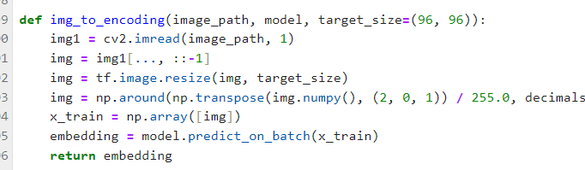

Face Verification

Face Recognition

