**IT21038914**

**Lab 4 - yolo**

**7.Explanation for 1783 Boxes**

The shape (1783, 4) indicates that 1783 bounding boxes are predicted, each described by 4 coordinates (x, y, width, height). The number of boxes is influenced by the dimensions of the input tensors and the threshold value used in the yolo_filter_boxes function.

**Maximum and Minimum Number of Boxes**

* **Maximum Number**: The maximum number of boxes can be (19 * 19 * 5), as there are 19x19 grid cells and 5 anchor boxes per cell, which equals 1805 boxes.
* **Minimum Number**: The minimum number of boxes can be 0, which occurs if none of the predicted boxes exceed the threshold confidence level.

8. **Advantage of Using Anchor Boxes in YOLO:**

* **Object Detection Flexibility**: Anchor boxes allow YOLO to predict bounding boxes with different aspect ratios and sizes within a single grid cell. This enables the model to detect multiple objects of varying dimensions at the same location, which is crucial for detecting small and large objects in the same image.
* **Speed and Efficiency**: By pre-defining the anchor boxes, the YOLO model can make predictions quickly. Instead of predicting arbitrary bounding boxes, it predicts adjustments to these predefined shapes, which simplifies the learning process and speeds up inference.

**Method Used to Determine the Sizes of Anchor Boxes:**

* **K-means Clustering**: The sizes of anchor boxes are typically determined using a K-means clustering algorithm on the dataset of ground truth bounding boxes. The idea is to find the most common sizes and aspect ratios of objects in the dataset. K-means clustering groups these bounding boxes into clusters, and the centroids of these clusters are used as the dimensions for the anchor boxes.

In your case, the anchor box dimensions provided in yolo_anchors.txt are:

* (0.57273, 0.677385)
* (1.87446, 2.06253)
* (3.33843, 5.47434)
* (7.88282, 3.52778)
* (9.77052, 9.16828)

9.

My traffic image

Output

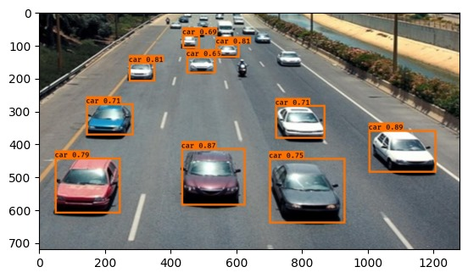

10. There are correctly identified images, but there are also many unrecognized images. Additionally, a black Jeep is not recognized in any images.

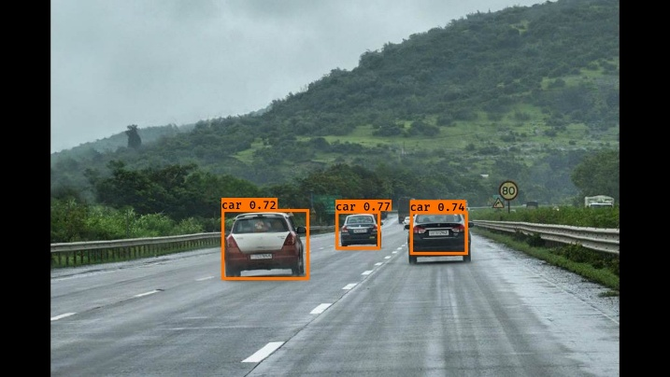

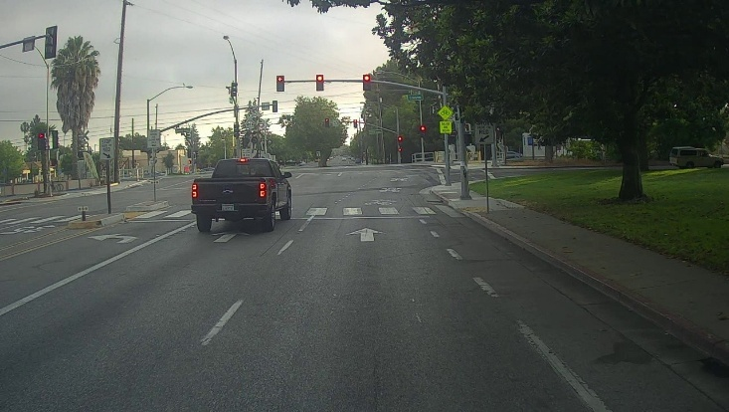

11.

### max_boxes

* Value = 20

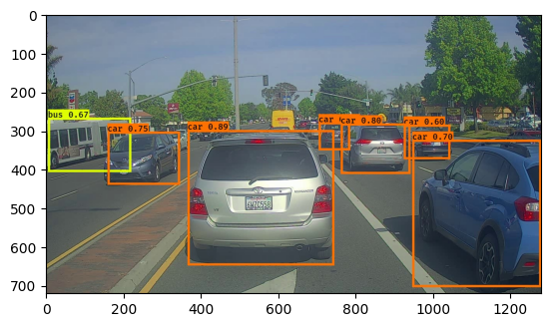

* Value = 2

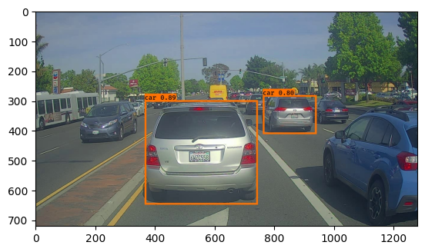

Increasing max_boxes: More boxes considered, potentially more detections, but also more clutter.

Decreasing max_boxes: Fewer boxes considered, cleaner output, but miss some detections.

### score_threshold

* Value = 0.8

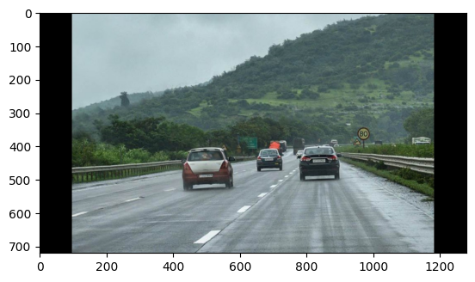

* Value = 0.4

Increasing score_threshold: Fewer boxes with higher confidence, reduced false positives, but possible missed detections.

Decreasing score_threshold: More boxes with lower confidence, more detections, but potential increase in false positives.

### iou_threshold

* Value = 0.8

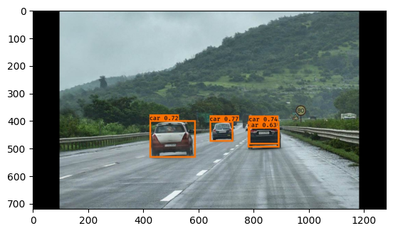

* Value = 0.3

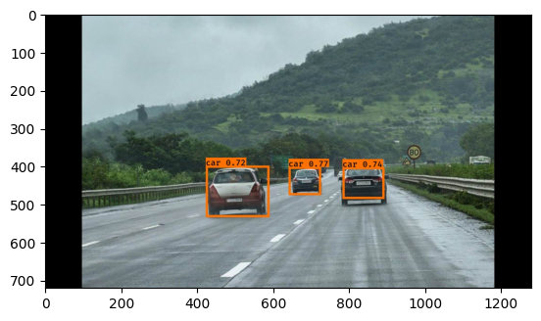

Increasing iou_threshold: Fewer overlapping boxes, clearer results, but possible missed detections.

Decreasing iou_threshold: More boxes considered overlapping, more detailed detections, but can lead to cluttered results.