

Development and Optimization of An IOT Spider Robot for Home and Industrial Security with Emergency Response

NSBM Green University Town

Faculty of Computing

December 2024

**By**

**BHKL Dayawardana**

**(21871)**

**CONTENTS**

**CHAPTER 1- INTRODUCTION** 3

**1.1Chapter Overview** 3

**1.2 Problem Background** 3

1.2.1 Problem Discussion/Argument 4

**1.3 Problem Statement** 4

1.3.1 Background 5

1.3.2 General Problem 5

1.3.3 Specific Problem 6

**1.4 Research Question** 6

**1.5 Research Motivation** 7

**1.6 Research Aim** 9

**1.7 Research Objectives** 10

1.7.1 Identify 10

1.7.2 analyze 11

1.7.3 To Design / Implement / Develop 12

1.7.4 To Evaluate 13

**1.8 Visualizing the Workflow and System Integration** 14

**1.9 Resource Requirements** 15

1.9.1 Hardware 16

1.9.2 Software 16

**1.10 Project scope** 17

1.10.1 Defining the Project Scope: Inclusions and Exclusions 17

**1.11 Chapter Summary** 17

**CHAPTER 02 - LITERATURE REVIEW** 19

**2.1 Chapter overview** 19

**2.2 Conceptual taxonomy of the literature organization** 19

**2.3 Domain Overview** 19

**2.4 Existing Systems** 20

**2.5 Technological Analysis** 21

2.5.1 Algorithmic Analysis 21

2.5.2 Design analysis 22

2.5.3 Workflow analysis 22

**2.6 Reflection and Research Gaps** 23

**2.7 Chapter Summary** 23

**CHAPTER 03 - METHODOLOGY** 25

**3.1 Chapter Overview** 25

**3.2 Research Paradigm: Positivism** 25

# **CHAPTER 1- INTRODUCTION**

## **1.1Chapter Overview**

This chapter discusses the spider robot project, particularly built for boosting home security in Sri Lanka utilizing IoT technology. The robot contains six lags, enabling it to walk successfully on different interior surfaces, such as carpets and tiled floors, making it well-suited for Sri Lankan houses. It incorporates modern sensors to detect gas leaks, fires, or intruders, offering an extra protection while homeowners are not there.

When a possible danger is discovered, the robot delivers quick notifications to the owner’s mobile device via a linked application. This guarantees that homeowners are continually informed about the state of their property, allowing them to react swiftly to crises and boosting overall security.

In addition to its main security responsibilities, the robot monitors around variables, including temperature and humidity, as well as its own battery level. Where humidity and temperature variations may influence house safety. Furthermore, the system incorporates a another external unit that may be connected into conventional power outlets. If the robot senses a fire, it sends a signal to this device, which may switch off the power supply to avoid additional damage and safeguard the property.

This chapter will offer an overview of the project, explaining its aims and the technologies employed, including the ESP8266, Arduino, and numerous sensors designed for monitoring the home environment. Additionally, it will explain how the robot connects with mobile and online apps via the BLYNK 2.0 platform, ensuring homeowners stay informed and in charge of their home security.(Filliat et al. 1999; Perilla et al. 2018; Al-Kuwari et al. [no date])

## **1.2 Problem Background**

A growing number of house invasions, burglaries, and mishaps like fires and gas leaks have made home security a top priority in recent years. Although they sometimes have drawbacks, traditional security systems, such cameras or alarms, may inform homeowners. For instance, they may not cover the whole home, or they might not function well under certain circumstances, such as a power loss.

Moreover, a lot of security systems don't do anything until after an incident occurs, like a fire or break-in. This implies that the homeowner often receives notification too late to avert harm or risk. A more sophisticated system that can monitor, identify, and react to different hazards within the house even while the homeowner is away required due to this weakness in proactive home security. (Baballe [no date])

### **1.2.1 Problem Discussion/Argument**

The concept of using robots with IoT (Internet of Things) capabilities emerged from the demand for more intelligent home security systems. A mobile robot, as opposed to a typical system, can travel across various surfaces, such as carpets or stairs, cover blind spots, and look after for different areas of the home.

This IoT idea presents the concept of a six-legged spider robot that can check for dangerous conditions like gas leaks or fires and detect intruders and also the robot provides an mobile and web application protection by using sensors such as fire sensors, gas sensors, and PIR motion detectors and few other senser to check robot status.

Furthermore, it is unusual for current systems to be able to control the electrical safety of the home. One innovative component of this spider robot concept is its ability to interact with an application that is powered by the home's electricity source. If a fire is detected, a safety feature that cuts off the power to the whole home to stop more damage.

Therefore, the topic of debate is on how the inability of present home security systems to actively react to threats in real time. The spider robot's mobility, intelligent sensors, and capacity for proactive response when required fill these gaps. (Baballe et al. 2021)

## **1.3 Problem Statement**

For the purpose of this section, the precise issues that the project intends to address are defined. The limits of the home security systems that are now available are discussed, and the need of a more modern solution that is able to monitor, identify, and react to dangers that are present inside the home is brought to light. By providing an overview of these difficulties, the issue statement lays the groundwork for the reasons why this spider robot project is essential and the ways in which it may fill the holes that was previously present in conventional security systems.

### **1.3.1 Background**

More people are adopting security systems as their concerns about the safety of their houses grow. Traditional security technologies, such as closed-circuit video cameras, motion detectors, and sirens, have various disadvantages. Many of these devices are permanently fixed, therefore they cannot fully cover the whole home. They also rely heavily on an internet connection or a power supply, which may make them vulnerable during outages or system malfunctions.

Recent improvements in IoT technology have offered smarter solutions, where devices can communicate with one other and deliver real-time warnings to homes via mobile apps. Despite these developments, many home security systems still do not provide proactive functions, such the capacity to roam about the house or react to particular risks like fire or gas leaks. Additionally, most systems only inform the homeowner after an incident has happened, giving little time to respond before harm is done.

This concept solves these difficulties by integrating IoT technology with a mobile robot that can actively patrol the home and identify dangers in real time. With capabilities such as gas leak detection, fire alarms, and intruder monitoring, this spider robot delivers a more complete and dynamic security system for contemporary houses.

### **1.3.2 General Problem**

The primary issue with conventional home security systems is their restricted capacity to stop or lessen harm caused by dangers such as gas leaks, fires, and incursions. Usually, these systems don't identify issues until they arise, which leaves the homeowner with little time to take preventative measures to avoid harm or risk. For instance, a fixed camera could record video of a break-in, but it can't stop the burglar or notify the owner beforehand.  
  
Furthermore, conventional systems are unable to react to various threats. While some are capable of detecting motion, they often miss additional threats like gas leaks, temperature increases, or fire breakouts. Due to this, houses are more susceptible to various situations, which, if they are not promptly handled, may result in expensive damage, loss of property, or even fatalities.  
  
In essence, homes who don't have an integrated, live security system are left without complete protection. This issue highlights the need for a more sophisticated system that can keep the house secure by acting pro-actively and detecting different threats.

### **1.3.3 Specific Problem**

The majority of home security systems are built to target certain risks, including motion detection or surveillance. Unfortunately, since these systems are often installed in one location, it may be difficult to cover every section of the house, particularly the blind spots. For instance, cameras are unable to travel about the home or patrol it, thus certain sections remain unmonitored.  
  
The incomplete integration of conventional home security systems with additional safety measures is another major problem. While some systems are capable of detecting intruders, very few have the ability to monitor environmental parameters like temperature and humidity or detect fires or gas leaks. This results in a gap in security coverage as it may be expensive and difficult to maintain for homeowners to install numerous systems in order to handle various threats.  
  
Furthermore, the majority of current systems are incapable of taking proactive measures to halt harm before it becomes worse. For example, in the event of a fire, conventional systems are limited to informing the homeowner; they are unable to initiate an action to turn off the power to stop the spread of the fire.  
  
By developing a mobile, all-in-one spider robot that can patrol the home, identify various threats, and even initiate safety measures like turning off the electricity in the event of a fire, this project specifically solves these drawbacks. The area of unmet need in the field of home security research is the creation of a complete, integrated system that incorporates mobility, many sensors, and proactive measures—all of which are currently uncommon in current systems.

## **1.4 Research Question**

The question this project seeks to answer is:

**"** **How to make a mobile robot with sensor-equipped, increase home security by detecting and reacting to multiple threats such as invasions, gas leaks, and fires, while giving real-time notifications to the homeowner?"**

This research topic focuses on providing a complete home security solution that overcomes the limitations of previous systems. It intends to examine how a six-legged spider robot, coupled with numerous sensors and IoT capabilities, can actively monitor the house and identify possible risks and react to them.(Taryudi et al. 2018; Gul et al. 2019)

The question key areas:

Mobility

* Can a mobile robot offer superior security coverage compared to fixed equipment by roaming the home and reaching regions where static cameras or sensors cannot?

Threat Detection

* How well can the robot employ several sensors (such gas, IR, and PIR motion sensors) to identify different forms of hazards in real time? This includes incursions, fires, gas leaks, and environmental conditions like as temperature and humidity.

Preventive Action

* Can the robot not only identify risks but also take preventive steps, such as sending signals to turn off the home’s power supply during a fire to limit additional damage.

Real-Time Alerts

* How effectively can the robot transmit alerts and notifications to the homeowner's mobile device via the BLYNK 2.0 platform, ensuring the owner is aware and can take action, even while away from home?

Robot Self-defense system

* How to defend the robot from burglars?
* How to defend the robot if someone is try to touch it or destroyed while it’s on security mode?

Although this study focuses on developing a full security system, there are sub-optimal zones to consider. For example:

* The robot’s capacity to identify hazards can be restricted by sensor range or environmental interference.
* There can be issues in ensuring the robot operates smoothly across diverse surfaces or confined areas.
* Battery life might restrict how long the robot can patrol before having to recharge.

## **1.5 Research Motivation**

The fundamental purpose of this project is to build a unique spider robot meant to increase home security in Sri Lanka using superior mobility and sensor technologies. This initiative attempts to solve particular security concerns encountered by households in the nation, such as burglary, fire dangers, and gas leaks. By the conclusion of this project, we intend to accomplish three critical results that will substantially enhance home safety and give peace of mind for homeowners.

* Individual Experiences

The worry and terror associated with home security problems, like break-ins, fires, or gas leaks, are well-known to the public. Families are distressed emotionally as well as physically by these occurrences, which endanger their safety. For me, seeing a friend's house broken into deeply worried about home security. This incident made clear how exposed houses can be, particularly when conventional security systems fall short of meeting security requirements.

* Growing Concerns About Safety

Statistics show an increase in fire incidents and home invasions. This alarming trend emphasises the critical need for efficient home security systems. Furthermore, a common omission is the risk of gas leaks, which can cause fires or explosions. The National Fire Protection Association reports that fires that are discovered after the fact account for nearly half of home fire fatalities. This data lends credence to the idea that homeowners need a proactive security system that can spot threats before they become dangerous situations.

* The Need for Innovation

This study was also driven by the urge to develop and enhance current security solutions. Many of the solutions available today are constrained by their fixed nature; they only use cameras or alarms, which can only respond after an event has occurred. This gap offers an intriguing chance to create a mobile security system that keeps an eye out for potential threats like gas leaks and fires in addition to detecting breaches. The development of a robot capable of preemptive maintenance, like turning off the electricity in the event of a fire, is a major step forward for home security.

* Advancements in Technology

Home security systems have become more sophisticated and adaptive as a consequence of real-time data collecting and device connection made possible by the Internet of Things (IoT). There is a unique opportunity to create a mobile robot that can monitor the home environment proactively thanks to recent advancements in robotics, sensing, and communication technologies. The potential of combining these technologies led to the idea of developing a spider robot that can patrol the home, recognise various threats, and communicate with homeowners instantly.

* Conclusion

Personal experiences, a rising concern for home safety, the urgent need for improved security solutions, and the exciting potential of new technologies are the sources of inspiration for this study. In all, the motivation for this research derives from a combination of these factors. By addressing these reasons, the objective is to build a home security system that is both comprehensive and effective, with the purpose of providing homeowners with peace of mind and guaranteeing that they possess a sense of safety and security inside their houses.

## **1.6 Research Aim**

The fundamental purpose of this project is to design a unique spider robot that promotes home security in Sri Lanka via mobility and superior sensor technologies. By the conclusion of this project, we intend to accomplish six critical results that will help to enhancing home safety for homeowners throughout the country.(Carroll et al. [no date])

* Development of a Mobile Security Robot

The principal purpose is to develop and construct a functioning prototype of the spider robot. This robot will have six legs, enabling it to travel smoothly over diverse surfaces in homes, such as carpets, tiled floors, and uneven terrains often seen in country residences. By making the robot mobile, it can patrol various sections of the house, addressing blind spots that fixed security cameras or sensors typically overlook. This element is significant since many break-ins occur in less visible regions, and a mobile solution may give greater overall coverage.

* Integration of Multiple Sensors

Another key purpose is to incorporate numerous sensors into the robot, including PIR motion sensors for detecting intruders, gas sensors for diagnosing leaks, and IR sensors for detecting heat from fires. Where natural catastrophes like fires may pose a severe threat, having a multi-sensory approach would guarantee that householders are alerted to threats in real-time, giving them a greater opportunity to react effectively before a problem worsens.

* Real-Time Communication with Homeowners

We want to develop a strong communication system between the spider robot and homes utilising the BLYNK 2.0 platform. This platform will allow the robot to deliver real-time alarms and notifications to the homeowner’s mobile device. Whether it’s an intruder identified by the motion sensor, a gas leak, or a fire threat, the homeowner will get timely notifications. This timely information is crucial for taking rapid action, such as calling local authorities or evacuating the premises.

* Implementation of Preventive Safety Features

A significant objective from this study is to create preventative safety measures that may limit harm during crises. For instance, if the robot senses a fire, it should be able to send a signal to a linked device that may switch off the home’s energy, lowering the danger of future risks. In Sri Lanka, where electrical safety is a serious issue, this preventive strategy may assist prevent fires from worsening and safeguard both lives and property.

* User-Friendly Design and Usability

We also want to design a user-friendly interface for both the mobile and online apps, enabling homeowners to effortlessly monitor their home security. The application should give basic controls and clear information about the robot’s condition, battery level, and any alarms. Ensuring that the system is straightforward to operate will encourage more homeowners to use this new technology, making their homes safer.

* Contribution to Research and Technology

Finally, this project hopes to contribute to the larger area of home automation and security technologies in Sri Lanka. By researching the combination of robots, IoT, and sensor technologies, this project may give useful insights and new routes for future developments. The results might stimulate continued development of such technology, ensuring a safer environment for households throughout the nation.

## **1.7 Research Objectives**

The CREATE of a spider robot especially intended to improve home security in Sri Lanka is the main goal of this project's research aims. Homeowners are looking for creative ways to safeguard their assets and security worries rise. With the use of cutting-edge sensor technology and mobility, this project seeks to develop a robotic system that would meet these urgent demands.  
  
Each aim mentioned in this part emphasizes a distinct component of the research process, directing the overall design, execution, and assessment of the robot. These goals serve as a roadmap, ensuring that all relevant components are properly studied and developed to produce a complete security solution. By concentrating on these goals, we hope to guarantee that the robot is effective, dependable, and user-friendly, satisfying the particular security needs of homes.

### **1.7.1 Identify**

To identify the key security dangers faced by households, such as burglary, fire hazards, and gas leaks. This purpose attempts to learn the unique hazards and problems residents encounter, which will impact the design and functioning of the spider robot.

In Sri Lanka, home security is a growing issue due to several causes, including expanding urbanization and the possibility for both human-related and natural dangers. Burglary is one of the most prevalent security hazards, particularly in metropolitan locations where residences are left unattended for lengthy periods. Fires, typically caused by poor wiring or neglect, offer another severe concern, while gas leaks from kitchen equipment or pipes may result in fatal repercussions if not identified early.

To reach this purpose, we will undertake research via surveys, interviews, and case studies with homeowners, security professionals, and municipal officials. These strategies will help us acquire firsthand data on the most prevalent and serious hazards in households. We will also review local criminal reports and fire department information to better understand how frequently these occurrences occur and in which places they are most common.

By understanding these security issues in depth, we may adapt the spider robot's characteristics to meet particular concerns. For example, if gas leaks are shown to be a prevalent concern, the robot would prioritize the integration of gas sensors to offer early alerts. Similarly, in locations prone to break-ins, the robot’s motion detection and surveillance functions will be tailored for increased efficacy.

Ultimately, identifying these dangers will enable us to create a solution that offers optimal protection for Sri Lankan houses, making the spider robot a highly personalised and efficient security system.

### **1.7.2 analyze**

To assess the present home security systems and technologies currently accessible in Sri Lanka. This aim focuses on investigating the many home security gadgets that are routinely utilised by homeowners to secure their houses. By evaluating these systems in depth, strive to understand their strengths, weaknesses, and areas that want development. This study will guide the design of the spider robot to ensure that it meets gaps in existing solutions.  
  
many households depend on conventional security systems such as alarms, CCTV cameras, and simple sensor systems. While these technologies offer a measure of safety, they typically have limitations that make them less successful in totally defending residences. For instance, simple alarm systems may occasionally be activated mistakenly or fail to react to more sophisticated break-in tactics. Similarly, CCTV cameras provide passive monitoring, but they demand continual attention and do not deliver real-time warnings until connected with other technologies. Environmental sensors, such as smoke or gas detectors, are generally solitary devices that don’t connect with other systems, restricting their capacity to offer a full safety solution.  
  
This aim entails a complete analysis of various security systems via market research, product comparisons, and customer feedback. We will assess how each sort of security equipment works in various scenarios—such as detecting intruders, reacting to fire dangers, and finding gas leaks. Additionally, we will look at how these systems are priced, how accessible they are to the general people, and how simple they are to install and utilise in homes.  
  
By extensively evaluating these current systems, we can determine the fundamental shortcomings that our spider robot may improve upon. For example, if we discover that many systems lack real-time warnings or are not mobile enough to cover blind areas in houses, the spider robot will be created with mobility and immediate alerting capabilities. Similarly, if existing solutions are costly or difficult to maintain, we will work on making the robot economical and user-friendly.

### **1.7.3 To Design / Implement / Develop**

To design, implement, and build a prototype of the spider robot equipped with sophisticated sensors and mobility abilities. This purpose is concentrated upon the actual building of a working spider robot that can successfully increase home security by travelling diverse surfaces and identifying possible dangers. The robot’s design and development will combine sophisticated sensor technologies, mobility systems, and user-friendly communication features.  
  
A significant aspect of the design is the robot’s mobility. Since houses contain a range of surfaces, including carpets, tiles, and hardwood floors, the spider robot must be able to travel smoothly and consistently over these diverse kinds of flooring. The six-legged design of the robot gives stability and flexibility, enabling it to travel across the home without being hampered by impediments like carpets or uneven floors. This adaptability will guarantee the robot can watch every aspect of the property, boosting security coverage.  
  
For the body of the robot, I will utilise clear plastic glass sheets. This material is lightweight but sturdy, offering protection for the internal components while giving the robot a sleek, contemporary look. The transparency of the plastic glass sheets also permits easy sight of the interior mechanics, which might be advantageous for troubleshooting or maintenance.

* The robot will have this set of sensors to read environment
* Gas sensors will be used to identify dangerous gases, such as propane or natural gas leaks, which may represent a major threat if not recognized early.
* Fire detection sensors (presumably infrared or temperature sensors) will be included to monitor for rapid spikes in temperature or flames, enabling the robot to immediately inform homeowners in the case of a fire.
* PIR motion sensors will detect movement within the house, helping to identify possible burglars while the homeowner is not there.
* The temperature sensor will detect excessive heat levels, helping you spot early indicators of fire or overheated equipment before they become a significant concern.
* The humidity sensor will monitor moisture levels, which may be spotting possible problems like leaks, or excessive wetness.
* Sensors for mobility and functionality of the robot.
* First ultrasonic sensor: this sensor will identify objects in front of the robot, such as walls or furniture. When the robot detects an obstruction in its route, it will raise an alarm and measure the reflection. The robot can navigate the home with ease since it can sense obstacles and change course to prevent mishaps.
* Second Ultrasonic Sensor: This sensor will be placed to identify any dangers such as stairs, hills, or other uneven terrain that the robot may not be able to navigate. With the aid of this function, the robot will be able to securely explore the house without running the danger of hurting itself or its surroundings by falling or becoming trapped.
* The robot's power supply will be continually monitored by an inbuilt battery level sensor. When the battery is getting low, this sensor will determine its charge level and alert the homeowner using a mobile application. This guarantees that there won't be any unplanned power outages, enabling the robot to go on efficiently monitoring the house.

Beyond danger detection, the spider robot will also be built to interface with a smartphone application utilizing the BLYNK 2.0 platform. This will enable the robot to transmit real-time notifications to the homeowner’s smartphone anytime a hazard is identified, whether it’s a gas leak, fire, or break-in attempt. The robot will also monitor environmental parameters like temperature and humidity, giving residents with frequent information regarding their home’s safety condition.

### **1.7.4 To Evaluate**

To assess the performance and efficacy of the spider robot in real-world circumstances. This aim focuses on testing the spider robot to verify that it accomplishes the desired objectives of boosting home security and providing dependable monitoring. The study will analyse how effectively the robot works in identifying different dangers such as invasions, gas leaks, fires, and environmental changes and how efficiently it conveys these concerns to the homeowner.

The assessment will be undertaken via real-world testing in diverse household contexts, such as apartments, houses with several rooms, and homes with varied flooring kinds (e.g: carpet, tile, and hardwood). By deploying the robot in various varied environments, we will be able to test its adaptability, precision, and overall dependability. Specific areas of concentration will include:

* Navigation

Evaluating the robot's mobility over diverse surfaces and its ability to avoid obstacles and dangers like walls, furniture, stairs, or slopes, using its ultrasonic sensors. This will guarantee the robot can securely and effectively travel around diverse house layouts.

* Communication

Measuring the usefulness of the robot’s contact with the homeowner through the mobile app, including the speed and reliability of real-time alerts when a threat is identified.

* Threat Detection: Assessing the robot's proper identify possible hazards including gas leaks, fire, and intruders using its integrated sensors. I will assess how soon and efficiently the robot recognizes these hazards.
* Battery Life: how long the robot can work on a single charge

Ultimately, this assessment will offer a clear image of how effectively the spider robot operates in real-world conditions.

## **1.8 Visualizing the Workflow and System Integration**

This chapter shows a graphic depiction of the suggested spider robot system for home security. I will use this design to define the system main components and how they work with each other.

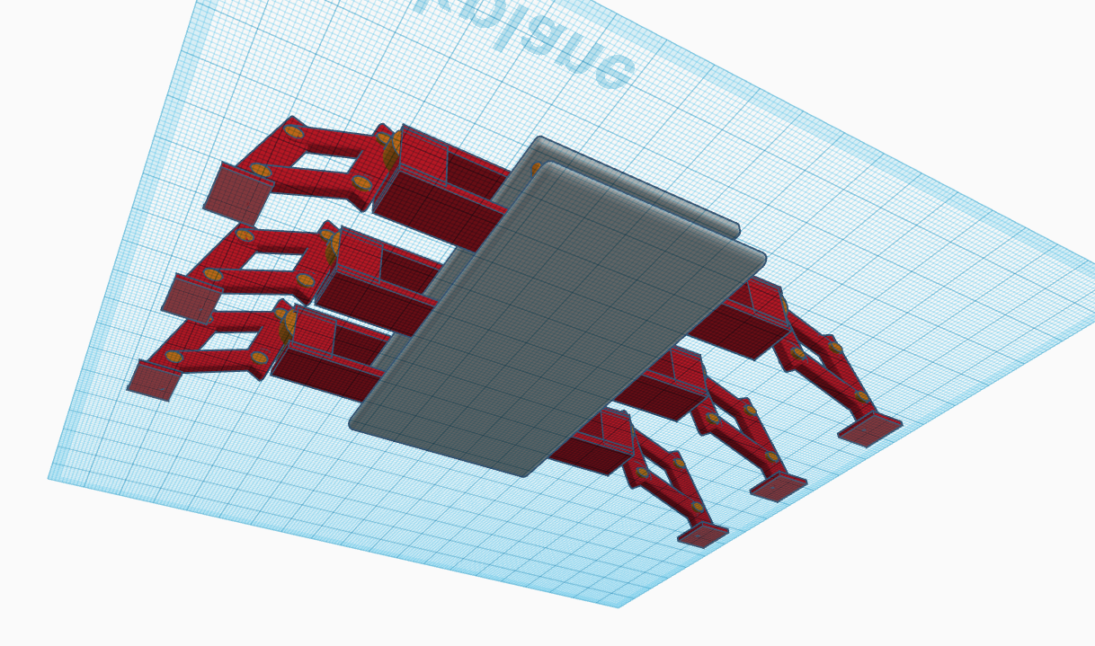

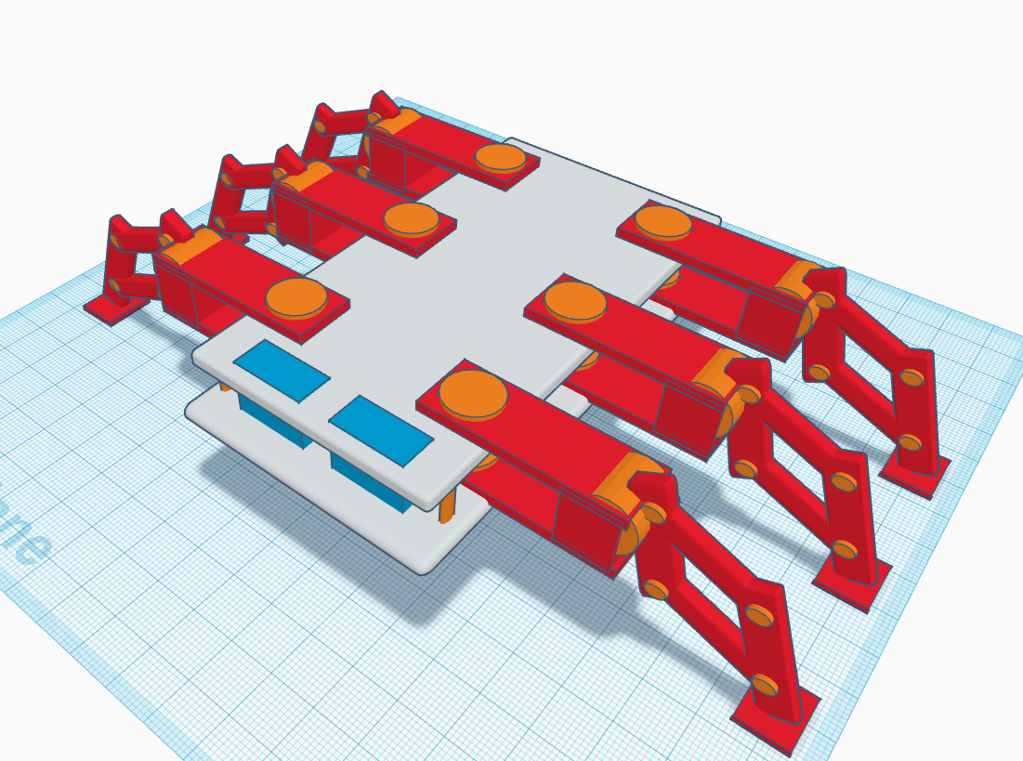

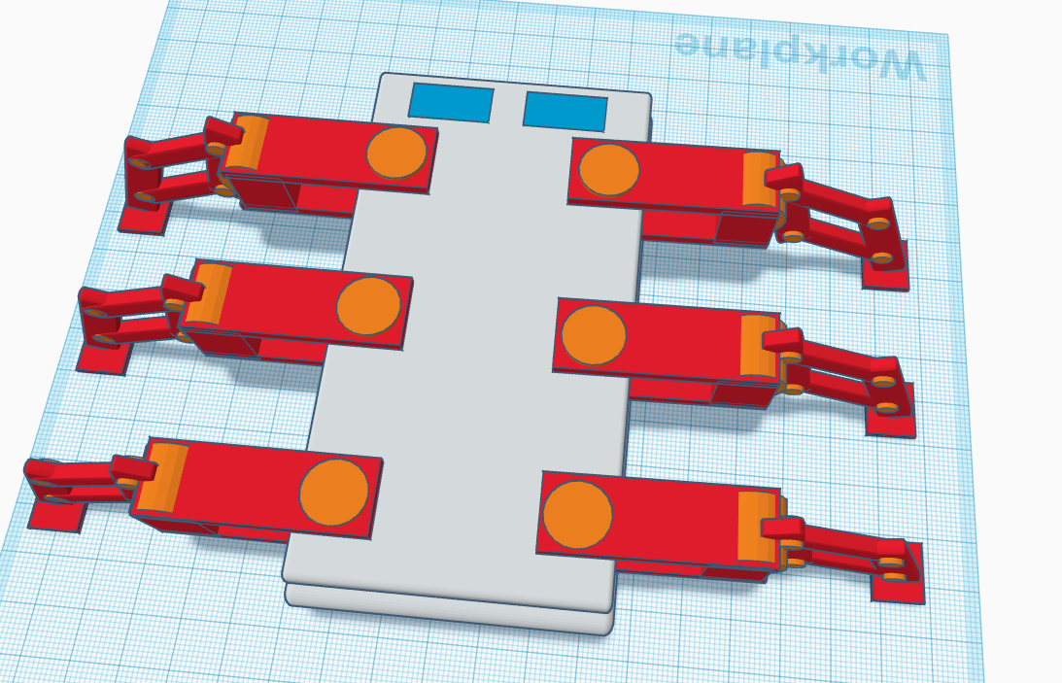

**1.9 Resource Requirements**The essential materials required for the effective conception, creation, and deployment of the spider robot system for home protection are listed in this section. Hardware and software needs are separated into two groups.

### **1.9.1 Hardware**

1. ESP8266 (Wi-Fi Microcontroller) – for communication with the mobile application via the BLYNK platform.
2. Arduino Board – Used to control lags of the robot.
3. 12 Servo Motors – To provide mobility and movement to the spider robot’s six legs.
4. Ultrasonic Sensors (x2) – One sensor for detecting objects in front of the robot and another for detecting stairs or slopes.
5. Gas Sensor – To detect any harmful gas leaks like LP gas in the home environment.
6. Infrared (IR) Fire Sensor – For detecting flames or heat.
7. PIR Motion Sensor – For detecting movement inside the house.
8. Temperature and Humidity Sensors – To monitor environmental conditions.
9. Battery Level Sensor – To continuously monitor the robot’s power levels.
10. Transparent Plastic Glass Sheets – Used for constructing the body of the robot.
11. Rechargeable Battery Pack – To power the robot and its sensors.
12. Charger – To recharge the battery pack of the robot.

### **1.9.2 Software**

1. Arduino IDE – For writing and uploading the code to control the sensors.
2. BLYNK 2.0 – A platform for developing the mobile application and web application.
3. C++ Programming Language – Used to program the microcontrollers.
4. Sensor Libraries – Libraries for each sensor type.
5. Cloud Storage (BLYNK/other) – To store data collected from the robot.

## **1.10 Project scope**

### **1.10.1 Defining the Project Scope: Inclusions and Exclusions**

|  |  |
| --- | --- |
| In Scope | Out of Scope |
| Designing and creating a practical spider robot with 6 legs, capable of traversing varied surfaces. | creation of a finished product that is prepared for mass manufacturing. |
| Identifying potential threats to home security by integrating sensors (such as motion, temperature, humidity, gas, and fire). | sophisticated threat response techniques, such as engaging intruders head-on. |
| using BLYNK 2.0 to notify the homeowner in real time about environmental and security concerns. | creating a unique app from the ground up without using BLYNK. |
| avoiding obstructions and spotting slopes or stairs with the use of ultrasonic sensors. | robot charging options that use on solar electricity or wireless technology. |
| Battery level monitoring is included to provide an alarm when the robot needs to be recharged. | Complete firefighting or suppression system. |
| keeping an eye on the house's interior temperature, humidity, and air quality. | External environmental monitoring outside the house. |

## **1.11 Chapter Summary**

In this chapter, I investigated the core parts of the spider robot project developed for boosting home security in Sri Lanka. I started with an introduction of the project, detailing its aims and novel features that employ IoT technology to enable complete monitoring and danger detection. The conversation addressed the distinct security concerns encountered by homeowners in Sri Lanka, underlining the significance of designing a solution that answers these unique demands.   
  
I defined the essential hardware and software resources needed for the project, defining the components that would allow the robot to function efficiently in diverse conditions. The project scope was established explicitly, differentiating between what would be included and excluded in the development process, guaranteeing a focused approach.

Additionally, I defined research goals that drive the design, deployment, and assessment of the spider robot, reaffirming my dedication to providing a dependable and user-friendly security solution. Finally, the chapter addressed the notion of visualizing the workflow via a rich image, which would serve as a guide for understanding the interactions inside the system.   
  
Overall, this chapter establishes the framework for the upcoming parts, preparing the way for a full analysis of the technical requirements, development procedures, and testing stages of the spider robot project.(Cavas 2019; Jdeed et al. [no date])

# **CHAPTER 02 - LITERATURE REVIEW**

## **2.1 Chapter overview**

This chapter provides a thorough literature analysis on the topic of building a spider robot for domestic security, with a focus on the Sri Lankan setting. First, it lays forth the project's theoretical underpinnings and essential principles in an organized fashion. Here we take a look at the home security system landscape as it is right now, showcasing the many frameworks and technologies that are already in use. To determine the relative merits of the proposed solution and the current state of the art, a comprehensive analysis of related systems and designs is provided.

Part of this chapter is an investigation of the technology that will be used to build the spider robot; specifically, it looks at the algorithms, designs, and workflows that will be used. In order to justify any judgements taken, this study will determine if these technologies are appropriate for the situation at hand. At the end of the chapter, there is a reflection that lays out the project's goals and identifies research gaps in the current literature.(Taryudi et al. 2018; Cavas 2019; Gul et al. 2019; Baballe et al. 2021; Baballe [no date]; Carroll et al. [no date]; Surabaya et al. [no date][a])

## **2.2 Conceptual taxonomy of the literature organization**

This part will give the reader an organized overview of the literature studied for this chapter, making it easier for them to understand how the chapter is structured and what its main points of emphasis are.

## **2.3 Domain Overview**

This section provides a cursory but essential overview of the home security industry, emphasizing the significance of security systems overall, typical dangers, and current trends. This foundation helps put the spider robot project in the larger context of home security, which is what this section aims to do.

* Current Trends in Home Security

Rapid technical breakthroughs are occurring globally in the home security market, particularly with the rise of IoT (Internet of Things) devices. Real-time monitoring, remote access, and automation are made possible by these technologies, which improve home security and management effectiveness. Typical patterns involve the application of

* Smart cameras
* Motion detectors
* Voice-activated assistants
* CCTV

Even if the use of these technologies is growing gradually, many homes still rely on outdated security systems and basic locks. On the other hand, as new technology and IoT awareness increase, so does the need for more sophisticated security solutions.

* Common Threats in Home Security

A number of threats highlight the need for improved home security systems. a few of the most frequent risks that homeowners must deal with.

* Burglaries and break-ins.
* Fire hazards.
* Gas leaks.
* Environmental threats.
* Significance of Security Systems

The suggested spider robot is an adaptable and economical solution that can monitor environmental dangers like gas leaks and fires in addition to detecting intrusions. Many existing systems aren't mobile enough or have the multi-sensory capabilities that a robot could, so this kind of innovation gives homeowners a chance to control security concerns in a way that works for them and their property.

In order to assess how the spider robot could address current shortcomings and offer a more versatile, portable, and technologically sophisticated answer to typical home security issues, this section first establishes this knowledge of the home security domain.(Kodali and Gorantla 2018; Perilla et al. 2018; Taryudi et al. 2018; Baballe et al. 2021; Al-Kuwari et al. [no date]; Baballe [no date]; Surabaya et al. [no date][b])

## **2.4 Existing Systems**

Here I take a look at the state of home security systems, frameworks, and robot designs as they pertain to identifying and avoiding dangers. I will describe the proposed spider robot's performance in comparison to other systems, such as cameras, alarms, and sensor-based solutions.

* Alarm Systems

Conventional alarm systems, which are commonly utilized, use door/window sensors and motion detectors to sound an alarm when an entry is detected. But they have restrictions.

* Only monitor specific areas.
* don't provide updates unless integrated with smart tech like ESP8266.
* Can be triggered by small movements

The benefit of a spider robot is that, in contrast to static alarms, it can move around the house and identify hazards in various locations. In addition, it keeps an eye out for temperature, gas leaks, and fires, offering a more complete security solution.

* Security Cameras

In addition to collecting video and providing real-time monitoring, cameras can also send out alerts when they detect motion. Although helpful, they have disadvantages.

* Cameras only capture dedicated areas, and it’s fixed.
* don’t do anything beyond recording.

This robot don’t have Cameras but in the other hand the spider robot is its mobility, which allows it to cover a variety of regions that are inaccessible to cameras. In addition to detecting motion, it keeps an eye out for environmental dangers and notifies homeowners in real time.

* Robotic Security Systems

Existing security robots, often outfitted with cameras and sensors, provide autonomous navigation but have limits.

* These robots are high cost
* Some robots struggle with uneven surfaces

The spider robot's six-legged design lets it to walk on a variety of surfaces, including carpets offering it greater mobility than wheeled robots. It's also inexpensive yet providing advanced protection.

## **2.5 Technological Analysis**

This section delves into the technological aspects of home security systems, focusing on how effectively they perform in real-time contexts, structural designs, and workflows. It is separated into three major categories: algorithmic analysis, design analysis, and workflow analysis.

### **2.5.1 Algorithmic Analysis**

In this section, I assess the algorithms employed by existing security robots and sensors, focusing on those that detect motion, temperature, gas leaks, and fire. The emphasis is on how efficiently and accurately these algorithms detect dangers in real time.

The spider robot has an advantage in that it uses modern algorithms to reduce false alarms and enhance danger detection accuracy by merging inputs from numerous sensors (ultrasonic, PIR,Fire, and gas).

An other benefit of using multi-sensor integration to monitor both gas and fire risks, resulting in a greater range of detection and higher accuracy, even in homes with diverse layouts.

Also algorithms in gas and fire sensors frequently detect only particular circumstances.

### **2.5.2 Design analysis**

This section examines the construction of security robots, particularly with regard to their mobility and capacity to traverse various household environments. Given the combination of carpeted flooring, tiles, and potential obstructions like furniture or stairs, a robot's functionality in a typical home is directly impacted by its design.

* A lot of current robots feature treads or wheels that perform well on level ground but poorly on uneven ground.
* The advantage of the spider robot is that it can walk on a variety of surfaces, including carpets, and even avoid obstructions because of its six legs, which are equipped with ultrasonic sensors that can detect objects or drops in its route.
* Transparent plastic glass sheets, which are strong and lightweight and perfect for indoor use, will be used to construct the robot's body. This material is appropriate for general use in both home and industrial settings because it is also reasonably priced.

### **2.5.3 Workflow analysis**

I go over how data moves via different systems in this section, as well as how they manage alert and communication systems. Timely responses to security concerns depend on effective communication.

* When dangers are identified, traditional systems notify users by email or SMS.
* The benefit of the spider robot is that it uses the BLYNK 2.0 platform to communicate in real-time, alerting the homeowner's mobile app when a threat is detected. Beyond merely warning the homeowner, it also works with a wifi relay device that can turn off the house's electricity in the case of a fire.
* Current systems frequently don't provide real-time battery level data, which makes them susceptible to malfunctioning at crucial times.
* The benefit of the spider robot is that it keeps track of its battery level and notifies the homeowner when it needs to be charged, guaranteeing that the system is always functional.

## **2.6 Reflection and Research Gaps**

The literature review is summarized in this section with an emphasis on finding weaknesses in the current home security systems and technologies. A number of drawbacks have emerged from the analysis of existing solutions, indicating the necessity for additional study.

* Reflection on Existing Systems

Alarms, cameras, and static sensors are examples of modern home security systems that excel at issuing alerts and keeping an eye on particular regions. However, their immobile nature, restricted coverage, and lack of motion result in blind spots and lessen their overall efficacy in offering complete protection. Additionally, these systems do not integrate many sensors, which limits their ability to identify a variety of dangers such as gas leaks, fires, or invasions in various parts of a house.

Robotic security systems, while advanced, often face challenges such as high cost, limited mobility on varied surfaces, and difficulty detecting obstacles or stairs. These robots, though innovative, are not fully optimized for the typical indoor environments in Sri Lanka, where uneven terrain, carpets, and obstacles like stairs are common.

* Identified Research Gaps

Existing robotic systems have trouble navigating terrain, and the majority of systems are static. A flexible mobile solution that can go freely on stairs, tiles, and carpets is required.  
  
Current systems frequently concentrate on detecting only one or two hazards, such as fire or motion. There is a lack of a multi-sensor solution that combines environmental monitoring (temperature and humidity), motion detection, gas detection, and fire detection.

Although certain systems issue warnings, they hardly ever take prompt preventative measures. Systems that can actively intervene, like turning off the electricity in the event of a fire, are lacking, which would provide an additional degree of security.

The typical Sri Lankan householder cannot afford the high-tech robotic solutions that are now available. A solution that is both affordable and offers cutting-edge security features is required.

## **2.7 Chapter Summary**

In this chapter, I examined current research and technological advancements pertaining to home security systems, emphasizing both their advantages and disadvantages. Current home security trends were highlighted in the domain review, especially in Sri Lanka, where gas leaks, fire dangers, and burglaries are key concerns.

The algorithms, designs, and processes of these systems were examined in greater detail by the technological analysis. I discovered that whereas current algorithms are capable of identifying particular hazards, they frequently fail to integrate several sensors for thorough coverage. Additionally, the present robots' designs are not flexible enough for Sri Lanka's typical indoor conditions. Furthermore, active threat response such as immediately turning off the electricity in the house.

The reflection concluded by highlighting important research needs, including the requirement for a transportable, multi-sensor, and reasonably priced solution. These deficiencies call for more study to create the suggested spider robot, which will solve these issues and offer a creative, reasonably priced home security solution designed for Sri Lankan homes.

# **CHAPTER 03 - METHODOLOGY**

## **3.1 Chapter Overview**

The process for creating and assessing the spider robot for home protection in Sri Lanka is described in this chapter. It describes the research's philosophical underpinnings, methodology, and strategy to guarantee the project achieves its goals. The chapter starts out by defending the application of the positivist research paradigm, emphasizing the collection of quantifiable and objective facts.  
  
After discussing the research strategy, the different methodologies that were used to develop, implement, and test the robot are described, including case studies and experimental methods. In order to ensure thorough fact collecting, this section also discusses the various data collection techniques, including questionnaires, interviews, and expert input. The project management and design methodologies are also described, emphasizing the methodical approach taken throughout the undertaking.  
  
The chapter concludes by going over the research workflow, covering every step from problem identification to development, and outlining the project management strategies that were employed to guarantee on-time delivery and risk reduction. Additionally stressed are the implementation of SCRUM, project schedules, and risk detection techniques. This chapter offers a road map for how the study was carried out methodically to produce trustworthy and impartial findings.

## **3.2 Research Paradigm: Positivism**

The research paradigm used in this project is positivism, which emphasizes gathering quantifiable and objective data in order to evaluate the spider robot's performance and efficacy in home protection. According to positivism, knowledge is derived from quantifiable and observable facts, and conclusions are free from subjective interpretations or personal judgements.  
  
By going with positivism, I want to evaluate the spider robot quantitatively using things like sensor data, system performance metrics, and quantifiable user input. The project's emphasis on technical analysis and real-world data collection, as opposed to depending solely on subjective interpretations or opinions, led to the choice to adopt this paradigm.



## **3.2 Research Approach**

In order to investigate and verify the spider robot's efficacy for home security, I am using deductive and inductive methods in this research.

### **3.2.1 Inductive** The spider robot is placed in various home locations and particular information is gathered about how it walks on various surfaces, how well it finds gas leaks, fires, or intrusions, and how well it notifies the homeowner of dangers.

|  |  |  |  |  |
| --- | --- | --- | --- | --- |
| Surface Type | Speed Time(s) | Gas Leak Detection Time (s) | Fire Detection Accuracy (%) | Intrusion Detection Accuracy (%) |
| Carpet | 30s | 55s | 80 | 80 |
| Tile | 10s | 20s | 70 | 95 |
| Wood | 8s | 20s | 60 | 90 |

* Speed Time

Shows how quickly the robot can move across various surfaces. A slower pace on carpet suggests possible difficulties.

* Gas Leak Detection Time

The amount of time needed for the robot to identify gas leaks.

* Fire Detection Accuracy

The proportion of tests that successfully detect fires.

* Identification of Intrusions Accuracy

The proportion of successfully identified incursions.

### **3.2.2 Deductive**