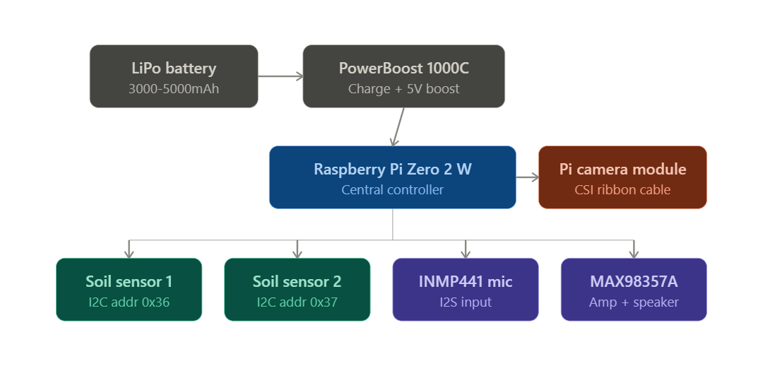
Component | Part | Image | Available Qty | Qty | For five projects(what we have to buy)
Compute | Raspberry Pi Zero 2 W | 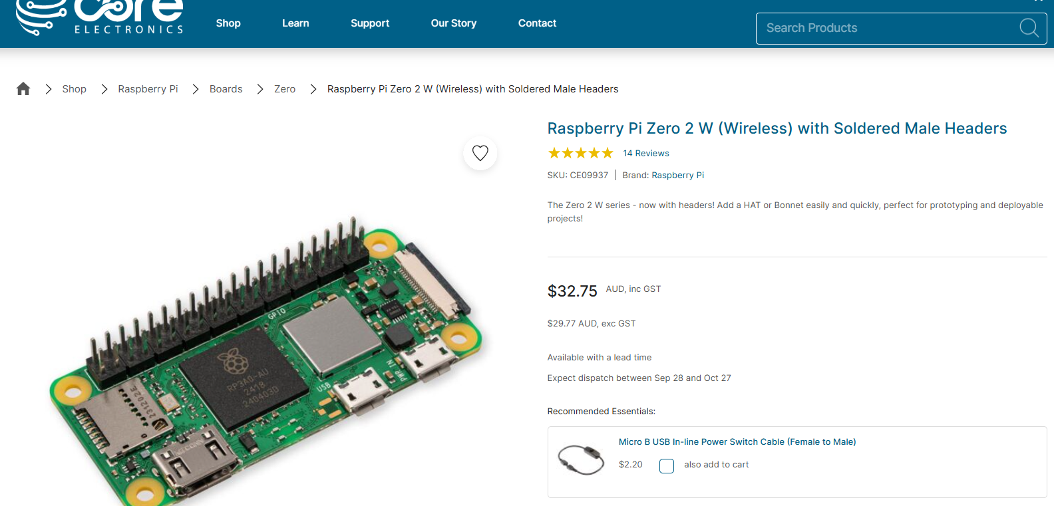 | 1 | 1 | 4
Soil sensors | Adafruit STEMMA Soil Sensor | 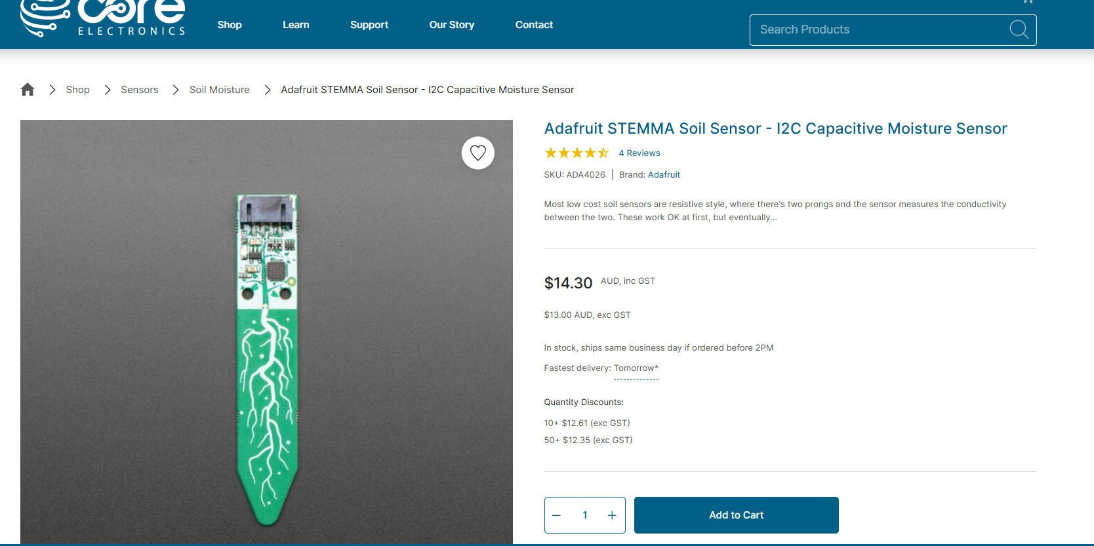 | 3 | 2 | 7
Camera | Pi Camera Module + Zero-specific CSI ribbon | 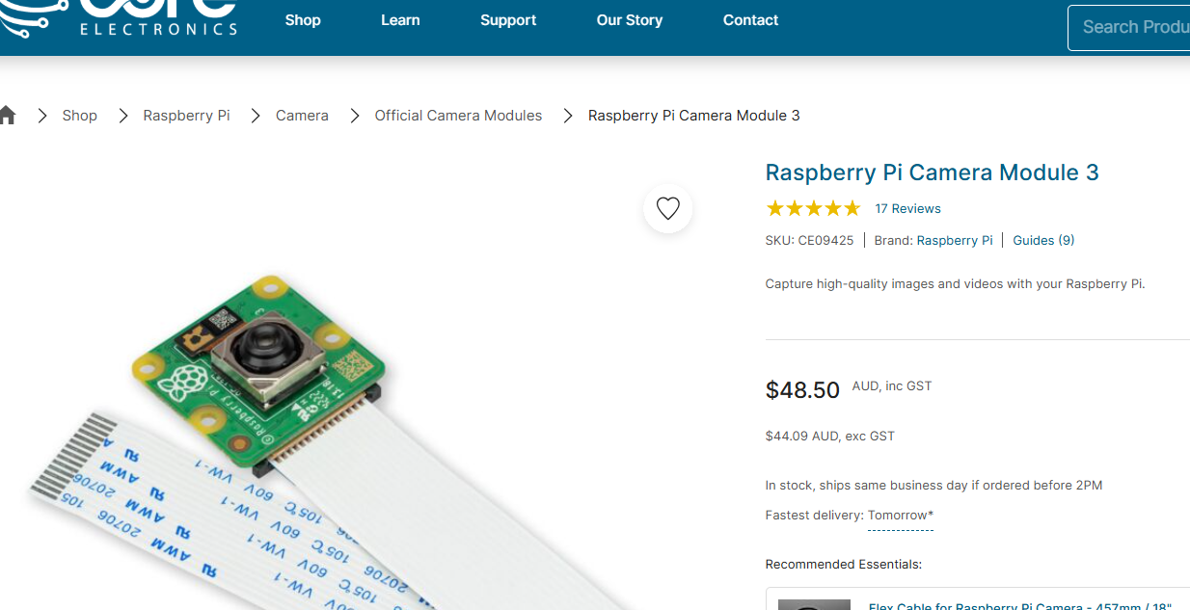 | 2 | 1 | 3
Mic | INMP441 I2S MEMS mic breakout | 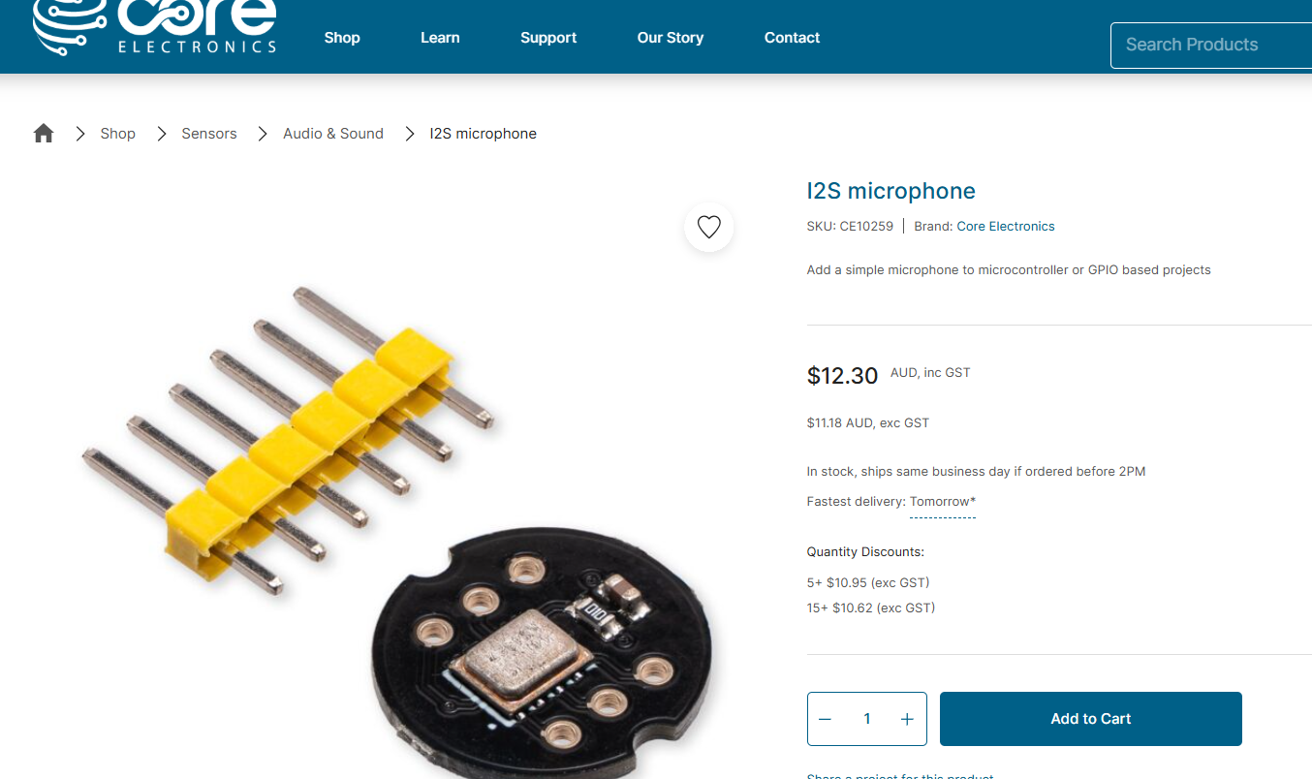 | 0 | 1 | 5
Speaker amp | MAX98357A I2S Class-D amp breakout | 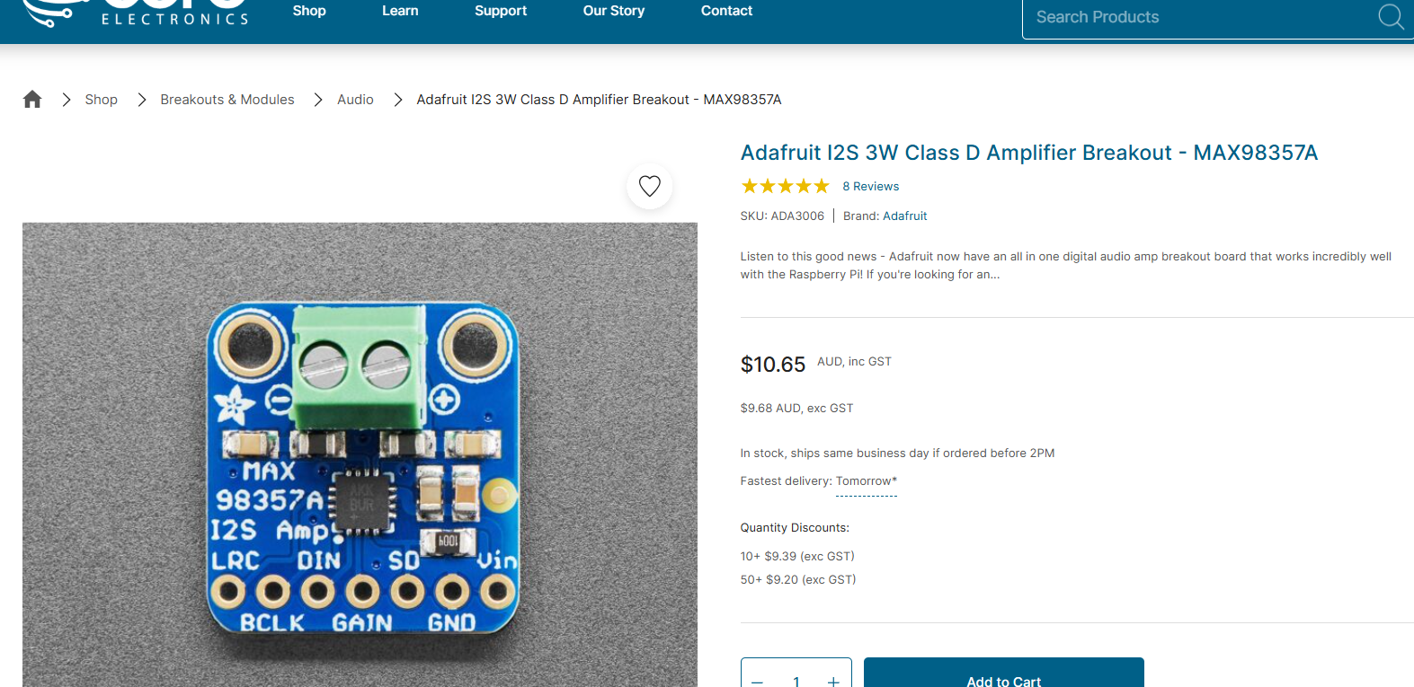 | 3 | 2 | 7
Speaker | Small 4Ω/3W speaker (28-36mm) | 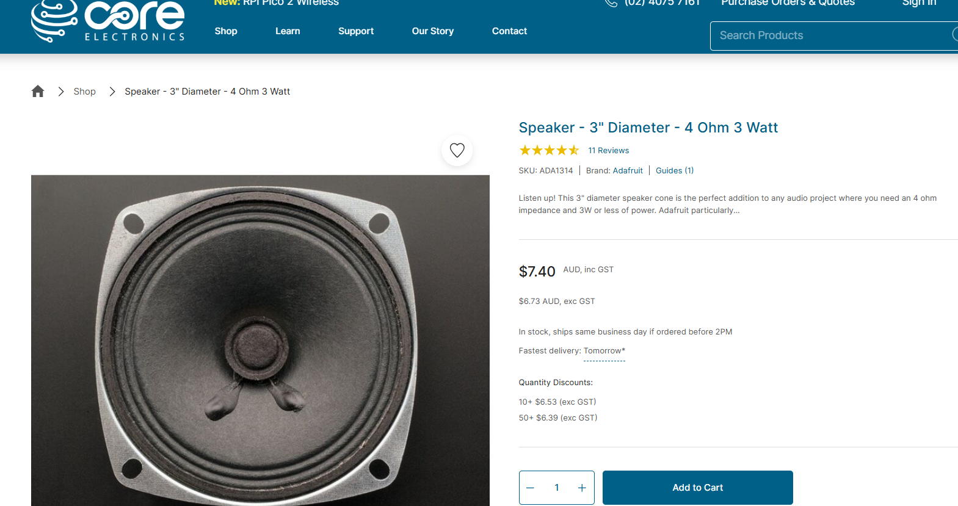 | 0 | 2 | 10
Battery | LiPo, 1100mah, JST-PH connector | 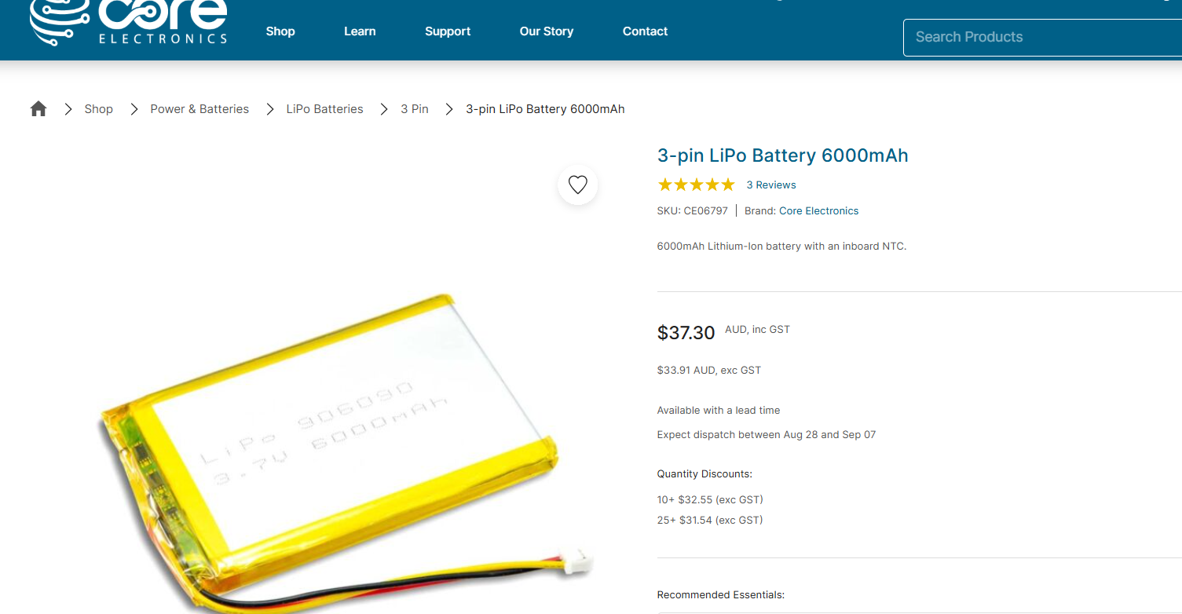 | 0 | 1 | 5
Charger/boost | Adafruit PowerBoost 1000C | 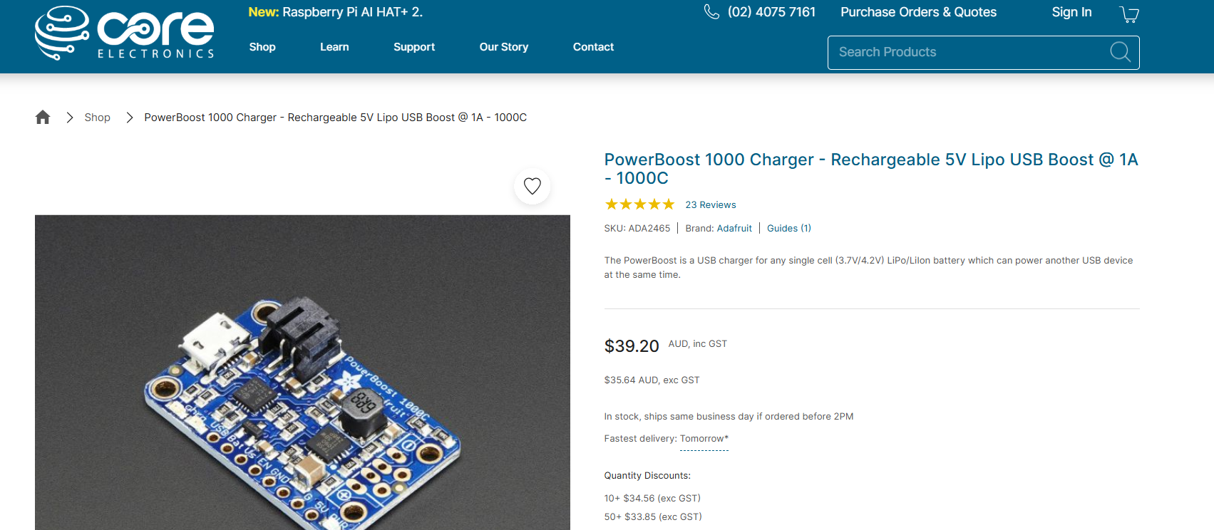 | 0 | 1 | 5

