1.

package Q_01;  
import java.lang.Math;  
public class Q_01 {  
 public static void main(String[] args) {  
 int A = 5;  
 int B = 10;  
 int C = 2;  
 int X = 20;  
 int Y = 5;  
 int R = 7;  
 final double Pi = 3.14;  
 System.*out*.println("a. " + Math.*sqrt*((B * B) - 4 * A * C));  
 System.*out*.println("b. " + Math.*sqrt*(X + 4 * (Y * Y * Y)));  
 System.*out*.println("c. " + Math.*cbrt*(X*Y));  
 System.*out*.println("d. " + Pi*R*R);  
 }  
}

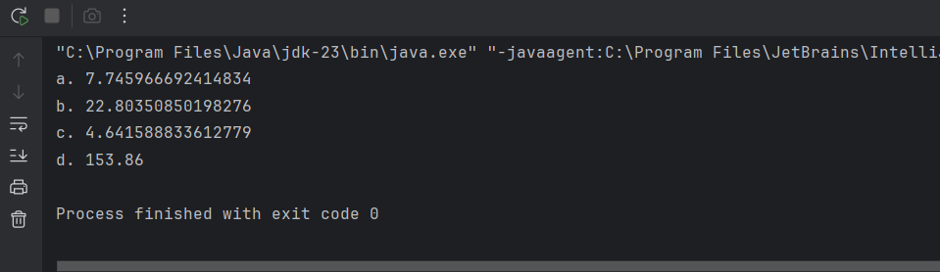

2.

package Q_02;  
import java.util.Scanner;  
public class Q_02 {  
 public static void main(String[] args) {  
 Scanner scan = new Scanner(System.*in*);  
 System.*out*.print("Enter the value in inches : ");  
 double inches = scan.nextDouble();  
 double cm = inches * 2.54;  
 System.*out*.println(inches + " inches --> " + cm + " cm.");  
 }  
}

3.

package Q_03;  
import java.util.Scanner;  
public class Q_03 {  
 public static void main(String[] args) {  
 Scanner scan = new Scanner(System.*in*);  
 System.*out*.print("Enter the value in Temperature (°C): ");  
 double celsius = scan.nextDouble();  
 double fahrenheit = (celsius * 1.8) + 32;  
 System.*out*.println(celsius + "°C --> " + String.*format*("%.2f" ,fahrenheit) + "°F");  
 }  
}

4.

package Q_04;  
import java.util.Scanner;  
public class Q_04 {  
 public static void main(String[] args) {  
 Scanner reader = new Scanner(System.*in*);  
 System.*out*.print("Enter Your Weight (pound): ");  
 double pound = reader.nextDouble();  
 double calories = pound * 19;  
 System.*out*.println("You Need to " + calories + " calories per day.");  
 }  
}

5.

package Q_05;  
import java.util.Scanner;  
public class Q_05 {  
 public static void main(String[] args) {  
 Scanner scan = new Scanner(System.*in*);  
 System.*out*.print("Enter the value in Temperature (°F): ");  
 double fahrenheit = scan.nextDouble();  
 double celsius = (fahrenheit - 32) * 5/9;  
 System.*out*.println(String.*format*("%.2f°F --> %.2f°C", fahrenheit, celsius));  
 }  
}

6.

package Q_06;  
import java.util.Scanner;  
import java.time.Year;  
public class Q_06 {  
 public static void main(String[] args) {  
 Scanner scan = new Scanner(System.*in*);  
 System.*out*.print("Enter Your born Year: ");  
 int birthYear = scan.nextInt();  
 int CurrentYear = Year.*now*().getValue();  
 int age = CurrentYear - birthYear;  
 System.*out*.println("You were born in " + birthYear + " and will be (are) " + age + " this year.");  
 }  
}

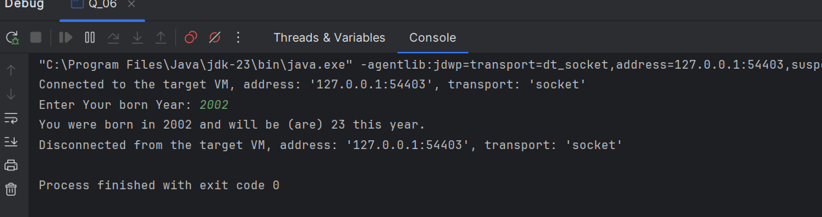

7.

package Q_07;  
import java.util.Scanner;  
public class Q_07 {  
 public static void main(String[] args) {  
 Scanner scan = new Scanner(System.*in*);  
 System.*out*.print("Enter your weight in kg: ");  
 int weight = scan.nextInt();  
 System.*out*.print("Enter your height in cm: ");  
 int height = scan.nextInt();  
 double bmi = weight / Math.*pow*(height / 100.0, 2);  
 System.*out*.println("Your BMI is: " + String.*format*("%.2f", bmi));  
 if (bmi < 18.5) {  
 System.*out*.println("Your weight is low.");  
 } else if (bmi < 25) {  
 System.*out*.println("You are normal.");  
 } else if (bmi < 30) {  
 System.*out*.println("Your weight is high.");  
 } else {  
 System.*out*.println("You are obese.");  
 }  
 }  
}

8.

import java.util.Scanner;  
public class Q_08 {  
 public static void main(String[] args) {  
 Scanner scan = new Scanner(System.*in*);  
 System.*out*.print("Enter the radius of the Sphere: ");  
 double radius = scan.nextDouble();  
 double PI = 3.14;  
 double volume = (4.0/3.0) * PI * Math.*pow*(radius, 3);  
 System.*out*.println("The Volume of the Sphere is: " + String.*format*("%.2f", volume));  
 }  
}

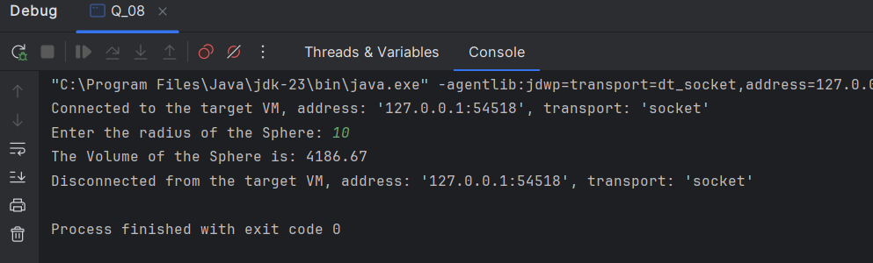

9.

package Q_09;  
import java.util.Scanner;  
public class Q_09 {  
 public static void main(String[] args) {  
 Scanner scan = new Scanner(System.*in*);  
 System.*out*.print("Enter the amount of investment: ");  
 double investment = scan.nextDouble();  
 System.*out*.print("Enter the annual interest rate in percentage: ");  
 double rate = scan.nextDouble();  
 System.*out*.print("Enter the number of years: ");  
 int years = scan.nextInt();  
 double InvestmentGrows = investment * Math.*pow*((1 + rate / 1200), years * 12);  
 System.*out*.println("The Investment value after " + years + " years is: " + String.*format*("%.2f", InvestmentGrows) + "$");  
 }  
}

10.

package Q_10;  
import java.util.Scanner;  
public class Q_10 {  
 public static void main(String[] args) {  
 Scanner scan = new Scanner(System.*in*);  
 System.*out*.print("Enter Loan Amount: ");  
 double loan = scan.nextDouble();  
 System.*out*.print("Enter Annual Interest Rate: ");  
 double rate = scan.nextDouble();  
 System.*out*.print("Enter Loan Period (year): ");  
 double period = scan.nextInt();  
 double monthInerestRate = rate/100.0/12;  
 double noOfPayment = period * 12;  
 double monthPayment = (loan * monthInerestRate)/(1-Math.*pow*(1/(1+monthInerestRate),noOfPayment));  
 double totalPayment = monthPayment * noOfPayment;  
 System.*out*.println("Monthly Payment: Rs:" + String.*format*("%.2f",monthPayment));  
 System.*out*.println("Annual Payment: Rs:" + String.*format*("%.2f",totalPayment));  
 }  
}

