
Beyond Retrieval: An LLM-Supported Dashboard for Literature Review and Research Gap Suggestion
Capstone Project Working Progess Report
Pehesara Gunawardena
Student ID: 270684416
Master of Software Engineering (Level 9)
MSE907: Industry-based Capstone Research Project
Supervisor: Dr Helena Bahrami
October 2026
Table of Contents
1. Introduction 6
2. Background and Problem Statement 6
3. Objectives of the Project 7
4. Literature Review (Indicative) 8
4.1 A published variability range, reproduced 9
4.2 A prediction that did not hold 9
4.3 The methodological warning, confirmed 9
4.4 Where the literature is thin 10
5. Identified Gaps or Challenges 10
5.1 Two challenges that emerged during implementation 11
6. Research/Project Questions or Hypothesis 11
7. Methodology / Approach 12
7.1 Why this methodology fits 13
7.2 Data collection and evaluation corpus 13
7.3 Methodological commitments 14
8. Tools and Technologies Used 14
9. System Design or Architecture Overview (if applicable) 15
9.1 Planned versus delivered 16
9.2 The process path 17
9.3 How the tool is used 18
9.4 Extensibility, by example 23
10. Implementation Plan and Progress 24
10.1 Software engineering principles applied 24
10.2 Defects worth reporting 25
11. Evaluation or Testing Strategy 25
11.1 Screening, per review 26
11.2 Retrieval, and an honest comparison 27
11.3 What the verifier actually buys 27
11.4 Why verification fails 28
11.5 Gap suggestion: precision and recall together 28
11.6 Full text, as a demonstration 29
11.7 Testing 29
12. Ethical, Legal, and Cultural Considerations 29
12.1 Data privacy and user consent 29
12.2 Legal and licensing 30
12.3 Research ethics approval: an open risk 30
12.4 Bias, with measured evidence 31
12.5 Automation bias, and why decisions are withheld 31
12.6 Cultural considerations and adaptation 32
13. Timeline and Project Plan 32
14. Current Status and Completed Deliverables (WIP) 33
15. Timeline for pending Deliverables 34
16. References 36
18. Appendix 38
Appendix A — Reproducing the results 38
Appendix B — Evidence index 38
Appendix C — The interface at submission 38

List of Figures
Figure 1. System architecture as delivered: product path and evidence path separate. 16
Figure 2. Process flow. Peach marks human-in-the-loop steps; teal the verification gate. 17
Figure 3. The question, stated plainly, becomes the inclusion rule given to the screening prompt. 18
Figure 4. Suggested papers, each carrying the sentence the judgement rests on and, where the authors state one, their own gap. 19
Figure 5. The run at a glance, and whether other authors already state the question as an open gap, in their own words. 20
Figure 6. The researcher chooses which papers to read in full. 21
Figure 7. Full text from Europe PMC: the gaps this paper states in its own body, each quoted and placed in its section, above the categorised fields and the publisher's own tables. 22
Figure 8. Every selected paper at a glance, and the export that leaves the tool as summary, structured data, CSV tables and figures. 23
Figure 9. The front door; the guest path keeps search, screening and gap suggestion open. 39

List of Tables
Table 1. Project objectives and status at week 13. 8
Table 2. RQ1 trust properties, mechanisms and evidence. 12
Table 3. The evaluation corpus; ingested counts match the proposal. 14
Table 4. Technology choices and justification. 15
Table 5. Screening results, qwen2.5:7b-instruct at USD 0.00; dashes mark figures not computed. 26
Table 6. TNR@95 by retrieval strategy; blanks are not run. 27
Table 7. Verification failures by category; automatic labels, blind rating pass pending. 28
Table 8. Fifteen-week schedule, exit tests and status. 33
Table 9. Pending deliverables, dependencies and completion criteria. 36

1. Introduction
Beyond Retrieval is a tool that intends to make progress by answering a researcher's question, recommending a set of papers to read, reporting whether these papers have already cited that question as an open research question, and obtaining structured data from the recommended papers. Works behind two AI providers, ChatGPT (OpenAI) and Gemini, in one interface, with the ability to cross-check a suggested gap with the other, as the supervisor requested. This is submitted at week 13 of a 15 week capstone from one developer.
There are three changes. It is no longer a plan; the system has been run against a 6 review set of 12,598 records and found 80 run directories, along with unexpected findings of the proposal. In week 13 the artefact was restructured from a 6-panel dashboard to a single page product (section 9). In section 7 the supervisor's October feedback introduced precision, recall and F1 per extraction type, where there was an annotated reference set.Precision, recall and F1 per extraction type were added by the supervisor's October feedback where there was an annotated reference set (section 7).
Sections 4–5 address LO1, sections 6, 7 and 11 LO2, sections 8–10 LO3, and section 12 LO4.

2. Background and Problem Statement
Research published is increasing at a rate that exceeds any one's ability to keep up, creating two burdens. Screening: a review starts with thousands of candidates, with a very small percentage eligible, and each title/abstract read by a human. Absence: what is not studied, which faster reading cannot resolve, the answer is in none of the papers' results.
The state of the art in screening is 95–100% recall, as reported in the recent work of Cohen et al. (2006) which has been followed for 20 years by automatic screening. The results are brought into question. Khraisha et al. (2024) reported GPT-4 sensitivity of 0.42 on balanced data, Kusa et al. (2023) demonstrated that the default efficiency metric is not comparable across reviews of different prevalence and Hida et al. (2026) presented a 47 percentage-point accuracy difference between models and inter-run Gwet AC2 ranging from 0.55 to 1.0.
The second burden is virtually untouched. Twenty-one review tools were evaluated and compared with thirty-four review features; in the study by Bolaños et al. (2024), none of the thirty-four were identified as absent research and only four of the tools were open-licensed and independently evaluable.
These are then grouped together to form a problem. The researcher on which a screening depends cannot at present verify the screening decision, except by reading the paper again to determine if it is based on anything the paper states. The issue of the problem is not whether a model is accurate or not, but whether its output is verifiable independently.

3. Objectives of the Project
The objectives are unchanged from Assessment 1, with status reported against success conditions fixed before implementation.
# | Objective | RQ | Status at week 13
O1 | Ingest a benchmark corpus with recorded human decisions, keeping ground truth out of prompts | Both | Met. 12,598 records across six reviews.
O2 | Screen records against published criteria, rejecting any decision whose quote is not in the source | RQ1 | Met. The span verifier gates all screening paths.
O3 | Measure accuracy, effort saved, cost and reproducibility per review | Both | Met. Per review, never pooled; 80 run directories.
O4 | Compare against random, lexical and dense baselines, plus an external active learner | RQ2 | Met. BM25, dense, hybrid, rerank and ASReview.
O5 | Suggest research gaps stated in abstracts and measure precision and recall | RQ2 | Met with a caveat. 74 statements rated (87.8% precision); blind-sampled recall is lower.
O6 | Deliver an interface a researcher can operate without the author present | Both | Built and verified; the usability exit test needs a second person and is open.
O7 | Extract structured study data from abstracts and, as a demonstration, full text | RQ2 | Met for abstracts across six reviews; full text a demonstration (section 11).
Table 1. Project objectives and status at week 13.

4. Literature Review (Indicative)
Assessment 1 brought together 20 sources in four themes. The review since then has been expanded to include the method of evaluation and active learning, and in most critical terms, the testing of the literature's claims against the measurements used for this project. There are three answers that are not consistent with the published answer.

4.1 A published variability range, reproduced
According to Hida et al. (2026), the inter-run Gwet AC2 values range between 0.55 and 1.0, with the highest value at temperature 0.0. The verification rate remained at 50.5-50.8% and the inter-run AC1 was 1.0 for five independent runs against Nelson_2002 with the cache disabled, with 186 records verified in common. Their discovery is not a problem of the inference stack of one vendor.

4.2 A prediction that did not hold
According to Khraisha et al. 2024, the best prediction of accuracy will be for balanced data; thus, this project, with its high prevalence review, should be looked upon with the highest favor. It does not. In six reviews, ranging from 0.8% to 21.9% inclusion, the most variable property is not the accuracy, but the rate of verification, from 35.6% to 94.8%, and without tracking prevalence: Smid_2020 (1%) verifies at 91.7%, and van_der_Valk_2021 (12.3%) verifies at 39.3%. An accuracy number, but no verification rate, refers to a quantity whose denominator changes in an unobserved manner.

4.3 The methodological warning, confirmed
If the prevalence of the reviews differs, then the efficiency measures cannot be compared, according to Kusa et al. (2023). One of the algorithms in this project does not change from the baseline, with a score of TNR@95 of 0.520 on Smid_2020 and 0.038 on Nelson_2002, a 14-fold difference from the corpus alone. If you were to sum them all up, the largest would be the review that was easiest so those figures are included in section 11 with the inclusion rate next to them.

4.4 Where the literature is thin
The following pattern is evident in the screening literature: Single runs pooled across corpora, accuracy only. Very few studies report any variance between the runs; virtually no studies make any distinction between correctness and verifiability; and there is not much distinction drawn between a decision that a model made wrong and one that the model could not substantiate. At the tool level, Bolaños et al. (2024) demonstrate this lack as well. The most powerful open counter-example so far, which is used here as an outside comparator, is the ASReview (van de Schoot et al., 2021).

5. Identified Gaps or Challenges
- Gap 1 — demonstrated capability has not become open, evaluated systems. Confirmed and addressed: the artefact is open-licensed, publicly hosted, runs behind a single interface against any AI provider, and each of the figures is back-traced to a run directory stored in the artefact with its configuration and commit hash.
- Gap 2 — cost and reproducibility are uncharacterised. Addressed with numbers. The two properties reported are byte-identical metrics with a stored configuration and inter-run agreement with the cache disabled (AC1 = 1.0). Cost to date: USD 0.00; two-provider comparison costed at USD 0.26, and not yet run.
- Gap 3 — identification of absent research is unaddressed. Addressed and measured. The recommended gaps are accurate at 87.8% over 74 labelled statements with a recall between approximately 0.40 and 1.00, depending on the review: the tool has a high precision and a low recall on gap statements.

5.1 Two challenges that emerged during implementation
Verification establishes that a sentence is real, not that it is relevant. Empirically determined, 4 times. For a model, it returned a set of eligibility criteria for its prompt, and a set of limitation sentences for its paper, and a set of result sentences if it was asked for gaps in the paper. All of these are real, no gap, and all of these pass the span verifier. The solution was always the same: "manage what the model sees.
An evaluation of an LLM pipeline measures the whole instrument, not the model. Five times a model failure appeared to be a retrieval problem: a BM25 baseline with scores that drifted with the reviews they indexed; the criteria echo above; Europe PMC's 1,058 character stub for an open access paper; a retrieve option for reviews for which the embeddings were not computed; and a pinned dependency that was pulled downstream.

6. Research/Project Questions or Hypothesis
RQ1 (primary) — Trustworthiness. Can an LLM-supported literature review tool produce screening decisions a researcher can independently verify and rely on? Trust is treated as four measurable properties enforced in code, not as an attitude to be surveyed. The refinement since Assessment 1 is a boundary: whether a decision can be substantiated, which the measurements show is distinct from whether it is correct.
Property | Mechanism | Evidence at week 13
Verifiable | A decision is withheld unless its quote is found verbatim in the source | Verification rate 35.6%–94.8% per review; 5,909 failures classified
Accurate | The harness measures each configuration against recorded human decisions | Recall, precision and TNR@95 per review, never pooled
Reproducible | Cache keyed on model, prompt version and record; request fingerprint; seed sent | Byte-identical metrics across repeated runs; inter-run AC1 = 1.0 over five cache-bypassed repeats
Overridable | System proposes, reviewer disposes; overrides retained as labelled data | 69.2% override rate on 13 dispositions; 13/13 matched ground truth
Table 2. RQ1 trust properties, mechanisms and evidence.
RQ2 (secondary) — Fast, accurate knowledge discovery. How much reviewing effort, time and cost does the system remove at a fixed level of recall, and can it suggest the gaps authors state in their own papers? Where a missed paper costs far more than a false positive, effort saved is always reported at a fixed recall target.
Refinement added at the supervisor's request (October 2026). Full-text extraction is kept as a demonstration and not as an important statement since no ground truth is available for it across the corpus. Extraction quality will be judged by a set of manually annotated reference sentences, and precision, recall and F1 will be reported per extraction type, while exact-match accuracy and a tolerance for numeric values will be reported.

7. Methodology / Approach
The project is based on Design Science Research as the contribution is an artefact to be evaluated against criteria rather than a theory to be tested against a hypothesis. Every week concludes with an exit test in which one factual claim is met, and scope reduction is not an option when an exit test is not met.

7.1 Why this methodology fits
There are three aspects that make design science an appropriate approach. The research questions have to do with properties of a built system that cannot be investigated without constructing the system, such as verifiability or reproducibility or cost. Success criteria are predetermined benchmarks. Evaluation is comparative to existing baseline data and primary questions do not need human-subjects data.

7.2 Data collection and evaluation corpus
The live product path uses OpenAlex, which is open, keyless and CC0. Evaluation is done via SYNERGY (De Bruin et al., 2023), a benchmark of decision making with recorded human decisions. A subset of 6 reviews was selected to capture 0.8%–21.9% of the reviews.
Review | Domain | Records | Included | Prevalence
Radjenović_2013 | Software engineering | 5,935 | 48 | 0.8%
Smid_2020 | Computer science (statistical methodology) | 2,627 | 27 | 1.0%
van_der_Waal_2022 | Medicine | 1,970 | 33 | 1.7%
Menon_2022 | Medicine | 975 | 74 | 7.6%
van_der_Valk_2021 | Medicine, psychology | 725 | 89 | 12.3%
Nelson_2002 | Medicine | 366 | 80 | 21.9%
Total |  | 12,598 | 351 | 2.8%
Table 3. The evaluation corpus; ingested counts match the proposal.

7.3 Methodological commitments
There are seven rules governing the work which are enforced either by code or by review. Ground truth is never added to the prompt: The label of inclusion is added by the ingest_loader and read by the metrics_module, and the assertions test the boundary. Each number is followed by a run directory and its configuration and commit hash. Results are reported as per review and never pooled, and the inclusion rate is provided next to these results (Kusa et al., 2023).

8. Tools and Technologies Used
Choices were made against two constraints: a USD 50 budget ceiling and roughly twelve developer-hours a week.
Layer | Choice | Justification
Language / runtime | Python 3.13 | Ecosystem fit for the NLP stack. The documented 3.11 pin was corrected: the environment was always 3.13, where the faiss pin had no wheel.
Storage | SQLite with FTS5 | Single-file and zero-administration; FTS5 supplies the BM25 baseline without a second dependency.
AI providers | ChatGPT (OpenAI) and Gemini, behind one provider interface | Two vendors, so a suggested gap can be cross-checked rather than taken on one model's word. A mock stands in for both under test.
Model for the reported runs | qwen2.5:7b-instruct | Every figure in section 11 comes from this one arm at USD 0.00; the ChatGPT and Gemini arms are built and costed at about USD 0.26, pending (section 15).
Embeddings | SPECTER2 via the adapters library | Retrieval-tuned for scientific text; the proximity adapter was verified active.
Vector search | FAISS, flat index | 12,598 records is far too small for an approximate index to be worth its accuracy loss.
Re-ranking | MiniLM cross-encoder | Applied to the fused top 200 only; re-ranking a whole corpus is slow and pointless.
API / interface | FastAPI and Streamlit | Fast to build; Streamlit's AppTest harness tests the interface without a browser.
External baseline | ASReview, run as its own CLI | Run as an external tool rather than reimplemented, removing an implementation risk.
Full text | Europe PMC open-access JATS XML | Tables and equations are parsed from structured markup rather than inferred.
Testing | pytest — 506 tests | Guards encode decisions, not only behaviour (section 10).
Table 4. Technology choices and justification.

9. System Design or Architecture Overview (if applicable)
The system design is a layer cake layered modular structure, a very thin layer of interface, an HTTP API layer, a services layer containing all the domain logic and an adapter layer that encapsulates each external dependency. A monolith fits for one researcher's machine, and the layering allows independent testing of the components.
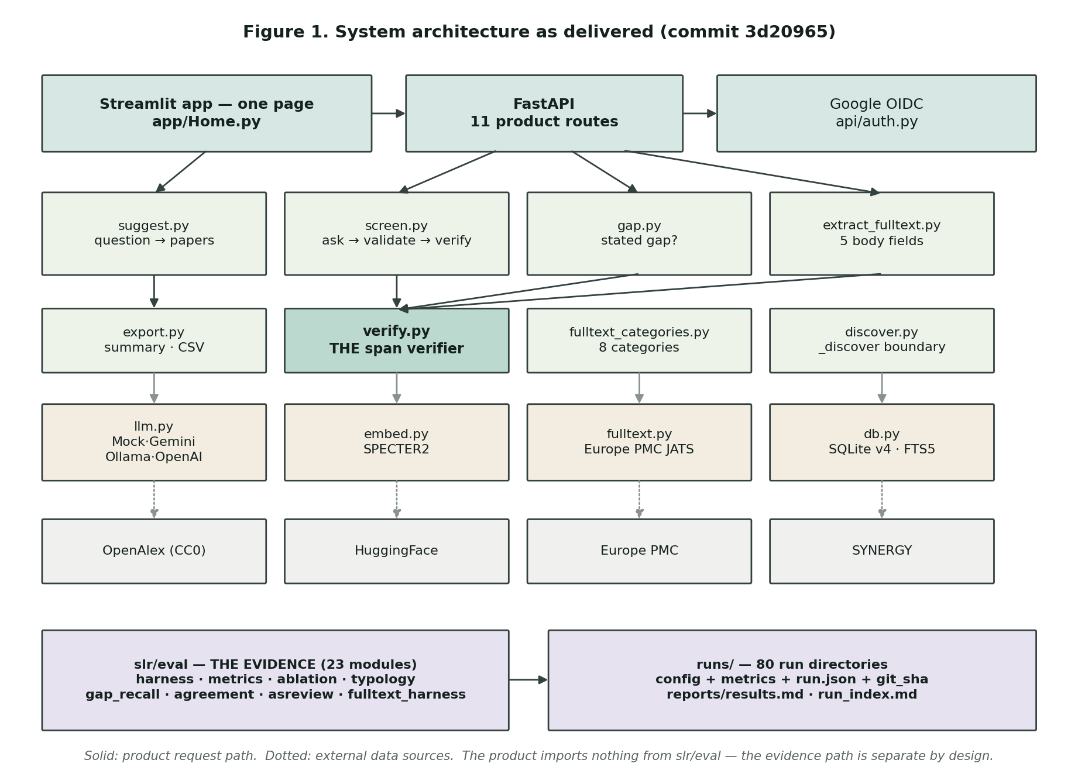
Figure 1. System architecture as delivered: product path and evidence path separate.

9.1 Planned versus delivered
Assessment 1 indicated six dashboard views, which included the benchmark evaluation in five of the views. It was given to them in week 12 and modified in week 13 because they found one question: What are the six benchmark reviews for, in the product? Nothing — they are the test harness. Now the separation is enforced: the product imports nothing from the evaluation package.

9.2 The process path
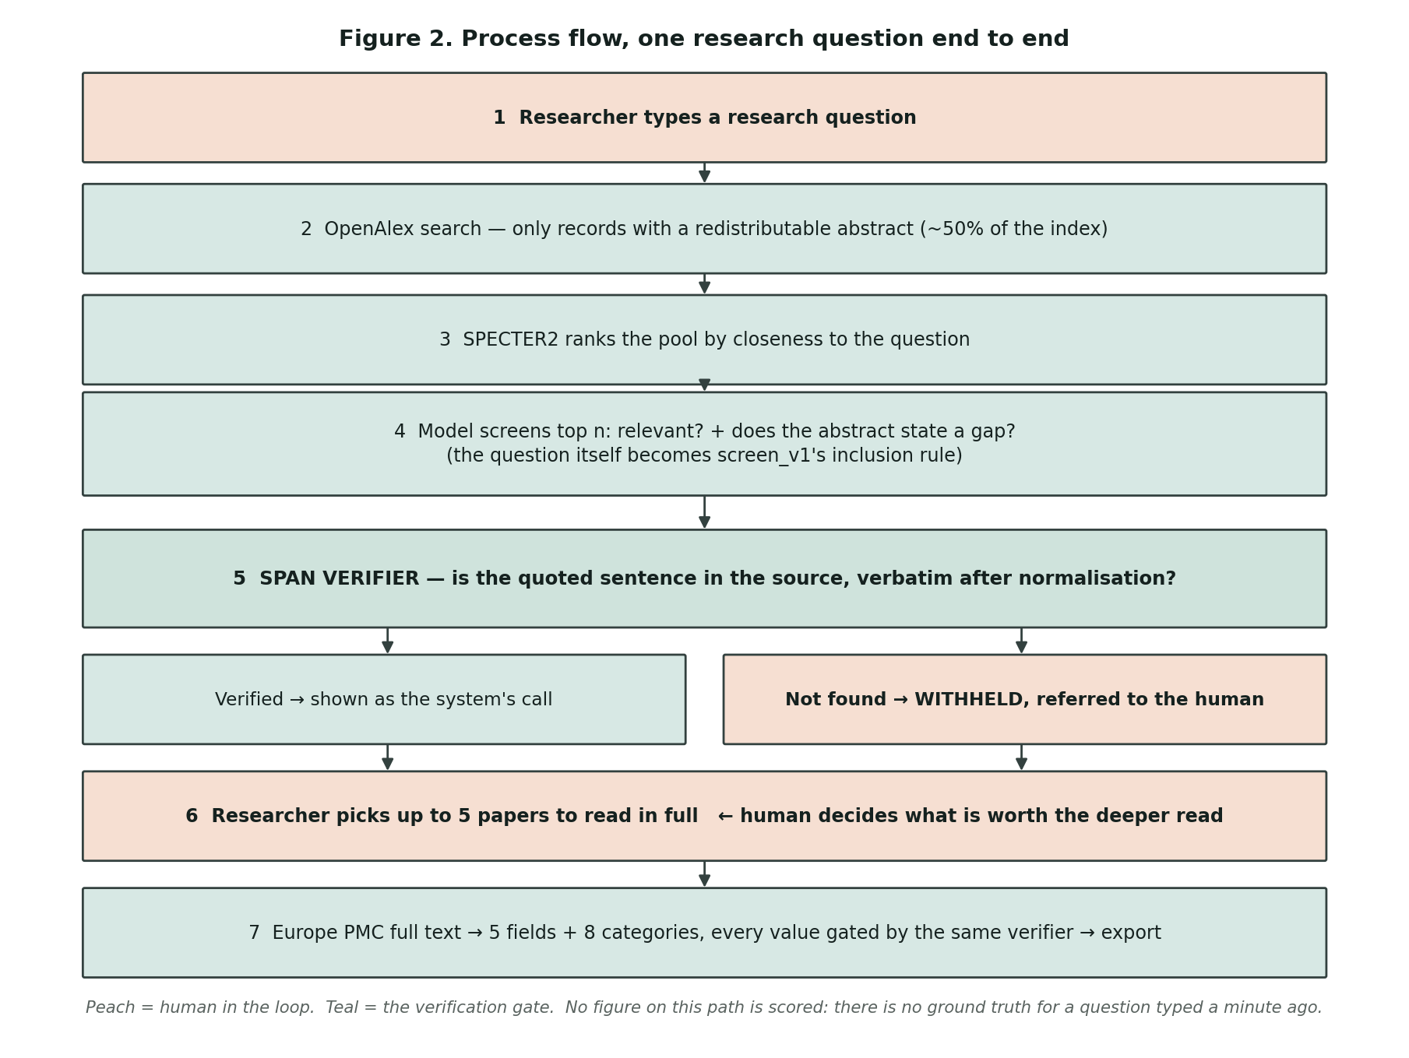
Figure 2. Process flow. Peach marks human-in-the-loop steps; teal the verification gate.
The two decisions are the most important arguments of the project. The path is not fully automatic, the researcher chooses which papers are worth a deeper examination based on the two-step structure systematic review methodology prescribes. The verification gate is located between the model and the display, which means that a decision that cannot be found in the quotation is withheld, but not displayed in the form of a confidence score.

9.3 How the tool is used
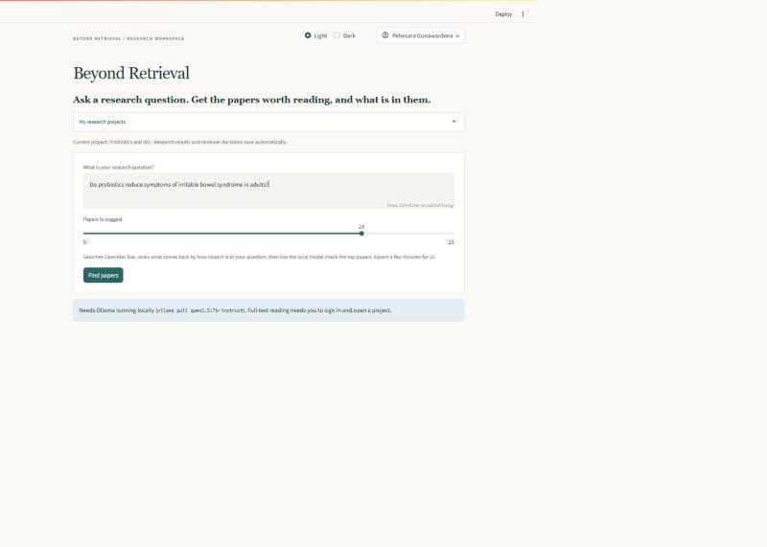
Figure 3. The question, stated plainly, becomes the inclusion rule given to the screening prompt.
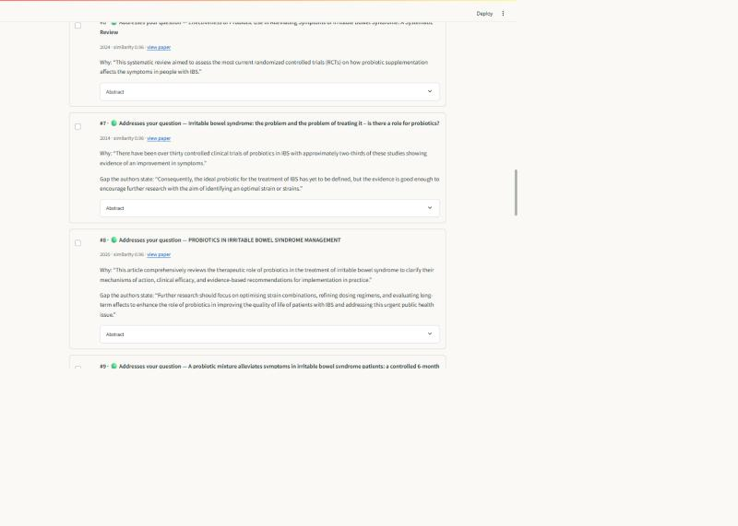
Figure 4. Suggested papers, each carrying the sentence the judgement rests on and, where the authors state one, their own gap.
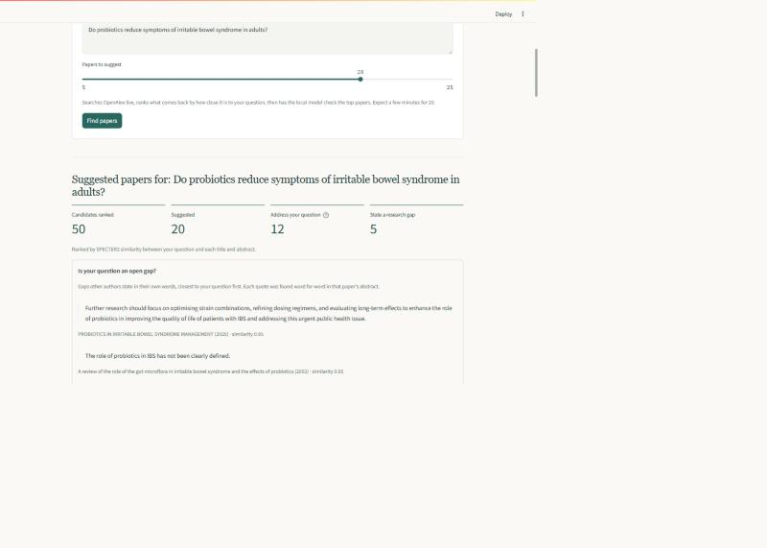
Figure 5. The run at a glance, and whether other authors already state the question as an open gap, in their own words.
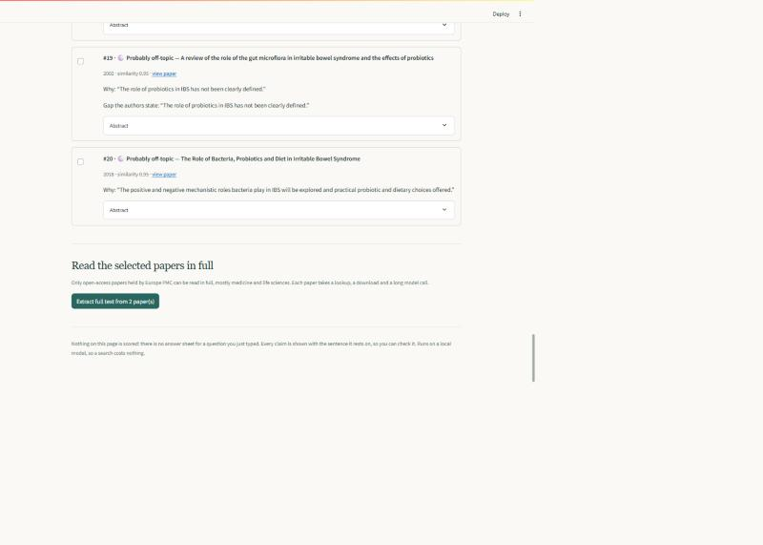
Figure 6. The researcher chooses which papers to read in full.
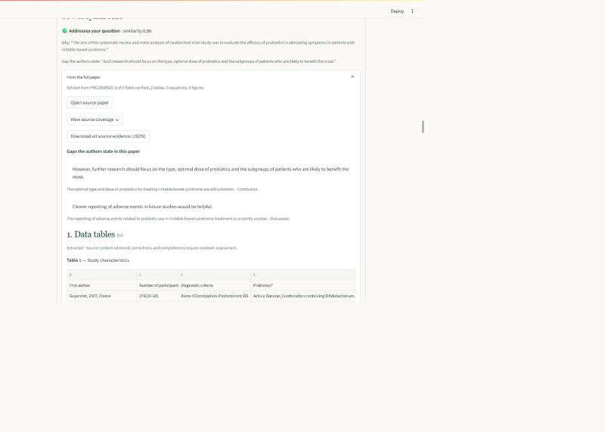
Figure 7. Full text from Europe PMC: the gaps this paper states in its own body, each quoted and placed in its section, above the categorised fields and the publisher's own tables.
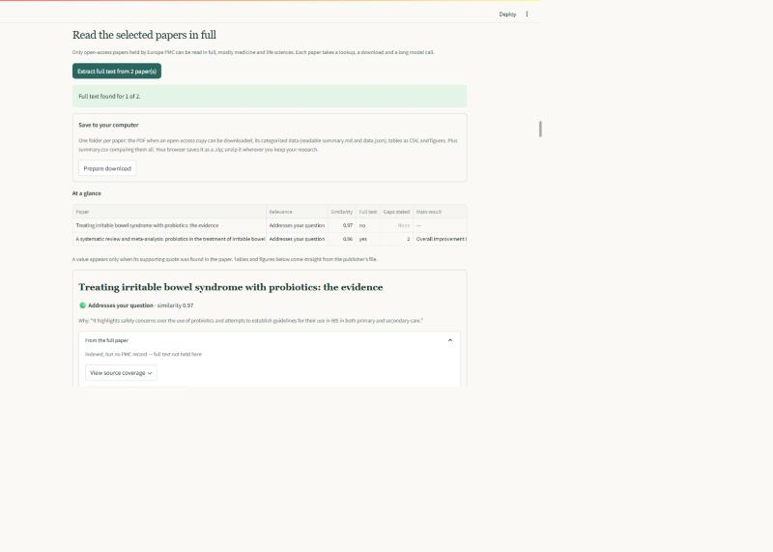
Figure 8. Every selected paper at a glance, and the export that leaves the tool as summary, structured data, CSV tables and figures.

9.4 Extensibility, by example
Two late requirements were used to test the realism of the architecture. The third model vendor required one class behind the current provider interface, while the ad-hoc user criteria did not require a new screening path as the service already accepted criteria as plain text.

10. Implementation Plan and Progress
The evaluation harness was introduced in week 8, followed by retrieval optimisation in week 9, following the philosophy that if you have a faster retriever without any way to measure it, then it's time that you can't measure.

10.1 Software engineering principles applied
Separation of concerns, enforced. Domain logic, external systems, measurement are in services, adapters, evaluation package. The interface was completely reworked in week 13 without any services being modified, and no measured figure changed in the test suite.
Interface segregation and dependency injection. There is one provider protocol behind Mock, ChatGPT, Gemini and Ollama, with each service getting its provider, not building one themselves, thus allowing the pipeline to be deterministic on a mock. That is lying about 20% of the time intentionally, hence the failure to verify path is executed for each test.
Tests as executable design decisions. There are 506 tests, a subset of which encode commitments, not behaviour; as the ground truth does not reach a prompt; as ad hoc records do not enter in the evaluation corpus; as three models screening one record produce three distinct cache entries (in this case, with a collision, an agreement figure is read as 1.0 by construction).
Fail fast, and name the failure. No warnings: The budget ceiling aborts a run; a cached response whose fingerprint differs raises, not serves stale; a retrieval strategy that cannot run names the missing package.
Reproducibility treated as an engineering property. The metrics file is a purely configuration/corpus file: if the file contains timestamps and commit hash, the testability of reproducibility is easy to check, but not necessarily achieved.

10.2 Defects worth reporting
But four defects are reported, since they were all design flaws, not typing errors. The web framework sends dependency and route body to different workers, fixed in the database layer, and database connections are thread-affine. One extraction run served stale responses from a previous broken run as a result of a cache-staleness bug – the response schema wasn't in the hash of the request. The BM25 baseline was not corpus-independent and all numbers on it were moved, corrected runs are listed next to the ones that were moved. The fourth was due to the product itself: OpenAlex returns abstracts as a word-to-positions index and when traversing the positions, starting with zero and going up to the maximum, one position missing meant the whole question was failed with a server error.

11. Evaluation or Testing Strategy
The evaluation focuses on RQ1 by answering the question if the provided information is verifiable, accurate, reproducible, and if there is a gap in the information that was suggested by the author, the effect of human override; and RQ2 by answering the question about effort, latency, cost, and author-stated gap suggestion. It employs the six-review SYNERGY subset shown in Table 3, with each review scored independently of the one it has been given as human decision, which are not used in retrieval or in prompts, but rather are only used for scoring purposes. Every run records its configuration, prompt and model versions, corpus identifiers and commit hash.
Screening is evaluated based on precision, recall against verified decisions, verification rate, recall of unverified referrals after being retained, and retrieval at fixed recall target (95%) with TNR against random, BM25 and ASReview, with latency and cost as secondary criteria (after quality). Inter-run agreement is obtained from repeat runs without the cache. Gap suggestion is manually rated under a rule set that is determined prior to the rating; full-text extraction is a demonstration only until the reference set is annotated. There are 506 tests that are passed and the usability condition is pending ethics approval.
Each of the numbers below is an index into 80 run directories, keyed by kind and commit_hash. Total spend = USD 0.00.

11.1 Screening, per review
Review | Prev. | Verified | Recall (verified) | Recall (+referrals) | TNR@95 | AC1
Radjenović_2013 | 0.8% | 35.6% | 0.925 | 0.938 | 0.209 | 0.950
Smid_2020 | 1.0% | 91.7% | 0.308 | — | 0.113 | —
van_der_Waal_2022 | 1.7% | 39.3% | — | — | — | —
Menon_2022 | 7.6% | 94.8% | — | — | — | —
van_der_Valk_2021 | 12.3% | 39.3% | 0.320 | 0.809 | 0.138 | —
Nelson_2002 | 21.9% | 51.9% | 0.906 | — | 0.164 | —
Table 5. Screening results, qwen2.5:7b-instruct at USD 0.00; dashes mark figures not computed.
The column that is not typically reported in the literature is the verification rate and is the most important column. A decision which isn't found in a quote is a referral, not a prediction and is scored accordingly – with recall being listed alongside it.

11.2 Retrieval, and an honest comparison
Review | BM25 | Dense | Hybrid | Rerank | ASReview
Radjenović_2013 | — | — | — | — | 0.947
Smid_2020 | 0.520 | 0.696 | 0.757 | 0.757 | 0.822
van_der_Waal_2022 | — | — | — | — | 0.813
Menon_2022 | — | — | — | — | 0.723
van_der_Valk_2021 | 0.049 | 0.181 | 0.068 | 0.068 | 0.500
Nelson_2002 | 0.038 | 0.178 | 0.094 | 0.094 | 0.497
Table 6. TNR@95 by retrieval strategy; blanks are not run.
All strategies created here pass on all three comparisons available the lexical baseline making it through the week 9 exit test. But it's not surprising that ASReview outranks them all, as it goes over the true labels as it proceeds and retrains, while each of the strategies listed here rank once and not update. This is a case for adaptive re-ranking in the future.

11.3 What the verifier actually buys
An ablation replayed the un-verified system's answers for each of the 12,598 decisions, providing a perfect reconstruction of the system. When decisions are not trusted, recall increases on all reviews between +0.027 and +0.697. The price is just volume: 13 records, as opposed to 451 records, on one review; 141 as opposed to 3,953 records on another — a trade, not a win.

11.4 Why verification fails
Failure category | Count | Share
Echoed the eligibility criteria from the prompt | 5,778 | 97.8%
Near paraphrase of a real sentence | 53 | 0.9%
Stitched from separate sentences | 57 | 1.0%
Genuinely fabricated | 12 | 0.2%
Other | 9 | 0.2%
Total failures across six reviews | 5,909 | 100%
Table 7. Verification failures by category; automatic labels, blind rating pass pending.
This alters the claim of the project in a predominantly positive manner. It hardly ever makes up a quote — 12 times in 5,909 attempts. It does answer another question, namely, the rule it used if you ask it for it. This isn't a deceptive failure of prompt comprehension, but rather a measure of prompt quality.

11.5 Gap suggestion: precision and recall together
Each of the 74 statements in all six reviews was rated with respect to the full abstract under a rule set a priori: 87.8% precision; 75.7% if the rating does not include statements naming a gap the same paper that fills it. Recalls estimated by blind labelling a seeded sample of records, which ranged from 0.40 to 1.00 for four reviews, and whose 95% Wilson interval was large enough to suggest only direction. The majority of misses sampled are motivating, and suppress them.

11.6 Full text, as a demonstration
Full text is a demonstration under the supervisor's direction. The three papers and one open access stub were created in 78 seconds in one live run across four papers. Four out of 20 field slots verified; nine correct refusals, editorial with no primary outcome, told by the system. There were two types of failure: when the model generates its own prose instead of a quotation, and when it repeats a quotation in three fields. A second ability came on 22 October, which a paper states in its body. It has been run once to give the same limit as in section 5.1, and the model now selects from three of four gaps that include a result sentence that is quotable, using forward-looking language to determine that one of them is quotable. There is no measurement for precision and recall.

11.7 Testing
506 automated tests pass. The interface controls the canned responses and separately the live API; the latter identified three errors that the former missed.

12. Ethical, Legal, and Cultural Considerations

12.1 Data privacy and user consent
As little personal data as possible is stored in the system but still allows for saved work. Authentication is based on Google OpenID Connect identity scope only, and all passwords and tokens are not stored, only the stable subject identifier, verified email and display name. Sessions are stateless hashes, and are valid for 24 hours before they expire and upon sign out. Saved projects belong to the accounts, and tests are that one account cannot read another's.
The one-time login ticket is sent as a URL parameter (as opposed to being stored in the residual risks). It is only used once, it has a 120 second expiration time and it is tied to the originating browser, but it will be recorded in the browser history.

12.2 Legal and licensing
OpenAlex is CC0, and can be freely displayed; Europe PMC is queried solely for its open-access subset. The SYNERGY abstracts are not redistributable content: The data directory and the raw responses to the models are not under version control, and only the beginning sentences of the sources are quoted in the report. The published eligibility criteria are stored locally, hashed to all the metrics files for the sake of provenance, and not committed. These credentials are omitted by default from the repository as it is public, and are also not added if they are omitted because the exclusion is checked before keys are added.

12.3 Research ethics approval: an open risk
The proposal outlined it would be seeking ethics approval for the usability study in week 7. Not submitted and reported as live risk.
The resulting outcome is limited. It only affects one half of the human-subjects usability evaluation, the exit test in which a second person completes a query on his own, and has no effect on any result in section 11, which is an absolute measurement against a published benchmark. The interface is functioned end-to-end with real data and there is no author assessment of the usability of their tool.

12.4 Bias, with measured evidence
Three biases are identifiable; one can be quantified.
Disciplinary bias in the extraction schema. Four of the abstract level extraction fields (study design, sample size, country, key finding) were influenced by conventions for the reporting of clinical trials. A software engineering review, measured by the number of records, found the lowest frequencies, with 36% of the records and 7.6% sample size verified by study design. Such a tool that presented these fields as universal would fail to adequately serve non-medical researchers.
Language bias. The literature search and the corpus are English-only and it is noted as a limitation, not a solution.
Source coverage bias. Coverage of OpenAlex is not equal across region or publisher, and Zheng et al. (2025) report on the under-coverage of Chinese scholarship. The second is the nature of the system itself: OpenAlex can share abstracts that are redistributable for only roughly half of the papers it indexes, and those abstracts go through the pipeline, so no matter how relevant a paper is, if it doesn't have an abstract that can be shared, then it is rendered invisible.

12.5 Automation bias, and why decisions are withheld
The primary ethical concern is that the researcher relies on the tool and calibration measurement makes that clear: mean model confidence was 0.813 when the quote was verified and 0.798 when it was not, based on 23,148 decisions. The model is not less confident when it is unable to give an answer than when it is able to, there is no threshold to divide the two. If there is no substantiation, the decision is deferred and referred.

12.6 Cultural considerations and adaptation
Culture of research varies across disciplines. The gap-statement rate is measured and ranges from 3.8% to 52.2% depending on the genre of the abstract (the six reviews), rather than depending on the prevalence of gap statements, which can be conventional in environmental-health reviews, but are not very common in software engineering reviews. If a software engineering researcher writes that there were no gaps, then he or she reports a writing convention as a finding.
Three adaptations follow. The extraction schema should be flexible on a per-discipline basis. It is important to note that gap suggestion should only be made if any gap is found and not as a conclusion; the base rate of the discipline should be reported with any gap. The tool is open and keyless, in addition to being usable without institutional database subscriptions – it reads OpenAlex, and requires only a provider API key.

13. Timeline and Project Plan
Week | Deliverable | Exit test | Status
7–8 | Evaluation harness, ingest, span verifier, baselines | A stored configuration reproduces an identical metrics file | Passed
9 | SPECTER2 embeddings, FAISS, rank fusion, cross-encoder | Beats the lexical baseline on ≥3 reviews | Passed
10 | Prompt variants, model tiers, repeats, overrides | Every RQ1 property has a number | Passed
11 | Gap suggestion and go/no-go checkpoint | 30 statements rated, precision recorded, decision minuted | Exceeded target (74 rated); go decision approved; minute pending
12 | API and interface | A second person completes a query unassisted | Open — requires a participant (section 12.3)
13 | Hardening and reproduction script | A fresh clone runs on a second machine | Passed, with one caveat: a pinned dependency was withdrawn upstream
14 | Code frozen, all baselines run | Every figure traces to a run directory and commit | Met — 80 run directories indexed by kind and commit
15 | Report, packaging, submission | Submitted | In progress
Table 8. Fifteen-week schedule, exit tests and status.

14. Current Status and Completed Deliverables (WIP)
At week 13 the artefact is functionally complete and the evaluation substantially so. Delivered and verified:
- One-page research tool: question in; gap signal; ranked, screened papers; full-text extraction of selected papers; gap extraction in selected papers' body; export to summary, data, CSV tables and figures.
- 5,909 model claims were failed by a span verifier and type failure was reported and 12,598 records were evaluated per review.
- A comparative retrieval evaluation with random, lexical, dense, hybrid and cross-encoder strategies, along with ASReview – an exact ablation of the verification mechanism, and a blind-sampled recall estimate for gap suggestion.
- 80 run directories containing configuration, metrics and commit hash that are indexed in reports/run_index.md; 506 tests passed..
Five items are open: the usability exit test, which requires a second participant; the ethics application; a hand-rating pass to validate automatic failure classifications; the second provider arm, which is built and costed at about USD 0.26, and whose agreement does not test correctness, but consistency; precision and recall for gaps suggested from full text.

15. Timeline for pending Deliverables
The remaining work is scheduled to be completed in the sequence below: These are weeks that you are committed to, not weeks that you have reached, and no human-participant work will start until approved. If the dependency cannot be achieved, the failure is noted in the final report, and the dependency is not deleted.
Pending deliverable | Target | Dependency | Completion criterion
Ethics application | Week 14 | Supervisor review and the institutional ethics process | Submit and retain the decision; no recruitment or participant data before approval.
Unassisted usability exit test | Weeks 14–15 | Ethics approval, consent and an available second participant | A second person completes a query unassisted. If approval is unavailable, report the exit test as not met and withdraw the usability claim.
Manual validation of failure classifications | Week 14 | The stored 5,909 classifications and a procedure fixed before rating | A documented hand-rating pass reporting how far the automatic categories agree with manual judgement.
Second provider comparison | Week 14 | Provider access and budget; estimated cost about USD 0.26 | Run the same records through ChatGPT and Gemini and report quality, agreement, cost and latency. If not run, report the comparison as designed but unexecuted.
Annotated extraction and full-text gap evaluation | Week 14–15 | A manually annotated reference set, with field definitions and scoring rules fixed first | Precision, recall and F1 per extraction type, exact-match accuracy for numbers, and precision and recall for full-text gap statements, with quote verification kept separate.
Final report, reproducibility check and submission package | Week 15 | Completed evaluations or explicitly recorded limitations; supervisor feedback | Update claims and figures, verify each result against its run directory and commit, record the dependency-pin caveat, and submit the report and runnable artefact.
Table 9. Pending deliverables, dependencies and completion criteria.

16. References
Bolaños, F., Salatino, A., Osborne, F., & Motta, E. (2024). Artificial intelligence for literature reviews: Opportunities and challenges. Artificial Intelligence Review, 57(10), 259.
Cohan, A., et al. (2020). SPECTER: Document-level representation learning using citation-informed transformers. Proceedings of ACL 2020.
Cohen, A. M., et al. (2006). Reducing workload in systematic review preparation using automated citation classification. Journal of the American Medical Informatics Association, 13(2), 206–219.
De Bruin, J., et al. (2023). SYNERGY — Open machine learning dataset on study selection in systematic reviews. DataverseNL.
Gwet, K. L. (2014). Handbook of inter-rater reliability (4th ed.). Advanced Analytics.
Hida, G. S., Ribeiro, D. M., & Yahata, E. (2026). Beyond accuracy: LLM variability in evidence screening for software engineering. arXiv:2604.27006.
Khraisha, Q., et al. (2024). Can large language models replace humans in systematic reviews? Research Synthesis Methods, 15(4), 616–626.
Kitchenham, B., & Charters, S. (2007). Guidelines for performing systematic literature reviews in software engineering (EBSE Technical Report EBSE-2007-01).
Kusa, W., et al. (2023). An analysis of work saved over sampling in the evaluation of automated citation screening. Intelligent Systems with Applications, 18, 200193.
Priem, J., Piwowar, H., & Orr, R. (2022). OpenAlex: A fully-open index of scholarly works, authors, venues, institutions, and concepts. arXiv:2205.01833.
Singh, A., et al. (2023). SciRepEval: A multi-format benchmark for scientific document representations. Proceedings of EMNLP 2023.
van de Schoot, R., et al. (2021). An open source machine learning framework for efficient and transparent systematic reviews. Nature Machine Intelligence, 3, 125–133.
Zhang, C., et al. (2023). Automatic recognition and classification of future work sentences from academic articles in a specific domain. Journal of Informetrics, 17(1), 101373.
Zheng, X., et al. (2025). Understanding discrepancies in the coverage of OpenAlex: The case of China. Journal of the Association for Information Science and Technology.

18. Appendix

Appendix A — Reproducing the results
The repository is public at github.com/KavinduPehesara/Beyond-Retrieval. One script performs the whole chain: environment, pinned install, tests, ingest of the six reviews, and a smoke evaluation writing its own run directory. Verified in week 13 from a fresh clone, with all tests passing and ingested counts matching Table 3.

Appendix B — Evidence index
Every figure traces to a stored run directory. reports/run_index.md lists all 80 with harness kind, configuration, reviews and commit hash; ten that produced no figure are set aside.

Appendix C — The interface at submission
Figure 9 is the front door. Every walkthrough figure in section 9.3 was captured from one signed-in session on 25 October 2026 at commit 442559c, the state submitted.
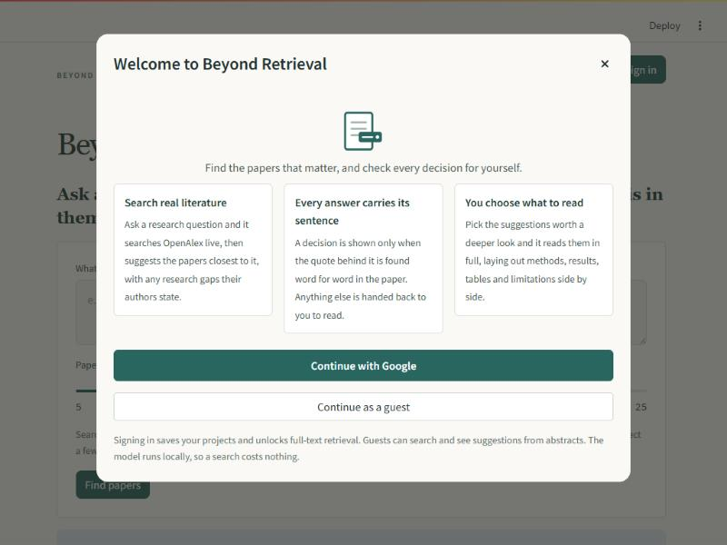
Figure 9. The front door; the guest path keeps search, screening and gap suggestion open.

