Beyond Retrieval
An LLM-Supported Tool for Literature Discovery and Research Gap Detection
MSE907.2 — Work in Progress Report
Name: Nadurana Pathirennahalage Kavindu Pehesara Gunawardena
Student ID: 270684416
Programme: Master of Software Engineering (Level 9), 180 Credits
Course: MSE907: Industry-based Capstone Research Project (60 Credits)
Supervisor: Dr Helena Bahrami
Assessment: Assessment 2 — Work in Progress Report (40%)
Date: 25 October 2026
Repository: github.com/KavinduPehesara/Beyond-Retrieval (public)
Reported at: commit 442559c

1. Introduction
This report describes progress on Beyond Retrieval, a locally runnable tool that takes a researcher's question, finds the papers worth reading, reports whether other authors already name that question as an open research gap, and extracts structured data from the papers selected. It is submitted in week 13 of a fifteen-week capstone by one developer at roughly twelve hours a week, building on Assessment 1.
Three things have changed since that proposal. The evaluation is no longer a plan: the system has run against a six-review benchmark of 12,598 records, producing 80 run directories and findings the proposal did not expect. The artefact was restructured in week 13 from a six-panel dashboard into a single-page product (section 9). And the supervisor's October feedback added an evaluation requirement — precision, recall and F1 per extraction type against an annotated reference set — now in section 7.
Sections 4–5 address LO1, sections 6, 7 and 11 LO2, sections 8–10 LO3, and section 12 LO4.

2. Background and Problem Statement
Published research grows faster than anyone can follow, imposing two burdens. Screening: a review begins with thousands of candidates, a very small fraction eligible, each title and abstract read by a human. And absence: what has not been studied, which faster reading cannot solve, because the answer is in no single paper's results.
Screening has twenty years of automation behind it, from Cohen et al. (2006), and recent work reports language models screening at 95–100% recall. Those results are contested. Khraisha et al. (2024) measured GPT-4 sensitivity at 0.42 on balanced data; Kusa et al. (2023) showed the default efficiency metric is not comparable across reviews of differing prevalence; and Hida et al. (2026) reported a 47 percentage-point accuracy spread between models and inter-run Gwet AC2 from 0.55 to 1.0, the same model asked twice.
The second burden is almost untouched. Bolaños et al. (2024) surveyed twenty-one review tools against thirty-four features: none of the thirty-four concerns identifying absent research, and only four tools were open-licensed and independently evaluable.
These combine into one problem. A model's screening decision cannot currently be checked by the researcher who depends on it: there is no mechanism short of re-reading the paper to establish whether the verdict rests on anything the paper says. The problem is therefore not whether a model screens accurately, but whether its output can be made independently verifiable, and whether the same discipline can surface the gaps authors state themselves.

3. Objectives of the Project
The objectives are unchanged from Assessment 1, with status reported against success conditions fixed before implementation.
# | Objective | RQ | Status at week 13
O1 | Ingest a benchmark corpus with recorded human decisions, keeping ground truth out of prompts | Both | Met. 12,598 records across six reviews, matching the proposal.
O2 | Screen records against published criteria, rejecting any decision whose quote is not in the source | RQ1 | Met. Span verifier gates all screening paths.
O3 | Measure accuracy, effort saved, cost and reproducibility per review | Both | Met. Per review, never pooled; 80 run directories.
O4 | Compare against random, lexical and dense baselines, plus an external active learner | RQ2 | Met. BM25, SPECTER2 dense, hybrid, rerank and ASReview.
O5 | Detect research gaps stated in abstracts and measure precision and recall | RQ2 | Met with a caveat. 74 statements rated (87.8% precision); blind-sampled recall is lower.
O6 | Deliver an interface a researcher can operate without the author present | Both | Built and verified; the usability exit test needs a second person and is open.
O7 | Extract structured study data from abstracts and, as a demonstration, full text | RQ2 | Met for abstracts across six reviews; full text a demonstration (section 11).
Table 1. Project objectives and their status at week 13.

4. Literature Review (Indicative)
Assessment 1 synthesised twenty sources across four themes. The review has since extended to evaluation methodology and active learning and, more importantly, to testing the literature's claims against this project's own measurements. Three results do not agree with the published position.

4.1 A published variability range, reproduced on different hardware
Hida et al. (2026) report inter-run Gwet AC2 between 0.55 and 1.0, the upper end at temperature zero. Five independent runs against Nelson_2002 with the cache disabled gave inter-run AC1 = 1.0 across the 186 records verified in common, verification rate holding at 50.5–50.8%. The result sits at the temperature-zero edge of their range on a different model and different hardware, so their finding is not an artefact of one vendor's inference stack.

4.2 A prediction that did not hold
Khraisha et al. (2024) predict accuracy looks better on balanced data, so this project's high-prevalence review should look strongest. It does not. Across six reviews spanning 0.8%–21.9% inclusion, the sharpest-varying property is not accuracy but verification rate, ranging from 35.6% to 94.8% without tracking prevalence: Smid_2020 at 1.0% verifies at 91.7%, van_der_Valk_2021 at 12.3% verifies at 39.3%. An accuracy figure reported without a verification rate describes a quantity whose denominator varies unobserved.

4.3 The methodological warning, confirmed empirically
Kusa et al. (2023) argued that efficiency metrics are not comparable across reviews of differing prevalence. This project's BM25 baseline, one unchanged algorithm, scores TNR@95 of 0.520 on Smid_2020 and 0.038 on Nelson_2002 — a fourteen-fold spread from the corpus alone. Any pooled figure would be dominated by whichever review happened to be easiest, which is why section 11 reports per review with the inclusion rate beside it.

4.4 Where the literature is thin
The screening literature shows a consistent pattern: single runs, pooled across corpora, accuracy alone. Few studies report inter-run variance, almost none separate verifiability from correctness, and the distinction between a decision a model got wrong and one it could not substantiate is generally not drawn. Bolaños et al. (2024) show the same absence at the tool level. ASReview (van de Schoot et al., 2021) is the strongest open counter-example, used here as an external comparator.

5. Identified Gaps or Challenges
- Gap 1 — demonstrated capability has not become open, evaluated systems. Confirmed and addressed: the artefact is open-licensed, publicly hosted, runs locally at zero marginal cost on a consumer GPU, and every figure traces to a stored run directory with its configuration and commit hash.
- Gap 2 — cost and reproducibility are uncharacterised. Addressed with numbers. Reproducibility is reported as two properties: byte-identical metrics from a stored configuration, and inter-run agreement with the cache disabled (AC1 = 1.0). Cost to date is USD 0.00, because the reported evaluation runs on local inference.
- Gap 3 — identification of absent research is unaddressed. Addressed and measured. Gap discovery achieves 87.8% precision over 74 rated statements, but blind-labelled recall is between roughly 0.40 and 1.00 depending on the review: a high-precision, low-recall detector of literal gap statements.

5.1 Two challenges that emerged during implementation
Verification establishes that a sentence is real, not that it is relevant. Found empirically, four times. In screening the model returned the eligibility criteria from its own prompt as the evidence quote; in full text it quoted a table cell as prose and a competing-interests statement as a limitation; asked for a paper's stated gaps, it returned results sentences. Each is real, none is a gap, and all pass the span verifier. The fix in all four cases was the same: control what the model may see, rather than catching a bad quotation afterwards.
An evaluation of an LLM pipeline measures the whole instrument, not the model. Five times a figure that looked like a model failure proved to be an instrument problem: a BM25 baseline whose scores drifted with which reviews were indexed; the criteria echo above; Europe PMC flagging a paper open access then serving a 1,058-character stub; a retrieval option offered for reviews whose embeddings were never computed; and a pinned dependency withdrawn upstream. Attributing any of these to the model would have published a number that was wrong.

6. Research/Project Questions or Hypothesis
RQ1 (primary) — Trustworthiness. Can an LLM-supported literature review tool produce screening decisions a researcher can independently verify and rely on? Trust is treated as four measurable properties enforced in code, not as an attitude to be surveyed. The refinement since Assessment 1 is a boundary: whether a decision can be substantiated, which the measurements show is distinct from whether it is correct.
Property | Mechanism | Evidence at week 13
Verifiable | A decision is withheld unless its quote is found verbatim in the source | Verification rate 35.6%–94.8% per review; 5,909 failures classified
Accurate | The harness measures each configuration against recorded human decisions | Recall, precision and TNR@95 per review, never pooled
Reproducible | Cache keyed on model, prompt version and record; request fingerprint; seed sent | Byte-identical metrics across repeated runs; inter-run AC1 = 1.0 over five cache-bypassed repeats
Overridable | System proposes, reviewer disposes; overrides retained as labelled data | 69.2% override rate on 13 dispositions; 13/13 matched ground truth
Table 2. RQ1 trust properties, mechanisms and evidence.
RQ2 (secondary) — Fast, accurate knowledge discovery. How much reviewing effort, time and cost does the system remove at a fixed level of recall, and can it surface the gaps authors state in their own papers? Where a missed paper costs far more than a false positive, effort saved is always reported at a fixed recall target.
Refinement added at the supervisor's request (October 2026). Full-text extraction is retained as a demonstration rather than a core claim, because no reliable ground truth exists for it across the corpus. Extraction quality is to be evaluated against a manually annotated reference set, reporting precision, recall and F1 per extraction type, with exact-match accuracy and a predefined rounding tolerance for numerical values. A verified quote demonstrates traceability, not correctness, so quote verification is reported separately.

7. Methodology / Approach
The project follows Design Science Research, because the contribution is an artefact evaluated against stated criteria rather than a theory tested against a hypothesis. Each week ends in one factual claim — an exit test — with scope cut rather than time extended when one fails.

7.1 Why this methodology fits
Three features of the problem make design science appropriate. The research questions concern properties of a built system — verifiability, reproducibility, cost — that cannot be investigated without building it. Success criteria are thresholds fixed in advance, which prevents a result being rationalised afterwards. And evaluation is comparative against existing baselines, so the primary questions require no human-subjects data.

7.2 Data collection and evaluation corpus
The live product path uses OpenAlex, which is open, keyless and CC0. Evaluation uses SYNERGY (De Bruin et al., 2023), a benchmark of reviews with recorded human decisions. A six-review subset was chosen so inclusion rates span 0.8%–21.9%, because screening accuracy inflates on balanced data.
Review | Domain | Records | Included | Prevalence
Radjenović_2013 | Software engineering | 5,935 | 48 | 0.8%
Smid_2020 | Computer science (statistical methodology) | 2,627 | 27 | 1.0%
van_der_Waal_2022 | Medicine | 1,970 | 33 | 1.7%
Menon_2022 | Medicine | 975 | 74 | 7.6%
van_der_Valk_2021 | Medicine, psychology | 725 | 89 | 12.3%
Nelson_2002 | Medicine | 366 | 80 | 21.9%
Total |  | 12,598 | 351 | 2.8%
Table 3. The evaluation corpus; ingested counts match the proposal.

7.3 Methodological commitments
Seven rules govern the work, enforced in code or by review. Ground truth is never placed in a prompt: the inclusion label is written by the ingest loader, read only by the metrics module, and tests assert the boundary. Every number comes from a run directory with its configuration and commit hash. Results are reported per review and never pooled, with the inclusion rate beside them (Kusa et al., 2023). A fourth rule, recording a negative result the day it is observed, produced most of section 5.

8. Tools and Technologies Used
Choices were made against two constraints: a USD 50 budget ceiling and roughly twelve developer-hours a week.
Layer | Choice | Justification
Language / runtime | Python 3.13 | Ecosystem fit for the NLP and evaluation stack. The documented 3.11 pin was corrected: the environment had always been 3.13, where the original faiss pin had no wheel.
Storage | SQLite with FTS5 | Single-file and zero-administration; FTS5 supplies the BM25 baseline without a second dependency.
Local inference | Ollama running qwen2.5:7b-instruct | Zero marginal cost on the author's own GPU, preserving the budget for a paid comparison arm, and its JSON-schema parameter gives the same constrained-output guarantee as hosted providers.
Hosted inference | Google Gemini; OpenAI (built, not yet run) | The cost and latency arm for RQ2, behind the same provider interface.
Embeddings | SPECTER2 via the adapters library | Retrieval-tuned for scientific text. The proximity adapter was verified active by comparing embeddings with and without it.
Vector search | FAISS, flat index | 12,598 records is far too small for an approximate index to be worth its accuracy loss.
Re-ranking | MiniLM cross-encoder | Applied to the fused top 200 only; re-ranking a whole corpus is slow and pointless.
API / interface | FastAPI and Streamlit | Fast to build; Streamlit's AppTest harness tests the interface without a browser.
External baseline | ASReview, run as its own CLI | Run as an external tool rather than reimplemented, removing an implementation risk.
Full text | Europe PMC open-access JATS XML | Tables and equations are parsed from structured markup rather than inferred from prose.
Testing | pytest — 506 tests | Guards encode decisions, not just behaviour (section 10).
Table 4. Technology choices and their justification.

9. System Design or Architecture Overview
The system is a layered modular monolith: a thin interface over an HTTP API, over a services layer holding all domain logic, over adapters isolating every external dependency. A monolith suits one researcher's machine; the layering makes the components independently testable.
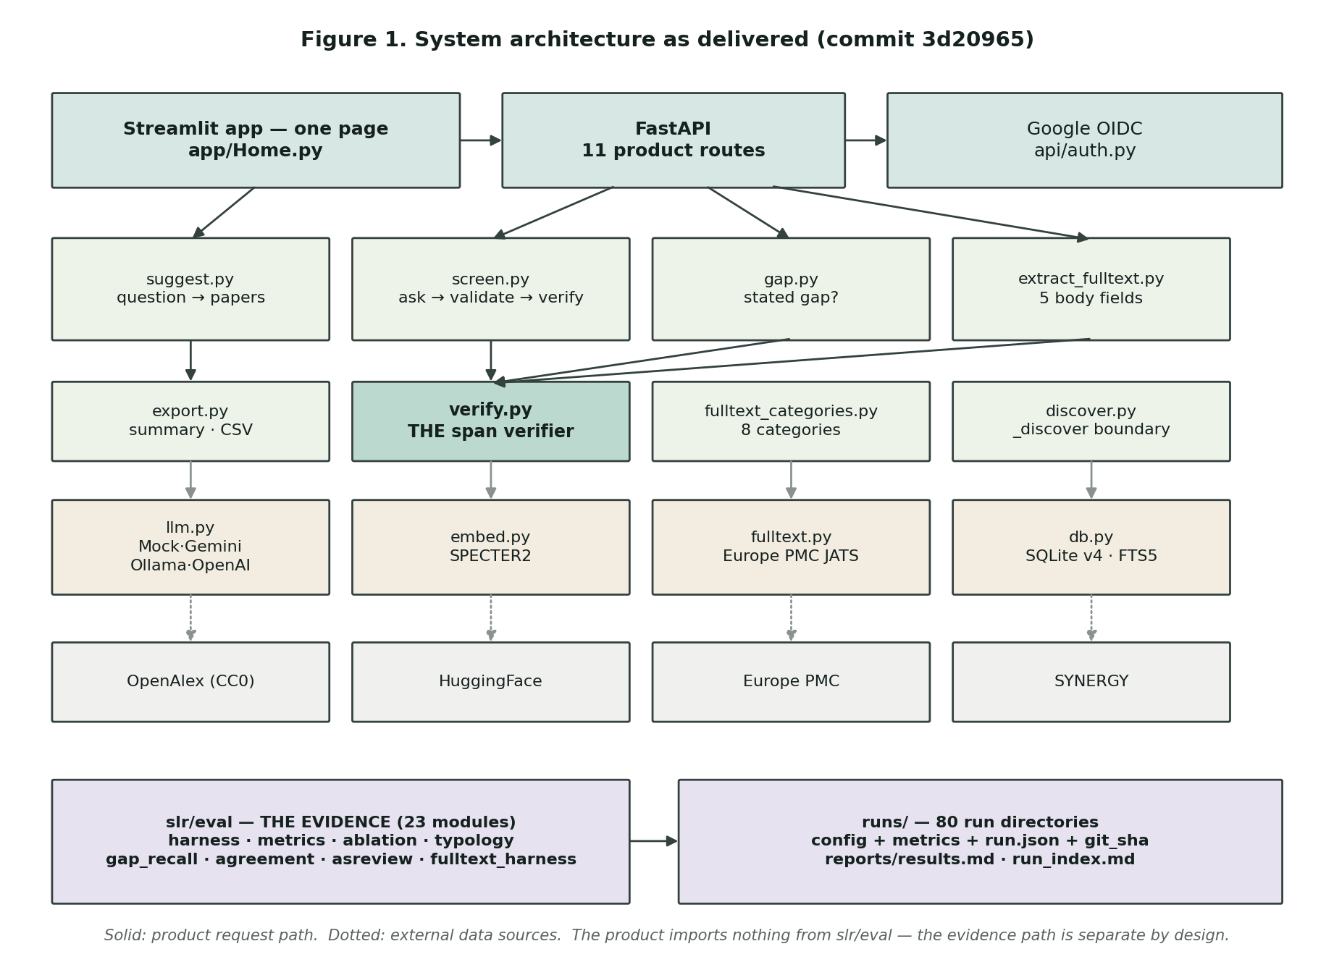
Figure 1. System architecture as delivered: product path and evidence path separate.

9.1 Planned versus delivered
Assessment 1 specified six dashboard views, five presenting the benchmark evaluation. That design was delivered in week 12 and revised in week 13 after one question: what are the six benchmark reviews for, in the product? Nothing — they are the test harness, and an interface leading with them demoed as a report about its own evaluation rather than as a tool. The separation is now enforced rather than conventional: the product imports nothing from the evaluation package.

9.2 The process path
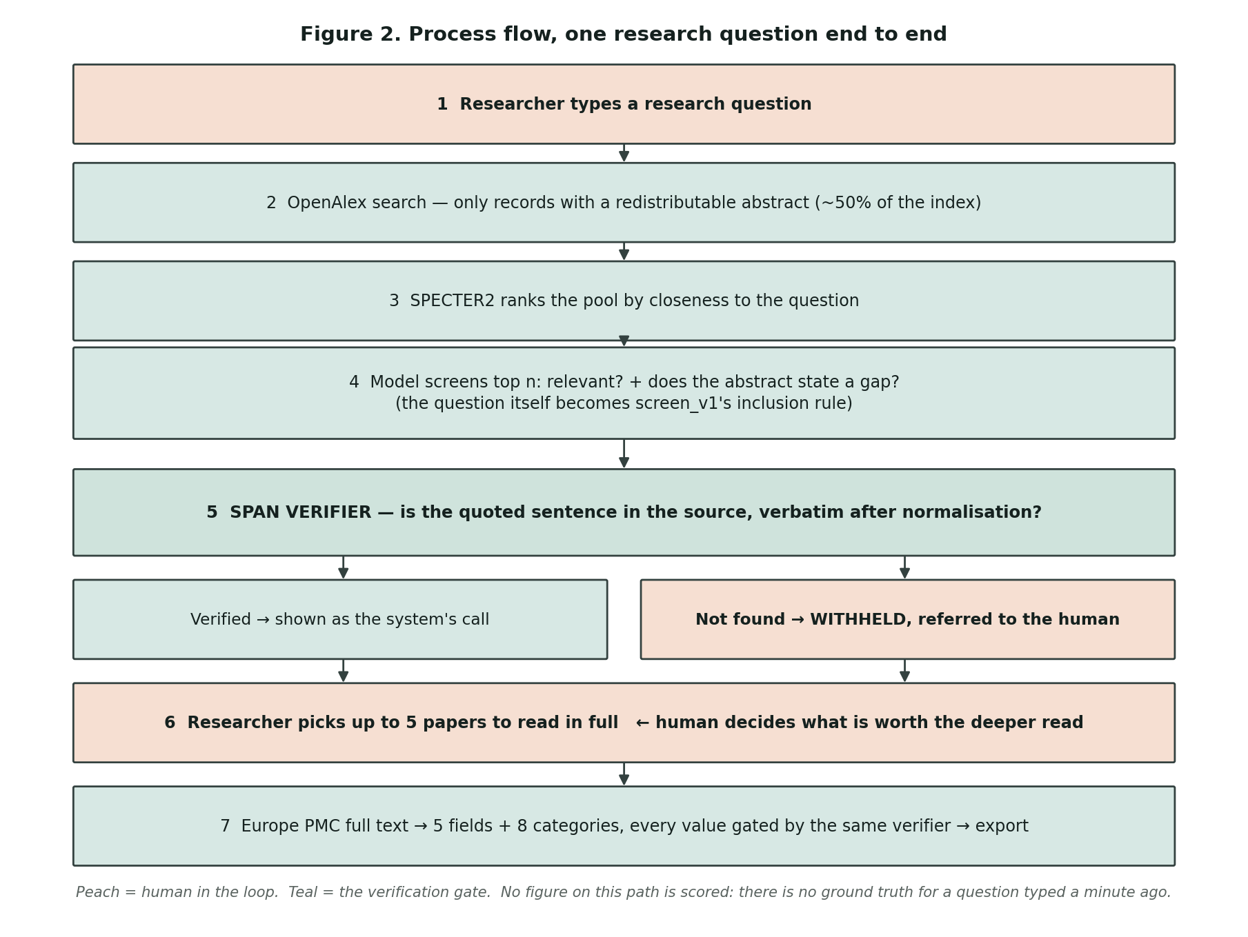
Figure 2. Process flow. Peach marks human-in-the-loop steps; teal the verification gate.
Two decisions carry most of the project's argument. The path is deliberately not fully automatic: the researcher decides which papers deserve a deeper read, following the two-stage structure systematic review methodology prescribes. And the verification gate sits between the model and the display, so a decision whose quotation cannot be located is withheld and referred rather than shown with a confidence score.

9.3 How the tool is used

Figure 3. The question, stated plainly, becomes the inclusion rule given to the screening prompt.
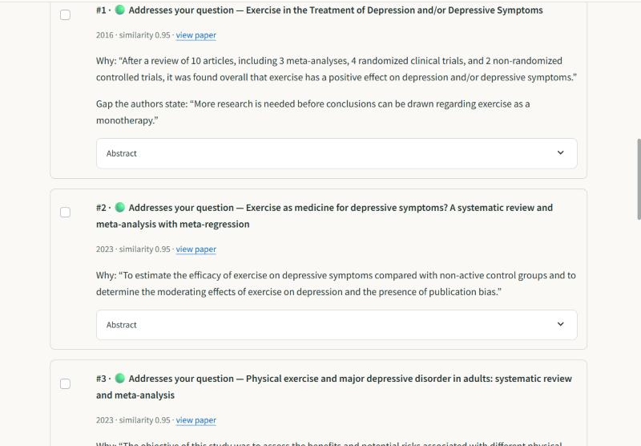
Figure 4. Suggested papers ordered by what the system can substantiate; unverifiable ones are withheld.
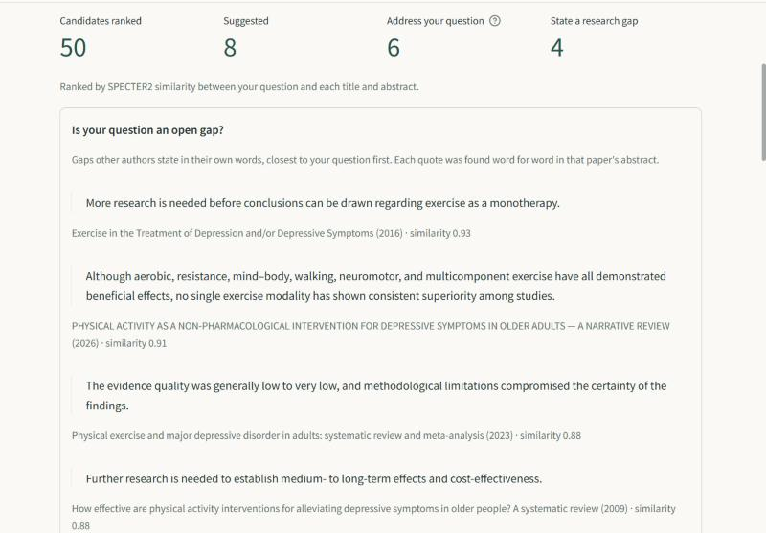
Figure 5. Whether other authors already state the question as an open gap, in their own words.
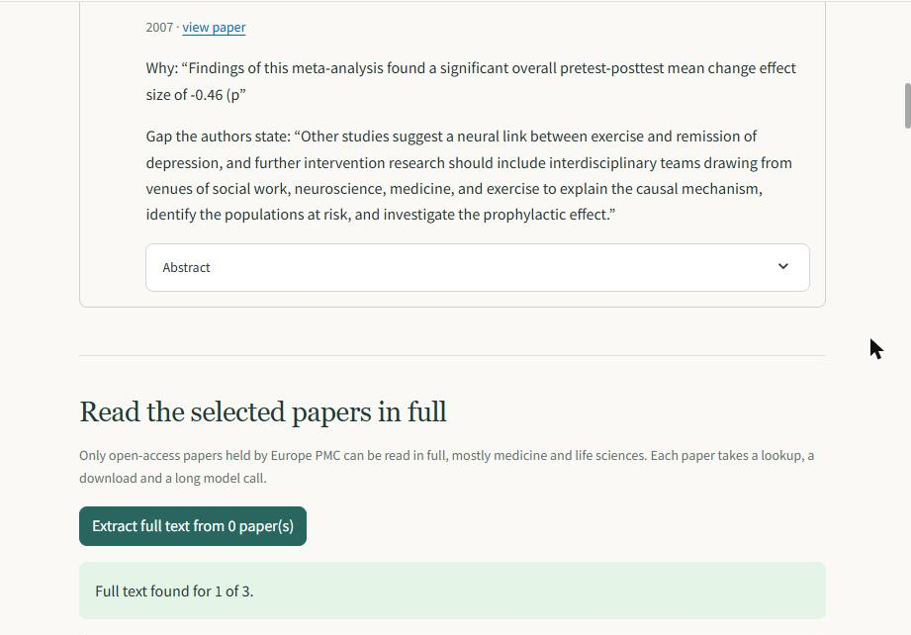
Figure 6. The researcher chooses which papers are worth a deeper read.
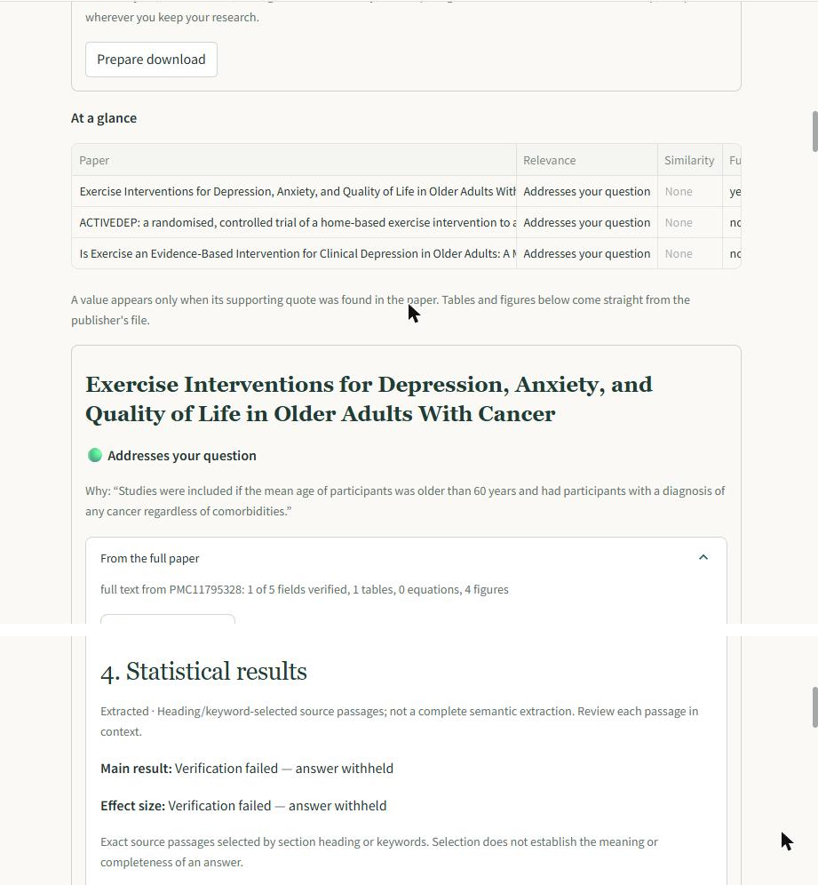
Figure 7. Full text from Europe PMC, categorised; a value appears only where its quote was found.
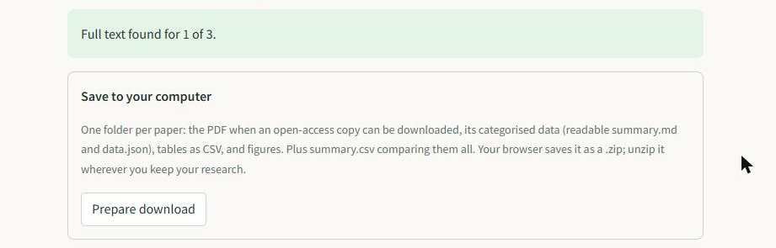
Figure 8. The session exported as summary, structured data, CSV tables and figures.

9.4 Extensibility, by example
Two late requirements tested whether the architecture was real or decorative. Ad-hoc user criteria needed no new screening code path, because the service already accepted criteria as plain text. A third model vendor needed one class behind the existing provider interface.

10. Implementation Plan and Progress
Implementation ran from week 7 in a deliberate order: the evaluation harness in week 8, before retrieval optimisation in week 9, on the principle that a faster retriever with no means of measuring it is time that cannot be reported.

10.1 Software engineering principles applied
Separation of concerns, enforced. Domain logic lives in services, external systems in adapters, measurement in the evaluation package. The interface was restructured in week 13 without touching a single service, and the test suite confirmed no measured figure moved.
Interface segregation and dependency injection. Mock, Gemini, Ollama and OpenAI sit behind one provider protocol, and every service receives its provider rather than constructing one, which lets the pipeline run deterministically against a mock. That mock fabricates roughly 20% of the time on purpose, so the verification-failure path runs on every test.
Tests as executable design decisions. Of 506 tests, a subset encodes commitments rather than behaviour: that ground truth never reaches a prompt; that ad-hoc records never enter the evaluation corpus; that three models screening one record produce three distinct cache entries, because a collision would make an agreement figure read 1.0 by construction.
Fail fast, and name the failure. The budget ceiling aborts a run rather than warning; a cached response whose fingerprint differs raises rather than being served stale; a retrieval strategy that cannot run names the missing package.
Reproducibility treated as an engineering property. The metrics file is a pure function of configuration and corpus, with timestamps and commit hash in a separate artefact, which makes reproducibility testable rather than aspirational.

10.2 Defects worth reporting
Four defects are reported because each was a design fault, not a typing error. Database connections are thread-affine while the web framework dispatches dependency and route body to separate workers; that was fixed at the database layer. A cache-staleness bug let one extraction run serve a previous broken run's responses, because the response schema was not part of the hashed request. The BM25 baseline proved not to be corpus-independent, moving every number resting on it; corrected runs are recorded beside the originals, since the drift is itself a finding about the instrument. The fourth came from using the product: OpenAlex ships abstracts as a word-to-positions index, the reconstruction walked every position from zero to the highest, and the positions are not contiguous, so one record missing one position failed the whole question with a server error.

11. Evaluation or Testing Strategy
Every figure below comes from one of 80 stored run directories, indexed by kind and commit hash. Total spend is USD 0.00.

11.1 Screening, per review
Review | Prev. | Verified | Recall (verified) | Recall (+referrals) | TNR@95 | AC1
Radjenović_2013 | 0.8% | 35.6% | 0.925 | 0.938 | 0.209 | 0.950
Smid_2020 | 1.0% | 91.7% | 0.308 | — | 0.113 | —
van_der_Waal_2022 | 1.7% | 39.3% | — | — | — | —
Menon_2022 | 7.6% | 94.8% | — | — | — | —
van_der_Valk_2021 | 12.3% | 39.3% | 0.320 | 0.809 | 0.138 | —
Nelson_2002 | 21.9% | 51.9% | 0.906 | — | 0.164 | —
Table 5. Screening results, qwen2.5:7b-instruct, local inference, USD 0.00; dashes are not computed.
Verification rate matters most and is the column the literature does not generally report. A decision whose quote cannot be located becomes a referral, not a prediction, so accuracy is scored over verified decisions only, with recall including referrals beside it.

11.2 Retrieval, and an honest external comparison
Review | BM25 | Dense | Hybrid | Rerank | ASReview
Radjenović_2013 | — | — | — | — | 0.947
Smid_2020 | 0.520 | 0.696 | 0.757 | 0.757 | 0.822
van_der_Waal_2022 | — | — | — | — | 0.813
Menon_2022 | — | — | — | — | 0.723
van_der_Valk_2021 | 0.049 | 0.181 | 0.068 | 0.068 | 0.500
Nelson_2002 | 0.038 | 0.178 | 0.094 | 0.094 | 0.497
Table 6. TNR@95 by retrieval strategy; blanks are not run.
Every strategy built here beats the lexical baseline on all three reviews where a comparison exists, clearing the week 9 exit test. ASReview nonetheless out-ranks all of them, unsurprisingly: its active learner sees true labels as it proceeds and retrains, whereas every strategy here ranks once and never updates. RQ1 concerns trust rather than ranking supremacy, but the comparison argues for adaptive re-ranking in future work.

11.3 What the verifier actually buys
An ablation reconstructed the un-verified system exactly by replaying the model's literal cached answers for all 12,598 decisions. Refusing to trust unverified decisions raises recall on every review, by between +0.027 and +0.697. The price is reading volume: on one review the researcher reads 13 records instead of 451, on another 141 instead of 3,953 — a trade, not a win.

11.4 Why verification fails, which reframes the headline
Failure category | Count | Share
Echoed the eligibility criteria from the prompt | 5,778 | 97.8%
Near paraphrase of a real sentence | 53 | 0.9%
Stitched from separate sentences | 57 | 1.0%
Genuinely fabricated | 12 | 0.2%
Other | 9 | 0.2%
Total failures across six reviews | 5,909 | 100%
Table 7. Verification failures by category; automatic labels, blind rating pass pending.
This changes what the project can claim, mostly in the model's favour. It almost never invents a quotation — twelve times in 5,909 failures. What it does overwhelmingly is answer a different question: asked for the sentence justifying its decision, it returns the rule it applied. That is a prompt-comprehension failure, not dishonesty, so a verification rate is partly a measure of prompt quality rather than solely of model trustworthiness.

11.5 Gap discovery: precision and recall together
Gap discovery was rated over 74 statements across all six reviews, each judged against the full abstract under a rule fixed in advance: 87.8% precision, or 75.7% excluding statements naming a gap the same paper then fills. Recall was estimated by blind-labelling a seeded sample of records the model marked as stating no gap, and ranges from 0.40 to 1.00 across four reviews, with 95% Wilson intervals wide enough to indicate direction only. Most sampled misses are motivating gaps — “little is known about” — which the prompt suppresses.

11.6 Full text, as a demonstration
Following the supervisor's guidance, full text is a demonstration. One live run over four papers produced three complete papers and one open-access stub in 78 seconds at USD 0.00. Four of twenty field slots verified; nine were correct refusals, an editorial having no primary outcome and the system saying so rather than inventing one. Two failure modes appeared: the model writing its own prose where a quotation is required, and reusing one quotation across three fields. A second capability followed on 22 October, the gaps a paper states in its own body, which the abstract stage cannot see. Its first run reproduced the limit in section 5.1, three of four proposed gaps quoting results sentences, so quotable sentences are now selected deterministically by forward-looking wording and the model chooses among them. It then returned the one gap that paper states, verbatim and in its section. Precision and recall are unmeasured.

11.7 Testing
506 automated tests pass. The interface is driven by Streamlit's own test harness against canned responses, and separately against the live API; the two catch different classes of defect, and the second found three faults the first could not see.

12. Ethical, Legal, and Cultural Considerations

12.1 Data privacy and user consent
The system stores as little personal data as it can while still supporting saved work. Authentication uses Google OpenID Connect with identity scopes only, storing the stable subject identifier, verified email and display name, and no passwords or tokens. Sessions are hashed at rest, expire after 24 hours and are revoked on sign-out. Saved projects are account-owned, and tests assert one account cannot read another's. Research sessions live in a database separate from the evaluation corpus.
One residual risk is recorded rather than hidden: the one-time login ticket travels as a URL parameter. It is single-use, expires in 120 seconds and is bound to the originating browser, but it will appear in browser history.

12.2 Legal and licensing
OpenAlex is CC0 and may be displayed freely; Europe PMC is queried only for its open-access subset. SYNERGY abstracts are third-party content and are not redistributed: the data directory and raw model responses are excluded from version control, and reports quote only short source sentences. Published eligibility criteria are quoted from the original reviews, stored locally, hashed into every metrics file for provenance, and not committed. The repository is public, so credentials are excluded by configuration and the exclusion is verified before any key is added.

12.3 Research ethics approval — an open risk, stated plainly
The proposal stated that ethics approval for the usability study would be obtained in week 7. It has not been submitted, and is reported here as a live risk rather than deferred.
The consequence is bounded. It gates only the human-subjects half of the usability evaluation, the exit test requiring a second person to complete a query unassisted, and affects no result in section 11, all of which are comparative measurements against a published benchmark with no human participants. The interface has been verified functionally end to end against real data, and the usability claim is not made rather than supported by the author's assessment of their own tool.

12.4 Bias in the methodology, with measured evidence
Three biases are identifiable; one can be quantified.
Disciplinary bias in the extraction schema. The four abstract-level extraction fields — study design, sample size, country, key finding — were shaped by clinical-trial reporting conventions. Measured against a software engineering review, study design verified in 36% of records and sample size in 7.6%, the lowest of any review, because empirical software engineering papers describe datasets, repositories and metrics rather than patient cohorts with a stated design and N. A tool presenting these fields as universal would under-serve non-medical researchers.
Language bias. The literature search and the corpus are English-only. This is acknowledged as a limitation rather than solved, and it means findings describe English-language literature.
Source coverage bias. OpenAlex coverage is uneven by region and publisher; Zheng et al. (2025) document under-coverage of Chinese scholarship. The system's own measurements add a second caveat: OpenAlex can share redistributable abstracts for only about half of what it indexes, and the pipeline filters to those, so papers without an available abstract are invisible regardless of relevance.

12.5 Automation bias, and the ethical argument for withholding
The main ethical risk is that a researcher defers to the tool, and the calibration measurement makes that concrete: mean model confidence was 0.813 where the quote verified and 0.798 where it could not be found, a gap of 0.015 across 23,148 decisions. The model is as confident when it cannot substantiate an answer as when it can, so no threshold separates the two. An unsubstantiated decision is therefore withheld and referred.

12.6 Cultural considerations and adaptation
Research culture differs by discipline. The measured gap-statement rate varies from 3.8% to 52.2% across the six reviews and tracks the genre of the abstract rather than prevalence: environmental-health reviews conventionally close with “further studies are needed”, whereas software engineering abstracts rarely state gaps at all. Reporting “no gaps found” to a software engineering researcher would report a writing convention as a finding.
Three adaptations follow. The extraction schema should be configurable per discipline. Gap detection should report the discipline's base rate alongside any result, so an absence is read as a convention rather than a conclusion. And because the tool runs locally at zero marginal cost, it is usable without institutional subscriptions, a deliberate equity property of the design.

13. Timeline and Project Plan
Week | Deliverable | Exit test | Status
7–8 | Evaluation harness, ingest, span verifier, baselines | A stored configuration reproduces an identical metrics file | Passed
9 | SPECTER2 embeddings, FAISS, rank fusion, cross-encoder | Beats the lexical baseline on ≥3 reviews | Passed
10 | Prompt variants, model tiers, repeated runs, overrides | Every RQ1 property has a number | Passed
11 | Gap discovery and go/no-go checkpoint | 30 statements rated, precision recorded, decision minuted | Exceeded target (74 rated); go decision approved; formal minute pending
12 | API and interface | A second person completes a query unassisted | Open — requires a participant (section 12.3)
13 | Hardening and reproduction script | A fresh clone runs on a second machine | Passed, with one caveat: a pinned dependency has since been withdrawn upstream
14 | Code frozen, all baselines run | Every figure traces to a run directory and commit hash | Met — 80 run directories indexed by kind and commit
15 | Report, packaging, submission | Submitted | In progress
Table 8. Fifteen-week schedule with exit tests and current status.

14. Current Status and Completed Deliverables (WIP)
At week 13 the artefact is functionally complete and the evaluation substantially so. Delivered and verified:
- A working one-page research tool: question in; ranked, screened papers out with a gap signal; full-text extraction and categorisation on the selected papers, with the gaps those papers state in their own body; export to summary, structured data, CSV tables and figures.
- A span verifier gating every model claim, with 5,909 verification failures classified by type, and a six-review evaluation of 12,598 records reported per review: accuracy, effort saved, verification rate, agreement and inter-run reproducibility.
- Comparative retrieval evaluation against random, lexical, dense, hybrid and cross-encoder strategies plus ASReview; an exact ablation of the verification mechanism over all 12,598 decisions; and a blind-sampled recall estimate for gap discovery with confidence intervals.
- 80 run directories, each with configuration, metrics and commit hash, indexed in reports/run_index.md; 506 automated tests passing; total spend USD 0.00.
Five items remain open: the usability exit test requiring a second participant; the ethics application; a hand-rating pass validating the automatic failure classifications; a second-model gap-discovery arm, built and costed at approximately USD 0.26; and precision and recall for gaps read from full text.

15. Timeline for Pending Deliverables
Pending work is the final rows of Table 8: the ethics submission and usability exit test, the second-model arm, and the final report in week 15. If ethics approval does not arrive, the week 12 exit test is reported as not met and the usability claim withdrawn rather than weakened. If the second-model arm cannot be run, inter-model agreement is reported as designed and costed but not executed.

16. References
Bolaños, F., Salatino, A., Osborne, F., & Motta, E. (2024). Artificial intelligence for literature reviews: Opportunities and challenges. Artificial Intelligence Review, 57(10), 259.
Cohan, A., et al. (2020). SPECTER: Document-level representation learning using citation-informed transformers. Proceedings of ACL 2020.
Cohen, A. M., et al. (2006). Reducing workload in systematic review preparation using automated citation classification. Journal of the American Medical Informatics Association, 13(2), 206–219.
De Bruin, J., et al. (2023). SYNERGY — Open machine learning dataset on study selection in systematic reviews. DataverseNL.
Gwet, K. L. (2014). Handbook of inter-rater reliability (4th ed.). Advanced Analytics.
Hida, G. S., Ribeiro, D. M., & Yahata, E. (2026). Beyond accuracy: LLM variability in evidence screening for software engineering. arXiv:2604.27006.
Khraisha, Q., et al. (2024). Can large language models replace humans in systematic reviews? Research Synthesis Methods, 15(4), 616–626.
Kitchenham, B., & Charters, S. (2007). Guidelines for performing systematic literature reviews in software engineering (EBSE Technical Report EBSE-2007-01).
Kusa, W., et al. (2023). An analysis of work saved over sampling in the evaluation of automated citation screening. Intelligent Systems with Applications, 18, 200193.
Priem, J., Piwowar, H., & Orr, R. (2022). OpenAlex: A fully-open index of scholarly works, authors, venues, institutions, and concepts. arXiv:2205.01833.
Singh, A., et al. (2023). SciRepEval: A multi-format benchmark for scientific document representations. Proceedings of EMNLP 2023.
van de Schoot, R., et al. (2021). An open source machine learning framework for efficient and transparent systematic reviews. Nature Machine Intelligence, 3, 125–133.
Zhang, C., et al. (2023). Automatic recognition and classification of future work sentences from academic articles in a specific domain. Journal of Informetrics, 17(1), 101373.
Zheng, X., et al. (2025). Understanding discrepancies in the coverage of OpenAlex: The case of China. Journal of the Association for Information Science and Technology.

18. Appendix

Appendix A — Reproducing the results
The repository is public at github.com/KavinduPehesara/Beyond-Retrieval. One script performs the whole chain: environment, pinned install, tests, ingest of the six reviews, and a smoke evaluation writing its own run directory. Verified in week 13 from a fresh clone: all tests passed and ingested counts matched Table 3.

Appendix B — Evidence index
Every figure traces to a stored run directory. reports/run_index.md lists all 80 with harness kind, configuration, reviews and commit hash. Ten that produced no figure are listed and set aside.

Appendix C — The interface at submission
These three figures are a second example, captured on 25 October 2026 at commit 442559c, the state submitted, using a question a reader can check against the live literature: “Do probiotics reduce symptoms of irritable bowel syndrome in adults?” The run ranked 50 candidates, suggested 20, judged 12 as addressing the question and found 5 papers stating a research gap, at USD 0.00. The six walkthrough figures in section 9.3 were captured on 20 October 2026 at commit 3d20965, before the gap block of section 11.6 was added, which is why it does not appear in Figure 7.
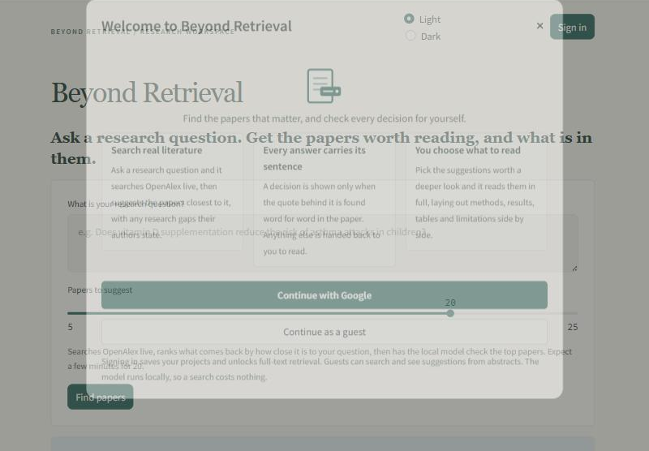
Figure 9. The front door; the guest path keeps search, screening and gap discovery open.
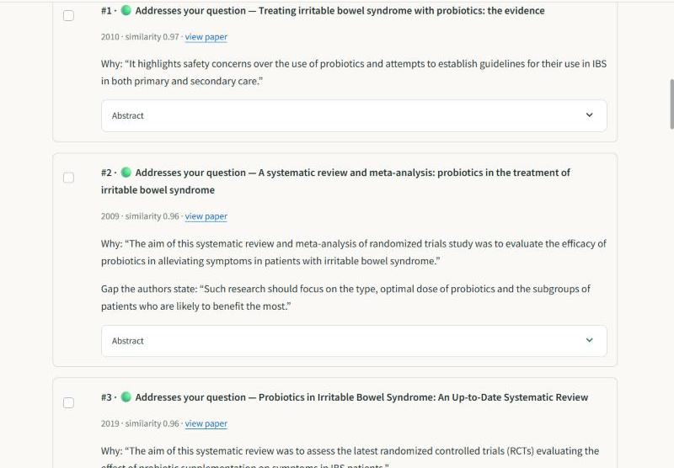
Figure 10. Suggested papers, each with the sentence the judgement rests on and the authors' own gap.
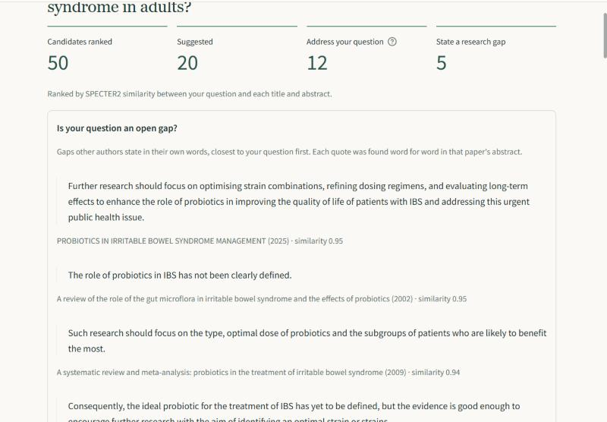
Figure 11. Five of twenty papers state the question as an open gap, quoted word for word.
Full-text reading needs a signed-in account; these figures were captured on the guest path. Figure 7 shows that stage.

