1. Demo output with API integration.

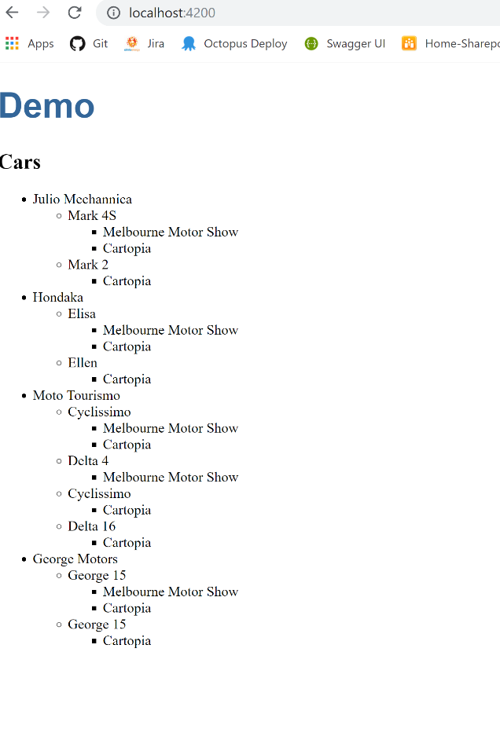

The problems that I ran into:

1. Access denied to request the <http://eacodingtest.digital.energyaustralia.com.au/api/v1/cars> directly in http://localhost:4200 as CORS is not enabled in the server.
2. Alternatively, I used “angular2-in-memory-web-api” to mock API response. But, there is a compatibility issue with the versions of angular2-in-memory-web-api and Angular 7. Hence, following error occurred. (Error is displayed below.)

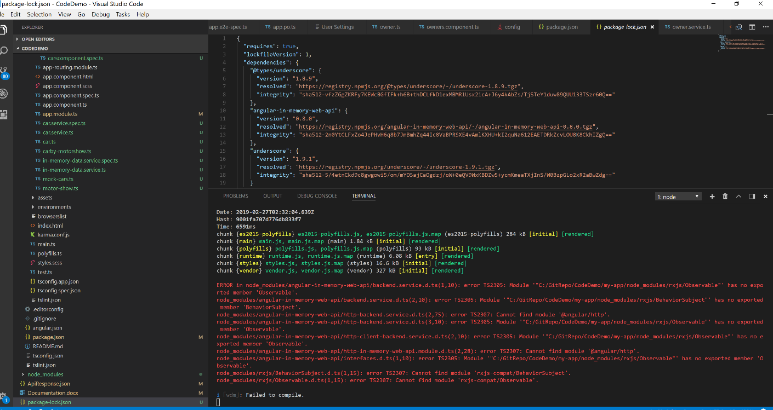Fig : *“angular2-in-memory-web-api”* usage error in typescript.