Q1.

Code:

|  |
| --- |
| ***package Q_01; import javax.swing.*;     public class Q_01 {  public static void main(String[] args) {  JFrame frame = new JFrame();  frame.setSize(800,600);  frame.setTitle("Welcome to java");  frame.setVisible(true);  }  }*** |

Output:

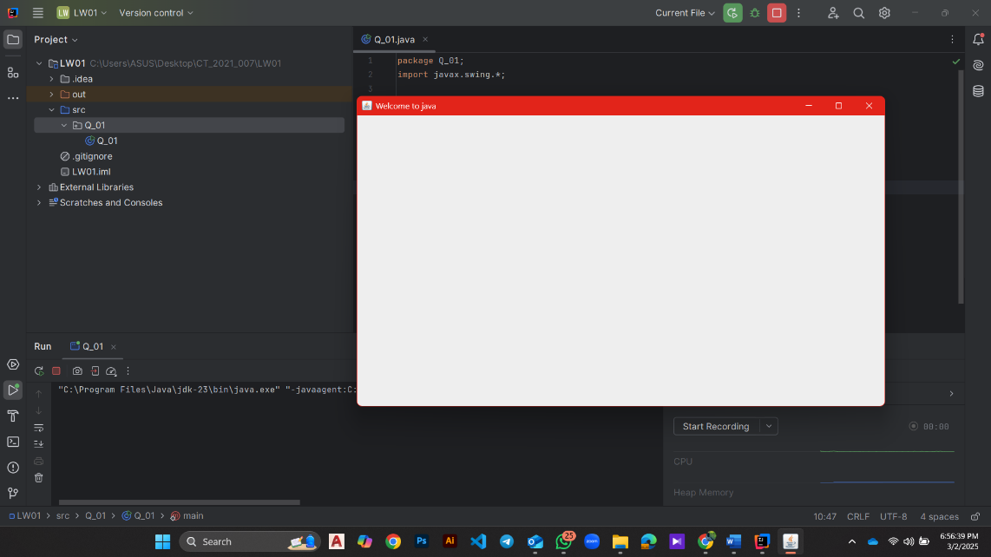

Q2.

Code:

|  |
| --- |
| ***package Q_02;  import javax.swing.*; import java.util.Scanner;  public class Q_02 {  public static void main(String[] args) {   Scanner name = new Scanner(System.in);  System.out.println("Enter the first name: ");  String firstName = name.next();  System.out.println("Enter the second name: ");  String secondName = name.next();   JFrame frame = new JFrame();  frame.setSize(800,600);  frame.setTitle(firstName+" "+secondName);  frame.setVisible(true);  } }*** |

Output:

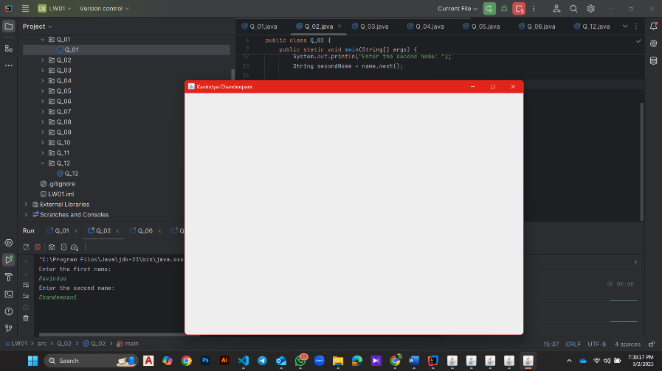

Q3.

Code:

|  |
| --- |
| ***package Q_03;***  ***import java.util.Scanner;***  ***public class Q_03 {***  ***public static void main(String[] args) {***  ***Scanner name = new Scanner(System.in);***  ***System.out.println("Enter the first name: ");***  ***String firstName = name.next();***  ***System.out.println("Enter the middle name: ");***  ***String middleName = name.next();***  ***System.out.println("Enter the Last name: ");***  ***String lastName = name.next();***  ***String initial = middleName.substring(0,1);***  ***System.out.println(firstName+"."+initial+"."+lastName);***  ***}***  ***}*** |

Output:

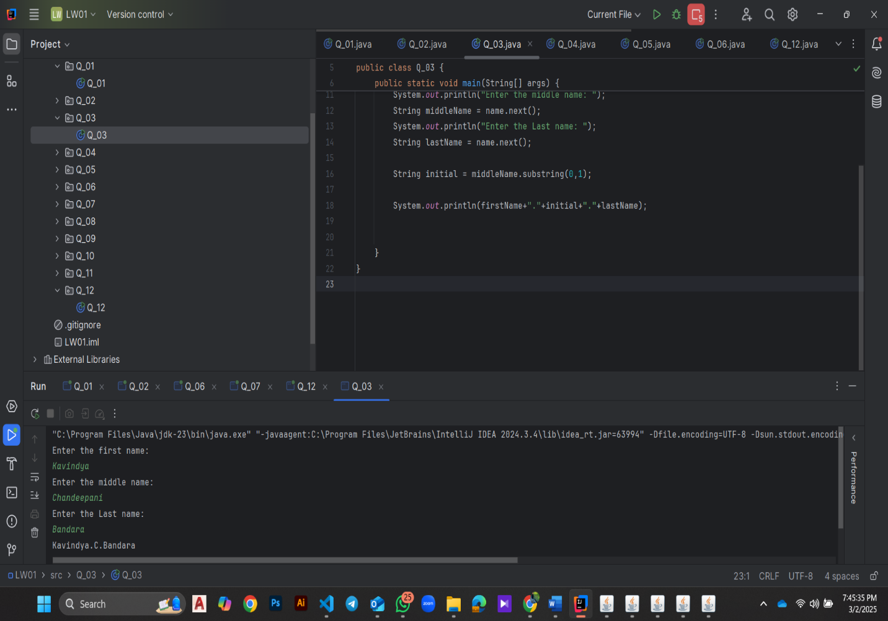

Q4.

Code:

|  |
| --- |
| ***package Q_04;  import java.text.SimpleDateFormat; import java.time.LocalDate; import java.util.Date; import java.util.logging.SimpleFormatter;  public class Q_04 {  public static void main(String[] args) {   /*LocalDate today = LocalDate.now();  System.out.println(today);*/   Date day = new Date();  System.out.println(day);   SimpleDateFormat sdf = new SimpleDateFormat("dd MMM yyyy");  System.out.println(sdf.format(day));   } }*** |

Output:

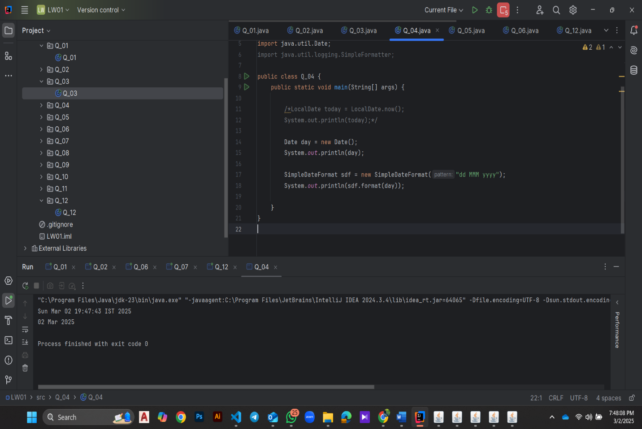

Q5.

Code:

|  |
| --- |
| ***package Q_05;  import javax.swing.*; import java.util.Scanner;  import java.text.SimpleDateFormat; import java.util.Date;  public class Q_05 {  public static void main(String[] args) {   Date day = new Date();  SimpleDateFormat sdf = new SimpleDateFormat("EEEE, MMMM dd, yyyy");  System.out.println(sdf.format(day));  } }*** |

Output:

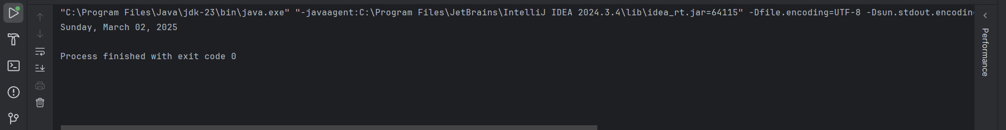

Q6.

Code:

|  |
| --- |
| ***package Q_06;  import javax.swing.*; import java.util.Scanner;  public class Q_06 {  public static void main(String[] args) {   JFrame frame = new JFrame();  Scanner scanner = new Scanner(System.in);   System.out.println("Enter the width :");  int W = scanner.nextInt();   System.out.println("Enter the height :");  int H = scanner.nextInt();   frame.setSize(W,H);  frame.setTitle("Window");  frame.setVisible(true);  } }*** |

Output:

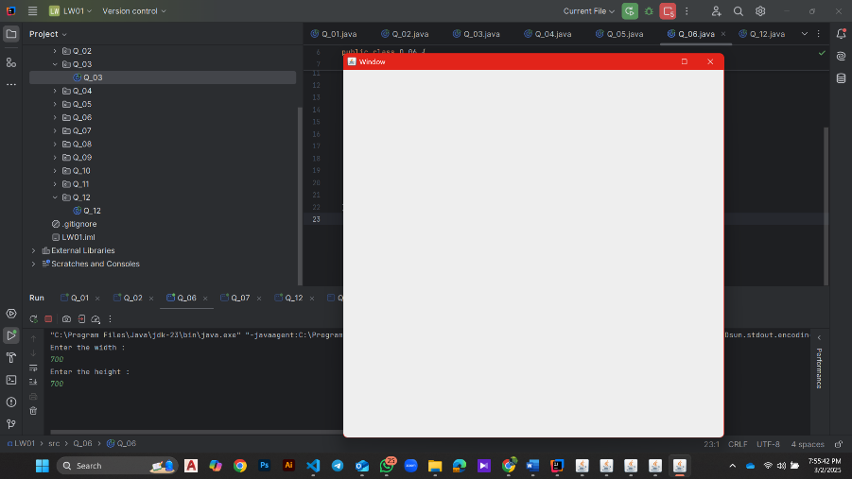

Q7.

Code:

|  |
| --- |
| ***import javax.swing.*; import java.text.SimpleDateFormat; import java.util.Date;  public class Q_07 {  public static void main(String[] args) {   JFrame frame = new JFrame();  Date date = new Date();  SimpleDateFormat sdf = new SimpleDateFormat("HH:mm:ss a");   String title = sdf.format(date);   frame.setSize(250,150);  frame.setTitle(title);  frame.setVisible(true);  } }*** |

Output:

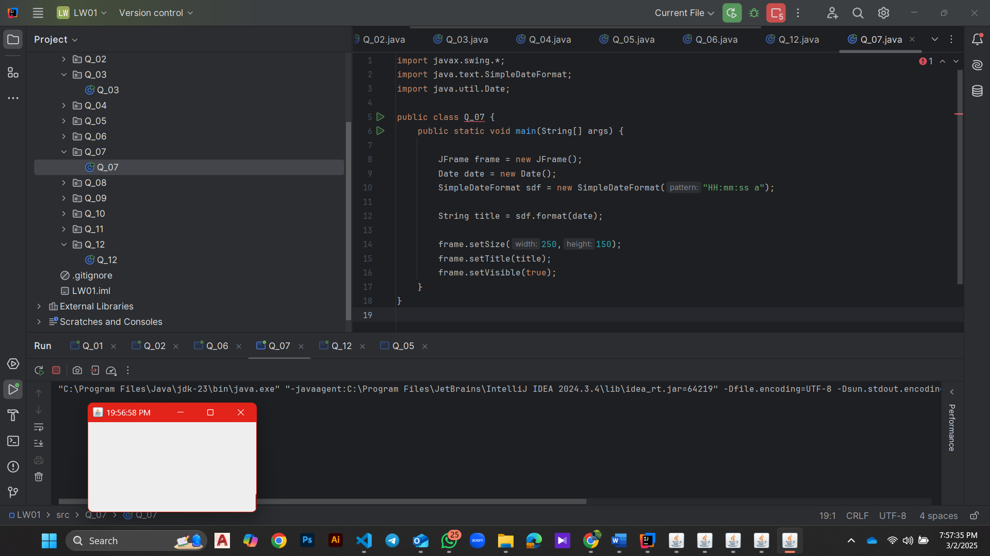

Q8.

Code:

|  |
| --- |
| ***package Q_08;  import java.util.Scanner;  public class Q_08 {  public static void main(String[] args) {  Scanner scanner = new Scanner(System.in);  System.out.print("Enter a string containing an exclamation mark: ");  String input = scanner.nextLine();  scanner.close();   int index = input.indexOf('!');  if (index != -1) {  String before = input.substring(0, index).trim();  String after = input.substring(index + 1).trim();  System.out.println(before);  System.out.println(after);  } else {  System.out.println("No exclamation mark found in the input.");  }  } }*** |

Output:

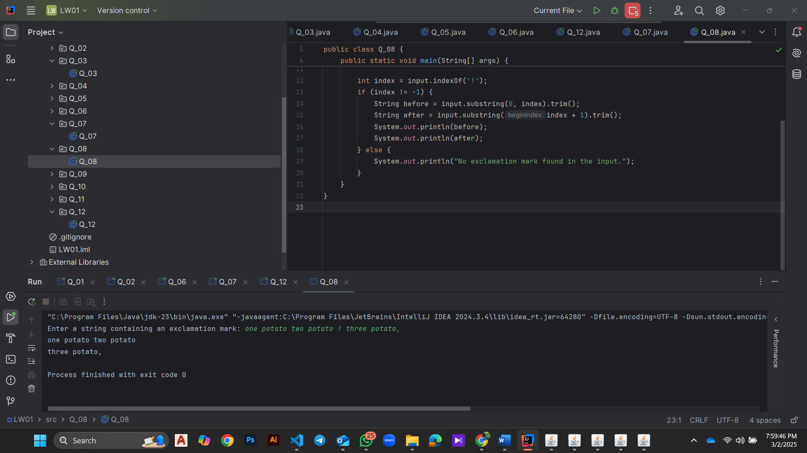

Q9.

Code:

|  |
| --- |
| ***package Q_09;  import java.util.Scanner;  public class Q_09 {  public static void main(String[] args) {  Scanner scanner = new Scanner(System.in);  System.out.print("Enter a string: ");  String input = scanner.nextLine();  scanner.close();   int length = input.length();  char firstChar = input.charAt(0);  char lastChar = input.charAt(length - 1);   System.out.println(length);  System.out.println(firstChar);  System.out.println(lastChar);  } }*** |

Output:

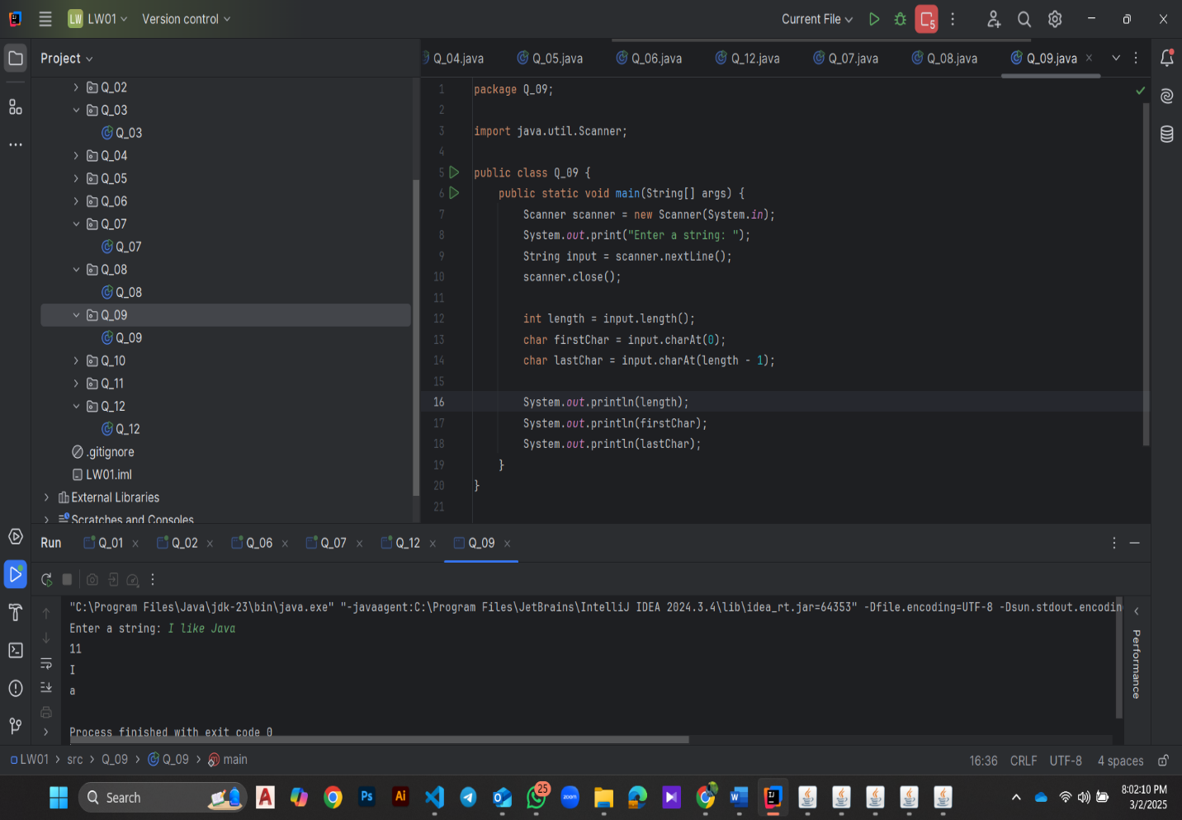

Q10.

Code:

|  |
| --- |
| ***package Q_10; import java.util.Scanner; public class Q_10 {  public static void main(String[] args) {  Scanner scanner = new Scanner(System.in);  System.out.print("Enter an odd-length word: ");  String word = scanner.nextLine();  scanner.close();   if (word.length() % 2 == 1) {  int middleIndex = word.length() / 2;  char middleChar = word.charAt(middleIndex);  System.out.println(middleChar);  } else {  System.out.println("Please enter a word with an odd length.");  }  } }*** |

Output:

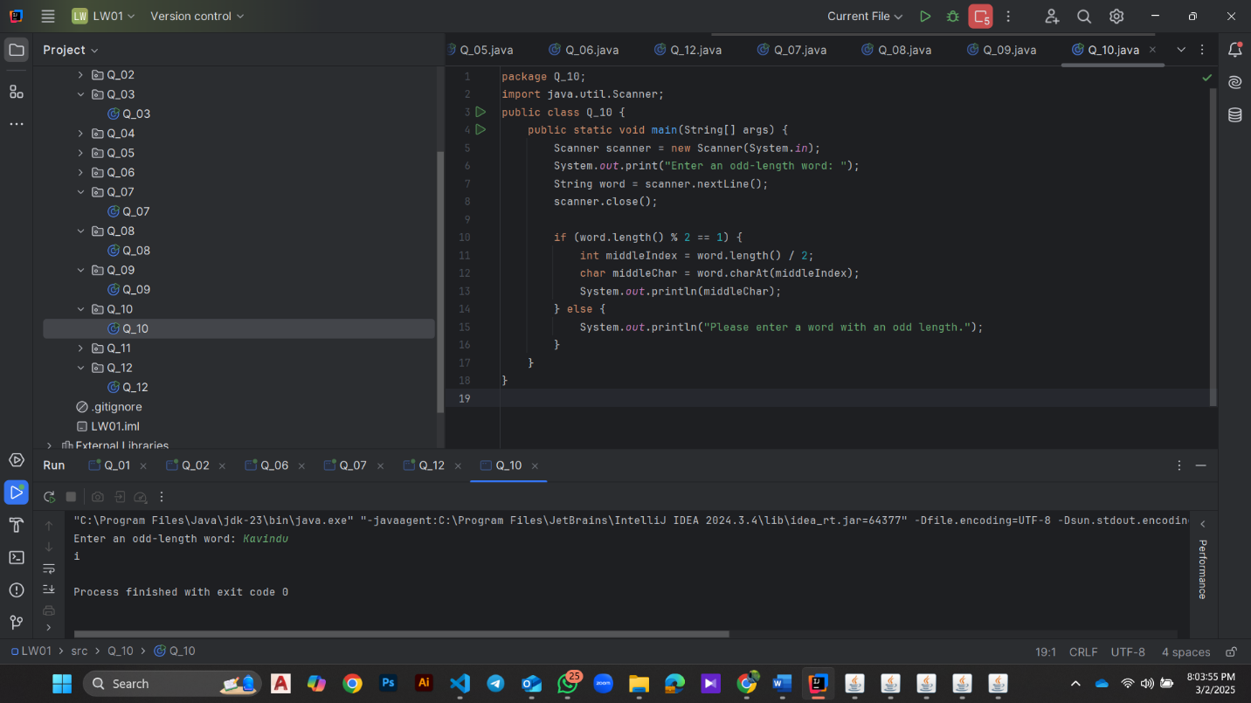

Q11.

Code:

|  |
| --- |
| ***package Q_11;***  ***import java.util.Scanner;***  ***public class Q_11 {***  ***public static void main(String[] args) {***  ***Scanner scanner = new Scanner(System.in);***  ***System.out.print("Enter your full name (first middle last): ");***  ***String fullName = scanner.nextLine();***  ***scanner.close();***  ***String[] nameParts = fullName.split(" ");***  ***if (nameParts.length < 3) {***  ***System.out.println("Please enter your full name in the format: first middle last.");***  ***} else {***  ***String firstName = nameParts[0];***  ***String middleName = nameParts[1];***  ***String lastName = nameParts[2];***  ***System.out.println(lastName + ", " + firstName + " " + middleName.charAt(0) + ".");***  ***}***  ***}***  ***}*** |

Output:

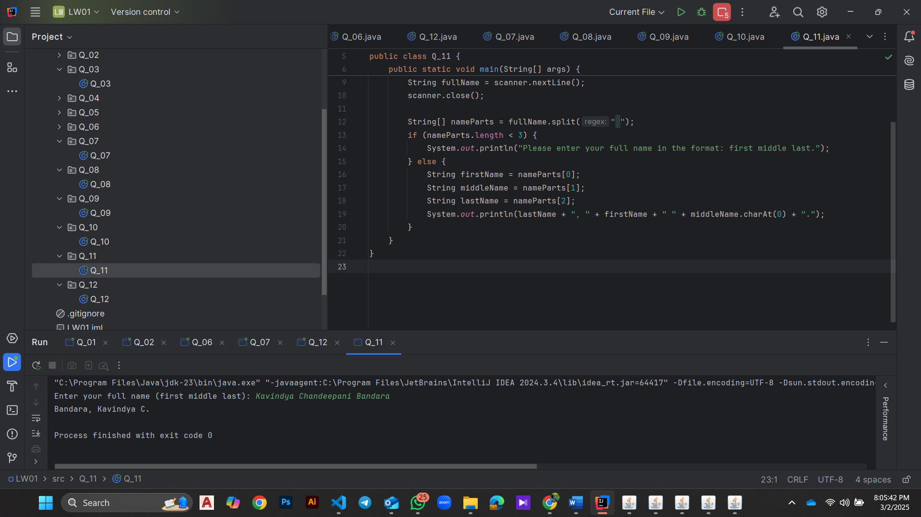

Q12.

Code:

|  |
| --- |
| ***package Q_12;***  ***import javax.swing.*;***  ***public class Q_12 {***  ***public static void main(String[] args) {***  ***JFrame frame = new JFrame("My First Frame");***  ***frame.setSize(300, 200);***  ***frame.setLocation(100, 50);***  ***frame.setDefaultCloseOperation(JFrame.EXIT_ON_CLOSE);***  ***frame.setVisible(true);***  ***}***  ***}*** |

Output:

