Ex. No:7
Date:

VERSION CONTROL AND REPOSITORY MANAGEMENT USING GIT AND GITHUB
AIM:
To understand and implement version control using Git and GitHub by creating a repository, adding files, making commits, and managing version history. This lab helps in learning how to collaborate on projects, track changes, and maintain code efficiently using GitHub.

PROCEDURE:

Step 1: Create a GitHub Account
- Go to GitHub.
- Click Sign Up in the top-right corner.
- Enter a username, email, and password and complete the verification.
- Click Create account and verify your email.

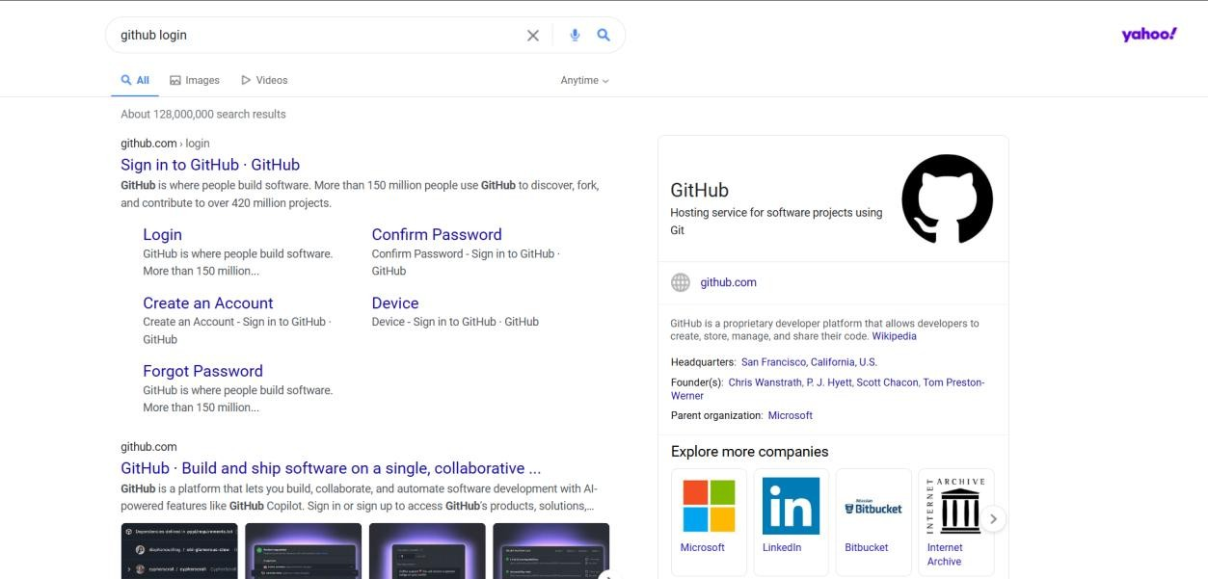



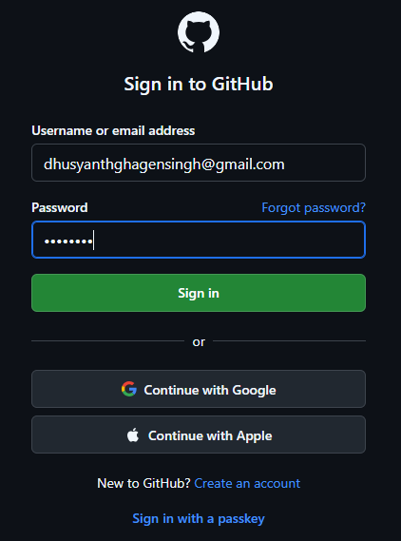

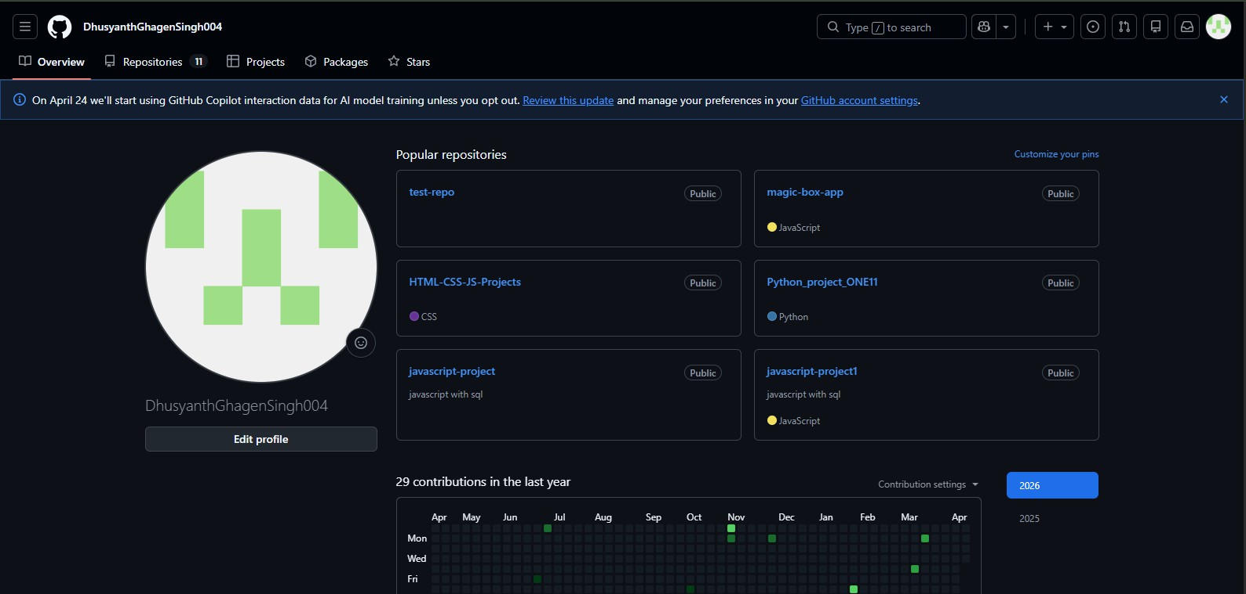

Step 2: Create a New Repository
- After logging in, click the "+" icon in the top-right corner.
- Select "New repository".
- Enter a repository name (e.g., MyFirstRepo).
- Choose "Public" or "Private".
- Check the box "Add a README file" (this initializes the repo with a README).
- Click Create repository.

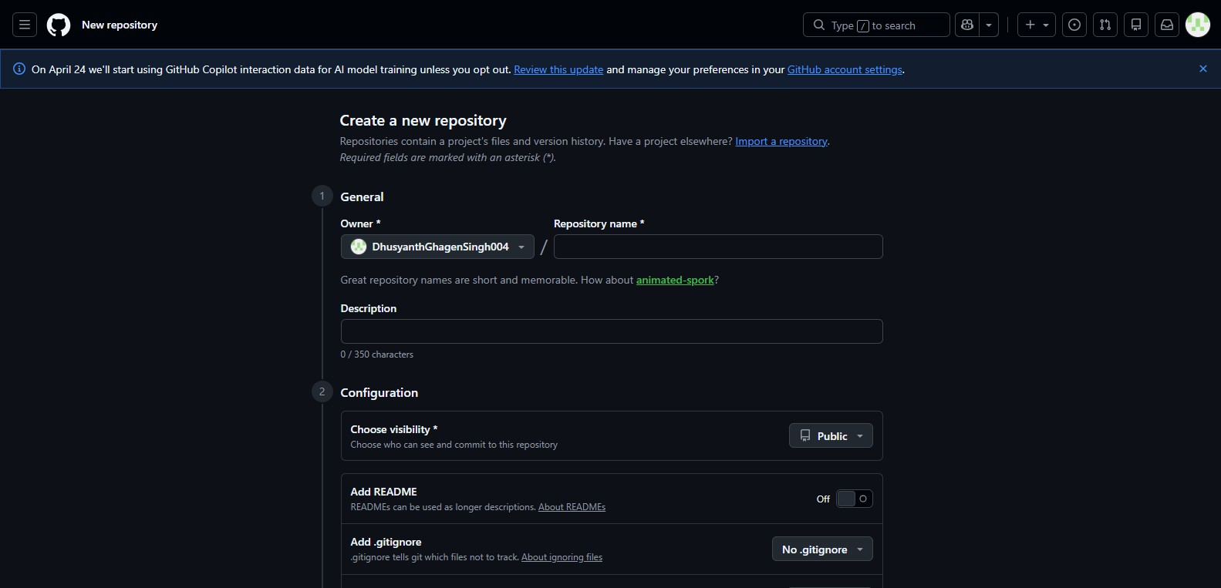

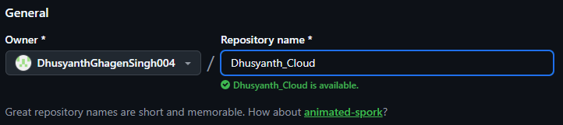

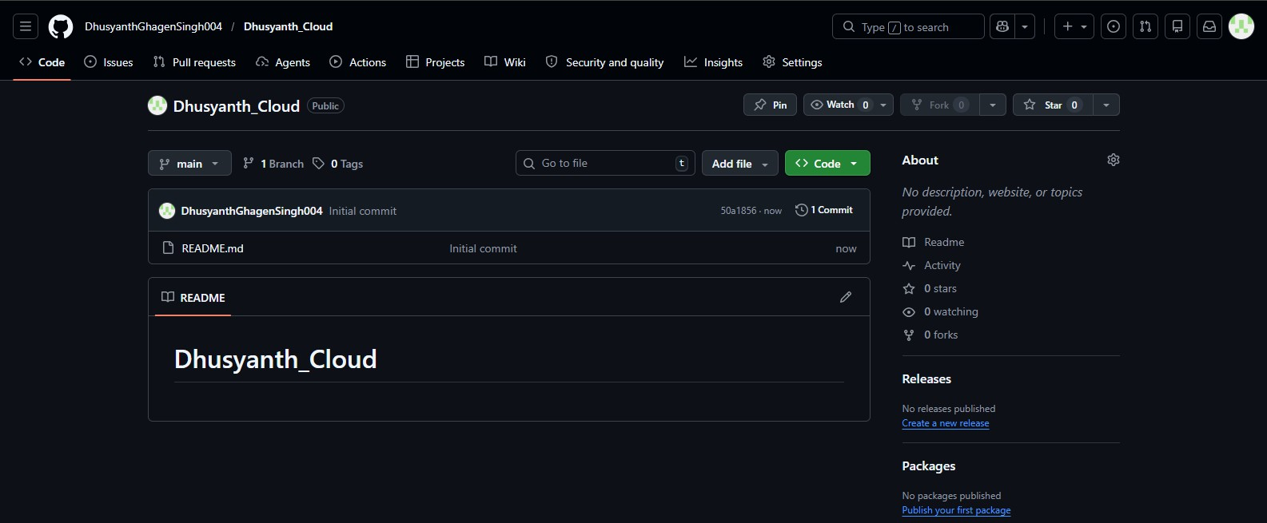

Step 3: Upload a File to GitHub
- Open your newly created repository.
- Click "Add file" → "Upload files".
- Click "Choose your files" and select the file you want to upload.
- Add a commit message (e.g., "Added first file").
- Click "Commit changes".


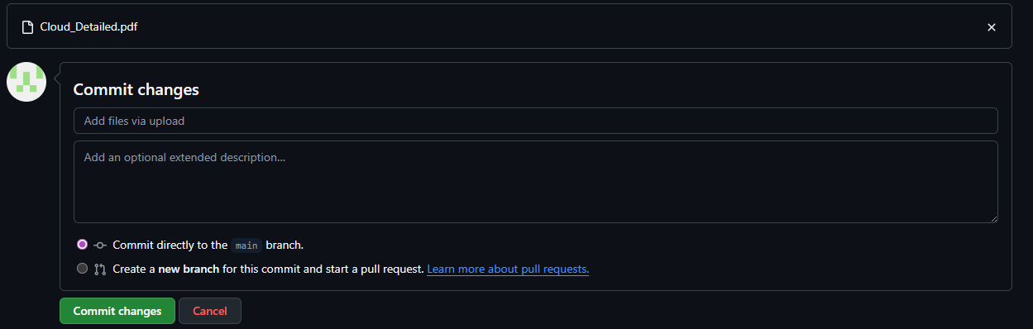
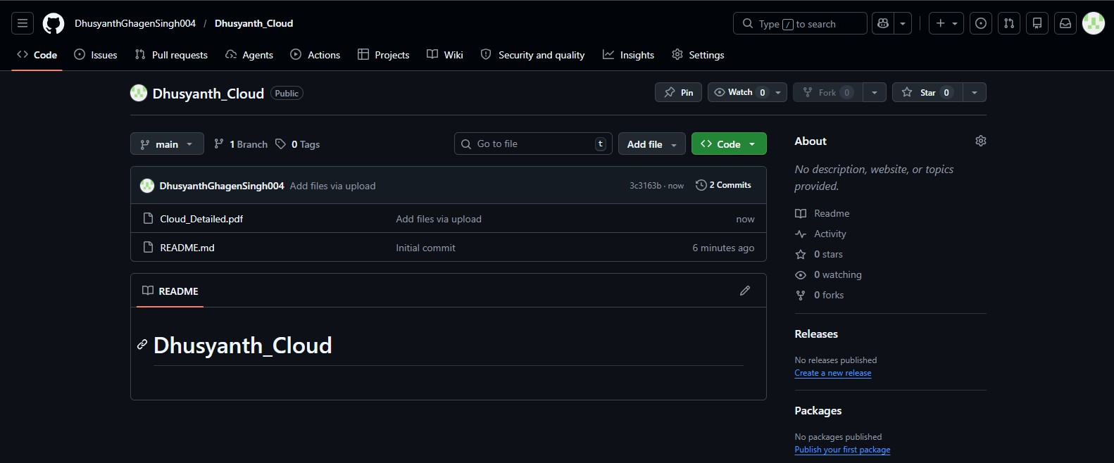

COE(30)
Record(20)
Viva(10)
Total(60)

Result:
Successfully created a GitHub repository, initialized it with a README file, uploaded files, and managed version control using Git.

