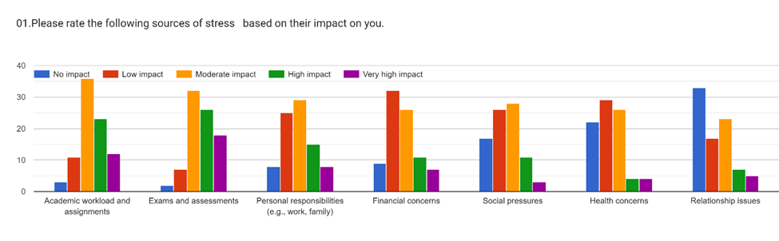**Sources of the Stress**

This bar chart shows the sources of the stress among the students of the university. The **y-axis** represents the number of students who rated the impact of each source of stress at different levels: no impact (purple), low impact (green), moderate impact (orange), high impact (red), and very high impact (yellow), while the **x-axis** lists various sources of stress, which include academic workload, exams and assessments, personal responsibilities, financial concerns, social pressures, health concerns, and relationship issues. The colour-coded bars indicate the level of impact each source of stress has on individuals.

The academic workload appears to have a varied impact on students. A considerable number of students have rated it as having a moderate impact, indicating that the volume or difficulty of academic work could be causing stress. However, it is worth knowing that there are also students who have rated the academic workload as having a high or very high impact, suggesting that for some students, managing academic responsibilities could be a major source of stress.

Exams and assessments seem to have a more uniformly distributed impact across all levels from no impact to very high impact. This could suggest that while exams and assessments are a common source of stress for many students, the level of stress experienced can greatly vary among students.

The bar chart also reveals interesting insights about the impact of social pressures on students. While a significant number of students reported no or low impact, there is a considerable portion of students for whom social pressures have a moderate to very high impact. This suggests that while social pressures might not be as universally impactful as academic workload or exams, they still represent a significant source of stress for a subset of students.

In terms of personal responsibilities, such as work or family obligations, the impact appears to be quite evenly distributed across all levels from no impact to very high impact. This indicates that the effect of personal responsibilities on stress levels greatly varies among students, possibly due to differences in individual circumstances.

Lastly, according to this chart relationship issues seem to have the least overall impact on students’ stress levels. A majority of students reported no or low impact from relationship issues.

In conclusion, the bar chart provides a comprehensive overview of the impact of various sources of stress on individuals. Relationship issues have the lowest impact, with a majority of individuals rating it as no impact or low impact. Academic workload has the highest impact because most individuals rate it as high impact or very high impact. The chart underscores the multifaceted nature of stress, highlighting that it is not solely academic pressures that contribute to stress levels but also personal and social factors.