GRAPH DATABASE

G.A.Kavinila (17PD12)

S.Kaviya (17PD13)

V.Shrinidhi (17PD30)

This graph contains the top 15 leading brands of soft drinks as of 2013 according to brand value .It will serve as a classification system based on the qualities of the drink as well as the company manufacturing it. We will also have access to the brand value statistics, allowing us to make certain queries pertaining to tendencies in the market. This graph contains the top 15 leading brands of soft drinks as of 2013 according to brand value. It will serve as a classification system based on the qualities of the drink as well as the company manufacturing it. It uses a simple domain model that will nevertheless allow for some interesting queries.

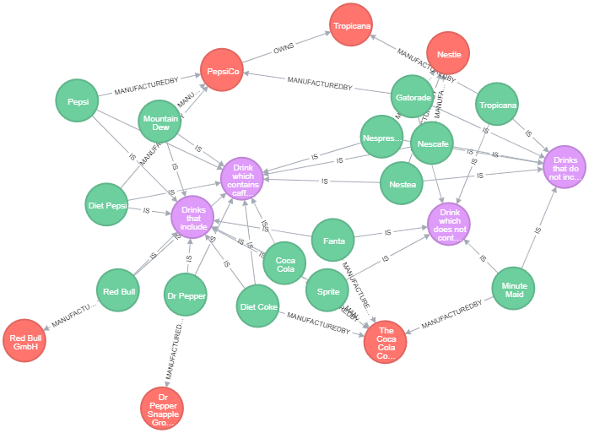

CREATION OF GRAPH:

CREATE (CocaCola:Drink {name: "Coca Cola" , brandValue :64698}),

(DietCoke:Drink {name: "Diet Coke" , brandValue :13717}),

(RedBull:Drink {name: "Red Bull" , brandValue :10558}),

(Pepsi:Drink {name: "Pepsi" , brandValue :9799}),

(Nescafe:Drink {name: "Nescafe" , brandValue :5639}),

(Tropicana:Drink {name: "Tropicana" , brandValue :4808}),

(Nespresso:Drink {name: "Nespresso" , brandValue :4478}),

(Sprite:Drink {name: "Sprite" , brandValue :4127}),

(Fanta:Drink {name: "Fanta" , brandValue :3974}),

(Gatorade:Drink {name: "Gatorade" , brandValue :3750}),

(MountainDew:Drink {name: "Mountain Dew" , brandValue :2495}),

(MinuteMaid:Drink {name: "Minute Maid" , brandValue :2296}),

(DrPepper:Drink {name: "Dr Pepper" , brandValue :2236}),

(DietPepsi:Drink {name: "Diet Pepsi" , brandValue :2230}),

(Nestea:Drink {name: "Nestea" , brandValue :1852})

CREATE (TheCocaColaCompany:Company {name: "The Coca Cola Company"}),

(RedBullGmbH:Company {name: "Red Bull GmbH"}),

(PepsiCo:Company {name: "PepsiCo"}),

(Nestle:Company {name: "Nestle"}),

(TropicanaProducts:Company {name: "Tropicana Products"}),

(DrPepperSnappleGroup:Company {name: "Dr Pepper Snapple Group"})

CREATE (Caffeinated:Type{type:"Caffeinated",description:"Drink which contains caffeine"}),

(Carbonated:Type{type:"Carbonated",description:"Drinks that include carbon dioxide dissolved in water"}),

(Flat:Type{type:"Flat",description:"Drinks that do not include carbon dioxide dissolved in water"}),

(NonCaffeinated:Type{type:"NonCaffeinated",description:"Drink which does not contain caffeine"})

CREATE(CocaCola)-[:MANUFACTUREDBY]->(TheCocaColaCompany),

(DietCoke)-[:MANUFACTUREDBY]->(TheCocaColaCompany),

(RedBull)-[:MANUFACTUREDBY]->(RedBullGmbH),

(Pepsi)-[:MANUFACTUREDBY]->(PepsiCo),

(Nescafe)-[:MANUFACTUREDBY]->(Nestle),

(Tropicana)-[:MANUFACTUREDBY]->(TropicanaProducts),

(Nespresso)-[:MANUFACTUREDBY]->(Nestle),

(Sprite)-[:MANUFACTUREDBY]->(TheCocaColaCompany),

(Fanta)-[:MANUFACTUREDBY]->(TheCocaColaCompany),

(Gatorade)-[:MANUFACTUREDBY]->(PepsiCo),

(MountainDew)-[:MANUFACTUREDBY]->(PepsiCo),

(MinuteMaid)-[:MANUFACTUREDBY]->(TheCocaColaCompany),

(DrPepper)-[:MANUFACTUREDBY]->(DrPepperSnappleGroup),

(DietPepsi)-[:MANUFACTUREDBY]->(PepsiCo),

(Nestea)-[:MANUFACTUREDBY]->(Nestle),

(PepsiCo)-[:OWNS]->(TropicanaProducts),

(CocaCola)-[:IS]->(Carbonated),

(CocaCola)-[:IS]->(Caffeinated),

(DietCoke)-[:IS]->(Carbonated),

(DietCoke)-[:IS]->(Caffeinated),

(RedBull)-[:IS]->(Carbonated),

(RedBull)-[:IS]->(Caffeinated),

(Pepsi)-[:IS]->(Carbonated),

(Pepsi)-[:IS]->(Caffeinated),

(Nescafe)-[:IS]->(Flat),

(Nescafe)-[:IS]->(Caffeinated),

(Tropicana)-[:IS]->(Flat),

(Tropicana)-[:IS]->(NonCaffeinated),

(Nespresso)-[:IS]->(Flat),

(Nespresso)-[:IS]->(Caffeinated),

(Sprite)-[:IS]->(Carbonated),

(Sprite)-[:IS]->(NonCaffeinated),

(Fanta)-[:IS]->(Carbonated),

(Fanta)-[:IS]->(NonCaffeinated),

(Gatorade)-[:IS]->(Flat),

(Gatorade)-[:IS]->(NonCaffeinated),

(MountainDew)-[:IS]->(Carbonated),

(MountainDew)-[:IS]->(Caffeinated),

(MinuteMaid)-[:IS]->(Flat),

(MinuteMaid)-[:IS]->(NonCaffeinated),

(DrPepper)-[:IS]->(Carbonated),

(DrPepper)-[:IS]->(Caffeinated),

(DietPepsi)-[:IS]->(Carbonated),

(DietPepsi)-[:IS]->(Caffeinated),

(Nestea)-[:IS]->(Flat),

(Nestea)-[:IS]->(Caffeinated)

QUERIES:

1.Sort the Drinks ordered by brand value

MATCH (drink:Drink)

RETURN drink.name AS Name, drink.brandValue as BrandValue

ORDER BY drink.brandValue DESC

2. Drinks sorted by manufacturer

MATCH (manuf:Company)-[:MANUFACTUREDBY]-(x)

RETURN manuf.name AS Manufacturer, collect((x.name)) as Drinks

3. Top flat drink

MATCH (drink:Drink)-[:IS]-(x)

WHERE x.type="Flat"

RETURN drink.name AS Name

ORDER BY drink.brandValue DESC

4. Carbonated drinks without caffeine

MATCH (y{type:"Carbonated"})-[:IS]-(drink:Drink)-[:IS]-(x{type:"NonCaffeinated"})

RETURN drink.name AS Name

5. Value per company

MATCH (manuf:Company)-[:MANUFACTUREDBY]-(x)

RETURN manuf.name AS Manufacturer, sum((x.brandValue)) as MillionsDollars

ORDER BY MillionsDollars DESC

6. Caffeinated drinks not manufactured by Coca cola or Pepsico

MATCH (c)-[:MANUFACTUREDBY]-(drink:Drink)-[:IS]-(x)

WHERE x.type="Caffeinated" and c.name<>"The Coca Cola Company"

and c.name<>"PepsiCo"

RETURN drink.name AS Name

ORDER BY drink.brandValue DESC

7. Value by type

MATCH (drink:Drink)-[:IS]-(x)

RETURN x.type AS Type, sum (drink.brandValue) as MillionsDollars

ORDER BY MillionsDollars DESC