SIMATS ENGINEERING
ASSESSMENT TOOL 1
COURSE NAME: Operating Systems
COURSE CODE: CSA-0409
COURSE OUTCOME COVERED
CO3: Evaluate memory management mechanisms such as linking, paging, and segmentation to determine their effectiveness for different system requirements Assessment Tool Weightage: 40%
QUESTIONS: 5 Total Marks: 50
1. Logical Address to Physical Address Using Base and Limit Registers
Question
Design and implement a program to simulate the translation of a logical address into a physical address using base and limit registers. The program should accept a logical address as input, check for validity, and compute the corresponding physical address. Display appropriate messages for valid and invalid addresses.
Aim
To simulate logical-to-physical address translation using base and limit registers. Algorithm
1. Start the program.
2. Read the base register value.
3. Read the limit register value.
4. Read the logical address.
5. Check whether the logical address is less than the limit.
6. If valid, calculate:
Physical Address = Base + Logical Address 7. Otherwise, display "Invalid Logical Address". 8. Stop.
C Program
#include <stdio.h>
int main() {
int base, limit, logical, physical;
printf("Enter Base Register: ");
scanf("%d", &base);
printf("Enter Limit Register: ");
scanf("%d", &limit);
printf("Enter Logical Address: ");
scanf("%d", &logical);
if (logical >= 0 && logical < limit) {
physical = base + logical;
printf("\nLogical Address : %d", logical); printf("\nPhysical Address: %d", physical); printf("\nAddress is Valid.\n");
} else {
printf("\nInvalid Logical Address.\n"); printf("Address is outside the limit.\n"); }
return 0;
}
Sample Result
Enter Base Register: 1000
Enter Limit Register: 500
Enter Logical Address: 250
Logical Address : 250
Physical Address: 1250
Address is Valid.
Result: Thus, the logical address was successfully translated into a physical address using base and limit registers.
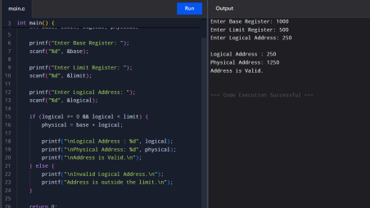
2. Paging Memory Management
Question
Write a program to demonstrate the paging memory management scheme. The program should divide memory into fixed-size pages and frames, accept a page number and offset as input, and compute the corresponding physical address using a page table.
Aim
To implement the paging memory management scheme and translate a logical address into a physical address using a page table.
Algorithm
1. Start the program.
2. Read the number of pages and frames.
3. Enter the page table mapping.
4. Read the page number.
5. Read the offset.
6. Check whether the page number is valid.
7. Obtain the corresponding frame number from the page table.
8. Calculate:
Physical Address = Frame Number × Page Size + Offset
9. Display the physical address.
10.Stop.
C Program
#include <stdio.h>
int main() {
int pages, pageSize;
int pageTable[20];
int page, offset, frame, physical;
int i;
printf("Enter number of pages: "); scanf("%d", &pages);
printf("Enter page size: ");
scanf("%d", &pageSize);
printf("\nEnter page table entries:\n");
for (i = 0; i < pages; i++) {
printf("Page %d -> Frame: ", i); scanf("%d", &pageTable[i]); }
printf("\nEnter page number: "); scanf("%d", &page);
printf("Enter offset: ");
scanf("%d", &offset);
if (page < 0 || page >= pages) { printf("\nInvalid Page Number.\n"); }
else if (offset < 0 || offset >= pageSize) { printf("\nInvalid Offset.\n");
}
else {
frame = pageTable[page];
physical = frame * pageSize + offset;
printf("\nPage Number : %d", page);
printf("\nFrame Number : %d", frame);
printf("\nOffset : %d", offset);
printf("\nPhysical Address: %d\n", physical);
}
return 0;
}
Sample Result
Enter number of pages: 4
Enter page size: 100
Enter page table entries:
Page 0 -> Frame: 3
Page 1 -> Frame: 1
Page 2 -> Frame: 4
Page 3 -> Frame: 2
Enter page number: 2
Enter offset: 25
Page Number : 2
Frame Number : 4
Offset : 25
Physical Address: 425
Result: Thus, paging was successfully implemented and the physical address was obtained using the page table.
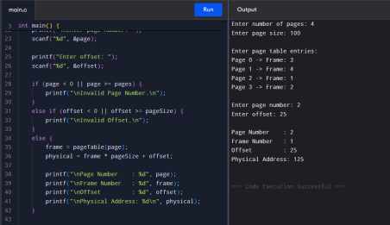
3. Page Table Simulation
Question
Develop a program to simulate a page table. The program should allow the user to input page table entries and logical addresses, then map them to physical addresses. Clearly show how page numbers are translated into frame numbers.
Aim
To simulate a page table and demonstrate the translation of page numbers into frame numbers.
Algorithm
1. Start the program.
2. Read the number of pages.
3. Enter the frame number for each page.
4. Display the page table.
5. Read the logical page number and offset.
6. Find the corresponding frame number.
7. Calculate:
Physical Address = Frame × Page Size + Offset
8. Display the page-to-frame translation. 9. Stop.
C Program
#include <stdio.h>
int main() {
int pageTable[20];
int n, pageSize;
int page, offset, frame, physical;
int i;
printf("Enter number of pages: ");
scanf("%d", &n);
printf("Enter page size: ");
scanf("%d", &pageSize);
printf("\nEnter frame number for each page:\n");
for (i = 0; i < n; i++) {
printf("Page %d -> Frame ", i);
scanf("%d", &pageTable[i]);
}
printf("\nPage Table\n");
printf("-----------------\n");
printf("Page\tFrame\n");
for (i = 0; i < n; i++) {
printf("%d\t%d\n", i, pageTable[i]);
}
printf("\nEnter logical page number: ");
scanf("%d", &page);
printf("Enter offset: ");
scanf("%d", &offset);
if (page < 0 || page >= n) {
printf("\nInvalid Page Number.\n");
}
else if (offset < 0 || offset >= pageSize) {
printf("\nInvalid Offset.\n");
}
else {
frame = pageTable[page];
physical = frame * pageSize + offset;
printf("\nPage %d is mapped to Frame %d", page, frame); printf("\nPhysical Address = %d\n", physical); }
return 0;
}
Sample Result
Enter number of pages: 3
Enter page size: 100
Enter frame number for each page:
Page 0 -> Frame 5
Page 1 -> Frame 2
Page 2 -> Frame 7
Page Table
-----------------
Page Frame
0 5
1 2
2 7
Enter logical page number: 1
Enter offset: 30
Page 1 is mapped to Frame 2
Physical Address = 230
Result: Thus, the page table was successfully simulated and the logical page was mapped to its corresponding physical frame.
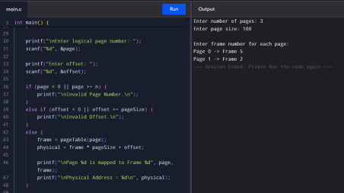
4. Translation Lookaside Buffer (TLB)
Question
Implement a program to simulate the working of a Translation Lookaside Buffer (TLB). The program should demonstrate how TLB improves memory access time by calculating the effective memory access time with and without TLB.
Aim
To simulate the working of a Translation Lookaside Buffer (TLB) and compare memory access time with and without TLB.
Algorithm
1. Start the program.
2. Read TLB access time.
3. Read main memory access time.
4. Read TLB hit ratio.
5. Calculate access time without TLB:
EAT = 2 × Memory Access Time
6. Calculate access time with TLB:
EAT = Hit Ratio × (TLB Time + Memory Time) + Miss Ratio × (TLB Time + 2 × Memory Time)
7. Display both values.
8. Stop.
C Program
#include <stdio.h>
int main() {
float tlbTime, memoryTime, hitRatio; float missRatio;
float withoutTLB, withTLB;
printf("Enter TLB access time: "); scanf("%f", &tlbTime);
printf("Enter memory access time: "); scanf("%f", &memoryTime);
printf("Enter TLB hit ratio (0 to 1): "); scanf("%f", &hitRatio);
if (hitRatio < 0 || hitRatio > 1) { printf("Invalid hit ratio.\n"); return 0;
}
missRatio = 1 - hitRatio;
withoutTLB = 2 * memoryTime;
withTLB = hitRatio * (tlbTime + memoryTime)
+ missRatio * (tlbTime + 2 * memoryTime);
printf("\nMemory Access Time without TLB: %.2f", withoutTLB); printf("\nEffective Access Time with TLB: %.2f\n", withTLB);
return 0;
}
Sample Result
Enter TLB access time: 10
Enter memory access time: 100
Enter TLB hit ratio (0 to 1): 0.8
Memory Access Time without TLB: 200.00
Effective Access Time with TLB: 130.00
Result: Thus, the TLB was successfully simulated, and it reduced the effective memory access time compared with memory access without TLB.
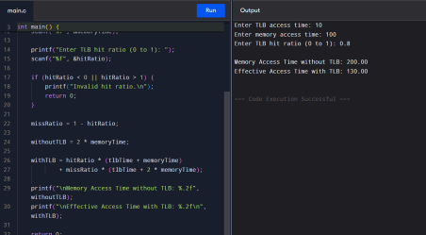
5. Memory Protection Using Base and Limit Registers Question
Write a program to illustrate memory protection using base and limit registers. The program should verify whether a given logical address lies within the valid range and prevent unauthorized access.
Aim
To implement memory protection using base and limit registers and prevent access to invalid memory locations.
Algorithm
1. Start the program.
2. Read the base register.
3. Read the limit register.
4. Read the logical address.
5. Check whether:
0 ≤ Logical Address < Limit
6. If valid, calculate:
Physical Address = Base + Logical Address
7. Allow memory access.
8. Otherwise, deny memory access.
9. Display the appropriate message.
10.Stop.
C Program
#include <stdio.h>
int main() {
int base, limit, logical, physical;
printf("Enter Base Register: ");
scanf("%d", &base);
printf("Enter Limit Register: ");
scanf("%d", &limit);
printf("Enter Logical Address: ");
scanf("%d", &logical);
if (logical >= 0 && logical < limit) {
physical = base + logical;
printf("\nAccess Allowed");
printf("\nLogical Address : %d", logical); printf("\nPhysical Address: %d\n", physical); }
else {
printf("\nAccess Denied!");
printf("\nUnauthorized memory access.\n"); }
return 0;
}
Sample Result — Valid Address
Enter Base Register: 2000
Enter Limit Register: 500
Enter Logical Address: 300
Access Allowed
Logical Address : 300
Physical Address: 2300
Sample Result — Invalid Address
Enter Base Register: 2000
Enter Limit Register: 500
Enter Logical Address: 600
Access Denied!
Unauthorized memory access.
Result: Thus, memory protection was successfully implemented using base and limit registers, allowing only valid logical addresses to access memory.
