COURSE CODE/NAME: CSA 1606-DATA WAREHOUSING AND DATA MINING
NAME/REG: KAVINILAVU.S / 192565038
Activity-APPLICATION BUILDING USING WEKA TOOL

1. Weather-Based Play Prediction ��️
Build a WEKA application that predicts whether a person should play outdoors
based on weather conditions.
• Dataset: Outlook, Temperature, Humidity, Windy
• Target: Play (Yes/No)
• Algorithm: J48 Decision Tree
• Tasks:
1. Load the dataset into WEKA.
2. Preprocess the data.
3. Apply J48.
4. Visualize the decision tree.
5. Predict Play for a new weather condition.
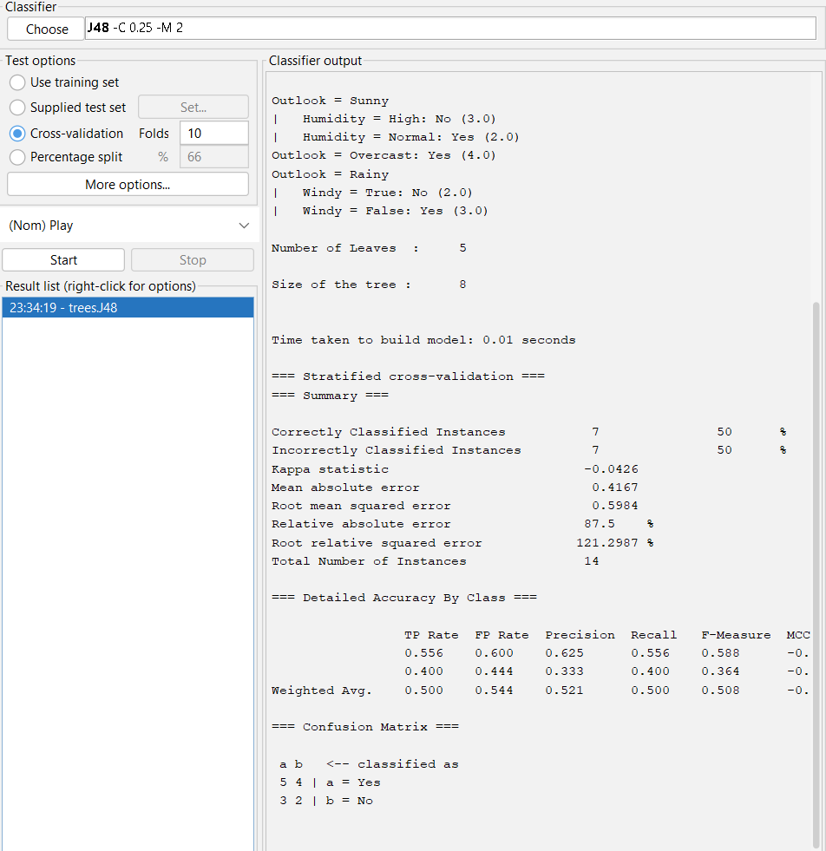
RESULT:
Thus, a weather-based Play prediction system was successfully implemented using the J48 Decision Tree algorithm in WEKA.

2. Flower Species Classification ��
Build a WEKA application that identifies the species of a flower from its
physical measurements.
• Dataset: Iris dataset
• Attributes: Sepal Length, Sepal Width, Petal Length, Petal Width
• Target: Iris Species
• Algorithm: J48 or Naive Bayes
• Tasks:
1. Load the Iris dataset.
2. Select the classification algorithm.
3. Train the model.
4. Evaluate its accuracy.
5. Classify a new flower.
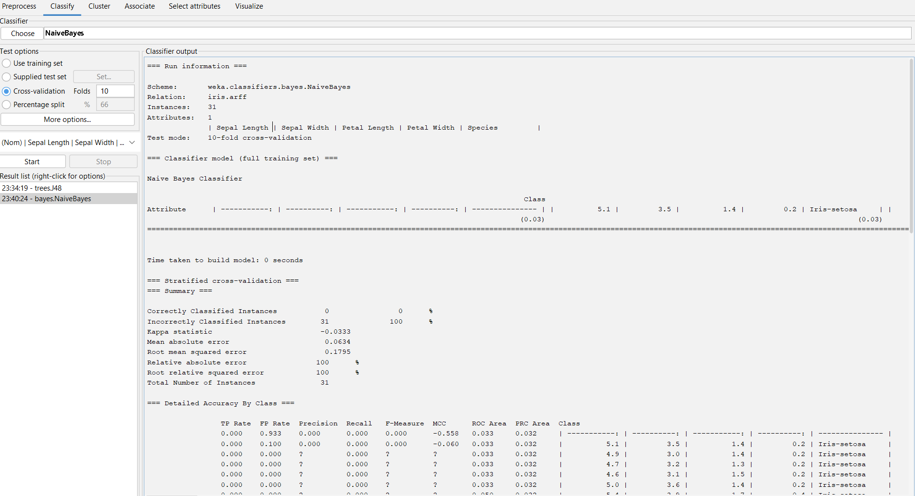

RESULT:
Thus, the Iris flower classification system was successfully implemented using the Naive Bayes algorithm in WEKA, and the trained model was used to classify a new flower.

