1 | Perform a Cutting and filing for the given profile as per the given dimensions.  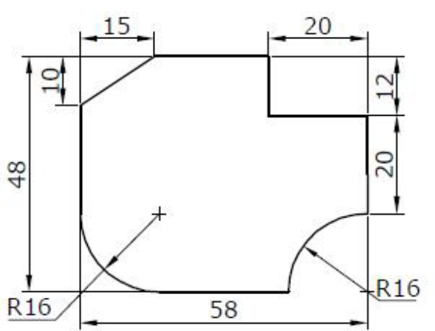  All Dimensions are in MM  Dimensions may be altered as required

ALLOCATION OF MARKS

SNo | Descriptions |  | Max. Marks | Marks Awarded
1 | Marking / Circuit Diagram |  | 25
2 | List of Tools |  | 10
3 | Cutting and Filing / Circuit / Pipe Connection |  | 25
4 | Dimension / Verification of Connection |  | 20
5 | Written Test (Theory Portion) |  | 20
TOTAL |  |  | 100
Internal Examiner |  | External Examiner

2 | Perform Drilling, Reaming and Tapping as per the given dimensions  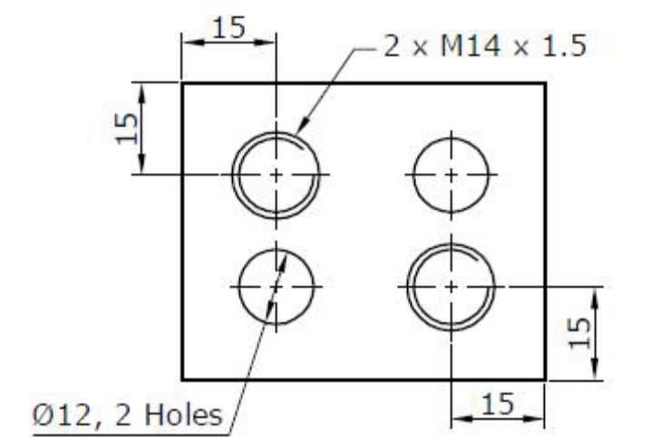  All Dimensions are in MM  Dimensions may be altered as required

ALLOCATION OF MARKS

SNo | Descriptions |  | Max. Marks | Marks Awarded
1 | Marking / Circuit Diagram |  | 25
2 | List of Tools |  | 10
3 | Cutting and Filing / Circuit / Pipe Connection |  | 25
4 | Dimension / Verification of Connection |  | 20
5 | Written Test (Theory Portion) |  | 20
TOTAL |  |  | 100
Internal Examiner |  | External Examiner

3 | Perform L Mating as per the given dimensions  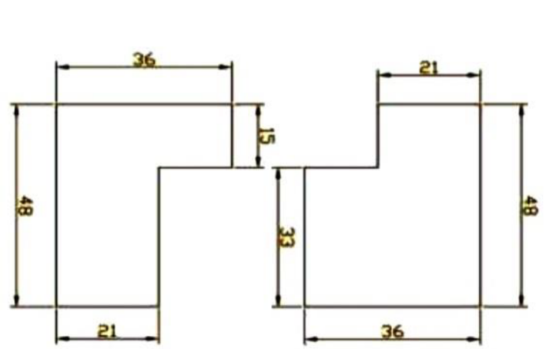  All Dimensions are in MM  Dimensions may be altered as required

ALLOCATION OF MARKS

SNo | Descriptions |  | Max. Marks | Marks Awarded
1 | Marking / Circuit Diagram |  | 25
2 | List of Tools |  | 10
3 | Cutting and Filing / Circuit / Pipe Connection |  | 25
4 | Dimension / Verification of Connection |  | 20
5 | Written Test (Theory Portion) |  | 20
TOTAL |  |  | 100
Internal Examiner |  | External Examiner

4 | Draw the circuit diagram and connect for the connection of two lamps, two switches with sockets for parallel and series connection.

ALLOCATION OF MARKS

SNo | Descriptions |  | Max. Marks | Marks Awarded
1 | Marking / Circuit Diagram |  | 25
2 | List of Tools |  | 10
3 | Cutting and Filing / Circuit / Pipe Connection |  | 25
4 | Dimension / Verification of Connection |  | 20
5 | Written Test (Theory Portion) |  | 20
TOTAL |  |  | 100
Internal Examiner |  | External Examiner

5 | Draw the circuit diagram and connect the connection for Fan switch regulator.

ALLOCATION OF MARKS

SNo | Descriptions |  | Max. Marks | Marks Awarded
1 | Marking / Circuit Diagram |  | 25
2 | List of Tools |  | 10
3 | Cutting and Filing / Circuit / Pipe Connection |  | 25
4 | Dimension / Verification of Connection |  | 20
5 | Written Test (Theory Portion) |  | 20
TOTAL |  |  | 100
Internal Examiner |  | External Examiner

6 | Draw the circuit diagram and connect for the Stair case wiring

ALLOCATION OF MARKS

SNo | Descriptions |  | Max. Marks | Marks Awarded
1 | Marking / Circuit Diagram |  | 25
2 | List of Tools |  | 10
3 | Cutting and Filing / Circuit / Pipe Connection |  | 25
4 | Dimension / Verification of Connection |  | 20
5 | Written Test (Theory Portion) |  | 20
TOTAL |  |  | 100
Internal Examiner |  | External Examiner

7 | Install a Battery and Test for it using a hydrometer

ALLOCATION OF MARKS

SNo | Descriptions |  | Max. Marks | Marks Awarded
1 | Marking / Circuit Diagram |  | 25
2 | List of Tools |  | 10
3 | Cutting and Filing / Circuit / Pipe Connection |  | 25
4 | Dimension / Verification of Connection |  | 20
5 | Written Test (Theory Portion) |  | 20
TOTAL |  |  | 100
Internal Examiner |  | External Examiner

8 | Connect a tap using - PVC pipe, fittings and a tap

ALLOCATION OF MARKS

SNo | Descriptions |  | Max. Marks | Marks Awarded
1 | Marking / Circuit Diagram |  | 25
2 | List of Tools |  | 10
3 | Cutting and Filing / Circuit / Pipe Connection |  | 25
3 | Dimension / Verification of Connection |  | 20
4 | Written Test (Theory Portion) |  | 20
TOTAL |  |  | 100
Internal Examiner |  | External Examiner

9 | Connect the pipe line for the Sink / Wash basin

ALLOCATION OF MARKS

SNo | Descriptions |  | Max. Marks | Marks Awarded
1 | Marking / Circuit Diagram |  | 25
2 | List of Tools |  | 10
3 | Cutting and Filing / Circuit / Pipe Connection |  | 25
4 | Dimension / Verification of Connection |  | 20
5 | Written Test (Theory Portion) |  | 20
TOTAL |  |  | 100
Internal Examiner |  | External Examiner

10 | Connect the pipe line for the Rain Water Harvesting Arrangement.

ALLOCATION OF MARKS

SNo | Descriptions |  | Max. Marks | Marks Awarded
1 | Marking / Circuit Diagram |  | 25
2 | List of Tools |  | 10
3 | Cutting and Filing / Circuit / Pipe Connection |  | 25
3 | Dimension / Verification of Connection |  | 20
5 | Written Test (Theory Portion) |  | 20
TOTAL |  |  | 100
Internal Examiner |  | External Examiner

