1 | A) Draw and render of your own imaginary drawing with an appropriate finishing materials.  B) Draw a One-point perspective view of a Bedroom using colour rendering  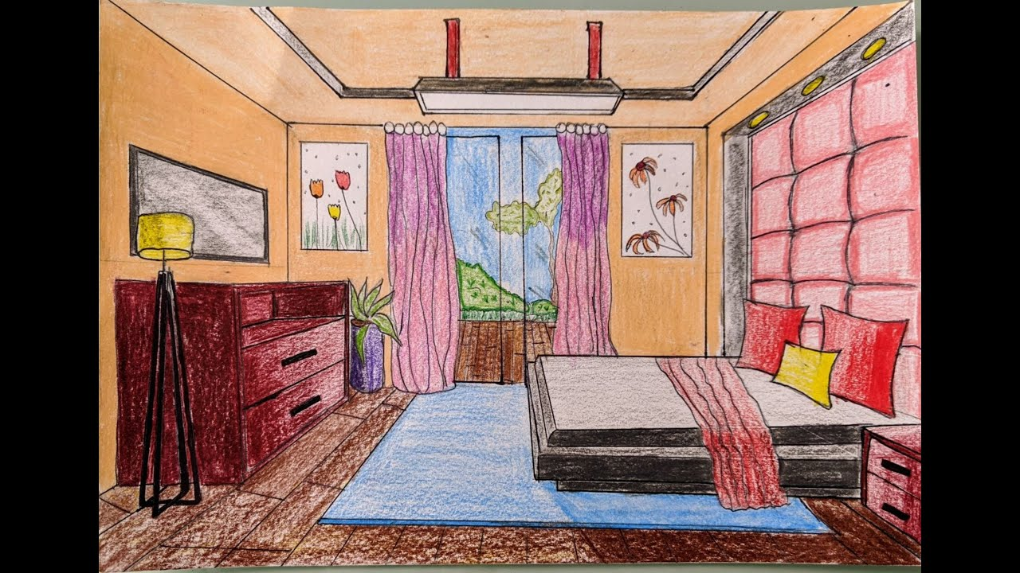

ALLOCATION OF MARKS

SNo | Descriptions |  | Max. Marks | Marks Awarded
1 | Part A |  | 40
2 | Part B |  | 50
3 | Viva voce |  | 10
TOTAL |  |  | 100
Internal Examiner |  | External Examiner

2 | A) Draw and render of your own imaginary drawing with pencil or pen and ink ? including trees, cars and human figures.  B) Draw a One-point perspective view of a Kitchen using colour rendering.  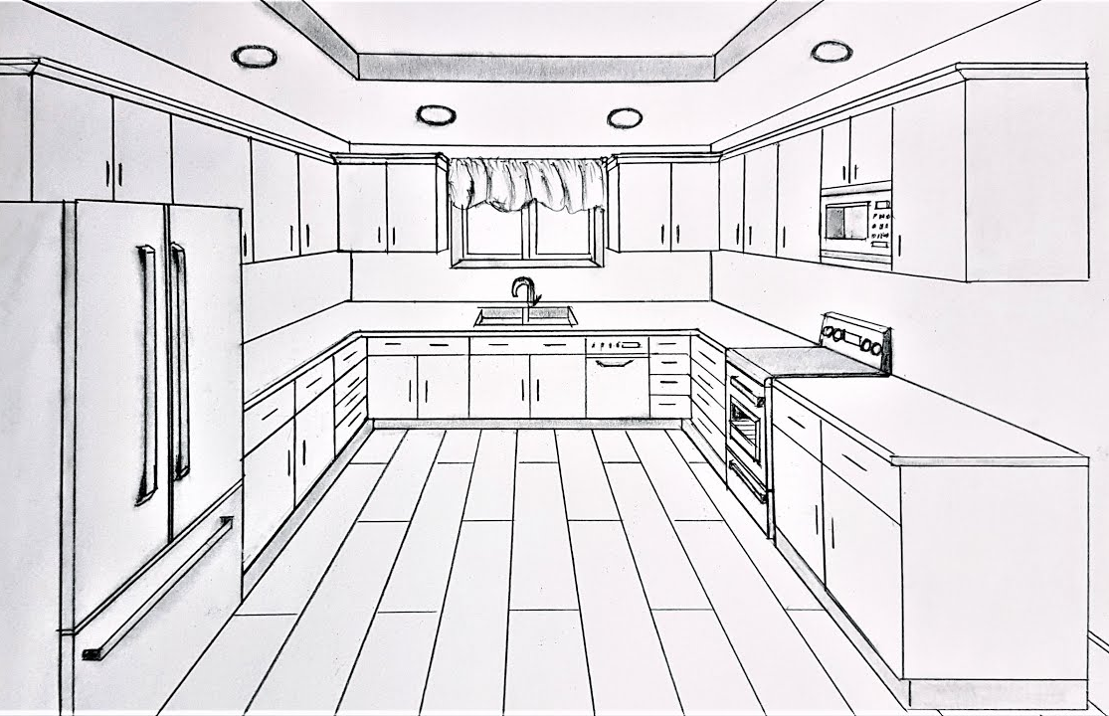

ALLOCATION OF MARKS

SNo | Descriptions |  | Max. Marks | Marks Awarded
1 | Part A |  | 40
2 | Part B |  | 50
3 | Viva voce |  | 10
TOTAL |  |  | 100
Internal Examiner |  | External Examiner

3 | A) Draw a Two-point perspectives of Residence using pencil rendering  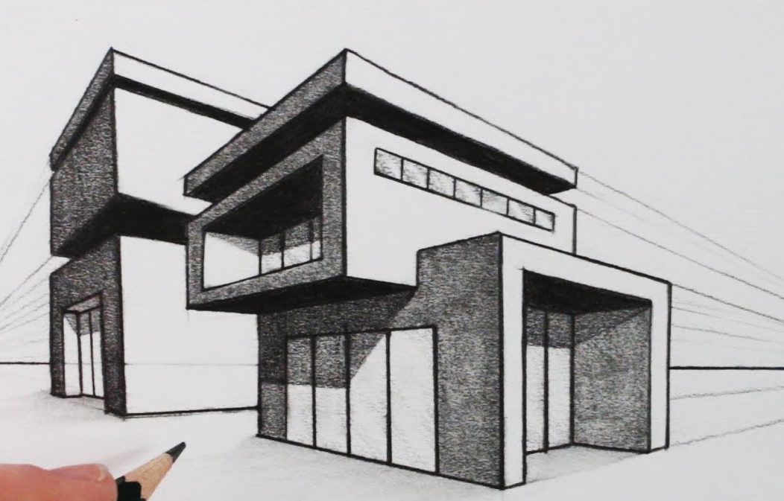  B) Draw the sciography in view of Steps given plan  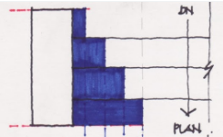

ALLOCATION OF MARKS

SNo | Descriptions |  | Max. Marks | Marks Awarded
1 | Part A |  | 40
2 | Part B |  | 50
3 | Viva voce |  | 10
TOTAL |  |  | 100
Internal Examiner |  | External Examiner

4 | A) Draw a Two-point perspectives of Residence using pencil rendering.  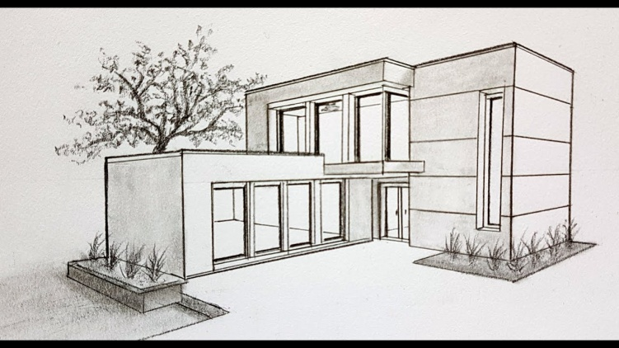  B) Draw the sciography of Steps (or), Fins, (or) columns (or) curved objects

ALLOCATION OF MARKS

SNo |  | Descriptions |  | Max. Marks | Marks Awarded
1 |  | Part A |  | 40
2 |  | Part B |  | 50
3 |  | Viva voce |  | 10
TOTAL |  |  |  | 100
Internal Examiner |  |  | External Examiner
5 | A) Draw and render of your own imaginary drawing with an appropriate finishing materials.  B) Draw a One-point perspective view of a Dining using colour rendering.  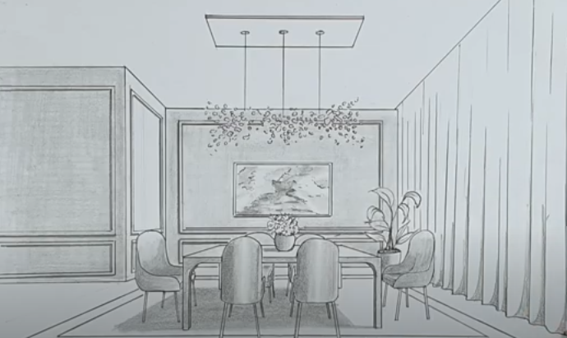

ALLOCATION OF MARKS

SNo | Descriptions |  | Max. Marks | Marks Awarded
1 | Part A |  | 40
2 | Part B |  | 50
3 | Viva voce |  | 10
TOTAL |  |  | 100
Internal Examiner |  | External Examiner

6 | A) Draw and render of your own imaginary drawing with an appropriate finishing materials.  B) Draw a One-point perspective view of a Living room using colour rendering  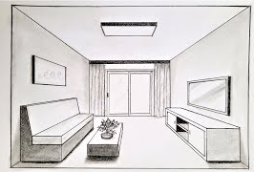

ALLOCATION OF MARKS

SNo | Descriptions |  | Max. Marks | Marks Awarded
1 | Part A |  | 40
2 | Part B |  | 50
3 | Viva voce |  | 10
TOTAL |  |  | 100
Internal Examiner |  | External Examiner

7 | A) Draw and render of your own imaginary drawing with an appropriate finishing materials.  B) Draw the sciography view of Fins,(or) colum

ALLOCATION OF MARKS

SNo | Descriptions |  | Max. Marks | Marks Awarded
1 | Part A |  | 40
2 | Part B |  | 50
3 | Viva voce |  | 10
TOTAL |  |  | 100
Internal Examiner |  | External Examiner

